Irradiation Requirements for Radioisotope Production

D. Hergenreder1, S. Matzkin1

1) INVAP SE, Nuclear Engineering Division,Cte. Luis Piedrabuena 4950 (R8403CPV), Bariloche, Argentina

Corresponding author: hergend@invap.com.ar

**Abstract**. The radioisotope demand is increasing worldwide. In some cases the irradiation process is fulfilled with new research reactor projects where the design of the reactor is carried out taking into account the radioisotope production requirements.

In other cases, the irradiation process will be fulfilled with research reactors already built several years ago. In these cases, the redesign of some irradiation positions makes it possible the use of the reactor for radioisotope production.

In this work reactor design requirements and considerations will be presented to be taken into account for the production of several radioisotopes.

Design guidelines in terms of irradiation volumes, neutron flux values, spectra, self shielding, heat load deposition and cooling requirements will be presented.

Additional requirements related to facilities needed to insert/remove the target from the core and transport it to a Radioisotope Production plant are presented.

**1. Introduction**

The production of radioisotopes in a research reactor is based on either of two predominant mechanisms: neutron capture in a target material or products from fission in a fissile target material.

Significant changes have taken place in many aspects of radioisotope production during the last few years, in particular, regarding the situation with research reactor facilities. Many research reactors worldwide are approaching the end of their operating lives, and have either ceased operation or are due for shutdown and replacement by new ones, or are being subjected to costly modernization in the near future (reference [1]).

On the other hand, considerable experience and knowledge have been gained in the production of important radioisotopes as well as research by medical investigators. The discoveries of new nuclear medicine procedures for diagnostics, therapy and palliative care have had a remarkable influence on the introduction of many new radioisotopes.

The resultant collaborative research of nuclear medicine investigators, reactor operators and processing laboratories has led to success in establishing several new and challenging technologies for radioisotope production using research reactor [1].

In this paper two cases will be analyzed: the design from the conceptual engineering state of a research reactor focused into radioisotope production and the modification of an existing research reactor in order to produce radioisotopes.

**2. Commercial Radioisotope Production in a reactor**

The irradiation process in a research reactor aimed at the commercial production of radioisotopes depends on the available neutron fluxes and the irradiation volumes [2]. The cycle length and the capability for loading/unloading the irradiation target during operation may affect the production.

The production of some of the most demanded radioisotopes by industry and medicine will be described in the following sections.

**2.1. 99Mo production**

Nowadays the most demanded radioisotope for medical diagnoses is 99Mo. The preferred target to generate 99Mo as a fission product is Uranium with an enrichment of 20%.

The plate geometry maximizes the area required for heat transfer from the Uranium target to the cooling water. Moreover, taking into account that MTR fuel is a proven technology, Uranium plate targets are widely used in the nuclear industry.

Typical Uranium plates consist in a core of Uranium dispersed in a matrix of Aluminum (“meat”). The meat is encapsulated within an Aluminum cladding.

The power generated by fission in the fissile targets may be revelevant compared with the power generated by fission in the fuel in reactors that produce large amounts of 99Mo.

As a practical rule, it has been found that when the Uranium target generates a fission power of 20 Watts, the saturation activity of 99Mo in the target is 1 Ci.

Due to the fact that the practical irradiation time is shorter than the one required to reach saturation, the 99Mo activity reached in the sample is a fraction of the saturation activity. Table 1 shows values for the 99Mo activity for several typical irradiation times.

When the reactor produces one batch of 99Mo per week, a typical irradiation time may be 5 days and the remaining 2 days the reactor is shutdown. For this case, the 99Mo activity reached in the target at the end of irradiation is 71.6% of the saturation activity.

Reactors with a cycle length greater than 15 days usually operate in a continuous mode, that is, the reactor operates at constant power from beginning of cycle to end of cycle and then the reactor is in shutdown for refueling and maintenance activities during 2 days. In this case irradiation times for the Uranium targets can be in the range from 7 to 12 days, obtaining higher values of 99Mo activity in the targets at the end of irradiation.

Once the Uranium target is removed from the core it is usually kept under water for a cooling time of a few hours (depending on the power density) until the decay heat decreases to some value that it makes possible the cooling of the Uranium plate with air. In this condition, the plate may be transported inside a shielded cask to the Radioisotope Production Plant.

The 99Mo separation process takes place in the Radioisotope Production Plant demanding for example, 24 hs. Adding to the separation time the previous cooling time under water (for example, 12 hours), it takes 36 hs since the target is removed from the core until the 99Moseparation process finish.

In order to show some examples of the 99Mo 6-day activity calculation, it is assumed an efficiency of 60% for the separation process.

TABLE I: 99Mo Activity for different irradiation schemes

|  |  |  |  |
| --- | --- | --- | --- |
| **Irradiation Time [Days]** | **Fraction of the Saturation Activity [%]** | | |
| **End of Irradiation** | **End of Separation Process**  **(60% efficiency)** | **Six Days** |
| 5 | 0.716 | 0.295 | 0.065 |
| 7 | 0.829 | 0.341 | 0.075 |
| 12 | 0.951 | 0.391 | 0.086 |

Considering an irradiation scheme where the Uranium plates are irradiated during 7 days and assuming 12 hs of decay time in the Reactor Pool and 24 hs of separation process with an efficiency of 60% it is required a fission power of 270 Watts to produce 1 6-day Ci.

Figure 1 shows the evolution of the 99Mo activity when the target is removed from the core for a 7 day irradiation.



*FIG. 1. Evolution of the 99Mo activity after target is removed from the core in a 7 days irradiation schema.*

Typically, the cooling system shall remove about 100 kW per Uranium plate irradiation rig with a downward flow in order to enable the loading/unloading of the targets with the reactor in operation.

**2.2. 192Ir production**

The Iridium sources are usually in the form of wires or stacks of thin foil discs. The 192Ir has dual applications: medicine and industry.

192Ir is used medically in brachytherapy to treat various types of cancer. The 192Ir implants may be used in wire form and are introduced through a catheter to the target area especially in the head and breast. After being left in place for the time required to deliver the desired dose, the implant wire is removed.

Industrial applications of 192Ir are mainly non-destructive testing (NDT) and to a lesser extent radio-tracing in the oil industry. Industrial gamma radiography involves the testing and grading of welds on pressurized piping, pressure vessels, high capacity storage containers, pipelines, and certain structural welds. Other tested materials include concrete (locating rebar or conduit within the concrete), machined parts, plate metal, or pipe wall. Gamma radiography is also used to identify flaws in metal castings and welded joints, as well as indicate structural anomalies due to corrosion or mechanical damage.

Due to the high density of the Iridium material and its large capture cross section the thermal flux depression inside the target is very significant. For this reason, the Iridium target consists of thin discs. Typical diameters range between 0.5 to 3.5 mm and thicknesses vary from 0.2 to 0.5 mm.

Also, the Iridium for irradiation may take wire shapes or pellets. The dimensions of the wire are about 0.6 mm diameter and 3.5 mm wire length or a diameter of 0,5 x 0,5 mm length in case of a pellet shape.

Iridium targets need to be irradiated in high flux positions. Usually for gammagraphy sources the thermal neutron flux should be greater than 2 1014 n/cm2s.

The typical irradiation time for the gammagraphy Iridium target varies from 30 to 70 days.

The reactivity worth of some Iridium targets is such that the loading/unloading shall be carried out with the reactor in shutdown. In order to improve the commercial 192Ir production, the reactor cycle length shall be at least of 30 – 35 full power days.

The heat load deposition in each 192Ir irradiation rigs is about 5 kW.

**2.3. 131I production**

Iodine-131 is a radioisotope with a half life of 8.02 days, frequently used in thyroid cancers therapies.

In medicine, 131I is primarily used to study the functioning of the thyroid though it can also be employed in the treatment of hyperthyroidism as well as thyroid cancer.

It is used in low doses for medical examinations; 131I is an ideal tracer.

Stronger doses of 131I are also used in radioactive therapies aimed at dealing with thyroid cancers.

131I radioisotope may be produced in a research reactor either as a fission product or by thermal neutron capture of Tellurium targets. In the first case, it is separated in a Radioisotope Production Plant from the 99Motarget. Thus, the irradiation scheme is the same as for 99Mo.

131I can be obtained from a 130Te (n,γ) 131I reaction [3]. The irradiation target consists of a mass of TeO2 powder encapsulated in Aluminum Cans.

The heat load deposition in Tellurium irradiation rigs is about 5 kW.

**2.4. Radioisotope Production Rate**

The following table shows the estimated production rate for a 10 MW reactor dedicated to produce multiple types of radioisotopes.

TABLE II: Estimated Radioisotope Production rate for a 10 MW reactor.

|  |  |  |
| --- | --- | --- |
| **Radioisotope** | **Indicative Production Rate (end of process)** | **Production Method** |
| 99Mo | 5000 (6-days) Ci/week | Fission |
| 131I | 1100 Ci/week | Fission |

**3. Design of a Radioisotope Production Reactor**

Before starting the design of a Multipurpose Reactor or a Radioisotope Production Reactor a comprehensive plan to cover the following studies shall be carried out:

* identification of key targeted production radioisotopes for medical and industrial applications
* identification of radioisotope marketing opportunities and challenges at local, regional, and global levels
* development of a long-term sustainable business model for radioisotope production
* identification of potential partners and association models to support the investment
* identification of capital and operating costs associated to the potential production of radioisotopes

The design of the reactor shall be carried out to fulfill the production requirements identified in the analysis of the of radioisotope marketing.

Starting with the specific reactor design, an Open Pool Reactor allows a full access to all irradiation positions, making the task of loading/removing targets from the core easier. When the reactor is intended for radioisotope production on a large scale, an Auxiliary Pool connected with the Reactor Pool allows the storage and decay of irradiated targets.

A Hot cell connected to the Auxiliary Pool allows the disassembling of the irradiation rigs, the removing of the irradiated targets and the loading of the target into a shielded cask required to transport the target from the reactor to the Radioisotope Production plant. Also the Hot cell allows the loading of fresh targets into the activated Irradiation rigs.

Reactors where the priority is the 99Mo production will be designed to maximize 99Mo production and to lowering the fuel consumption and operation cost. This design will take advantage of the power generated by the Uranium targets (for example 1.35 MW for a weekly production of 5000 Ci six day of 99Mo) locating the Uranium irradiation targets close to the core or inside the core.

In order to allow the loading/unloading of the Uranium targets with the reactor in operation the cooling flow shall be downwards. The loading/unloading velocity may have to be limited taking into account the reactivity insertion rate of the targets.

In High flux reactors required to produce several types of radioisotopes, the Uranium targets are located at a distance from the core such as the thermal neutron flux is about 1 1014 n/cm2s. The highest flux positions are used for the production of 192Ir.

In the case where the 131I is obtained from the 130Te (n,γ) 131I reaction, it is required to irradiate TeO2 powder in a thermal neutron flux of about 1.5 1014 n/cm2s.

**4. Modification of a Reactor to produce Radioisotopes**

The following consideration shall be taken into account when an upgrade of a reactor is analyzed in order to start with the radioisotope production or improve the current capabilities of Radioisotope production:

* Maximum reactor power
* Irradiation volumes available and neutron flux values at these volumes.
* Reactor cycle length
* Installed capabilities to manipulate radioactive material and the possibility to expand the installed facilities according to the radioisotope production requirements.
* Capability to load/unload underwater the targets into a shielded cask to transport the target to the Radioisotope Production plant.

For a reactor with power levels about 10 MW, the amount of radioisotope to be produced strongly depends on the already installed capabilities to manipulate radioactive material and how these capabilities could be expanded.

For a reactor with a power level about 1 MW, the amount of radioisotope to be produced depends on the irradiation volumes available, the neutron flux values at these volumes and the availability of adequate cooling for the targets.

**5. INVAP Experience in Radioisotope Production**

INVAP has a wide experience in the field of Radioisotope Production. This experience covers from the target preparation until the Radioisotope is ready to be delivered to the client.

The irradiation target can be prepared in a laboratory located inside the reactor building or in a laboratory located in the Radioisotope Production Plant. Some special targets such as the Uranium plate shall be fabricated in a Fuel Fabrication plant, for which INVAP also has the design and construction capabilities.

INVAP designed, built and commissioned at the People’s Democratic Republic of Algeria a Fuel Fabrication Plant and a 1 MW multipurpose Research Reactor (NUR). Currently INVAP is upgrading the reactor to increase the radioisotope production capabilities and designing a Radioisotope Production plant able to produce among other radioisotopes 99Mo and 131I from fission.

INVAP is also currently designing a Radioisotope production plant to produce 99Mo and 131I from fission in the Republic of India.

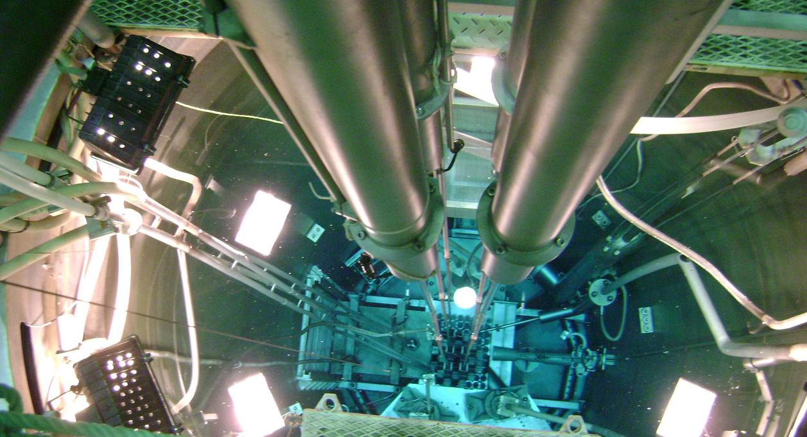

*FIG. 2. NUR reactor core and irradiation positions.*

INVAP designed, built and commissioned in the Arab Republic of Egypt a Fuel Fabrication Plant, a 22 MW multipurpose Research Reactor (ETRR-II) and a Radioisotope Production plant able to produce 99Mo and 131I by fission process, 51Cr, 192Ir for both medical and industrial applications, and 125I.

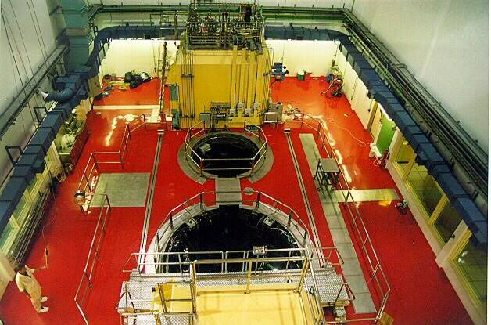

*FIG. 3. ETRR II Reactor Pool, Auxiliary Pool and Hot Cell.*

INVAP design, build and commissioned at Sydney the OPAL reactor (a 20 MW multipurpose research reactor) able to produce among other radioisotopes 99Mo, 131I and 192Ir.



*FIG. 4. OPAL Reactor Pool and Auxiliary Pool.*

**6. Final Remarks - Conclusions**

Before starting with the design of a Multipurpose Reactor or a Radioisotope Production Reactor a comprehensive radioisotope marketing analysis and the development of a business model has to be carried out.

Due to the current medical applications demand, the design of a multipurpose reactor should take into account the 99Mo production. The production of 131I from fission can be added with minimal investment in the Radioisotope Production Plant.

Production of 192Ir may be used, provided the adequate conditions are met, to complement medical applications with industrial applications.

**7. References**

1. INTERNATIONAL ATOMIC ENERGY AGENCY, Nuclear Energy Series No. NP-T-5.3 “The applications of Research Reactor”, Vienna (2014).
2. INTERNATIONAL ATOMIC ENERGY AGENCY, The applications of Research Reactor, IAEA-TECDOC-1234, Vienna (2001).
3. INTERNATIONAL ATOMIC ENERGY AGENCY, Manual for reactor produced radioisotopes, IAEA-TECDOC-1340, Vienna (2003).