Neutronic Calculation Methodology for Research Reactors

E. Villarino1

1) INVAP SE, Cmte Luis Piedrabuena 4950  
S.C. de Bariloche, Argentina

Corresponding author: [men@invap.com.ar](mailto:men@invap.com.ar)

**Abstract**. The variables needed in reactor physics analysis and design depend on the interaction of neutrons with matter. This simple sentence implies a multidisciplinary problem that requires taking into account several different aspects in the whole process of the Reactor Design.

As a matter of fact when a Reactor Design is carried out, several miscellaneous aspects are to be faced as a whole, namely: The properties of the matter, given by the nuclear Cross Section Data and Engineering Data; The Engineering Data, which depends on the Reactor Design and the reactor operational conditions; The neutron transport equation that describes the neutron distribution and can be solved with different methods and tools; The computer tools to be used, that need suitable models to describe the system to be analyzed using several approximations where some of them are defined by a user/analyst; The accuracy of the models developed, which depends on the specific user skills, where currently the only way to evaluate his/her capability to perform such task with high level of accuracy is the on the job experience; Suitable training of users/analysts, which is compulsory in order not only to develop accurate models, but also to be capable to analyze the problem; The correct definition, assessment and utilization of a set of procedures to follow up and verify the proper utilization of the tools and the quality of the results; The review process to properly verify the fulfillment of the requirements and design criteria, in the frame of a research reactor project;

This paper describes the INVAP neutronic calculation methodology, which deals with the whole process to obtain accurate results, starting from the nuclear cross section data, the calculation tools, the calculation procedures, the review process and the qualification of the analyst.

# Introduction

INVAP designs and builds research reactors with very demanding requirements, which need better prediction capabilities to reduce the design margins due to the numerical and engineering uncertainties. INVAP uses computational tools to predict the behavior of the reactor to be built. Every new reactor needs increasingly detailed analysis from different points of view, as nuclear safety and fulfillment of user requirements (flux and production levels, spectra requirements, perturbation, etc). Furthermore, this detailed analysis must be modeled with a consistent level of detail from all the engineering variables, and the analysts play a very important role in the development of accurate models, which are used to simulate the system.

The following sections briefly describe all the aspects needed to predict the behavior of a nuclear research reactor from reactor physics point of view, for example: Design and Calculation methodologies, engineering data, user dependencies. A summary of the different sources of the calculation uncertainties is also given to finally present INVAP’s experience mitigating the user dependency developing accurate models using two different approaches: ensuring the correct training and qualification of the calculation staff on the one hand , and using procedures to verify the proper utilization of the computational tools on the other hand. Finally the review process is also described to properly verify all the design stages and the fulfillment of the project requirements.

# Design Methodology.

INVAP’s design methodology is presented in Figure 1 with the following concepts:

* **Safety as priority**: Using the requirements of the regulatory body of the country where the reactor will be built, the Argentine regulatory body requirements and the IAEA safety guidelines or recommendations.
* **Custom designed reactor**: All the operational design criteria are taken into account (examples given in the next section) and all project specific engineering data are collected in a database.
* **Minimize risk using proven technology**: When a novel design is needed experiments or mock-ups are used to adequately verify the design.
* **Qualified methods, tools and procedures**: New versions of the codes are in continuous development. A dynamic improvement and maintenance process is adopted to keep up with modern reactor’s evolving requirements (always maintaining a proper verification and validation stage).
* **Well trained nuclear analysts**: The design teams are continuously trained or re-trained to properly develop a solid understanding of each reactor design. This allows the analysts to prepare accurate models.

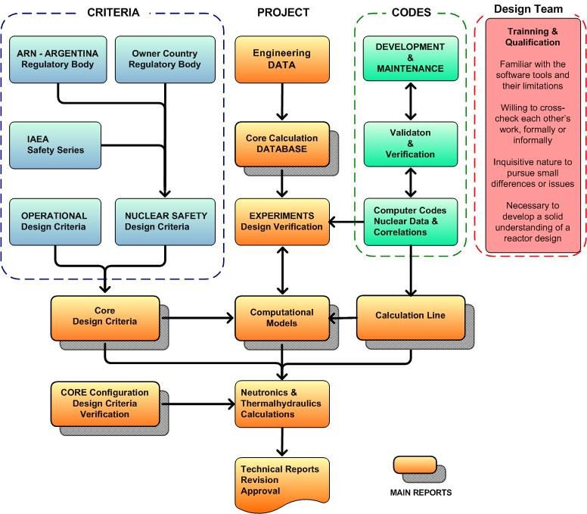

FIGURE 1: Design Methodology Flowchart.

The need of continuous improvement of the design methodology is mainly driven by the increasingly demanding design requirements of each new research reactor. The following list shows as an example the level of reactor performance requirements needed:

* **Flux or production levels**: Normally there are facilities with a minimum level of flux or production (for example radioisotope activity), but there are also facilities that require a limited, very precise flux range in the target region (±10%).
* **Spectra**: Multipurpose research reactors require different neutron spectra for the different applications. For example, Cold (En < 10 meV), Thermal (10 meV < En < 100 meV), hot neutrons (100 meV < En < 1eV) for beams application, Thermal (En < 0.625 eV) and Fast fluxes (En > 0.1 MeV) for radioisotope production and Fast fluxes for material damage applications (En > 1 MeV).
* **Flux homogeneity**: Same flux level for different irradiation rigs of the same type, or precise flux profiles (Radial and axial) are some examples.
* **Perturbation**: Along the operation of the reactor during the whole cycle or due to the movement of different irradiation facilities.
* **Operational requirements**: Like cycle length, discharge burnup and restart capabilities.

# Calculation Line

The improvements in the computational systems (increasing the memory and storage capacity and reducing the computational time) allows the development of innovative methods for reactor calculations, including not only better theories and numerical methods, but also adding more prediction capabilities and additional engineering information to perform the numerical analysis of the system. As an example, nowadays it is possible to integrate different tools with interdisciplinary or multi engineering information. These innovative methods improve the analysis of the calculated systems, and ease the input preparation process. Unfortunately, in some cases they enable the un-experienced user to venture in the design of a new model design.

Then, the problem that arises with these computational tools is that they allow the un-experienced user to perform reactor physics calculations without a solid understanding of the set of characteristics that constitute an accurate model taking into account all the engineering aspects of the system under analysis. For example, we can see more frequently than we would desire, a very detailed geometrical model without the proper temperatures information or without the impurities of the materials, which produces higher inaccuracies than a properly-made, geometrically simplified model.

Is due to this fact that the continuous training of analysts plays a key role in INVAP´s neutronic calculation group, where internal workshops, pair reviewing, and experimental and numerical benchmarking exercises of diverse designs are common practices.

The Figure 2 shows INVAP´s calculation line[1], which has been used by INVAP and several of its customers for the design, optimization and follow-up of several reactors throughout the world obtaining optimal results, like RA-6, NUR, RA-8, ETRR2, OPAL, CAREM, CNA-II, LPRR, etc. These codes are also used by nuclear engineering students, master’s and doctoral thesis students of the Balseiro Institute, performing a large number of calculations for different reactor types such as MTR, PWR, BWR, PHWR, TRIGA, FBR and Homogeneous reactors. A few of the characteristics of this calculation line are:

* Integration between deterministic and stochastic codes like MCNP [2] and Serpent [3].
* Capability to perform calculations with macroscopic or microscopic cross section data.
* Capability to perform thermal-hydraulic analysis for coupled neutronic/thermal-hydraulic calculations [4-5]. This feature is very important for power feedback coefficients, thermal-hydraulic margins to critical phenomena and the calculation of the growth of oxide layer, which is a limiting factor for high performance MTR fuel assemblies.

In order to make proper use of all these capabilities, well trained analysts are required.

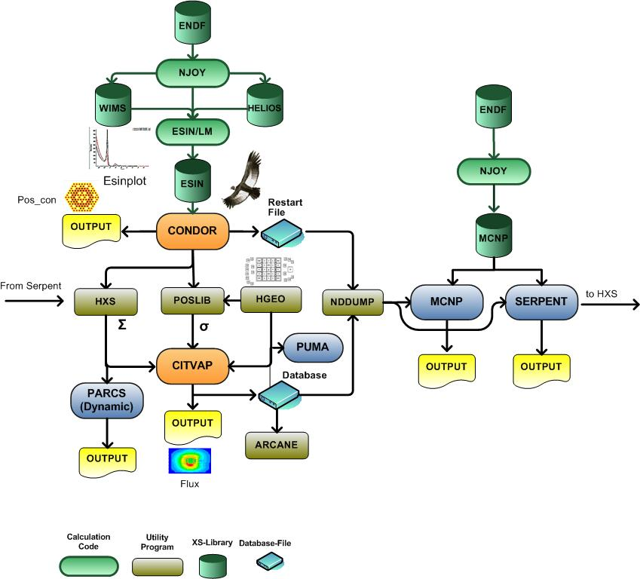

FIGURE 2: Calculation Line

# Calculation Uncertainties

As was already mentioned, the variables needed in reactor physics analysis depend on the interaction of the neutron with the matter. The properties of the matter are given by the nuclear cross section data and engineering data, which depends on operational conditions. The numerical solution of the neutron distribution can be obtained with different codes through analyst provided models. Then, in order to obtain accurate results we need accurate nuclear data, codes, models and engineering data:

**Nuclear data**: The nuclear data is continuously improved by the international community though the different sources and releases of the libraries (ENDF/B, JENDL, JEFF, etc), improving the provided data, adding new isotopes, etc. Nevertheless, we still have high level of uncertainties of about 500 pcm when using different libraries.

**Engineering data**: There is no practical way to eliminate the engineering data uncertainties, but the tolerances need to be in agreement with the design uncertainties. This is an important parameter to be evaluated in order to achieve a solid understanding of the reactor design. The following list shows example of the tolerances/uncertainties to be taken into account:

* The dimensions of the calculated system with their manufacturing or erection tolerances.
* The compositions of the materials. For example alloy specifications, and impurities.
* The operating conditions engineering data, which suffer of the approximation of the calculated values (For example temperatures, thermal expansion, etc) and also of the impossibility to predict all the possible operational conditions under normal and abnormal conditions, during the whole life of the reactor.

**Calculation Codes**: The validation of the codes is a continuous process and it is normally carried out by the code developer and the users. It is good practice to use the design calculation tools in a wide range of different reactor designs to acquire confidence in the calculated parameter when the predicted value is out of the scope of previous experience.

**Calculation Models:** The accuracy of the models depends on the specific analyst, and currently the only way to measure his/her capability to model different systems with acceptable level of accuracy is his/her experience or engineering judgment.

# Mitigating the User Dependence on the Models

As it was described, the accuracy needed in the design, analysis and calculation of new research reactors has several components such as the Nuclear and engineering data, the calculation tools and methodology, and the model of the system. Tools and data are continuously improved and can be properly evaluated through the validation of a calculation line using experimental data where the results are already known.

The analyst capacity to perform new accurate models to design or calculate new research reactors or irradiation facilities can be only evaluated through his/her experience.

INVAP mitigates the user dependency for developing accurate models using two different approaches:

* Planning specific training, and qualification for the calculation staff
* Using specific procedures to verify the proper utilization of the tools

## Training

INVAP understands the training does not rely only on the formal acquisition of knowledge in the reactor physics field and the solid understanding of the theories and utilization of the computational tools but also in the real analyst’s ability to prepare accurate models and identify minor differences or relevant issues.

The analysts get formal acquisition of the reactor physics knowledge in the universities, internal training courses, or international training courses. INVAP also promotes the self-training of the analysts as a natural response of his/her inquisitive nature.

The analysts are encouraged to teach internal training courses, and some of them are assistant or professors in the Balseiro Institute transmitting their expertise to the future generations of the world’s nuclear industry personnel.

Besides, INVAP promotes the educational participation of the analyst as technical advisors in different thesis (Engineering, Magister and PhD degree).

In order to develop the analyst’s ability to prepare different models, INVAP promotes the following activities:

* *Training to become familiar with the computational tools (their capabilities and limitations):* This is carried out performing calculation of different reactors (analysts do not perform always the same type of models or inputs).
* *Training to clearly understand the different methods used by the computational tools:* This is carried out using the different methods available in the codes or using different tools.
* *Will to cross-check between analyst’s works, formally and informally:* Discuss and share the different results between them.
* *Every model developed will serve a future purpose and will be reviewed by another analyst:* As the analysts understand this concept, they thrive to achieve a clear and understandable model that can be easily reviewed and updated by colleagues.

INVAP promotes an inquisitive attitude to pursue small differences or issues. Any unexpected difference observed between models or results when using different tools are clearly understood.

All this activities are carried out together with the development of a solid understanding of a reactor design.

## Calculation methodologies

INVAP uses different procedures for three conceptually different topics: Documentation; Model preparation; Specific design parameters.

In each of these areas, INVAP uses the following methodology to perform reactor physics analysis:

* **Documentation:** Any parameter or set of parameters are properly documented in a report, which is issued by the analysts in charge of the analysis and reviewed at least by the responsible of the reactor physics area for the project. Additionally each report has and approval stage, to verify that the document is coherent with the documentation of the project. The responsibilities of each of this activities can be summarized as follows:

a) The analysts who prepare a report are directly responsible for the veracity, accuracy, and significance of all information contained and transmitted in the document.

b) The analysts who revise a report are indirectly responsible, they manifest that nothing as to content of the document contradicts their experience and verifies the proper computational tools utilization. It is also their responsibility to raise the attention under any doubt about the veracity, accuracy and significance of the document and ensure its resolution before signing.

c) The persons who approve a document are responsible, not only for the content of the document itself, but also for certifying that the content of a document is coherent with all other project documentation, instructions, or management policies within their scope of authority. Approving the document, they endorse the application of its recommendations to the degree they assume its content to be correct.

* **Model preparation**: The input, auxiliary and output files are stored in a folder together with its table of contents explaining the purpose of each file. In complex or more sensitive models, these files are reviewed by another analyst that verifies the proper modeling of the system. This procedure has the following benefits:

a) It allows a detailed review of the calculated parameter and the models used.

b) It easies the transfer of the experience between analysts sharing the different models.

c) It minimizes input errors, preparing models ready to be reviewed.

* **Calculated parameters**: In complex reactor designs, there are additional levels of verification:

a) The same analyst makes the calculation of important parameters using different computational tools (For example deterministic and stochastic codes).

b) Different analysts perform independent calculations of the most relevant parameters using the same computational tools (normally non INVAP users) starting from the engineering data and requirements preparing their own models.

c) Different groups make the calculation of the most relevant parameters using different tools (normally customer staff).

## INVAP Calculation procedures

The calculation activities are carried out on a Linux cluster where the analyst has clearance to perform his/her input preparation and calculation activities.

The calculation staff has a project leader, who is responsible of project planning, the activities carried out for the analysts and some administrative task for the proper development of the project.

Each project starts with the creation of a directory structure to fulfill all the concepts commented in this paper. The Figure 3 shows a scheme of the directory structure of a generic project.



FIGURE 3: Project directory structure.

The reactor physics project leader has the administrative control of this structure and he is the responsible to properly document the tools and libraries that are to be used.

The project leader decides the level of revision needed for a specific analysis, moving the input/output files in “1 Revision” to the “2 Valid” directory according to the review process. When a report is superseded by another analysis, the project leader moves the input and output files to the “3 Superseded” directory.

The project leader also selects the general purpose databases needed for the other analyst into a specific “Libraries” directory. Normally these databases are Cell or Core general purposes models, Macroscopic Libraries Cross Sections, Equilibrium cycle data bases, etc.

The analyst shares the information in all the directories that belong to the same project, but he/she has permission to write only in his own working area, and in the “1 Revision” directory.

The analyst is responsible to move the Input, Output and any auxiliary files (spreadsheets, auxiliary programs, etc) to the “1 Revision” directory in one compressed file. He/she moves only all the files required, with a table of contents file with the following information:

a) Filename

b) File type

1. CRC file information (To verify the integrity of the file)
2. A short description of the purpose of the file

This process is done with an automatic script that performs these activities with additional checks for example:

1. Input file older than output file
2. Contextual verification of the files (Depends on the computational code)
3. CRC generation
4. Compressing the files in a ZIP file checking the consistency of the file name with the report coding structure

The review process of sensitive models and documents is carried out by other analysts, and they perform the following activities:

1. Copy the files to his working area (to avoid any modification of the data to be reviewed).
2. Review the input files checking for proper modeling.
3. Verify the objective and scope of the calculated parameters.
4. Verify the input (engineering) data was properly used.
5. Check the output files and their agreement with the documented data.
6. Cross check outputs with different tools (output pos-processor or Arcane[6] program).
7. Fill the review document with the recommendations or changes needed to be done.

# Design Review

The previous process fulfill the requirements of the analysis carried out from the reactor physics point of view, but do not clearly verify the proper fulfillment of the project requirements. For this reason during the development of the Preliminary Engineering Design stage, two review meetings are carried out together with the other designing teams other involved Areas (such as T/H, process, layout, etc): Preliminary Design Review (PDR) and Critical Design Review (CDR). Both review meetings are planned at the early stages of the project for the design to be examined and judged with sufficient time in advance to modify it without a major impact on the project. The PDR in early stages of the preliminary engineering, and the CDR near ending the preliminary engineering, but with sufficient time in advance to be able to modify the design before initiating the Detail engineering stage.

Both reviews meeting involve the critical analysis of the relevant issues of the proposed design, e.g:

* Compliance of contract requirements
* Functional parameters
* System features
* Performance
* Interfaces with another systems
* Applicable standards
* Safety considerations

# Conclusion

The INVAP neutronic calculation methodology deals with the whole process to obtain accurate results. It includes all the required aspects like the Nuclear Cross Section data, the calculation tools, the calculation procedures, the review process of the neutronic results, the qualification of the analysts and the overall review processes of the design to properly verify accurately the project requirements. Each of these topics can be summarized as follow:

**The Nuclear Cross Section data and calculation tools:** they are continuously updated and upgraded, for example developing innovative methods for reactor calculations, or integrating deterministic and stochastic calculation methods.

**INVAP´s methodologies**: they were developed to mitigate the analyst dependence in the development of accurate models. Basically these methodologies are divided in training and utilization of procedures for the model preparation.

1. The training is carried out not only during the formal acquisition of the knowledge (theories and utilization of computational codes), but also promoting academic activities and certain specific attitudes based on fomenting the inquisitive nature of the personnel.
2. The procedures used for documentation, input and output handling and calculated parameter allow to the sharing of knowledge, databases and models between the analysts of a project, or different projects, giving to the analysts a solid understanding of the reactors design.

**The review processes:** to properly verify the fulfillment of the requirements and design criteria, in the frame of a research reactor project.

The main aspects discussed in this paper can be extended to other engineering areas of nuclear reactor design.

# References

1. E. Villarino, I. Mochi, I, P. Sartorio; “INVAP Neutronic Calculation Line”, XXI Congreso sobre Métodos Numéricos y sus Aplicaciones 23 - 26 de September 2014, Bariloche, Rio Negro, Argentina.
2. Forrest Brown, Brian Kiedrowski, Jeffrey Bull, "MCNP5-1.60 Release Notes", LA-UR-10-06235.
3. Jaakko Leppänen, Maria Pusa, Tuomas Viitanen, Ville Valtavirta, Toni Kaltiaisenaho, VTT Technical Research Centre of Finland, "The Serpent Monte Carlo code: Status, development and applications in 2013", Annals of Nuclear Energy (2014).
4. Eduardo A. Villarino, Ignacio Mochi; “Thermal Hydraulic Models for Neutronic and Thermaly Hydraulic Feedback in CITVAP Code”, XXI Congreso sobre Métodos Numéricos y sus Aplicaciones 23 - 26 de September 2014, Bariloche, Rio Negro, Argentina.
5. Y. AlZaben and E. Villarino; “Development of Fuel Rod Thermal-Hydraulic Model for the Thermal-Hydraulic Feedback in CONDOR Code”, XXI Congreso sobre Métodos Numéricos y sus Aplicaciones 23 - 26 de September 2014, Bariloche, Rio Negro, Argentina
6. Eduardo A. Villarino; “ARCANE and STORM Database for the Integration of Different Calculation Tools”, XXI Congreso sobre Métodos Numéricos y sus Aplicaciones 23 - 26 de September 2014, Bariloche, Rio Negro, Argentina