Ageing Management, Obsolescence and Refurbishment of GHARR-1 Structures, Systems and Components (SSCs).
E.O. Amponsah-Abu¹, J.K. Gbadago¹, H. Obeng¹, K. Gyamfi¹, A.G Ampong¹, P.D. Gasu¹, B. Emi –Reynolds²

- Nuclear Reactors Research Centre, National Nuclear Research Institute, Ghana Atomic Energy Commission, P. O. Box LG 80,Legon – Accra, Ghana

- Nuclear Power Centre , National Nuclear Research Institute, Ghana Atomic Energy Commission, P. O. Box LG 80,Legon – Accra, Ghana

E-mail of the corresponding author: edwardabu2002@yahoo.com

Abstract
The Ghana Research Reactor-1 (GHARR-1) Facility is a Miniature Neutron Source Reactor with a rated power of 30 kW. GHARR-1 was commissioned on 8th March, 1995. It has since been in operation. The facility is being operated using the Micro-Computer Closed Loop System (MCCLS) and original Control Console (CC) for the past 19 years. The control systems have undergone modifications, upgrading and refurbishing since their construction in order to meet the requirements for higher performance. The Instrumentation and Control (I & C) systems are important for reactor safety to guard against abnormal occurrences and reactor control involving startup, shutdown and power regulation.
The routine practices and operational procedures have been set out with clear emphasis on ageing management programme at the facility. Due to unavailability of spare parts, especially, electronics components for replacement in case of components failure; the ageing management programme adopted a system of listing various components and finding their alternates or equivalents. Little alterations and modifications are made to some component equivalents in particular circuits in the control console, pneumatic control system and radiation monitor in the control system. A high voltage circuit in the IAEA TECDOC - 530 was adopted to replace broken down radiation monitor circuits in the control console. Methods have been developed to test the IC components to determine their state of function in the circuits of operation. This enabled us to change some of the electronic components during maintenance sessions. Regular purification of the reactor and pool water are performed to mitigate corrosion. This paper outlines the ageing management programme and mitigation practices. Strategies for ageing management; including periodic safety reviews, design features for components and unit replacement, and succession planning. Information sharing with other operating organizations is one of the means considered by GHARR-1 to attain excellence.

Keywords: Structures, Systems and Components (SSCs), Integrated Circuit, ageing Management, GHARR-1, Comparator Circuit.

1.0 Introduction
GHARR-1 is a 30 kW tank-in-pool type research reactor. It is cooled by natural convection and can be operated at its maximum thermal power corresponding to neutron flux of 1x10¹² n/cm²s. The reactor complex contains 5 major components. These are the reactor assembly, control console, auxiliary systems, irradiation system and the pool containing light water [1]. All these form the whole reactor to ensure safe operation and full utilization of the MNSR.
Most of the electronics components used in designing the various control circuits have been found to be obsolete and not in used anymore. It becomes very problematic when a component in a particular circuit in the instrumentation and control fails. Most of the component are not found at the local market. Some gating integrated circuits (ICs) in the control circuit of the pneumatic system for sample transfer, C035 and C036 failed. A dual power supply was used to test the circuit to confirm its failure after the modification using binary high (HI) and low (LO) on an electronic bread board. Equivalent ICs; CD 4023 and CD 4011 were sought for in the local market to replace the failed ICs respectively with little modifications. The specification were the same but the pin configurations were not the same. The circuit were somehow modified by rearranging the pins of the IC sockets and fixed on the original base to connect well with the circuit. The voltages of the ICs were between 12 Volts to 15 Volts. The gating circuits control some thyristors to open the electric valves for air pressure to send samples into the irradiation site of the reactor core. The testing method was used to examine all the gating ICs on the main electronic board of the control console of the reactor. It was observed that, most of the ICs were Quad, 2 and 3 inputs AND, NAND, OR AND NOR gating circuits. It was realized after the test that one or two gates out of the four in a chip were not functioning properly and were replaced. Neutron flux comparator circuit of the console of the control and instrumentation that sets the upper and lower threshold of the neutron flux from the current micro- amplifier circuit failed and were replaced using equivalents.
A high voltage power supply that biases the gamma detectors in the radiation monitoring circuit in the control console got burnt. Since the high voltage transformer was not available on the market, a high voltage supply circuit in the IAEA TECDOC – 530 [2] was adopted with little changes. A prototype was designed on an electronic bread board, tested and later transferred onto a printed circuit board. 1000 Volts DC was generated to bias the detectors.
All the ICs, Transistor, and other active components have been listed. A search has been conducted to find their equivalents from catalogs and internets and bought them down as a means to mitigate against the components failure and scarcity. These ageing practices have enabled the research reactor to be operated to date.
2.0 Ageing Management Programme of Gharr-1
2.1 Management Responsibility and Structure
The National Nuclear Research Institute (NNRI) of Ghana Atomic Energy Commission (GAEC) is the Operating Organization (OO) of the Ghana Research Reactor-1 (GHARR-1) facility. The reactor is operated by staff of Nuclear Reactors Research Centre (NRRC) for and on behalf of the Director of NNRI. The Radiation Protection Board (RPB) of GAEC, established by Legislative Instrument, LI 1559 of PNDCL 308, 1993 of the Republic of Ghana is the regulatory body. The Director of NNRI appoints responsible officers to constitute the Reactor Safety Committee (RSC) to review and make recommendations on reactor and radiological safety of the facility to the Reactor Manager (RM). The RM is responsible for the approval of operating procedures, after review by the Safety Committee. The operating procedures are made available to the Regulatory Body for its consideration before it is used [3].
2.2 Scope of Ageing Management
The ageing programme for GHARR-1 ageing management focuses on the management of physical and non-physical ageing of Structures, Systems and Components (SSCs). Ageing is a general process in which the characteristics of SSCs gradually change with time or use. Research reactors experience two kinds of time dependent changes:
(1) Degradation of SSCs (physical ageing), i.e. gradual deterioration in their
physical characteristics;
(2) Obsolescence of SSCs (non-physical ageing), i.e. their becoming out of date in comparison with current knowledge, standards and technology.

Major components of ageing management programme are:
- Operational Procedures
- Maintenace Procedures
- Periodic Testing and Inspection Procedures
- Radiation Protection Procedures
- Utilization and Modification Procedures
- Administrative Procedures
2.3 Detection, monitoring and trending of ageing degradation
Evaluation of SSCs’ importance to safety have been listed and examine as to whether their ageing degradation have the potential to cause failure to the structure or component.
Below are methods for examination:
- Inspections
- Monitoring
- Perfomance tests
- Periodic testing and
- Visual examination.
Mondays are used for preventive maintenance work, including purification of reactor and pool water, gas purge and instrumentaion. The resistivity for the reactor water and the pool water are measured every Monday. The monthly average resistivity values are converted to conductivity by the relationship below:
1
Where C is the conductivity in cm/Ω (or μS) and ρ is the resistivity measured in MΩ.
The results from the measurement for 2013 are shown in Table I. The permissible conductivity ranges for both reactor and pool water are 0.5 – 1.0 μS and 1.0 – 2.0 μS according to the Safety Analysis Report [3]. Annual maintenance is conducted in January to ascertain variation.
TABLE I ׃ Reactor and Pool Water Conductivity
MONTHLY AVERAGE RECORDS OF REACTOR AND POOL WATER
 | WATER PURIFICATION DATA FOR 2013
 | Monthly Average Readings
Months | Reactor Water |  | Pool Water
 | Resistivity | Conductivity | Resistivity | Conductivity
 | ≥ 0.5MΩ/cm | ≤ 2.0 µS | ≥ 0.1MΩ/cm | ≤ 10µS
JANUARY | 1.65 | 0.61 | 0.65 | 1.54
FEBRUARY | 1.65 | 0.61 | 0.73 | 1.37
MARCH | 1.10 | 0.91 | 0.68 | 1.47
APRIL | 1.65 | 0.61 | 0.70 | 1.43
MAY | 1.63 | 0.62 | 0.73 | 1.37
JUNE | 1.63 | 0.62 | 0.73 | 1.37
JULY | 1.64 | 0.61 | 0.62 | 1.64
AUGUST | 1.63 | 0.62 | 0.71 | 1.41
SEPTEMBER | 1.65 | 0.61 | 0.75 | 1.33
OCTOBER | 1.65 | 0.61 | 0.74 | 1.35
NOVEMBER | 1.65 | 0.61 | 0.80 | 1.25
DECEMBER | 1.65 | 0.61 | 0.78 | 1.28

2.4 Obsolescene and associated ageing effects, and ageing management actions
Materials and component screening, for ageing management, of the SSCs of GHARR-1 were done to assess and indicate their importance to safety and their ease of replacement, as well as the relevant ageing mechanism [4].
2.5 Records keeping
The GHARR-1 ageing management activities are planned and performed, and their results recorded in accordance with approved procedures and instructions, and are further included in the documentation of the management system for ageing management.

2.6 Resource Management
The operating organization (NNRI) provides adequate resources (both human resources and financial resources) to execute the ageing management programme. The management of the operating organization, in particular the reactor manager, participate in the ageing management activities by:
(a) Determining the required staff competence and providing training where appropriate;
(b) Preparing and issuing specifications and procedures for the ageing management programme;
(c) Having frequent personal contact with staff, including observation of work in progress;
(d) Supervising external personnel (from different institute) who at times are called to perform ageing management activities, and ensuring that these personnel are adequately trained and qualified;
(e) Supporting and participating in ageing evaluations.

3.0 Operational Safety Approach and Mitigation Practices
3.1 List of components and their equivalents
A list of Integrated Circuits ICs and their equivalents for replacement when the original component fails has been compiled at the facility [5]. Most of the original components have become obsolete and difficult to find on the market, making it difficult during maintenance in case of component failure or malfunction.
4.0 Replacement of Safety Components in Control Instrumentation
4.1 Replacement of Integrated Circuits (ICs) in Control Instrumentation of the GHARR-1 Control Console
The reactor was pre-set at half power which corresponds to 5.0 x 10¹¹n/cm²s. The reactor was started but the flux could not build up to the pre-set value and the overpower warning light shown up followed by the buzzer. The reactor was shut down and the fission chamber was disconnected. Keithley calibrator / source instrument model 263 was used to calibrate the neutron flux measuring circuit to access the operationability of the micro current amplifier ( current-voltage transformer), band – change comparator, band-change control and order of magnitude comparator circuits.
An inverted current pulse of magnitude of 10 µA was injected into the micro current amplifier input but the warning light shown up as before. The band-change comparator which sets the upper and the lower limit voltages of 6 V and 0.46 V respectively (IC LM339) was suspected to be faulty [6]. The LM 339 was tested on a breadboard together with the power protection circuit ICs, LM 339 and CD 4023.
Figures 1 and 2 show a single voltage and op-amp comparators with
V1 and V2 - inputs
Vout - the voltage output;
Vcc – voltage supply connected across the comparator
GND – grounding
Vcc and Vss - positive and negative voltage supply connected across the op-amp comparator.
When V1 becomes greater than V2 (V1>V2), the output voltage would be approximately equal to the voltage supply (High). When V1 is less than V2, the output voltage would be low, approaching zero but in the case of the op-amp, Vout would be approaching the negative supply. This simple method was used to test all the Voltage and Op-Amp Comparator ICs on the control board.

Vcc + Vcc +
V1
Vout
L1
V1
V2
Vout
L1
V2

Vss (-)
GND
FIG. 1. Single Voltage Comparator FIG. 2. Single Op-Amp Comparator
Figures 3 and 4 show the pin configuration of the two ICs, comparator and a logic gate. Table II shows the testing result of LM 339.
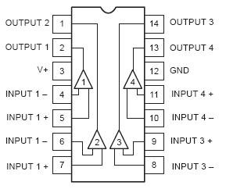
FIG. 3. Quad Voltage Comparator

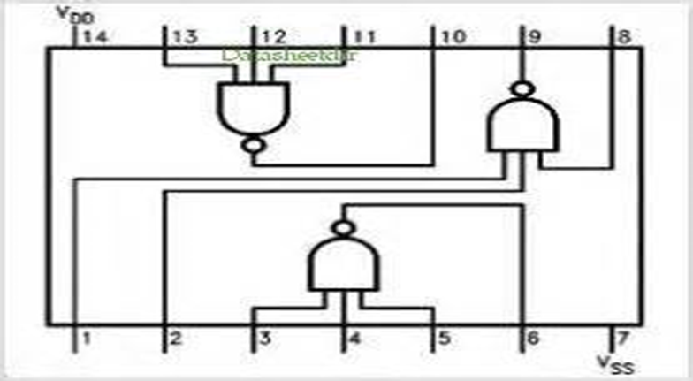
FIG. 4. Triple I/P NAND Gate
TABLE II: Testing results of voltage comparator LM 339
Vcc | V1 | V2 | Vout
5V  5V  5V  5V | 1V  0.5V  1V  0.5V | 0.5V  1V  0.5V  1V | Position | Good | Bad
 |  |  | 1  2  3  4 | HI (4.95V)  LO (1.85V)  LO (1.90V) | LO (1.85V)

The gating IC (CD4023) was a Triple I/P NAND gate circuit. The integrated circuit (IC) was mounted on an electronic bread board and a 5V DC supply was connected across it to the ground and a logic LOW (LO) and HIGH (HI) voltages were applied at the inputs and measured the output, see Table III. With NAND gates circuit, LO at the inputs of the chip gives out HI and vice – versa.
TABLE III: Testing procedure for triple i/p NAND gate circuit
INPUTS |  |  | OUTPUTS
C | B | A | Y
LO | LO | LO | HI
LO | LO | HI | HI
LO | HI | LO | HI
LO | HI | HI | HI
HI | LO | LO | HI
HI | LO | HI | HI
HI | HI | LO | HI
HI | HI | HI | LO

4.2 High Voltage Power Supply
A high voltage power supply that biases the gamma detectors in the radiation monitoring circuit in the control console got burnt in 2012. Since the high voltage transformer was not available on the market, A high voltage circuit in the IAEA TECDOC - 530 was adopted to replace broken down radiation monitor circuits in the control console with little modifications. A prototype was designed on an electronic bread board, tested and later transferred onto a printed circuit board. 1000 Volts DC was generated to bias the detectors. The high voltage has since being working.
4.2.1 Operation of the high voltage
The power supply assembled and tested could produce between 900 and 1,000 V DC at approximately 1 mA. The circuit diagram is shown in Figure 5.
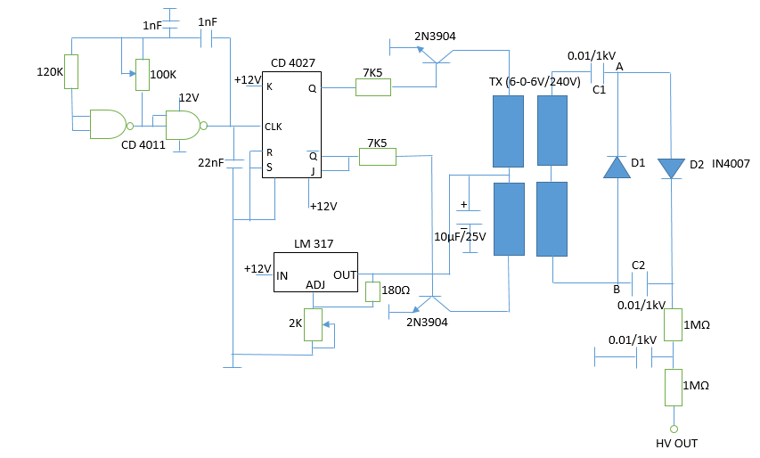
FIG. 5. High Voltage Power Supply
A square wave oscillator feeds a driver stage which is connected to a step-up transformer. The center tap of the primary winding is connected to a 12 V dc supply coming from a voltage regulator. Under these condition, a 440 V square wave (AC) is developed across the secondary winding. This AC voltage is rectified in a doubler type rectifier circuit.
The doubler circuit works as follows: diode D1 charges capacitor C1 to the peak of the voltage present at the secondary. Between A and B, a voltage which is the sum of the dc voltage developed at C1 plus the AC voltage at the secondary winding is in turn rectified by D2 and filtered by C2. The result is that, capacitor C2 is charged to the peak value of the voltage existing between A and B, that is to say, double of the peak voltage at secondary winding.
5.0 Safety Features of GHARR-1 Research Reactor [4]
a. The reactor is inherently safe with a very strong capability of power self-limitation.
b. The total core excess reactivity is 4.0 mk and it is controlled by one central control rod of worth 7 mk, which ensures a shutdown margin of about 3 mk. This is sufficient to maintain the reactor in safe shutdown condition.
c. A scram is provided such that the reactor power will not exceed 120% nominal power and the temperature difference between the core outlet and inlet must not exceed 120% of the nominal limit.
d. The reactor can be shut-down by inserting cadmium rabbits into the core using the pneumatic transfer system. Four (4) cadmium capsules of 4 mk worth is provided for shutting down the reactor in the event of a failure of the control system. Auxiliary shutdown is accomplished by the manual insertion of cadmium capsules into the inner irradiation sites. To ensure deep subcritical reactivity of the reactor, additional string of cadmium capsules of three (3) pieces knotted together at the worth of 3 mk is available to replace the control rod when failure occurs.
6.0 Periodic Safety Review for Gharr-1 [7]
Safety reviews are performed regularly to ensure adherence to regulations governing reactor systems operation. The Reactor Safety Committee (RSC) as well as the Radiation Safety Committee (RadSC) perform regular safety reviews and make recommendations to the Reactor Manager and the Director of NNRI for the necessary actions to be taken.
The RSC has the responsibility to review experiments, modification, procedures, reportable occurrences and personnel qualification. Review of safety documents are conducted every two (2) years prior to the safety analysis report (SAR) which is reviewed every five (5) years.
Feedback from previous safety review mission and operational experience, expert missions’ recommendation and documents developed by the reactor manager and team assist in the review for onward submission to the regulatory agency for approval.
Modifications and experiments having significant effect on safety are reviewed by the reactor safety committee and recommendations are made to the reactor manager for review before onward submission to the regulatory body for further review and approval.
7.0 Ageing of Staff / Succession Plan [7]
In accordance with Article 3 of Act (2000) which mandates the Commission to collaborate with the Universities in training and teaching in the field of nuclear energy, Ghana Atomic Energy commission (GAEC) with the University of Ghana and IAEA has established a Postgraduate School of Nuclear and Allied Sciences (SNAS) to train personnel for Ghana’s nuclear practice and that for the Africa Region. The objectives are to preserve and enhance knowledge in nuclear technology and to develop human and institutional capacity in the field of nuclear and allied sciences. The following M.Phil. and Ph.D. Courses are offered: Nuclear Engineering, Applied Nuclear Physics, Nuclear and Environmental Protection, Radiation Protection, Nuclear Agriculture, Medical Physics, Nuclear and Radiochemistry among others. Hence, with these arrangements in place, Sustainable Human Resource Development (HRD) is assured.

References
[1] Gao Jijin (1993). General Description of Ghana Miniature Neutron Source Reactor. Training Manual. China Institute of Atomic Energy, Beijing, China.

[2] IAEA-TECDOC-530 (1989). Nuclear Electronics Laboratory Manual, a technical document issued by the International Atomic Energy Agency, Vienna. pp 27.

[3] GBADAGO J.K, ADDO M. A, ENNISON I, ODOI H.C, BOFFIE J, BOAFO E.K, SOGBADZI R.B.M, ABREFAH R.G, AMPONG A.G, AMPONSAH-ABU E.O, AMPOMAH-AMOAKO E, DEBRAH S.K (2011 updated). Safety Analysis Report for Ghana Research Reactor-1, National Nuclear Research Institute, Ghana Atomic Energy Commission, GAEC-NNRI-RT-2011, Revised. December 2011, Accra, Ghana.

[4] INTERNATIONAL ATOMIC ENERGY AGENCY, Ageing Management for Research Reactors, IAEA Safety Standards Series No. SSG – 10, IAEA, Vienna (2010)

[5] NATIONAL SERMICONDUCTOR COROPERATION (1988). CMOS Logic Databook.

[6] WANG YONGMAO, PENG CHUNYUAN, GAO JIJIN, CHEN SHUPING, LI YULUN (1992). Control System for Miniature Neutron Source Reactor, Code MNSR-DC-3. China Institute of Atomic Energy, Beijing, China. pp 5, 21.

[7] AMPONSAH ABU E.O, GBADAGO J.K, ADDO M.A, SOGBADJI R.B.M, ODOI H.C, AMPONG A.G, OPATA N.S (2013). Ageing, Modernization and Refurbishment of Ghana Research Reactor. International Workshop on Research Reactor Ageing, Modernization and Refurbishment-DAEJEON, REPUBLIC OF KOREA, 4th to 18th October, 2013. South Korea.

