**Investigation of Mixed Enrichment Core Loadings**

**for the PULSTAR Reactor**

A. I. Hawari*, J. L. Wormald,

Nuclear Reactor Program, Department of Nuclear Engineering

North Carolina State University

Raleigh, NC 27695, USA

Corresponding author: [ayman.hawari@ncsu.edu](mailto:ayman.hawari@ncsu.edu)

MCNP6 simulations were performed of the 1-MWth North Carolina State University (NCSU) PULSTAR reactor core to quantify the potential for the utilization of UO2 fuel assemblies that are enriched to 6% in U-235 (in addition to the resident 4% enriched fuel) within the currently licensed Technical Specifications. The 6% fuel assemblies belonged to the “sister” PULSTAR reactor that was located at the Buffalo Materials Research center (BMRC) at the State University of New York (SUNY) at Buffalo. Except for enrichment, these assemblies are identical in materials and configuration to the assemblies that are currently in use at the NCSU PULSTAR. Moreover, the utilization of similar assemblies at BMRC was demonstrated up to a power of 2-MWth. The constructed MCNP6 model was found to yield good agreement with historical operational PULSTAR data including measurements of excess reactivity, rod-worth and assembly peaking factors. Using this model, key Technical Specification parameters were predicted for representative core configurations that include mixed enrichment (4% and 6%) loading of fuel assemblies. Mixed enrichment configurations where the margin for a given limit is predicted to be near or greater than 15% are considered acceptable. In all cases, the PULSTAR was shown to maintain its overall negative feedback behavior with a power coefficient of less than -300 pcm/MW. Consequently, the results indicate that the insertion of 6% fuel in pre-selected locations of the PULSTAR core should meet the limits set by the current Technical Specifications.

**1. Introduction**

Plans are underway to upgrade the power of the North Carolina State University (NCSU) PULSTAR reactor from its current level of 1-MWth to a power of 2-MWth. This increase in power would directly support the PULSTAR’s educational and research activities. Fundamentally, the PULSTAR represents an intense radiation (neutron, gamma-ray and positron) source. Consequently, doubling its power is expected to result in effectively doubling the available radiation fluxes that are useable in various irradiation applications. In addition, as a part of the upgrade process, refueling of the PULSTAR core will take place using fresh UO2 fuel assemblies that have identical configuration to the current assemblies but are enriched to 6% in U-235 as opposed to 4%. To support the power upgrade, a complete refurbishment of the primary and secondary cooling systems for the PULSTAR reactor was completed. At this stage, the PULSTAR continues to operate at its original power of 1-MWth. Operation at 2-MWth will commence once a license amendment is approved by the United States Nuclear Regulatory Commission (US NRC). In this work, an overview of the neutronic analysis that was conducted to support the power upgrade and the refueling process is presented.

**2. PULSTAR Reactor Characteristics**

The PULSTAR represents an open pool and light water moderated and cooled reactor that is fueled with uranium dioxide (UO2) enriched to 4% in U-235. The fuel is configured into assemblies that contain 25 fuel pins each and are arranged in a square 5×5 array. The fuel pins are clad with Zircaloy 2 cladding. The core contains 25 assemblies that are arranged in a 5×5 square array. In addition, four Ag-In-Cd control blades are utilized in the core. Figure 1 shows a schematic of the PULSTAR core and a cutaway of a typical fuel assembly. To enhance the core’s neutron economy and to extend its lifetime, beryllium reflectors are used on two sides of the core. For utilization purposes, vertical irradiation access tubes are placed at the core periphery and are routinely used in materials testing experiments. In addition, the PULSTAR is equipped with a pneumatic system that can place samples in close proximity to the core to perform neutron activation analysis irradiations. Furthermore, the core is surrounded by 5 beam tubes and has a sixth through beam tube. These beam tubes have been the subject of much development in the past few years resulting in the installation of an advanced neutron imaging facility, a neutron powder diffraction system, an intense positron beam, and an ultracold neutron source. These facilities have resulted in establishing the PULSTAR as a center for fundamental and applied research in neutron physics and the characterization of nanomaterials [1-4].

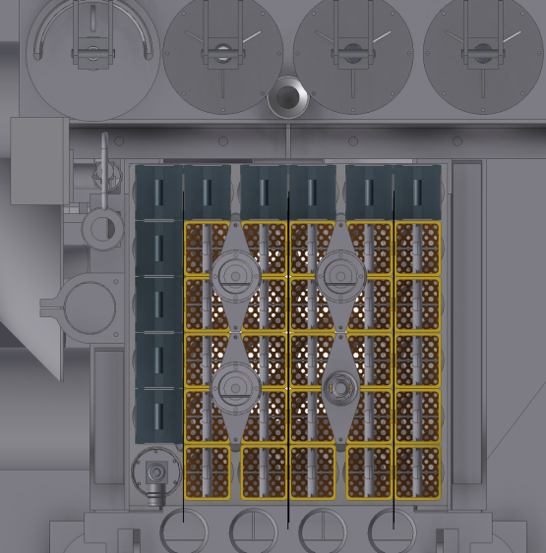

**FIG. 1.** A top view of the current PULSTAR core (left) and a cutaway of a typical fuel assembly (right). The dark squares in the core schematic (top and left sides) represent the beryllium reflector blocks.

Due to the use of UO2 fuel and its low enrichment, the PULSATR reactor is characterized with a negative reactivity feedback behavior, as quantified by its power coefficient of reactivity (PCR) that reaches -330 pcm/MW, where a pcm represent a percent milli k/k and k is the effective multiplication factor. This is considered relatively large especially when compared to other common research reactor designs, e.g., MTR reactors, which typically have a PCR that is lower by an order of magnitude or more. Furthermore, the design of the PULSTAR reactor core represents a highly under moderated system that results in the thermal neutron flux reaching its peak at the periphery of the core and at the entrance of the beam tubes. This results in preferential leaking of thermal neutrons into the beam tubes and in turn enhanced fluxes at the sample positions for the various facilities.

**3. MCNP Neutronics Calculations**

**3.1 Model Development and Validation**

The Monte Carlo code MCNP6 and its associated ENDF/B-VII.1 nuclear data libraries were used to perform the neutronic analysis of the PULSTAR reactor core [5]. In addition, the S(,) thermal treatment for light water was implemented to describe neutron thermalization in the light water moderator. Full advantage was made of the MCNP three dimensional combinatorial geometry capabilities to produce a heterogeneous model of the PULSTAR core and its surroundings including the beam tubes. To assure the geometrical accuracy of the model, the original as-built drawings of the PULSTAR core (and surroundings) were used and updated to include any recently performed dimensional measurements. The core was explicitly modeled to represent the 25 fuel assemblies and the 25 UO2 pins within each assembly. Furthermore, the assemblies were divided into 10 axial layers of equal length covering the height of the core. Consequently, a total of 6250 volume cells were modeled in the core with each representing a unique material cell for the purposes of depletion calculations. The model also included the core’s four Ag-In-Cd control blades. Finally, it should be noted that the MCNP6 models were executed in parallel mode on a computational cluster that is equipped with 264 processors, which allowed for simulation turnaround times on the order of hours and days. All simulations were set up to achieve maximum statistical uncertainties of ±1% in flux estimation or ±100 pcm in reactivity estimation.

The principle objective of the neutronic simulations is to provide the needed input for the safety analysis that is required to obtain the US NRC approval for operating at the higher power of 2-MWth and for utilizing the fresh 6% enriched fuel in the core. This input mainly consists of the pin power distributions in the PULSTAR core and the fuel and moderator reactivity coefficients. Therefore, to ensure a reasonable level of accuracy in the simulations, the original core of the PULSTAR reactor, which was loaded in 1972, was considered the starting and reference point for the simulations. Clearly, this core would be highly accessible to modeling as its starting composition is well known to be fresh UO2 fuel that is, according to available assay data, enriched to 4.026% in U-235. Once the depletion of this core was completed, the resulting composition was used as the starting point for the subsequent core. This approach was used to cover the 8 configurations of the PULSTAR core that were implemented during the period of 1972 to 2014. In addition, Core #8 was considered as the starting point for the analysis of Core #9 into which fresh fuel with 6% U-235 enrichment is introduced. Figure 2 shows the MCNP6 geometry top view for Core #1 (1972-1977) and the current Core #8 (2011-present).

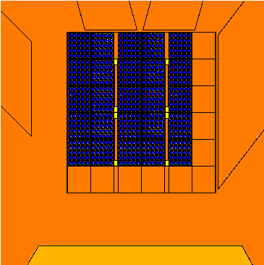 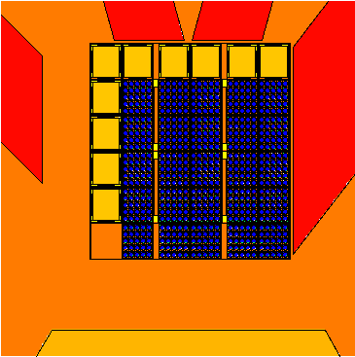

**FIG. 2.** The MCNP top view of Core #1 (left) and core #8 (right). Notice that core #1 was unreflected, while Core #8 is reflected by beryllium blocks shown on the upper and left side of the rectangular core.

As discussed above, the MCNP6 simulations were guided by historical measurements and by the licensing requirements as represented in the PULSTAR reactor safety analysis report (SAR) and technical specifications [6]. According to the technical specifications, a given PULSTAR core loading should produce an excess reactivity less than 3970 pcm, a shutdown margin of at most -400 pcm, and a maximum power peaking factor less than 2.92. Figure 3 shows the excess reactivity for the various configurations of the PULSTAR core starting with Core #1 (loaded in 1972) to the present Core #8. The MCNP depletion calculation used the code’s inherent capability, which is based on the CINDER code and its associated nuclide database [7]. In addition, all simulations were performed with the control blades completely withdrawn from the core. For each core configuration the depletion was performed in two steps at a power of 1-MWth. The first burn step of 3 MWd establishes equilibrium xenon, while the second step burns for the duration for the operation period of the core configuration. At the end of the step a decay period was executed to allow for the decay of poisons such as xenon. In general, the calculations were initiated for each configuration under cold clean conditions. Subsequently, depletion is initiated with the light water moderator temperature set to 41 °C and the fuel temperature to 145 °C, which mimics the conditions of the PULSTAR core at a power of 1-MWth. To assure the accuracy of the calculation the appropriate cross section libraries for the constituents of the moderator and the fuel were generated, using the NJOY code, at these temperatures [8]. For the results presented in FIG. 3, the measured values were obtained using measured control blade positions combined with measured worth curves. The MCNP generated value of delayed neutron fraction (eff) of 745 ± 50 pcm was used to process the measured data. The differences between the calculated and measured values are found to be on the order of the 2 uncertainty limits in the measurements of nearly ±400 pcm.



**FIG. 3.** The excess reactivity of the different configurations of the PULSTAR core (designated 1 through 8 for the period 1972 to the present day) as calculated by MCNP6 and in comparison to measured data. The uncertainty in the simulations is ±100 pcm. The measurement uncertainty is estimated to be ±200 pcm.

**3.2 Simulations in Support of Safety Analysis**

MCNP simulations were also utilized to generate the reactivity feedback coefficients for the different configurations of the PULSTAR core. In general, all feedback coefficients were calculated for the Core #8 configuration (with the control blades fully out of the core) as the reactivity difference from cold clean conditions; where the cold clean condition is a xenon free core at 21 °C. Based on that, estimates were obtained for the fuel temperature (i.e., Doppler) coefficient, the moderator temperature coefficient and the moderator void coefficient. Table 1 gives the value of the calculated coefficients in comparison to measured values.

The fuel temperature coefficient was estimated using the difference between the core reactivity under isothermal conditions at 37.8 °C and the reactivity as the fuel temperature is raised to 61, 82, 103 and 145 °C. To perform the calculations, the NJOY code was used to prepare the U-238 and U-235 cross section libraries at the specified temperatures. The variation of reactivity with fuel temperature was found to be highly linear and the temperature coefficient was extracted as the slope of this linear relationship. The moderator temperature coefficient was calculated based on varying the core temperature isothermally and subtracting the Doppler coefficient from the resulting isothermal coefficient. The calculations were performed at moderator temperatures of 21 and 37.8 °C. The appropriate cross section libraries were prepared for the light water moderator at these temperatures. In addition, the density of the moderator was adjusted to reflect this variation in temperature. Based on this, the moderator temperature coefficient was extracted as the slope of the nearly linear variation in reactivity with temperature. The moderator void coefficient was estimated under the cold clean condition while voiding select channels surrounding a pin. Finally, using the fuel temperature coefficient and the moderator temperature coefficient, the power coefficient was estimated and found to be -335 pcm/MW, which is in good agreement with the measured value of -330 pcm/MW.

**Table 1.** The reactivity feedback coefficients for PULSTAR reactor Core #8 configuration.

|  |  |  |
| --- | --- | --- |
| **Feedback Coefficient** | **MCNP calculation** | **Measurement** |
| Fuel temperature coefficient  (pcm/°C) | -2.95 | -2.88 |
| Moderator temperature coefficient  (pcm/°C) | -4.05 | -4.12 |
| Moderator void coefficient  (pcm/cm3) | -1.09 | ---- |
| Power coefficient (pcm/MW) | -335 | -330 |

Furthermore, to support the safety analysis, the power distribution of PULSTAR Core #8 was calculated using the developed MCNP model. In this case, both the assembly wise relative power distributions and the pin power distributions were calculated using the F7 fission energy deposition tally to yield the needed distributions. Table 2 below compares the calculated and measured assembly total power peaking factors. The calculated value represents the relative value of the power in the hottest axial zone (out of 10) in each assembly to the average of all core zones (250 axial zones). The measured value represents the relative value of the maximum axial flux in an assembly zone (out of 24) to the average flux of all core zones (625 axial zones). As it can be seen, the agreement between measurement and calculation is reasonable considering the physical differences in the definition of the computational and experimental zones. The calculated maximum pin power peaking factor was found to be 2.56, which is below the limit set in the PULSTAR technical specifications of 2.92. Figure 4 below shows the total pin power distribution for Core #8.

Investigation of insertion of a single assembly enriched to 6% in U-235 in various Core #8 locations permitted the establishment of safe loading zones for the this fuel. For example, it was found that if the 6% assembly is inserted in row F and column 6 the maximum total pin power peaking factor reaches 2.52 while the excess reactivity is increased from its current value of approximately 2600 pcm to a maximum of 2700 pcm. Insertion of multiple assemblies enriched to 6% in U-235 was also investigated for a hypothetical Core #9. If three assemblies enriched to 6% in U-235 are loaded into F2, F4, and F6 positions the total pin power peaking factor reaches 2.59 while the excess reactivity is increased to a value of 3200 pcm. This scenario is shown in Fig. 4. It shows that configurations of a mixed 4% and 6% PULSTAR core are possible while maintaining the limits set in the technical specifications.

**4. Conclusions**

Neutronic analysis of the NCSU PULSTAR reactor was performed using the MCNP6 Monte Carlo code. As a first step, an MCNP model was established of all 8 PULSTAR core configurations that were loaded during the period 1972 to 2014. This initial analysis showed reasonable agreement between the results of the MCNP models and the current and historical measurements of the PULSTAR core characteristics including excess reactivity, feedback coefficients and power distributions. The established model was used to investigate the use of fuel assemblies that are enriched to 6% in U-235 in the PULSATR core. It was found that the loading of assemblies in peripheral core locations would increase the excess reactivity of the core while meeting the limit on the pin power peaking factor. At this stage, the MCNP model is being implemented to supply the input needed to perform the safety analysis for mixed 4% and 6% enrichment core configurations at powers of 1-MWth and 2-MWth.

**Table 2.** The assembly power peaking factors map for Core #8. The map represents the core layout showing the locations of fuel assemblies (red) and Be reflector assemblies (gray). In the fuel locations, the top number is the result of the MCNP calculation and the bottom number is extracted from measurements. The uncertainty in the calculated result is ±3%. The measurement uncertainty is ±7%.

|  |  |  |  |  |  |  |
| --- | --- | --- | --- | --- | --- | --- |
| **ASSEMBLY TOTAL POWER PEAKING FACTORS** | | | | | | |
| 1 | | 2 | 3 | 4 | 5 | 6 |
| A | Be | Be | Be | Be | Be | Be |
| B | Be | 1.46  1.45 | 1.53  1.64 | 1.58  1.76 | 1.37  1.36 | 1.00  0.96 |
| C | Be | 1.59  1.61 | 1.69  1.72 | 1.75  1.69 | 1.51  1.50 | 1.10  1.08 |
| D | Be | 1.69  1.61 | 1.77  1.75 | 1.84  1.73 | 1.60  1.68 | 1.15  0.97 |
| E | Be | 1.42  1.24 | 1.53  1.44 | 1.60  1.66 | 1.36  1.69 | 1.00  0.81 |
| F | Fission chamber | 1.10  0.98 | 1.18  1.06 | 1.25  1.66 | 1.09  1.30 | 0.79  0.60 |

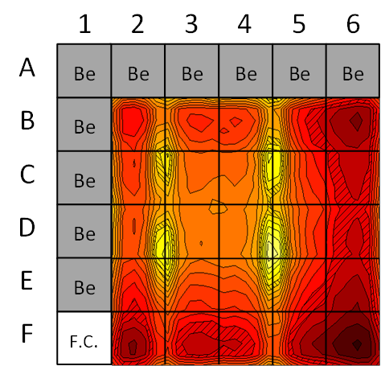 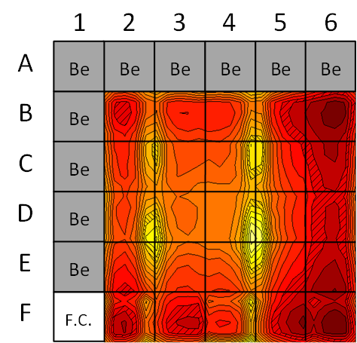 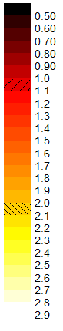

**FIG. 4.** The total pin power peaking factor maps for Core #8 (left) and a hypothetical Core #9 (right) where fuel assemblies enriched to 6% in U-235 are inserted in the F2, F4, and F6 locations. The intensity scale is shown to the right of the figure.

**5. Acknowledgements**

This work was supported by the US Department of Energy through the NEUP program.

**6. References**

1. Mishra, K.K., Hawari, A.I., and Gillette, V.H., “Design and Performance of a Neutron Imaging facility at the NC State University PULSTAR Reactor,” IEEE Transactions on Nuclear Science, **53** (2006) 3904.
2. Hawari, A.I., et al., “Operation and testing of the PULSTAR reactor intense slow positron beam and PALS spectrometers,” J. of Phys: Conference Series **262** (2011) 012024.
3. DiJulio, D.D., Hawari, A.I., “Characteristics and Performance of the Neutron Powder Diffractometer at the NC State University PULSTAR Reactor,” PHYSOR-2008: International Conference on the Physics of Reactors, Nuclear Power: A Sustainable Resource, Interlaken, Switzerland, 2008.
4. Korobkina, E., et al., “An Ultracold Neutron Source at the NC State University PULSTAR Reactor,” Nuclear Instruments and Methods in Physics Research A **579** (2007) 530.
5. Goorley, J.T. et al., “Initial MCNP6 Release Overview MCNP6 Version 1.0,” Los Alamos National Laboratory report LA-UR-13-22934 (2013).
6. Safety Analysis Report, North Carolina State University PULSTAR Reactor, License No. R-120, Docket No. 50-297 (1997).
7. Wilson, W.B., et al., “Recent Development of the CINDER'90 Transmutation Code and Data Library for Actinide Transmutation Studies," Proc. GLOBAL'95 Int. Conf. on Evaluation of Emerging Nuclear FuelCycle Systems, September 11-14, 1995, Versailles, France, pp. 848 (1995).
8. MacFarlane, R.E., Muir, D.W., “The NJOY Nuclear Data Processing System Version 91,” Los Alamos National Laboratory report LA-12740-M (1994).