Characterization of UO₂-Gd₂O₃ nuclear fuel obtained by co-precipitation by Transmission Electron Microscopy

I. Gana Watkins¹, J. Menghini¹, M. Prado^{1,2}, H. Troiani^{1,2}, A.L. Soldati^{1,2}

1) Centro Atómico Bariloche (CAB) - Comisión Nacional de Energía Atómica (CNEA), Av. Bustillo 9500, CP: 8400 Bariloche, Argentina
2) Consejo Nacional de Investigaciones Científicas y Técnicas (CONICET), Av. De los Pioneros 2300 CP: 8400 Bariloche, Argentina

Corresponding author: asoldati@cab.cnea.gov.ar

Abstract. In this work we characterize the chemical and structural homogeneity of a 4% weight Gd₂O₃ doped UO₂ nuclear fuel obtained by co-precipitation techniques, using Transmission Electron Microscopy (TEM and STEM) coupled to an Energy Dispersive Spectroscopy (EDS) system. Particle morphology and crystallite sizes were determined using bright/dark field and high resolution (HR-TEM) images. We determined that the particles have an average crystallite size of 90±10 nm, with rounded forms. Convergent beam Energy Dispersive Spectroscopy (EDS) and Electron Diffraction (ED) were used to evaluate sample composition and homogeneity, even at the nanometer scale. We found that the apparent homogeneity observed with a Scanning Electron Microscope (SEM) at the micron scale, results in an inhomogeneous Gd distribution at the nanoscale. Moreover, from TEM-EDS analyses we determined the presence of Gadolinium in all the analyzed crystallites but with ±20% variation among the average concentration. Although burnable poison fuels are widely used for Nuclear Power Reactors, the methodology used in this work has demonstrated to be a helpful tool to understand (even at the nanometric level) their composition, structure and morphology, moreover it is suitable for its application in new Nuclear Research Reactors fuel materials research.

1. Introduction

The development of new materials for the nuclear industry clearly challenges the material scientists, which are encouraged to develop new compounds that should resist high temperatures, corrosive environments and radiation damage, presenting minimum degradation or reaction over longer life spans, and requiring also a simple way to be handled after operation. In this sense, it is well known that particle morphology, grain size, crystal structure, composition and chemical speciation influence the material physicochemical properties and its behavior and resistance to hostile environments. Thus, tailoring these parameters allows the development of materials with the required properties.

One bottleneck however, is to fully characterize the resultant products even at the sub-micrometric level. For that, a technique with excellent spatial resolution is required. One of the best candidates for this kind of analyses is the Transmission Electron Microscopy (TEM). In this case, a beam of hundreds of keV electrons passes through a thin sample (< 100 nm), resulting in three main information packages:

First, transmission images in bright field (transmitted beam), dark field (one of the diffracted beams) or high resolution modes (combination of transmitted and diffracted beams), which can be used to find sample parameters such as morphology, grain sizes, signs of stress and degradation, crystal defects induced by synthesis, thermal treatment or radiation damage, etc. Second, electron diffraction patterns which allow identification of crystal phases, amorphization, signs of degradation, presence of precipitates. And third, when coupled to an Energy Dispersive Spectroscopy (EDS) detector, TEM provides local information about the chemical composition, in areas as small as some nanometers. The spatial resolution achieved with TEM is in that case better than in a Scanning Electron Microscope (SEM) due to the small volume of interaction for the X-rays, given by the thickness of the sample and the size of the convergent electron beam on the sample plane.

In this work, we used a TEM operated with a LaB₆ filament and a Field Emission Gun (FEG) TEM both coupled with an EDS system, to fully characterize a 4%wt Gd₂O₃ doped UO₂ pellet synthetized by the “Reverse Strike” co-precipitation method. This material, a nuclear fuel with integrated Gadolinium as burnable poison, is of interest for the Argentine reactor CAREM [1]. A burnable poison is an element that has a thermal neutron absorption section sufficiently high to compensate the reactivity excess during the first fuel cycle stage [2]. These compounds can be selected in order to burn faster than the fuel and so, to avoid a significant impact through a negative reactivity increment. In this way, they allow to fill more fuel without need of incrementing the control requirements of the reactor.

Gadolinium has been used as burnable poison since the 60´s and the technical aspects regarding fabrication and characterization of UO₂ fuels doped with Gd₂O₃ are very well known [3]. Indeed, the Nuclear Materials Department of the Centro Atómico Bariloche (CAB) has been working since many years in different processes of synthesis and characterization of nuclear fuels of this type. Actually, in 2011 the group obtained UO₂ pellets doped with 4%wt of Gd₂O₃ through a reverse strike co-precipitation method from nitrate salts [4]. SEM imaging showed that the material was composed by sub-micrometer size particles agglomerates. However, those studies could not determine the particle sizes clearly. In addition, X-ray Diffraction (XRD) and EDS studies did not detect composition heterogeneities at the micrometric level, suggesting that the Gd was homogeneously distributed in the product.

Before scaling to an industrial level, an intensive research is necessary to correlate the materials characteristics with the physicochemical properties and its response to the environmental conditions present in the reactor nucleus. Here we present a detailed analysis of the crystal structure and homogeneity of the material. On the one hand, the acquisition of images of bright field, dark field and high resolution modes allowed us to show the actual size and shape of the crystallites. Moreover, electron diffraction and EDS point analyses using a convergent beam provided information on the composition in areas of less than 2 nm² to check the material homogeneity inside each particle, and even determine if there is a preferential position for the Gd ions in the UO₂ crystal lattice.

2. Materials and Experimental Method

UO₂ powder doped with 4%wt of Gd₂O₃ was prepared by the “Reverse Strike” co-precipitation method [4]. After this process the “co-precipitated powder”, a mix of Ammonium Diuranate (ADU) and Gd(OH) ₃, was calcined in a furnace at 800°C through 4 hours to obtain the Gd₂O₃ and U₃O₈ mix powder. Then the U₃O₈ was reduced in Noxal atmosphere (Ar-5% vol CH₄) at 1800°C to obtain UO₂. After that, the reduced mix was milled in a planetary balls mill and pressed in green pellets with diameter of 9.5 mm. Finally, these pellets were sintered at 1700 °C during 2 hours in reducing atmosphere of Noxal. The entire process was realized in the Uranium Laboratory of the Nuclear Materials Department at CAB.

2.1 Transmission Electron Microscopy (TEM)

Pellet samples were milled for some minutes with a pestle and mortar of agate. Some milligrams of material were dispersed in 1 ml isopropyl alcohol by ultrasonication for 5 minutes. A drop of the solution was transferred to an ultra-thin carbon film supported on holey carbon at a 300M Gold grid. The grid was let dry in air. Two TEM instruments were used: A Philips 200UT with LaB₆ filament operated at 200keV and a TECNAI F20 TEM/STEM equipped with a Field Emission Gun (FEG). TEM images were acquired using a VELETA CCD camera and the software Digital Micrograph© with the latter. In addition selected sectors were scanned in the nanoprobe mode by combining the High-Angle Angular Dark Field (HAADF) and the EDAX-EDS detectors. For that, a convergent electron beam of 2nm² on the sample surface was used. The EDS spectra were achieved for 200 s, between 0 and 20 keV, with a counting rate of at least 500 cps and a dead time of less than 20%. Posterior data and image treatment was done both with the commercial program TEAM© and the software MATLAB2010©.

2.2 Crystal size measurements

Bright field, dark field and high-resolution images were processed with the software i-TEM© and the free software imageJ© to identify the different crystallites from the agglomerates. A single crystallite is recognized by its homogeneous colors, white in dark field images and black or a tone of gray in the bright field mode, and by a predominant direction of the atoms in high resolution mode. Once identified the particle, its characteristic length (L_{c}) was measured as the diameter (in case of round particles) or the longest diagonal (in case of irregular shapes). The average sizes were calculated as the arithmetic average of more than a hundred particles.

2.3 Determination of the Gd/U relationship

On a 100gr mix of 4%wt Gd₂O₃ doped UO₂, 84.6% of the weight refers to Uranium, 3.5% to Gadolinium and the rest corresponds to the Oxygen. Thus, the nominal concentration ratio for that mixture can be calculated as ${(Gd/U)}_{w[nom]}=0,041$, where the w sub-index remarks that the ratio is calculated between partial weights and the nom sub-index indicates its character of nominal value (4%wt).

EDS spectra acquired in different particles with the TEAM© software were used to calculate the local composition relation ratio ${(Gd/U)}_{w[i]}$. Indeed, the ratio for each particle (i) was calculated as the mathematical average of the ratios obtained in different points of a single particle. Then, the difference between particles was compared and correlated with variations in the UO₂-4%w Gd₂O₃ mix homogeneity at a nanometric level.

FIG. 1 shows an example of an EDS X-ray spectrum acquired and analyzed with TEAM© software. The identified components comprised Uranium, Gadolinium and Oxygen from the sample, Iron and Manganese belonging to the TEM pieces, and Carbon and Gold from the TEM grid. For quantification only the Lα layer X ray peaks were used (GdL_{α} = 6,05 keV and UL_{α} = 13,615 keV respectively). FIG.2 shows the spectrum details in the two regions of interest; a) the GdLα peak and b) ULα peak (data extracted from TEAM© software).

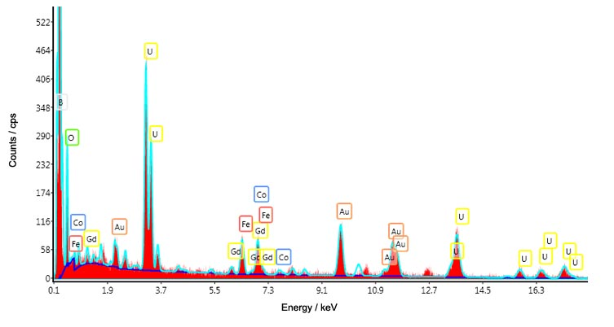
FIG. 1. TEM-EDS spectrum of a UO₂ 4%wt Gd₂O₃ nanoparticle. The spectrum was achieved for 200s in an area of 2nm² on the sample.

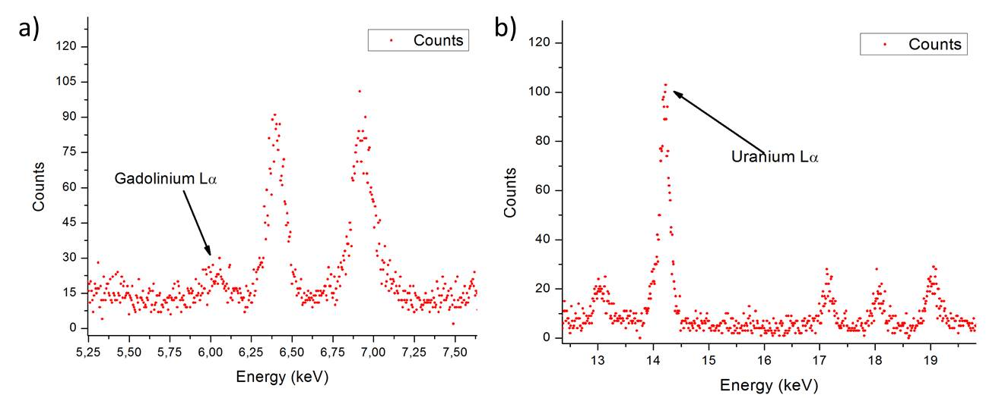
FIG. 2. Amplification of the spectrum shown in FIG.1 at the peaks of interest: a) Gadolinium Lα peak in 6,05keV; b) Uranium Lα peak in 13,615keV

A total of 12 particles were analysed; at each particle 5 EDS spectra were obtained at different points and a mean value of $\overline{{(Gd/U)}_{w[particle]}}$ was calculated. The points were preferably selected well distributed over the entire particle, to obtain representative values for the analysis. Thus, the obtained ratio represents the average composition of a single particle. FIG. 3 shows as an example one of the twelve analyzed particles, indicating the points where a spectrum was obtained.
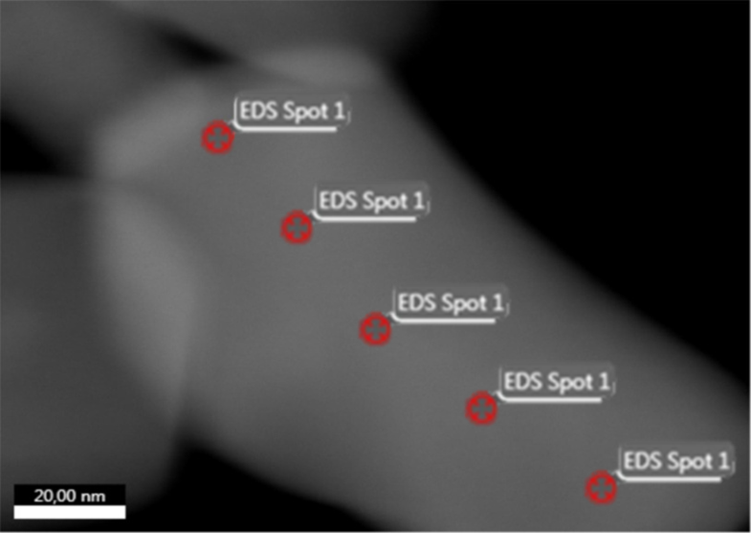
FIG. 3. Example of an analyzed particle, showing the specific points where the EDS analysis were performed.

3. Results and Discussion

3.1 Particle morphology and crystal size
Preliminary studies with SEM [4] detected particles in agglomerates of 0.6 to 10 μm. However, the SEM technique could not resolve well the particle sizes inside those aggregates. The new STEM analyses showed that the agglomerates are composed of well sintered particles of smaller size (see FIG 4A). Some of these particles were dispersed thanks to the ultra-sonication used during the sample preparation and they could be observed as smaller groups (see FIG. 4B) or even isolated (see FIG 4C).

TEM images using bright/dark field contrast allowed definitively identification of each particle, even within each agglomerate (see FIG 5). The images clearly showed particles with sub-micrometric sizes and with rounded, but irregular, shapes (see FIG 6A). In addition, Electron Diffraction (see FIG 6B) and High Resolution images (see FIG 6C) demonstrated that these particles are all single crystals, i.e. each one presents a unique atomic orientation. Besides, no amorphous zones or precipitates were observed at the particle boundaries or inside them.

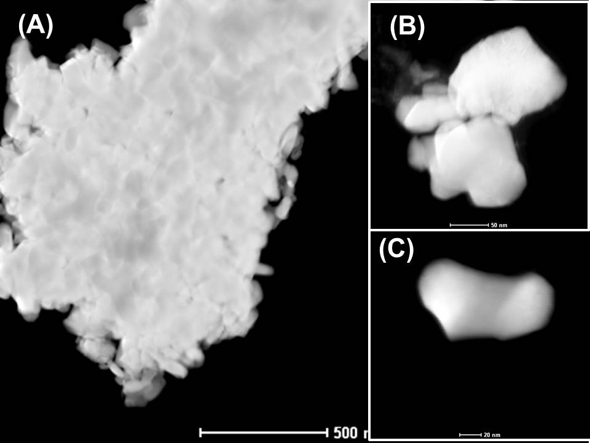
FIG. 4. STEM images of an agglomerate of nanoparticles (A), a group of nanoparticles (B) and a single nanoparticle (C) of 4%wt Gd₂O₃ doped UO₂.

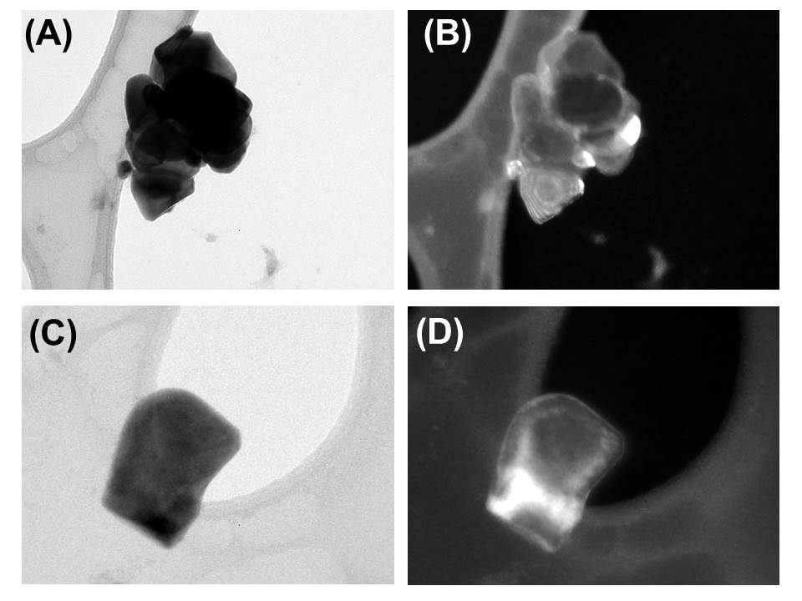
FIG. 5. TEM images of a co-precipitated 4%wt Gd₂O₃ doped UO₂ agglomerate (top) and a nanoparticle (bottom). (A and C) images obtained using only the transmitted electron beam (called “bright field” mode). (B and D) Images obtained with one of the diffracted beams (“dark field” mode).
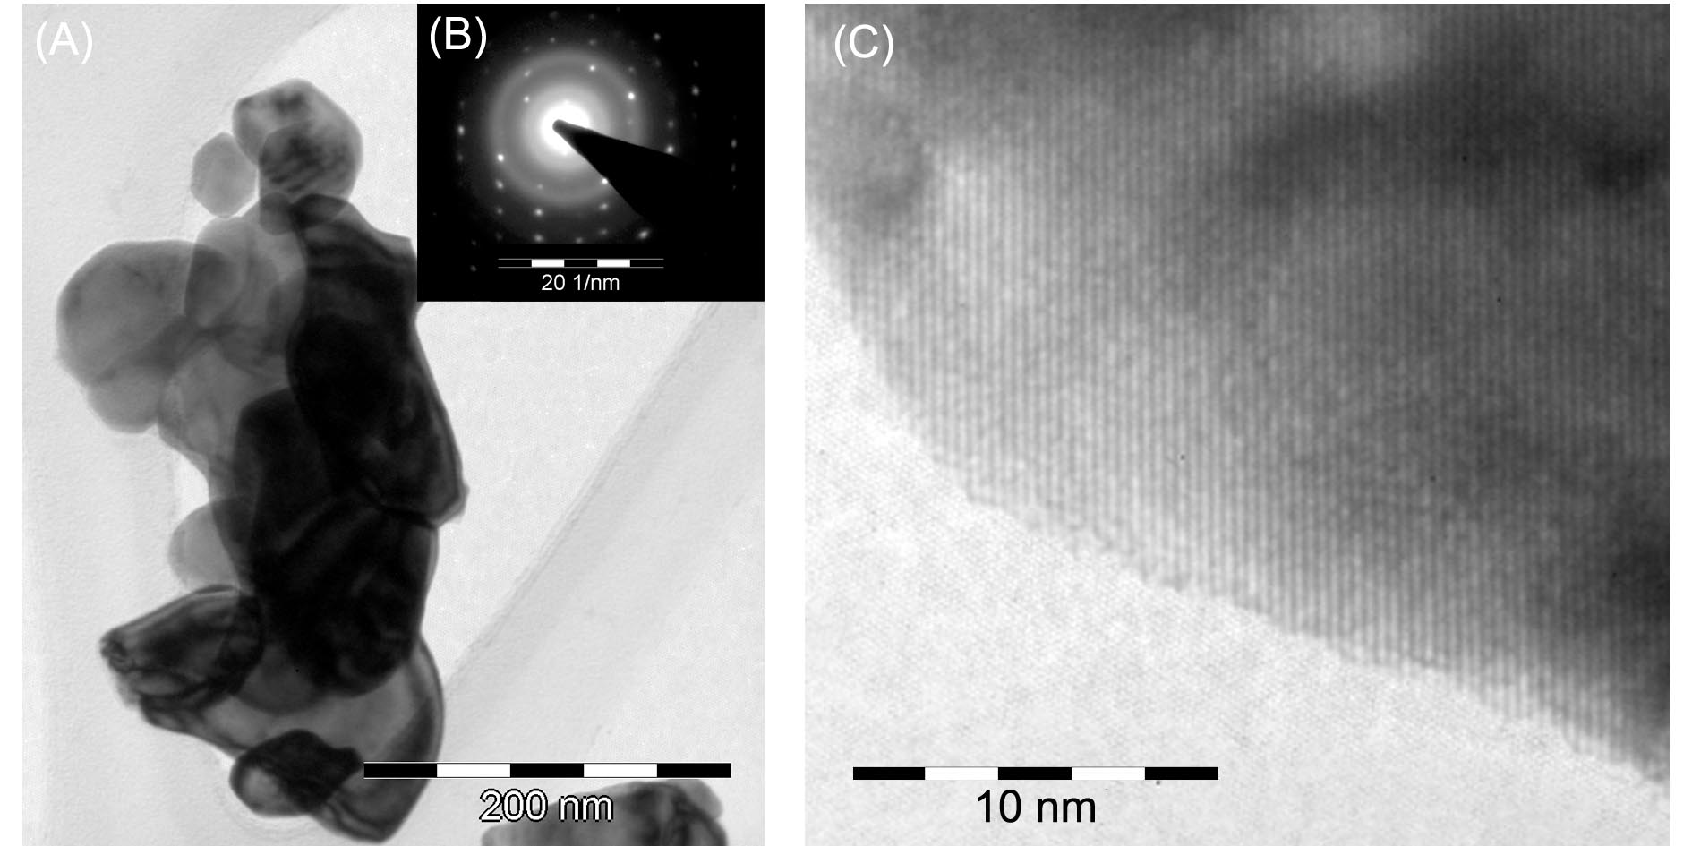
FIG. 6. TEM image (A) of an agglomerate of nanoparticles. (B) Electron Diffraction of one nanoparticle. The pattern shows a crystal with Fluorite structure. (C) High resolution image showing the atomic planes, well crystalline until the particle border.

A characteristic length (Lc) histogram (see FIG. 7) was constructed from the data measured in different TEM and STEM images. Using a Gaussian distribution for the statistical analysis, it could be verified that the crystallite size in our 4% Gd₂O₃ doped UO₂ material results in 90±10 nm. Considering the high temperatures used during sintering (1700 °C) and the fact that very few particles were observed with more than 200 nm crystallite sizes, it is suggested that the synthesis method used here results in a narrow particle size distribution.

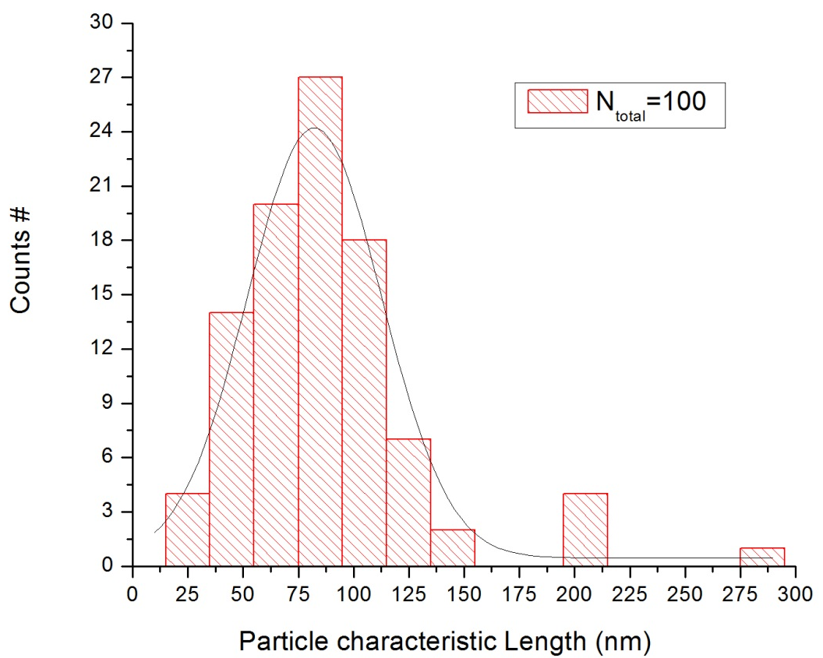
FIG.7. Particle characteristic length (Lc) distribution, the mean value of the sample is 90±10 nm. The histogram was constructed taking into account 100 different particles imaged in Bright/Dark Field and High Resolution modes.

3.2 Gd/U relationship – EDS Analyses

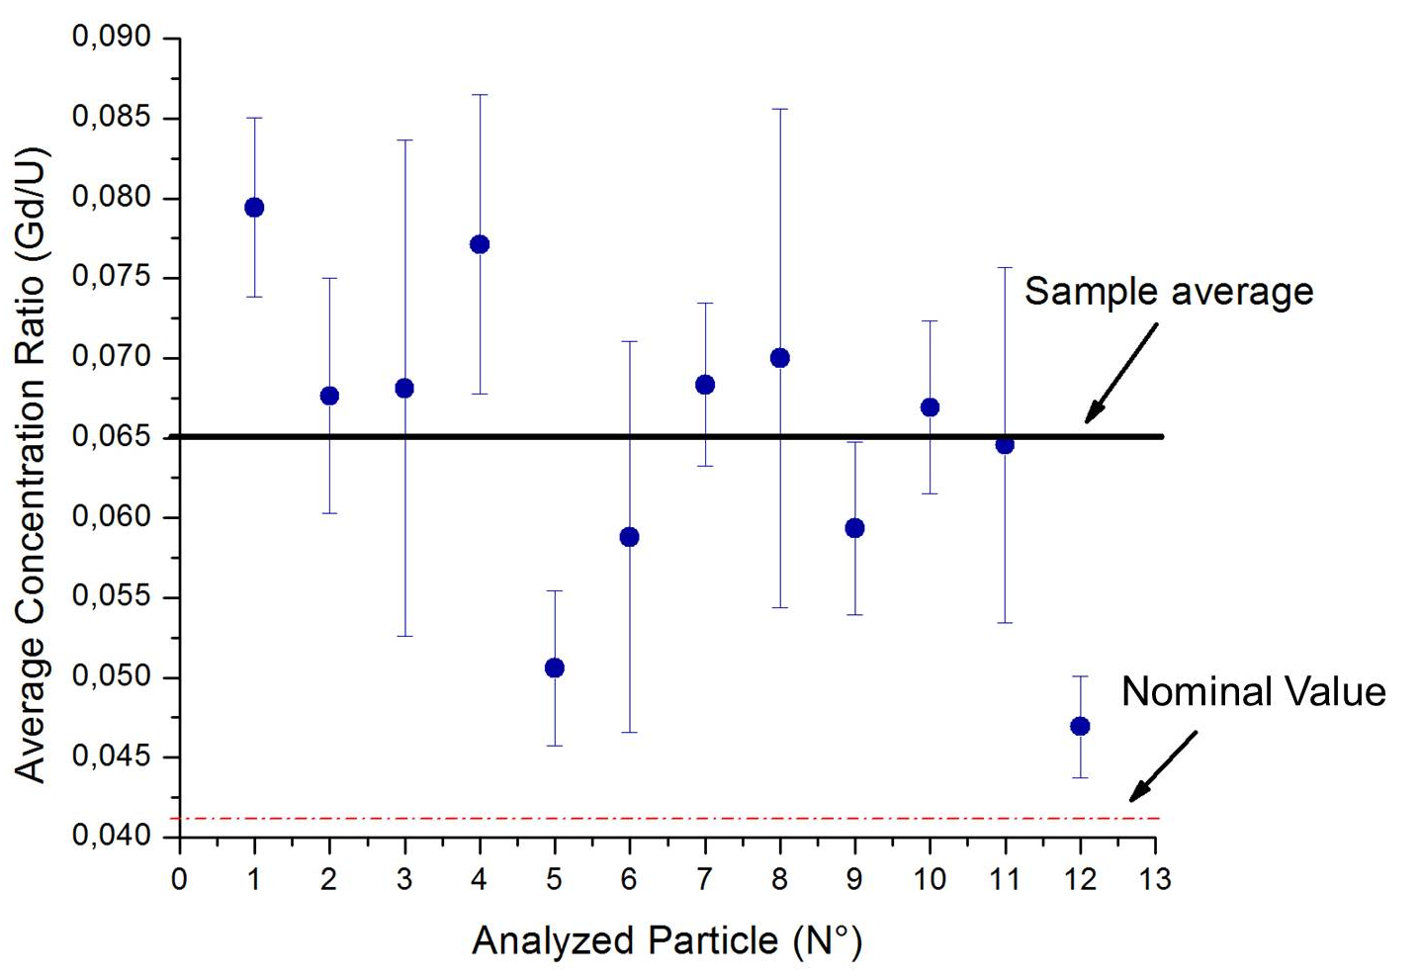
FIG. 8. Mean Gd/U relationship for the analyzed particles (blue dots). The error bars show the standard deviation of 5 measurements obtained from different places of a single particle. The average concentration ratio (indicated as “Sample Average”) of all mean values is shown as a black line (0.065); and the Gd/U nominal value is shown in the red dash dot line.

FIG. 8 shows the relationship $\overline{{(Gd/U)}_{w[particle]}}$ for all analyzed particles (blue dots), the medium value of the sample (black line), and the nominal value $\overline{{(Gd/U)}_{w[nom]}}$ (red dash dot line). It is observed that all analyzed samples present U and Gd. In addition, it was detected a random oscillation in the $\overline{{(Gd/U)}_{w[particle]}}$ ratios showing difference as high as ±20% in the Gadolinium concentration between the different particles.
The mean sample ratio is $\overline{{(Gd/U)}_{w[sample]}}=0,065±0,003$, which is 60% greater that the nominal value (0,041). This value can be correlated with a Gadolinium concentration in the analysed sample of 6 %wt. The difference between the measured and the expected Gd concentration (4 %w) may have different origins, for example could be related with systematic errors in the synthesis process, such as precipitation on the walls of the glass devices used for the wet chemistry, or could be a result of the low statistics allowed by a TEM measurement.

4. Final Remarks - Conclusions

TEM and STEM coupled with EDS systems allowed us to determine that 4% wt Gd₂O₃ doped UO₂ pellets consist of 90±10 nm nanoparticles with Gd concentrations that vary ±20% between different particles. The results obtained with these techniques will be used to optimize the synthesis process and thermal treatment, aiming to maximize fuel homogeneity.

5. References

[1] BOADO MAGAN, H. et al. Project Report: CAREM Project Status, Science and Technology of Nuclear Installations, (2011) p. 1-6.
[2] HELLSTRAND, E. Burnable poison reactivity control and other techniques to increase fuel burnup in LWR fuel cycles, Trans. Am. Nucl. Soc., (1982) N°40, p. 181.
[3] BÖHM, W. et al. Gd₂O₃ up to 9 weight percent, an established burnable poison for advanced fuel management in pressurized water reactors. Kerntechnik, 1987, N° 50, p. 234.
[4] PAVON, C. “Obtención y caracterización de pastillas de Uranio y Gadolinio por el método de Co-Precipitación”. Nuclear Engineer Thesis, Balseiro Institute – Cuyo National University (2011).

