Neutronic Design of the RMB Research Reactor

J.M.Tuñón1, E.A.Villarino1, D. Ferraro1, P. Camusso1, G. Sarabia1, H. Meier1, A. Soares2, A.Dos Santos2, Mitsuo Yamaguchi2, Leda C.C.B. Fanaro2

1) INVAP S.E, Nuclear Engineering Division, Av. Cmte. Luis Piedrabuena 4950, S.C. de Bariloche (R8403CPV), Argentina

2) Instituto de Pesquisas Energéticas e Nucleares – IPEN/CNEN-SP

Av. Prof. Lineu Prestes, 2242, CEP 05508-900, Cidade Universitária, São Paulo, Brazil

Corresponding author: jtunon[@invap.com.ar](mailto:a.malaquias@iaea.org)

**Abstract**. The RMB Research reactor is a multi-purpose open-pool type reactor, to be built as an initiative of CNEN (Brazil). The nominal fission power of the reactor is 30 MW, with the capability of producing several radioisotopes, while providing suitable conditions for many types of simultaneous irradiation tests and Silicon doping.

The reactor core is located inside a chimney, surrounded by heavy water contained in the Reflector Vessel. The whole assembly is at the bottom of the Reactor Pool, which is full of de-mineralized light water acting as coolant, moderator and biological shielding.

Reactor shut down can be achieved by two different means, which are the insertion of six Control Rods into the core, or the partial drainage of the heavy water from the Reflector Vessel.

Two types of neutron sources are foreseen: a cold neutron source with two tangential beams and several neutron guides, and thermal neutron source with two beams and several neutron guides.

The current neutronic design and the verification of the neutronic design criteria, as well as the testing capabilities are also fully described.

**1. Introduction**

The RMB Research Reactor is a multi-purpose open-pool type facility, which design is carried out by INVAP [1]. It has currently ended the Preliminary Engineering stage.

The nominal fission power is 30 MW. The reactor’s core is located inside the Chimney, surrounded by heavy water contained in the Reflector Vessel. The whole assembly is at the bottom of the Reactor Pool, which is full of de-mineralized light water acting as coolant, moderator and biological shielding. The coolant flows upwards.

The reactor core is composed by 3 main components:

1. 23 plate-type Fuel Assemblies (FAs).
2. 6 Absorber Plates (AP) which are driven through Guide Boxes.
3. 2 in-core Fast flux Irradiation Facilities.

The FAs are square shaped, each of them containing 21 fuel plates and using Cd wires as burnable poison.

Reactor shut down can be achieved by two independent means, which are the insertion of the six APs into the core, or the partial drainage of the heavy water from the Reflector Vessel.

The reactor is designed for the accomplishment of two main purposes:

1. The continuous production of several radioisotopes, such as 99Molybdenum, and 192Iridium, among others; and Neutron Transmutation Doping in Silicon ingots.
2. Perform several types of experiments, for what features Fast neutrons in-core Irradiation Facilities, Pneumatic Rigs with a wide range of neutron fluxes, two Cold Neutron Beams provided by a Cold Neutron Source, two Thermal Neutron Beams, one particular Beam for a Neutron radiography facility and one Power Reactor FAs testing Loop.

Both of these purposes are compatible, minimizing the perturbations produced by one another.

The reactor will be provided with a particularly designed Cold Neutron Source to produce neutrons in specific spectral ranges. Specially designed neutron beam guides featuring high technology super-mirrors will extract these neutrons from the Reflector Vessel up to the positions where the experiments will be located.

**2. General Description of the Capabilities of the RMB**

Figure 1 shows a scheme of the current design of RMB Reflector Tank and Core.



*Figure 1: Scheme of the RMB Reflector Vessel and Irradiation Facilities Layout*

The layout of the Out-Of-Core Irradiation Facilities responds mainly to the Thermal flux levels, in order to accomplish the performance requirements. For each of them, the heat load deposition is estimated in order to ensure a proper cooling.

The Molybdenum, NTD-Silicon and Pneumatic rigs are non-fixed positions, which means that can be loaded or unloaded while operating the reactor.

Two neutron beams transport very low energy neutrons (namely, cold neutrons, with energies below 0.001 eV) - which are moderated in the Cold Neutron Source- outside the Reflector Vessel. From there, neutron guides transport neutrons from one beam to the Reactor Face; and to the Guide buildings from the other.

Two neutron beams transport thermal neutrons (E < 0.1 eV) -which are originated in a Thermal Peak zone- outside the Reflector Vessel. From there, neutron guides transport neutrons from one beam to the Reactor Face; and to the Guide buildings from the other.

A fifth beam transports Thermal neutron to a Neutron radiography facility.

The partial dumping of the Heavy Water in the Reflector Vessel works as the Second Shutdown System.

Figure 2 shows a scheme of the RMB reactor core, limited by the Chimney. Three main components can be observed: Fuel Assemblies, Absorber Plates that slide inside the Guide Boxes and two Fast Neutron Flux Irradiation Facilities.

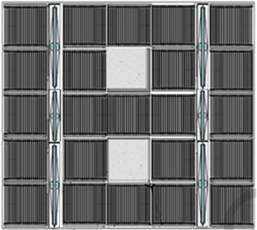

*Figure 2: RMB reactor core.*

The Standard Fuel Assemblies use U3Si2 with a Uranium density of 3.5 g U/ cm3. The fuel management strategy has an operating cycle of around 30 Full Power Days, and around 2 days for maintenance and refueling. Each cycle, six FAs are to be refueled.

The Absorber Plates are used to control the reactivity, and also works as the First Shutdown System, and are moved separately.

The Fast Flux Irradiation Facilities are modeled as an Aluminum block, to preserve the Fast component of the spectra, and to avoid Power Peaks around them.

**3. Neutronic Design Requirements**

The Neutronic Design requirements can be divided in two main groups: Safety Requirements and Performance Requirements.

**3.1. Safety Requirements**

These requirements are based on the CNEN Regulatory Normative (Norm 1.04), IAEA’s safety standards [2], and the Argentinean Regulatory Normative; and are focused to ensure the safe operation of the reactor. This section gives a summary of the nuclear safety neutronic design criteria:

1. ***Reactivity Design Criteria:*** negative feedback coefficients, enough shutdown margins for both shutdown systems, including single failure criteria. Actuation time of the shutdown systems, reactivity worth of irradiation facilities, reactivity insertion rate of the non-fixed irradiation facilities, reactivity insertion rate of the control system, and more.
2. ***Thermal-hydraulics related criteria:*** the number of FAs shall be 23 and the Power Peaking Factor lower than 3.

**3.2 Performance requirements**

These requirements are based on the optimization of the usage of the reactor, both in FAs and Irradiation Facilities. This section gives a summary of the Performance neutronic design criteria:

1. ***Flux level:***Several irradiation facilities require a minimum value for the neutron flux; but there are other irradiation facilities requiring a minimum and maximum neutron flux value*.*
2. ***Flux spectra:***Differentflux levels according to the energy range of neutrons are required in some facilities, for example, in the Cold Neutron Source and Thermal or Neutron radiography Beams.
3. ***Flux Homogeneity:***There are requirements on the flux homogeneity in some irradiation facilities, for example the axial homogeneity on Silicon doping facilities.
4. ***Flux Perturbation:***The flux in the Irradiation Facilities should be perturbed as less as possible during normal operation.
5. ***Burnup:***A minimum discharge burnup of the FAs is required*.*
6. ***Reactivity Excess****:* Strongly related to the reactor operation and the burnup of the FAs, a criterion is established to allow the facilities operation through all the cycle while assessing the shutdown margins at the same time.

**4. Neutronic Design Process**

Figure 3 shows the design flowchart, which covers all the neutronic design aspects. It shows how the Neutronic Design is guided by the following topics:

1. Neutronic Design criteria
2. Documented calculation model and data.
3. Usage of validated calculation codes
4. The usage of experimental measurements to verify a proposed design, etc.

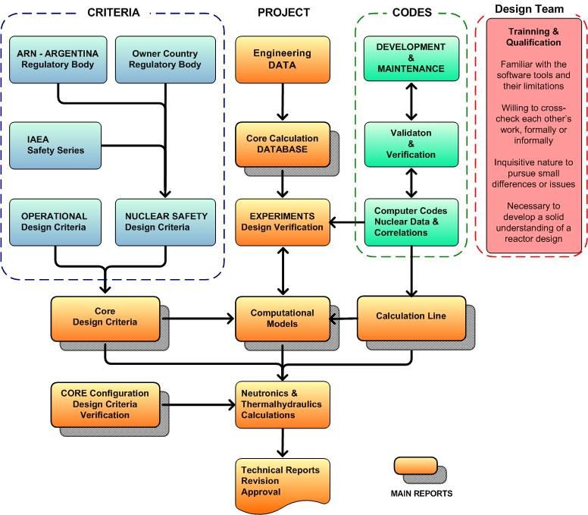

*Figure 3: Neutronic Design Flowchart*

**5. Neutronic Calculation Line**

The calculation of the RMB is carried out with different validated codes. The calculation line comprises one Deterministic Line [3], and one Stochastic Line.

The Deterministic Line is formed by several codes, described below:

1. ***ESINLM:*** (EScuela Ingeniería Nuclear Library Manager). This program is used for the maintenance of the nuclear microscopic multigroup XS library. It has for example, the capability to add isotopes from ENDF/B files after NJOY processing. It is based on the WIMS and HELIOS XS libraries.
2. ***ESINPLOT***: This is a graphical post processor to plot XS available in the nuclear library.
3. ***CONDOR* [**4**]**: This is the cell code performing the neutronic calculation of the fuel assembly (FA) or any component of the reactor core. CONDOR calculates homogenized and condensed macroscopic XS to be used by the core code. It can be also used for the analysis of the FA, or to generate additional data to be used by other codes.
4. ***HXS*** ***(Hand XS):*** Macroscopic XS library manager. This program is the interface between Cell code and Core code. It has the capability to import XS from different cell codes, and export them to different core codes.
5. ***POSLIB:*** This program is used to generate CITATION microscopic XS libraries from the CONDOR outputs.
6. ***HGEO (Hand GEOmetries):*** This program is a visual pre processor to generate the geometrical input for CITVAP. It also has the capability to generate PUMA geometrical input.
7. ***CITVAP:*** This is the core code performing burnup-dependent calculation of nuclear reactor cores, calculating the nuclear parameters associated with several states of the reactor taking into account the feedback of many thermal-hydraulic parameters.
8. ***NDDUMP (Numerical Densities DUMP):*** This utility is capable to generate burnup dependent numerical densities to be used by MonteCarlo codes such as MCNP or SERPENT codes.
9. ***ARCANE (Advance Reactor Core ANalysis Environment:*** enhancing the esoteric art of reactor design***):*** This tool allows performing numerical calculations and verifications with the core or cell code calculated parameters.
10. ***POS_CON:*** This is a graphical post processor of the CONDOR code.
11. ***FLUX:*** This is a graphical post processor of the CITVAP code.

The Deterministic Line is used for two purposes mainly:

1. ***Calculation using Macroscopic cross sections:*** *This methodology is used for almost all the neutronic parameters. The equilibrium core burn-up distribution is the most important calculated parameter.*
2. ***Calculation using Microscopic cross sections:*** *This methodology is used for the calculation of the kinetic parameters and time dependent calculation.*

These deterministic calculations are performed following three main steps: XS library generation, Cell calculations and Core calculations

The Stochastic Line comprises the well-known 3-D Montecarlo transport code MCNP [5], in an up-to-date version. For neutron and gamma calculations, ENDF/B-VI and ENDF/B-VII cross sections are available (among others). This code is mainly used to verify some neutronic parameters by means of an independent calculation method.

Both Calculation Lines are coupled by the NDDUMP code, which exports compositions from the Deterministic Line to the MCNP format. It is used mainly for exporting the FAs burnup compositions, as well as the depleted composition of some components of interest.

These methodologies and their interfaces are shown in Figure 4, where many utilitarian codes are included.

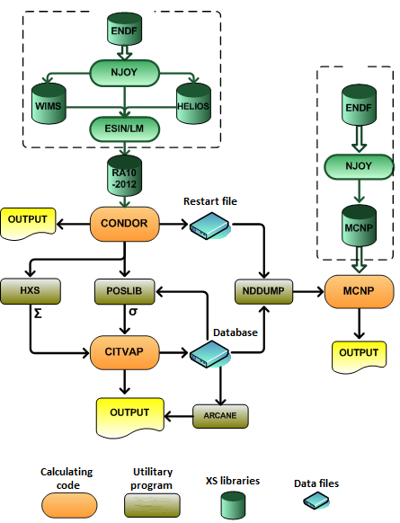

*Figure 4: Neutronic Calculation Line*

**6. RMB Reactor Estimated Neutronic Parameters**

**6.1. Core Reactivity Excess in the main Operational Conditions**

Table I shows the core reactivity excess in the main operational conditions, the Xenon reactivity worth, and the cold-hot reactivity swing.

TABLE I: Main reactivity values

|  |  |  |  |  |
| --- | --- | --- | --- | --- |
| **Operational Condition** | **BOC** | **EOC** |  |  |
| Cold Shutdown | 8100 pcm | 5700 pcm | Xenon reactivity worth | ~ 3700 pcm |
| Hot Shutdown | 7800 pcm | 5400 pcm | Cold-Hot reactivity swing | 300 pcm |
| Full Power | 4200 pcm | 1700 pcm |  |  |

The EOC reactivity is an indicator of the usage of the Fuel, allowing at the same time enough margins to allow an easy operation of reactor facilities, for what the design is focused on obtaining a Reactivity Excess as close as possible to the 1300 pcm.

Table II shows the verification of the main safety design criteria parameters.

TABLE II: Verification of the Safety Design Criteria

| **Design Criteria** | **Limit** | **Estimated** |
| --- | --- | --- |
| Shutdown margin (SM) of the First Shutdown System (FSS) | ³ 3000 pcm | 7500 pcm |
| SM with single failure of the FSS | ³ 1000 pcm | 4000 pcm |
| Second Shutdown System (SSS) Shutdown margin | ³ 2000 pcm | 2000 pcm |
| Power Peaking Factor | ≤ 3.0 | < 2.5 |

**6.2. Neutronic Fluxes in the Irradiation Facilities**

Table III shows the design objectives for the different Irradiation Facilities. All values are accomplished by the design.

TABLE III: Neutronic Flux requirements in the Irradiation Facilities

| **In- Core Irradiation Facilities** | **Value** | **Comments** |
| --- | --- | --- |
| Fast neutrons flux irradiation facility  (E > 0.1 MeV) | > 3.0 1014 n/ cm2 s |  |
|  |  |  |
| **Out- Of- Core Irradiation Facilities** |  |  |
| Molybdenum | 8.0 1013 – 1.5 1014 n/ cm2 s |  |
| Medical Iridium / Lutetium | > 2.0 1014 n/ cm2 s |  |
| Industrial Iridium / Other Radioisotopes | > 1.3 1014 n/ cm2 s |  |
| NTD- Silicon | 1.7 1012 – 1.7 1013 n/ cm2 s |  |
| PWR FAs irradiation Loop | 8.0 1013 n/ cm2 s | Thermal flux |
| 1.4 1013 n/ cm2 s | Epithermal + Fast flux |
| Pneumatic Rigs | 3.0 1011 – 2.0 1014 n/ cm2 s | Thermal flux |
| 1.5 1013 n/ cm2 s | Fast flux |
|  |  |  |
| **Neutron Beams** |  |  |
| Cold Neutron Beams to Guide hall  (E < 0.01 eV) | > 1.0 109 n/ cm2 s |  |
| Cold Neutron Beams to Reactor Face  (E < 0.01 eV) | > 4.0 109 n/ cm2 s |  |
| Thermal Neutron Beams to Guide hall  (E < 0.1 eV) | > 1.0 109 n/ cm2 s |  |
| Thermal Neutron Beams to Reactor Face  (E < 0.1 eV) | > 1.0 1010 n/ cm2 s |  |

A representative map of the Thermal Neutrons Flux is provided in Figure 5, corresponding to the axial middle plane of the core.

The map also shows the geometrical modeling in the diffusion code.

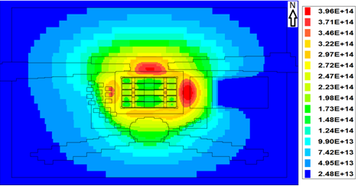

*Figure 5: Thermal Neutron Flux map in the core and surroundings (n/ cm2 s)*

**7. Conclusions**

At the present, the RMB neutronic design is at the end of the Preliminary Engineering stage.

Several design aspects for this reactor, along with the main calculation tools used and the Design process have been presented and discussed.

The current consolidated design accomplishes all the safety requirements imposed by the CNEN Regulatory Normative, as well as the IAEA´s safety Standards.

Additionally, the reactor design is oriented to a high operational performance in its Irradiation Facilities, for both In-Core and Out-of-Core. The Irradiation facilities comprise radioisotopes production, Neutron Transmutation Doping in Silicon, several neutron beams and pneumatic rigs; and a PWR fuels testing Loop.

Regarding the overall operation performance, the usage of the Uranium in the Fuel Assemblies has been optimized, allowing enough margins to allow an easy operation of facilities and satisfying all shutdown criteria at the same time.

**8. References**

[1] Most of the information presented in this paper is obtained from the RMB project documentation, which is confidential, and property of the CNEN, with their permission.

[2] IAEA Safety Standards, **NS-R-4 Safety of Research Reactors UR DS476.**

[3] Villarino, E; Mochi, I; Sartorio, P; “INVAP Neutronic Calculation Line”, Mecánica Computacional Vol. XXXIII, pages from 3217 to 3226; Asociación Argentina de Mecánica Computacional.

[4] CONDOR Calculation Package Physor 2002, "International Conference on the New Frontiers of Nuclear Technology: Reactor Physics, Safety and High-Performance Computing. Author: E. Villarino.

[5] Forrest Brown, Brian Kiedrowski, Jeffrey Bull, "MCNP5-1.60 Release Notes", LA-UR-10-06235.