Status of uranium targets irradiation in MARIA reactor for molybdenum production

G. Krzysztoszek

National Centre for Nuclear Research, A. Sołtana 7, 05-400 Otwock, Poland

G. Krzysztoszek : g.krzysztoszek@ncbj.gov.pl

**Abstract**

The high flux research reactor MARIA is operated at the National Centre for Nuclear Research. It is a water and beryllium moderated reactor of pool type with graphite reflector and pressurized channels containing concentric tube of fuel element. Due to supply shortages of molybdenum-99 during July 2009 – February 2010 there was developed the Mo-99 irradiation and transport technology in MARIA reactor facility and then its expedition to the processing facility in Petten (Holland). From February 2010 till the end of 2013 were irradiated 600 uranium plates. Especially important was MARIA reactor operation from the mid of December 2012 till the end of April 2013 when the quantity of delivered for market Mo-99 covered about 15% of global demand. After upgrading of the primary fuel channel cooling system we are available to install an additional channel for U-targets irradiation (increased capacity around 50%). Under collaboration with Mallinckrodt Pharmaceuticals and with reactors HFR and BR-2 we are developing irradiation and transport technology of a new designed LEU targets for molybdenum production.

**1. Introduction**

Due to the shutdown of the NRU reactor (Canada) and plans for scramming the HFR reactor (Holland) in the half of 2009 a decision was taken on cooperation between IAE and COVIDIEN which was aimed to initiate an irradiation of high-enriched uranium plates in MARIA reactor for production of molybdenum Mo-99. There was developed the Mo-99 irradiation and transport technology in MARIA reactor facility and then its expedition to the reprocessing factory in Petten (Holland). The physics calculation, safety analyses, technical projects of equipment for irradiation and transport inside the reactor facility and loading to the special transport container (MARIANNE) were made.

We received the positive opinion of the Nuclear Safety Committee of IAE and approvals released by the National Atomic Energy Agency.

The first irradiation of uranium plates has been taken place in the MARIA reactor from February 2010. In 2010 in MARIA reactor we have made 21 cycles of U-targets irradiation for Mo production. Because the MARIA reactor is quite far from molybdenum production facility (if we compare with HFR and BR-2 reactors) in Petten we agreed with Mallinckrodt to realize at least 10 cycles of U-targets irradiation in euch calendar year.

**2. MARIA research reactor description**

The research reactor MARIA is operated at the National Centre for Nuclear Research. The multipurpose high flux research reactor MARIA is a water and beryllium moderated reactor of a pool type with graphite reflector and pressurised channels containing concentric tubes assemblies of fuel elements. It has been designed to provide high degree of flexibility. The fuel channels are situated in a matrix containing beryllium blocks and enclosed by lateral reflector made of graphite blocks in aluminium cans, *FIG.1*. The MARIA reactor is equipped with vertical channels for irradiation of target materials, a rabbit system for short irradiations and six horizontal neutron beam channels.



*FIG. 1. Vertical cross-section of MARIA RR.*

The main characteristics and data of MARIA reactor are as follows:

* nominal power 30 MW (th),

thermal neutron flux density 3.0 ⋅ 1014 n / cm2 ⋅ s,

* moderator H2O, beryllium,
* cooling system channel type,
* fuel assemblies:

- material U3Si2

- enrichment 19,75 %

- cladding aluminium alloy

- shape five concentric tubes

- active length 1000 mm

* output thermal neutron flux

at horizontal channels 3 ÷ 5⋅109 n / cm2 ⋅ s

The reactor was fully converted from HEU to LEU fuel in the end of August 2014.

Now we are using MC LEU fuel CERCA type:

* + fuel: U3Si2
  + enrichment: 19,75 %
  + mass of U-235: 485g
  + thickness of cladding: 0,6 mm

During period January 2013 – June 2014 according to the agreement between NCBJ and TVEL Company we have tested new LEU MR Russian type fuel. The results of irradiation testing are positive and probably in the beginning of 2015 the National Atomic Energy Agency will issue a license for LEU MR type fuel operation in MARIA reactor.

The main areas of reactor application are as follows:

* production of radioisotopes,
* research in neutron and condensed matter physics,
* neutron radiography,
* neutron activation analysis,
* neutron transmutation doping,
* testing of fuel and structural materials for nuclear power engineering.

**3. Developing the uranium targets irradiation technology, safety analysis,   
measurements and tests**

In the period from June 2009 up to January 2010 the technology and safety analyses of irradiation and shipment of uranium was developed and also a number of tests and measurements were conducted. They included the hot test in which several test plates were irradiated.

Technology for irradiation and handling of uranium plates comprise of:

* Irradiation of plates and initial cooling in the irradiation channel
* Calorimetric measurement of heat generation in the capsule with plates
* Transport of plates into the hot cell
* Handling operations in the hot cell
* Loading of plates into the transport cask MARIANNE

Calculations and safety analyses at steady states were as follows:

* Calculations of molybdenum activity
* Neutronic calculations
* Thermal-hydraulic calculations at steady states
* Activity of fission products and thermal power of the uranium plate batch
* Cooling of uranium plates in the capsule for irradiation during natural convection in the air
* Shielding calculations and an assessment of radiological hazard for personnel pending reloading – transport operations

Program of examinations and installation tests consist of:

* Hydraulic measurement of channel for irradiation of capsules containing the mock-ups of plates
* Cold trials of reloading and transport operations with a batch of dummy plates
* Calibration measurements of calorimeter for measuring of thermal power of 4 plate batch
* Measurement of axial distributions of the neutron flux density in the capsule containing dummy plates
* Measurements of the heat balance in molybdenum installation with the dummy plates
* Test irradiation of uranium plates and their dispatching
* Measurements of temperatures of uranium plates in the air

**4. Current status of Mo-99 production in the MARIA reactor**

In the period March 2010 to October 2014, 73 irradiation cycles in the MARIA reactor were conducted. In all cycles were irradiated 1064 plates.

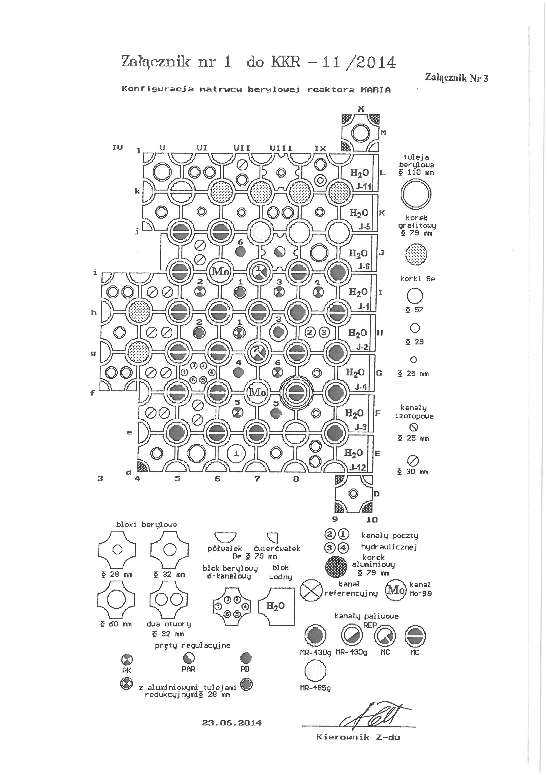

*FIG. 2. A typical configuration of the MARIA reactor core with molybdenum channels.*

Irradiations were conducted in two different locations of molybdenum channels (f-7 and i-6) and different configurations of the core. The typical configuration of the core for irradiations of molybdenum channels is shown in Fig.2.

The details of irradiation cycles of uranium plates in the Maria reactor are presented below:

* time of irradiation – 120 [hours]
* average power – 180 ÷ 200 [kW]
* Mo-99 activity at the end of irradiation (EOI) – 7000 ÷ 8000 [Ci]

The technological parameters of MARIA RR core are shown in *FIG.3*.

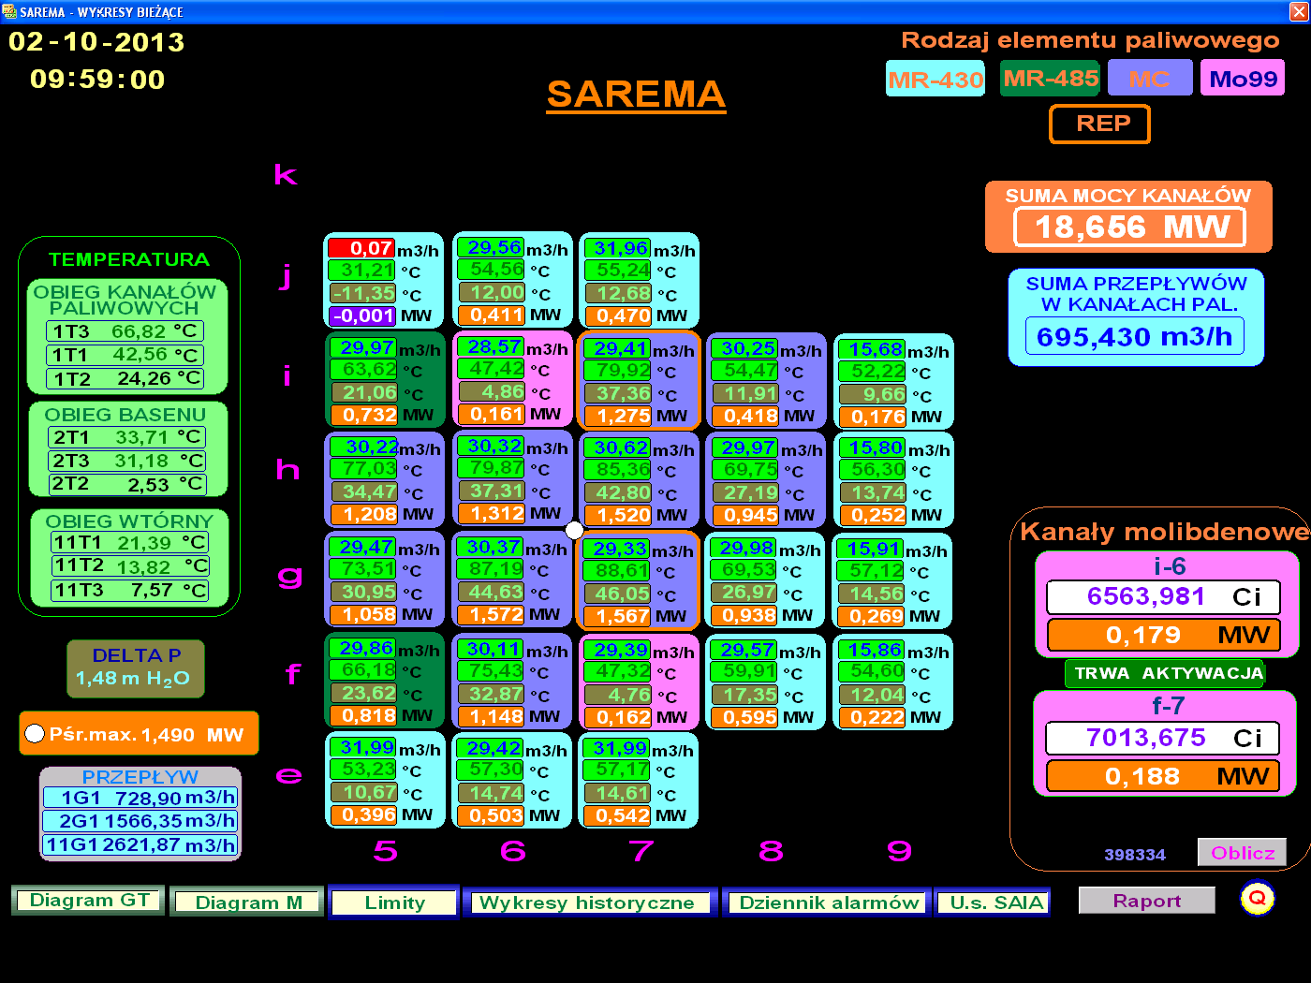

*FIG. 3. Diagram of MARIA RR core.*

The programme of HEU targets irradiations in 2015 connected with 20 cycles   
is shown in *FIG.4*.

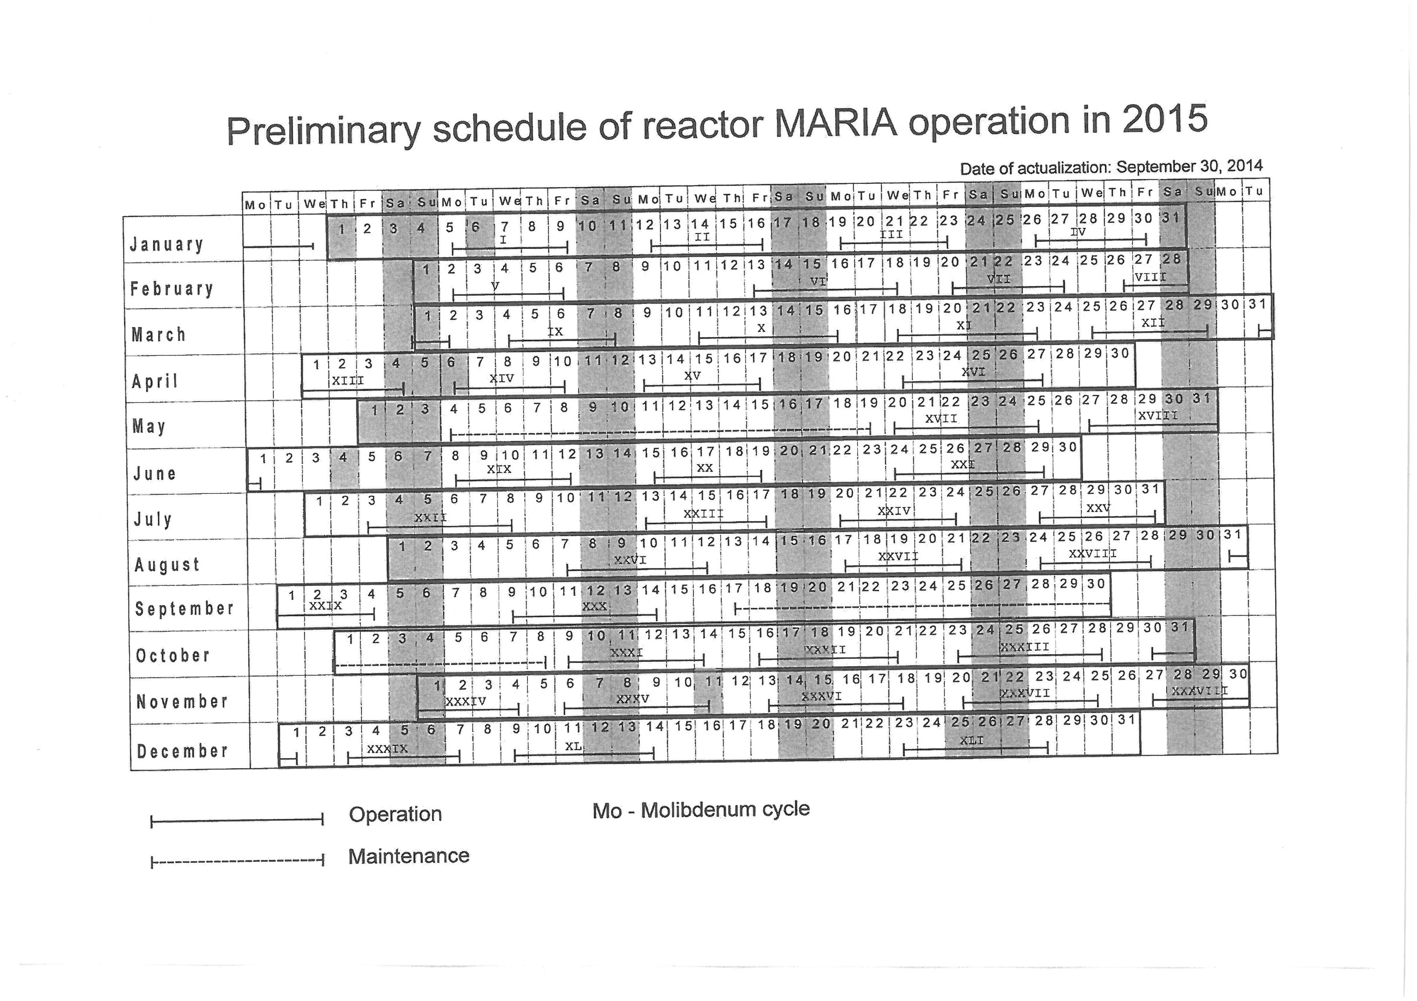

FIG. 4. Schedule of reactor MARIA operation in 2015.

**5. Possibilities of increasing Mo-99 production in the MARIA reactor**

The substantial rise in the production is possible by increasing the number of molybdenum channels or increasing the number of containers with uranium plates in the channel.

5.1 Increasing the number of molybdenum channels in the MARIA reactor

After modernization of the cooling channel circuit (exchange of pumps) it is possible to enlarge of the MARIA reactor core and to install another molybdenum channel in the h-8 position. It make possible to increase the Mo-99 yield by 50% in comparison to current state.

5.2 Increasing the number of the containers with uranium plates (up to 3)

The height of the fuel zone of the MARIA reactor (1000 mm) makes it possible to irradiate simultaneously 3 containers with 12 uranium plates in the molybdenum channel.

The assumption was made that the modification of the molybdenum channel means increasing the number of containers in the channel and placing the containers in such a way that they are symmetrical in relation to the maximum of the neutrons flux in the channel.

Total efficiency of Mo-99 production grows in the version with three containers up to 135% in relation to the version with two containers.

The total thermal power generated in the channel reaches the value of 300 kW compared with 220 kW in the version with 2 containers.

**6. Irradiation of HEU IRE targets in MARIA**

In the beginning of 2014 we have started cooperation between NCBJ and IRE, Belgium to develop the technology of U-targets irradiation, handling and loading to the AGNES transport containers and then expedition of irradiated targets to the processing facility in Flerus (Belgium).

The scope of program includes:

* safety analysis (neutronic, thermohydraulic in steady states, transient and emergency situation),
* technology of irradiation handling and reloading of irradiated targets:
* manufacturing and commissioning of an irradiation facility,
* licensing process (interaction between NCBJ and Regulators Authority
* training of MARIA reactor operators,
* hot tests.

We plan to irradiate HEU IRE targets tubes in position h-8 of MARIA reactor core, fig. 2.

In one channel will be irradiated 9 tubes and total power generated in these tubes will be around 190 kW during 120 hours of irradiation time. We assume that activity of molybdenum will be 107 - 6 day Ci per target.

**7. Certification of LEU target.**

Under supervision of the Mallinckrodt Pharmaceuticals and with collaboration with HFR and BR2 reactors we are developing irradiation and transport technology of a new designed Low Enriched Uranium (LEU) targets for molybdenum production.

In order to support the qualification of the new LEU targets at MARIA reactor the following activities must occur:

* modification of the design existing molybdenum channel and manufacturing the new parts of the modified irradiation rig
* design of inner part of molybdenum channel adapted to LEU targets
* safety analysis report (SAR)
* manufacturing and commissioning the new parts of irradiation rig
* mechanical and hydraulic tests and Q.A (special emphasis paid for vibration analysis of molybdenum channel with new targets)
* licensing process: (interactions with safety committee)
* upgrading of expedition devices including modification inner transportation container
* modification of existing equipment in the Hot Cell
* adaptation of the hoisting device for MARIANNE container with new inner container
* hot test with dummy plates
* test irradiation
* PIE analysis of irradiation facility
* licensing process

**6. Conclusion**

From the 2010 when we started irradiation of HEU U-targets MARIA research reactor is in the supply chain to ensure a reliable supply of molybdenum-99 for nuclear medicine.

After upgrading of the pumps in the primary cooling system we increased capacity of Mo-99 irradiation in MARIA reactor around 50%.

In the near future we will start to irradiate HEU targets for the new partner.

The specific activity of U-targets reached in MARIA is very high and the period December 2012 – April 2013, we delivered for market Mo-99 covered about 15% of global demand.

We also working on qualification LEU target for molybdenum production.