**IAEA TM-47154**

**OPERATION, MAINTENANCE EXPERIENCE AND FUTURE CHALLENGES OF TRIGA RESEARCH REACTOR OF BANGLADESH**

M. A. Salam1, M. A. Sarder1, A. Haque1, M. A. M. Soner1, M. M. Uddin1,A. Kalam1, M. Shabuddin1, M. M. Rahman1, A. Rahman1, M. B. Shohag1, M. R. Hasan1, M. M. Haque2 and M. A. Zulquarnain2

1Reactor Operation and Maintenance Unit (ROMU), AERE, Ganakbari,

P. O.: DEPZ-1349, Savar, Dhaka, Bangladesh

2Bangladesh Atomic Energy Commission, Paramanu Bhabon, Agargaon, Dhaka-1207, Bangladesh

E-mail: [masalam61@gmail.com](mailto:masalam61@gmail.com)

**Abstract:** The 3 MW TRIGA Mark-II research reactor of Bangladesh Atomic Energy Commission (BAEC) is a light water cooled, graphite reflected reactor. The reactor achieved its first criticality on 14 September 1986. Since then, it has been used for manpower training, radioisotope production and various R&D activities in the field of neutron activation analysis (NAA), neutron radiography (NR) and neutron scattering (NS) experiments. The reactor facility along with the associated laboratories has been used successfully for carrying out routinely thesis works of students from different public universities of the country and different training programmes are conducted for human resources development. Different experimental studies are conducted for the nuclear engineering students of the country.

During the last period of operation about 28 years, the reactor facility encountered a couple of incidents, the major incidents are N-16 decay tank leakage problem, melting of specimen container (aluminium can and pyrex vial) during the irradiation of TeO2 powder in the dry central irradiation tube (DCT) for production of I-131 isotope, leakage of radial beam tube-1. All incidents were reviewed and analysed and successfully solved the problems by BAEC personnel. In some cases, help of experts from various local organizations/institutions as well as from the International Atomic Energy Agency (IAEA) were taken. Different modification, rectification, up-gradation and modernization activities have been performed for safe operation and utilization of the BAEC TRIGA Research Reactor (BTRR). Under the modernization programmes the old analogue control console system was replaced by digital control console systems. The radial beam port-2 and tangential beam port have been modernized by installing high resolution neutron power deffractrometer and digital radiography system respectively. The major challenges of the facility are ageing management, uncertainty in the supply of spare parts of instrumentation and control system, collection of new fuel elements, inadequate facilities for handling and storage of spent fuel and drainage of trained/qualified manpower. The paper highlights the experience with operation, maintenance and utilization of the research reactor for the last 28 years as well as root causes analysis of some incidents. It also presents some of the modification, up-gradation and modernization works carried out for enhancing the utilization and operational safety of the reactor. More over the paper focuses on future challenges for sustainable and safe operation of the BTRR.

**1. Introduction**

The BAEC TRIGA research reactor (BTRR) is a light water cooled, graphite reflected reactor, designed for steady state and square wave operation up to a power level of 3 MW (thermal) and for pulsing operation with a maximum pulse power of 852 MW [1]. During the 28 years of operation of the reactor various types incidents encountered.

Reactor Operation and Maintenance Unit (ROMU) is responsible for operation and maintenance of the research reactor. During the last twenty eight years ROMU carried out several refurbishments, replacement, modification and modernization activities in the reactor facility. The major tasks carried out under refurbishment program were replacement of the corrosion damaged N-16 decay tank by a new one, replacement of the fouled shell and tube type heat exchanger by a plate type one, modification of the shielding arrangements around the N-16 decay tank & ECCS system and solving the radial beam tube-1 leakage problem. All of these refurbishment activities were performed under an annual development project (ADP) funded by Bangladesh Government [2-3].

The BTRR was operated by analogue control console system from its commissioning to July, 2011. Old analogue based console has been replaced by digital console on June, 2012. Besides this, the Neutron Radiography (NR) facility has been replaced by the addition of a digital neutron radiography set-up at the tangential beam port. The Neutron Scattering (NS) facility also has been upgraded by the installation of a high performance neutron powder diffractometer (HRPD) at the radial beam port-2 of the reactor. The major incidents and its root causes, rectification, replacement and maintenance experience carried out during the last three decade of operation of the BTRR are briefly describes in the following sections.

**2. Brief Description of the Reactor Incidents Root Causes and Solutions**

**2.1 Cracks in Exi-Check Valve of the Primary Cooling System**

A fault at the weld-joint in the form of a crack over a length of about 25.40 cm (10 inch) in Exi-check valve of the primary cooling system was detected on 4 September 1990. Upon investigation by an in-house team in collaboration with Bangladesh University of Engineering Technology (BUET) and the Bangladesh Chemical Industries Corporation it was pointed out that excessive vibration induced stress in primary pipes was one of the reasons for this. Design defects such as pipe supports, couplings spacers and hubs; misalignment of pump and motor, defective motor bearings, static imbalance of pump impeller, faulty pipe layout and pump foundation and undesirable throttling of discharge valves of the pumps were identified as some of the possible reasons leading to the fault.

The Exi-check valve was duly repaired and reinstalled. Pipe supports and pump foundations were modified so as to reduce stress and vibration. Impeller and shaft of one of the primary pump were also balanced statically to reduce vibration.

**2.2** **N-16 Delay Tank Leakages**

A leakage was detected in the decay tank of the primary cooling system of the research reactor on 14 July 1997. The bottom part of the decay tank was damaged due to the pitting corrosion where rainwater accumulated for a long period. About 45,000 liters of de-mineralized water with an activity concentration of about 28 Bq/liter due to the presence of Ce58, leaked out from the primary cooling loop. The water was collected and contained in a special storage and in plastic containers.

In July 1997, the decay tank made of aluminium alloy of 6061-T6 was found damaged due to pitting corrosion in several areas where rain water seeped through the RCC shielded roof and vent pipe during the monsoon and accumulated for a long period. Corrosion was found between the decay tank bottom and saddle contact region. The decay tank leakage incident is considered to be the single most significant incident in the reactor facility.



*Fig. 1: Marks of corrosion pitting of the old decay* *tank*

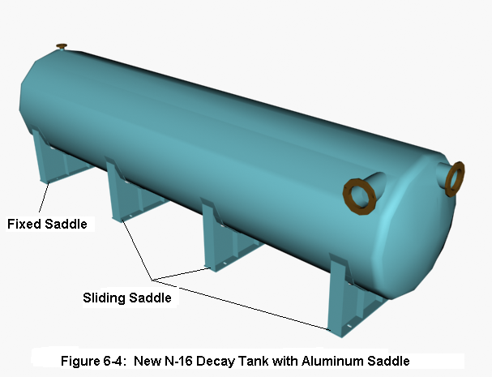

*Fig. 2: New decay tank with aluminium saddle*

Figure 1 shows some of the corroded parts of the decay tank bottom and Figure 2 shows the new decay tank with aluminium saddle. Due to decay tank leakage, high power operation (power level over 250 kW) of the reactor remained suspended for about four years. However, reactor operations were continued during this period up to a power level of 250 kW with a temporary by-pass connection established across the decay tank. A new decay tank of aluminium alloy of 5052-H112 with four aluminium saddles welded to its body was installed in the decay tank room. Each saddle was anchored to floor with four steel routed bolts. The saddles were bolted to the floor in a way such that one of the saddles remained fixed and the other three could slide on the floor. Sliding saddles have been used in order to allow thermal expansion of the decay tank having a length of about 900 cm and a diameter of about 250 cm.

**2.3 Melting of Sample Container in the DCT during Irradiation of TeO2 Powder**

An Al-can containing about 40g of TeO2 target material loaded into a quartz vial is irradiated every week in the Dry Central Thimble (DCT) of the BTRR for production of Iodine-131 radioisotope (RI). At the end of the irradiation during 26-30 October 2008, the Al-can was cooled in situ for more than two days. After that reactor operators attempted to lift the irradiated can from the DCT using General Atomics (GA) supplied specimen handling tool on 02 November 2008. At that time the upper part of the Al-can came out. The rest of the Al-can with irradiated quartz vial remained inside the DCT. Several tools (electromechanical gripper, pneumatic gripper, etc.) were used to take the sticking irradiated Al-can out of the DCT, but all the efforts were unsuccessful. Finally, on 13 January 2009, it was possible to take the Al-can out along with the quartz vial containing irradiated TeO2 using an innovative tool designed and developed by the reactor operation personnel. The tool used some adhesive (with an appropriate applicator) for gripping the can. The incident did not make any damage to the reactor core or cause any significant release of radioactivity to the environment. The surface gamma dose rate of the removed Al‑can (with the quartz vial containing TeO2 in it) was approximately 4.29 mSv/hr. The incident was timely informed to the regulatory authority. Necessary cleaning up operation was carried out jointly by the reactor operation personnel and the health physics group so as to make the DCT ready again for irradiation of TeO2 powder for I-131 production.

* 1. **Leakage of Radial Beam Tube-1**

The BTRR has four beam ports (BP). These are (1) Tangential BP, (2) Radial Piercing BP, (3) Radial BP-1 (RBP-1) and (4) Radial BP -2 (RBP-2). When not in use, the BPs are filled up with removable inner and outer BP Plugs, mainly consisting of (a) Graphite plug (diameter: 15.25 cm, length: 102 cm), (b) Lead plug (diameter: 20.32 cm, length: 12.7 cm) and (c) HD polyethylene plug (diameter: 20.32 cm, length: 91.5 cm) [4].

For installation of the HRPD in RBP-1, it becomes necessary to remove all the BP plugs from the beam port. The HD Polyethylene plug is a lightweight device and can be removed easily by hand. But for removing the graphite and lead plug, a custom-made equipment called, Cask and Carriage [supplied by GA, the reactor manufacturer], is used.

*Fig. 3: Broken graphite plug (1st break)*

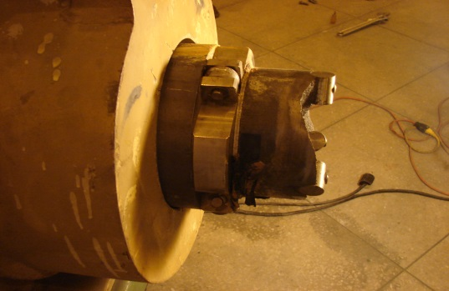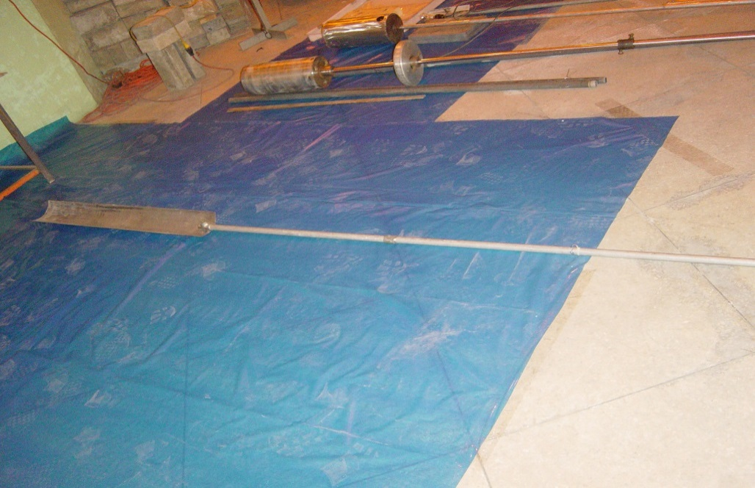

*Fig. 4: Scoop used for BP plug removal*

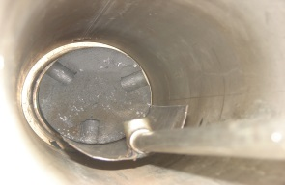

The graphite part of the inner BP plug got broken in a way as shown in Figure-3 while it was being removed on 30th March 2009 with the help of the Cask and Carriage. An emergency joint meeting of the AERE-RROUC (AERE-Research Reactor Operation & Utilization Committee) & AERE-RSCC (AERE-Radiation Safety and Control Committee) was held on 05/04/2009 to undertake necessary measures for taking the broken part of the graphite plug (having a length of about 102 cm) out. The graphite plug got broken again while it was being removed on 10th April 2009 with a scoop-like device (Figure-4), designed and developed by ROMU with the assistance of Central Engineering Facility, AERE. The picture of the piece of broken BP plug (which is about 60.96 cm (24 inch) in length and 25.24 cm (6 inch) in diameter) is shown in Figure-5. The part of the graphite plug, which is about 33.02 cm (13 inches) in length, was eventually removed by an auger of appropriate size.

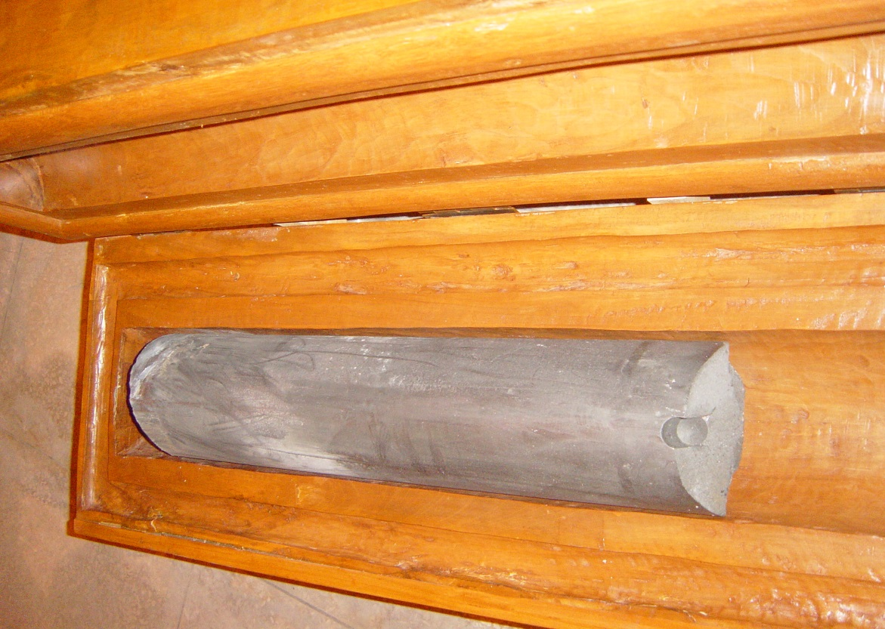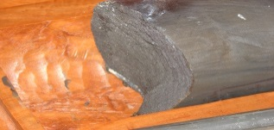

*Fig. 5: Broken graphite plug (2nd break)*

After removal of the inner 33.02 cm (13 inches) long graphite plug, the RBP-1 was found leaking at a rate of about 500 ml/day. Detail investigation showed that the aluminium part of the RBP-1 located within the reactor tank had developed corrosion leakage on its bottom part. With the approval of regulatory authority, a split type encirclement clamp (STEC) was designed and fabricated locally and then installed around the RBP-1 on 26 February 2010. The RBP-1 was observed for 72 hours and no leakage of water was noticed. Reactor operations were started again from 01 March 2010. It is to be noted that the HRPD was installed in RBP-2. Figure 6 shows the split type encirclement clamp.

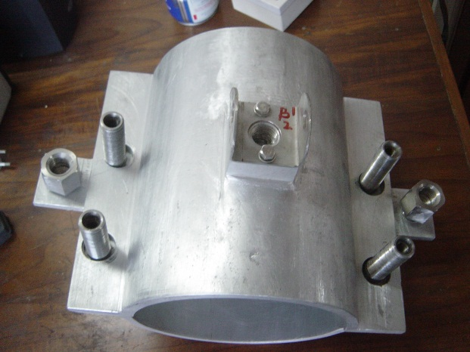

*Fig. 6: Split type encirclement clamp*

**3. Modification and replacement work**

**3.1 Modification of the Cooling System with a New N‑16 Decay Tank and Associated Components**

In July 1997 a major corrosion induced damage was detected in the N-16 decay tank of reactor primary cooling loop. As a result of this all reactor operations under forced convection cooling mode remained suspended until August 2001. However, reactor operations were carried out during this period at 250 kW power level under natural convection cooling mode of operation by establishing a temporary by-pass connection across the N-16 decay tank. In January 2000, BAEC undertook a project with a project cost of about 0.9 million US dollars for supply and installation of a new decay tank, a plate type heat exchanger, necessary piping, valves, etc. such that the problems of the reactor cooling system could be resolved properly. After successful completion of the project, the reactor has now been made operational again at full power of 3 MW. Before the full power operation of the reactor, thermal power calibration and control rod worth measurement were carried out and commissioning of the cooling system was completed successfully [3].

The major tasks carried out for the upgrading of the cooling system include the followings:

1. Installation of a new N-16 decay tank,
2. Installation of a plate type heat exchanger,
3. Installation of a chemical injection system for the secondary cooling system,
4. Modification of primary and secondary cooling system piping arrangements,
5. Modification of piping supports,
6. Modification of the shielding arrangements around the decay tank and
7. Modification of the emergency core cooling system (ECCS)

**3.2. Installation of a Plate Type Heat Exchanger**

The efficiency of the shell and tube heat exchanger was seriously degraded due to fouling on the surfaces of the tubes. A new plate type heat exchanger with cooling capacity of about 4 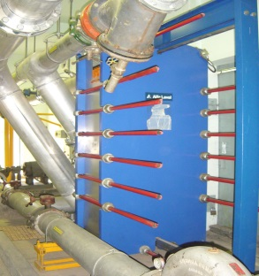MW (extendable up to 7 MW) was installed replacing the old shell and tube heat exchanger. With the introduction of the high performance plate type heat exchanger, the cooling rate of the primary water has noticeably improved. As a result, it has been possible to operate the reactor at full power with comparatively lower core inlet temperature [5]. Figure 7 shows plate type heat exchanger.

*Fig. 7: Plate type heat exchanger*

exchanger

**3.3. Installation of a Chemical Injection System for the Secondary Cooling System**

A microprocessor based chemical controller was installed for secondary cooling loop. The controller injects three chemicals into the secondary loop water so as to maintain the secondary water chemistry parameters (conductivity, total alkalinity, chlorides, total hardness, silica, phosphonate) within permissible limits.

**3.4. Modification of the Primary and Secondary Cooling System Piping Arrangements:**

A fault at the weld-joint in the form of a crack having a circumferential length of about 25 cm in the exi‑check valve of the primary cooling system was detected in September 1990. It was found that vibration induced stress in the primary pipes was one of the reasons for this failure [2]. Design defects such as pipe supports, layout, couplings spacers and hubs; misalignment of pump and motor, defective motor bearings, static imbalance of pump impeller and undesirable throttling of discharge valves of the pumps were identified as some of the possible reasons leading to the fault. The exi-check valve was duly repaired and reinstalled.

So as to reduce stress and vibration a Y-connection was introduced in place of the T-connection at the discharge side of primary pumps (Figures 8 & 9). A butterfly valve was installed at the inlet of the decay tank. Two 25.40 cm (10 inch) butter fly valves were installed in primary piping adjacent to the inlet and the outlet of the plate type heat exchanger. Design of the secondary cooling system piping arrangement at the inlet of the heat exchanger was changed by ROMU personnel in order to reduce the height of the dischargelines of secondary pumps to about 8 feet and 3 inch to facilitate the maintenance of the Y-strainers. A paddle wheel type flow sensor was installed in the suction line of the secondary pumps to measure the flow rate of secondary cooling loop.

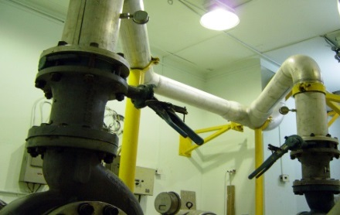

*Fig. 9: Y- Connection* *at* *discharge side of primary pumps*

*Fig. 8: T- Connection at discharge side of primary pumps*

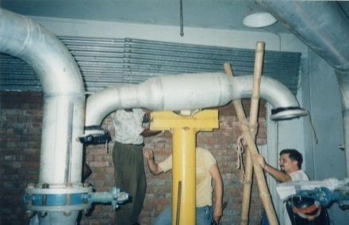

**3.5. Modification of Piping Supports**

Necessary pipe supports were provided at different locations of the primary and secondary cooling systems in order to reduce the vibration of the piping to a minimum level. Three types of mild steel (M.S.) pipe supports were used for this purpose. The types used include adjustable floor mounted type, adjustable roof mounted type and wall mounted type. In addition to these, a few supports, which are simultaneously connected to the floor and the wall, were also installed.

**3.6 Modification of the Shielding Arrangements around the Decay Tank**

A concrete shielding wall having a thickness of about 44 inch was constructed between the decay tank room and the primary pump room in order to protect the personnel working in the primary pump room and adjacent areas from radiation hazard. A M.S. door (203.2 cm X 63.5cm X 3.175 cm) was provided in the shielding wall to facilitate periodic inspection of the decay tank room. Decay tank room top shielding is also raised 20 inches from its previous position. A room with C.I. sheet roof was constructed on the top of the decay tank room, such that rainwater cannot enter into the decay tank room. C. I. sheet roof on Decay tank room & modification of top shielding shown in Figure 10.

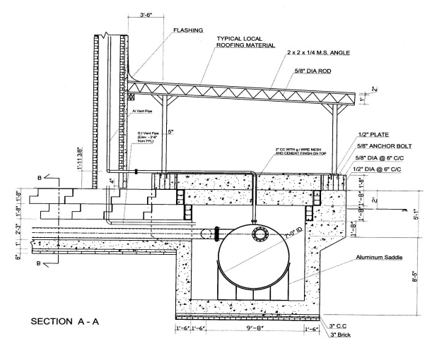

*Fig. 10: Modifications around the decay tank room*

**3.7. Modification of the Emergency Core Cooling System (ECCS)**

ECCS is the single most important engineered safety system of the BTRR that plays the key role for protecting the reactor fuel in the event of a loss of coolant accident (LOCA). The initial installation of the ECCS had several deficiencies, such as improper routing of the piping, defective installation of battery, battery-charger and pump motor unit, etc. Therefore, in order to improve the operational safety of the ECCS, several modifications were needed to be carried out on the system. These modifications were implemented after the installation of the new decay tank and associated components of the reactor cooling system which comprises of the plate type heat exchanger, modified Y-connection, new isolation valves, etc. The modifications of the ECCS mentioned above include thefollowings:

1. Modification of the ECCS piping layout
2. Shifting of the ECCS mounting block containing the ECCS pump-motor to a safe height and battery & charger unit to another location and
3. Replacement of the old ECCS lead-acid battery by new Ni-Cd battery

**3.7.1. Modification of the ECCS Piping Layout**

The section of the ECCS piping was installed at about 5cm above the decay tank room floor. Appropriate supports were also placed at different locations of this pipe section. It is to be mentioned that the earlier pipe layout at this section was defective. This is because, the pipe was laid in a way such that it remained covered with the C.C shielding wall that stood between the decay tank and primary pump room. The C.C shielding wall was in direct contact with the pipe and as a result, the pipe got corroded [6].

**3.7.2. Shifting of the ECCS Mounting Block Containing the ECCS Pump-Motor to a Safe Height and Battery and Charger unit to Another Location**

It is essential that the ECCS should remain operational under all abnormal situations. One of such abnormal situation is the flooding of the decay tank and primary pump room by water leaking out from the primary cooling loop. The ECCS mounting block must not get under water in the event of such flooding.

The ECCS equipment, which comprises of the battery set, the battery charger, the pump-motor unit and the start/stop solenoid switch were mounted on the same ECCS mounting block. In order to keep the ECCS unaffected in the event of flooding as mentioned above, safe mounting height of the ECCS mounting block from the primary pump room floor (PP room floor) was calculated to be 3 feet and 6 inch. But the mounting block was installed at a height of 36 inch from the PP room floor. The ECCS pump motor unit is raised 6 inch accordingly. A separate mounting block was made for the Ni-Cd battery set and the battery charger unit, which is placed in the heat exchanger room.

To ensure safe and prolonged operation of the ECCS, the lead-acid battery (1x12 V) was replaced by a Ni-Cd battery set (10 no of 1.2V) in March 2002. It is to be mentioned that the capacity of the previous lead-acid battery was 100 ampere-hour, whereas the capacity of the new Ni-Cd battery set is 168 ampere-hour. Because of higher ampere-hour capacity of the newly installed battery, it has been possible to increase the operating time of the ECCS pump approximately by 10 hours.

1. **Installation of Digital Control Console Systems**

The Reactor Instrumentation and Control (I&C) system is designed and manufactured to comply with the guidance given in American Nuclear Society (ANS) ANSI Guide ANSI/ANS 15.15-1978, Criteria for the Reactor Safety Systems of Research Reactors and the IAEA Safety Series 35-S1, particularly with respect to physical separation and electrical isolation of the reactor protection system (RPS). The reactor I&C system include instrumentation for monitoring reactor parameters during all operational states and for recording all variables important to reactor operation. It also manages all control rod movements taking into account the choice of operating mode and interlocks. The I&C system is a computer-based system, but includes dedicated hardwired displays and controls so that safe operation can continue if the computer become unavailable. This system contains control system console (CSC) as well as data acquisition and control unit (DAC) [7]. Figure 11 shows the control system console of the reactor. Figure 12 shows the data acquistition and control unit of the reactor. DAC is responsible for interfacing and communication between hardware and software system. DAC contains the following components

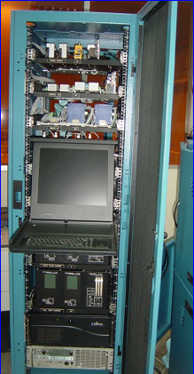

*Fig.12: Data acquisition and control (DAC)Unit*

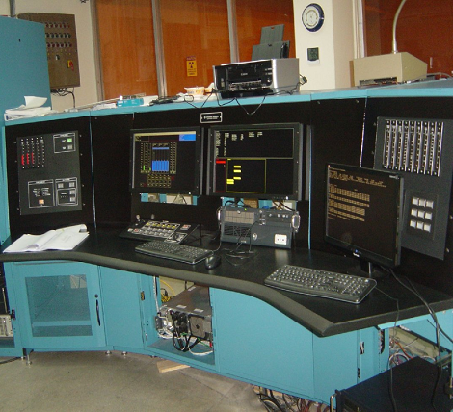

*Fig. 11: Control system console (CSC)*

* Fuel Temperature Monitoring Channels
* Wide-Range Log Power Channel
* Safety Power Channels
* Multi-Range Linear Power Channel
* Control rod drives
* Peripheral I&C System

1. **Major Issues and Challenges**

GA is the manufacturer of TRIGA fuel. Recently they are not producing fuel element which causes uncertainty on procurement of TRIGA fuel. Almost similar problem occurred with the spare parts for digital console. Only a few spare parts are available which is not sufficient in the long run. Another problem is ageing management. It is an important issue although many modifications and refurbishment works at the reactor facility have been performed previously. As a result of ageing, some of the reactor tank internals that are directly connected to the reactor core, such as the radial beam tube, rotary specimen rack, (Lazy Susan) sample loading tube, etc. have developed corrosion damage. Beside these there are some major challenges like sustainable operation of the reactor and enhancement of education and training programs for human resource development for Nuclear Power Plant (NPP) by utilization of the research reactor.

1. **Conclusions**

The BAEC reactor has been operated as per the technical specifications and procedures as laid down in the safety analysis report (SAR) of the research reactor. Moreover, special cares were taken for routine check and surveillance activities for preventive and corrective maintenance of systems and equipment. Refurbishment works were performed in the cooling system and rectification of BP leakage problem was really ensures the sustainable, safe and reliable operation of the reactor. After satisfactory installation of the plate type heat exchanger and modification of cooling system piping arrangements have significantly improved the cooling system parameters and reduced vibration level. Modification of ECCS has also enhanced the overall safety of the reactor. The digital I&C system will be helpful for the BAEC professionals to develop better understanding about the I&C systems of the reactor. After modernization of the beam port facilities, neutron based R&D activities have been increased significantly. Furthermore, the ageing related activities of the BAEC research reactor needs to be improved focusing on Structure System Components (SSCs) to enhance safe and more reliable operation of the reactor. The reactor facility is also used for training and educational purpose also and so far been utilized to train up a total of 27 personnel including several foreign/nationals to the level of Senior Reactor Operator (SRO) and Reactor Operator (RO).

1. **References**

[1] General Atomics (GA), Safety Analysis Report of BAEC 3MW TRIGA Mark-II Research Reactor, 1986.

[2] M. A. Zulquarnain "Rectification Work on the Primary Cooling System of the 3 MW TRIGA Mk-II Research Reactor of Bangladesh Atomic Energy Commission”, Proceedings of the 5th Asian Symposium on Research Reactors, Taejon, Korea, 1995.

[3] M. M. Haque, M. A. Salam, Report on Commissioning of the Cooling System of the BAEC 3 MW TRIGA Mk-II Research Reactor with the New Decay Tank and Associated Components, 2003

[4] GA Document No. GA-A17054, “Mechanical Operation and Maintenance Manual”, General Atomics Project 2299, (May 1984).

[5] Department of MME, BUET, Dhaka, Bangladesh; “Report on Probable Solution for Corrosion of Aluminum Tube of Radial Beam Port # 1 and #2 of the 3MW TRIGA Mark-II Research Reactor of Bangladesh Atomic Energy Commission (BAEC), Savar”; (Feb 2010).

[6] ROMU Document No. WPP # ROMU-WP0901, “Work Plan & Procedures (WPP) for the

Removal of the Broken and Sticking Graphite Plug from Inside the RBP-1 of the 3MW TRIGA Mark-II Research Reactor of BAEC”, (Jul 2009).

[7] M. M Haque1, M. A. M.Soner2, et al “Strengthening the Analogue Control System of BAEC TRIGA Mark-II Research Reactor by Installing Digital Control Console”, Conference on Electronics and ICT for National Development 2012, Bangladesh Electronic Society, Bangladesh Atomic Energy Commission, Dhaka.