ADVANCE IN THE RA-10 REACTOR PROJECT

H. Blaumann, A. Vertullo

National Atomic Energy Commission, Department of Nuclear Engineering,
Av. Bustillo 9500, 8400 S. C. de Bariloche, Río Negro, Argentina

Corresponding autor: blaumann@cab.cnea.gov.ar
Abstract. A new multipurpose research reactor, which will replace RA-3 reactor, will be built in Argentina in order to satisfy the increasing national and regional demands for radioisotopes. The project, supported by the National Administration, started in 2010 and is planned to be operative in 2018. The expertise acquired in the country, in the design and licensing of nuclear reactors, encourages the National Atomic Energy Commission (CNEA) to face the challenge. INVAP S.E. is involved in the design of the reactor facility and related installations, playing the role of main contractor.

The RA-10 is a 30 MW thermal power reactor and is designed to achieve high performance neutrons production to fulfill the stakeholder’s requirements in compliance with stringent safety regulations. The principal objectives of the facility are: to consolidate and increase the radioisotope production in order to cover future demands, to provide fuel and material testing irradiation facilities in order to support national technology development on this field, to offer new applications in the field of science and technology based on modern neutron techniques.

The reactor is an open-pool facility with a compact core with MTR (Material Testing Reactor) low enriched uranium (LEU) fuel assemblies consisting of uranium silicide fuel plates, cladded in aluminum. Reactivity control is performed by hafnium plates. A heavy water reflector tank surrounds the core. It provides a high thermal neutron flux adequate to house irradiation facilities. A diverse and independent shutdown system is engineered through its drainage. The fundamental safety objective of the design is the radiological protection of the public, the personnel and the environment; consequently, the design is based in three main principles: responsibility in safety management, defense-in-depth and safety features. Engineered Safety Features are provided with the capability of maintaining the reactor in a safe condition under all anticipated operational conditions and design basis event.

The basic design of the reactor has been completed, under a contract with INVAP S. E. The detailed design is being developed in the frame of a new contract with INVAP S. E. The Preliminary Safety Report was presented to the Regulatory Body in September 2013. The technical specification development for the facility construction has been finished for initiating the bidding process, as well as the Environmental Assessment Study. The construction license of the reactor was granted in October 2014, while its commissioning is planned for late 2018.

1. Introduction

In the context provided by the Argentinian Nuclear Programme with on-going projects such as Atucha II Nuclear Power Plant (NPP) and CAREM reactor (a Pressurized Water Reactor prototype), the National Atomic Energy Commission (CNEA) is running a project for a new multipurpose research reactor: the RA-10. This new reactor will provide a replacement for the RA-3 reactor (1967) with greater capabilities for radioisotopes (RI) production in order to support the local and regional future demand, increasing the production of molybdenum-99 (at least 2500 Ci/week) but also the production of lutecium-177 and iridium-192 and it will try the generation of new radioisotopes (RI) such as bismut-213.

This reactor will also support the national capabilities related to nuclear fuel production through the implementation of irradiation facilities for testing new fuel elements developments including miniplates, MTR and NPP fuel assemblies and for materials testing focused on radiation damage and corrosion evaluation. It will also offer to the scientific and technological system new capabilities based on neutron techniques through the implementation of thermal and cold neutron facilities for their applications to nuclear technology, material science and biology.
The RA-10 project was approved by the government as «Design, construction and commissioning of an Argentinian multipurpose reactor: RA-10»; and it was officially started by the CNEA in June 2010. It will be placed in the Ezeiza Atomic Centre, close to Buenos Aires city, where other facilities related to the reactor applications, such as spent fuel assembly storage facility, hot cells, fission plant, solid waste storage facility and liquid effluent treatment plant already exist. Also it is close to an international airport, which can reduce the delivery time of radioisotopes, increasing its specific activity

2. Design Objectives

The RA-10 reactor is then conceived as a multipurpose facility suitable for RI production, materials and fuel irradiation, neutron techniques applications and silicon doping. Its design is based on LEU fuel elements and must meet the Argentinian Safety Regulations and International Atomic Energy Agency (IAEA) Standards.

2.1 Safety Related Objectives

The Argentinian Nuclear Regulatory Body (ARN) does not impose restrictive conditions for general cases. Instead, the regulation is based on performance or risk-oriented requirements. This means that it should be guaranteed; for all postulated accidental sequences that the risk on the public (radiological individual risk) and on the reactor operators is sufficiently low [1]. For each potential accidental sequence a probability (annual occurrence) and a resulting dose (effective dose in a representative person) are then evaluated, and the resulting radiological risk must be lower than reference values for public and operators in order to get the plant to be acceptable from the licensing point of view. The design must also meet some prescriptive conditions and follow national [2] and international guides [3].

2.2 Design Objectives Related to Reactor Applications

2.2.1 Radioisotopes Production

The design requirements related to radioisotopes production are shown in Table 1.

Application | Spectrum | Flux  (n/cm² s) | Irradiation Conditions | Section  (cm) | Length  (cm) | Positions
Mo-99 | Thermal | 1.0-1.5x10¹⁴ | Continuous | Ø 5.2 | 30 | 10
Ir-192 (industrial)/  Other RI | Thermal | 1.0-1.5x10¹⁴ | 2-3 cycles | Ø 5.2 | 12 | 4
Ir-192 (medicinal) / Lu-177 | Thermal | > 1.8x10¹⁴ | 2-3 cycles | Ø 5.2 | 12 | 4
Table 1: Requirements for radioisotopes production

2.2.2 Materials Testing

The design requirements related to materials testing are shown in Table 2.

Application | Spectrum | Flux  (n/cm2 s) | Irradiation Conditions | Section  (cm) | Length  (cm) | Positions
Structural materials | Fast  (E>0.1MeV) | > 3x10¹⁴ | Rig | Ø 5 | 12 | 2
MTR / miniplates | Thermal | >1.0x10¹⁴ |  | 8x8 | 65 | 2
NPP vessel materials | Reactor | 10¹³ | Rig | Ø 5 | 12 | 2
Table 2: Materials testing requirements

2.2.3 NPP Fuel Irradiation Facility

A facility for NPP fuel irradiation in NPP pressure and temperature conditions is planned. The tests that are expected to be performed are listed in Table 3.

Burnup build-up tests | Transient tests
-base irradiation at constant power  -1 a 3 fuel rods  -up to 500 W/cm  -up to 60000 Mwd/tonU  -3 Full power operation years | -power ramp with slope 10-50 W/cm.min  -1 fuel rod  -100 to 600 W/cm  -up to 10% enrichment
Table 3: Tests to be performed in NPP test irradiation loop

2.2.4 Neutron Beams

The design requirements related to neutron beams are shown in Table 4.

Application | Spectrum  (eV) | Flux  (n/cm2 s) | Irradiation conditions | Section | Positions
Cold source | Thermal |  | D2, cryogenic power<5kW | 18 l. | 1
Cold beams | E<0.01 | >10⁹ (neutron beams hall) | In-pile guide |  | 2
Cold beams | E<0.01 | >4x10⁹ (reactor face) | In-pile guide |  | 1
Thermal beams | E<0.1 | >10⁹ (neutron beams hall) | In-pile guide |  | 2
Thermal beams | E<0.1 | >10¹⁰ (reactor face) | In-pile guide |  | 1
Table 4: Neutron beams requirements

2.2.5 Other Facilities

The design requirements related to other facilities are shown in Table 5.

Application | Spectrum | Flux | Irradiation Conditions | Section  (cm) | Length  (cm) | Positions
NTD | Thermal | 1x10¹³-4x10¹³ | With rotator and flux-flatter devices | Ø 15.24(x2) Ø 20.32(x2) Ø 25.40(x1) | 60 | 5
NAA | Thermal+ Epithermal | 2x10¹⁴ | Pneumatic device | Ø 3cm | 12-30 | 1
NAA | Thermal | 1x10¹³-2x10¹⁴ | Pneumatic device | Ø 3-5cm | 10 | 12
Under water NR | Thermal | >1x10⁸ | L/D>150 | Ø 15cm | - | 1
Surveillance programme | Reactor | Maximum flux | capsule | Ø >5cm | 12 | 3
Table 5: Other facilities design requirements

3. Reactor General Characteristics

The reactor is a 30 MW open-pool facility. The core is a square array with 19 MTR LEU fuel assemblies and 6 in-core irradiation facilities. The core is contained inside an open pool of demineralized water that provides both cooling and shielding against radiation from the core. Fuel plates are arranged in parallel forming channels in-between to remove fission heat by means of a forced upward water flow. Reactivity control is performed by control plates placed in the core, constituting also the first shutdown system. A heavy water reflector tank surrounds the core. It provides a high thermal neutron flux adequate to house irradiation facilities and perform a diverse and independent shutdown system by means of its drainage. A chimney rises above the core to guide the primary flow to the pump, a closure flow entering the top of the chimney prevents active particles from reaching the surface of the pool. The presence of the chimney also increases natural convection driving force improving cooling during shutdown state and provides a safety feature for loss of coolant beyond design basis events by keeping coolant inside the core. The irradiation rigs are independently cooled by means of the pools cooling system.

3.1. Reactor Core

The reactor core is a compact square array with internal irradiation positions as shown in Figure 1. The fuel elements are placed in a 5x5 grid with 19 fuel assemblies, 2 fast flux central positions and 4 adjacent positions. Fuel assemblies are MTR type, consisting of uranium silicide fuel plates, cladded in aluminum. The plates are of 1.45 mm thickness and the meat thickness is of 0.71 mm. Each fuel has 565 g of U²³⁵ and 20 cadmium wires inserted in the aluminum fuel frames in order to improve core management. The cycle length will be of approximately 29.5 days of continuous operation. Reactivity control and reactor shutdown is performed by two rows of control plates with three hafnium plates each, placed after the first and fourth row of fuel elements. The core is radially reflected by means of a heavy water tank.

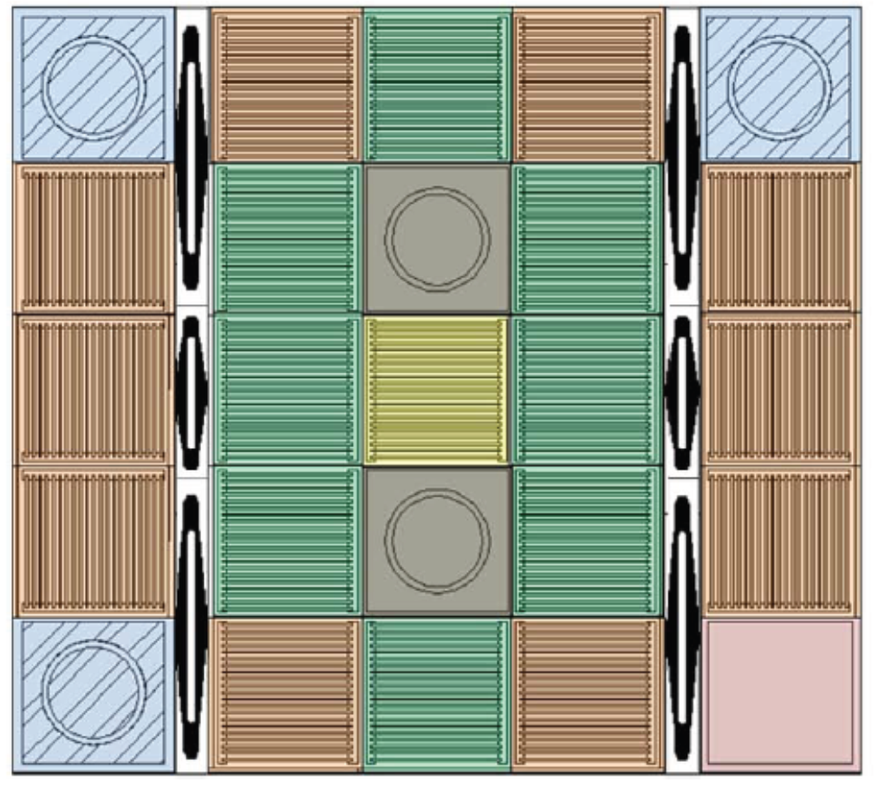
Adjacent position
Central positions
Control rods
Figure 1:. Reactor Core

3.2. Reflector tank

The heavy water reflector tank surrounds the core. It provides a high thermal neutron flux to irradiation facilities. A detailed description of the diverse irradiation facilities housed by the reflector tank, as well as neutron beams, can be seen in Figures 2 and 3.

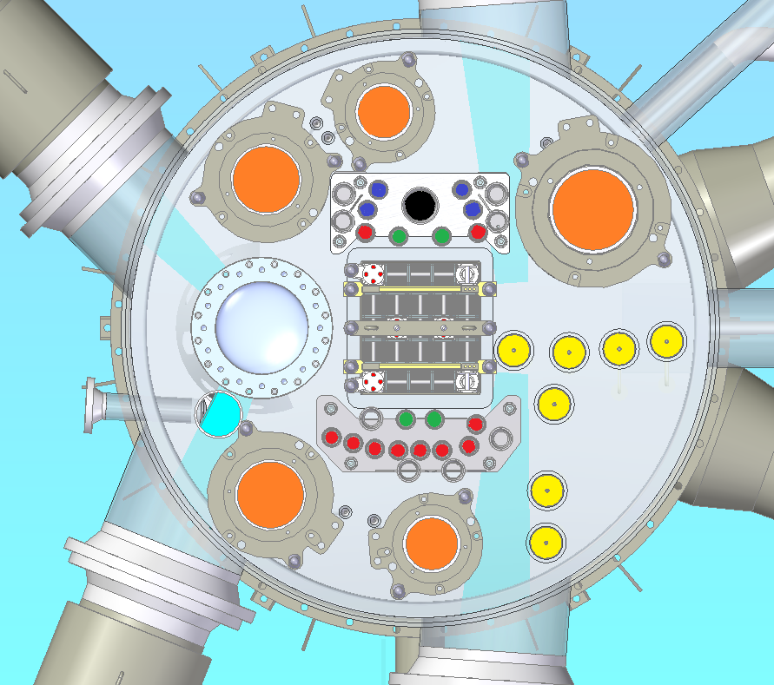
LUTETIUM PRODUCTION
MOLI PRODUCTION
IRIDIUM PRODUCTION
FUEL LOOP IRRADIATION FACILITY
PNEUMATIC TUBES
SILICON DOPING
COLD NEUTRON SOURCE
Figure 2: Reflector tank with irradiation facilities

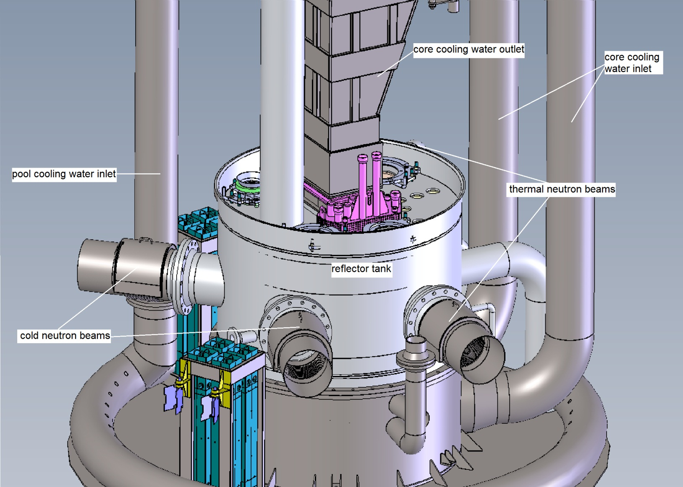
Figure 3:. Reflector tank with neutron beams and internals

4. Structures, Systems and Components (SSCs) Classification

4.1 Objective and Basis

All structures, systems and components will be classified based on their function and importance to safety. The objective of a safety classification is to guarantee that, for all SSCs fulfilling safety functions, seismic, quality and reliability requirements are adequate during design, construction and maintenance stages. From this classification criteria and requirements will be derived for the different engineering stages and for the reactor life stages.

The SSCs classification is based on considering the defence in depth criteria, the safety functions that each SSCs is called to perform, the importance of the failure of any SSCs for safety, the probability of each SSCs of being demanded to fulfil a safety function and the elapsed time after the occurrence of a Postulated Initiated Event in which the actuation of a SSCs is required.

4.2. Requirements

Requirements are assigned at four stages: related to function level, related to design level, related to equipment performance level and related to quality assurance, verification and maintenance level. The level of the requirements of each class is consistent with the importance of the SSCs related with the specific safety function to comply.

4.3. Safety Classes

Following a summary of the main characteristics of each safety class is described:

Class A
SSCs whose failure could provoke unacceptable consequences when required.
SSCs whose failure could provoke unacceptable consequences and there is no Class A SSCs to cope with such failure.
Any SSCs whose mitigation action is required to take the plant to a controlled state following a Design Basis Event or an Anticipated Occurrence.

Class B
SSCs controlling and limiting relevant process variables.
Those SSCs whose failure demands the actuation of a Class A SSCs.

Class C
Those SSCs that contribute to ensure Class A or B reliability.
Any auxiliary or process SSCs performing mitigation functions after a Beyond Design Basis Event.

4.4. Methodology for SSCs classification

1. Postulation of Initiating Events: The methodology adopted is an iterative process. A good acquaintance of the installation is required as the first step for classification. From this understanding of the systems and processes, an Initiating Events (IEs) list can be identified and postulated. The list is completed with information from IAEA Safety guides as well as local operational experience and international incident reports.

2. Safety functions identification: From the postulated IEs list, the required safety function can be derived applying the principle of Defence in Depth.

3. Safety function class assignment: With the list of required safety functions they can be classified according to the class definition described previously (see 4.3).

4. Requirements per class assignment: Assignment of a clear and good defined set of requirements to each class for the four stages described in section 4.2.

5. Safety function groups identification: This implies identifying a SSCs related with the safety function to be performed.

6. Refinement of class assignment: During the previous process, it could be possible that new safety functions, requirements and even SSCs appear. The procedure of identifying and classifying safety functions (item 3) must continue until a complete and coherent list is obtained for each engineering stage.

4.5 Example of SSCs Classification

Table 6 provides an example for some SSCs classification is provided in the conceptual design stage.

Stuctures, systems and components | Safety Class
Reactor Protection System | A
First Shutdown System | A
Emergency core cooling system | C
Second Shutdown system | C
Confinement Ventilation and Isolation system | C
Core | A
Reflector Tank | A
Cold Neutron Source Vessel | A
Reactor Control and regulation System | B
Primary Cooling System (outside de reactor pool) | B
pH/Conductivity Control System | C
Table 6: Example of SSCs classification

5. Performance

Below is shown the performance of irradiation facilities.

  - In-core facilities performance

Table 7 shows the thermal, epithermal and fast flux for the in-core facilities.

Irradiation Position | Thermal Flux | Epithermal Flux | Fast Flux
Central | 1.4x10¹⁴ | 4.4x10¹⁴ | 5.1x10¹⁴
Adjacent | 3.0x10¹⁴ | 1.7x10¹⁴ | 1.3x10¹⁴
Table 7: Thermal, epithermal and fast flux for in-core facilities

5.2 Radioisotopes performance

Table 8 shows the Radioisotopes performance, target shape and irradiation period.

RI facility | Target geometry | Irradiation period | Final Activity
Mo99 | LEU miniplates | 5 days | 4000 Ci*
Ir 192 (med) | Wires | 1 cycle | 34400 Ci
Lu 177 | Cans | 1 cycle | 1700 Ci/g
Ir 192 (ind) | Foils | 1 cycle | 12600 Ci
(*) 6 days Curies
Table 8: RI performance, target shape and irradiation period

5.3 Beams performance

It is foreseen to locate thermal and cold instruments in the neutron beam hall and at reactor face. Table 9 resumes the position and neutron flux expected. In brackets are shown the required fluxes.

BEAM TYPE | POSITION | NEUTRON FLUX  (n/cm2/sec)
Thermal | neutron beams hall (50 m from reactor core) | 2.5 x10⁹ (1x10⁹ )
Thermal | reactor face | 2.9 x10¹⁰ (1 x10¹⁰)
Cold | neutron beams hall (50 m from cold source) | 5.4 x10⁹ (1 x10⁹)
Cold | reactor face | 1.4 x10⁹ (4x10⁹)
Table 9: Position and neutron flux in beams

5.4 Loop performance

The NPP fuel test irradiation loop is a test section capable of irradiate up to 3 UO2 fuel rods of 40 cm length, cooled with light water at 18 MPa and 350 ºC. Structural material is stainless steel. The total power and average lineal power for 7.5 % enrichment are shown in Table 10.

 | 3 rods (base mode) | 1 rod (ramp mode)
Total power (kW) | 51.2 | 21.4
Average lineal power (W/cm) | 426.7 | 535
Table 10: Total power and average lineal power for the two fuel rods configurations corresponding to the operation modes of the loop (7.5% enrichment)

- Project Milestones

The basic design of the reactor has been completed, under a contract with INVAP S. E. The detailed design is being developed in the frame of a new contract with INVAP S. E. The Preliminary Safety Report was presented to the Regulatory Body in September 2013. The technical specification development for the facility construction has been finished for initiating the bidding process, as well as the Environmental Assessment Study. The construction license of the reactor was granted in October 2014, while its commissioning is planned for late 2018. The project timeline is showed in Figure 4.

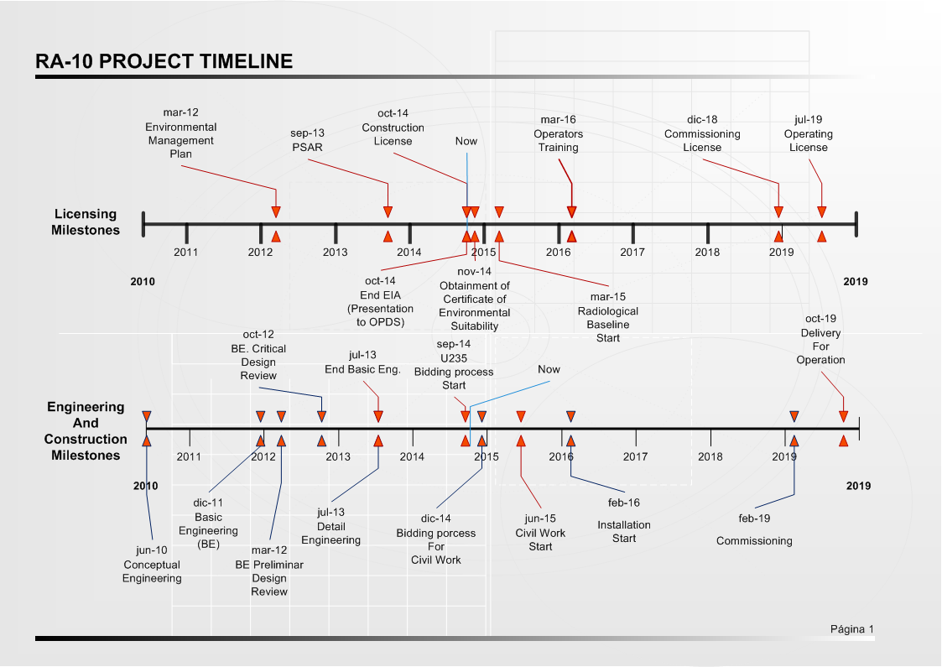
Figure 4: Project Timeline

- References

[1] Norma AR 4.1.3, Criterios Radiológicos Relativos a Accidentes en Reactores de Investigación Rev. 2, 2002.
[2] Norma AR 4.2.2, Diseño de Reactores de Investigación Rev. 1, 2002.
[3] INTERNATIONAL ATOMIC ENERGY AGENCY, Safety of Research Reactors Safety Requirements, IAEA Safety Standards Series No. NS-R-4, Vienna 2005

