Neutron and Gamma Shielding Design of the Neutron Guide
Primary Shutter in a Research Reactor

A. Maître, F. Albornoz

INVAP S.E. Comandante Luis Piedra Buena 4950, 8400 San Carlos de Bariloche, Río Negro, Argentina, http://www.invap.com.ar

Corresponding author: aramaitre@invap.com.ar

Abstract. Many of high performance research reactor designs include neutron beams provided with neutron guides that allow carrying out experiments requiring high intensity neutron sources outside the Reactor Pool. In order to guarantee acceptable dose rate levels at the Reactor Beam Hall when the neutron guides are not being used, a proper design of a neutron guide shutter is necessary. In the studied case, neutron and gamma fluxes have to be reduced in ~10 orders of magnitude through the closed shutter. Size limitations are also a constraint, thus a multilayer design has been chosen that combines light and heavy elements to achieve the flux reduction levels required. The adequacy of the multilayer setup has been checked by means of 2D calculations with the DORT code, resulting in acceptable dose rate levels when the bulk of the shielding is tested. To estimate in detail the efficiency of the shielding, 3D calculation of dose rates from neutrons and gammas, in front of the shutter gate, are carried out with the Monte Carlo probabilistic code MCNP5. Due to the high flux reduction levels required, and as happens in many Monte Carlo shielding studies, the lack of statistic is the main problem. To solve them variance reductions techniques such as weight windows are used, both in neutron- and photon-only setup problems, and in the final coupled neutron-gamma calculation. A particular attention is given to the influence of the gaps in the shielding that can lead to high dose rate spots on the external surface of the shutter gate. Given that one of the goals of the study is to provide a geometry of the shutter that minimize the impact of these gaps, the feedback from the transport calculations to the mechanical design of the shutter has allowed reducing the intensity and number of these hot spots. In the end, in order to check the adequacy of 2D deterministic model, a comparison of the 2D calculations against the more detailed 3D calculations is made, proving the deterministic model as an adequate tool at preliminary design level.

1. Introduction

In a will to support the local and international demand for radioisotopes as well as being independent from foreign facilities for its nuclear research programs, Argentina is running a project for a new multipurpose research reactor: the RA-10 [1]. This project is owned by the National Atomic Energy Commission (CNEA), who has selected INVAP S.E. as the main contractor for the basic and detailed engineering stages.

More than just radioisotopes production, it aims for neutron physics and nuclear fuel research and development. This is why the reactor is also equipped with thermal and cold neutron facilities, in-core and out-of-core irradiation facilities, high-pressure test loops and other research equipment.

The beam tubes are used to extract neutrons from the core to several experimental facilities located in the Neutron Beam Hall and, further away, in the Neutron Guides Hall. In-pile and out-of-pile sections of neutron guides are used to drive thermal and cold neutrons. Primary shutters are designed to close the in-pile section of the neutron guides, in order to allow free and safe access to positions facing the primary shutters while the facilities are not being used.

The detailed design of the primary shutter requires a full 3D calculation that includes all relevant geometrical detail (gaps, slots, spaces kept empty for mechanical design constraints, etc.). This 3D calculation allows verifying the adequacy of the shielding, as well as checking the preliminary 2D calculations that were performed to design the bulk of the shielding. The relevant steps performed to verify the design of the shutter are presented in the following sections.

2. Primary shutter description

The RA-10 is being designed with two cold beams and two thermal beams (see FIG. 1). One cold beam and one thermal beam both point directly to the Neutron Beam Hall in the Reactor Building, while the remaining two beams point to the Neutron Guides Bunker: This bunker is designed to contain and shield the out-of-pile section of the guides, which ends in the Neutron Guides Building.

FIG. 1. Position of the primary shutters in the reactor block for all the cold and thermal beams

The primary shutters allow or block the extraction of thermal and cold neutrons from the core through the beam tube and neutron guides (FIG. 2). The opening/closing of the shutter is performed by rotating 90° the cylindrical shutter according to its axis. In the closed position, the mobile shielding assembly blocks the beam tube and thus stops the extraction of neutrons (FIG. 3).

The whole primary shutter assembly is inside a stainless steel container embedded in the reactor block. Provisions are made to allow replacement of the in-pile section of the neutron guides if such a replacement is required during the reactor operating life.

The primary shutters have to be able to reduce the neutron and gamma flux by, at least, ~10 orders of magnitude. By doing so, an acceptable dose rate behind their gate (at reactor face) is achieved, so as to comply with the radiation protection requirements for personnel accessing that position.
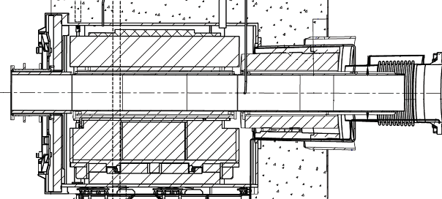FIG. 2. Primary shutter. Vertical cut along the neutron guide axis – open position

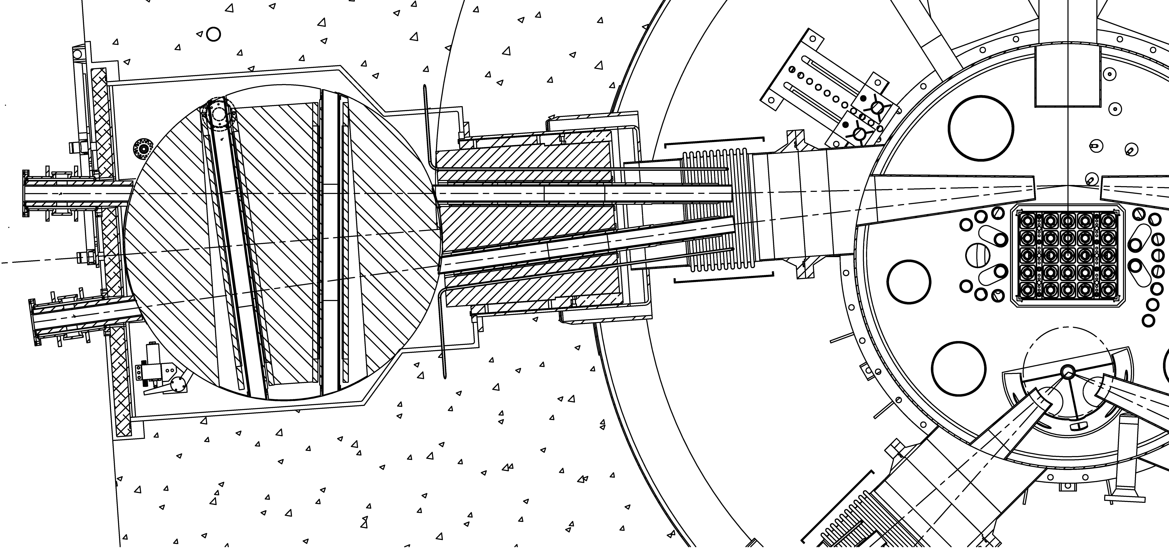
FIG. 3. Primary shutter. Horizontal cut – closed position

Size limitations are also a constraint, thus a multilayer design has been chosen that combines light and heavy elements to achieve the flux reduction levels required. The adequacy of both the multilayer setup and the rotating concept has been proven in previous INVAP's designs.

3. Radiation behavior in the primary shutter

Cold and thermal neutrons produced in the reactor core are transported from there to the experimental facilities thanks to the neutron guides as shown in FIG. 2.

Prompt fission gammas and also gammas from the decay of fission products are generated in the reactor core. This gamma radiation is also inevitably transported along the neutron beams to the experimental facilities.

Neutron interaction with beam and shielding materials also produce secondary gammas of significant energy via inelastic scattering and capture reactions.

The three components described above contribute to the total radiation that produces dose rate at reactor face. Therefore, the primary shutters have to be effective to stop such a neutron and gamma beam.

A typical solution to shield a neutron and gamma field when the space available is a constraint is the use of the so called laminated or multilayer shield. In this kind of shields, made by alternate layers of light and heavy materials, the light material provides neutron moderation, while the heavy material contributes to gamma absorption.

In the RA-10 primary shutter, preliminary 2D calculations have shown that the proposed use of alternate layers of polypropylene (light material) and steel (high density and high atomic number material), arranged perpendicularly to the particles' beam (when the shutter is closed) provides the required attenuation level for radiation penetrating the shutter through the bulk of the shielding.

Given this material combination and in general terms, polypropylene contributes to neutron moderation, while iron in steel provides thermal neutron and gamma absorption. But besides its thermal neutron and gamma absorption characteristics, iron in carbon steel also contributes to slowing down neutrons to energies below 1 MeV due to its high effective inelastic scattering cross section. In consequence, the secondary gammas produced while neutrons are slowed down in iron, are added to the secondary gammas produced by the thermal capture of neutrons in iron and to the secondary gammas produced by thermal capture of neutrons in hydrogen.

In order to enable the rotation and the refrigeration of the shutter, there are gaps in its geometry. Other gaps, slots, and empty spaces are due to functional and maintenance requirements. Neutrons and gammas move freely through these empty spaces to bypass the shield. Even though the amount and size of these gaps is kept as small as possible, a further gap reduction is limited by mechanical and refrigeration considerations. In order to deal with the remaining gaps and slots, the strategy adopted consists in making harder for radiation to bypass the shielded parts of the shutter by breaking any significant gaps in several steps. Thus, particles are avoided to travel uncollided in a straight line through an important distance.

Given the origin of radiation and its expected behavior through the shutter as explained above, any calculation strategy that intends to calculate accurately the dose rate at reactor face with the shutter in the closed position has to be able to properly take into account all these phenomena.

4. Shielding calculations

4.1. General

The code used for the detailed 3D calculations was MCNP version 5.1.60 [2], a Monte Carlo code for neutron and gamma transport that is suitable to address the physics and geometry complexities described in the previous section. The ENDF/B-VII cross section libraries distributed with the code were used for most of materials, together with a few specific sets that incorporate gammas from the decay of fission products to uranium and plutonium isotopes; and another set that incorporates gammas generated by activation in aluminum.

Preliminary results that allowed the design of the multilayer arrangement of polypropylene and steel were obtained for a simplified 2D geometry with the discrete ordinates code DORT [3] and using the BUGLE-96 cross section library [4].

4.2. Intermediate surface sources

Given the system's complexity, decoupling the core to the shutter was decided as a first strategy to perform the calculations. To do so, intermediate surface sources were recorded on a surface perpendicular to the axis of one of the thermal neutron beams, at a position outside the reflector vessel (see FIG. 4). At this position it is possible to obtain, in a core calculation, a statistically representative number of particle crossings in a reasonable computer time. Due to the different contributions to be considered, two surface sources were recorded:

- The first one (neutron source) is the result of the transport of neutrons from the core to the chosen surface, and enables to calculate the distribution of both neutrons and secondary gammas produced by neutron interaction with the shield.

- The second one (gamma source) is the result of the transport of prompt and delayed gammas from the core. It also contains those secondary gammas produced by neutron interaction with materials inside the reflector vessel. It enables to calculate the distribution of "core" gammas through the shield.

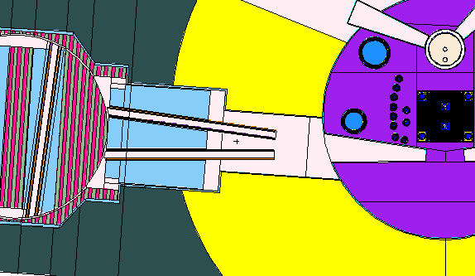
FIG. 4. Intermediate surface source

4.3. Variance reduction strategy

In order to get statistically meaningful results, the use of a superimposed weight windows mesh was chosen as a variance reduction technique. This is a well suited variance reduction technique for deep penetration problems, even after considering that the coupled neutron-gamma problem to be solved would require a specific strategy to obtain a final weight windows distribution adequate to calculate all different contributions to dose rate at the shutter gate.

First of all a weight windows mesh is generated only for neutrons with reduced material densities in a neutrons only calculation. Then the calculation is iterated by increasing the material densities until reaching the real material densities with a satisfying statistics. This method provides a weight windows mesh that optimizes neutron results. From this point on, the neutron dose rate can be calculated with a good statistic.

The same process is used in a gamma only calculation to get a weight windows mesh that optimizes the results for "core" gammas. From this point on, the core gamma dose rate can be calculated with good statistics.

To get reliable gamma dose rates for secondary gammas produced in the shield materials, a series of neutron-gamma calculations would be needed in order to generate a neutron-gamma weight windows mesh optimized for these secondary gammas. Due to the significant amount of computer time that would require implementing a similar strategy as that followed for neutron-only or gamma-only calculations, the same process was not used and then a special methodology is used instead.

This time, for the first iteration of the calculation, the former neutron weight windows mesh (optimized for neutron dose rates) is used to transport neutrons and the former gamma weight windows mesh (optimized for core gamma dose rates) is used to transport gammas. The material densities are the real ones. This first guess creates a neutron-gamma weight windows mesh that tends to optimize the statistic of the dose rate for gammas created in the shield by neutron moderation and captures. This mesh is iterated a few times in order to be optimized for this second gamma dose rate. Note that this weight windows mesh is adequate for secondary gammas only and gives poor statistics for neutron and core gamma calculations.

5. Results

5.1. Dose rate at the shutter gate position

The calculation strategy followed (intermediate sources + weight windows mesh) enabled calculating the neutron and gamma distribution all over the primary shutter system and, as the main result, the dose rate in front of the shutter gate with a good enough statistic at a reasonable computer time.
The dose rates due to the three contributors mentioned (neutrons, secondary gammas, core gammas) are added to obtain the total dose rate map in contact with the shutter gate, as shown in FIG. 5.
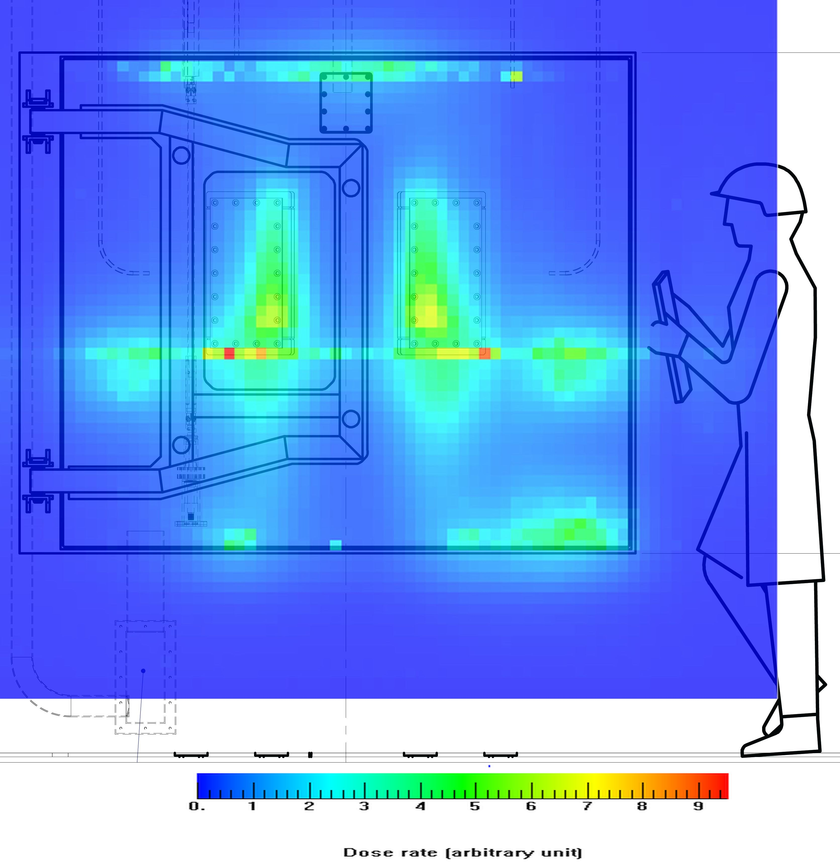
FIG. 5. Total dose rate map at reactor face

For each point of the above map, the contribution to the total dose rate from core gammas is negligible (less than 5% of the sum of the three contributions).
For each point of the above map, the contribution to the total dose rate from neutrons and secondary gammas is similar.
Several hot spots appear in the dose rate map shown. All of these hot spots are due to the gaps in the geometry:

- The upper hot zone comes from the gap between the mobile cylinder and the shutter's roof. Its impact is mitigated by shielding steps.

- The hot spots in front of the guides come from the particles that, after passing through the lateral gap that enables the shutter's rotation, return to this zone because of their incidence angle when they leave the gap.

- The hot horizontal line just below the neutron guides comes from a gap inside the mobile cylinder. This gap is located under the guides and is used to position them.

- The two hot spots at both the left- and right-end of this line also come from empty spaces left to locate the neutron guides positioning device.

- The hot spot in the right bottom corner of the shutter gate comes from the lack of shield in the last centimeters before the gate because of the presence of the rotating system for the mobile cylinder.

- The two hot spots in the lowest zone of the gate and underneath the guides come from the particles going through the rails that are used to position the mobile cylinder inside the steel container of the shutter.

The remaining zones show dose rates far below the design limit established. This highlights the importance of finding engineering solutions to reduce the impact of gaps on the dose rate and becomes the main objective in such detailed 3D calculations.

5.2. 2D (DORT) vs. 3D (MCNP) flux profile comparison

A collateral benefit obtained from the MCNP calculations is the possibility to compare the detailed 3D results against the 2D results obtained with DORT during the preliminary design stage. At that stage, the main design objective from the shielding point of view is finding a suitable arrangement and thickness of the layers in the shield that could comply with the space constraints, while assuring the dose rate at reactor face is below the required value.

Fig. 6 shows the neutron and gamma flux profiles along the thermal beam axis, as calculated by DORT and MCNP. In the 2D DORT calculations, the vertical direction is not modeled, so the results obtained have to be interpreted as the expected values at the beam's midplane. For that reason, no vertical leakages are taken into account, and the representation of gaps and empty spaces is limited by discretization constraints. The profiles shown for the MCNP case are the average taken in 30 cm of axial length.

Agreement for fast (E > 1 MeV) neutron flux is quite good. Differences at positions closer to the core are mostly due to normalization and fission spectrum that have been modeled, in DORT, in a simplified way. Fast flux at reactor face is highly anisotropic, so the effect of fast neutrons transported through gaps in the shield (which has not been taken into account in DORT) is marginal and just compensates the overestimation registered in positions closer to the core.

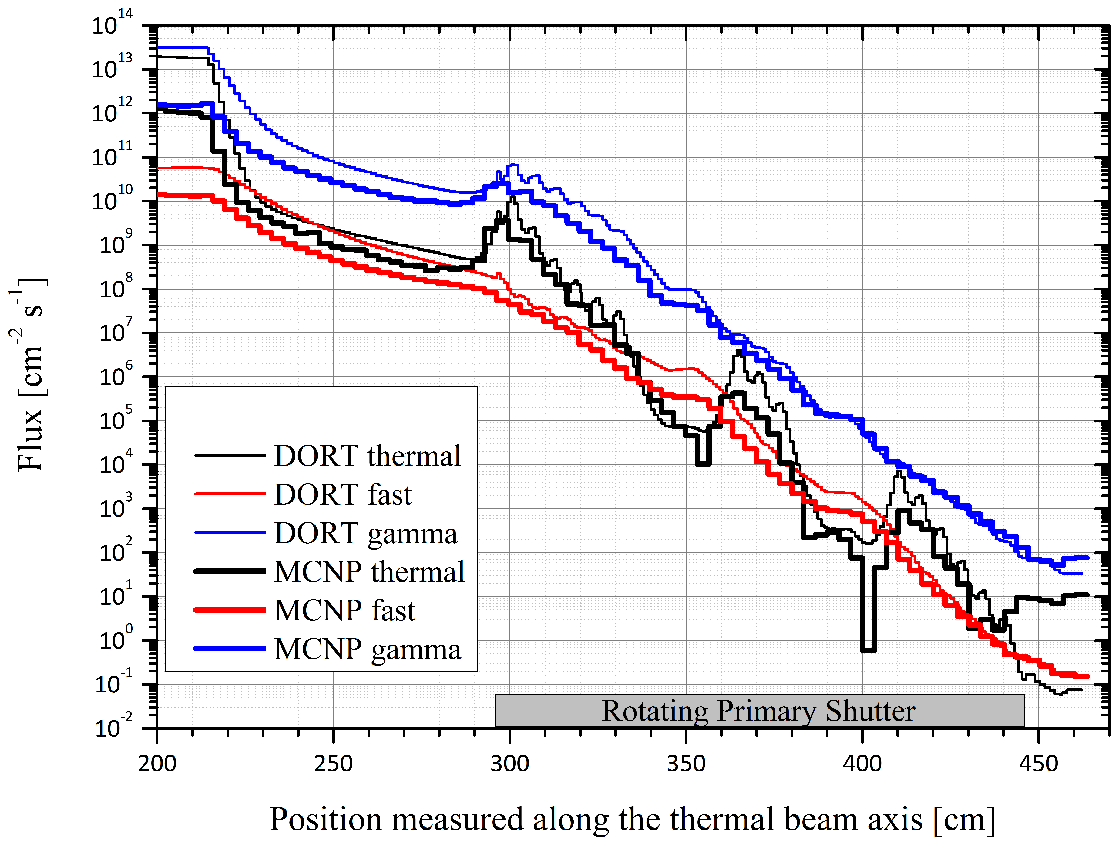
FIG. 6. Flux profiles along the thermal beam axis calculated with DORT and MCNP

The thermal (E < 0.625 eV) flux profiles are also quite similar. The effect of the polypropylene and steel in the multilayer shield is clearly seen in both calculations. Few points with too low values calculated by MCNP are seen. These are due to the lack of good statistics at those positions. At reactor face, however, the difference is close to 2 orders of magnitude. At these positions, the effect of gaps is significant and then the thermal flux calculated with MCNP is higher than the value obtained with DORT.

The total gamma flux is dominated by secondary gammas produced by neutron interaction with the shield material. Thus, the noticeable differences seen at positions closer to the core (again, due to a rough normalization used in DORT), are reduced as long as radiation crosses the multilayer shield. Since the agreement in fast flux was quite good, and the gammas are produced while fast neutrons are being moderated and then captured, a good agreement at positions closer to reactor face is reasonably expected.

6. Final Remarks – Conclusions

The detailed MCNP 3D calculations allowed modeling the complexities of the shutter design. The preliminary results obtained were then used to provide feedback to mechanical designers in order to reduce as much as possible the impact of gaps and empty spaces to dose rate at the shutter gate positions. These calculations led to the final shutter geometry which is expected to comply with the dose rate limits imposed by Argentinean regulations.
The study presented has also confirmed that the DORT code is well suited for preliminary radiation transport studies in order to find suitable multilayer configurations and to test conceptual designs.

However, the MCNP calculations have proven the need of a full 3D modeling that considers all the unavoidable gaps that appear in the shield. Not taking this into account could lead to unexpected hot spots that might result in dose rate values much higher than the imposed limits.

The nature of the problem (a coupled neutron-gamma deep penetration transport problem) requires a convenient and reliable variance reduction strategy. Several weight windows superimposed meshes adjusted to the different contributions expected at reactor face have been obtained and have proven to be adequate for dose rate calculations at reactor face.

9. References

- BLAUMANN, H., et al., "RA-10: A new Argentinian multipurpose research reactor", International Conference on Research Reactors, Rabat, Morocco, November 14-18, 2011.
- MCNP – A General N-Particle Transport Code, Version 5 – Volume I: Overview and Theory, X-5 Monte Carlo Team, LA-UR-03-1987, Los Alamos National Laboratory (April, 2003, revised February 2008).
- DOORS3.2a, One, Two- and Three Dimensional Discrete Ordinates Neutron/Photon Transport Code System. Available from Radiation Safety Information Computational Centre at Oak Ridge National Laboratory as CCC-650, October 2003.
- BUGLE-96: Coupled 47 Neutron, 20 Gamma-Ray Group Cross Section Library Derived from ENDF/B-VI for LWR Shielding and Pressure Vessel Dosimetry Applications. Available from Radiation Safety Information Computational Centre at Oak Ridge National Laboratory as DLC-185, March 1996.

