Experimental Investigation of Operational Parameters in the CDTN TRIGA Reactor

A.Z Mesquita, R.M.G.P.Souza

Nuclear Technology Development Center/Brazilian Nuclear Energy Commission (CDTN/CNEN), Campus of UFMG – Pampulha. Zip Code: 31270-901
Belo Horizonte, MG - Brazil

Corresponding author: amir@cdtn.br

Abstract. A 100 kW TRIGA Mark I research reactor has been functioning since 1960 at the Nuclear Technology Development Center (CDTN), Belo Horizonte, Brazil. The reactor was installed for research, manpower training and production of radioisotopes to be used in industry, agriculture and medical treatment. The IPR-R1 TRIGA is a pool type reactor cooled by natural circulation of light water and an open surface. TRIGA reactors, developed by General Atomics (GA), are the most widely used research reactors in the world and they are characterized by inherent safety. The IPR-R1 was designed to operate at 30 kW steady-state power and 100 kW power for limited periods, namely four hours a day, two days a week. The reactor could not meet the increasing demand for operation with natural circulation alone. The forced cooling system was built in the 70s and the power was upgraded to 100 kW. Recently the core configuration and instrumentation were upgraded again to 250 kW at steady state. This paper describes some results of experiments that have been carried out in the IPR-R1 reactor in recent years with the aim of evaluating the behavior of some thermal-hydraulic and neutronic operational parameters. The research project meets the recommendations of the IAEA for strategic plan for research reactors utilization. This work is in line with the strategic objectives of Brazil, which aims to design and construct the Brazilian Multipurpose research Reactor (RMB).

1. Introduction

Brazil has four research reactors in operation: the MB-01, a 0.1 kW critical facility; the IEA-R1, a 5 MW pool type reactor; the Argonauta, a 500 W an Argonaut type reactor, and the IPR-R1, a 100 kW TRIGA Mark I type reactor. They were constructed mainly for using in nuclear research, education and radioisotope production. Of these reactors, the IPR-R1 TRIGA is the only one that displays coupled neutronic and thermal-hydraulic behavior. The coupling between these two areas is an innovative field of study.

The experience acquired in the project can be applied in the development of the Brazilian research Multipurpose Reactor (RMB) as well as for staff training in nuclear reactor technology. This research project meets the recommendations of the International Atomic Energy Agency (IAEA), which has encouraged its members to develop strategic plans for the use of its research reactors [1].

2. The IPR-R1 TRIGA Reactor

The IPR-R1 TRIGA reactor at CDTN in Belo Horizonte is a typical TRIGA Mark I light-water reactor cooled by assisted natural convection with an annular graphite reflector. It is a research pool reactor and the core is placed at the bottom of an open tank of about 6 m height and 2 m diameter, able to assure an adequate shielding of radiation from the core. The cylindrical fuel elements are a homogeneous mixture of zirconium hydride and uranium 20% enriched in ²³⁵U with a cylinder of metallic zirconium inside and aluminum or stainless steel cladding. The moderating effects are entrusted both to the light water coolant and to the zirconium hydride in the mixture. The hydride fuel possesses a very high negative prompt temperature coefficient that is the main reason for the high inherent safety behavior of the TRIGA reactors. This temperature coefficient allows great freedom in steady state and transient operations.

Figure 1 shows the forced cooling system, which transfers the heat generated in the reactor core to a water-to-water heat exchanger. The secondary cooling system transfers the reactor core heat from the heat exchanger to a cooling tower. In the diagram it is also shown the instrumentation distribution and the forced and natural circulation paths in the pool.

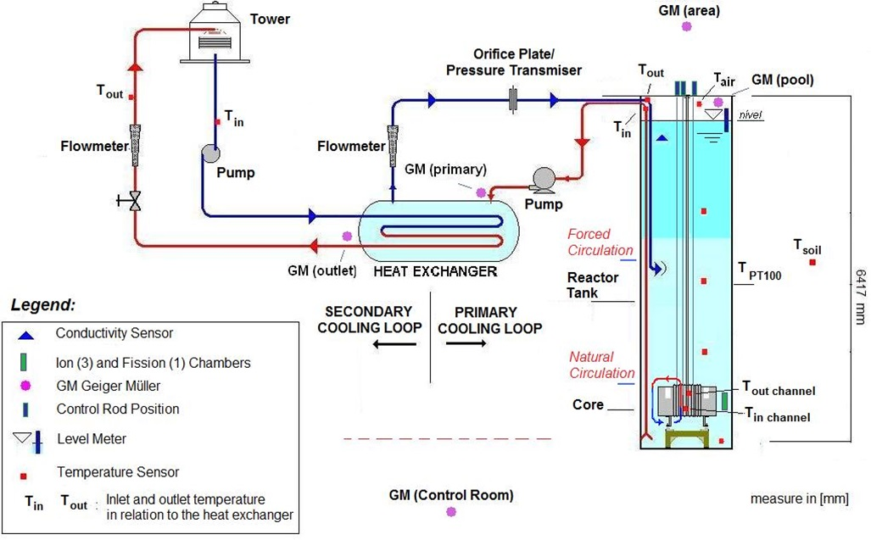

FIG 1. IPR-R1 TRIGA reactor cooling system and instrumentation distribution.

A data acquisition system was developed in order to facilitate the data acquisition in experiments performed in the reactor (Fig. 2) [2]. The information of reactor operation is displayed on the computer screen. The color graphic monitors display real-time operation data in concise, accurate, and easily understood formats. Besides showing the real-time performance of the plant, the system stores the information in a computer hard disk, with an accessible historical database. Some of the parameters monitored are: the control rod positions and their reactivity, the reactor power, the fuel and water temperatures, the radiation levels, the primary cooling system flow, the water pool level and so on. About forty variables are registered by the data acquisition system. The system responds to the IAEA recommendations on the monitoring and recording of the operational variables [3]. A fuel element instrumented with thermocouples, shown in Fig. 3, was inserted in the IPR-R1 core to perform the thermal hydraulic and neutronic experiments [4].

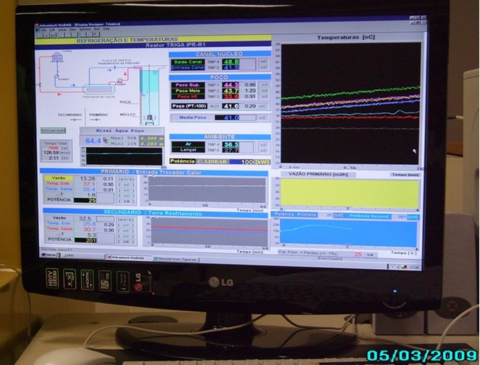

FIG. 2. User interface of the data acquisition system developed for IPR-R1 reactor.

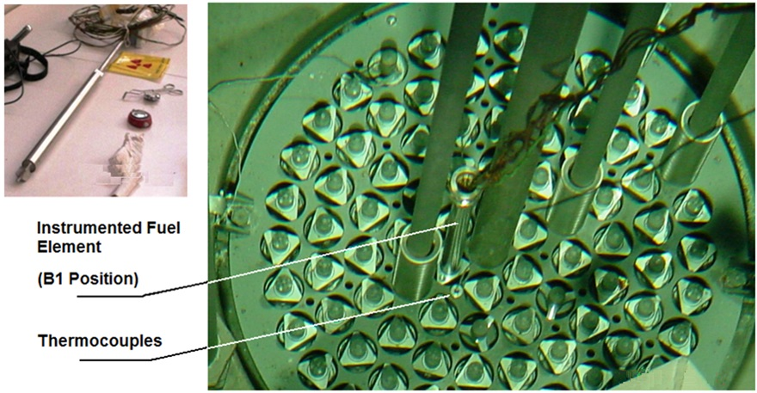

FIG. 3. Instrumented fuel element before and after it was been positioned in the IPR-R1 reactor core.

3. Thermal-hydraulic Experimental Research

The reactor power was calibrated and monitored using thermal techniques and after the channels of the neutron power measurements were adjusted. The basic safety limit for the TRIGA reactor system is the fuel temperature, both in steady-state and pulsed mode operation. Several experiments were carried out with the measurement of the temperature inside the fuel element, in the reactor core, and at different height of the reactor pool. During these experiments the reactor was set in many different power levels up to 250 kW. The mass flow rate through the core coolant hot channel was indirectly determined from the heat balance across the channel. This was done using measurements of the water entrance and exit temperatures, with the forced cooling system switched off and on. The thermal conductivity of the fuel and the heat transfer coefficient from the cladding to the coolant were also evaluated experimentally. It was also presented a correlation for the gap conductance, between the fuel and the cladding, using the instrumented fuel element [5].
4. Neutronic Experimental Research

The knowledge of the reactor’s response to specific control rod motions is essential to the safe and efficient operation of nuclear reactors. They must have sufficient excess reactivity to compensate the negative reactivity feedback effects such as those caused by the fuel temperature and power defects of reactivity, fuel burnup, fission poisoning production, and also to allow full power operation for predetermined time period. To compensate for this excess reactivity, it is necessary to introduce an amount of negative reactivity into the core which one can adjust or control it at will. Several experiments have been performed in the reactor to determine neutronic parameters such as: control rods worth, core reactivity excess and shutdown margin, reactivity changes induced by a simulated void, reactivity power coefficient and power defect, temperature and isothermal reactivity coefficients, xenon poisoning, and neutrons flux. From the results, it is possible to balance all the determined reactivity losses with the reactivity excess available in the reactor, considering the present and the future power [6], [7].

Temperature is one of the operating conditions that affect the reactivity of a reactor core. Such reactivity variation with temperature is the principal feedback mechanism determining the inherent stability of a nuclear reactor. The temperature coefficient of reactivity is defined as the change in reactivity due to a variation in the average temperature of each component of the core. Using the values of the temperatures found in the fuel and in the core, it was presented an experimental curve of the total temperature reactivity coefficient versus the core average temperature [8].

5. Results

5.1. Thermal-hydraulic Experiments

Thermal power calibrations
Two methods were tested for thermal power calibration of the IPR-R1 reactor: the calorimetric and heat balance. The calorimetric procedure was done with the reactor operating at a constant power, with the primary cooling system switched off. The rate of temperature rise of the water was recorded. The reactor power was calculated as a function of the temperature-rise rate and the system heat capacity constant. The heat balance procedure consists in the steady-state energy balance of the primary cooling loop of the reactor. For this balance the water flow in the primary cooling loop and its inlet and outlet temperatures were measured. The heat transferred through the primary loop was added to the heat leakage from the reactor pool.

Table I summarizes the results of calibrations at 100 kW and 250 kW. The calorimetric method calibration presented a large uncertainty. The main source of error was the determination of the heat content of the system, due to a large uncertainty in the volume of the water in the system and a lack of homogenization of the water temperature. The heat balance calibration in the primary loop is the standard procedure for the calibration of the IPR-R1 reactor power [9].

TABLE I. Results of some reactor power calibrations
Parameter | Calorimetric Method | Heat Balance Method
Power in Linear Channel (reference) | 100 kW | 100 kW | 250 kW
Temperature-rise rate (∆T/∆t) | 4.84 ºC/h | -- | --
Average water temperature rise | 34 ºC to 41 ºC | --
Water volume rise | 17.36 m³ to 17.86 m³ | --
Average water volume | 17.7 m³ | 17.7 m³ | 18.00 m³
Power dissipated | 99 kW | --
Thermal losses from the reactor pool | 3 kW | 1.4 kW | 3.8 kW
Uncertainty | ± 21 kW (± 21 %) | ±6.6 kW(± 5.9 %) | ± 19 kW (± 7.2%)
Average primary loop coolant flow rate | -- | 30.09 ± 0.02 m³/h | 32.73 ± 0.05 m³/h
Average primary loop inlet temperature | -- | 33.4 ± 0.2 ºC | 41.7 ± 0.3 ºC
Average primary loop outlet temperature | -- | 30.2 ± 0.2 ºC | 34.8 ± 0.3 ºC
Power dissipated in the primary loop | -- | 111 kW | 261 kW
Standard deviation of the readings | -- | ± 4.0 kW | 3.7 kW
Power dissipated in the secondary loop | -- | 85 kW | 248 kW
Total reactor power | 102 kW | 112 kW | 265 kW

Fuel temperature
Figure 4 shows the results of fuel temperature versus reactor thermal power. In the experiment the instrumented fuel element was positioned in each core ring. As it was to be expected the temperatures increase with the power and with the distance from the core center.

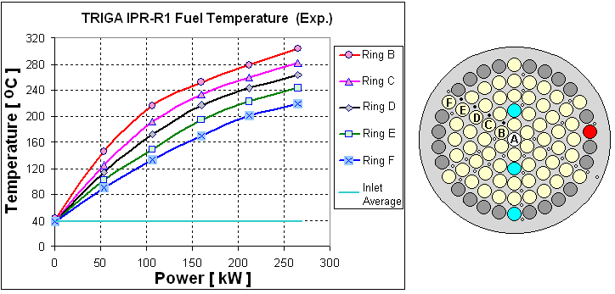

FIG. 4. Fuel temperature as function of the reactor power in all core rings.

Core temperature

The experimental outlet coolant temperature for each core ring is shown in Fig. 5 as a function of the reactor power. The aluminum probe with thermocouple was inserted in each hole at the top grid plate, and the coolant inlet temperature obtained was about 38 ºC, in all measurements.
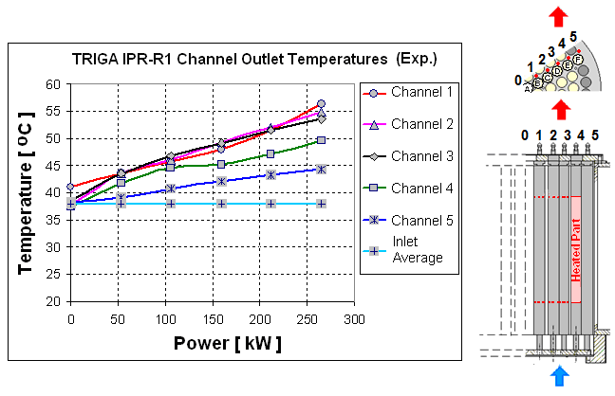

FIG. 5. Outlet coolant temperature as function of the thermal power.

Thermal conductivity and the heat transfer coefficient of the fuel elements
The IPR-R1 reactor was configured to operate until a maximum of 250 kW. The heat transfer regime, between the clad surface and the coolant, change from single-phase convection to subcooled nucleate boiling, and the transition point between them, on the cladding surface in the central channels of the IPR-R1 core, is approximately 60 kW as shown in Fig. 6 [5]. As the reactor core power increases, the heat transfer regime from the fuel cladding to the coolant changes from single-phase natural convection to subcooled nucleate boiling. Results indicated that subcooled boiling occurs at the cladding surface in the central channels of the reactor core at power levels in excess of 265 kW.

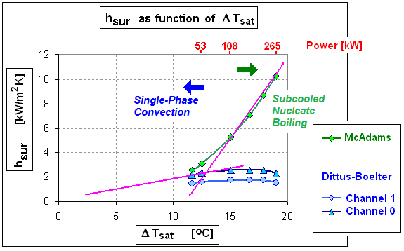
FIG. 6. The onset of subcooled nucleate boiling in the fuel element surface of the IPR-R1 reactor.

In Figure 7 it is presented a correlation for the heat transfer coefficient through the gap as a function of the reactor power, evaluated experimentally using the instrumented fuel element [5]. This figure also shows three theoretical values for the heat transfer coefficient recommended by General Atomic, the TRIGA reactor builder [10].

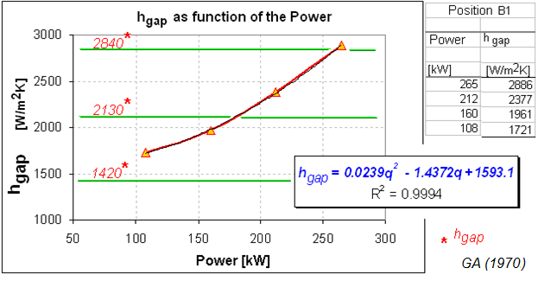

FIG. 7. Heat transfer coefficient through the gap as a function of the power.

5.2. Neutronic Experiments

Control rod worth and excess of reactivity

In the IPR-R1 reactor the reactivity control is done by three control rods that can be inserted into or withdrawn from the core. The control rods are calibrated by the positive period method that consists of withdrawing the control rod from a known critical position through a small distance and, after the transient, to measure the doubling time (DT). DT is the time required for the power increases by a factor of two. The period is then obtained using the doubling time that is the time required for the power increase by a factor of two. Each successive step is compensated by inserting the other control rod just enough to reestablish criticality. In this process the control rod under calibration proceeds from the most inserted position (maintaining the reactor critical) to fully removed. The Safety and Shim rods are intercalibrated. The idea is to measure one control rod in presence of another rod, used for compensating the reactivity introduced by step withdrawal of the measured rod. The reactivity measurements are performed at low power so the increase in temperature during the experiment is negligible. The reactivity values associated with the periods obtained are gotten from the graphical form of the inhour equation.

The integral fitted worth curves of the Regulating, Shim and Safety control rods as a function of their positions are shown graphically in Fig. 8 and Fig. 9. The Fig. 8 also shows the differential curve of the Regulating rod. The maximum in the differential curve occurs approximately in the center, and is small near the ends because of the smaller flux density. The equations representing the fitted model, and the coefficients of determination R², that confirm the goodness of the fit, are also shown in the figures. The equations were added to the data acquisition program. The integral control rod worth curve is particularly important in research reactor operation. The measured values of the Regulating, Shim and Safety control rod worth were 0.48 $, 3.21 $ and 2.84 $, respectively [11].

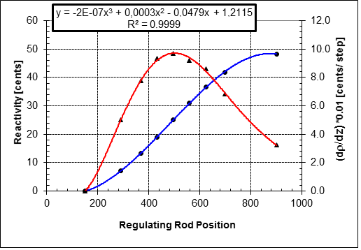

FIG. 8. Integral and differential curves of the Regulating control rod.

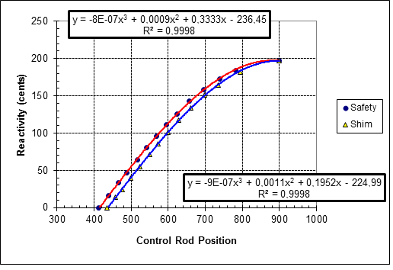
FIG. 9. Integral curves of the Shim and Safety control rods.

Loss of reactivity with power increase and xenon poisoning

Because of the prompt negative temperature coefficient, a significant amount of reactivity is needed to overcome temperature and allow the reactor to operate at high power levels. Figure 10 shows two curves: the power coefficient of reactivity, (α_{P}= Δρ/ΔP), and the associated reactivity loss to achieve a given power level versus the reactor power. The power defect, which is the change in reactivity taking place between zero power and 250 kW is around 1.6 $, and the power coefficient of reactivity is about -0.66 ¢/kW [7].

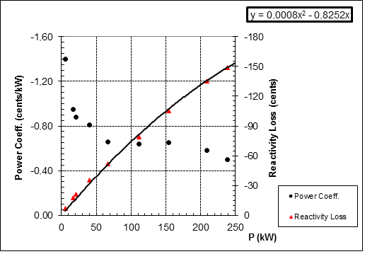

FIG. 10. Power coefficient of reactivity and reactivity loss versus reactor power level.

During the operation of a nuclear reactor, the fission fragments and their many decay products accumulate. The xenon-135 is the mainly substance, because it has large cross section for thermal-neutron absorption. Figure 11 shows the reactivity loss caused by the ¹³⁵Xe poisoning during the reactor operation at 250 kW. After 5.6 hours, the value of the negative reactivity introduced in the reactor was around 27 cents.

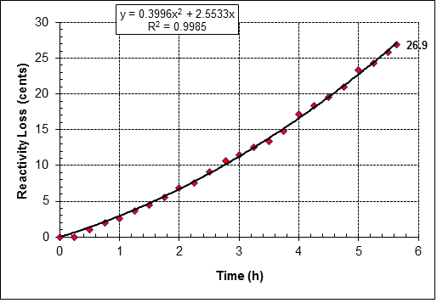

FIG. 11. Xenon poisoning during power operation at 250 kW.

Temperature and isothermal reactivity coefficient

The prompt negative temperature reactivity coefficient of the reactor is defined as α_{c}=Δρ/ΔT. The α_{c} negative means that an increase in temperature will cause a decrease in the reactivity, ρ, and then a the decrease in the reactor power and in the temperature tend to stabilize the reactor power. The experiment was performed by increasing the power, and, consequently, the fuel temperature, by withdrawing the Regulating rod in a number of steps. The heat of the core, and then ΔT, was estimated from the power versus time curve, and the The reactivity change Δρ was determined from the Regulating calibration curve, considering its positions. The obtained average value of the temperature reactivity coefficient was (-1.1 ± 0.1) ¢ /ºC [6].

The isothermal temperature coefficient was measured by observing the reactivity change when the core temperature is raised by other means while the reactor is operating at a very low, almost zero power level. When the reactor is at zero power there is no sensible heat being released in the fuel, and the entire reactor core can be characterized by a single temperature. The isothermal reactivity coefficient, α_{ISO} computed was -0.5 ¢/°C [6]. It is the excess reactivity required for the transition from cold conditions to hot operating conditions. It was also observed that the water temperature increases little with the increase of the power level, and that the rise in the coolant temperature contributes with a small fraction to the observed power reactivity coefficient. Then the results demonstrated that the fuel temperature coefficient is the main contributor to the reactivity power coefficient of the TRIGA reactor. Figure 12 shows the experimental curve and equation of the total temperature reactivity coefficient versus the core average temperature [8].

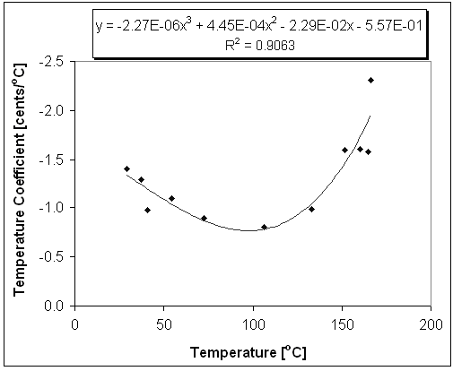
FIG. 12. Overall temperature reactivity coefficient.

Thermal neutron flux

The thermal neutron flux at the central thimble and at the rotary specimen rack were obtained by neutron activation measurements, using bare and cadmium-covered foils. Gold and cobalt foil detectors were irradiated in the rotary specimen rack and in the central thimble, respectively, with the reactor operating at 100 kW and 250 kW. Their gamma activities were measured using Ge spectrometer. The average thermal neutron flux determined at the rotary specimen rack was (6.6 ± 0.4) x 10¹¹ n.cm⁻².s⁻¹, and at the central thimble was (4.1 ± 0.3) x 10¹² n.cm⁻².s⁻¹ with the reactor at 100 kW, and (1.6 ± 0.1) x 10¹² n.cm⁻².s⁻¹ and (0.9 ± 0.1) x 10¹³ n.cm⁻².s⁻¹, respectively, with the reactor operating at 250 kW.

6. Conclusions

This paper describes a short review of the experimental research project carried out in the IPR-R1 TRIGA reactor, in recent years, with the aim of evaluating the behavior of some thermal-hydraulic and neutronic operational parameters. The data acquisition and processing system and a software developed in this project allowed on line monitoring and registration of the main reactor operational variables. The experiments have given better comprehension of the reactor behavior and helped to develop numerical models, contributing to operational safety improvements and experimental research.

Since the inherently safe operation of a reactor is dependent on the reactivity control, it is essential to have information on this parameter. The fuel elements have been designed to provide a significant negative prompt temperature coefficient that allows safe reactor operation. The experimental thermal hydraulic and neutronic results are within the safety limits as describe in the IPR-R1 TRIGA Safety Analysis Reporter. Many of the reactor parameters which determine the reactivity of reactor are dependent on the temperature of the fuel, moderator and coolant.

7. Acknowledgments

Participation in this event is sponsored by the following Brazilian institutions: Nuclear Technology Development Center (CDTN), National Nuclear Energy Commission (CNEN), Research Support Foundation of the State of Minas Gerais (FAPEMIG), National Council for Scientific and Technological Development (CNPq), and the National Institute for Innovative Nuclear Reactors (INCTRNI).

8. References

[1] INTERNATIONAL ATOMIC ENERGY AGENCY, Strategic Planning for Research Reactors – Guidance for Reactor Managers, IAEA-TECDOC-1212, Vienna. (2001).
[2] MESQUITA, A.Z.; COSTA, A.C.L.; SOUZA, R.M.G.P., “Modernisation of the CDTN IPR-R1 TRIGA Reactor Instrumentation and Control”. International Journal of Nuclear Energy, Science and Technology, v. 6, p. 153-165. DOI: 10.1504/IJNEST.2011.041649. (2011).
[3] INTERNATIONAL ATOMIC ENERGY AGENCY, Operational Limits and Conditions and Operating Procedures for Research Reactors, IAEA-Safety Guide No. NS-G-4.4, Vienna. (2008).
[4] GULF GENERAL ATOMIC, “15” SST Fuel Element Assembly Instrumented Core, Drawing Number TOS210J220, San Diego, CA. (1972).
[5] MESQUITA, A.Z., Experimental Heat Transfer Analysis of the IPR-R1 TRIGA Reactor. International Atomic Energy Agency (IAEA-CN-156). IAEA Publication - Research Reactors: Safe Management and Effective Utilization, p. 1-10. Vienna. (2008).
[6] SOUZA, R.M.G.P.; MESQUITA, A.Z., “Measurements of the Isothermal, Power and Temperature Reactivity Coefficients of the IPR-R1 TRIGA Reactor”. Progress in Nuclear Energy, v. 53, p. 257-306. DOI: 10.1016/j.pnucene.2011.06.010. (2011).
[7] SOUZA, R.M.G.P.; MESQUITA, A.Z., “Reactivity Balance in the IPR-R1 TRIGA Reactor”. Progress in Nuclear Energy, v. 53, p. 307-405. DOI: 10.1016/j.pnucene.2011.06.011. (2011).
[8] MESQUITA, A.Z.; SOUZA, R.M.G.P., “On-Line Monitoring of the IPR-R1 TRIGA Reactor Neutronic Parameters”. Progress in Nuclear Energy, v. 52, p. 292-297, 2010. doi:10.1016/j.pnucene.2009.07.013. (2010).
[9] MESQUITA, A.Z.; REZENDE, H.C.; SOUZA, R.M.G.P., “Thermal Power Calibrations of the IPR-R1 TRIGA Reactor by the Calorimetric and the Heat Balance Methods”. Progress in Nuclear Energy, v. 53, p. 1-11. DOI: 10.1016/j.pnucene.2011.08.003. (2011).
[10] GENERAL ATOMIC, Safeguards summary report for the New York University TRIGA Mark I Reactor. Reporter GA-9864. San Diego, CA. (1970).
[11] SOUZA, R.M.G.P.; MESQUITA, A.Z., “Neutronic Tests in IPR-R1 TRIGA Reactor”. IAEA Publications - International Conference on Research Reactors: Safe Management and Effective Utilization, v. 1, p. 45-51, Serie: IAEA-188. (2012).

