Numerical Investigation of Cooling in the Pool of the Brazilian Multipurpose Reactor (RMB)

F.L.A. Schweizer, A.Z. Mesquita, A.A.C. Santos, A.C.L. Costa, H.C. Rezende

Nuclear Technology Development Center/Brazilian Nuclear Energy Commission (CDTN/CNEN)
Campus of UFMG - Pampulha
ZIP Code: 31.270-901 - Belo Horizonte, MG – Brazil
Corresponding author: amir@cdtn.br

Abstract. The Brazilian Multipurpose Reactor (RMB) consists of a pool open type research reactor with 30MW currently under construction. The RMB is intended to produce a neutron flux for materials irradiation, production of radioisotopes, materials and fuels tests. For protection against the radiation emitted by the reactor, it is immersed in a cylindrical pool of water that acts as a biological shield. For high power reactors such as RMB, it is used a hot water layer system (CAQ in Portuguese) for water filtering and heating at the top of the pool. This system prevents the contaminated water of the pool next to the reactor core reaches the surface. This reduces the dose of radiation in the reactor room. In this work a study of the behavior of this hot layer is performed since its formation to its operation, in which perturbations due to cooling and pool heating circuits cause a moving in the CAQ, which reduces the radiation protection. This study is conducted numerically by simulating a model of the RMB pool using CFX 14.0 CFD (Computational Fluid Dynamics) commercial code. This article presents the results of numerical simulations. These simulations were assessed at different turbulence models. It were analyzed: the position and speed of water injection and removal in the circuit, the heater power, the formation temperature, and the radiation level during the reactor operation.

1. Introduction

Brazil has four research reactors in operation: the MB-01, a 0.1 kW critical facility; the IEA-R1, a 5 MW pool type reactor; the Argonauta, a 500 W Argonaut type reactor and the IPR-R1, a 100 kW TRIGA Mark I type reactor. They were constructed mainly for using in education, radioisotope production and nuclear research. IEA-R1 is the only one that has been used for radioisotope production. The recent international molybdenum-99 supply crisis has affected significantly the Brazilian nuclear medicine services, since 100% of this radioisotope used to be imported from Canada [1]. The RMB is designed to perform three main functions: radioisotope production (mainly molybdenum); fuel and material irradiation testing to support the Brazilian nuclear energy program; and provide neutron beams for scientific and applied research (in complement to the existing synchrotron light laboratory). The other RMB applications are the radioisotope production to attend medical and industrial needs and a large spectrum neutron flux for nuclear researching [1].

The RMB will be an open pool multipurpose research reactor, using low enriched uranium fuel. Its concept has similarity with the OPAL Reactor (Open Pool Australian Light-water) differencing mainly by its larger thermal power, 30 MW in RMB against 20 MW in OPAL and the RMB ability for fuel testing. Therefore, modifications will be needed in reactor design due to its greater power and get a design that meets the Brazilian purposes [2] [3]. For RMB project development was contracted the Argentine company INVAP.

Research reactors are commonly built inside deep pools that provide radiological and thermal protection and easy access to its core. Reactors with thermal power in the order of MW usually use an auxiliary thermal-hydraulic circuit at the top of its pool to create a purified hot water layer (CAQ). Thermal-hydraulic analysis of the flow configuration in the pool and CAQ is paramount to insure radiological protection. A useful tool for these analyses is the application of CFD (Computational Fluid Dynamics) [4]. To obtain satisfactory results using CFD it is necessary the verification and validation of the CFD numerical model. Verification is performed evaluating the correctness of the CFD code implementation and the uncertainty of the numerical solution due to numerical parameters. Validation is performed through comparison of numerical and experimental results.

In this paper, the flow is studied in the reactor pool, with the aim of analyzing the behavior of the hot water layer (CAQ) to be generated on top of the pool. With this simulation, it is expected to analyze the disturbances caused in hot water layer by the reactor coolant circuits. Different temperature settings will be checked to ensure its stability along the reactor operation which will allow the system pre-design.

2. The Brazilian Multipurpose Reactor (RMB) Cooling System

The RMB concept consists in open pool research reactor in which its core is located at a deep pool filled with demineralized light water that provides free access to the core, thermal and radiological protection. In RMB design, there are three pools: the reactor pool where the reactor core and the irradiation devices are located, the service pool for spent fuel storage and an auxiliary pool. The reactor and service pools are connected by a transfer channel. The service and auxiliary pool are also connected; however a gate that remains closed during operation separates them. The RMB reactor general conception is shown in Figure 1.

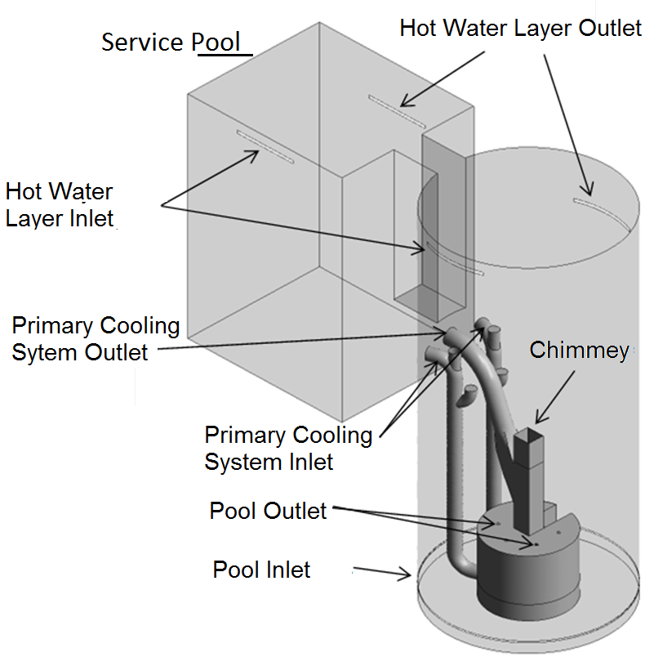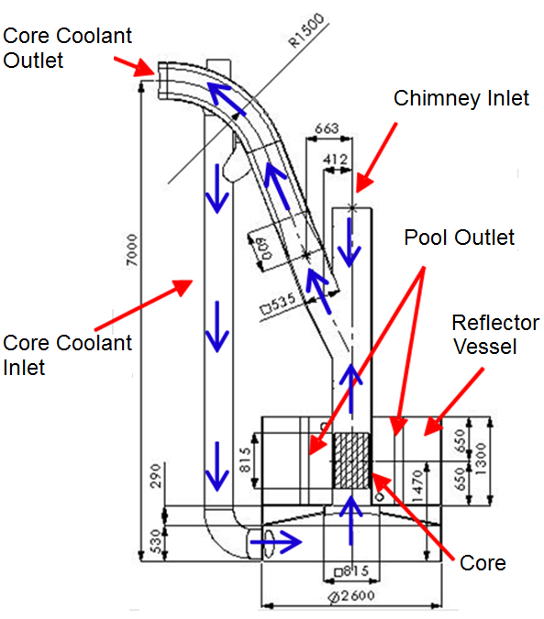

FIG. 1. General conception and pool geometry of the RMB.

The reactor compact core is located inside a chimney structure that gives free access to the fuel and irradiation sites. The RMB will use a MTR fuel assembly type with planar plates. Surrounding the chimney there is a reflector vessel filled with heavy water that hosts the irradiation devices and a beryllium plate for fuel testing positioning [5]. A tank with heavy water surrounds three faces of the chimney in the core area working as a reflector and enabling the extraction of neutron beams and placement of materials for irradiation. In the remaining face, beryllium is used as a reflector. The heavy water temperature will be controlled by a dedicated cooling system [6]. The whole core structure will be located within a squared cross-section channel, “core chimney”, which is part of the primary cooling circuit. The core will be cooled by a flow of demineralized light water moving upwards through the core. In normal operation, the coolant is pumped through the core and then to the pipes to a heat exchanger before returning to the core inlet [7].

All the core structure will be located within a square cross section (chimney) that will form part of the primary cooling circuit. The cooling of the reactor core will be promoted by forced circulation of demineralized water in upward direction. In normal operation, the refrigerant will be pumped through the channels of the core and then, through pipes, to the heat exchanger before returning to the reactor core. A removable grid is placed on top of the chimney to do the calibration of water flow and to protect the core of any falling objects. The core will be surrounded by a heavy water tank, where devices will be positioned for radioisotope production except from one side where beryllium and light water are used for fuel material testing. The region of the reflector will include a facility to accommodate the cold neutron source. The core (and chimney) and the reflector are located within a pool of demineralized light water, which will provide cooling and radiation shielding in all conditions of reactor operation. The pool water also cools the outer region of the core during normal operation and removes the residual heat after shutdown [3].

A forced upward water flow is induced through the reactor core by the primary cooling system to remove heat from the fuel elements. The water enters in a plenum at the bottom of the core and exits by a lateral opening in the chimney. An interconnection system deviates 10% the total mass flow of the primary cooling system inlet to the pool cooling system inlet. The difference between inlet and outlet water mass flow is compensated by suction of water from the pool through the chimney. The downward flow induced from the pool to the chimney prevents water from the primary cooling system that passes through the core to directly reach the pool. The pool cooling system works to maintain the pool water temperature constant and purified during operation and to cool the irradiation devices. In this system the injection of water occurs at the pool bottom and its suction is through the irradiation devices in the reflector tank [3].

Natural convection is performed in case of flow loss in the primary cooling system by the opening of the natural circulation valves in the primary system ducts and the chimney. The limitations of the water purification process from the primary system increase the concentration of radioactive elements in the pool where the major contamination are ²⁴Na, ²⁷Mg and ⁴¹Ar [8]. The main generation of the ²⁴Na is by neutron activation of the aluminum in the fuel cladding. The pool top dose rate in research reactors is increased due to the interconnection system [9] where 98% of its dose rate is caused by radioactive elements presents in the pool water and only 2% from direct radiation from the reactor core [8].

2.1. The Hot Water System (CAQ)

One effective way to reduce the dose rate on the reactor room is preventing that contaminated water reaches the top of the pool. A usual process adopted in research reactors is the installation of an auxiliary system that purified and heats the water at the top of the pool creating a hot water layer (CAQ). The application of the CAQ system may reduce the dose rate over 10 times on the pool surface and enables safe work conditions inside the reactor containment according to safety norms of radiological exposition [10].

At the top of the pool, an additional heating and purification circuit inject water through nozzles at a higher temperature that the rest of the water pool and sucks 1.5 meters below the injection temperature, creating a layer of hot water stabilized at the top of the reactor pool. This layer acts as a barrier preventing water contaminated with radioactive particles reaches the surface by convective motion of water, which would increase the radiation level at reactor room. For this circuit is given the name of CAQ (hot water layer system) [11]. The hot water layer system is formed by a circuit with both pumps operating in redundancy, two electric heating resistors which are driven together only for the initial formation of the layer system and a decay filtering exchange resin column and ions for their purification.

A thermo-hydraulic analysis of the CAQ on a RMB numerical prototype was performed in the present work using a CFD (Computational Fluid Dynamics) code. The results of the CAQ behavior obtained through the CFD simulation of the RMB prototype were compared with the obtained in a 1/10 scale down model of the prototype. The comparison was performed to evaluation the construction of a physical experiment of the RMB pool in a reduced scale which would supply experimental data for the validation of a CFD simulation procedure applied to the study of the RMB CAQ [4].

3. Methodology

To perform the numerical calculation using finite volume method the pool geometry was discretized in a hybrid tetrahedral prismatic element mesh with a total of 360,000 nodes. The maximum edge size used to generate the mesh was 250 mm and the minimum was 0.5 mm that was applied in the window of the CAQ. Figure 2 shows details of the generated mesh

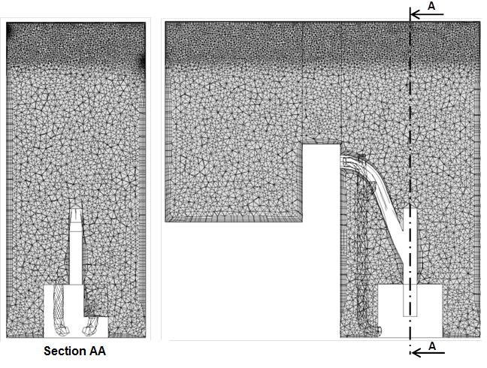
FIG. 2. Mesh to simulate the formation of the CAQ.
4. Results

4.1. Evaluation of the turbulence model.
The graph in Figure 3 shows the variation of the thickness of the CAQ in the simulation of reactor operation using different types of turbulence. It was observed that, using the RS-ω model, the CAQ showed lower mixing with the pool water. One possible reason for this is that the model be able to capture the anisotropy of turbulence in thermally stratified interface of the CAQ with the pool and therefore estimate a lower mixture.

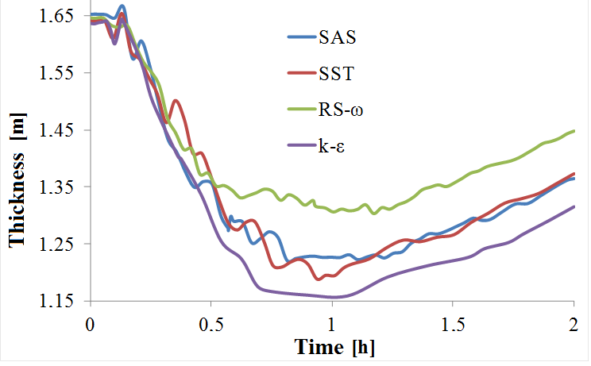

FIG. 3. Average thickness of the CAQ for different turbulence models.

SAS and SST models showed similar results, indicating that the turbulent scales captured by the SAS model to the mesh size and time step adopted, did not affect significantly the mixing of the CAQ. The difference in the thickness of the CAQ found between the k-ε model and the SST shows that there was an influence on your wall outlets. It was concluded that the reduced thickness of the CAQ calculated using the k-ε model can have two reasons.

The layer had a higher turbulent viscosity, remaining stratified at the top while the other models there was a greater mixture causing the layer to expand, taking the criterion of difference of 5 ° C to a deeper position. The mixture layer was larger, so that its bottom portion is cold, raising the height difference where the criterion of 5 ° C is satisfied.

Through the graphs in Figure 4, which shows the temperature variation of the CWC along its height, in two moments of reactor operation. It was observed that the ratio of the k-ε model show a lower thickness was the largest in the mixture layer.

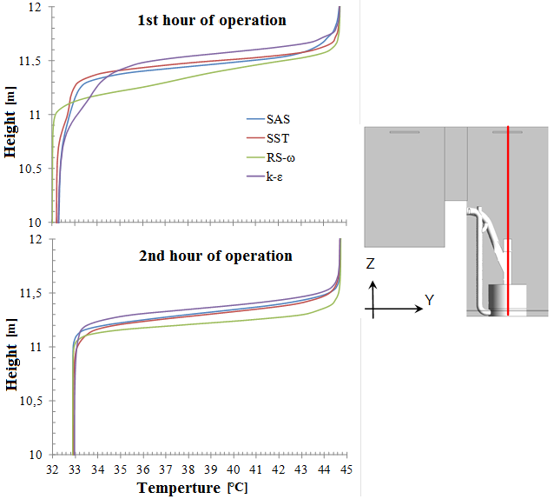

FIG. 4. Temperature profile of CAQ for different turbulence models.

As there is no experimental data to make a comparison between the numerical values of the models, it was adopted for all simulations the k-ε model. This model results in a higher mixing increasing safety and improving radiological shielding.

Figure 5 shows the four tested configurations. In all configurations the temperatures were higher than 5 °C, which is the value that ensures the stratification between the pool and the CAQ.

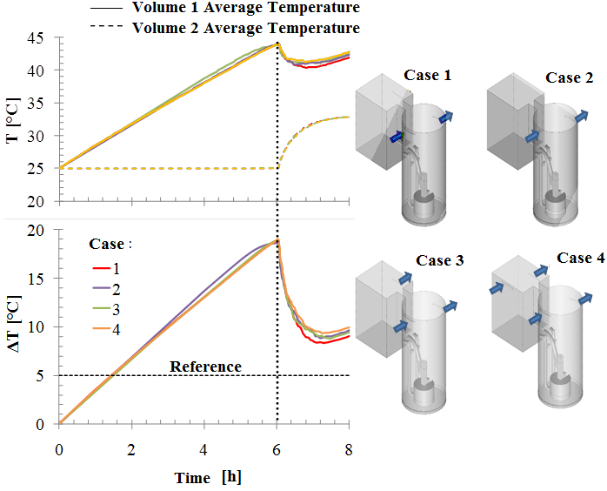
FIG. 5. Variation of temperature in the pool.

It is observed that the first 6 hours is the period of formation of the CAQ in the reactor and its cooling systems are off. Figure 6 shows the thickness of the QAC during operation of the reactor.
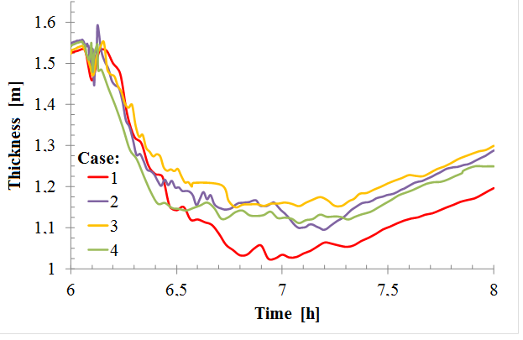
FIG. 6. Average thickness of the CAQ during reactor operation.
Case 3 had higher mean thickness among the cases studied. Like any position tested satisfies the conditions of operation of the CAQ, the recommendation is that the configuration of Case 3 be adopted. This setting presents a unique region of injection in the reactor pool, which simplifies the pipeline.

Figure 7 shows the temperature distribution and the direction of the velocity vectors on the superior portion of the reactor extracted of the transverse plane xz pool. It is observed in this plan for each case the influence of injection rate in CAQ.

In Case 1, the injection rate was 0.0185 m/s, and the average velocity in the transverse plane xz was 0.0065 m/s, 2 hours after the start of operation. In Case 2 the injection speed was 0.2951 m/s, and the average speed 0.023 m/s in the plane. The average pool speed in the CAQ in the lower region in each case was 0.0015 m/s.

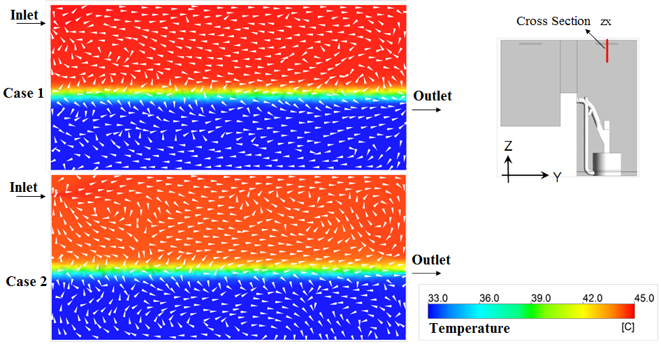

FIG. 7. Section of RMB pool after 2 hours of operation.

4.2. Evaluation of the injection temperature of the CAQ
The graph in Figure 8 shows the average height of the CAQ during the regime of reactor operation. In this graph a comparison was made of the recovery time of the CAQ formed initially at 45 ° C, for different values of heater power.
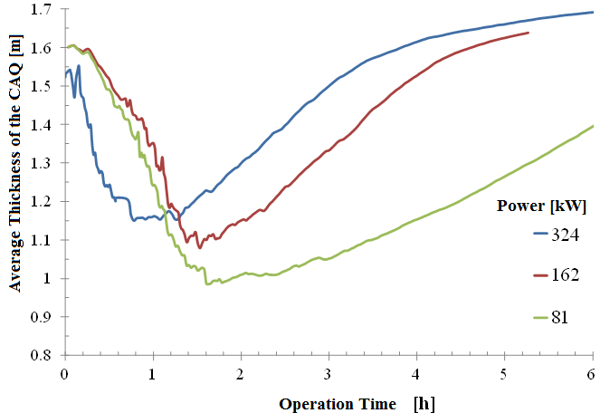

FIG. 8. Average height with the CAQ initially at 45 ° C, for different heating power.

It was observed that for the three power values of the heaters, the CAQ remained stable over 1.0 m, returning to the initial height at the following times:

- 324 kW in 3 hours;
- 162 kW in 5 hours;
- 81 kW more than 9 hours (estimated).

Examining the point of minimum height was noted that the curve for the 324 kW of power was delayed. This difference was due to the boundary condition, which was implemented in the other curves the power function, which made the injection temperature of the water in the pool circuit varied from 25 °C to 33 °C in one hour, while for power of 324 kW instantaneously initial temperature was 33 ° C, resulting in a premature disruption.

In Figure 9, the temperature distribution in the longitudinal plane of the model is shown after 2 hours of operation, at this time the CAQ has a higher disturbance in the three situations proposed in the graph of Figure 10.

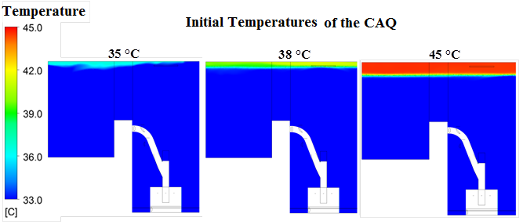

FIG. 9. Temperature distribution in the RMB pool after 2 h of operation for the CAQ
formed at 35ºC, 38ºC, and 45 °C.

Analyzing the behavior in the CAQ during reactor operation, it was found that the cause of disturbance in the CAQ are given by heated water injected into the pool base, which could be accelerated by the buoyancy of the water mixing with the pool bottom stratification layer. After temperature stabilization in the pool, it was found that it restores the CAQ. The flow caused by the pool cooling circuit and the induced flow in the reactor chimney were not enough to disturb it. The CAQ formation time, considering the pool at an initial temperature of 25 °C to the situations proposed in Figures 8 and 9 was calculated from Equation 1, obtaining the results listed in Table 1.

(1)
V_{CAQ} is the volume occupied by the CAQ, considering your height 1.5 m on pool top; ΔT is the temperature difference between the injection and suction of the CAQ and P_{aquec} is the power of the heater circuit.

TABLE 1: Time of formation of the CAQ
Temperature CAQ [°C] | Heater Power [kW] | Time Formation [h]
45 | 324 | 5.6
45 | 162 | 11.2
45 | 81 | 22.4
38 | 162 | 7.2
35 | 162 | 5.6

4.3. Evaluation of radiation level on the surface of the pool

Figure 10 shows the variation of calculated radiation dose on the surface of the reactor pool, for the heating power and the initial pool temperature [12]. It is observed that the highest radiation level on the pool surface is the period between the first and second hour of operation. During this period the water injected through the pool cooling circuit to a temperature above the pool reaches the CAQ reducing its thickness. After this period the pool temperature, and the water injected by its refrigerant circuit is stabilized, allowing the reconstitution of the CAQ, reducing the radiation dose rate at the pool surface. Figure 12 shows a variation of 28 times of the value formed for the CAQ at 45 °C with heater of 324 kW, and the value formed at 35 °C with heater 162 kW.

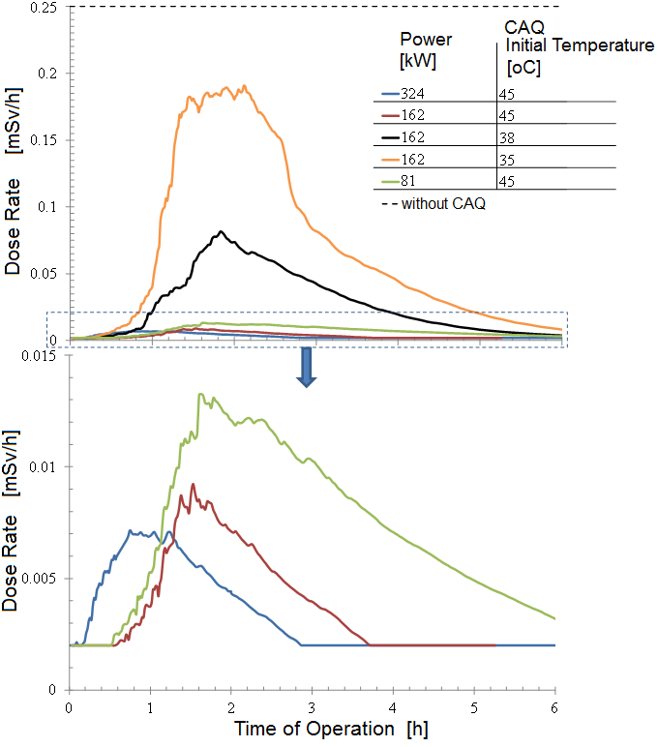

Fig. 10. Radiation level on the surface of the RMB pool.

5. Conclusion

This paper presented a study of the hot water layer system (CAQ) at the top of the RMB reactor research pool. Numerical simulations were performed using computational fluid dynamics to evaluate the coolant influence in the formation of the CAQ. To perform the simulations different turbulence models were tested, different inlet and outlet positions, and different injection/removal velocities of water in the circuit. It was analyzed also the heater powers from the CAQ system, the temperature of layer formation, and the radiation dose rate at the top of the pool during reactor operation.

Of turbulence models tested, the k-ε model was chosen because result a smaller thickness of the CAQ during simulations. Four different positions for the injection and removal of water from the CAQ were tested. It was adopted the configuration of a single inlet in the reactor pool with water injection at low speed. This configuration had low mixing in the CAQ region and higher heating in the reactor pool. Outlets were placed in service pool and in the reactor pool at 1.5 m deep, to ensure water purification of the CAQ.

Three powers of heaters, 324 kW, 162 kW and 81 kW were tested. The three powers were sufficient to maintain the CAQ. The CAQ is a protection system therefore recommended two heaters of 81 kW, acting together in the formation of the layer by redundancy during reactor operation.

6. Acknowledgments

This research is supported by the following Brazilian institutions: Nuclear Technology Development Center (CDTN), National Nuclear Energy Commission (CNEN), Research Support Foundation of the State of Minas Gerais (FAPEMIG), National Council for Scientific and Technological Development (CNPq), and the National Institute for Innovative Nuclear Reactors (INCTRNI).

7. References

[1] J.A. PERROTTA, I.J. OBADIA, “The RMB Project Development Status”. International Conference on Research Reactors: Safe Management and Effective Utilization. Rabat, Morocco. IAEA Proceedings Series. (2011).
[2] AUSTRALIAN NUCLEAR SCIENCE AND TECHNOLOGY ORGANISATION (ANSTO). Disponível em: http://www.ansto.gov.au. Acessado em 02.03.2014. (2014).
[3] AUSTRALIAN NUCLEAR SCIENCE AND TECHNOLOGY ORGANISATION (ANSTO). “Safety Analysis Report (SAR) for ANSTO Replacement Research Reactor Facility.” (2004).
[4] ANSYS. “CFX-14.0 - User manual”, ANSYS-CFX, (2012).
[5] Schweizer, F.L.A., Santos, A.A.C., Lima, C.P.B., Costa, A.L., Costa, A.C.L., Veloso, M.A.F. “CFD aided analysis of a scaled down model of the RMB pool”. International Nuclear Atlantic Conference (INAC 2013), Recife. (2013).
[6] SOARES, H.V.; ARONNE, I.D.; PEREIRA, C.; VELOSO, M.A. “Analysis of Loss of Flow Events on Brazilian Multipurpose. Reactor Using the RELAP5 Code”. International Journal of Nuclear Energy. Hindawi Publishing Corporation. (2014). http://dx.doi.org/10.1155/2014/186189.
[7] SOARES, H.V.; COSTA, A.L; PEREIRA, C.; VELOSO, M.A., ARONNE, I.D.; REIS, P.A.L. “RELAP5-3D Modeling Of The Brazilian Multipurpose Reactor”. 22nd International Congress of Mechanical Engineering (COBEM 2013). 2013, Ribeirão Preto, SP, Brazil. (2013).
[8] BAPTISTA, B. D. “Desenvolvimento do Sistema da Camada de Água Quente do Reator IEA-R1 do IPEN”. IPEN. São Paulo. (2002).
[9] SHOKR, A. M., “Performance analyses of the pool-top radiation level reduction system at the ETRR-2 research reactor”. Kerntechnik, vol. 71, p. 130-133, (2006).
[10] LEE, S. et al. “Reduction of the pool-top radiation level in HANARO”, JAERI –conf, p.124 – 129, (1999).
[11] Metcalf, P., “Distributed Control system: Linear design options and analysis for a reactor hot layer system”, IEEE International Conference on Control applications, p. 2421-2425, (2010).
[12] British Standard 4094. “Recommendation for data on shielding from ionizing radiation. Part 1. Shielding from gamma radiation”. British Standards Institution, (1966).

