Neutron Cold Source Optimization for RA-10 reactor

- Márquez¹, F.Sánchez¹

1) Comisión Nacional de Energía Atómica (CNEA), Centro Atómico Bariloche (CAB), Bustillo 9500, 8400 S.C de Bariloche, Argentina

Corresponding author: marqueza@ib.cnea.gov.ar

Abstract. RA-10 is a project run by the Argentine National Atomic Energy Commission that involves the engineering design and construction of a multipurpose research reactor in Ezeiza, Argentina. RA-10 reactor, estimated to be operative in 2018, will be primarily committed to medical radioisotope production and industrial applications. It will also provide thermal and cold neutrons for scientific experiments. For the latter purpose, a liquid-deuterium Cold Neutron Source was designed and optimized.

The neutronic optimization process includes a Monte Carlo analysis of the volume of moderator, the position of the cold source relative to the reactor core, the cold neutron flux available in the neutron guides and the heating power to be removed from the facility. The last variable establishes design possibilities, given the 5kW of maximum heat removal capability of the helium refrigeration system. Furthermore, the use of a displacer (a region of helium introduced into the moderator chamber to facilitate cold neutron leakage) is considered.

The main results of the present analysis suggest that when the design constraint is the refrigeration power, higher moderator volumes do not necessarily imply higher cold fluxes. This is particularly true for RA-10 reactor, in which a smaller cold source placed closer to the core has shown a better (calculated) performance in both intensity and spectrum. The use of a displacer is discouraged when “ultra-cold to cold” ratio is observed. As a consequence of this analysis an 18-liter deuterium cold source without displacer was selected for the RA-10 reactor.

1. Introduction

RA-10 is a project run by the Argentine National Atomic Energy Commission that involves the engineering design and construction of a multipurpose research reactor in Ezeiza, Argentina. RA-10 reactor, estimated to be operative in 2018, will be primarily committed to medical radioisotope production and industrial applications. It will also provide thermal and cold neutrons for scientific experiments. For the latter purpose, a Cold Neutron Source (CNS) was designed and optimized.

The optimization process was developed during the conceptual and basic engineering stages of the RA-10 Project with the main purpose of comparing the performance of many CNS designs in consideration. The CNS consists of a moderator chamber containing liquid deuterium at a temperature of 20K, which is placed into a cylindrical vacuum container. Cold neutrons are extracted through two helium-filled tubes, which communicate the CNS with the experimental facilities placed in the reactor face and with the neutron guides which conduct these neutrons to the experiments hall.

The optimization variables considered in the present study were (a) the liquid deuterium volume of the cylindrical moderator chamber and (b) the option of adding a displacer. A displacer consists of an additional helium-filled chamber placed into the moderator region, close to one of the two extraction tubes. This chamber is usually connected to the main cooling system of the CNS, and its function is to help the leakage of cold neutrons through the adjacent extraction tube.

2. Methods and results

A MCNP5 input was developed, including not only a detailed core and CNS models, but also all of the in-core and ex-core irradiation facilities. The CNS model can be seen in FIG.1. Regarding the optimization process of the CNS, six cases were considered: three deuterium volumes of 15, 18 and 20 liters with and without displacer. The studied cases were labeled as shown in Table I. The volume was varied conserving the aspect ratio of the cold source.

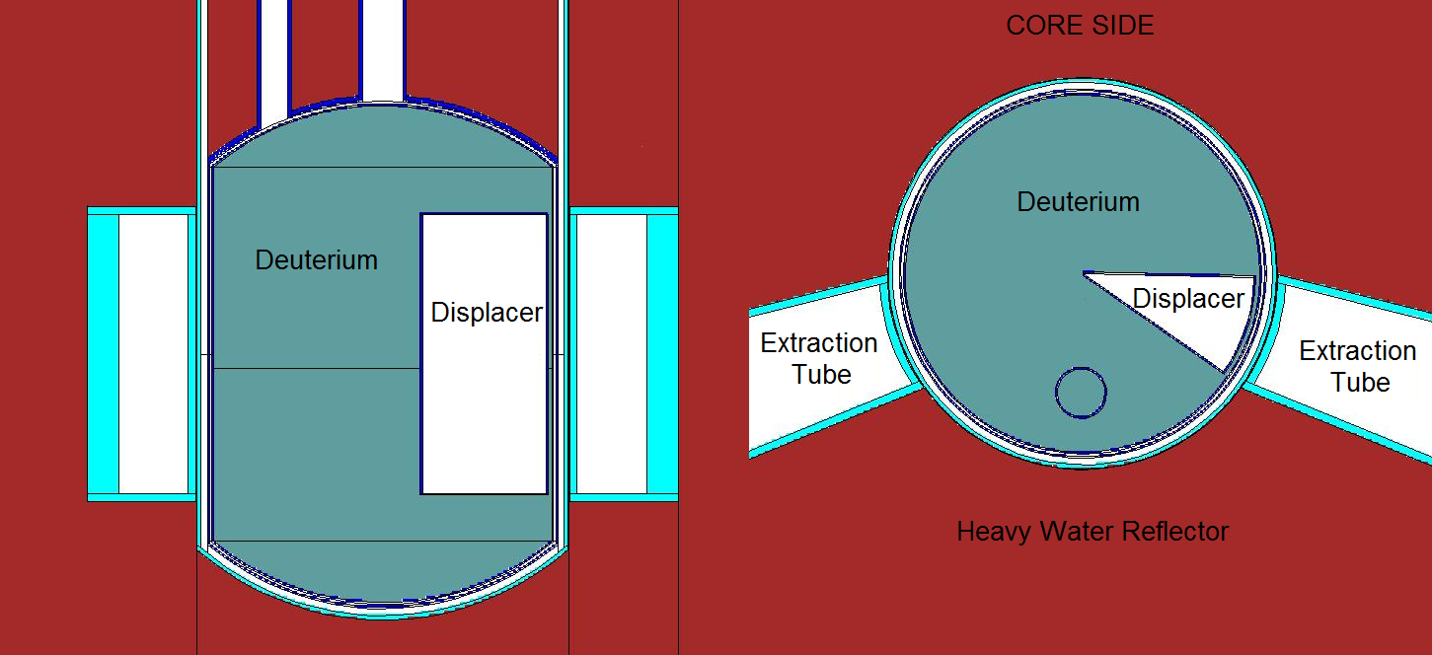

FIG.1 Calculation model for the Cold Neutron Source.

TABLE I: studied cases for the Neutron Cold Source.

Case ID | Description
15L,18L and 20L | Deuterium volumes of 15, 18 and 20 liters without displacer
15L/D, 18L/D and 20L/D | Deuterium volumes of 15, 18 and 20 liters with displacer

Two situations were considered when comparing the previously listed cases. The first consisted in placing the different CNS volumes and designs in the exact same position relative to the reactor core (in this case, the distance x between the center of the core and the center of cylindrical deuterium chamber remained constant). The ratio between the results obtained for one of the cases and any of the remaining was called apparent gain G_{A}. The second situation is related to the heat removal capability Q of the helium refrigeration system, which is a typical design constraint in the engineering of cold neutron sources. For RA-10 reactor, a maximum Q value of 5 kW was specified as a performance requirement of the facility. An uncertainty margin of 1 kW was adopted, resulting in a maximum allowed (calculated) Q of 4 kW. The second method for comparing cases consisted –then– in placing each of the cases where a value of Q = 4 kW was achieved. In this situation, the ratio between any two of the cases was called real gain G_{R}. The latter is a preferred indicator when comparing cases, given that it includes information of the real positioning of the device which is set by the maximum Q constraint. The tallies evaluated with MCNP were (a) collimated neutron spectral currents J(E), i.e., the spectra of neutrons crossing the outlet surfaces of the extraction tubes with a divergence of less than 4 degrees; (b) the heating load Q of the device, which included: neutron and prompt gamma heating over the deuterium moderator and aluminum structures, heating due to delayed gammas of the fuel (ENDF/ACE cross section libraries were modified ad hoc in order to add these photons to the steady-state calculations) and heating caused by activation of aluminum (prompt gamma and subsequent beta decay).

FIG. 2 shows J(E) for the cases 18L/D and 18L and FIG. 3 shows the apparent spectral gain (ratio of J(E) for case 18L/D to case 18L when both are placed at x = 55 cm). It can be seen that, when observing integral intensity up to 10 meV the displacer is beneficial. However, (see FIG. 3) that gain is mainly due to neutrons moderated to energies higher than 1.5 meV. Moreover, for neutrons below that energy the displacer showed a noticeable disadvantage.
FIG. 2. Spectra obtained for cases 18L and 18L/D, x=55 cm.
This can be explained by looking at the ortho- (and para-) deuterium cross sections: the range of energies showing gain G > 1 coincides with a region of relatively high deuterium cross section (see FIG. 4), i.e., neutrons created far from the extraction tube with final energies of E > 1.5 meV are more likely to reach the tube if a portion of vacuum is added. However, when adding a displacer, a portion of moderator close to the tube is removed, that is, a portion of deuterium with high scape probability for the moderated neutrons. These two effects compete: in particular, G < 1 was observed for extra-cold neutrons of E < 1.5 meV, which can be explained also by noting that the associated cross section is smaller than in the previous case. In these circumstances, the negative effect of removing a volume of moderator (by adding a displacer) dominates over the benefit mentioned before, since those neutrons (E < 1.5 meV) are naturally more likely to reach the outlet surfaces because of the lower cross section value in that energy range. As a consequence of all this arguments, the spectral gain follows the form of the deuterium cross section, which can be seen in see FIG. 3.

A second part of the present study consisted in evaluating real gains, as defined previously. FIG. 5 shows, as a function of the core-CNS distance x, the heating Q and the integrated (E<10 meV) neutron current J for all the cases. Intersections between design value of Q = 4 kW and the Q(x) curves defines the position for each case. Found x for a certain case, J(x) can be read at the right edge (e.g. for case 15L, x ≈ 53 cm, J(53 cm) ≈ 4.7E10 n·cm⁻²·s⁻¹). Neutron spectra found at x = 55 cm were re-normalized to the integral values obtained as formerly explained, to find the real spectral gains.

FIG. 3. In black (left axis): Apparent gain J(E)(case 18L/D)/J(E)(case 18L), at x = 55 cm.
In red (right axis): ortho-deuterium scattering cross section.
FIG. 4. Ortho- and para-deuterium scattering cross sections.
FIG. 5. In black (left axis): Q(x) for all the cases.
In red (right axis): J(x) (J(E,x) integrated up to E=10 meV) for all the cases. J for case 15L/D was omitted, since it was coincident with case 15L.
It is important to note that the cases 15L and all of the cases with displacer showed an equivalent integral intensity, which was higher than in cases 18L and 20L. Provided that (a) the case 15L showed higher intensities of ultra-cold neutrons than the cases with displacer (which can be seen in FIG. 6) and (b) a CNS without displacer is technologically simpler, this was the optimal among the considered cases. It is also noticeable that, when observing the cases without displacer and considering real gains, the smallest deuterium volume 15L showed the highest intensity, not only in the integral form but also in almost all of the energy range (see FIG. 7, now relative to 15L/D for a clearer comparison). A summary of the results is presented in Table II.

TAB. II: summary of results.

Case | Distance center of the core – center of CNS ( in cm) for Q = 4kW | Real integral gain relative to 15L | G_{A}: apparent integral gain of the displacer (x = 55 cm) | G_{R}: real integral gain of the displacer
15L | 52.9 | ~ 1 | - | -
15L/D | 54.0 | ~ 1 | 3.6% | 0
18L | 55.6 | 0.95 | - | -
18L/D | 56.6 | ~ 1 | 6.2% | 5.4%
20L | 57.3 | 0.92 | - | -
20L/D | 58.1 | ~ 1 | 10.3% | 8.9%

FIG. 6. Real spectral gain relative to 15L.

FIG. 7. Real spectral gain relative to 15L/D.

3. Conclusions

An optimization process was developed and performed for the Cold Neutron Source to be installed in RA-10 Reactor. Although having found as optimal (among the considered cases) a CNS of 15 liters without displacer, an 18-litre volume without displacer was finally adopted. This option was preferred because it was estimated that no prototype construction was needed as long as the volume of the CNS did not differ in more than 10% of the one constructed for the OPAL reactor (20 liters), for which a prototype was constructed that certified the design.

The optimization scheme showed in the present work might be adopted for cold neutron sources in similar reactors.

4. References

- H. Blaumann, A. Vertullo, F. Sánchez, F. Brollo and J. Longhino “RA-10: A new Argentinian Multipurpose Research Reactor”. International Conference on Research Reactors: Safe Management and Effective Utilization Proceedings (2011), Rabat, Morocco.
- Forrest Brown, et al., “MCNP5-1.60 Release Notes”, LA-UR-10-06235
- X-5 Monte Carlo Team, MCNP- “A General Monte Carlo N-Particle Transport Code”, Version 5 - Volume II: User’s Guide, LA-CP-03-0245 (April 2003, revised 2/1/2008).

