The Jules Horowitz Reactor: A new high performance
MTR (Material Testing Reactor) working as an International User Facility in support to Nuclear Industry, Public Bodies and
Research Institutes.
Gilles Bignan;Jérôme Estrade
French Atomic Energy Commission/Nuclear Energy Directorate
Cadarache Research Centre-France
Corresponding author: gilles.bignan@cea.fr

ABSTRACT

The Jules Horowitz Reactor (JHR) is a new Material Testing Reactor (MTR) currently under construction at CEA Cadarache research center in the south of France. It will represent a major research infrastructure for scientific studies dealing with material and fuel behavior under irradiation (and is consequently identified for this purpose within various European road maps and forums; ESFRI, SNETP…). The reactor will also contribute to medical Isotope production.
The reactor will perform R&D programs for the optimization of the present generation of Nuclear Power Plans (NPPs), support the development of the next generation of NPPs (mainly LWRs) and also offer irradiation capabilities for future reactor materials and fuels.
JHR is fully optimized for testing material and fuel under irradiation, in normal and non-normal Conditions:
- with modern irradiation loops producing the operational condition of the different power reactor technologies,
- with major innovative embarked in-pile instrumentation and out-pile analysis to perform high-quality R&D experiments,
- with high thermal and fast flux capacity to address existing and future NPP needs.
JHR is designed, built and will be operated as an international user-facility open to international collaboration. This results in several aspects:
- a partnership with the funding organizations gathered within an international consortium,
- setting-up of an international scientific community around JHR through seminars, working groups to optimize the experimental capacity versus future R&D needs.
- preparation of the first JHR International Program potentially open to non-members of the JHR consortium.
It will answer needs expressed by the scientific community (R&D institutes, TSO…) and the industrial companies (utilities, fuel vendors…).
Consequently, the JHR facility will become a major scientific hub for cutting edge research and material investigations (multilateral support to complete cost effective studies avoiding fragmentation of scientific effort, access to developing countries to such state of the art research reactor facilities, supra national approach….).
This paper gives an up-to-date status of the construction and of the developments performed to build the future experimental capacity and also provides focus on proposed operating rules of JHR as an International user facility on research reactors.

- Introduction

European Material Testing Reactors (MTR) have provided an essential support for nuclear power programs over the last 50 years within the European Community.

However, the large majority of these Material Test Reactors (MTRs) will be more than 50 years old this decade, leading to the increasing probability of some shutdowns for various reasons (life-limiting factors, heavy maintenance constraints, possible new regulatory requirements…). Such a situation cannot be sustained in the long term [1].
On the other hand, associated with hot laboratories for the post irradiation examinations, MTRs remain key structuring research facilities for the European Research Area in the field of nuclear fission energy.
MTRs address the development and the qualification of materials and fuels under irradiation with sizes and environment conditions relevant for nuclear power plants in order to optimize and demonstrate safe operations of existing power reactors as well as to support future reactor design:
- Nuclear plants will follow a long-term trend driven by the plant life extension and management, reinforcement of the safety, waste and resource management, flexibility and economic improvement.
- In parallel to extending performance and safety for existing and power plants to come, R&D programs are taking place in order to assess and develop new reactor concepts (Generation IV reactors) that meet sustainability purposes.
- In addition, for most European countries, keeping competences alive is a strategic cross-cutting issue; developing and operating a new and up-to-date research reactor appears to be an effective way to train a new generation of scientists and engineers.

This analysis was already made by a thematic network of Euratom 5th FP, involving experts and industry representatives, in order to answer the question from the European Commission on the need for a new Material Testing Reactor (MTR) in Europe [2].
Consequently, and in its specific position of new MTR under construction in Europe, the JHR research infrastructure has been identified on the ESFRI Roadmap since 2008.

- Highlights of the JHR project

JHR will offer modern irradiation experimental capabilities to study material & fuel behavior under irradiation. JHR will be a flexible experimental infrastructure to meet industrial and public needs within the European Union related to present and future Nuclear Power Reactors.
JHR is designed to provide high neutron flux (notably twice as large as the maximum available today in the currently operating French MTR OSIRIS, and at the best standards worldwide), to run highly instrumented experiments, to support advanced modelling giving prediction beyond experimental points, and to operate experimental devices giving environment conditions (pressure, temperature, flux, coolant chemistry, …) relevant for water power reactors (PWRs, BWRs, VVERs), but also in support of non-water reactors R&D (Sodium cooled fast reactors…).
These objectives require representative tests of structural materials and fuel components as well as in-depth investigations with “separate effects” experiments coupled with advanced modelling.
For example, the JHR design accommodates improved on-line monitoring capabilities such as a fission product laboratory directly coupled to the experimental fuel sample under irradiation.
As a modern research infrastructure, JHR will contribute to the development of expertise and know-how, and to the training of the next generation of scientists and operators with a positive impact on nuclear safety, competitiveness and social acceptance. The JHR is designed mainly to meet these technical objectives.
As an associated objective, the JHR will also contribute to secure the production of radioisotopes for medical applications.

JHR, as a future international User Facility, is funded and steered by an international consortium gathering industry (Utilities, fuel vendors…) and public bodies (R&D centers, TSO, Regulator…). The generic model of JHR consortium is the following:
- CEA remains the owner and the nuclear operator of the nuclear facility with all liabilities,
- JHR Consortium Members are the owners of Guaranteed Access Rights to the experimental capacities in proportion to their financial commitment to the construction and with a proportional voting right in the Consortium Governing Board,
- A Member can use totally or partly his access rights for implementing proprietary programs with full property of results and/or for participating to the Joint International Programs open to non-members
- JHR consortium membership is open to new members until completion of the reactor.
CEA is encouraged by the consortium to enlarge JHR membership and, as of mid-2014, the present members list of JHR consortium is the following:
CEA (France), EDF (France), AREVA (France), European Commission-JRC, SCK-CEN (Belgium), UJV (Czech Republic), VTT(Finland), CIEMAT(Spain), Vattenfall (Sweden), DAE(India), IAEC (Israel), NNL (UK).
There also exists an implementing agreement between CEA and JAEA (Japan) with a view to access to JHR.
A more extensive and in-depth JHR facility description including development of the first experimental capacity can be found in the proceedings and presentations of recent RRFM and IGORR conferences (see for examples ref [3], [4], [5] and [6]).

- JHR update status
Operation of the new JHR facility is planned for the end of the decade.
Construction is currently under progress at CEA Cadarache Centre. Engineering studies were devoted to AREVA group subsidiary AREVA-TA, which ensures the supervision of the construction site, and is also in charge of providing key reactor components. More than twenty other suppliers in the fields of civil works, mechanics, heating, ventilation, air-conditioning, electric components… contribute to the construction of the facility.
Some illustrations of undergoing construction activities are hereby provided.

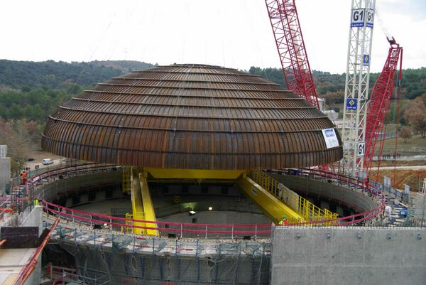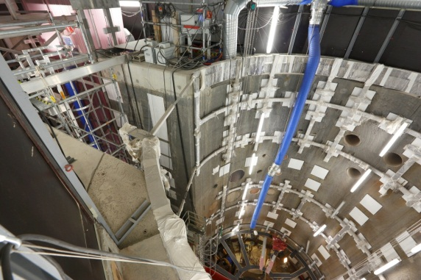
December 2013: Reactor dome installation April 2014: Reactor pool internal structures
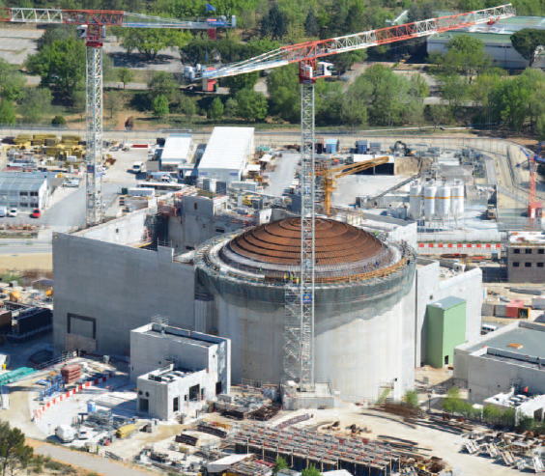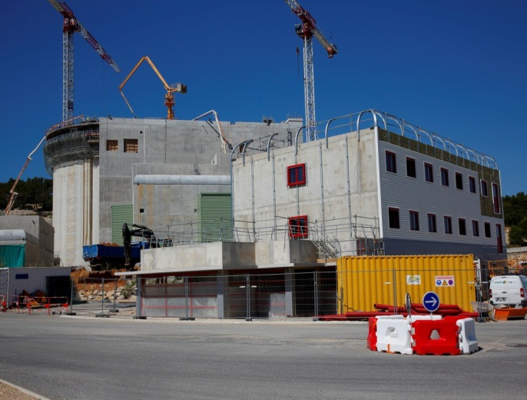
General view of Reactor Building and Auxiliary unit building (Mid-2014)
Figure 1: some views of the building site
- JHR Safety

As a new-built facility, JHR incorporates safety analysis right from the design phase, based on a modern reference system and methodologies; these can be related to those used in contemporary projects such as the EPR GEN3 NPPs under construction, but adapted to the characteristics and situation of a research reactor project.
The JHR Safety approach was presented in detail at the IAEA General Conference on Research Reactors in Rabat last November 2011.Some examples of incorporating safety from the design phase can be found in reference [7].
Following the Fukushima-Daichi Accident (March 2011), the French Regulator (ASN) also asked CEA to perform complementary safety assessments to meet objectives under extreme situations exceeding licensing basis (with focus on “cliff-edge” effect prevention).
The complementary safety assessments basically confirmed the sound design bases of the newly built JHR. A few selected needs for extra equipment were also identified, and, as an answer to French nuclear regulator requirements, CEA proposed a set of “hardened core” measures (eg. with a view to ultimate cooling capacity, to ultimate sensors, ultimate valve actuation or associated ultimate battery and generator set).

- Developing a modern experimental capacity

JHR is designed as a High Performance MTR (thermal power up to 100 MW) with the capacity to perform about 20 experiments at the same time. Characteristics (at full 100 MW capacity) are as follows:
- thermal neutrons flux in reflector: up to 5.5 E14 n/cm².s
- fast neutron flux in the core: up to 5.5 E14 n/cm².s for E > 1 MeV and/or up to
E15 n/cm².s for E> 0.1 MeV
- material ageing: up to 16 dpa/y
- 6 displacement systems to adjust fissile power and perform power transients
- power transients for fuel limit to clad failure studies: up to 600 W/cm.
At nominal operation JHR is to operate with 10 cycles a year (representing about 260 EFPD-Equivalent Full Power Days)
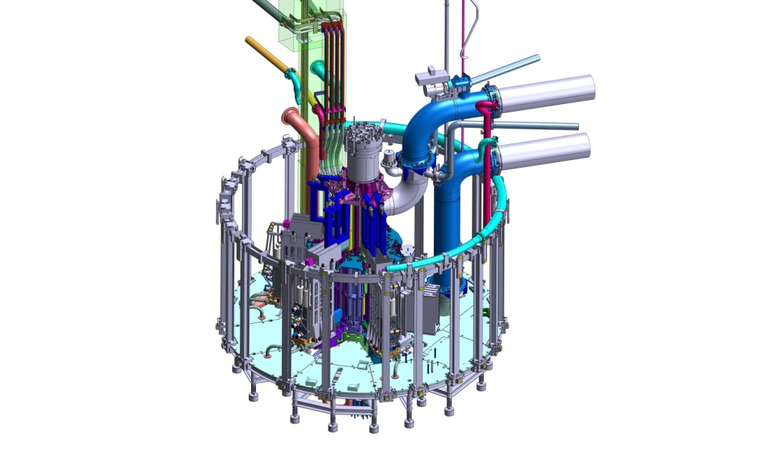
Figure 2: schematic view of JHR core and reflector where will be located experimental loops
CEA with its partners is preparing the first experimental capacities by developing some modern experimental devices for fuel and material behavior studies under irradiation such as the following:
- the MADISON loop (in relationship with HRP-Halden) for fuel investigation under normal situation (for PWR,BWR and VVER conditions)
- the ADELINE loop for power transient studies allowing clad failure for up-to-limit situations (with support from EDF)
- the LORELEI loop for safety LOCA (Loss Of Coolant Accident) studies for accidental scenarios (in collaboration with IAEC-Israel)
- the MICA capsules-CALIPSO loop for material investigation under high fast neutron flux and high dpa rate
- the MELODIE device for on-line bi-axial constraint analysis on material (in collaboration with VTT-Finland)
- the CLOE loop for material corrosion studies under constraint (in collaboration with DAE India).
Compared to the existing experimental capacities worldwide, a great effort is ongoing to improve the performance of such loops and to develop new devices with innovative concepts by:
- better monitoring and follow-up of the irradiation conditions,
- having a lot of on-line instrumentation to address key parameters (fast and thermal neutron fluxes, gamma heating, temperature, fission gas release for fuel investigation, material elongation…),
- having up-to-date post-irradiation exams either directly within JHR nuclear building (for non-destructive assay) or in Cadarache Hot Laboratory (for NDA and DA) or in Consortium Members Hot Laboratory.

- JHR as an International User-Facility through International Joint Programs and /or Academic Support

Parallel to the construction of the reactor, the preparation of an international community around JHR is continuing. This is an important topic because, as already indicated, building and gathering a strong international community in support to MTR experiments is a key-issue for the R&D in nuclear energy field.

Building international joint programs: According to the consortium agreement, JHR is aimed to become a user reactor at international level (cf achievements of the OECD/Halden Reactor Project) with multinational project and proprietary experiments. As anticipated preparatory actions, the JHR consortium has set-up a yearly scientific seminar and three working groups (Fuel, Material and Technology) to identify R&D topics of common interests and to prepare the first international joint programs addressing fuel and material issues that are key for operating plants and future NPP (mainly focused on LWR).

Academic opportunities / training
The JHR experiment team at Cadarache is already welcoming scientists, engineers (called Secondees) from various organizations/institutes who are integrated within the team for a limited period of time (typically one year) for various topics such as physics studies for the development of the experimental devices (neutron physic, thermo-hydraulic…) and/or for support to the future operator (Safety Analysis, I-C&C…).
This Secondment program is an important topic for countries willing to invest in nuclear technology helping them to create and sustain key competences.

In fact, between the academic training and the “commercial training linked to a product” there is a need to set up a framework for nuclear education “in the field” using modern High-Performance infrastructures dedicated to the training of future senior scientists, engineers…for the benefit of decision-makers in countries wishing to develop nuclear energy. The JHR Secondee Program is giving nuclear education “in the field” that offers direct experience of working in nuclear facilities and provides training opportunities that fill the gap between academic education and commercial-product specific training. This is fully compliant with the recent IAEA initiative on establishing labialized ICERR (International Centre based on Research Reactors) in order to rationalize the research reactors fleet worldwide and to harmonize Operation and Safety.

- Conclusion

The JHR construction is continuing, in accordance with plan to start operation by the end of this decade. Beyond construction activity, the facility – especially regarding the experimental capacity – is already open (and will be more and more so in the future) to international collaboration: JHR prepares to be a key infrastructure in the European and International Research Area for R&D in support to the use of nuclear energy during this century.

References

[1] The Green Paper, “Towards a European Energy Security Strategy”, published by the European Commission in November 2000

[2] FEUNMARR, Future European Union Needs in Material Research Reactors, 5th FP thematic network, Nov. 2001 – Oct 2002

[3] “The Jules Horowitz Reactor Project : a new High Performances European and international Material Testing Reactor for the 21st century”- G. Bignan, D.Iracane
Nuclear Energy International publication (NEI-Dec 2008)

[4] “Sustaining Material Testing Capacity in France: From OSIRIS to JHR”
G. Bignan, D. Iracane, S. Loubière, C. Blandin CEA (France) IGORR 2009 Conference (Beijing)

[5] “The Jules Horowitz Reactor: A new European MTR open to International collaboration” Gilles Bignan et al, IGORR 2010 (Knoxville TN –ORNL- September 2010)

[6] “The Jules Horowitz Reactor: A new European MTR (Material Testing Reactor) open to International collaboration: Description and Status”
G.Bignan, J.Estrade –IGORR 2013 –Daejeong Korea (October 2013)

[7] The Jules Horowitz Reactor: A new European MTR (Material Testing Reactor) open to International collaboration: Update Description and focus on the modern safety approach.
G. Bignan et al –IAEA International Conference on Research Reactors: Safe Management
and Effective Utilization (Rabat- November 2011)

