More than Forty Years of Neutronics Experiments in Critical Facilities of Cadarache Center: From EOLE and MINERVE to the Future ZEPHYR Reactor

Stephane Cathalau¹, Patrick Blaise¹, François Boussard², P. Leconte¹, J. Di Salvo¹
1. Department of Reactor Studies
2. Nuclear Facilities and Casks Project Department.
French Atomic and Alternative Energies Commission, C.E. Cadarache,
13108 St. Paul-lez-Durance, France

Corresponding author: stephane.cathalau@cea.fr

Abstract. The French Atomic Energy and Alternative Energies Commission (CEA) has been strongly involved in R&D research programs concerning GEN-2&3 LWRs for more than forty years (standard fuel utilization, poisoning effects, ageing plant management, optimization of the plutonium stockpile, MOX recycling, Advanced LWR studies). Core physics studies are an essential part of this comprehensive R&D effort and the EOLE, MINERVE zero power facilities played a key role in the validation of neutron physics calculation tools (codes and nuclear data). These two facilities are nowadays more than forty years old and should be strongly refurbished to meet the current safety criteria related to seism and Post-Fukushima recommendations. This explains why CEA is investigating the possibility to build a new facility in Cadarache, called ZEPHYR foreseen to reach first criticality in the next decade, for replacing EOLE and MINERVE and offering the same level of quality and services for reactor physics. After a description of the main experimental programs performed in EOLE and MINERVE facilities, an overview of the general design principles of ZEPHYR and its main characteristics are given in the final part of this paper.

1. Introduction.

For several decades, the French Atomic and Alternative Energy Commission has been undertaking experimental programs aimed at validating the calculation tools used to design standard and advanced LWRs. Two critical facilities [1] located at Cadarache have been mainly used to mock-up actual situations arising in LWRs in the EOLE facility, and measuring integral absorption cross-section of specific materials in the MINERVE pool reactor.

For example, after having investigated HCLWR concepts through the ERASME experiments in EOLE in the 80’s, many programs were launched for mocking-up PWR situations in France, and then in ALWRs - in collaboration with Japanese industrial partners - from 1990 to 2005. The MINERVE facility was used to investigate burn up credit in collaboration with UK [2] or to measure absorption cross-sections of heavy nuclides in collaboration with USA, through the INERI collaboration. More recently, MINERVE was used to determine integral capture cross-sections of current GEN2&3 absorbers and nowadays for measuring neutron characteristics of structural materials involved in the EPR™ GEN-III PWR reactor.

Today, the EOLE facility is dedicated to investigate neutron vessel fluency ageing depending on both core loading and internal structures of NPP from the French fleet, through the FLUOLE2 program. In the same time, MINERVE should be used to perform the first comparison tests a new in-core instrumentation system.

The experimental programs performed in EOLE and MINERVE were very fruitful for the LWR physical phenomena understanding, but today these facilities approach fifty years old and should be strongly refurbished in order to satisfy the safety criteria against earthquake and to meet the post-Fukushima requirements. Instead of renewing these facilities, CEA and its partners have begun to design a new facility in Cadarache, called ZEPHYR (Zero power Experimental PHYsics Reactor) aimed at offering at least, the same level of services as EOLE and MINERVE for the LWR codes experimental validation.

After a short description of the facilities and their capabilities, we emphasize the main results obtained in the MINERVE and EOLE facilities. The last part gives some details of the future ZEPHYR facility devoted to the French GEN2&3 LWR calculations but also, in some extent will deal with the 4th generation reactor neutron physics.

2. The EOLE and MINERVE Facilities.

The EOLE facility is a critical facility operating at a maximum power of 100W. It is dedicated to neutronics studies of moderated lattices with light water. EOLE is a readily versatile facility composed of a concrete structure, offering biological shielding for flux levels up to 10⁹n.cm⁻².s⁻¹, and a cylindrical vessel in aluminum alloy able to contain various types of core structures. Four safety banks (composed of 4 or 5 enriched B₄C rods each), a pilot rod, and water circuits coupled with thermoregulation stations to set the temperature of the moderator between 5°C and 90°C with a precision of 0.1°C are also part of the facility. The EOLE high flexibility enables to analyze the safety parameters of new types of fuels and/or core assembly designs by using dedicated devices (void boxes, mini-grids for local pitch modification) or by adding various absorbers (single or clusters), as natural or enriched B₄C, Silver-Indium-Cadmium (AIC) or Hf. An example of a mock-up core (a 100%MOX High burn up Advanced BWR configuration from the FUBILA program) implemented in the EOLE facility is given on Figure 1.

The MINERVE experimental reactor is devoted to neutronics studies of lattices of different reactor types. MINERVE achieved its first criticality in 1959 at the center of Fontenay-aux-Roses (near Paris). The reactor was transferred to CEA-Cadarache in 1977. MINERVE is a pool-type reactor operating at a maximum power of 100 watts. The core is submerged under 3 meters of water and is used as a driver zone for the different experimental lattices located in a central square cavity with a size of about 70×70 cm². The coupled lattices in this cavity are built such that they can reproduce the typical neutron spectrum of various reactors. The core is built in a parallelepiped pool of stainless steel containing about 100 m³ of water. The moderator is distilled water insuring also the cooling by natural convection. The driver zone consists in enriched metallic uranium/aluminum MTR-type plate cladded with aluminum and gathered in elements of 9, 12, and 18 plates. About 30 elements comprise the driver zone which is surrounded by a graphite reflector. Figure 1 gives an overview of the MINERVE pool facility.

These two facilities are connected to an experimental room where several γ-spectrometry benches are used to perform axial measurements or pin-by-pin fission power determination by comparison to a reference pin (Figure 3). Additionally, the MADERE platform is also used for specific measurements involving foils and dosimeters.

3. The past GEN2&3 Experimental Programs

Table 1 gives an overview of 30 years experimental programs performed in the MINERVE and EOLE facilities and aimed at validating calculation codes used for GEN2&3 safety and designs. The two first experimental programs devoted to GEN2 PWR lattices were the CREOLE [3] and CAMELEON [4] programs performed in early 80’s in the EOLE facility. They respectively aimed at measuring the temperature coefficient of UOX and MOX lattices up to 300°C and 150bars, and investigating neutron characteristic of GEN2-absorbers and Gd-poison rods in PWR lattices. The experimental results obtained during the program contributed to the validation of the previous CEA lattice code (APOLLO-1) and the recommended nuclear data libraries (CEA79 & CEA86) that are still in use for the experimental validation of the current APOLLO-2 lattice code and the recommended libraries (CEA97 based on JEF2.2 and CEA2005, based on the latest JEFF3.1.1 [5]).

For example, the APOLLO-2 code allows reproducing the efficiency of a single absorber in natural B₄C or AIC (Silver, Indium and cadmium alloy) loaded in the CAMELEON core within a ± 2% uncertainty. Several mock-up configurations were also investigated in this program: standard absorber clusters of 24 AIC rods or grey clusters composed of 16 AIC rods and 8 stainless steel rods were tested. The calculation of these configurations with the new recommended SHEM-MOC scheme shows a slight overestimation of + 4% with an experimental uncertainty of ±1% for the two clusters [6]. Concerning the CREOLE experiments, APOLLO-2 gives the temperature reactivity coefficient between 20°C and 300°C with (C-E)/E = - 0.1 ± 0.2 (1σ) pcm/°C for a UO2 core and slightly underestimates the reactivity effect of (C-E)/E = 1.6 ± 0.4 pcm/°C for a 100% MOX lattice [3].

Complementing the information obtained in the CAMELEON experiment, the MINERVE facility was used at that time to oscillate Gd samples allowing the determination of the integral capture cross-section of natural Gd. Additionally, some poisons rods were irradiated in the MELUSINE core in order to validate the Gd isotopes depletion [7].

From 1984 to 1988, the ERASME [8] and MORGANE [9] programs were undertaken in EOLE and MINERVE respectively and were devoted to HCLWRs; they were completed by the ICARE [10] tests performed in the irradiation reactor MELUSINE in order to measure integral capture cross-sections of the main actinides and of some fission products. These three experiments were designed to measure the main characteristics of under moderated lattices loaded with MOX fuel (multiplication factor, conversion ratio, some spectral indices and absorber efficiencies). A special care was also taken to measure the total void effect, which can be positive when the Pu enrichment is higher than 12%. This important measurement was possible because of the design of the core involving a HCLWR lattice loaded in a watertight central zone surrounded by a spectral adaptation zone and a UO2 driver zone. Those results were used to perform an adjustment of the multigroup CEA86, JEF2.2-based nuclear data library, in order to point out trends and possible improvement of cross section in the thermal and epithermal domains for LWR applications [11].

In 1989, CEA, the French electricity supplier EDF and the industrial FRAMATOME decided to launch the EPICURE program [12] devoted to 30% MOX fuel recycling in PWRs in the EOLE facility; after the investigation of reference configurations, a mock-up core called UMZONE [13] and involving a central 17x17 zoned MOX assembly surrounded by PWR 17x17 UO2 assemblies, was studied. The SHEM-MOC calculation of the experimental results gives a slight overestimation of the power in the central MOX assembly (+0.8% in average) and shows a very good agreement for the UO2 pins (Figure 4).

Additional experimental configurations involving 17x17 UOX assemblies or a 17x17 homogeneous MOX central zone, were implemented in the facility in order to mock-up GEN2 PWRs and to measure absorber cluster efficiencies and their associated pin-by-pin power distributions. The recommended SHEM-MOC scheme allows reproducing the power map with +0.8 ± 1.6% (2σ). The cluster efficiencies are also given at + 0.5 ± 2.0% (2σ) [13].

Between 1992 and 1999, the MINERVE facility was used to determine the absorption cross-sections of the main fission products involved in the burn-up credit. Thus, specific samples of UO2 doped pellets and of irradiated UO2 fuel were manufactured and oscillated in different neutron spectra generated by UOX and MOX lattices. The experimental information combined with those coming from the HTC/ALIX (2004-2010) [14] and the OSMOSE (2005-2009) [15] programs and from irradiated fuel isotopic analyses, allow to validate the loss of reactivity with burn-up and cross-sections of fission products and main minor actinides. Nowadays, APOLLO-2 is validated for UOX with enrichment up to 4.5% and burn-up of 85 GWd/t and for Pu 8.7w% in MOX with a burn-up of 65GWd/t [16]. Table 2 gives the exp./calc. discrepancies for heavy nuclide quantities in spent fuel : the ²³⁹Pu quantity seems to be correctly evaluated (²³⁸U capture cross-section) but the discrepancy on ²⁴⁰Pu is increasing with burn-up, indicating a possible overestimation of ²³⁹Pu capture cross-section. Other nuclide quantities are correctly reproduced.

From 1995 to 2005 began a collaboration between CEA and the Japanese governmental organism NUPEC (called JNES today) with the MISTRAL [17,18], BASALA [19,20] and FUBILA [21,22] programs in the EOLE facility and aimed at 100%MOX recycling in ALWRs. The whole neutronic characteristics achievable in a critical facility were measured for the validation of the French and Japanese calculation tools for GEN3+ reactors. Thus total void, partial void and also local void (simulation of “bubbles”) effects were measured during the three experiments. New absorber rods made of enriched B₄C (90% of ¹⁰B) were specially fabricated for measurements in order to increase absorption rates of the absorber clusters. Thermal coefficient was also determined in specific configurations in which it can be positive between 10°C and 30°C and negative for higher temperatures. A special care was also taken to measure the radial power distribution within assemblies in the BASALA and FUBILA programs because of their strong heterogeneity (several Pu enrichments, “water holes”, channel box, water gaps between assemblies).

Through the measurement performed during the MISTRAL program, APOLLO-2 and its JEF3.1.1 based library is able to give the delayed neutron fraction with +0.6 ± 1.5% (2σ) for a UOX core and +0.1 ± 1.6% (2σ) MOX core [23]. A complete analysis of the MISTRAL, BASALA and FUBILA programs feedback on code and nuclear data is resumed in [24].

More recently, the effort was done to investigate radial reflector effects with the FLUOLE [25] and PERLE [26] programs. The FLUOLE program was focused on neutron fluence on PWR vessel and the PERLE configurations were devoted to heavy reflector in PWRs such as the one designed in the EPR™. In the MINERVE facility, investigations were done in the MAESTRO program [27, 28] to measure the absorption cross-sections of the main structural materials of EPRTM (M5, Co, V, Stainless steel, etc.). Today, an industrial program along EDF additional request is in progress in the EOLE facility for a two year study.

4. The Future Facility: ZEPHYR

As CEA experimental reactor availability is still a strong need for core physics, codes and nuclear data, a new experimental facility called ZEPHYR is under feasibility studies with a target date for start-up at the beginning of the next decade. The basic option is to gather, in an optimized/improved way, both EOLE and MINERVE abilities and more, into a new Facility. Several attempts have been done in a recent past to meet such a goal by refurbishing the EOLE-MINERVE facilities or by implementing this project inside already existing ones in Cadarache. Those studies turned out to be no way in a risky or financial term. Eventually, CEA made a decision to launch a project of a new facility built in the Cadarache center.

The ZEPHYR project, so called both for Zero power Experimental PHYsics Reactor acronym and its mythological EOLE’s parentage is intended to give birth to a central R&D tool dedicated to reactor physics research (nuclear data, code validation in fundamental, mock-up and degraded/accidental configurations) open to the international community and Academia, whose functionalities and versatility would make it unique in the world..

4.1 Conceptual design and capacities
The experimental capabilities required for ZEPHYR are at least the same as in EOLE and MINERVE today, with some ambitious improvements and modifications. Today, EOLE is working with very flexible experimental configurations, to qualify computational schemes, whereas MINERVE operates more static configurations to realize oscillation measurements for improving nuclear data. One main ZEPHYR challenge is how to combine the basic functions of EOLE + MINERVE in only one core. Other additional improvements expected from ZEPHYR are the following:
- Possibility to perform coupled core configurations:
  - central area under water and self-critical (EOLE-like configurations) or –
  - central area under air (harder spectrum with possibility of MOX fuel rods and/or a smaller moderation ratio for fast spectrum configuration, using MASURCA fuel elements) with a sufficient size and a modular driver core,
- Additional control rod mechanisms, adding more flexibility in the programmes as regards to the safety constraints,
- Homogeneous sample heating and cooling system to measure high and low temperature Doppler effect under air or water configuration,
- Mobile automatic pilot with feed-back control from the oscillation function (oscillator or handling cask) and from the function of sample permutation under air and water configurations,
- Thermal/fast reference flux device for detector inter-calibration (fission chambers).
- Intensive training tool after the ISIS reactor shutdown,
- Qualification of computational tools and experimental devices for Jules Horowitz Reactor (JHR),
- Reception of irradiated fuel samples:
  - Oscillation samples of GEN-II,III, GEN-IV and MTR,
  - Fuel or assembly substitution,
- Computation of irradiated fuel sample worth, prediction of reactivity loss, study of power distribution and neutron/gamma fluxes,
- PIE on activated fuels under air or water by γ-spectrometry measurements.
Besides the above improvements, other potential functions could be implemented in ZEPHYR:
- Possibility to insert experimental loops of JHR type, such as NaK loop, possibly heated,
- Enhanced dosimetry capacities.
- Enhanced operation capabilities
Beside the erection and contractual work, the creation of a new nuclear facility requires going through a comprehensive administrative process: public enquiry, decree for the creation of a new facility, safety clearance, Euratom and physical protection authorizations. The construction of such a new facility should take less than 10 years, provided that no external major risks occurred.
The project includes a study of functions to be integrated or not in the facility, site qualification, and preliminary safety and security studies. A bird’s eye view of the Facility is pictured on Figure 9.

4.2 Project Status

A preliminary site has been selected, close to the MASURCA facility to gather both teams, with a surface of about 1 ha and on a convenient ground as regards to the earthquake hazard.
The preliminary design includes three buildings inside a fenced area: one reactor building with two independent thermo-stations, gamma spectrometer benches, a workshop for storage and mounting of components, one building for the storage of fissile materials and utilities for ventilation and electricity, and a third building for offices, cloakrooms and control room. Part of the fuel is expected to be coming from EOLE and MINERVE.
The very first assessment and calculation concerning what could be such a multipurpose (coupled) core has been started. The first calculations concern an optimisation of coupled fast/thermal lattices that are identified as dimensioning for the overall design and costs of the facility. The starting point is a re-visit of the ERMINE V lattice loaded in the 70’s, and in particular a critical analysis of the spectral conversion quality from the thermal buffer zone to the experimental central zone. Thanks to innovative advances in adjoint calculations implemented in the TRIPOLI4 Monte Carlo code, a direct comparison of the actual lattice spectral characteristics versus an ideal fast one (infinite lattice) is performed. An analysis is also made on representative samples to be oscillated in the central lattice. An optimisation study is then made.
Preliminary design calculations tend to demonstrate that optimal dimensions will be very close to the MINERVE ones (Figure 10), as an improvement of the conversion zone can be seriously envisaged. Several PhD theses will start by the end of 2014 and by the beginning on 2015, and will concentrate of design calculations of innovative configurations, as well as innovative experimental techniques and instrumentation.

6. Conclusions

This paper summarizes forty years of experiments performed in the EOLE and MINERVE facilities of CEA, mainly focused on standard and advanced light water reactors of GEN-2 and 3. Improving constantly the experimental techniques, the physicists give more and more precise experimental results which are very useful to validate the past and current calculation tools (codes and nuclear data libraries) used to design and safety calculations of LWRs.
- EOLE is a very flexible reactor that enables to build various types of lattice being representative of the target reactors (UO2-PWR, JHR, 100%MOX-ABWR…). Several concepts were thus investigated for UOX cores and a large range of moderation ratio for MOX cores (from strongly under-moderated to over moderated lattices).
- MINERVE, as a pool-type reactor, involves a driven zone in which several lattices can be implemented obtaining the target neutron spectrum in which the physicists measure reactivity effects of dedicated samples. This reactor was used to measure the reactivity effect of fresh and irradiated fuel rods to validate the reactivity loss with the fuel burn-up, just like the integral cross-sections of fission products and heavy nuclides involved in burn-up credit or absorbers, poison and heavy individual isotopes.

Both facilities have produced an almost unique experimental database for nuclear data and deterministic calculation scheme validation.

The future of these ZPRs is foreseen in a new facility, called ZEPHYR, to be commissioned in Cadarache during the next decade. This facility would merge EOLE and MINERVE experimental capabilities in an enhanced way, for the improvement of experimental and technological uncertainties, and associated instrumentation and flexibility.

Acknowledgement.

The authors would like to thank Electricité de France, AREVA and foreign governmental organizations for having co-sponsored many experimental programs enumerated in this paper.

References.

[1] P. Fougeras et al. “The place of EOLE, MINERVE and MASURCA facilities in the R&D activities of the CEA”. Proc. Int. Conf. PHYTRA2007, Marrakech, March 2007.
[2] A. Santamarina, et Al.,. “Reactivity Worth Measurement of Major Fission Products in MINERVE LWR-Lattice Experiment”, Nuc. Sc. Eng. 14-50 to be published
[3] L. Erradi and A. Santamarina. “Analysis of the CREOLE Experiment on the Reactivity Temperature Coefficient for PWR UO2 and MOX lattices using 3D transport calculation and JEFF3.1.1 library”. Proc. Int. Conf. on Mathematics Computational Methods (M&C 2009), Saratoga Springs, New York, May 3-7, 2009.
[4] P. Blaise, JF. Vidal, and A. Santamarina “Validation of the REL2005 code package on poisoned PWR type assemblies through the CAMELEON Experimental Program” ICAPP 09, Tokyo (Japon), 10-14 Mai 2009
[5] A. Santamarina et al., “The JEFF-3.1.1 Nuclear Data Library”, JEFF Report 22, 2009
[6] P. Blaise et al., ”Qualification of the French APOLLO2.8/CEA2005V4 code package on Absorber Clusters in 17x17 PWR type lattices through the CAMELEON Program”, Proc. Int. Conf. PHYSOR2010, Pittsburgh, USA (2010)
[7] P. Blaise and N. Dos Santos “Interpretation of GEDEON1 experiment in MELUSINE for the validation of Gadolinium depletion calculation using the APOLLO2.8/CEA2005V4.1 code package”, Second international Conference on Physics and Technology of Reactors and Applications, PHYTRA2, Fez 26-28 Sept. 2011
[8] L. Martin-Deidier et al., "ERASME: An Extensive Experiment for LWHCR Design Qualification" Top. Meet. on Advances in Reactor Physics - Saratoga Springs (USA) - Sept. 1986
[9] J. Mondot et al.: “MORGANE/S: fission product capture measurements in a HCLWR tight lattice”. Proc. ANS conf. JACKSON HOLE Sept. 88, Supplement: p. S–117
[10] S. Cathalau and A. Benslimane, "Qualification of JEF2.2 Capture Cross-Sections for Heavy Nuclides and Fission Products in Thermal and Epithermal Spectra", Proc. Conférence internationale GLOBAL'95 -Versailles (France) 11-14 Septembre 1995- Vol 2 - p. 1537
[11] S. Cathalau et al., "Qualification of JEF2.2 Cross-Sections in Epithermal and Thermal Energy Range Using a Statistical Approach", Nucl.. Sc. Eng. - Vol 12 - p. 326-333 (October 1995)
[12] J. Mondot et al. “EPICURE: an Experimental Programme devoted to the Validation of the Calculational Tools for Plutonium Recycling in PWRs”. Proc. Int. Conf. PHYSOR90, Marseille, France, 1990
[13] JF. Vidal, P. Blaise, A. Calloo « Qualification of the APOLLO2.8/JEFF-3.1.1 code package for the Calculation of Plutonium Recycling in PWRs using the EPICURE Experiments”», Proc. Int. Conf. PHYSOR2010, Pittsburgh, USA (2010)
[14] M. Antony et al. « Characterization of reactivity loss of UO2 spent fuels with pile oscillation measurements in the MINERVE facility’” PHYTRA 2 – The Second International Conference on Physics and Technology of Reactors and Applications. Fez, Morocco, September 26-28, 2011
[15] JP. Hudelot et al. “The OSMOSE Experimental Program in MINERVE for the qualification of integral cross sections of actinides”. Proc. Int. Conf. on Nucl. Data for Sci. and Tech. ND2001, Tsukuba, Japan, 2001.
[16] A. Santamarina, et al., « Validation of the new code package APOLLO2.8 for accurate PWR neutronics calculations » International Conference M&C 2013, Sun Valley, Idaho, USA, May 5-9, 2013
[17] S. Cathalau et al., “Full MOX recycling in ALWR : Lessons Drawn through the MISTRAL Program” PHYSOR 2002, Seoul, Korea, October 7-10, 2002
[18] O. Litaize et al.,“Monte Carlo Analysis of High Moderation 100% MOX BWR cores using JEF2 and JENDL3 Nuclear Data” PHYSOR2004, Chicago, Illinois, April 25-29,2004
[19] T. Yamamoto et al., "BASALA: Advanced BWR MOX Core Physics Experiments".2000 ANS Int. Meeting on Advances in Reactor Physics and Mathematics and computation PHYSOR2000 Pittsburg USA, 2000
[20] S. Cathalau et al., “Advanced BWRs fully loaded with MOX fuel: The BASALA Experimental Program” PHYSOR2004, Chicago, Illinois, April 25-29, 2004
[21] T. Yamamoto et al.,. “Analysis of reactivity measurements in core physics experiments on full MOX BWR.” Journal of Nuclear Science and Technology, 46,6, p.599-612, 2009
[22] P. Blaise, et al.,. “Monte carlo modelling of increasing void fraction in 100% MOX ABWR with JEFF-3.1.1 : lessons drawn from the FUBILA Experimental Program”. Journal of Nuclear Science and Technology, 47, 6 , p 1-12, 2010.
[23] P. Blaise et al., “Experimental Investigation of Isothermal Temperature Coefficient in ALWR-type UOx and full MOX cores” Global2005, Tsukuba, October 9-13, 2005
[24] P. Blaise et al., “Calculation of LWR βeff Kinetic Parameters: Validation on the MISTRAL Experimental Program” Annals of Nuclear Energy, 2012
[25] P. Blaise et al. “12 years of Franco-Japanese International Programs in EOLE for the validation of 100%MOX recycling in LWRs”, Proc. Int. Conf. PHYSOR2014, Kyoto, Japan, Sept.28 – Oct 3, 2014.
[26] P. Blaise et al., “Neutron fluence vessel assessment in the 1300MWe NPP French Fleet: The FLUOLE program in EOLE” ICAPP 2006- International Congress on Advances in Nuclear Power Plants, Reno, USA, 4-6 June 2006
[27] C. Vaglio-Gaudard et al. « Interpretation of the PERLE Experiment for the validation of Iron Nuclear Data using Monte Carlo calculations”. Nucl. Sci. Eng, 166, p.89-106, 2010.
[28] P. Leconte et al., “MAESTRO: an ambitious experimental programme in the MINERVE reactor for the improvement of nuclear data of structural, detection, absorbing and moderating materials” ANIMMA2013 Conference, Marseille, June 22-26 (2013)
[29] B. Geslot et al. “Results from the MAESTRO phase 2 and 3 program”, this conference

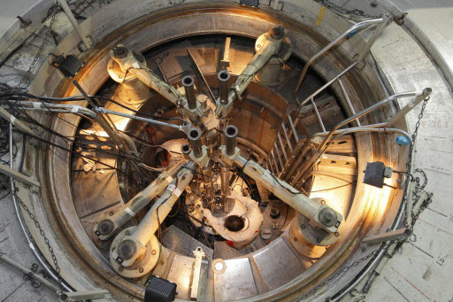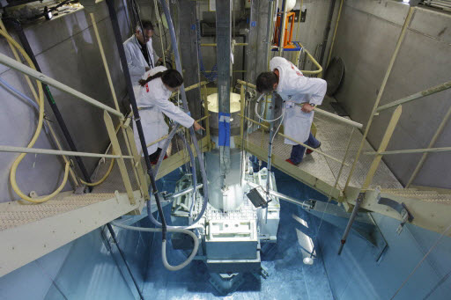
Figure 1: The EOLE facility Figure 2: The MINERVE pool-type reactor
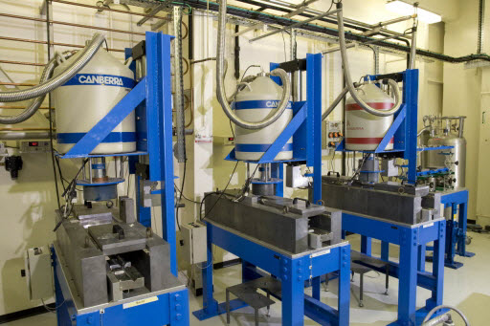
Figure 3: γ-Spectrometry benches
Figure 4: Exp./Calc. comparison for the pin by pin power map in the UMZONE configuration.

Figure 5: GEN-3 Reference core Figure 6: GEN-3 24 Gd cluster core
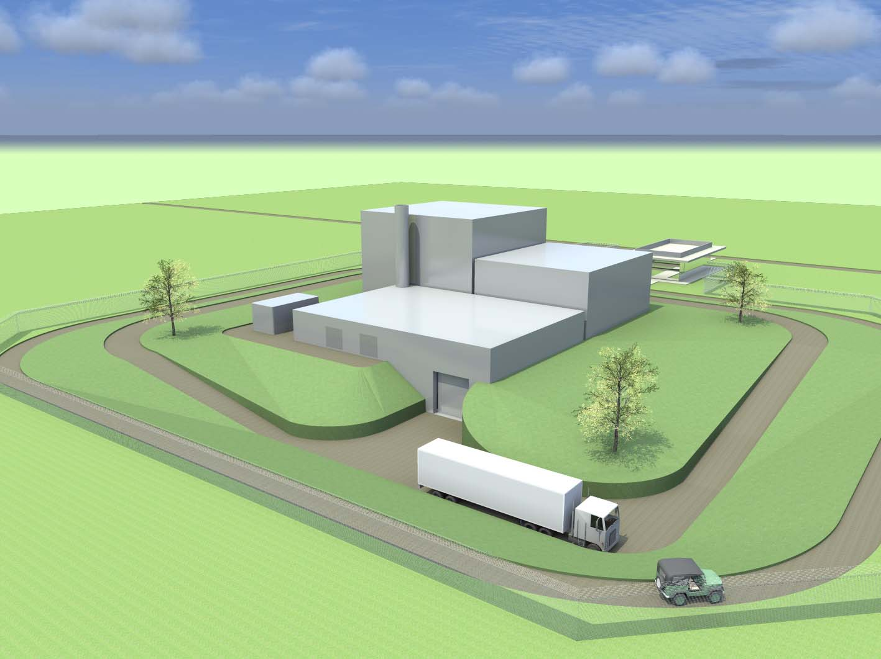
Artist’s view
Reactor Building
Building for fissile material storage and utilities
Office Building
Entrance gate

Truck entrance
HT station
Figure 6: Overview of the ZEPHYR Facility
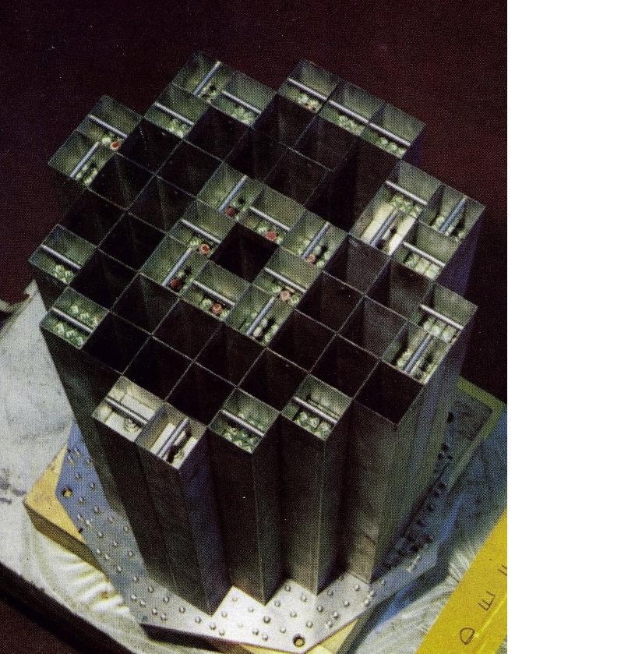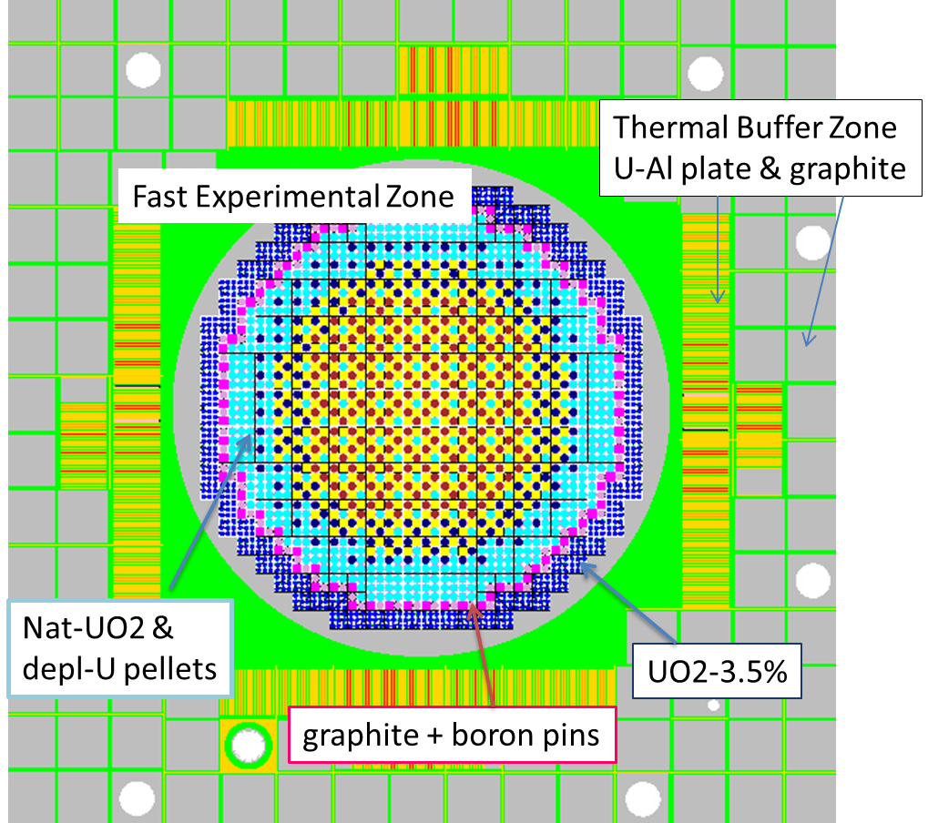
Figure 7:MINERVE ERMINE V coupled configuration: fast lattice (left ) and Monte Carlo radial view (right)
Table 1: Overview of the experimental programs performed in EOLE and MINERVE for GEN2 and GEN3 LWRs.

Program | Year | Facility | Lattice type | Main Purpose | Measurements
Experiments for GEN2 and GEN3 LWRs
CREOLE | 81-83 | EOLE | UOX-GEN1 | Temperature coefficient | Critical Buckling – Boron Efficiency – Temperature coefficient
CAMELEON | 83-84 | EOLE | UOX-GEN1 | Absorber and Poison study | Critical Buckling - Boron Efficiency – Absorber clusters Efficiency – Spectral indices –  Power distribution - Poison effects
MELODIE-Gd | 85 | MINERVE | UOX-GEN1 | Gd-Poison study | Integral absorption cross-section by oscillation technique
ERASME | 85-89 | EOLE | MOX GEN3+ | HCLWRs Physics | Critical Buckling – Spectral indices – Conversion ration – Absorber clusters Efficiency – Power distribution – Integral void coefficient
MORGANE | 85-87 | MINERVE | MOX GEN3+ | HCLWRs Physics | Fission products and actinides absorption cross-sections
EPICURE | 89-92 | EOLE | UOX & MOX GEN2 | 30% MOX recycling in PWRs | Critical Buckling - Boron Efficiency - Absorber clusters Efficiency - Power distribution - UOX/MOX ratio
CBU and CERES | 92-99 | MINERVE | UOX & MOX GEN2 | Burn-up credit | Irradiated Fuel and fission product effects
MISTRAL | 95-98 | EOLE | MOX GEN2&3 | 100% MOX recycling in PWRs | Critical Buckling – Spectral indices – Absorber clusters Efficiency - Temperature Coefficient - Power distributions – MOX/UOX ratio - Local void effects.
HTC - ALIX | 01-06 | MINERVE | UOX & MOX GEN2 | Irr. Fuel Eff. | Irradiated Fuel and fission product effects
BASALA | 99-01 | EOLE | MOX GEN2 | 100% MOX recycling in BWRs | Absorber clusters Efficiency - Poison effects - Temperature Coefficient –  Power distributions – void effects – delayed neutron fraction in UOX and MOX cores
FUBILA | 02-05 | EOLE | MOX GEN3 | 100% MOX recycling in BWRs | Absorber Clusters Efficiency - Poison effects - Temperature Coefficient - Power distributions – void effects
FLUOLE | 06 | EOLE | UOX GEN2 | Neutron fluence vessel ageing | Boron Efficiency - Power distributions - Flux distribution by dosimeters
OSMOSE | 06-08 | MINERVE | UOX & MOX GEN2 | Actinides cross-sections | Integral absorption cross-section by oscillation technique
PERLE | 07-08 | EOLE | UOX GEN2&3 | Heavy Reflector study | Critical Buckling - Reflector savings - Power distributions at the core/reflector interface: dosimetry and gamma heating
OCEAN | 08-10 | MINERVE | UOX & MOX GEN2 | Absorbers cross-sections | Integral absorption cross-section by oscillation technique
MAESTRO | 11-14 | MINERVE | UOX GEN2&3 | Structural Materials | Integral absorption cross-section by oscillation and activation techniques
FLUOLE2 | 14-16 | EOLE | UOX GEN2 | Neutron fluence vessel ageing | Power distributions - Flux distribution by dosimeters and miniature fission chambers – kinetics parameters
Experiments for cross-sections validation in fast neutron spectra.
ERMINE 1 and 2 | 66-70 | MINERVE | MAS1B (U and Pu) | Experimental Techniques development | Spectral indices, reactivity effect, Doppler Effects up to 800°C, local/global reactivity effects measurements
ERMINE 3,4 | 70-75 | MINERVE | Several lattices | Cross-sections of Pu isotopes and structural materials | Spectral indices, reactivity effect, Lattices with k∞=1
ERMINE 5, 6 | 75-85 | MINERVE | ”ZONA lattices” | Fission Products structural materials, spent fuel reactivity loss | Spectral indices, reactivity effect, Lattices with k∞=1, lattices with strong heterogenities

Table 2: Calc/Exp. discrepancies (%) for heavy nuclides mass in spent fuel. (Exp. Unc. 1σ)

Nuclide | 25 GWj/t | 45 GWj/t | 60 GWj/t | 74 GWj/t | 85 GWj/t
²³⁵U | +0.4 ± 1.0 | +0.9 ± 2.7 | +3.5 ± 4.0 | +6.5 ± 6.0 | +9.5 ± 7.0
²³⁶U | -0.1 ± 1.1 | -1.0 ± 0.9 | -1.1 ± 0.8 | -0.8 ± 1.1 | +0.3 ± 1.2
²³⁷Np | -2.8 ± 3.4 | -2.5 ± 3.3 | -1.3 ± 3.0 | -0.0 ± 2.6 | -2.6 ± 2.6
²³⁸Pu | -5.9 ± 4.0 | -6.2 ± 3.8 | -6.8 ± 3.7 | -5.0 ± 3.5 | -4.4 ± 3.3
²³⁹Pu | +0.6 ± 0.9 | +1.7 ± 1.2 | +2.3 ± 1.3 | +1.2 ± 1.5 | -1.5 ± 1.8
²⁴⁰Pu | +0.9 ± 1.7 | +1.3 ± 1.2 | +2.1 ± 1.1 | +4.6 ± 1.0 | +5.3 ± 1.0
²⁴¹Pu | -1.9 ± 2.0 | -0.9 ± 1.6 | -1.4 ± 1.6 | -0.9 ± 1.7 | -2.1 ± 1.8
²⁴²Pu | -0.4 ± 3.8 | +0.5 ± 3.1 | -2.5 ± 2.8 | -0.4 ± 2.6 | -0.3 ± 2.6

Table 3: Awaited Measurements in a future GEN-III program.
Configuration | measurements
Homogenous UO₂ 17×17 4.95%UO₂ Hot situation | Critical size
Homogenous UO₂ 17×17 4.95%UO₂ Hot situation | Radial fission rate distribution (“power map”)
Homogenous UO₂ 17×17 4.95%UO₂ Hot situation | Axial flux distribution
Homogenous UO₂ 17×17 4.95%UO₂ Hot situation | Modified Conversion ratio
Homogenous UO₂ 17×17 4.95%UO₂ Hot situation | Cd-covered ²³⁸U Capture
Homogenous UO₂ 17×17 4.95%UO₂ Hot situation | Differential boron efficiency
Homogenous UO₂ 17×17 4.95%UO₂ Hot situation | Isolated absorber worth (B₄C, AIC, Hf, SS)
Homogenous UO₂ 17×17 4.95%UO₂ Hot situation | Isolated burnable poison worth (Gd)
Homogenous UO₂ 17×17 4.95%UO₂ Hot situation | 5% substitution by 3.7%
Homogenous UO₂ 17×17 4.95%UO₂ Hot situation | γ heating in UO2 fuel pin
Cold Reference Gen-III 17x17 with guide-tubes | Critical size
Cold Reference Gen-III 17x17 with guide-tubes | Radial fission rate distribution (“power map”)
Cold Reference Gen-III 17x17 with guide-tubes | Axial flux distribution
Cold Reference Gen-III 17x17 with guide-tubes | Spectral indices
Hot Reference Gen-III 17x17  with guide-tubes | Critical size
Hot Reference Gen-III 17x17  with guide-tubes | Radial fission rate distribution (“power map”)
Hot Reference Gen-III 17x17  with guide-tubes | Axial flux distribution
Hot Reference Gen-III 17x17  with guide-tubes | Differential boron efficiency
Hot Reference Gen-III 17x17  with guide-tubes | Poison cluster worth
Hot Reference Gen-III 17x17  with guide-tubes | Absorber clusters (B4C, AIC, Hf, grey)
Hot Reference Gen-III 17x17  with guide-tubes | poison cluster worth (12Gd, 16Gd, 24Gd)
Hot Reference Gen-III 17x17  with guide-tubes | Perturbation of ICI by ASM
Hot Reference Gen-III 17x17  with guide-tubes | γ heating
Hot Reference Gen-III 17x17  with guide-tubes | Void effect (ASM) – Simulation of void
Hot Reference Gen-III 17x17  with guide-tubes | Water blade effect (ASM)
Hot Mock-up Gen-III 17x17  Assemblies  (24 absorber clusters, several Gd rods configurations) | Critical size
 | Radial fission rate distribution (“power map”)
 | Axial flux distribution
 | Differential boron efficiency
 | In-core Instrumentation effects
 | Aeroball irradiation

