Development of Laser Welding Technology for Fabricating Nuclear Fuel Test Rig

C.Y. Joung¹, J.T. Hong¹, S.H. Ahn¹, K.H. Kim¹, S.H. Heo¹

1) Dept. of HANARO Utilization & Research, KAERI, 989-111 Daedeok-daero Yuseong-gu, Daejeon, Korea

Corresponding author: joung@kaeri.re.kr

Abstract. To analyse the irradiation characteristics of a newly developed nuclear fuel in a laboratory, nuclear fuel test rigs must be fabricated with precise assembly and welding technologies. Recently, we designed and developed an automatic precise fiber laser welding system that is able to weld end-caps and a fuel cladding tube of a fuel test rod, and the components in a fuel test rig. This welding system can be mainly classified into a fiber laser source, a control system and a pressure chamber. The fiber laser source is an air cooling optical fiber type and its wave length is 1070 nm. The control system has a 3 axis-servo stage (X axis: 900 mm, Y axis: 300 mm, Z axis: 200 mm, θ axis: 360 degrees) controlled with a CNC program, and a vision system applied for checking welding status in a timely manner. The pressure chamber is used to make the welded surface of the cladding specimen clean with inert gas filled inside the chamber. To precisely weld the components for fabricating the nuclear fuel test rig, a welding process needs to establish welding parameters for the fiber laser welding system. Therefore, various welding experiments were carried out under various atmospheric conditions inside and outside the pressure chamber for the tube and end-cap specimen of AISI 316L and Zircaloy-4. The soundness of the test specimen welded by the laser welding system has been confirmed through visual inspection and microstructural analyses. Through these weld test, the optimum welding conditions were established.

1. Introduction

The rod inner pressure, centerline temperature, coolant temperature, and neutron flux resulting from the irradiation properties of nuclear fuels are important factors for evaluating the in-pile nuclear fuel properties. To measure these various irradiation characteristics of the nuclear fuel, most of the special sensors such as a TC (thermocouple), LVDT (linear variable differential transformer), and SPND (self-powered neutron detector) mounted in and out of the nuclear fuel test rigs are attached by using a welding process [1]. The welding process is one of the most important among the instrumentation processes of the nuclear fuel test rigs. Laser welding using high-density energy can be properly used in a deep permeation and in precisely welding narrow and deep joints. In particular, it has been applied to many metal welding fields [2]. To fabricate the nuclear fuel test rigs, a precise welding system needs to be fabricated to develop various welding technologies of the fuel test rigs jointing the various sensor and components on a tube of various materials such as AISI 316L and Zircaloy-4. Thus, we designed and fabricated an automatic precise fiber laser welding system consisting of an optical fiber laser source, a laser head, a 3-axis servo stage, an index chuck (θ), and a control PC. In a previous experiment on this system, some problems were found in welding properties such as an irregular bead by the oxidation and low penetration depth of FZ (fusion zone) [3]. Thus, this system was mounted with a chamber that can weld a specimen in a vacuum and inert gas atmosphere. Using this system, the performance tests in the atmosphere and in the chamber were carried out with a round weld for each welding condition.
This paper describes not only the contents for the design and fabrication of a fiber laser welding system but also some results from weld experiments to verify the laser welding performance for this system.

2. Fiber laser welding system development

2.1 Configuration of fiber laser welding system

A fiber laser welding system consists of a laser source (YLR-150/1500-QCW-AC model made by IPG co.), a laser head, a 3-axis (X, Y, Z) servo stage, an index chuck (θ), a control PC and a chamber as shown in Fig. 1. The laser source of a developed laser welding system is as follows: it is an air-cooling optical fiber, its wave length is 1070 nm, and its emission modes are continuous (CW), of which the laser generates continuous emission and pulse (QCW) modes in which the laser internally generates sequence of pulses. The main difference between pulse and continuous modes is that the maximum peak power in pulse mode is considerably higher than in continuous mode. In addition, the maximal peak power in the pulsed mode is 1.5KW (Max. Pulse Energy: 15J) and in the continuous mode maximal average power is 250W.

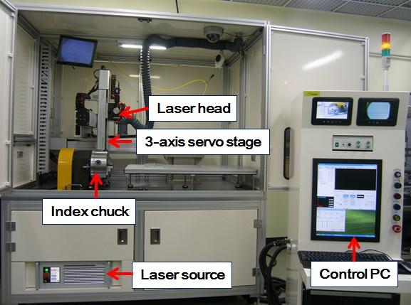

Fig. 1. Fiber laser welding system

The laser head used to emit a laser beam is equipped on the Z-axis LM guide. It has a vision system designed to protect the laser source and optical parts from the reflected beam during the laser welding process.
To protect the welding surface from oxidation during the welding process, welding purge gas is flowed through the laser head in the welding area. The focus distance of the head lens is 180 mm, and its beam size is ø276 µm. The movable length of the 3 axis-serve stage is 900 mm on the X axis, 300 mm on the Y axis, and 200 mm on the Z axis; its precision rate is ±0.02 mm. The index chuck (θ axis) is used to mount a cylindrical welding specimen, and its rotation (360 degrees) can be controlled with a CNC program.
The CNC welding program view of a control PC is shown in Fig. 2. The operation of the laser welding system is driven by control sentences written with G-codes and M-codes of a CNC program.

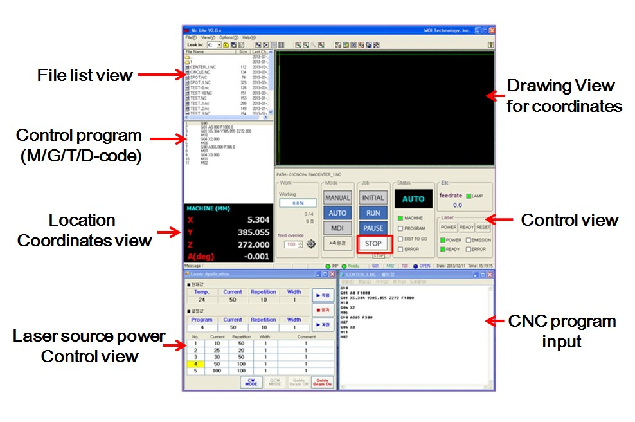
Fig. 2. CNC welding program of a fiber laser welding system

2.2 Welding chamber

A chamber has the design specifications of a 500mm width and 600mm length, and its upper section and base are made of AISI 304 stainless steel and 7000 series aluminum alloy, respectively. It is able to mount two pipes of a 50.8mm diameter and 600mm length on its left and right sides, which can be removed. Thus, it is possible to weld a long tube. This chamber is used to weld the joint surface between a cladding tube and an end cap of the nuclear fuel test rod and rig. It can also be used to weld assembly parts of the nuclear fuel test rig. Its inside was installed with sample holders and a weld head as shown in Fig 3.
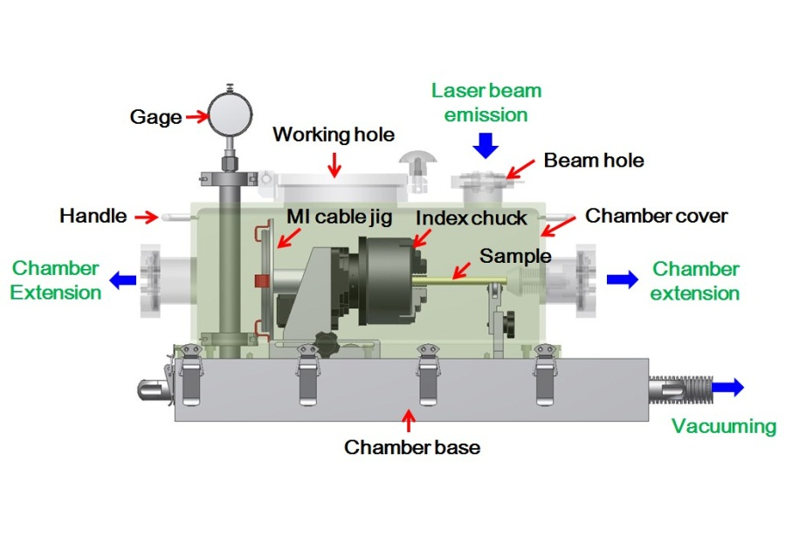
Fig. 3. Welding chamber installed in a fiber laser welding system

The entire laser welding process in the chamber is automatically implemented with the weld head supplied and programmed using weld parameters. The laser weld process conducted in the chamber is as follows: First, chamber extension holes and working hole according to the size, the specimen is fixed in an index chuck and then put into the chamber. Second, after vacuuming the chamber, a test sample is filled with inner gas (helium and/or argon) according to the pressure conditions. Finally, turn on the start button. To maintain a vacuum and inert gas atmosphere for the weld processes, a chamber is installed with a vacuum pump and a gas supply system. It is used to obtain a clean welded surface of the nuclear fuel test rigs with inert gas filled inside the chamber.

3. Experiments for laser welding condition establishment

3.1 Materials

The welding specimens used for the performance test is composed of the cladding tube and end-cap made of Zircalloy-4 or AISI 316L. The Zircalloy-4 is zirconium alloy containing minor additions of Sn in a solid-solution in a hexagonal close-packed phase (HCP) with minor additions of Fe, Cr, and/or Ni present in fine second phases [4]. Its tube size is 9.5mm in outer-diameter and 8.36mm in inner-diameter, and that of an end-cap is 9.5mm in outer-diameter, 5.5mm in inner-diameter, and 25mm in length. The AISI 316L are the materials of a nuclear fuel research rig for research testing. The size of its tube is ø9.53 mm in diameter and 7.75mm in inner-diameter, and that of the end cap is 9.53mm in outer-diameter, 5.5mm in inner-diameter, and 25mm in length. The laser welding process was conducted without the filler metal.

3.2 Welding conditions

The emission methods of the fiber laser source mounted in the fiber laser welding system are CW (continuous mode) and pulse mode. CW mode is used to continuously emit laser beams, and pulse mode is used to frequently emit a laser beam according to the frequency repetition. To confirm the welding properties for the emission modes of the laser source, a welding test was conducted on the tube specimens. In this test, we knew it was difficult to adjust a weld bead in CW mode, and thus we tested mainly for pulse mode. To establish the laser welding condition in pulse mode, the welding tests under these conditions were carried out under the five process variables, such as the laser power, laser pulse repetition, turn speed of the welding specimen, and the focus length between a focal lens and the work-piece, as listed in Table 1. All process variables in this welding test are used to check the width and penetration depth of HAZ and to analyze the welding properties.

Table 1. Range of process variables in pulse mode
Process variables |  | Ranges
Laser power |  | 60~100 % (900 ~ 1500 W)
Laser pulse repetition |  | 1 ~ 10 Hz
Turn speed of a specimen |  | F300~F1200 (0.087~0.348 rad/sec.)
Purge gas amount |  | 5 ~ 20 L/sec
Focus length |  | 183 ~ 189 mm

The experiments for the above conditions were conducted using helium and argon as a purge gas. The flow rate and pressure of the purge gases are fixed at 20liter/min. and 0.15MPa, and the purging gas after a laser welding is flowed for 3min. to prevent oxidizing the welded area from the atmosphere. To improve some problems from the previous results, a laser weld test using a chamber was carried out under equal welding conditions, as in the previous experiment.

3.3 Microstructural analysis

To analyse the specimens welded by the laser welding system, visual and metallographic tests were carried out for all test specimens. For metallography, the welded specimen was mounted in a plastic cup and ground using successive grades of emery paper. The final polishing was done using 1um diamond paste. To clearly reveal the fusion line and heat affected zone for the laser weld, the AISI 316L samples were etched using an electrochemical etcher (BUEHLER, ELECTROMET 4) using a mixture of 50% HNO₃ (60% nitride acid) and 50% 50% H₂O (distilled water), and the zircalloy-4 samples was etched using a mixture of 45% HNO₃ (nitride acid), 45% HF (hydrofluoric acid), and 10% H₂O.

4. Results of Experiments

4.1 Laser power

Microstructures of the FZ of AISI 316L and Zircaloy-4 specimens welded in the argon and helium purge gas according to the laser powers and the welding conditions fixed with a 10Hz repetition, a F300 (0.087rad/s) turn speed, gas amount of 20L/s, and a 187mm focus length are shown in Fig. 4. All specimens at 80% and 100% powers are jointed in the entire gap between the tube and end-cap, but those at 60% power are not jointed. Although the specimens at 100% powers are jointed in the entire gap, a large pit cratered by laser spattering is shown. In particular, the pit in the AISI 316L is larger than that in Zircaloy-4. This phenomenon is related to the reaction intensity between the specimen and laser beam. The penetration depth of the FZ by laser welding was also increased by increasing the laser power, and the degree of depression on all of the welded specimens was the least when the purge gases and low laser powers were used in the laser welding process.

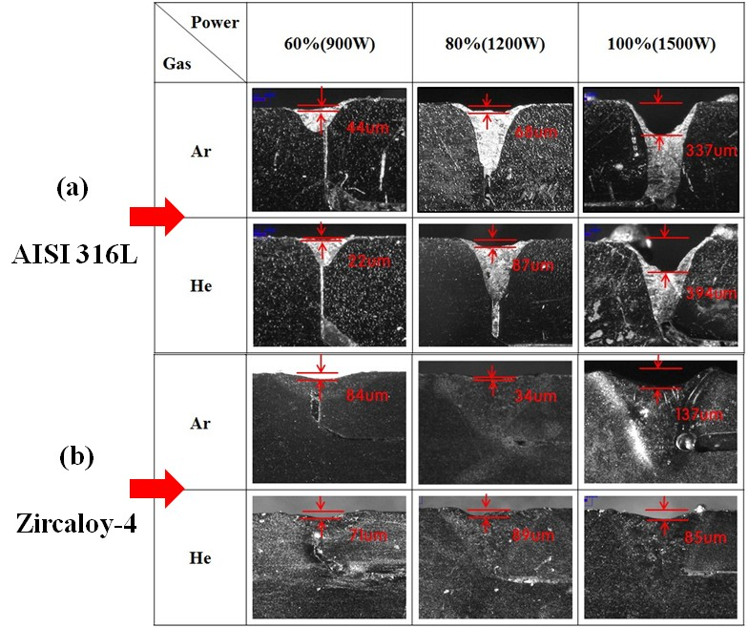

Fig. 4. Microstructures of (a) AISI 316L and (b) Zircaloy-4 specimens welded
in argon and helium purge gas according to the laser powers

Graphs of the bead width (a) and penetration depth analyzed from the previous test results are shown in Fig. 5. In this graph (a), the effect on the weld bead according to the laser power was regular but the bead width variation was less than 200um. In this graph (b), the penetration depth of all specimens with increasing power was largely increased until 90% laser power, but that it of the AISI 316 specimens was largely decreased at 100% power owing to a pit, as shown in Fig 4(a).
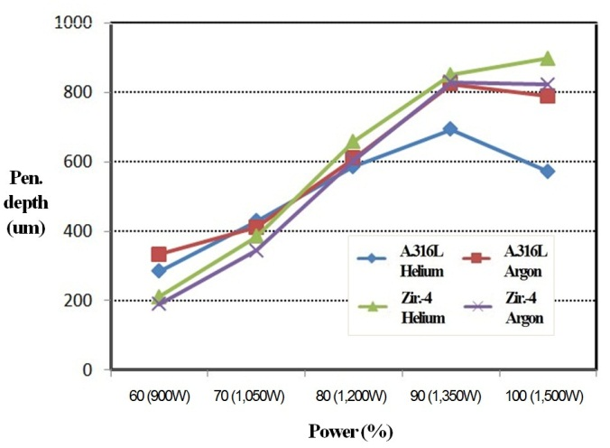
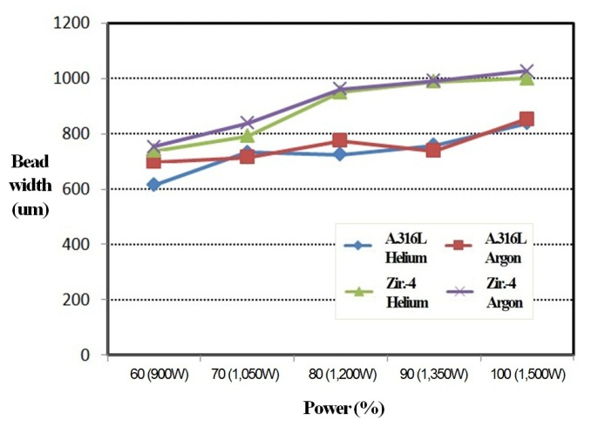
(a) Bead width (b) Penetration depth
Fig. 5. Property variations of the ZF of specimens welded in the helium
and argon purge gas according to laser powers.

4.2 Laser pulse repetition

The results of the fiber laser welding experiments when changing the frequency of the laser pulse repetition are shown in Fig. 6. A weld bead on the AISI 316L specimens was generated with the laser welding in the argon and helium purge gas according to the laser pulse repetitions (6-14 Hz) and the welding conditions fixed with 50% (750W) laser power, a F300 (0.087rad/s) turn speed, and the gas amount of 20L/s.

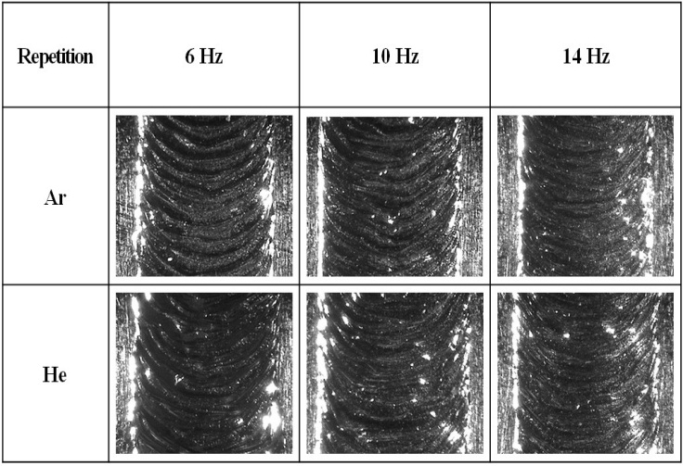

Fig. 6. Effects of laser pulse repetition on the microstructure of AISI 316L specimens
welded in the helium and argon purge gas according to laser pulse repetitions

Welded beads were overlapped between the beads formed under laser pulse repetitions, and the laser pulse repetition is caused by a gap between weld beads. The gap shapes were regularly dense in proportion to the laser pulse repetitions. At 14 Hz, the weld beads were irregular owing to the overlapped beads, but this trend was confirmed to relate greatly to a uniform penetration depth which was analyzed by metallography.

4.3 Turn speed of the specimen

Fig. 7 shows a weld bead of the AISI 316L specimens welded in the argon and helium gas with the turn speeds of the specimen and the welding conditions fixed with 50% laser power, a 10Hz repetition, and a 187mm focus length. As the turn speed of the specimen increases, the weld bead interval was regularly increased, and the bead width was similar in all the purge gases and turn speeds of the specimen. Therefore, the turn speed of the specimen is suitably based on the fabrication process of the nuclear fuel test rig.

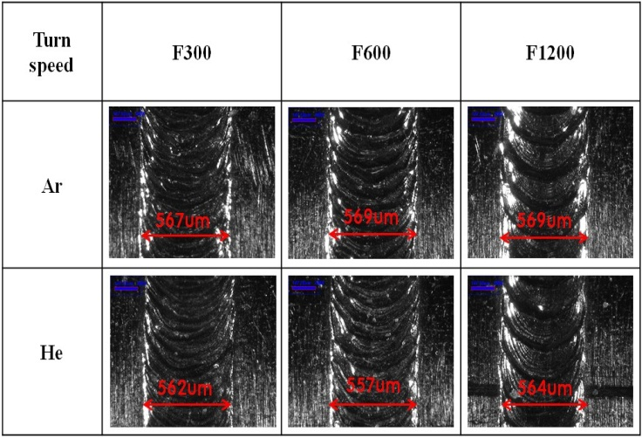

Fig. 7. Effects of turn speed on the microstructure of AISI 316L specimens
welded in argon and helium gas

4.4 Purge gas amount

Photographs of a weld bead on the AISI 316L specimens welded in argon purge gas with the gas amounts and the welding conditions fixed with 80% and 90% laser powers, a 10Hz repetition, a F300 turn speed and a 187mm focus length, are shown in Fig. 8. In the case of a small amount of purge gas, the weld bead is irregular and unsteady. The weld bead at 80% laser power is shown to be stabilized at over 15L/s, and at 90% laser power was found to be stabilized at over 20L/s.

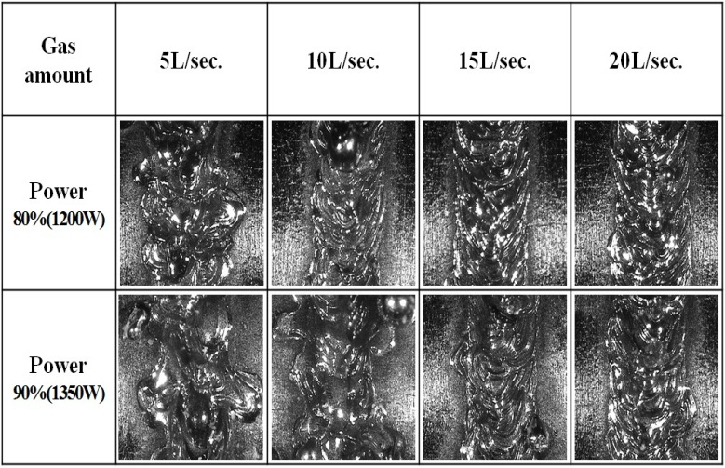

Fig. 8. Effects of gas amount and laser power on the microstructure
of AISI 316L specimens welded in argon gas

4.5 Focus length

Fig. 9 shows a weld bead of the Zircaloy-4 and AISI 316L specimens welded in argon gas with the focus lengths and the welding conditions fixed with 50% laser power, a 10Hz repetition and a F300 turn speed. Here, the focus length means the distance between the focus lens and welding point. As the focus length increases, the weld bead widths were regularly decreased and the weld bead shapes were steadied for all materials. Thus, it is obvious that the laser focus length of the weld bead is related with the laser intensity.

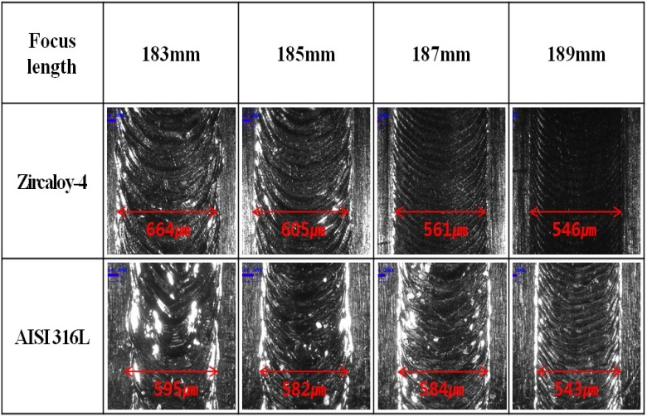

Fig. 9. Effects of focus length on the microstructure of Zircaloy-4
and AISI 316L specimens welded in argon gas

4.6 Laser welding in a chamber

To improve some of the problems in the above results, a laser weld test using a chamber was carried out in equal welding conditions as the above experiment. In the laser welding experiment using a chamber, no spattering phenomenon was observed on the weld surface of the specimen because the purge gas flowing at high pressure is not applied for the laser welding process and no pits shown in the above experiments were found on the welded surfaces. In addition, the penetration depth of FZ in the chamber was deeper than that in the atmosphere.

5. Conclusions

To precisely weld the components for fabricating a nuclear fuel test rig, a precise fiber laser welding system was developed. Using this system, a laser welding experiment was carried out for a tube and end-cap specimen of AISI 316L and Zircaloy-4 under five process variables including the laser power, laser pulse repetition, turn speed, and focus length. The welding effect of these variables shows a relatively large difference on the weld bead and penetration depth. In particular, the penetration depth according to the laser power was increased with increasing the power, and the degree of depression on all of the welded specimens was the least when the purge gases and low laser powers were used in the laser welding process. The laser welding using the chamber was not affected on the weld surface of the specimen because the purge gas flowing at high pressure is not applied for a laser welding process, and no pits cratered at a high laser power were found on the welded surfaces. Through the above test, the optimum welding conditions of the fiber laser welding system for the laser welding process were established for Zircaloy-4 and AISI 316L materials. In the future, we will use these welding techniques for assembling a nuclear fuel research rig.

6. Acknowledgements

This work was supported by the National Research Foundation of Korea (NRF) grant funded by the Korea government (MSIP) (2012M2A8A5010535)

7. References

[1] B.G. Kim, J.M. Sohn, K.N. Choo, “Development Status of Irradiation Devices and Instrumentation for Material and Nuclear Fuel Irradiation Tests in HANARO, Nuclear Engineering and Technology”, (2010) Vol 42., No. 2, pp. 203-210,.
[2] Yang, R. T., and Chen, Z. W., “A Study on Fiber Laser Lap Welding of Thin Stainless Steel,” IJPEM, (2013) Vol. 14, No. 2, pp. 207-214.
[3] Jintae Hong, Chang-Young Joung, Ka-Hye Kim, Sung-Ho Heo and Hyun-Gil Kim, “Study on Fiber Laser Welding Conditions for the Fabrication of a Nuclear Fuel Rod,” International journal of precision engineering and manufacturing (2014) Vol. 15, No. 4, pp. 777~781

