The RMB Research Reactor Project

Claudio Mazufri¹, Jose A. Perrotta², Néstor De Lorenzo¹, Adalberto Soares², Marcelo Barrera¹

1) Nuclear Projects Division, INVAP S.E, Av. Cmte. Luis Piedrabuena 4950, R8403CPV, S.C Bariloche, Argentina
2) RMB Project, IPEN- CNEN/SP, Av. Prof. Lineu Prestes 2242, CEP 05508-000, Sao Paulo, Brazil

Corresponding author: mazufri@invap.com.ar

Keywords: Research reactor.

Abstract. After the worldwide molybdenum supply crisis, the necessity for a continuous and reliable domestic production was embraced as a high priority short-term objective. The Brazilian Multipurpose Reactor (RMB) is the answer to this urgent demand but it is also envisaged as a world-class facility to complement the old Brazilian Nuclear Research Reactors´ fleet extending further the R&D capabilities available in the country and region.
In this regard, the RMB research reactor will be the centerpiece of a new nuclear research centre to be developed in Iperó in the state of Sao Paulo featuring the required infrastructure to perform, in a synergetic approach, production, research and development activities in a wide range of fields.
To fulfill these objectives, the RMB research reactor configuration selected is based on a 30 MW open pool design featuring LEU MTR fuels reflected by a heavy water tank and beryllium blocks providing space for both, in and out-of-core irradiation positions and a liquid deuterium cold neutron source.
These irradiation positions will provide a variety of neutron fluxes and spectra suitable to develop radioisotope production, nuclear materials and fuels testing, neutron activation analysis, silicon transmutation and neutron radiography among other applications.
Neutron beams to extract thermal and cold neutrons, laboratories, processing and transfer hot cells, extended capacity underwater and dry storage facilities for spent fuels, a waste management plant and other features are integrated in the design to ensure a safe, efficient and reliable operation of the whole centre.
This paper shows the main features, systems and layout of the research reactor facility developed up to now in the preliminary design.

Introduction

The RMB will be the centerpiece of a high-tech centre to be developed in Iperó in the state of Sao Paulo featuring the required infrastructure to perform, in a synergetic approach, production, research and development activities in a wide range of fields.
The Reactor Facility has been developed to be used for different purposes, using proven technology tailored to the specific requirements stated by CNEN. Mainly, the facility design addresses the following objectives:
- Provide relevant radioisotope production and irradiation facilities;
- Provide a Neutron Activation Analysis Facility,
- Provide tuned facilities to conduct advanced scientific and industry neutron research
The Reactor Facility occupies an area of approximately 8 thousand square meters, which includes the Reactor Building with the reactor and main reactor systems, the Neutron Guide Hall where the neutron guide systems and the research equipment are located, and associated auxiliary and office buildings.
To fulfill the design objectives to achieve high performance in the production of neutrons and to support Brazilian’s nuclear capability, the RMB configuration selected is based on a 30 MW open pool design featuring LEU MTR fuels reflected by a heavy water tank and beryllium blocks providing space for both, in and out-of-core irradiation positions and a liquid deuterium Cold Neutron Source. The reactor is designed to have an operational life of at least 40 years. FIG. 1. shows the main components if the reactor

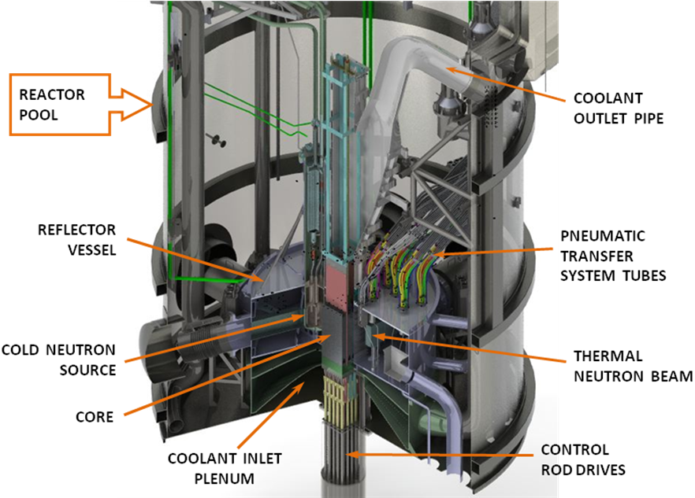

FIG. 1. Main components if the reactor

The Core

The Core Configuration is shown in the FIG. 2. The operational parameters are as follows:
- Core configuration: 5 x 5 grid with 23 Fuel Assemblies and 2 in-core irradiation positions surrounded by a Chimney
- Fuel Assemblies: square shaped, with twenty one (21) flat fuel plates, uranium silicide.
- Control Rods: 6 Hf plates (3 per each Control Rod Guide Box, one central and two laterals)

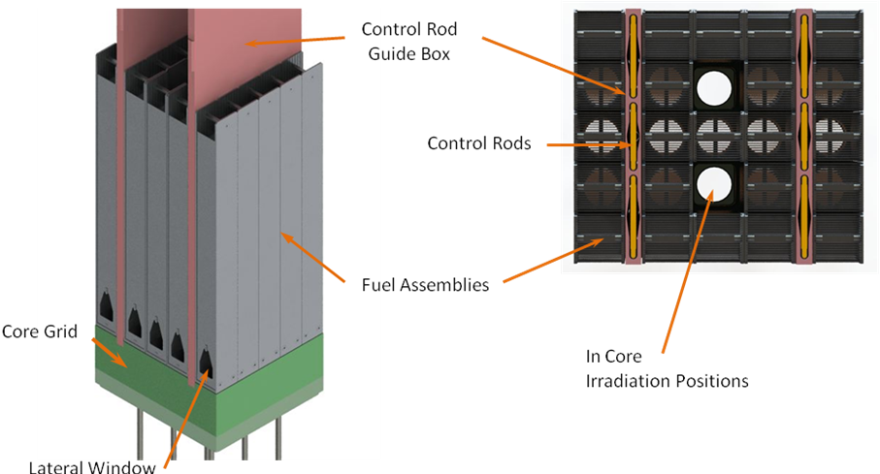

FIG. 2. Core Configuration

The core is located inside a chimney, surrounded by heavy water contained in the Reflector Vessel. The core is cooled by a flow of de-mineralized light water moving in the upward direction in forced-circulation cooling mode.

Reactivity Control and First Shutdown System

The six Control Rods (CRs) fulfill the function of power control during Power and Test States. If a rapid reactor shutdown is required to protect the core from an operational transient, the First Reactor Protection System initiates operation of the First Shutdown System (FSS) which decreases the reactor power level very quickly.
It performs this safety function by inserting the six control rods into the core. During normal operation the control rods are commanded by the Reactor Control and Monitoring System.
The reactivity control system encompasses the following major components:
- Control Rod Plates
- Control Rod Guide Box
- Control Rod Stems
- Seal Box Assembly
- Control Rod Drive (CRD)
- Support Table
The CRs are connected with the CRD room through penetrations through the bottom plate of the Reactor Pool. The penetrations are provided with seal assemblies to prevent leakage of Reactor Pool water into the CRD room. FIG. 3. presents a schematic of the components the reactivity control system and the FSS.

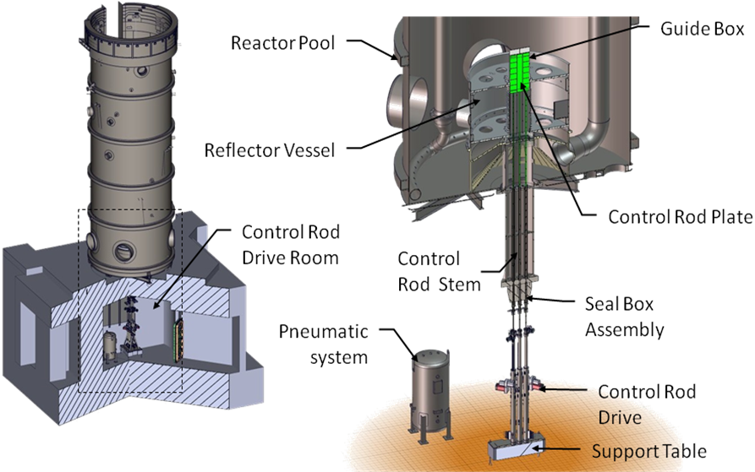
FIG. 3. Reactivity Control and First Shutdown System Components

Reflector Vessel

Irradiation Positions and Beam tubes
The Core is surrounded by a Reflector Vessel containing heavy water, which provides adequate neutron reflection and a large zone with high neutron flux.
The Reflector Vessel has a cylindrical shape and it is traversed in the axial direction by tubes of various diameters to accommodate:
- 5 Neutron Transmutation Doping Irradiation Positions
- 20 Bulk Irradiation Positions
- 14 Pneumatic Irradiation Positions
The Reflector Vessel geometry is conceived to allow the installation of a Fuel Irradiation Device and a Cold Neutron Source (CNS). The Reflector Vessel houses a light water volume where a Fuel Irradiation Loop can be placed. An array of beryllium prismatic elements acts as reflector for the irradiation loop volume
The Reflector Vessel also comprises five neutron beam tubes in the horizontal plane, i.e. two cold neutron beams that point to the CNS, two thermal neutron beams and an additional beam for neutrography. All beam tubes are tangential to the core. FIG. 4. shows the arrangement of the Reflector vessel.
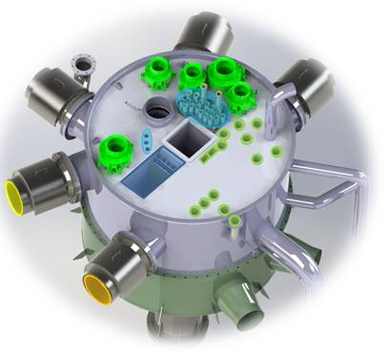
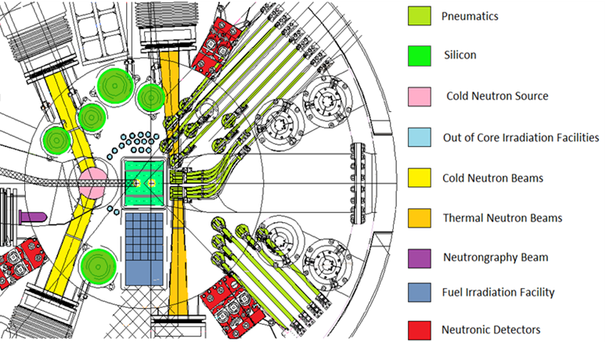
FIG. 4. Reflector Vessel

Second Shutdown system

Partial drainage of the Reflector Vessel fulfils the function of the Second Shutdown System, which is commanded by the Second Reactor Protection System, and provides an independent means of reactor shut down (see FIG. 5)

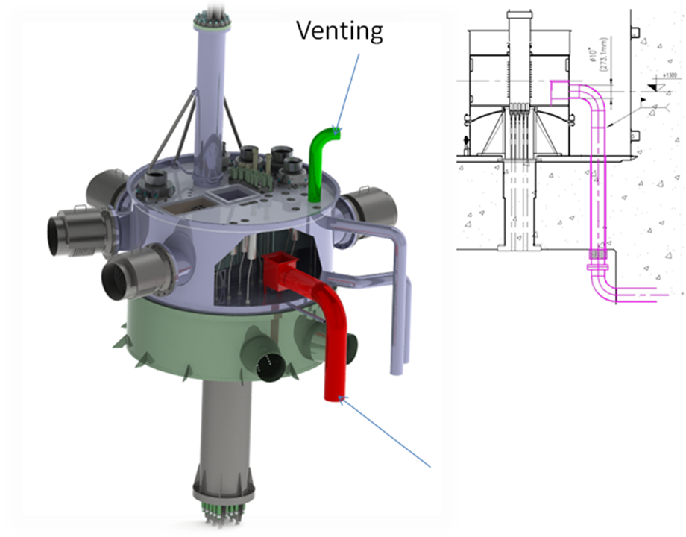

FIG. 5. Second Shutdown System

Core Structures

The reactor structures are a set of components that fulfill mechanical, neutronic and thermal-hydraulic functions associated with the core. On one hand they provide the needed mechanical support to the core, while on the other hand they are an integral part of the Core Cooling System (CCS). They also allow the collection and use of the neutrons produced in the core.
Surrounding the core is the Core Chimney that also constitutes the inner wall of the Reflector Vessel. The Reflector Vessel contains heavy water that acts as a reflector, and has penetrations for irradiation facilities, the CNS and beam assemblies. It has also a space filled with light water that houses a fuel irradiation loop.
The Riser is above the Reflector Vessel, with its support structure and a protection sieve to protect the core from falling objects. The Core Chimney and Riser bound the CCS water flow when passing through the core before it is extracted through the CCS outlet piping. The Reflector Vessel is supported by the Lower Plenum located below the core. (see FIG. 6.)
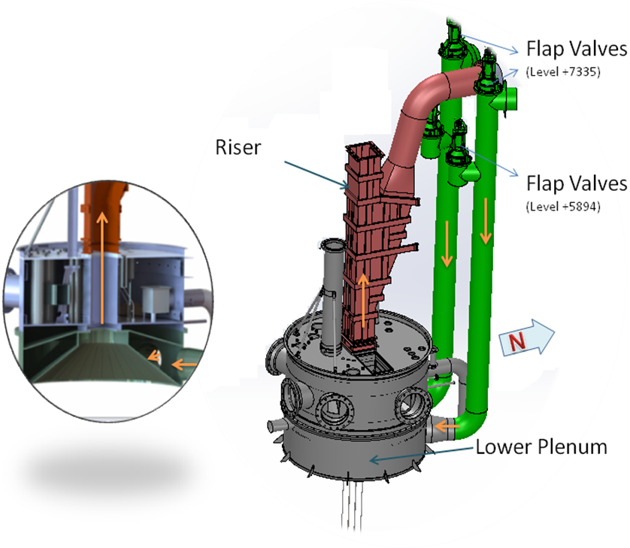
FIG. 6. Core Structures

The core inlet is provided with four flap valves located inside the Reactor Pool, two in each of the two pipelines. During normal operation, the four flap valves are maintained in the closed position by the pressure of primary coolant flow. On reactor shutdown, or pump or electric supply failure, loss of pump pressure results in the opening of the four flap valves. This opens up a flow path within the Reactor Pool, allowing the transfer of decay heat from the core to the pool water by natural circulation of pool water upward through the core.

Cold Neutron Source

The Cold Neutron Source consists of a liquid Deuterium moderator maintained at a temperature of around 20K, located close to the thermal flux peak in the Reflector Vessel, designed to yield neutron in the “cold” energy range. Neutrons moderated in this cold fluid are then transported through the neutron guides into the Reactor Beam Hall and the Neutron Guide Hall, where research facilities will be located.
The moderator is liquefied and maintained in the liquid state within a natural circulation Thermo-siphon loop, which has a heat exchanger and a cooling jacket fed with cryogenic Helium supplied by an active highly-reliable cryogenic system (see FIG. 7.)

FIG. 7. Cold Neutron Source - In Pile Components

Pools

The reactor building has two “in-confinement” pools, the Reactor Pool and the Service Pool. A large transfer channel connects the “in-confinement” Service Pool to an “out-of-confinement” pool, located in an adjacent building.

Reactor Pool

The Reactor Pool contains the core and associated structures, Chimney, Reflector Vessel, irradiation rig structures, neutron beam assemblies, Cold Neutron Source, part of the Primary Cooling System and the primary water inventory as shown in FIG. 8.

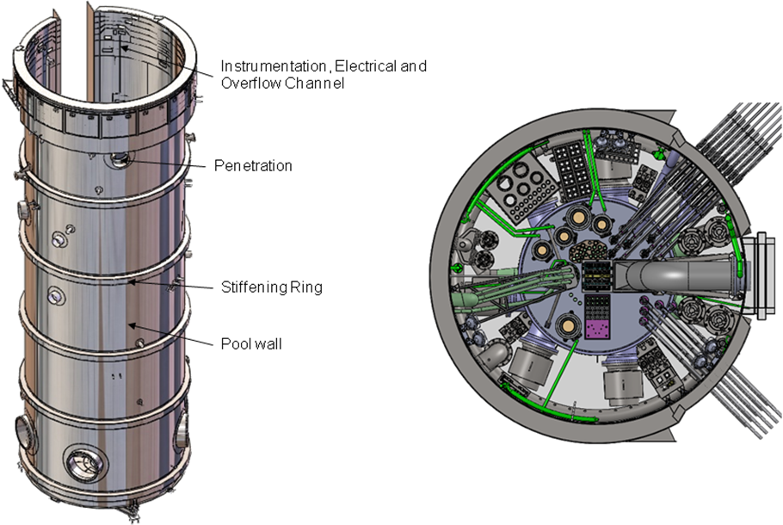
FIG. 8. Reactor Pool

In-Confinement Service Pool

The In-Confinement Service Pool provides shielding, cooling water, and working areas connected with the Reactor Pool by means of the Transfer Canal. The In-Confinement Service Pool contains storage space for the spent Fuel Assemblies (see FIG. 9.). It is also an area for handling irradiation rigs and allows communication with a Transfer Hot Cell by means of the Hot cell elevator.
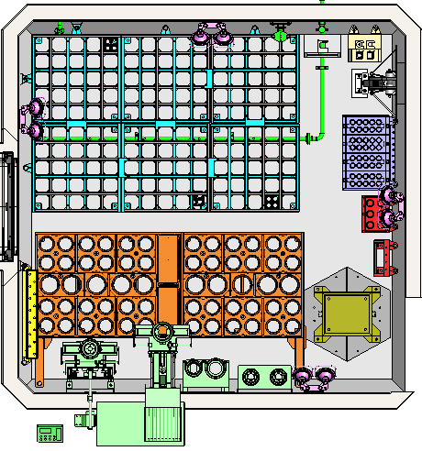
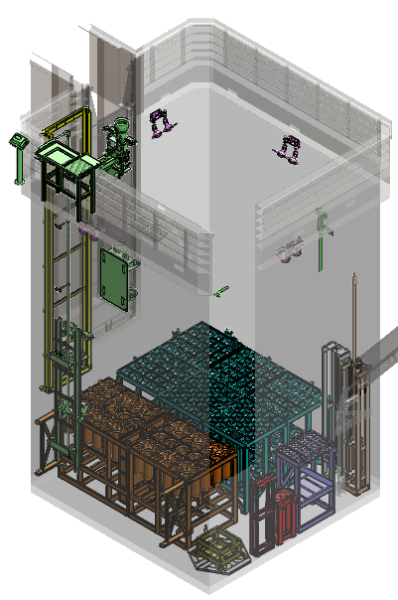

FIG. 9. In-Confinement Service Pool

Out of Confinement Pool

It is a pool located outside the reactor confinement area which intends to underwater storage of radioactive structures and spent fuel before transfer them to a dry storage. The Out-of-Confinement Pool is connected to the In-Confinement Pool through the Delivery Transfer Channel which has two isolation gates to maintain the physical and environment separation between the respective controlled areas (see FIG. 10.).

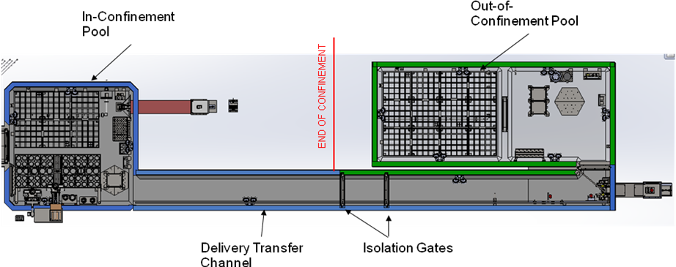

FIG. 10. Out-of-Confinement Pool

Cooling Systems

The Reactor Cooling System removes the heat generated in the Reactor core through direct cooling of the core and reflector, and cooling of the Reactor and Service pools. The heat is transferred ultimately to the atmosphere. The general layout of the cooling systems is presented in FIG. 11.

Core Cooling System

The function of the Core Cooling System is to remove the fission heat from the core in all operational and design basis accident conditions, maintaining the limits of the core below acceptance criteria for fuel and coolant temperature. The heat is extracted by the flow of demineralized cooling water through the core either by forced circulation when the Reactor is in Power State or by natural circulation when the Reactor is in Test, Shutdown or Refueling States. The Primary Cooling System pump discharge line has an interconnection with the Reactor and Service Pool Cooling Systems that diverts a fraction of the Core cooling flow to produce a downward flow at the top of the Chimney, preventing water, activated with nitrogen-16, from reaching the top of the reactor pool. The system includes a tank for nitrogen-16 decay. The heat extracted from the core is transferred to the Secondary Cooling System, directly through the heat exchangers of the Core Cooling System.

In Confinement Pools Cooling System

The In Confinement Pools Cooling System removes the heat from the Out of Core Irradiation Facilities (OCIF) and from the spent fuel in the Service Pool during all Reactor states, maintaining the Reactor Pool water within prescribed temperature limits.
The system removes heat from the OCIF and the spent fuels by forced circulation during the Reactor Power State and by natural circulation during the Reactor Test, Shutdown and Refueling States. The system is provided with a decay tank to allow for decay of nitrogen-16.
Heat from the In Confinement Pools Cooling System is transferred to the Secondary Cooling System via heat exchangers.

Heavy Water Cooling and Purification System

The Heavy Water Cooling and Purification System removes heat from the Reflector Vessel by forced circulation of heavy water, transferring the heat to an Intermediate Circuit, filled with demineralized water, which in turn transfers it to the Secondary Cooling System. The Intermediate Circuit provides physical isolation between the Heavy Water Cooling and Purification System and the Secondary Cooling System.
The system maintains the purity of the heavy water. A helium cover-gas atmosphere is used for the heavy water. The helium gas is circulated through the Deuterium Recombination System to keep the Deuterium and Oxygen concentrations below the flammability level of the mixture.
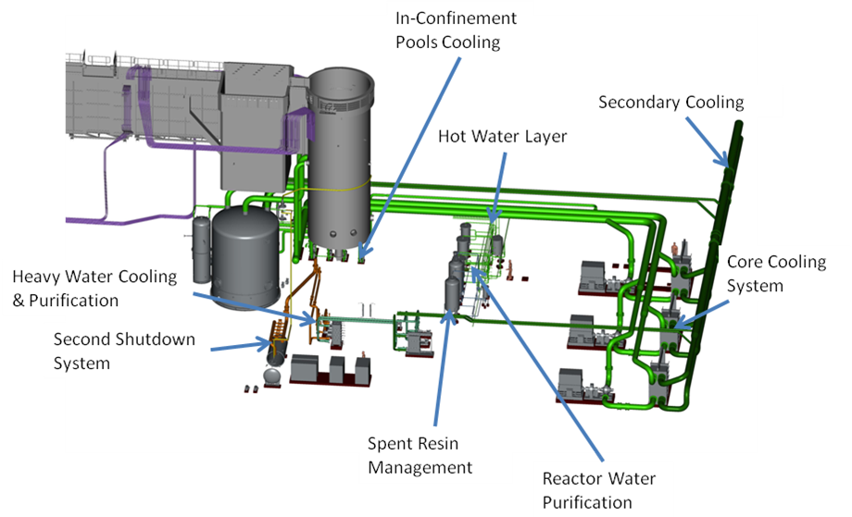
FIG. 11. Cooling Circuit layout

Reactor Block

The Reactor Block refers to the reinforced concrete structure which houses Reactor Pool, In-Confinement Service Pool, Out-of Confinement Pool, Delivery Transfer Channel, Control Rod room, Decay Tank room and rooms for resin purification. Hot Cells for bulk irradiation production, Pneumatic Hot Cells and Rig Manoeuvring are integrated with the Reactor Block. The reactor block and these adjacent structures are built using high-density concrete (i.e., containing special ore aggregates) to enhance their efficiency as radiation shields (see FIG. 12.)

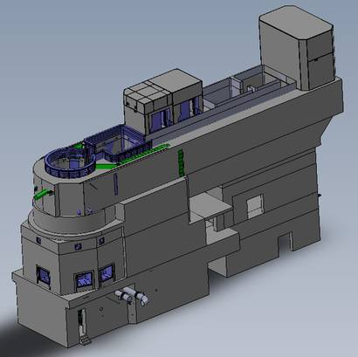
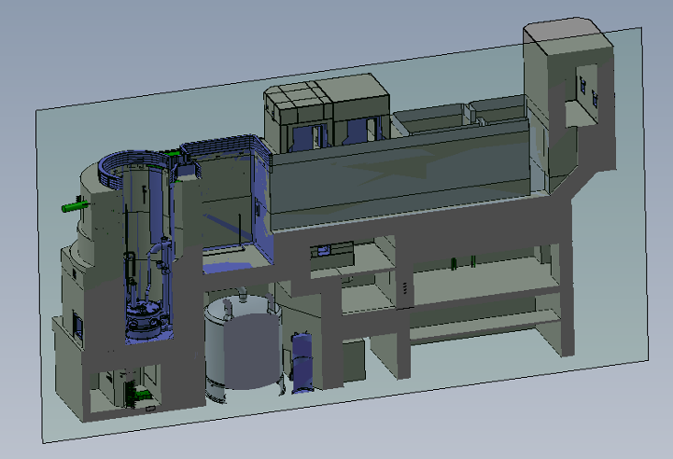
FIG. 12. Reactor Block

Neutron Beams and Shutters

Neutron guides are used to transport neutrons from the high intensity neutron source located in the Reflector Vessel to the research instruments located in the Reactor Beam Hall and the Neutron Guide Hall. Neutron beam facilities of the Reactor Facility include:
- Cold and thermal neutron source systems.
- Neutron guides for thermal and cold neutrons.
- Neutrography Facility
- Neutron beam shutters.
Each thermal neutron beam assembly can hold three thermal guides in the same horizontal plane. Each cold neutron beam assembly can hold three cold neutron guides in the same horizontal plane.
All neutron beams have Primary Shutters installed at the reactor block face. The Primary Shutters are movable shields that, when closed, interrupt the radiation flow along the beams allowing maintenance operations on the neutron guides or on the neutron research instruments to be carried out safely. In the open position the shutters let the neutron beam pass through (see FIG. 13.).

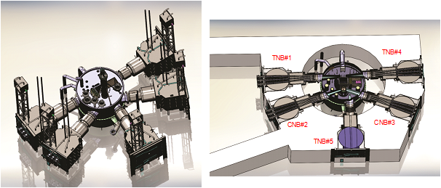

FIG. 13. Primary Shutters

Irradiation Services

The following irradiation facilities, laboratories and hot cells are provided:
- Neutron Transmutation Doping Irradiation Facilities
- Bulk Production Irradiation Facilities
- Pneumatic Irradiation Facilities and Labs
- Fuel Irradiation Facility
- Shielded Hot cells for target loading, unloading and transfer to the radioisotope production plant and to handle fuel testing irradiation rigs

Radioisotopes are produced by introducing targets into dedicated irradiation positions in the reflector vessel.

Neutron Transmutation Doping Facilities

These facilities are primarily used to irradiate silicon ingots of 6” and 8” diameter. After irradiation, silicon is placed for temporary storage in the service pool for partial decay, then removed and transported in a suitable cart to the Silicon Processing room.

Bulk Production Irradiation Facilities

The facility is designed with the capacity to produce up to 3000 Ci of molybdenum 99 per irradiation position at the end of irradiation. Those targets used to obtain molybdenum 99, are irradiated inside special rigs which are manually loaded into the bulk production irradiation positions of the Reflector Vessel, as indicated in section 4.1. Irradiated rigs are manually moved to the In-Confinement Service Pool for partial decay before they are transferred to the Transfer Hot Cell by means of the Elevator channel.

Pneumatic Irradiation Facilities

- Long Time Irradiation Facility
Material targets with low heat load and low activity are irradiated inside sealed aluminium cans that are transported to and from the Reflector Vessel by means the Pneumatic Transport Systems operated by nitrogen gas. The Pneumatic Transport System for Aluminum Cans comprises nine (9) irradiation rigs, namely:
- 7 thermal neutron flux rig, making 21 thermal neutron flux irradiation positions
- 2 fast neutron flux rigs, making 6 fast neutron flux irradiation positions
The nitrogen gas also provides for the cooling of the cans.
Can loading and unloading tasks are achieved by means of a specially designed terminal station located inside a Pneumatic Hot Cells provided next to the In-Confinement Service Pool. A Decay Station allows for the decay of short-lived activation products prior to their transference to the Radioisotope Production Facility.
- Short Time Irradiation Facility
This system is suitable for short exposure periods; irradiation times in the range from 3 seconds to some minutes being achievable.
Irradiated targets contained in plastic cans are transferred from the reflector vessel by the pneumatic system, to the Radiochemical laboratory (for DNAA and CNAA) which is provided with a loading/unloading station inside a radiochemical hood.

Fuel Irradiation Facility

Fuel irradiation rigs and loops can be allocated near the core to study the fuel behavior under irradiation, involving a high neutron flux. It allows simulating thermal-hydraulic conditions (pressure, temperature) and coolant chemistry, reproducing the typical conditions that can be found in light water reactors. The design allows the utilization of movable devices for the production of power ramps. Loading and unloading of the rigs are performed in an especially dedicated Loop Hot Cell provided next to the Out-of-Confinement Pool.

Shielded Hot Cells

The operation in hot cell includes the safe handling of irradiated materials and their transfer for processing at other buildings (see FIG. 14.).
The facility has four shielded Hot Cells built in high density reinforced concrete:
- Transfer Hot Cell: to receive the active material from the Reactor and Service Pools
- Pneumatic Hot Cell: to serve the pneumatically operated transfer system
- Loops Hot Cell: to handle active portions of the fuel testing irradiation rigs.
- Dispatching Hot Cell: to transfer Molybdenum and other targets to transfer casks

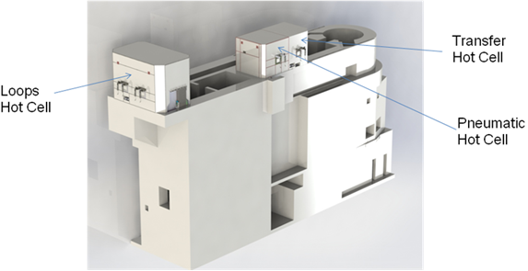

FIG. 14. Hot Cells

Conclusions

The RMB reactor will play a central role in Brazil, producing radioisotopes for cancer detection and treatment. With the RMB, Brazil envisages to become self-sufficient in the reactor radioisotope production to cover the national needs of the nuclear medicine radiopharmaceuticals.
The high neutron flux, irradiation capabilities and neutron beams for fundamental materials research gives to the RMB the position of an advanced research reactor in the world.

