FPGA Based Reactor Protection System Architecture

C.A. Verrastro, D.S. Estryk, G.F. Rodriguez, F.N. Ferrucci, J.E. Alarcón, G.E. Ríos, J.J. Lee

Instrumentación y Control - Centro Atómico Ezeiza - Comisión Nacional de Energía Atómica

cverra@cae.cnea.gov.ar

Abstract. Research Reactors (RR) and Nuclear Power Plants (NPP) require a simple, fast, reliable and easy to repair Reactor Protection System (RPS). These requirements can be fulfilled using old hardware architectures. However, in modern plants new requirements have been added during the last 20 years. These new features include online monitoring, easy configuration and automatic failure detection among others.
It is not feasible to include these new features in old hardware architectures as it quickly increases in complexity and power consumption. On the other hand, safety-related computer-based I&C systems must undergo a Verification and Validation (V&V) process, following the corresponding standards and regulations. Software complexity makes the V&V of computer-based I&C systems time consuming and expensive.
Supported by our previous experience on safety functions implementation for RA-1 and Central Nuclear Atucha II (CNAII), we propose a full hardware protection system based on Field Programmable Gate Array (FPGA) technology that achieves all the features required in a modern nuclear plant
RA-10 design has a triple-redundancy RPS in 2oo3 configuration. As most RPS, interchange data between redundant trains are needed for voting. Independency, isolation requirement and wiring complexity are fulfilled using serial transceivers over optical fiber. One-way communication protocol was design to be processed by simple state machines on FPGAs. These one-way communication channels serve as an insulation layer between redundant trains and other systems.
The goal of a simple hardware design is achieved using FPGAs, finite states machines and one-way communication channels. However, the new requirements add complexity that increases common cause failures. To address this problem, diverse implementation of complex modules (FPGA modules) run in parallel in each redundant channel.
In this paper we describe the system design, the problems faced during the design process and our approaches to solve them.

1. Introduction

A Reactor Protection System’s (RPS) primary goal is to ensure fulfilment of the safety functions of a nuclear reactor: reactivity control, heat removal and the confinement of radioactivity [1].

The RPS contains a set of components that automatically demand the actuation of front safety systems to guarantee that design specifications are not exceeded. The RPS has priority over the Reactor Control System (RCS).

The RPS of the Argentinian Reactor RA-10 has four protection actions with the associated trigger logics. Those protection actions are:
- First Shutdown System (FSS): drops all control and safety rods (SCRAM)
- Second Shutdown System (SSS): partial drainage of heavy water from the reflector tank to the storage tank
- Ventilation reconfiguration associated with the reactor confinement
- Evacuation alarm

The RPS performs the following functions:
- Monitors the evolution of variables and detects deviations beyond safe limits
- Implements the trigger logic that initiates the protective actions necessary to bring the reactor to a safe state
- Displays variable values and the internal state in control rooms
- Provides the operator with a manual trigger of the protection actions

RPS functions are classified as “Category A” as defined in IEC 61226 [2]. To reach this classification, the subsequent design criteria have been followed [3] [4]:
- Redundancy: provision of alternative components; any one of which can perform the required function, regardless of the state of operation or failure of any other component. RA-10 RPS has triple-redundancy with a 2 out of 3 (2oo3) configuration
- Fail-safe: design that prevents or mitigates unsafe consequences of failures
- Single failure criterion: systems perform all required safety functions for a design basis event in the presence of the any single failure [5]
- Design simplicity: the simplest solution that meets the requirements is chosen
- Well known technology
- Separation: systematic use of physical separation and decoupling devices to protect against Common Cause Failures (CCF) and to prevent fault migrations from one redundancy to another
- Independence: any single failure should affect only one redundancy
- Diversity: use of more than one physically or functionally different means of performing the same function to protect against certain types of CCF

In this work, the architecture of RA-10 RPS will be explained. Section describes the issues concerning FPGA utilization in safety systems and its antecedents. Section explains CNEA RPS architecture. Section details the diverse FPGA implementation approach. Section shows the dual Final Actuation Logic (FAL) configuration. Finally, section concludes the present work.

2. FPGA based RPS

Research Reactors (RR) and Nuclear Power Plants (NPP) require a simple, fast, reliable and easy to repair protection system.

Traditionally, Instrumentation and Control (I&C) systems were analog-based. In the 1980s and 1990s, computer-based I&C systems were developed adding many advantages compared with older analog-based systems (eg. thermal and ageing drift issues). Moreover, computer-based I&C systems contain many advanced features, including some automatic functions, which analog-based systems cannot provide [6].

Conversely, safety-related computer-based I&C systems must undergo a Verification and Validation (V&V) process, following the corresponding standards and regulations. Software complexity makes the V&V of computer-based I&C systems time consuming and expensive. In addition, computer-based systems use micro-processors which have short product life cycles compared with those in the nuclear industry.

Field Programmable Gate Array (FPGA) has been developed in the semiconductor industry, beginning in the 1990s. Unlike ordinary semiconductor devices or Application Specific Integrated Circuit (ASIC), logic circuits implemented with FPGAs can be determined or configured after they are shipped from semiconductor foundries. Therefore, FPGAs are suited for low volume applications, such as those in the nuclear industry.

There is a fundamental difference between FPGA-based systems and microprocessor-based systems. Since FPGAs are parallel by nature, their internal array elements can operate simultaneously, whereas microprocessors can only perform one function at a time. This parallel nature of FPGAs makes it not only higher performing, but also less complex than any microprocessor-based system since it eliminates the need for context switching and memory access [7].

Generally speaking, FPGA-based I&C systems are much simpler than computer-based I&C systems, which makes V&V efforts more attainable and affordable [6].

In addition, FPGA vendors tend to offer long term support of their products compared with microprocessor vendors. Also, designs are easily portable among platform using standard Hardware Description Languages (HDL), such as VHDL and Verilog.

Moreover, for the implementation of simple functions, there are devices called Complex Programmable Logic Device (CPLD) that are comparable to but smaller than FPGAs.

Due to the aforementioned benefits, at the end of 1990s, CNEA I&C chose CPLD/FPGA as the next generation RPS main device for RRs and NPPs. The basic RPS architecture for the CAREM NPP was designed during this period [8] [9].

In 2003, CNEA I&C developed and installed a replacement module for an obsolete Voting & Trip Logic for the RR RA-1 based on CPLD.

In 2009, the CAREM project selected CNEA I&C to provide the First RPS. At that time, the early-1990 architecture was updated. The main change was the substitution of the microprocessor that worked in parallel with the FPGA by an additional diverse FPGA. This architecture is the main topic of this work and will be explain in Sections and .

In 2011, CNEA I&C developed and implemented an Alternative Instrumentation for Atucha II NPP Boron Injection Safety System (SIA) based on the same architecture. In-factory System integration verification was carried out during 2012 and 2013. This process demonstrated the robustness and high reliability of the architecture.

A triple-redundant version of the CNEA I&C RPS architecture will be used in RR RA-10. At this time, the detail engineering is being carried out.

A recent survey [10] summarizes the latest international implementation of Safety Functions on FPGA-based systems.

Finally, it is important to note that in 2012, IEC 62566 was published [11]. This Standard deals with FPGA utilization for NPP “Category A” functions. CNEA I&C is following this recommendation to develop FPGA-based modules of the RPS.

3. CNEA RPS Architecture

FIG. 1 shows the Triple-Redundant RPS Architecture for RA-10.

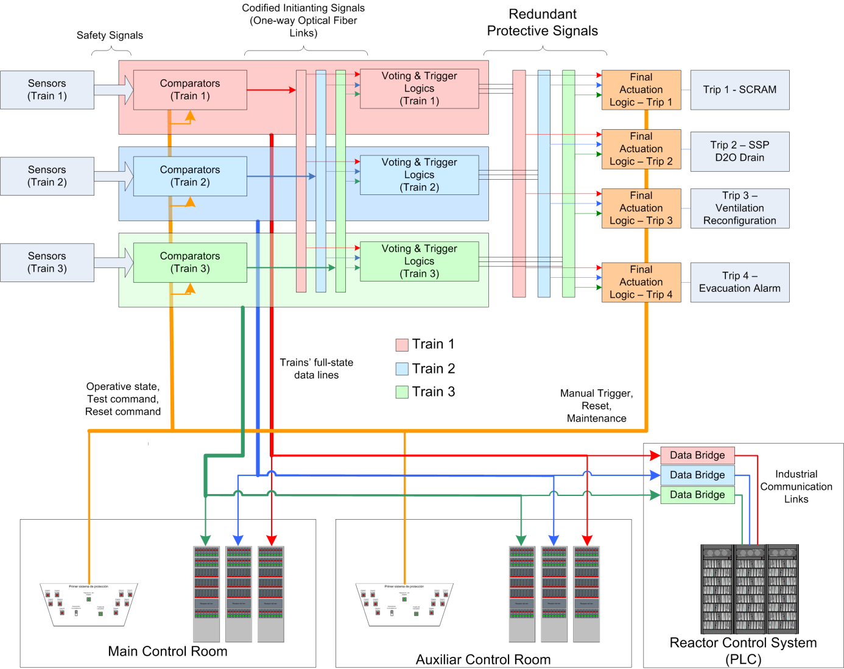
- RPS Architecture for RA-10.

The RPS continually monitors the safety signals. Each redundant train basically comprises an exclusive group of sensors, a comparators unit and a voting & trigger unit.

Safety signals are digitalized and compared with corresponding set-points. The comparison results are called initiating signals. When a safety signal exceeds its set-point (threshold value), the initiating signal turns to trigger state.

These initiating signals are interchanged between all the three trains, in such a way that each voting & trigger unit receives the three groups of signals. At the voting & trigger unit, the three redundant initiating signals, corresponding to the same type of safety signal, are voted in a 2oo3 logic. The voted initiating signals are used by the protection logics in order to generate the protection signals 1 to 4.

Each train generates its own set of protective signals. Each of them goes to one FAL associated to a particular protective action where a final 2oo3 hard-wired voting is performed.

There are a set of commands that are located in control and auxiliary rooms. With those commands the reactor operator can set the operative state of the reactor, manually trigger each protective action, reset them once the reactor is in safe state, select a train for maintenance and execute some test procedures.

Each of the three redundant trains provides three isolated data lines with the full state of the particular train. Two of those lines go to RPS visualization panels located in main and auxiliary control rooms, respectively, and the last one goes to RCS. A data bridge reads the RPS proprietary data link protocol and converts it to a standard industrial protocol. The data bridge unit is part of RCS, so its function has a safety classification “Category B”.

4. Diverse FPGA Implementation

The CCF is an important issue in safety systems based on software and FPGA technology. It is known that the implementation of diversity reduces the probability of CCF occurrences (IEC 61508 Part 7 Section B.1.4 [12]).

The diversification styles used are detailed below in Table I. Two diverse implementation of the digitalization module for SIA project are shown in FIG. 2.

TABLE I: Diversification styles used in CNEA I&C RPS implementation.
Diversification styles | Diverse Set A | Diverse Set B
Designers | Group A | Group B
FPGA Manufacture | Xilinx | Actel
FPGA Technology | SRAM | Flash
FPGA Design Software | Xilinx ISE | Libero IDE
PCB Technology | 4 layers | 2 layer
ADC Manufacture | Maxim | Analog Device
Voltage Reference Manufacture | Maxim | Analog Device
Operational Amplifiers Manufacture | Texas Instruments | Linear Technology

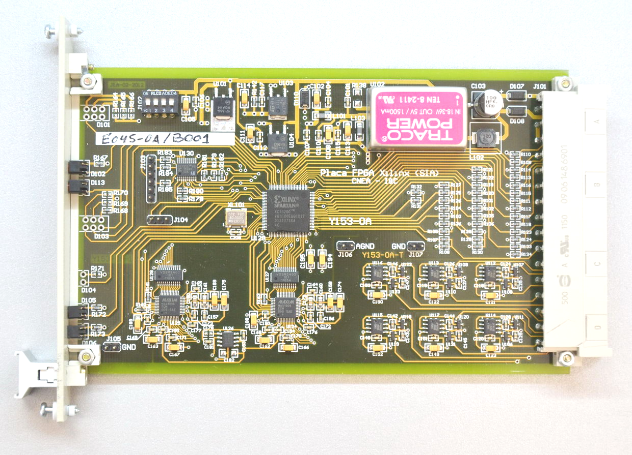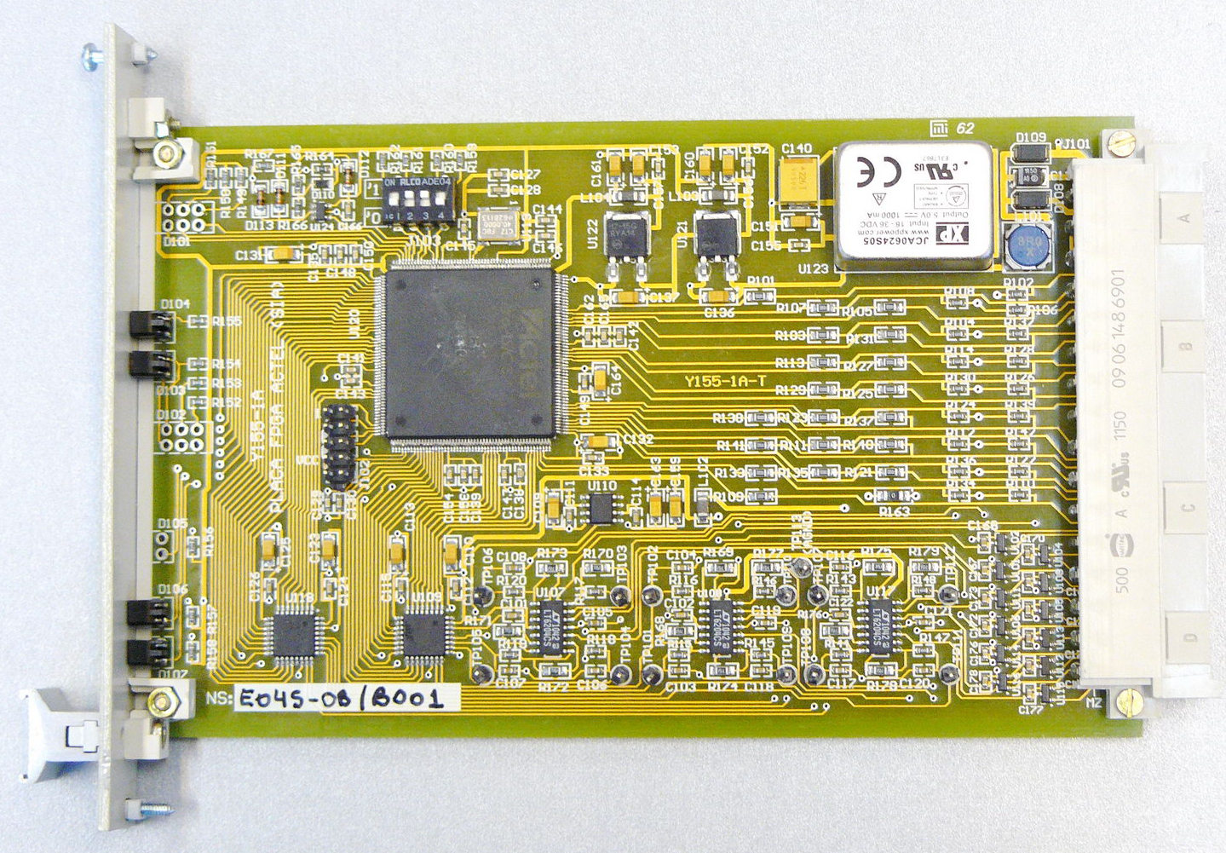
- Two diverse implementation of the digitalization module for SIA project

A train diagram block is shown in FIG. 3. Each safety signal is acquired by two diverse digitalization modules. The digital values are compared with the corresponding set-points by two diverse comparator modules. Each of them processes the whole set of safety signals and generates a set of diverse initiating signals. The output of each comparator is a serial stream which is sent to the other trains by independent optical fibers. This implementation saves the complex routing of hundreds of individual isolating signals.

Additionally, the diverse comparators perform a real time cross-verification of the initiating signals between each other in order to detect failures. The failsafe criteria are applied so that each diverse module forces the initiating signals to trigger state if discrepancies are detected. The short time of failure detection maximizes the effectiveness of diversity [13].

In each train, the voting & trigger module receives optic fiber lines with the state of the initiating signals from the other two trains' comparator units and with the information of its own comparator. With all this information, it performs a 2oo3 logic for each initiating signals type, as can be seen in FIG. 4. Voted initiating signals are used by protection logics to generate protective signals 1 to 4.

A diverse voting & trigger module does the same but with the other set of initiating signals (see FIG. 3).

Finally, the protective signals go from both diversities to driver modules and are then routed to the corresponding FALs.

Besides the main trip path, there are some modules and data signals for online monitoring and auto-verification functions. Comparators and voting modules provide full-state internal information by means of one-way serial data links. A data hub collects whole information from these links and makes a single serial data line with the full information of the train. This information is replicated in three optical fibers to provide information to the visualization panels in the control rooms and to the RCS. Moreover, the data hub compares the information acquired between diverse sets, providing early alerts in real-time (eg. discrepancies between diverse ADC digitalization without trip).

All data lines flow in one direction over point-to-point links with only one transmitter per line. These communication channels are based on deterministic behavior using fixed frames, specific interval repetition, cyclic redundancy check (CRC) and timeouts. Moreover, receivers process statistics of communication errors for early failure detection.

This simple communication design avoids the complexity of using neither media access control nor schemes such as master-slaves, and is suitable to be implemented in FPGA with small finite state machines.

Following the simplicity criterion, the reactor operator has very few RPS inputs to interact with. Basically, these are digital (binary) lines for: operative state setting (that selects of group of set-points), reset, test and maintenance commands. Manual triggers are routed directly to FALs.

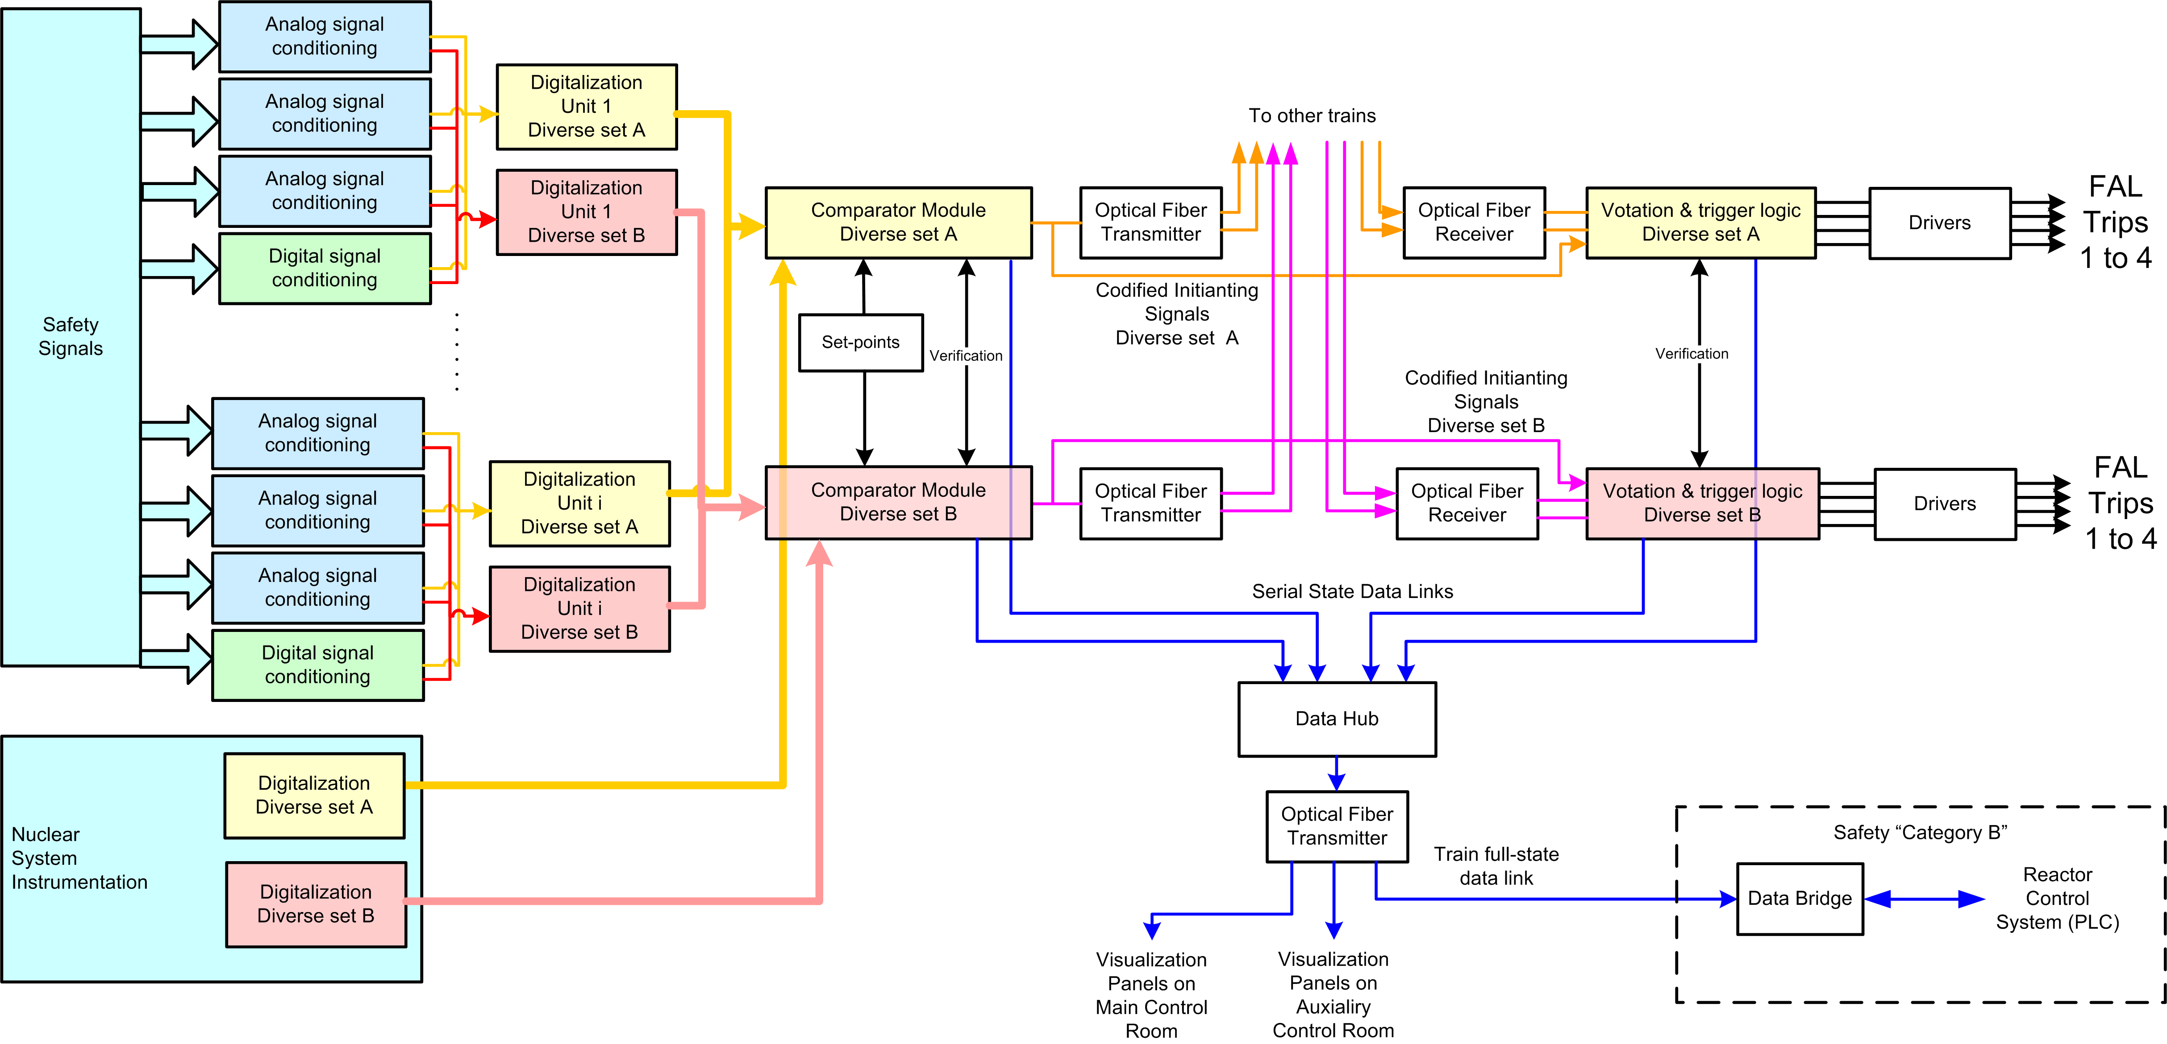
- Train diagram block.

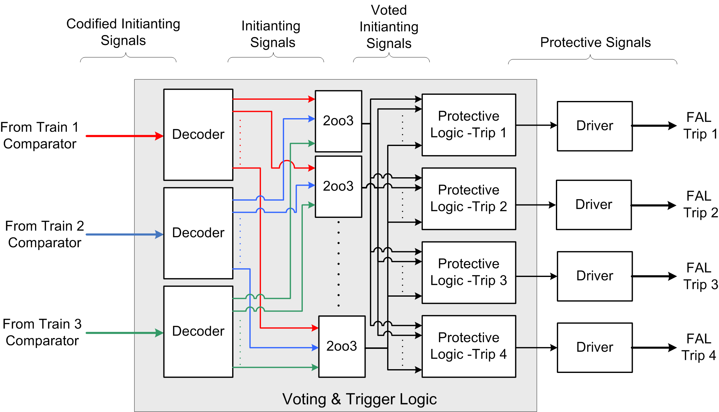
- Voting & Trigger Logic Diagram Block

5. Dual FAL Implementation

For RA-10 and CAREM RPS, dual FAL implementation is proposed, taking advantage of diverse sets of protective signals for each trip. FIG. 5 shows how these signals are routed.

This implementation solves a bottleneck in the reliability analysis from a previous scheme where diverse sets of protective signals were resolved in the driver modules using 1oo2 logic.
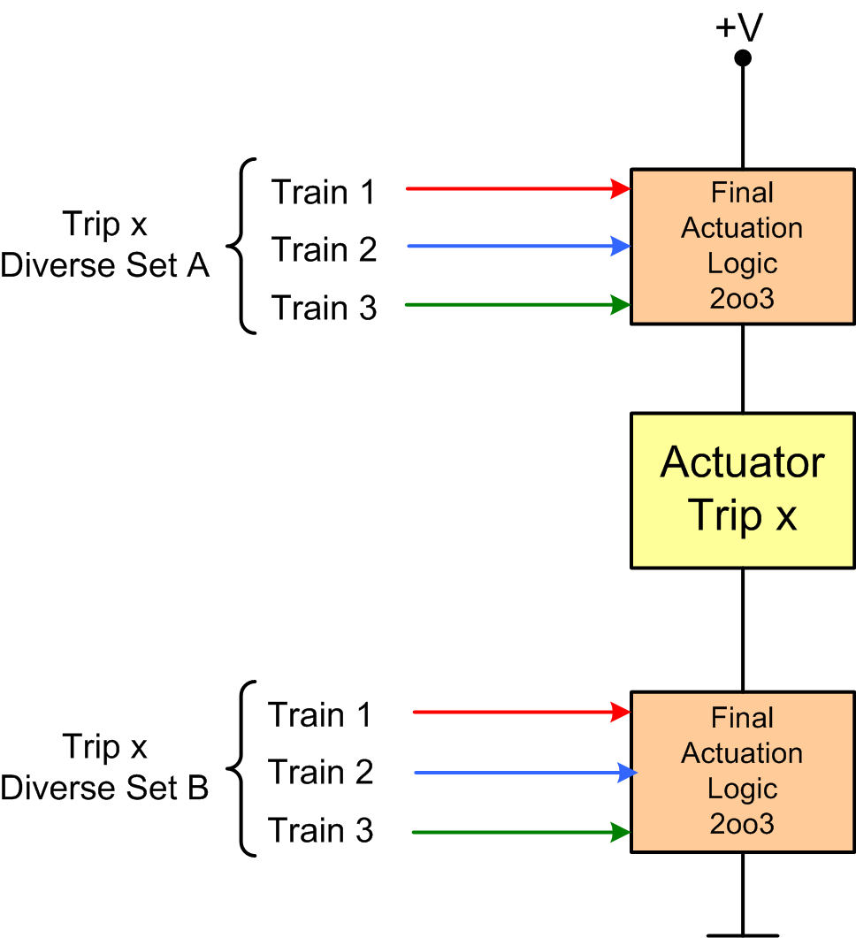
- Dual FAL implementation.

6. Conclusions

The use of FPGA technology, as the main component of RPS design, has proven to be very effective both locally and abroad. The numerous advantages FPGA offers have made it the preferred selection of many companies around the world.

The goal of a simple hardware design was achieved by using FPGAs, finite states machines and one-way communication channels. However, the new requirements in modern RPSs add complexity which in turn increases CCFs. To address this problem, the concept of diversity was implemented with FPGA modules running in parallel in each redundant train. The effectiveness of this diversity scheme is maximized thanks to real time cross verification between diverse modules.

The requirements for independence, isolation and wiring complexity reduction are fulfilled using serial transceivers over optical fiber. One-way communication protocol was designed which allows the implementation of the transmitter and receivers using simple state machines on FPGAs. These one-way communication channels serve as an insulation layer between redundant trains and other systems. This implementation saves the complex routing of hundreds of individual isolating signals.

7. References

- INTERNATIONAL ELECTROTECHNICAL COMMISSION, “Nuclear power plants - Instrumentation and control important to safety - General requirements for systems”, IEC 61513 Ed.2 (2011).
- INTERNATIONAL ELECTROTECHNICAL COMMISSION, “Nuclear power plants - Instrumentation and control important to safety - Classification of instrumentation and control functions”, IEC 61226 Ed.3 (2009).
- INTERNATIONAL ATOMIC ENERGY AGENCY, “IAEA Safety Standards Series. Instrumentation and Control Systems Important to Safety in Nuclear Power Plants Safety Guide”, NS-G-1.3 (2002).
- INTERNATIONAL ATOMIC ENERGY AGENCY, “Modern Instrumentation and Control for Nuclear Power Plants: A Guidebook”, Technical Reports Series No. 387, Vienna (1999).
- INSTITUTE OF ELECTRICAL AND ELECTRONICS ENGINEERS, “IEEE Standard Application of the Single-Failure Criterion to Nuclear Power Generating Station Safety Systems”, IEEE Std 379-2000 (R2008).
- MIYAZAKI, T., et al., "Qualification of FPGA-Based Safety-Related PRM System", International conference on opportunities and challenges for water cooled reactors in the 21. century; IAEA-CN-164, Vienna (2009)
- UNITED STATES NUCLEAR REGULATORY COMMISSION, “Instrumentation and Controls in Nuclear Power Plants: An Emerging Technologies Update”, NUREG/CR-6992 (2009).
- VERRASTRO, C.A., et al., "Arquitectura del Primer sistema de Protección de Reactor", AATN XXII, Argentine (2000)
- VERRASTRO, C.A., et al., "Reactor Protection System, Diverse Approach", International conference on research reactor utilization, safety, decommissioning, fuel and waste management, IAEA-CN-100, Chile (2003).
- RANTA, J., "The current state of FPGA technology in the nuclear domain", VTT Technology 10, Espoo (2012).
- INTERNATIONAL ELECTROTECHNICAL COMMISSION, "Nuclear Power Plants -Instrumentation and Control Important to Safety - Development of HDL-Programmed Integrated Circuits for Systems Performing Category A Functions", IEC 62566 (2012).
- INTERNATIONAL ELECTROTECHNICAL COMMISSION, “Functional safety of electrical/electronic/ programmable electronic safety related systems. Overview of techniques and measures”, IEC 61508-7 (2010).
- SUBHASISH, M., et al., “A design diversity metric and reliability analysis for redundant systems”, Test Conference 1999, IEEE Proceedings International (1999).

