Mechanicals description of RA-10 Reactor and Service Pool and main Core Components

A. Coleff^{1,2}, I. Block³

- Centro Atómico Bariloche CNEA, Av Bustillo km 9,5 San Carlos de Bariloche, Río Negro, Argentina, CP 8400
- Instituto Balseiro UNCUYO, Av Bustillo km 9,5 San Carlos de Bariloche, Río Negro, Argentina, CP 8400
agustin.coleff@cab.cnea.gov.ar
- INVAP SE, Av. Comandante Luis Piedrabuena 4950, San Carlos de Bariloche, Río Negro Argentina CP 8400
IBlock@invap.com.ar

Abstract. New Argentinean Research Reactor RA-10 is currently being designed under the supervision of CNEA and having INVAP SE as main contractor. This multipurpose open pool reactor will be used for basic sciences in the study of materials and other applications such as the production of radioisotopes for medical and industrial use.
Within the major mechanical components, leading to a challenge by engineering groups, there are the Reactor and Service Pools along with their connections, the reactor core grid and support, the Reflector Tank and the pneumatic transport systems.
The presentation will expose the bases, criteria and standards in the design of the described components. They will show results of FEM modeling Reflector Tank and describe the operation of the pneumatic transport system.

Key Words: Reactor and Service Pool, Reflector Tank, Core Support and Grid, Pneumatic System

1. Introduction
Within the Argentinean Nuclear Programme [1] leaded by the National Commission of Atomic Energy (CNEA), a new multipurpose research reactor is being designed and developed. The RA10 is without a doubt one of the most challenging and exciting projects that CNEA has been engaged in the last couple years. This new reactor is expected to reinforce the RA-3 reactor (1967) with greater capabilities for radioisotope (RI) production to meet the domestic and overseas demand, increasing the production of Molybdenum-99 (no less than 2500 Ci/week) as well as the Lutetium-177 and Iridium-192 production.

The RA-10 reactor will also foster the Argentinean capabilities of carrying on applied research in different fields (i.e. Material Science, Medicine, Biology, etc) based on the use of neutron techniques through thermal and cold neutron beams that are a key core of the reactor design. CNEA is also very interested in becoming a strong player within the nuclear fuel industry and is in this endeavor that the RA10 reactor will provide the structure needed to develop and test new fuel elements including mini-plates, MTR and NPP fuel assemblies.

The RA-10 reactor is then conceived as a multipurpose facility suitable for RI production, materials and fuel irradiation, neutron techniques applications and silicon doping. The core consists of a rectangular array of MTR type fuel and the produced thermal power is 30 MW. The thermal power is extracted by the refrigeration system via an ascendant light water flow through the core. The core is surrounded by a watertight tank containing heavy water acting as a neutron reflector. The tank is fully made of Zirconium Alloy and several tubes of different diameters go across it to hold the irradiation facilities present at normal operation.

One of the main characteristics of the RA-10 reactor is that have two safety and independent shutdown systems. The first one is by inserting neutron absorbing material in the core. The second shutdown system is the partial emptying of the Heavy Water Reflector Tank

Within the design challenge of the mechanical components, are to complying with the design basis imposes by neutron, process, instrumentation and safety requirements.

2. General Considerations

2.1 Coordínate System

The origin (0,0,0) of the coordinate system of the project is located at the upper side of the bottom plate of the Reactor Pool. The positive direction of the “x” axis points toward the Service Pool, the positive directions of the “z” axis points toward upward, and the “y” axis follows “Right Hand” rule.

3. Basis and criteria of mechanical main RA-10 components.

3.1 Reactor and Service Pool

The Reactor is an atmospheric open tank, connected by a Transfer Channel, to the Service Pool filled with light water. The Service Pool is connected with two Hot Cells.

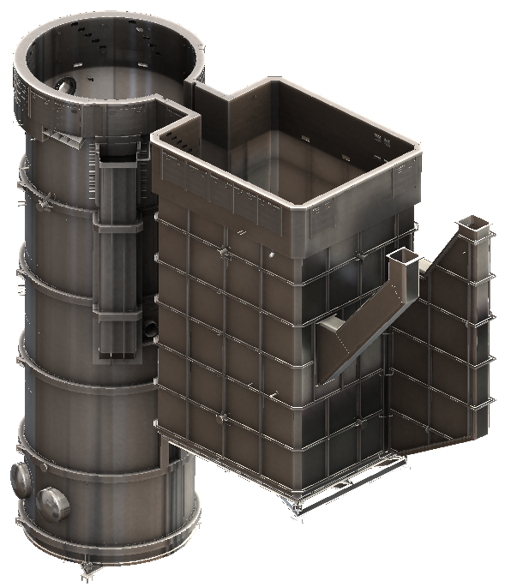
FIG. 1. Reactor and Service Pool.
The main Design Basis of the Reactor Pool is:
- Contain the core and structures, irradiation facilities, nucleonic instrumentation, and all other components required within the Reactor Pool.
- Keeping water inventory required by the core cooling systems and pool cooling system.
- Serve as biological shielding of radiation from the reactor core and internals.

The main Design Basis of the Service Pool is:
- Contains the Spent Fuel Element Container and Irradiation material
- Allow underwater transport of active materials to and from the hot cells, by interconnecting passages.
- Serve as biological shielding of radiation from the Spent Fuel Elements and irradiated materials storage.

To complying with the Design Basis the following Design Criteria was adopted:
- The Reactor Pool design must consider the mechanical fasteners for holding Core structure and upper chimney , Cooling Systems , the Cold Neutron Source, Neutrons Beams (cold and thermal), the Irradiation Testing Facilities , Pneumatic System for Analysis Neutron activation , containers for instrumentation, and all other internals.
- The Reactor Pool will be connected at its base to the Mechanisms Room, through mechanism penetrations, to allow the pass through of the control rods, the Fuel Elements fastener, and the core grid fasteners..
- The Reactor and Service Pool will have an external leak detection system.
- The Reactor and Service Pool shall be design to withstood the hydrostatic pressure, mechanical load from the Internals, transport and mounting conditions.
- A Transfer Channel connects the Reactor with the Service Pool.
- In the Reactor Pool, all the main process connections must be over the Siphon Break level.
- In the Service Pool, all the connections must be over the bottom level of the Transfer Channel.

The Reactor and Service Pool are designed following the ASME III ND code. The ASME III ND code defined the requirements for construction solutions, degree of testing and inspections and the criteria for stress analysis. The stress classification of ASME III NB or ASEM VIII Div 2 was adopted, when the design solution is required.
Table I list the main characteristics of the Reactor and Service Pool.

Design at a Basic Engineering of the Reactor and Service Pool are described following. (See Figure 1 and Figure 2)
- The Reactor Pool and Service Pool have vertical and horizontal stiffener Rings; they allow to transfer the mechanical loads directly to the Reactor Block.
- The Reactor and Service Pool have internal process piping connected over the siphon breaker level.
- At the Upper part they have the Instrumentation Channels. (See Figure 4)
- And independent Leveling Frame is design to allow the correct mounting and leveling.
- The Reactor Pool and Service Pool have internal supports for internal structures.

TABLE I: Reactor and Service Pool – Main Characteristics

Description | Reactor Pool | Service Pool
Design Code | ASME III ND | ASME III ND
Vessel Type | Vertical Cylinder | Rectangular
Design Temperature | 60 °C | 60 °C
Design Pressure | Atm | Atm
Ends | Top: Open  Bottom: Flat | Top: Open  Bottom: Flat
Main Dimensions | ID: 4500mm  Length: 14100mm | Internal Section: 4500mmx5300mm  High 7300mm
Weight (Empty) | 23 TN | 17,6 TN
Material | Stainless Steel 304/304L | Stainless Steel 304/304L
Main Thickness | 6mm /12mm | 6mm/12mm
Connection/Opening | 94 | 47
Internal Supports | 264 | 201

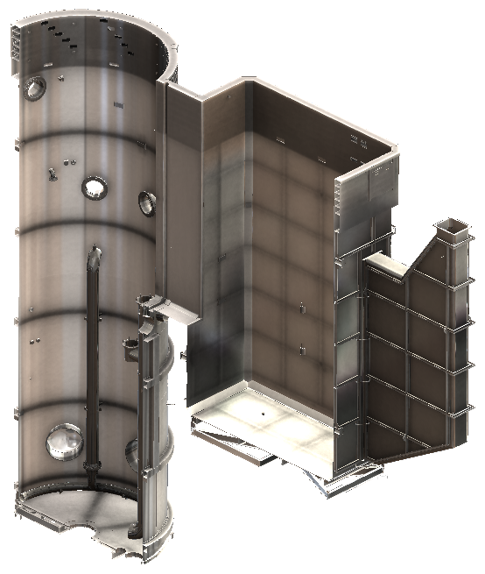
FIG. 2. Reactor and Service Pool – Isometric View

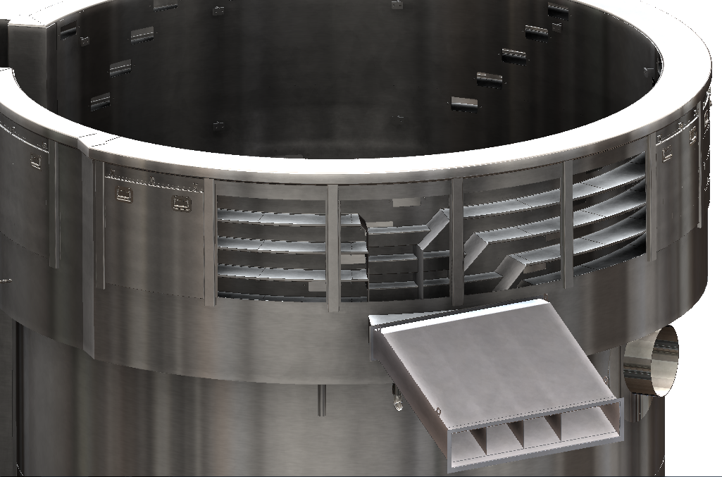
FIG. 4. Reactor Pool – Instrumentation channels.
3.2 Core Components

The core components define the core geometry and supports the loads to which are subjected the reactor core (see FIG.3.).
The main parts of the reactor core include: Fuel Elements, Internal Core Experimental Devices, Control Rods and Guide Box, Core Grid, Core Support and Control Rod Penetration.
The core has a Grid of 25 core positions with a 5x5 configuration. 19 core positions are occupied by Fuel Elements and 6 core positions are occupied by Internal Core Experimental Devices.
The reactor core is refrigerated with an upward flow, the core components are fastened from a mechanism room located in the lower part of the reactor building.
The Control Rods are moves inside the Box Guides and are driven by mechanisms from the mechanism room. The Control Rods have the function of controlling the reactivity and being part of the first shutdown system.
The Core Grid rests on a core support which in turn rests on the Control Rod Penetration.
The Core Support allows the passage of coolant through its interior and leads it to the Fuel Elements.
Core components levels:
- Mechanism Penetration: from z= -2000mm up to Z= 0
- Core Support: from z= 0 up to z=+1000mm
- Core Grid: z= +1000mm
- Reactor Core: (Center Line) z= +1520mm

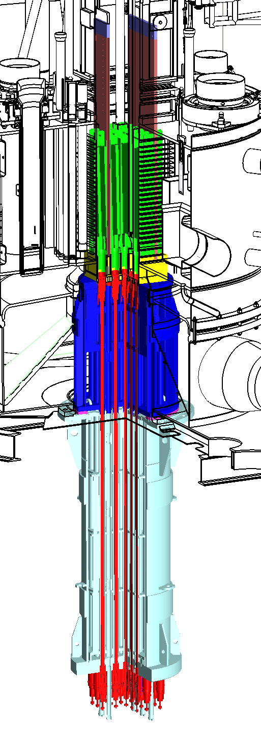
Fuel Elements
Control Rods and Guide Box
Internal Core Experimental Devices
Core Grid
Core Support
Control Rod Penetration
FIG. 3. Core Components.
3.3 Reflector Tank

The Reflector Tank is a watertight pressure vessel, made in Zirconium alloy, which contains the heavy, a central rectangular hollow for the core, and the ex-core irradiations position.
The Reflector Tank Design Basis is:
- Contain the Heavy water
- Contain the Core.
- Have different vertical tubes for irradiation positions
- Have a position for the Cold Neutron Source
- Have different location for the Pneumatic stations.
- Have 4 lateral Beams

The Reflector Tank Design Criteria is:
- Be watertight
- Withstand all the mechanical, operational and occasional loads.
- Be transparent to neutron, as much as possible.
- The design shall allow the Zirconium irradiation creep
- Allow the correct performance of the Secondary Shutdown system

The Reflector Tank is designed following the ASME III ND code. The ASME III ND code defined the requirements for construction solutions, degree of testing and inspections and the criteria for stress analysis. The stress classification of ASME III NB or ASEM VIII Div 2 was adopted, when the design solution is required.

Table II list the main characteristics of the Reflector Tank

To comply with the Design Basis and Criteria, a complete welding pressure vessel, made in zirconium alloy was designed. This is a very difficult task, because, Zirconium alloys are very hard to weld and machining. During the design, the designer team was in contact with INVAP´s workshop. INVAP´s workshop has a lot of experience in fabricated Zirconium alloy.

TABLE II: Reflector Tank – Main Characteristics

Description | Reflector Tank
Design Code | ASME III ND
Vessel Type | Vertical Cylinder
Design Temperature | 60 °C
Design Pressure | 122 kPa
Ends | Flat
Main Dimensions | ID: 2000mm  Length: 1000mm
Weight (Empty) | 2 TN
Material | Zirconium Alloy
Main Thickness | 4mm/12mm/20mm
Construction Type | Welded

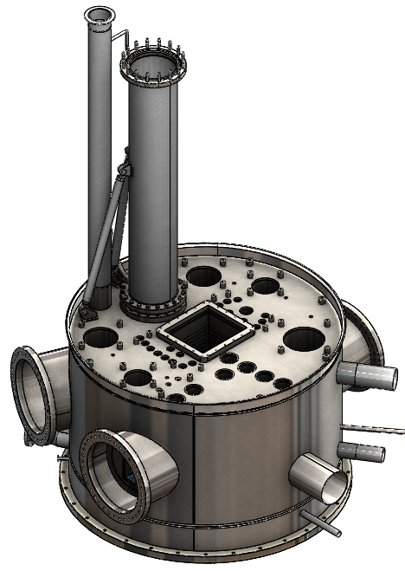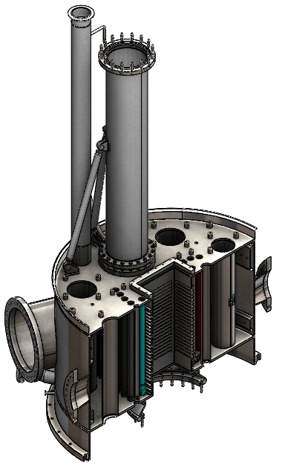

FIG. 4. Reflector Tank

Table III list the Irradiation facilities and they are shown in Figure 5
TABLE III: Reflector Tank – Irradiation Facilities

Description | Reflector Tank
Molybdenum 99 | 10 positions
Iridium 172/ Lutetium 177 | 4 positions
Iridium 172/ Other radioisotopes | 4 Position
Silicon Neutron transmuting Doping | 5 positions
LOOP for testing power fuel elements | 1 position
Cold Source | 1 position
Thermal Beam | 2 beams
Cold Beam | 2 Beams

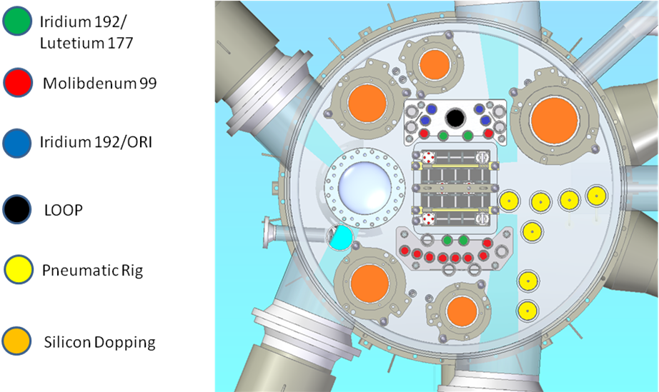
FIG. 5. Irradiation Facilities Location on Reflector Tank

3.3.1 Finite Element Model of the Reflector Tank
All the mechanical loads and their combinations were calculated and verified with a Finite Element Model (FEM) of the Reflector Tank.
During the Basic Engineering state, only the Principal membrane stress was used to verify the Reflector Tank, because of its simplicity. But during the Detail Engineering the ASME III NB Design by Analysis method is going to be used for all the stress classification and the Von Mises Stress will be used.
The following Figure 6 and Figure 7 shows the stresses under the second shutdown system mechanical loads. All stresses are below the allowable.

FIG. 6.Reflector Tank FEM – Second Shutdown system Load
FIG. 7.Reflector Tank FEM – Second Shutdown system Load

3.4 Pneumatic Transport System

The Pneumatic Transport System is designed for transporting samples contained in sealed capsules to irradiation positions located in the Reflector Tank.
The sealed capsules are made in aluminium alloy, nitrogen are used as driving and cooling fluid.
The Pneumatic Transport System has 12 positions for Long Residence Time Irradiation (SILT) and 2 positions for Neutron Activation Analysis (AAN).
The SILT capsules are loaded/unloaded in the hot cell using a mechanically assisted loading station. The AAN capsules are loaded/unloaded in the laboratory using a shielded radiochemistry fume hood.
SILT loading station

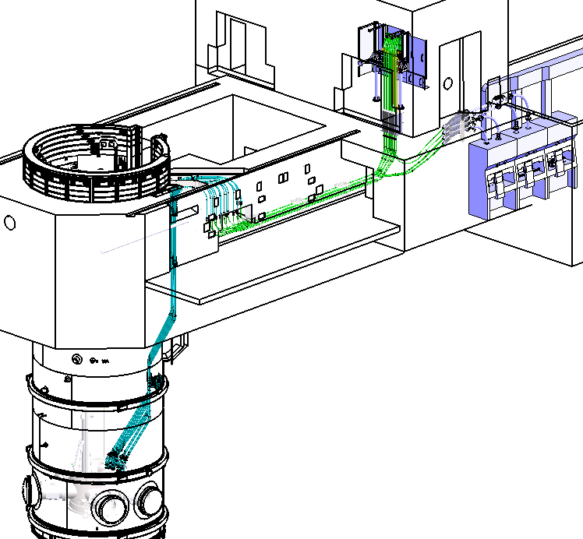
Irradiation positions in the Reflector Tank
AAN laboratory
FIG. 8. Pneumatic Transport System

4 Remarks and Conclusions

As it was mentioned in this work, all mechanical components involved in the RA10 reactor were design to address different requirements from different areas of the project. The designs are based on previous and proven designs and they were improved to achieve a better performance. ASME design recommendations were used and recommended good practice of mechanical engineering.
In the following stages of the project, the current design will be strengthen and will be subject to further revisions. This will concluded with the manufacturing stage, assembly and start up.

