Level 2 AND 3 Probabilistic Safety Assessment for licensing of RA-10 reactor

Mulleady, C¹; Caputo, M.A¹; Giménez, M.¹

1) CNEA, Centro Atómico Bariloche, S.C. de Bariloche, Río Negro, Argentina.

Corresponding author: mulleady@cab.cnea.gov.ar

Abstract. This paper describes the Level 2 and Level 3 Probabilistic Safety Assessment (L2 PSA and L3 PSA, respectively), and radiological risk assessment for the public. The aim is to verify compliance with the criterion curve for the public of AR 4.1.3 regulation established by the Argentinean Nuclear Regulatory Body (ARN), according to the scope defined in the RA-10 Reactor Safety Assessment and Licensing Process.
From the sequences analyzed in the L1 PSA, those showing damage in radioactive material sources (Core Fuel Assemblies, Storage Facility for Irradiated Fuel Assemblies and Irradiation Facilities) are identified and grouped into Plant Damage States (PDS) according to the radioactive material source, the severe accident progression and the damage severity. These groups represent the input data for de L2 PSA. The simplifying assumptions result in the absence of variations in the severe accident progression and release pathways to the atmosphere for each PDS. Thus, the Release Categories (RC) which constitute the L2 PSA/L3 PSA interface are directly linked with the PDS. Five RC were obtained and each one is characterized by a Source Term (ST) and a frequency of occurrence.
The STs, with the meteorological observation from the 2001-2010 period and the present demographical distribution, constitute the L3 PSA input data. The WinMACCS computer code was used to perform atmospheric dispersion and effective dose calculations. Finally, the radiological risk for the public was calculated in every point of the RA-10 site boundary and for each RC.
The maximum radiological risk value obtained for each RC and the limit value for the public, required to be below 10⁻⁷, as defined by the AR 4.1.3 regulation, were compared. The results indicate that the radiological risk value of every RC is smaller than 10⁻⁷, resulting in all the sequences analyzed outside the boundaries of the no-acceptance zone of the criterion curve for the public established by the AR 4.1.3 regulation. These results are currently under revision by the ARN.

Introduction

According to the argentine nuclear program framework, the National Atomic Energy Commission (CNEA) is developing the project of the new experimental reactor RA-10 with the aim of replacing the reactor RA-3 (1967). The RA-10 is a 30 thermal MW multipurpose experimental open pool reactor, with a compact core of MTR (Material Testing Reactor) type fuel assemblies, low-enriched uranium, surrounded by a heavy water reflector tank. It was designed to meet the growing demand at the national and regional level of radioisotopes and to provide facilities for fuel and materials tests in order to support the national technological development in these areas.
The present work was developed based on the Level 2 and Level 3 Probabilistic Safety Assessment (L2 PSA and L3 PSA, respectively), and on preliminary assessments according to the development degree of the RA-10 basic engineering. The Reactor Core Fuel Assemblies (FA), the Storage Facility for Irradiated Fuel Assemblies or Spend Fuel Assemblies (SFA) and the Irradiation Facilities of Uranium-Molybdenum (IF) were analyzed as the representative radioactive sources.
The L2 PSA involves the evolution of the severe accident analysis and the Source Term (ST) released into the atmosphere, and its frequency of occurrence estimations. The so-called Plant Damage States (PDS) are the input data for the L2 PSA, which arise from the L1 PSA/L2 PSA interface. From the PDSs arise a branch of sequences that depend on the severe accident progression, the confinement status and the release paths to the environment. The regrouping of these sequences constitutes the L2 PSA/L3 PSA interface, and the so-called Release Categories (RC) are defined. Every RC is characterized by a ST and a frequency of occurrence, which are part of the L3 PSA input data.
The L2 PSA for the RA-10 reactor was performed using bibliographic information and under conservative considerations related to: the fuel assemblies damage, the radioactive material retention in the molten fuel assemblies and in the surrounding water, the radioactive material retention inside the confinement, the radioactive material release inside the confinement, the radioactive material release paths to the environment and the release energy.
The L3 PSA aims to assess the radiological risk for the public due to radioactive material releases into the environment. In order to obtain the effective doses in the public, the air and floor level concentrations of each released radionuclide must be calculated. Then, the probability of fatality or severe health effect at each point of the reactor surroundings is obtained. Finally, using the probability of occurrence of each RC and the probability of fatality together, the radiological risk for each RC is calculated, and is used to verify the AR4.1.3 regulation for the public [].

Development of L2 and L3 PSA of RA-10 reactor for preliminary safety report

L1 PSA/L2 PSA interface

From all the possible Plant Final States (PFS), that are obtained from the L1 PSA, the ones that lead to a reactor core damage or/and a IF damage or/and a SFA from the service pool damage are selected. The regrouping of these sequences, according to specific characteristics of the severe accident progression (attributes), makes up the Plant Damage States (PDS) ensemble. The attributes considered for the L1 PSA/L2 PSA interface were:
- Affected radioactive material source
  - Reactor Core FA
  - IF
  - Reactor Core FA + IF
  - Reactor Core FA + IF + SFA
- Severe accident progression
  - Power excursion
  - Loss of coolant inventory
  - Loss of cooling
- Radioactive material source damage level
  - Total
  - Partial
The PDSs for the L2 PSA can be seen in TABLE I. The frequencies of occurrence of each PDS were obtained using the event trees and fault trees techniques in the L1 PSA, and the results are shown in TABLE II.
TABLE I: Correlation matrix between L1 PSA event tree and L2 PSA PDS
Grouping Atribute ̶ > | Comitted radioactive material |  |  |  | Severe accident progression |  |  | Damage magnitude |  |  |  |  |  | Plant Damage States (PDS)
Grouping Atribute ̶ > |  |  |  |  |  |  |  | Core FA |  | IF |  | SFA |  | Plant Damage States (PDS)
Atribute Value ̶ >  L1 PSA Event Tree . | Core FA | IF | Core FA + IF | Core FA + IF + SFA | PE-Power Excursion | LI-Loss of coolant Inventory | LC-Loss of Cooling | Ct-Total | Cp- Partial | Ft-Total | Fp-Partial | Pt-Total | Pp-Partial | Plant Damage States (PDS)
A. Reactivity Insertion due to control rod/s extraction |  |  | x |  | x |  |  | x |  | x |  |  |  | PE_Ct_Ft
B. Reactivity Insertion due to other initiating events |  |  | x |  |  |  | x |  | x | x |  |  |  | LC_Cp_Ft
C. Loss of offsite Power Supply |  |  | x |  |  |  | x |  | x | x |  |  |  | LC_Cp_Ft
D. Loss of one or both PCS pumps | x |  |  |  |  |  | x |  | x |  |  |  |  | LC_Cp
E. Core by-pass | x |  |  |  |  |  | x |  | x |  |  |  |  | LC_Cp
I. Loss of PCS coolant |  |  | x |  |  | x |  | x |  | x |  |  |  | LI_Cp_Ft
I. Loss of PCS coolant |  | x |  |  |  |  | x |  |  | x |  |  |  | LC_Ft
J. Loss of RSPCS coolant |  |  | x |  |  | x |  | x |  | x |  |  |  | LI_Cp_Ft
J. Loss of RSPCS coolant |  | x |  |  |  |  | x |  |  | x |  |  |  | LC_Ft
L. Loss of heat sink |  |  | x |  |  |  | x |  | x | x |  |  |  | LC_Cp_Ft
N. Loss of one RSPCS Pump |  | x |  |  |  |  | x |  |  | x |  |  |  | LC_Ft
P. Irradiation Facilities by-pass |  | x |  |  |  |  | x |  |  | x |  |  |  | LC_Ft
Q. Generic Transient | x |  |  |  |  |  | x |  | x |  |  |  |  | LC_Cp

TABLE II: Frequency of occurrence of the PDS
Plant Damage State (PDS) | Frequency of occurrence [year⁻¹]
LC_Cp | 1.94E-09
PE_Ct_Ft | 3.11E-10
LI_Ct_Ft | 5.04E-07
LC_Ft | 3.41E-05
LC_Cp_Ft | 5.85E-06

The obtained PDS were:
- LC_Cp: derived from loss of reactor core cooling events. The damage may occur by sequences with the extinction function failure and fail in the forced convection failure. Partial damage of the reactor core is the consequence.
- PE_Ct_Ft: derived from a control rod/s undesired extraction event with the extinction function failure, generating power excursion scenarios. Total damage of the reactor core and total damage of the IF are the consequences.
- LI_Cp_Ft: derived from the loss of coolant inventory events by the PCS (Primary Cooling System) or RSPCS (Reactor and Service Pools Cooling System) pipelines break, with the interruption of flow through the break failure. Total damage of the reactor core and total damage of the IIFF are the consequences.
- LC_Ft: derived from loss of IF cooling events. Total damage of the IF is the consequence.
- LC_Cp_Ft: derived from the loss of cooling events affecting the reactor core and the IF. For the reactor core case, damage is caused by the extinction function failure (regardless of whether it is possible to establish the natural circulation to cool the reactor core). For the IF case, damage is caused by the cooling function failure, or by the extinction function and forced convection cooling failure. Partial damage of the reactor core and total damage of the IF are the consequences.

L2 PSA

The conservative hypotheses made for the L2 PSA, concerning the radioactive material released to the environment, are described as follows:
- The damaged Fuel Assemblies are melted instantly. This is a conservative hypothesis because the radioactive decay is smaller in this case than if the FA melting were a progressive one.
- The damaged IF are melted instantly. This hypothesis is conservative by the same reason as the case presented above.
- The Indoor Air Quality System (IAQS) performance is not taken account. This hypothesis is conservative because the radioactive material retention of the IAQS (HEPA filters and activated carbon beds) is not considered in the analysis.
- The deposition of radionuclides on structures inside the confinement of the reactor is not taken account. This hypothesis is conservative because the possible capture of radioactive material both in ventilation ducts and surfaces within the confinement is not considered. Therefore the release to the environment is overestimated.
- The Insulation System of the confinement performance is not taken account. This hypothesis is conservative because without the Isolation System actions the released radioactive material is taken directly and instantly to the environment. Therefore, the radioactive decay (particularly the shorter half-life radionuclides) associated to a progressive release is not considered and the release to the environment is overestimated.
- The release of radioactive material into the environment is complete and occurs during a single period of one hour. Pollutant dispersion calculations showing that the effective dose is smaller when the release involves more than one period were performed. Therefore this hypothesis is conservative.

Radioactive Inventory

For the effective dose calculations, 69 radionuclides were considered as the most relevant. These radionuclides are grouped in 9 chemical classes (Xe, Cs, Ba, I, Te, Ru, Mo, Ce and La).
The activity of an average burned reactor core was considered as the reactor core radioactive inventory. It consists of 19 FA at different burned percentages: 3 FA at 10%, 4 FA at 20%, 4 FA at 30%, 4 FA at 40% and 4 FA at 50%.
For the Irradiated Fuel Storage Facility radioactive inventory was considered the activity of 496 (SFA) at 45% of burn rate, that is equivalent to 10.7 years of storage service.
The RA-10 reactor counts with IFs for Mo-99 production. The IFs are distributed in 10 positions within the reflector tank. Every one of them consists of UAI₂ miniplates with an enriched rate of 19.87%. The activity of the most relevant IF irradiated during 5 days without radioactive decay was considered.

Radioactive Inventory allocation for each PDS

The committed radioactive inventory in each of the PDS is determined based on deterministic analyses. In all the cases the damage level was overestimated in order to obtain conservative scenarios for the radioactive material releases to the environment.

Inventory allocation associated with LC_Cp
For this case a partial damage in the reactor core is obtained. According to deterministic analyses, every FA plate with a 2.0 peak factor will melt, involving therefore 81 plates. These plates are associated with higher power rates and radionuclide generation, so it is considered that their inventory doubles the average per plate. So the total inventory represents 162 average plates.
On the other hand, due to the fusion of the plates with peak factor greater than 2.0 group, and taking into account the radial progression of fusion, it is postulated the melting of two more plates on each side of the group. As there is at least one plate with more than 2.0 peak factor in each FA, 4 more plates are considered to be molten, resulting in a total of 4 x 19 plates. Finally it is considered an inventory of 81 x 2 + 4 x 19 average plates, this is a total of 238 average plates.

Inventory allocation associated with PE_Ct_Ft
This case corresponds to the total fusion of the reactor core FAs due to a radioactivity insertion event with the extinction function failure. This occurs with expulsion of water from the reactor pool. It is postulated that the affected radionuclide inventory is 100%.

Inventory allocation associated with LI_Ct_Ft
This case corresponds to the total core fusion by a loss of coolant inventory event by breakage of main pipe of the primary downstream from the pump with siphon breakers and extinguished reactor failure, produces the emptying of the pool of the reactor to uncover the core. The fusion of the core is relatively slow since it occurs progressively as it is uncovered.

At the same time the IF, resulting in its total fusion. However the radioactive inventory is about 3 orders of magnitude lower than that of the reactor core. Therefore it is assigned to this PDS inventory will be 100% of the reactor core, despising the IF inventory.

Inventory allocation associated with LC_Ft
This case corresponds to the fusion of one IF due to the loss of cooling event. It melts completely and under water. Therefore the assigned inventory corresponds to the 100% of the 10 positions.

Inventory allocation associated with LC_Cp_Ft
This case corresponds to the fusion of a limited number of plates in different reactor core FA and 10 IF. In this case it is assumed the same damage of reactor core than in the LC_Cp. The 10 IF inventory is despised because it is at least 2 orders of magnitude less than the 238 FA plates.

Release fractions

The release fractions represent the fission products that are released from the molten core fraction into the pool water. Then, the fission products fraction that will reach the confinement atmosphere will depend on the water cover. Therefore, two situations are taken account. The release could take place with uncovered core o under water. For the latest, two possible situation were considered: water surrounding the core is expelled from the pool (reactivity insertion accident type) and water is not expelled (extinction function transient failure with damage of the FA plates with higher peak factor). The release fractions values were taken from [2], which correspond to the release fractions associated with the inventory of a nuclear reactor with similar characteristics to the RA-10 reactor. The release fractions are shown in TABLE III.

TABLE III: Radionuclide Groups and their corresponding release fractions
Radionuclide Group | Release fractions of the molten core fraction from the core to the pool | Release fractions without water expelled from the pool to the confinement | Release fractions with water expelled from the pool to the confinement
Noble Gases | 100% | 2% | 40%
I, Te y Cs | 27% | 1 × 10^{–2} % | 5 × 10^{–1} %
Ba, Sr y Ru | 3% | 1 × 10^{–4} % | 1 × 10^{–4} %
Other fision products | 0.1% | 1 × 10^{–4} % | 1 × 10^{–4} %

For each PDS is assumed:
- LC_Cp: given that the merger is under water and progressive, are applied retention factor for the molten material under water and without expulsion of water.
- PE_Ct_Ft: given that the merger is fast and under water, are applied retention factor for the molten material under water and with expulsion of water.
- LI_Cp_Ft: Since the merger is under discovered reactor core, are applied retention factor for the molten material.
- LC_Ft: Since the merger is under water and progressive are applied retention factor for the molten material under water and without expulsion of water.
- LC_Cp_Ft: Since the merger is under water and progressive, are applied retention factor for the molten material under water and without expulsion of water.

L2/L3 PSA interface

The hypotheses made in the L2 PSA lead to no variants in the severe accident progression and in the radioactive material release paths to the environment for each PDS. Therefore each of the PDS directly corresponds to each of the RC, which forms the L2 PSA/L3 PSA interface. The obtained RC can be seen in TABLE IV, and each of them is associated to a ST that form part of the L3 PSA input data.

TABLE IV: Release Categories obtained for the RA-10 reactor
Release Category | PDS | Description
RC1 | LC_Cp | Partial reactor core FA merge: Hot Channel + other channels. 238 fuel plates merge.
RC2 | PE_Ct_Ft | Total reactor core FA merge by power excursion event with water covered core and water expelled from the pool.
RC3 | LI_Ct_Ft | Total reactor core FA merge and merge of all IF by water uncovering.
RC4 | LC_Ft | Loss of all IF in a water covered event.
RC5 | LC_Cp_Ft | Partial reactor core FA merge: Hot Channel + other channels. 238 fuel plates merge plus merge of all 10 IF.

Source Term

Each ST is characterized by the following properties:
- The quantity and isotopic composition: radioactive material released to the environment.
- Emission energy: radioactive material energy release.
- Starting time: instant in which occurs the SCRAM.
- Dynamic:
  - Time at which begins the release of radioactive material to the environment.
  - Release duration.
- Emission height: the ground level is taken as a reference.
- Annual release frequency.

TABLE V: Source Term associated with every RC
RC | PDS | Height[m] | Frequency. [1/year] | % released from the initial radioactive inventory
 |  |  |  | Xe | Cs | Ba | I | Te | Ru | Mo | Ce | La
1 | LC_Cp | 18 | 1.94x10⁻⁹ | 1.2 | 1.6x10⁻³ | 1.8x10⁻⁶ | 1.6x10⁻³ | 1.6x10⁻³ | 1.8x10⁻⁶ | 6.0x10⁻⁸ | 6.0x10⁻⁸ | 6.0x10⁻⁸
2 | PE_Ct_Ft | 18 | 3.11x10⁻¹⁰ | 40 | 0.14 | 3.0x10⁻⁶ | 0.14 | 0.14 | 3.0x10⁻⁶ | 1.0x10⁻⁷ | 1.0x10⁻⁷ | 1.0x10⁻⁷
3 | LI_Ct_Ft | 18 | 5.04x10⁻⁷ | 100 | 27 | 3 | 27 | 27 | 3 | 0.1 | 0.1 | 0.1
4 | LC_Ft | 18 | 3.41x10⁻⁵ | 2 | 2.7x10⁻³ | 3.0x10⁻⁶ | 2.7x10⁻³ | 2.7x10⁻³ | 3.0x10⁻⁶ | 1.0x10⁻⁷ | 1.0x10⁻⁷ | 1.0x10⁻⁷
5 | LC_Cp_Ft | 18 | 5.85x10⁻⁶ | 1.2 | 1.6x10⁻³ | 1.8x10⁻⁶ | 1.6x10⁻³ | 1.6x10⁻³ | 1.8x10⁻⁶ | 6.0x10⁻⁸ | 6.0x10⁻⁸ | 6.0x10⁻⁸

In TABLE V are expressed the release height, annual frequency and radioactive material proportion related to the initial inventory. This data conform the ST of each RC.
For all the ST it is assumed that all radioactive material is released at the initiating event time (t = 0s), in a single time interval of 3600s. This consideration is conservative since it was verified that in this case occurs the highest Risk Equivalent Effective Dose on the public. Also it is assumed that at this time the alarm is declared.

L3 PSA

For the public individual Radiological Risk determination of each RC, it is necessary to evaluate the probability of fatality or severe health effect at each point of the domain. Then, the effective dose in each sector that surrounds the nuclear installation must be calculated. Therefore, the concentration in air and floor of each of the radionuclides released into the environment must be evaluated. For this, it is necessary calculate the air and floor concentrations of every released radionuclide to the atmosphere.
The air and floor radioactive concentrations and the effective doses are calculated using the WinMACCS code [3]. The input data for this code are: meteorological data, radioactive inventory, dosimetric factors, retention factors, demographic data and ST. Each of the data used, will be described in the following paragraphs. WinMACCS makes all the evaluations using a Gaussian Plume atmospheric dispersion model.
The next considerations were made for the L3 PSA:
- It is considered the real population distribution.
- 10 years of meteorological data were used for the radiological risk calculations.
- 24 hours of exposure are considered.
- It is considered that the public continues with his normal activity.
- The countermeasures implementation is not considered, as is specified by the AR4.1.3 regulation [1].
The following sections detail each of the input data used in the PSA L3 and the results of radiological risk for each RC.

Input data

Meteorological Data
The Ezeiza’s weather station data were used for the meteorological input data. The records belong to the 2001-2010 period and contain hourly data of temperature (dry bulb, wet bulb and dew point), relative humidity, atmospheric pressure, wind speed and wind direction (16 sectors), plafond, horizontal visibility, present weather (general state of weather conditions at the time of measurement) and Pasquill stability classes. It also had daily data of accumulated precipitation, wind gusts, and mixed layer depth. From this weather information, WinMACCS takes the wind speed, wind direction, stability class and precipitation data for one year. Also, WinMACCS uses the mixed layer depth for two atmospheric stability conditions (neutral and unstable) and for each season of the year.
A data file was made for each year as the code manual indicates, including the folowing meteorological information:
- Wind speed: ms-1.
- Wind direction: direction towards which the wind is blowing. The wind directions correspond to a wind rose of 16, 32, or 64 sectors.
- Atmospheric stability: according to Pasquill [4], it starts at the letter "A" for an unstable atmosphere and ends in the letter "F" for a stable atmosphere.
- Accumulated precipitation: inches (1 inch equals 25.4 mm approximately).
- Mixed layer depth: hectometres. WinMACCS uses the seasonal mixed layer depth variations. Therefore, the code requires 8 mixed layer depth data, one for each year season for unstable and neutral atmospheric condition.
As the WinMACCS code is a Gaussian plume dispersion model, it requires dispersion parameters as input data. Therefore, it was use a parametrización scheme suitable for the RA-10 site.

Dosimetric Factors

For the effective dose calculations four exposure paths were considered:
- External exposure due to the passage of the radioactive cloud.
- External exposure due to soil deposition of radionuclides.
- External exposure due to skin deposition of radionuclides.
- Exposure due inhalation within the radioactive cloud.
The exposure contribution due to food ingestion is not considered since exposure times proposed by the regulations are not long enough.
The dosimetric factors were taken from the Federal Guidance Report 13 [5]. These are calculated for a receptor located under the plume centerline and in the deposited radioactive material surface center [6].

Demographic distribution
Every location considered for the RA-10 reactor sitting is shown in FIG. 1 with the letter “S” following by a number. Site S5 was selected for the RA-10 final location. Also, in FIG. 1 it can be seen the demographic distribution in the Ezeiza Atomic Center (CAE) vicinity. It can be seen two neighborhoods (outlined in green) located to the West and South-West from S5. The Ministro Pistarini International Airport is outlined in red and a Sport Village and a Golf Club are outlined in orange. The distances and directions to each of the mentioned locations from S5 are shown TABLE VI.

TABLE VI: Distances and Directions relative to the RA-10 Site
 | Site S5
 | Distance [km] | Direction
Neighborhood 1 | 1.7 | W
Neighborhood 2 | 1.8 | WSW
Mercantil Sport Villa | 1.6 | W
Cabeza de Caballo Golf Club | 3.0 | S

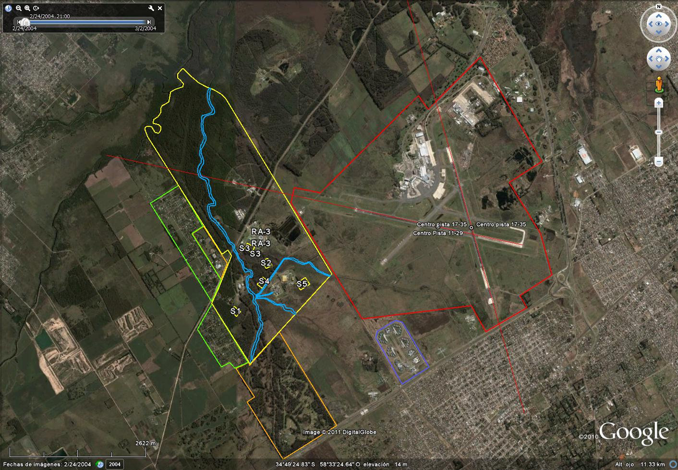
FIG. 1. Ezeiza Atomic Center location and the surrounding demographic distribution

Shielding
According to the regulations, the effective dose for the public must be calculated for a 24 hs exposure considering that the individuals didn’t interrupt their normal activities. The shielding factors were taken from reference [7].

Radiological Risk calculation

The following methodology was used for the radiological risk calculation for each RC:
- The effective dose for each position and weather condition is calculated.
- The fatality probability for each effective dose value is calculated.
- The fatality probability values are added for each domain position.
- The maximum value of the addition obtained in item 3 defined the position of the greatest radiological risk.
- The value of the maximum of the probability of fatality addition is divided by the number of cases for which non-zero effective dose occurs (Standardised Probability of Fatality maximum addition).
- It is estimated the effective dose based on the value obtained in the previous step, this is the so-called Risk Equivalent Effective Dose, in order to be able to plot the point corresponding to the RC in the Criterion Curve.
- It is estimated the probability of exposure using the ST frequency of occurrence and the likelihood of incurring an effective dose different from zero in the position obtained in point 4. The latter is calculated as the quotient between the number of weather conditions that generates non-zero dose (inferred from item 1) and the total number of meteorological conditions considered.
- The Radiological Risk is calculated by multiplying the probability of exposure (obtained in item 7) by the value obtained in item 5.
It was found that the point associated with the greatest radiological risk is located 1.6 km in the west direction from the reactor building. The results show that 6031 of the 87600 considered weather conditions generates a non-zero effective dose in the mentioned location. The radiological risk associated with each of the RC is presented in TABLE VII.
TABLE VII: Radiological Risk from every RC
RC | PDS | Damage associated with every RC | Maximum Probability of Fatality normalized Sum | Risk Equivalent Effective Dose [Sv] | ST annual probability | Exposure Probability | Maximum Radiologic Risk
RC | PDS | Damage associated with every RC | (Item 5) | (Item 6) |  | (Item 7) | (Item 8)
1 | LC_Cp | Partial core damage: Hot Channel + other channels. 238 FA plates are melted. | 1.2x10⁻⁵ | 2.4x10⁻⁴ | 1.9x10⁻⁹ | 1.3x10⁻¹⁰ | 1.6x10⁻¹⁵
2 | PE_Ct_Ft | Total core and IF damage by a power excursion event, with water covered core and expelled water from the pool. | 4.5x10⁻⁴ | 9.0x10⁻³ | 3.1x10⁻¹⁰ | 2.1x10⁻¹¹ | 9.6x10⁻¹⁵
3 | LI_Ct_Ft | Total core and IF damage byloss of coolant inventory. | 0.019 | 0.38 | 5.0x10⁻⁷ | 3.5x10⁻⁸ | 6.5x10⁻¹⁰
4 | LC_Ft | Total IF damage under water. | 4.2 x10⁻⁷ | 8.4x10⁻⁶ | 3.4x10⁻⁵ | 2.4x10⁻⁶ | 1.0 x10⁻¹²
5 | LC_Cp_Ft | Partial core damage and total IF damage: Hot Channel + other channels. 238 FA plates and the 10 IF positions are melted. | 1.2x10⁻⁵ | 2.4x10⁻⁴ | 5.9x10⁻⁶ | 4.0x10⁻⁷ | 4.9x10⁻¹²

AR4.1.3 Criterion Curve Verification and Conclusions

The Criterion Curve for the public (AR4.1.3 regulation) is plotted in FIG. 2, and it represents an upper limit for the public radiological risk of 10⁻⁷. The RC3 (LI_Ct_Ft) and RC5 (LC_Cp_Ft) are plotted on the Criterion Curve based on their corresponding Risk Equivalent Effective Dose and Exposure Probability values (TABLE VII). Only the points that lie within the limits of the Criterion Curve graph specified by the AR4.1.3 regulation are plotted. Since RC1 (LC_Cp) and RC2 (PE_Ct_Ft) exposure probability values are lower than 10⁻⁸, and RC4 (LC_Ft) Risk Equivalent Effective Dose value is lower than 10⁻⁴ Sv, are not plotted in FIG. 2. Therefore, it can be verified that every RC is located outside the boundaries of the No-Acceptance zone of the Criterion Curve for the public.
The proposed methodology and the results obtained in the present work form part of the 16th Chapter of the preliminary Safety Report of the RA-10 reactor, and are currently under revision by the Argentinean Nuclear Regulatory Body (ARN).
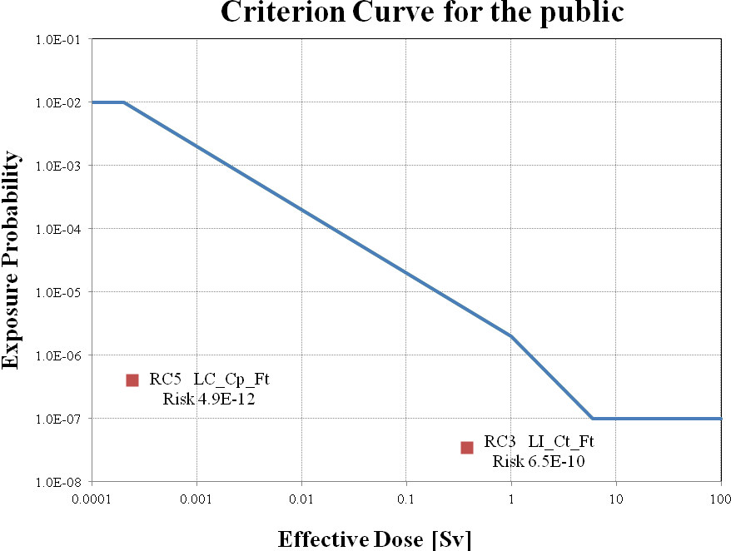
FIG. 2. Criterion Curve for the public and verification of the AR 4.1.3 regulation for the RA-10

References

[1] AR 4.1.3, Criterios radiológicos relativos a accidentes en reactores de investigación Rev. 2.
[2] INTERNATIONAL ATOMIC ENERGY AGENCY, Derivation of the Source Term and Analysis of the Radiological Consequences of Research Reactor, Safety Reports Series No. 53, IAEA, Vienna (2008).
[3] NUREG/CR-6613, Code Manual for MACCS2: Volume 1, User’s Guide Chanin D., Young L., Randall J., Jamali K..
[4] F. Pasquill, Atmospheric Diffusion: The Dispersion of Windborne Material from Industrial and other Sources, D. Van Norstand Company, Ltd., London, 1962.
[5] EPA 402-R-99-001 Federal Guidance Report No. 13 “Cancer Risk Coefficients for Environmental Exporsure to Radionuclides” Ekerman K F et al.
[6] MACCS2 Computer Code Application Guidance for Documented Safety Analysis. U.S. Departament of Energy. Office of Environment, Safety and Health. June 2004. DOE-EH-4.2.1.4-MACCS2-Code Guidance.
[7] NUREG/CR-7110, Vol. 2, “State-of-the-Art Reactor Consequence Analyses Project Volume 2: Surry Integrated Analysis”, Office of Nuclear Regulatory Research, U.S.NRC, 2012.

