Utilization of the High Flux Isotope Reactor at Oak Ridge National Laboratory¹

D. L. SELBY¹, H. Z. Bilheux², F. Meilleur³, D. H. Vandergriff¹,

A. B. Jones¹, and W. B. Bailey¹

- Instrument and Source Division, Oak Ridge National Laboratory

Building 7964K, Oak Ridge, Tennessee 37831-6430
- Chemical and Engineering Materials Division, Oak Ridge National Laboratory

Building 8600, Oak Ridge, Tennessee 37831-6475
- Biology and Soft Matter Division, Oak Ridge National Laboratory

Building 7962, Oak Ridge, Tennessee 37831-6393

ABSTRACT: This paper addresses several aspects of the scientific utilization of the Oak Ridge National Laboratory High Flux Isotope Reactor (HFIR). Topics to be covered will include: 1) HFIR neutron scattering instruments and the formal instrument user program; 2) Recent upgrades to the neutron scattering instrument stations at the reactor, and 3) eMod a new tool for addressing instrument modifications and providing configuration control and design process for scientific instruments at HFIR and the Spallation Neutron Source (SNS). There are 15 operating neutron instrument stations at HFIR with 12 of them organized into a formal user program. Since the last presentation on HFIR instruments at IGORR we have installed a Single Crystal Quasi-Laue Diffractometer instrument called IMAGINE; and we have made significant upgrades to HFIR neutron scattering instruments including the Cold Triple Axis Instrument, the Wide Angle Neutron Diffractometer, the Powder Diffractometer, and the Neutron Imaging station. In addition, we have initiated upgrades to the Thermal Triple Axis Instrument and the Bio-SANS cold neutron instrument detector system. All of these upgrades are tied to a continuous effort to maintain a high level neutron scattering user program at the HFIR. For the purpose of tracking modifications such as those mentioned and configuration control we have been developing an electronic system for entering instrument modification requests that follows a modification or instrument project through concept development, design, fabrication, installation, and commissioning. This system, which we call eMod, electronically leads the task leader through a series of questions and checklists that then identifies such things as ES&H and radiological issues and then automatically designates specific individuals for the activity review process. The system has been in use for less than a year and we are still working out some of the inefficiencies, but we believe that this will become a very effective tool for achieving the configuration and process control believed to be necessary for scientific instrument systems.

- Introduction

As reported in IGORR papers in 2003, 2005, 2007, 2010, and 2012 [1]; a program was initiated just over 10 years ago to significantly improve the scientific capabilities at all four neutron beams at the Oak Ridge National Laboratory (ORNL) High Flux Isotope Reactor (HFIR). This paper will focus on developments associated with these upgrades since material was last presented at an IGORR meeting.

- History and Description of the High Flux Isotope reactor

ORNL submitted a proposal for the construction of the HFIR to the Atomic Energy Commission in March 1959 and approval to proceed with construction was received in July

¹Notice: This submission was sponsored by a contractor of the United States Government under contract DE-AC05-00OR22725 with the United States Department of Energy. The United States Government retains, and the publisher, by accepting this submission for publication, acknowledges that the United States Government retains, a nonexclusive, paid-up, irrevocable, worldwide license to publish or reproduce the published form of this submission, or allow others to do so, for United States Government purposes.
of that year. The reactor design was completed in 1960 and construction began in June of 1961. Initial criticality was achieved on August 25, 1965 and full power normal operation (100 MW) was initiated in 1966 [2]. Since that time, the HFIR has operated for 457 fuel cycles (fuel cycle length of 21 to 27 days depending on the power level and experiments loaded in the core region).
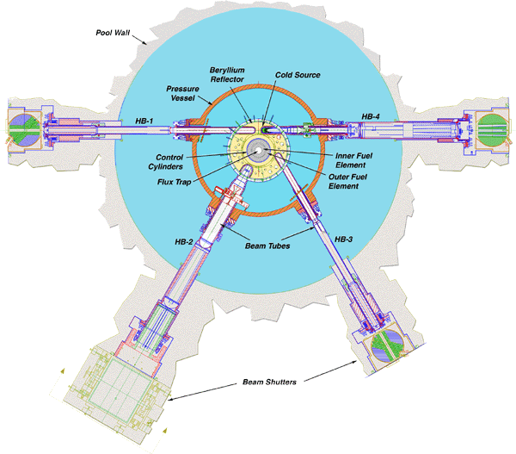
Figure 1 provides a layout of the reactor core, beryllium reflector and the four beam tubes. At the 85 MW full power operating condition the peak total neutron flux in the central flux trap for a typical target loading has been measured to be ~4.0 x 10¹⁵ n/(cm²-s) with a thermal to nonthermal ratio of ~1.7 [3]. The peak thermal flux in the beryllium reflector is ~ 1.4 x 10¹⁵ n/(cm²-s) and occurs near the tips of the beam tubes [2]. The neutron thermal to nonthermal ratio in the reflector ranges from around 1 to 30. There are three tangential beam tubes and one radial beam tube that start near the peak flux in the beryllium reflector and penetrate the reactor pressure vessel. The modifications to these four beam lines (including the installation of a super critical hydrogen cold neutron source) and the thermal and cold neutron instruments installed on those beam lines are the focus of the scientific upgrades that have been performed at the reactor facility.
Figure 1: Layout of HFIR Reactor Core, Reflector, and Beam Tubes

- New Single Crystal Quasi-Laue Diffractometer (IMAGINE) on Beam Line CG-4
Since material was last presented at an IGORR meeting the installation and commissioning of a new Single Crystal Quasi-Laue Diffractometer (IMAGINE) has been completed. The instrument was incorporated into the formal user program for the reactor cycle that began in October of 2013. This instrument which is located on cold guide 4 (CG-4) is shown in Figure 2. The instrument was built through a collaboration effort between DOE (through Oak Ridge National Laboratory) and the National Science Foundation (through a grant to Middle Tennessee State University). One of the unique features of this beamline and a difference from other instruments in the guidehall (as well as similar instruments at other facilities around the world) is its neutron optics system that uses elliptical mirrors, neutron filters and a flat mirror concept developed by the neutron optics group at ORNL to capture and focus the available neutrons at the sample position while maintaining an acceptable neutron divergence angle. Beam line features include delivery of neutrons into a 2.0 x 3.2 mm² focal spot at the sample position with full width vertical and horizontal divergence of 0.5° and 0.6°, respectively, and variable short and long wavelength cutoff optics that provide automated exchange between multiple wavelength configurations. Theoretically this concept was expected to provide a neutron flux at the instrument almost a factor of 40 greater than that which would be obtained from a conventional neutron guide. In reality we have measured about a factor of 25 over an estimated conventional neutron guide performance.

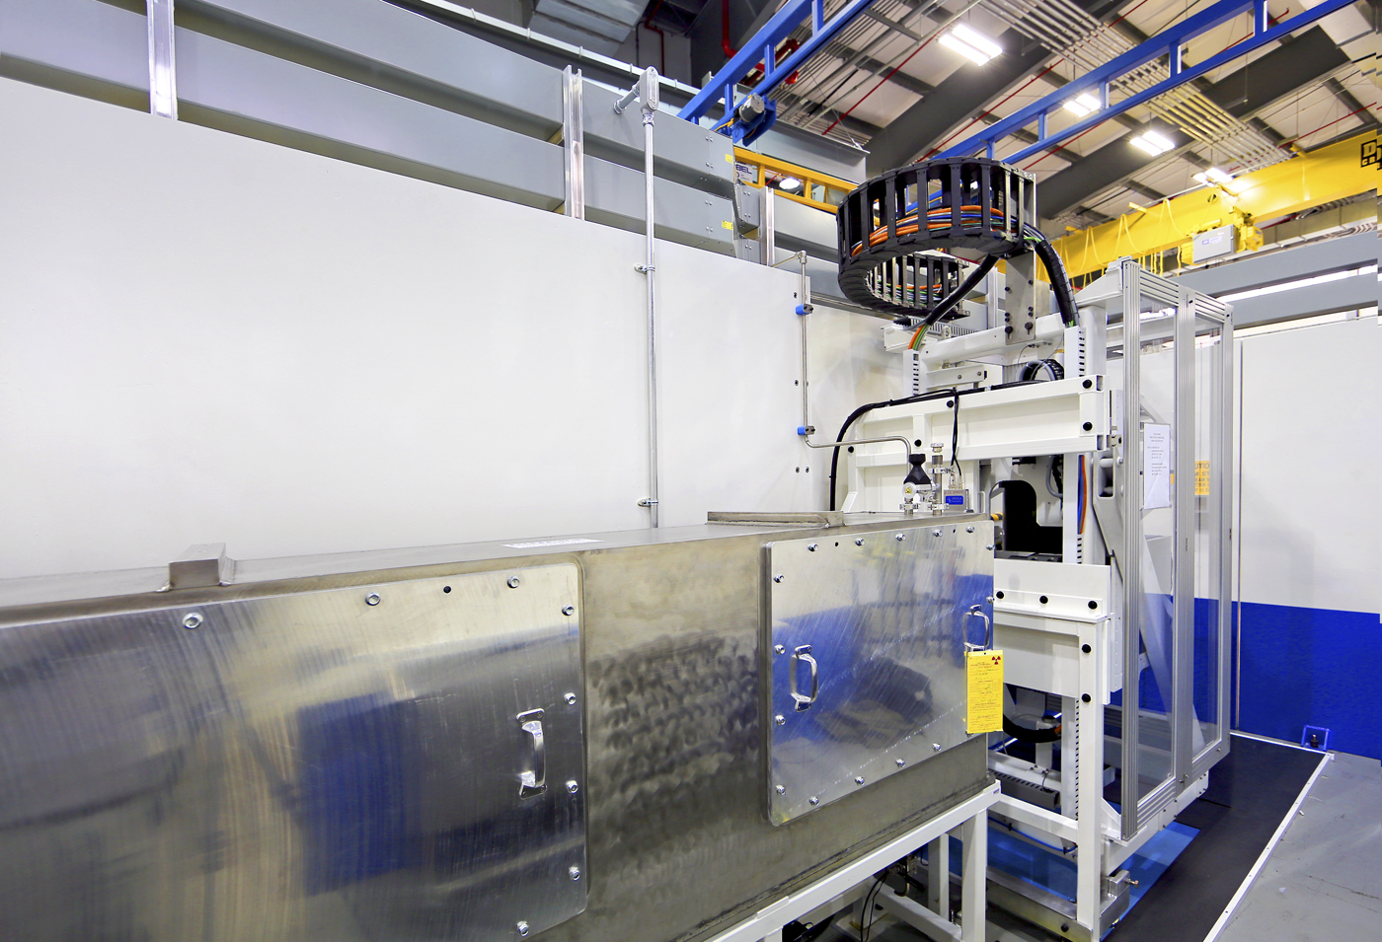

Figure 2: New Beam Line CG-4 Single Crystal Quasi-Laue Diffractometer (IMAGINE)

IMAGINE is a state-of-the-art facility for neutron-diffraction analysis of advanced materials and macromolecules [3]. IMAGINE is especially suited to pinpoint individual hydrogen atoms in protein structures, enabling neutron protein structures to be determined at or near atomic resolutions (1.5 Å) from crystals with volume < 1 mm³ and with unit cell edge of < 100 Å. An example of a protein crystal measured on IMAGINE include the RAS GTPase protein, an intra-cellular signaling switch, active in the guanosine triphosphate (GTP) bound state and inactive in the guanosine diphosphate (GDP) bound form. RAS proteins can have interactions that cause GDP to be replaced with GTP making the RAS active. There are other interactions that reverse this trend and convert the GTP back to GDP making the RAS protein inactive. However, mutations in the RAS can cause the protein to be locked into this active state and there is a data trend that implies a relationship between these mutations and the onset or growth rate of cancer tumors in humans and animals. Mutations that permanently activate RAS are found in 20% to 25% of all human tumors and up to 90% in certain types of cancer [4]. Experiments performed on the IMAGINE instrument allows one to observe the individual hydrogen atoms at the active RAS sites and thus provides knowledge that can be used to help understand this entire hydrolysis process and how it is hampered in ocogenic mutations. A typical diffraction pattern collected on IMAGINE is show in Figure 3. This is a representation in reciprocal space that can be analyzed using Fourier Transforms to provide information on atom locations within a crystal in real space.

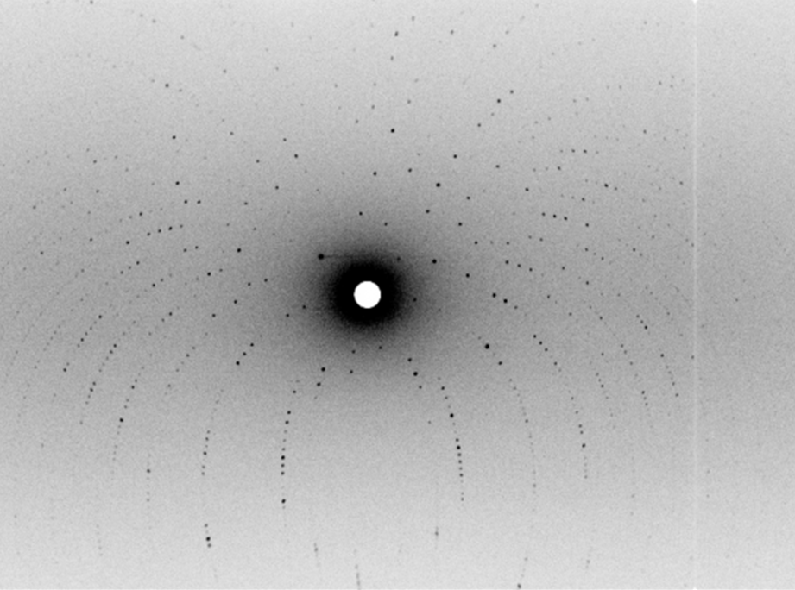

Figure 3: Typical quasi-Laue neuron diffraction pattern measured from protein crystals on the IMAGINE Instrument at HFIR

- Imaging Beam Line (CG-1D)
CG-1D was originally built as a test station for various activities including imaging and was not intended to be in the formal user program, but the high intensity flux of 1 x 10⁸ neutrons/(cm²-s) over an energy band of 0.8 to 10 Å (127 – 0.81 meV) [5], at the exit of the shielding assembly made it an attractive beam for imaging and a significant user program was developed around it to the point where the beam line was fully committed to imaging activities. An upgrade program was initiated in FY 2014 to improve the imaging capabilities including: a new micro channel plate detector, a new neutron optics system and additional background shielding. Figure 4 shows the imaging beam line in the HFIR guidehall.
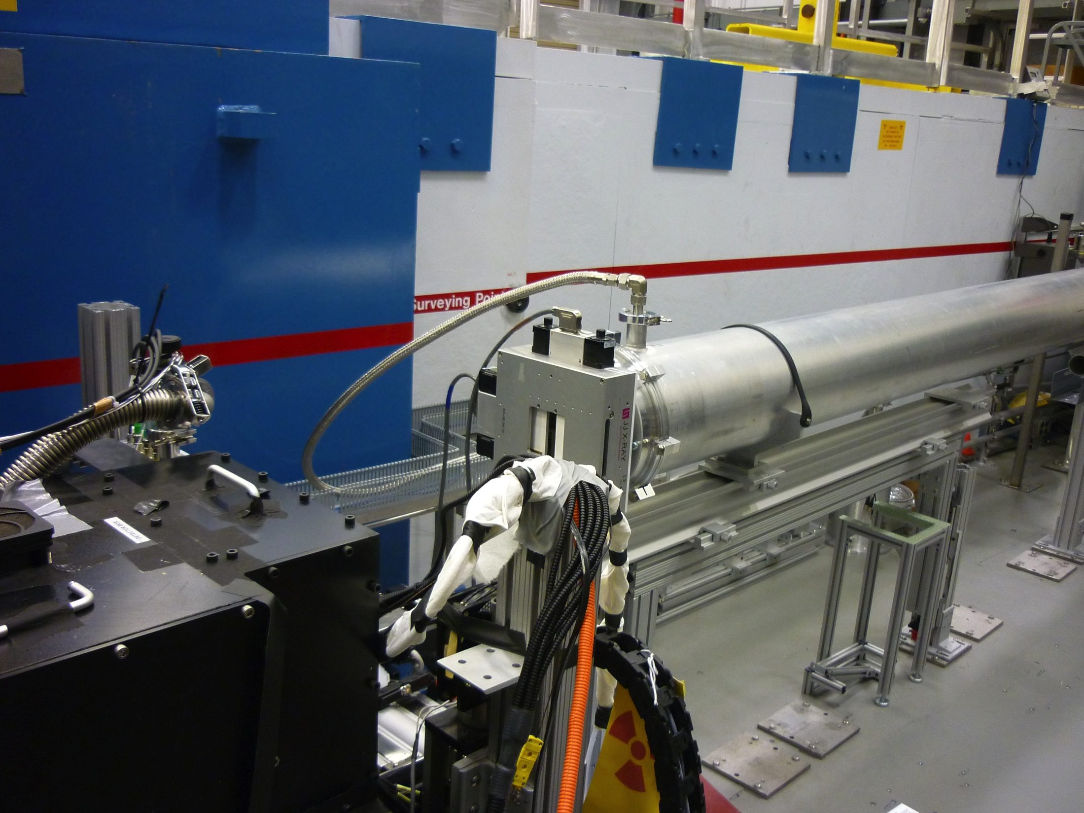

Figure 4: Photograph of the CG-1D neutron imaging beamline

The CG-1D imaging beamline² is equipped with exchangeable apertures that allow an L/D from 400 to 2000, where L is the distance between the aperture, of diameter D, and the detector. Three detectors are available for the user program and are listed below:

- A charge coupled device (CCD) with a 80-100 microns spatial resolution and a field of view of 7 cm x 7 cm (seconds to min acquisition for a neutron radiograph)

- A micro-channel plate (MCP) detector in two modes of operation:
  - 35-50 microns spatial resolution and a field of view of 2.8 cm x 2.8 cm (seconds to min acquisition for a neutron radiograph)
  - ~ 15 microns with the same field of view (a few hours acquisition time for a neutron radiograph)

- An sCMOS detector, with a spatial resolution of ~ 200 microns, 5 cm x 5 cm field of view and up to 100 frames/sec
These detectors offer different capabilities (large field of view, quick acquisition time, high spatial resolution) that are required for the facility as it supports a broad range of applications (additive manufacturing, materials science, engineering materials, biology, plant physiology, geosciences, archeology, etc.). An example of a 3-dimensional computed tomography of a Roman-period bronze oinochoe measured at the CG-1D neutron imaging beamline is illustrated in Figure 5 [6].

- New eMod System for Tracking and Controlling Modifications to Instruments
The need to plan, track, and control system modifications has long been recognized as important on the reactor side; but this was an area that for various reasons received very little attention on the scientific instrument side. As a result, we had instances where when we started an upgrade we had no drawings or reference information on the requirements

²The use of the imaging beam line at Oak Ridge National Laboratory’s High Flux Isotope Reactor was sponsored by the Scientific User Facilities Division, Office of Basic Energy Sciences, U.S department of Energy.
Figure 5: Photograph of the bronze oinochoe (left) and volume rendering the computed tomography acquired with neutrons (right). The height of the oinochoe is 8.5 cm.
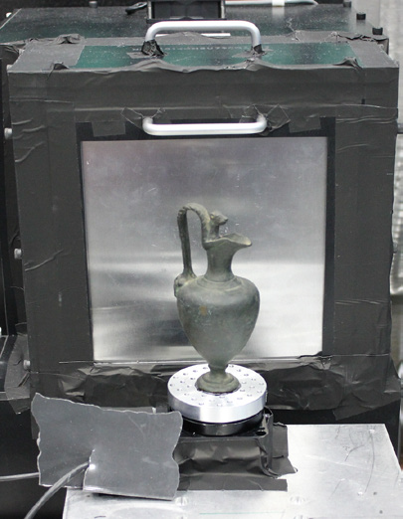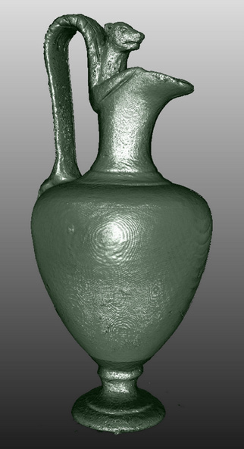

tied to existing equipment. In addition we found that some equipment that had been ordered

and was in use was not designed for what it was being used for. We also had feedback from the instrument teams that we did not always keep them sufficiently informed of the status of upgrades for their instruments. This all led to delays in projects and the need to take certain equipment out of service that was already being used. All of this cost us time, money, and the confidence of our instrument teams. After a number of discussions with reactor management and the manager for the SNS Instrument Engineering group who was having similar problems, we decided to develop an electronic system for the purpose of tracking modifications, providing configuration control, and keeping the instrument teams (our customers) informed and in the loop throughout the process. This system, which we call eMod), has been in place for about one year and although it is still being tweaked; it has clearly become a major tool for the engineering group to assure that proper processes are followed for modifications to instruments and documentation is maintained throughout the process. The system presently supports two types of modifications (minimods and mods) and will soon support a third category of modifications.

  - Minimod: As we started to develop an outline of what we wanted the eMod system to do; it quickly became clear that there were some modifications to instruments that were simple, had no significant safety implications, did not involve interfaces with other instruments or building facilities, and thus did not require a rigorous process. We designated modifications that fell into this category “minimods”. Types of instrument modifications that fall into this category include: instrument drawing changes, simple physical modifications to the instrument, updates to procurement documentation, engineering reviews, and temporary modifications for testing or checkout of systems. It was also noted that some changes need to be made in the field and we gave the task leader the option of documenting the minimod after the work had been completed provided that a simple “what could go wrong” logic test does not identify unacceptable risks. Figure 6 shows a screen shot of the minimod electronic entry page.

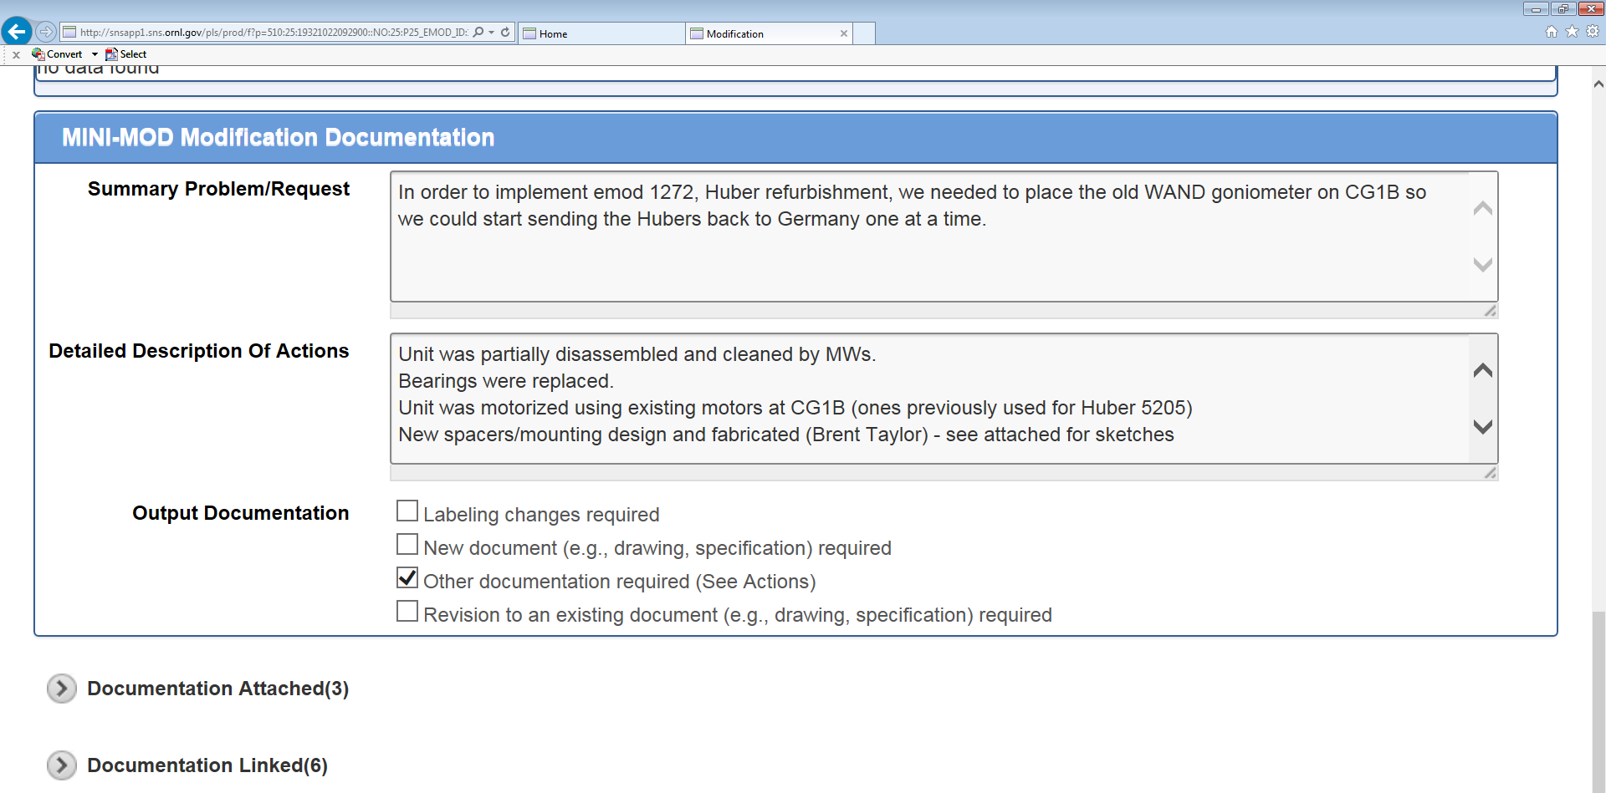

Figure 6 Minimod 1281 Entry Screen Shot

  - Mod: The full mod process involves tracking and performing certain functions through a series of phases (scope and requirements, concept development, design, fabrication, installation, and commissioning). Figure 7 shows the full set of phases of a mod. Each of these phases is in a sense a hold point that the task leader has to determine the phase is completed and push it to the next phase. The specific activities within each phase are described below. Figure 8 shows the general information page for Mod 1091 most of which comes in through the electronic work request system.

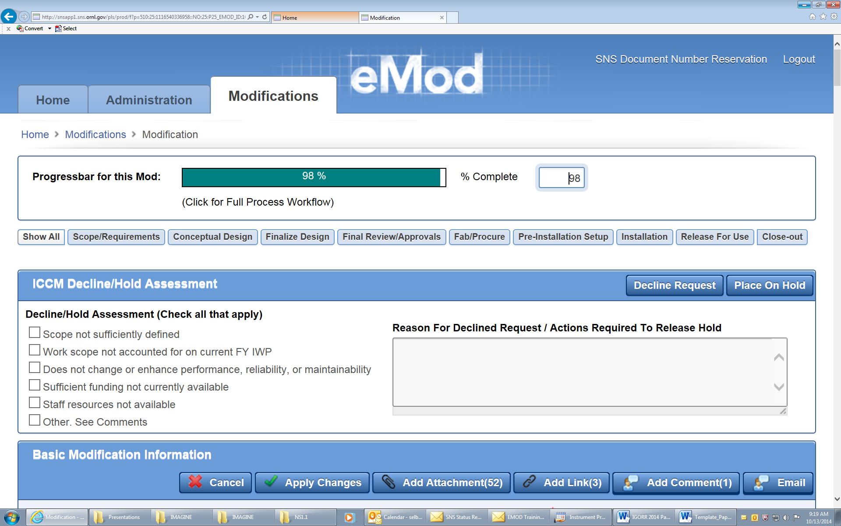
Figure 7: Opening Screen Heading for Mod 1091

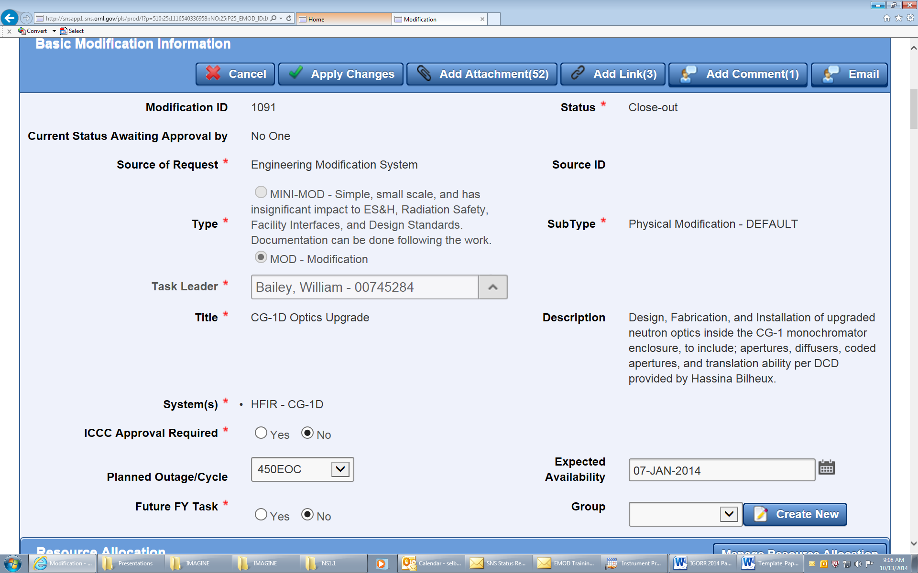

Figure 8 Screen shot of Mod 1091 General Information

    - Scope and requirements - Although all steps of the process are important, this step is absolutely critical and without proper communications, documentation, and agreement of requirements; the process may lead to an unacceptable product. eMod requires instrument scientist, engineer, instrument operations, and management review and approval of scope and requirements prior to proceeding to design.

    - Design and review – eMod steps through both conceptual design, final design, and reviews as needed for the particular modification. On the conceptual design page the task leader is asked specific questions regarding impact on radiological conditions at the instrument, potential impact on other instruments or facilities, and potential ES&H issues. This includes evaluations to determine if there are any interfaces with the reactor operations and/or safety functions for the reactor. If the answer to any of the questions is yes, the task leader is required to fill out a special electronic checklist related to that topic and a subject matter expert is automatically added to the review/approval list. Conceptual and final design phases allow input and agreement on the design direction for addressing the scope and requirements.

    - Procurement/fabrication, Preinstallation Setup (i.e. off-line testing of equipment, and Installation – All three of these phases have electronic pages for entering and attaching information like procurement files, off-line testing results and installation pictures or issues. These phases must be completed to the satisfaction of the task leader prior to proceeding to “Release for Use” to the instrument team.

    - Release for Use – Figure 9 shows a portion of the Release for Use electronic page for Mod 1091. The requirements for this phase are defined by entries made in previous sections. In this example, previous entries mandated that the electrical safety officer review the electrical setup and approve. The electrical safety officer receives an automatic e-mail to review the equipment electrical setup and approve when the task leader pushes the mod to Release for Use. The email contains a link that takes the electrical safety officer to the mod where there is an approval button for him to push when he is ready to approve. Other required documentations are identified on the Release for Use page also based on previous inputs and the task leader must show that each is completed prior to approval. The Release for Use is electronically approved by the task leader, the instrument system engineer, the lead instrument scientist, the instrument scientific associate, any defined discipline approvers, and the instrument configuration control manager. Once this approval is given the new equipment is declared ready for use and released to the instrument team to perform any commissioning activities.

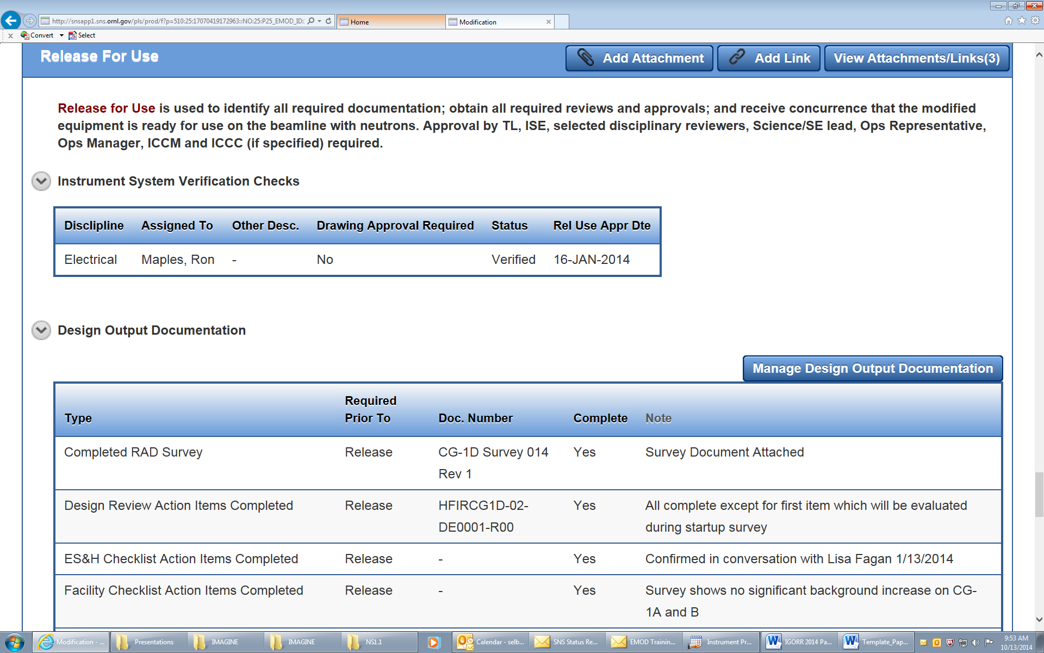
Figure 9: Release for Use Page for Mod 1091
    - Closeout – Once commissioning and other actions such as archival of ‘as built’ drawings are completed, the Mod closure is approved by the task leader, the instrument system engineer, and the instrument configuration control manager; and the mod activity is officially closed. With the completed package drawings, reviews, radiological surveys, fabrication files, etc. are all searchable by instrument, key word, by mod number, or by requester.

- Summary
In summary, since the last material was presented on HFIR scientific instrument upgrades there have been a number of activities, including the installation of a new instrument (IMAGINE) on the CG-4 beam line. In addition, since we are now transitioning from installing new instruments to modifying existing instruments, we have developed a means of tracking these modifications both from a configuration control and requirements perspective.

- References

[1] IGORR website proceedings section http://www.igorr.com/scripts/home/publigen/content/templates/show.asp?P=122&L=EN&ITEMID=4

[2] D. L. Selby and G. S. Smith, “Scientific Upgrades at the High Flux Isotope Reactor at Oak Ridge National Laboratory, Nuclear News Volume 53, Number 10 (September 2010).

[3] F. Meilleur, P. Munshi, L. Robertson, A.D. Stoica, L. Crow, A. Kovalevsky, T. Koritsansky, B. C. Chakoumakos, R. Blessing, and D. A. Myles; Acta Crystallographica Section D 69:2157-2160.

[4] I. A. Prior, P. D. Lewis, and C. Mattos (2012), “A comprehensive survey of RAS mutations in cancer”, Cancer Research 51:6114-6126.

[5] S. O. Schwahn, D. L. Selby, C. M. Martin, L. A. Fagan, and J. P. Abston, “Evaluation of Engineering and Administrative Features Used for Radiological Hazard Control
at the High Flux Isotope Reactor (HFIR) Beam Lines”, Management Assessment Report April 2014.

[6] K. Ryzewski, H. Z. Bilheux, S. N. Herringer, J.-C. Bilheux, L. Walker, and B. W. Sheldon, “The use and refinement of neutron imaging techniques for archeological artifacts”, Advances in Archaeological Practice: A Journal of the Society of American Archeology 2 (2014) 91-103

