**Renovation, improvement and experimental validation of the Helium-3 transient rods system for the reactivity injection in the CABRI reactor**

**Authors:** B. DUC, B. BIARD, P. DEBIAS, L. PANTERA, JP. HUDELOT, F. RODIAC

CEA, DEN, DER/SRES, Cadarache, F-13108 Saint Paul les Durance, France

*Abstract* – CABRI is an experimental pulse reactor operated by CEA at the Cadarache research center. Since 1978 the experimental programmes have aimed at studying the fuel behaviour under Reactivity Initiated Accident (RIA) conditions. At the centre of the CABRI driver core, an experimental loop was designed to accommodate the instrumented test device that contains the fuel rod to be tested, and to cool this fuel rod into the required thermal-hydraulic conditions.

For past FBR’s fuels studies, a sodium experimental loop was used. In order to study the PWR high burn up fuel behavior, the facility was modified in order to have a water loop able to provide thermal-hydraulic conditions representative of the nominal operating PWR’s ones (155 bar, 300°C). This project which began in 2003 lied within a broader scope including an overall facility refurbishment and a safety review. The global modification is conducted by the CEA project team. It is funded by IRSN[1], which is conducting the CIP experimental program, in the framework of the OECD/NEA project CIP.

In the framework of the reactor restart, commissioning tests are realized for all equipments, systems and circuits of the reactor.

This paper focuses on the renovation, the improvement and the experimental validation of the Cabri 3He transient rods system. This system controls the very fast depressurization of tubes (so called transient rods), located among the Cabri core fuel rods, filled of 3He (strong neutron absorber) into a discharge tank. The rapid absorber depressurization leads the tested fuel rod to be submitted to the desired power transient.

The 3He transient rods system requalification tests were performed from 2012 to 2013. They allowed validating the good functioning of the system (instrumentation, circuits, valves…) and of the new 3He fast-opening valves control device. In addition, the zeolite trapping operation performed on the 1000l volume of 3He stored since 2003 allowed getting very convenient final 3He purity.

# **Introduction**

Cabri is a pool-type reactor, with a core made of 1487 stainless steel clad fuel rods with 6% 235U enrichment. The reactor is able to reach a 25MW steady state power level. The reactivity is controlled via a system of 6 bundles of 23 Hf control and safety rods.

The key feature of CABRI reactor is its reactivity injection system. This device allows the very fast depressurization into a discharge tank of the 3He (strong neutron absorber) previously introduced inside 96 tubes (so called “transient rods”) located among the Cabri fuel rods. As the reactor is initially running at a low power (~100kW), the rapid absorber depressurization leads the tested fuel rod to be submitted to an important burst of power which decreases just as fast due to the Doppler effect and other delayed reactivity feed-backs (see Fig1). The total energy deposit in the tested rod is adjusted by dropping the control and safety rods after the power transient.

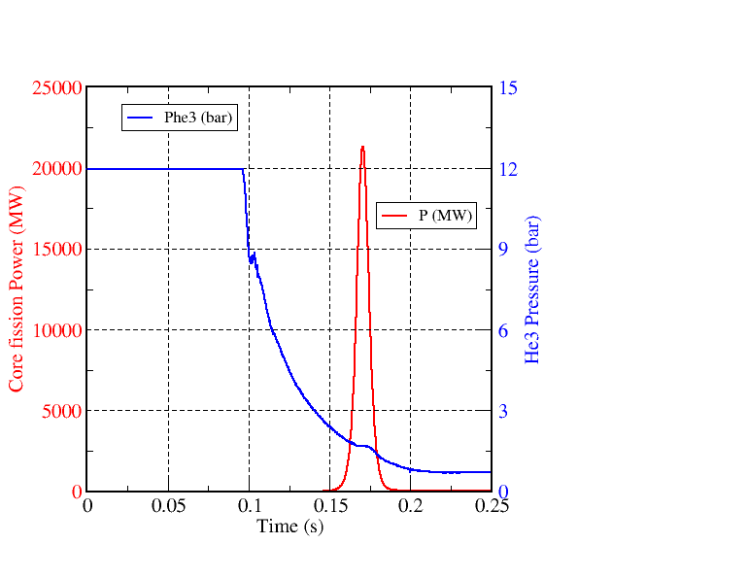

**Fig1 : Typical CABRI 3He Pressure and core power shapes during a RIA transient**

In the frame of the Cabri renovation operations, this 3He transient rods system has been modified and improved.

Thus, some works were carried out in order to enhance the 3He circuits operation and robustness. In addition, the 3He fast-opening and controlled valves of each depressurization flow channel were renovated. At last, a new 3He fast-opening valves control device was designed and manufactured taking into account the new safety rules applying to the Cabri facility. This system so called “digital and analogic set of command of the transient rods” (ENACBT[2]) was also enhanced in terms of reproducibility and control of the reactivity injection.

The good working of the Cabri 3He transient rods system (instrumentation, circuits, valves…) and of the new 3He fast-opening valves control device has been tested by the way of requalification tests performed from 2012 to 2013.

# **General presentation and Role of the transient rods system**

II.1 General Presentation

The Cabri transient rods system is mainly made of the following components (see Fig2):

* 4 fuel assemblies (7x7 pins) which are equipped on their periphery of 24 tubes (~9mm internal diameter) instead of 24 fuel rods. Theses tubes are connected together in the upper part of each assembly in order to join a 43mm diameter line which leads to a principal collector.
* From the top of this collector two flow channels (low and high flow rates) lead to a 1000l discharge tank set under vacuum before operation. The low flow rate channel is equipped of a fast-opening valve (VABT02 – Ø35mm) followed by a controlled valve (VABT04 - Ø30mm). The high flow rate channel is equipped of a fast-opening valve (VABT01 – Ø90mm) followed by a controlled valve (VABT03 – Ø80mm)
* The four transient assemblies are pressurised to the target pressure (15bar maximum) by the use of a compressor which pumps the 3He from its storage tank via a devoted circuit.
* A specific control device trigs the different orders of the experimental sequence and particularly those leading to the opening of the two fast-opening valves and to the reactor control rods shut down.
* Two different pressure transducers (PRBT100 and PRBT101) measure the 3He pressure at the inlet of the collector.



**Fig2: Principle of operation of the Cabri facility**

Those main components are completed by various operation circuits in order to perform:

* the command of the N2 driven fast-opening valves,
* the command of compressed air driven valves,
* the 3He cleaning (by zeolite trapping),
* the gaseous waste release.

A specific control command application allows the operator to perform a maximum of operations from the remote control room.

# **II.2 Key-role for RIA experiments**

The Cabri depressurization system causes the absorber ejection and this induces a reactivity injection possibly reaching about 4$ in a very short time (some milliseconds). The characteristics of the transient (maximum power, power half width and energy deposit) depend on the experimental sequence applied to the two fast-opening valves and on the adjustment of the associated controlled valves.

Thus the short half width power transients, so called “natural transients”, will be generated by the opening of the unique VABT01 fast-opening valve (high flow rate channel). The power peak amplitude is then very high (20 to 30GW) and the half width is short (no more than 10ms) due to Doppler Effect and other delayed reactivity feed-backs. The energy deposit in this case only depends on the initial pressure in the transient rods.

In order to be representative of other accidental power plant conditions, it is necessary to be able to increase the half width of the transient. This can be done by opening successively the two fast-opening valves (VABT02 first then VABT01). The adjustment of the time difference between the openings of the two fast-opening valves allows generating so called “structured transients” characterized by half widths varying from 20 to 80ms. A good precision in the adjustment of this time difference is very important for the respect of the experimental objective. This was one of the most important motivations (with safety one) for the manufacturing of a new control device for the transient rods system. For those last transients, the final deposit in the tested fuel rod depends of the initial 3He pressure but can also be adjusted by the control rods drop instant.

# **Renovation and enhancement of the transient rods system**

# **III.1 Improvement of circuits operation and robustness**

During the ten-year renovation period, the 1000l volume of 3He was stored in its dedicated tank, the integrity of which being continually supervised. Due to their long past service, several components of the other parts of the 3He circuits were renovated or replaced if necessary. This applies to the:

* Implementation of a new pump and a new release tank for gaseous wastes,
* Suppression of unused portions of circuit (two very slow flow rate 3He channels),
* Implementation of new instrumentation (manometers, pressure and vacuum transducers …),
* Renovation or replacement of valves, solenoid valves, check valves and pressure relief valves,
* Renovation of the two controlled valves VABT03 and VABT04 by replacing their old motor by a step motor equipped of a new system for the needle position recopy (based on a resolver and an axis card),
* Renovation of the two fast-opening valves VABT02 and VABT01 which have been completely dismounted. Indeed, these very specific valves work (opening and closing) by the control medium pressure unbalance between the two sides of their sealing piston[3] created by the opening of their respective solenoid valves (EVBT03 and EVBT05). So, these solenoid valves and all joints which participate to the static and dynamic sealing have been changed. Furthermore, some other mechanical improvements have also been implemented in order to increase the service life of these valves. At last, in order to avoid an irreversible pollution of the pure 3He volume due to an accidental control medium leakage, the 4He used before as control medium has been replaced by N2. Indeed, one can notice that the pressure level of the control medium is 50bar for VABT02 and 100bar for VABT01, that is to say far more than the 3He pressure (15bar max). This change has been qualified by experiments and only induces a low and not disturbing increase (+20 to 25ms) of the time required between the command order and the effective movement of the fast-opening valve (Δi, see Fig3).

Due to the Tritium accumulation in those circuits during the 30-year Cabri operation, these renovation operations needed complex and specific procedures. Particularly, the personnel protection had to be optimized in order to reduce its exposition.

# **III.2 Depressurization sequence and Safety of the transient rods system**

As noticed in §II.2, a good precision in the adjustment of the time difference between the two fast-opening valves is a key-role for the respect of the experimental objective. The new control device was thus designed in order to reach this objective but also to take into account new safety rules. Indeed, the Cabri renovation project was conducted after a safety review of the installation asked by the French safety authorities. From this review a hypothetical reference accident has been identified for the Cabri core integrity. This accident considers the hypothetical simultaneous opening of the two fast-opening valves from an initial 15bar pressure and with the two controlled valves at fully open position. Due to the potential consequences and in order to exclude this accident, a failure probability of 2.10-9/request was assigned to the new fast-opening valves control device. This drastic constraint has been taken into account from the beginning of its design as well from the material point of view as from the human factor one.

In order to answer these experimental and safety objectives, the new control device is made of different electronic modules. Thus, the figure3 gives the various chronograms which illustrate the principle of functioning of the system to get the desired depressurization sequence. In particular, one can see the successive various authorizations given by these electronic modules in order to get the desired opening for the VABT01 valve.

**III.2.1 Sequencer electronic Module (MS module)**

Concerning the experimental objective, the Sequencer Module is used to launch the different command orders (operator and experimenter needs…) imposed by the experimental sequence. The associated temporizations, implemented and then validated in the human-machine interface before the experiment, are described hereafter.

* T10: Beginning of the nuclear security inhibition ⇒ this inhibition has a fixed duration of 1second[4],
* T2: VABT02 opening command order ⇒ leads to EVBT03 solenoid valve excitation,
* T1: VABT01 opening command order ⇒ gives a first early authorization for VABT01 opening[5],
* K: multiplication coefficient (< 1) of the initial pressure ⇒ defines the pressure trip threshold K.P0,
* T21: duration deducted from the pressure trip threshold K.P0 ⇒ leads to the experimental objective that is exciting EVBT05 solenoid valve and then opening accurately VABT01 valve,
* T9: Experimental scram order ⇒ used to adjust the energy deposit in the tested rod and shut down the reactor.

On the upper chronogram of Fig3, one can notice that the real opening of each fast-opening valve VABT0i is dependent of two different durations so called “tr i” and “Δ i”. The first one corresponds to the duration of the opening command of the solenoid valve EVBT0i and the second one corresponds to the duration between EVBT0i excitation and the real opening of VABT0i. Due to the fast-opening valves renovation and to the new control device implementation, these durations have to be accurately determined in order to prepare the experiment. Indeed, their value and reproducibility directly participate to the good control of the duration between the openings of the two valves which represent the main researched experimental objective.



**Fig3: Chronograms of depressurization for “structured transients” and VABT01 various authorizations**

**III.2.2 Safety electronic Modules (SS Modules)**

As seen before, the drastic safety constraint has been taken into account from the beginning of the control device design. The principle which has been selected in order to avoid this hypothetical accident of simultaneous opening of both VABT01 and VABT02 is that the final opening order for the solenoid valve EVBT05 (which leads to the VABT01 valve opening) is given only if, at a predefined instant, the mean pressure in the transient rods stand within a predefined pressure range. Reliability studies have been led and concluded that the safety objective could be reached with a particular architecture based on two independent safety trains. Thus, two pressure transducers PRBT100 and PRBT101 (from different technologies and suppliers) have been implemented at the entry of the collector and their signals are directed independently to the two safety trains (SS Modules) of the control system. In addition, each safety train processes the pressure transducer signal it receives by two different integrate circuits (FPGA) working at different frequencies. At the end, the authorisation order for the opening of EVBT05 solenoid valve is given only when the four FPGA verify the good agreement between their measurements and the validated programmed parameters which are defined hereafter.

* TM0: duration between the instant of the pressure decrease detection and the instant when the mean pressure determination begins,
* dt: duration for mean pressure determination,
* Kmin: multiplication coefficient (< 1) of the initial pressure ⇒ defines the minimum authorized pressure value Kmin.P0 at the instant TM0 + dt,
* Kmax: multiplication coefficient (< 1) of the initial pressure ⇒ defines the maximum authorized pressure value Kmax.P0 at the instant TM0 + dt.

Due to the safety constraints, the input of these parameters in the human-machine interface has been considered as an important activity and a specific procedure has been implemented. In particular, the check list plans different review levels (technical + independent) to ensure a high confidence in this activity.

**III.2.3 Independent Sequencing System (SSI)**

Furthermore, in order to reach the very low failure probability desired, an independent complementary system so called “Independent Sequencing System“ (SSI) has been added on the EVBT05 line of command. This system is a simple line with delay (RC circuit) working on the 48VDC voltage of the solenoid valve EVBT03 (which leads to the opening of VABT02 valve). Unlike the “ENACBT” control device, the SSI Module is characterized by a fixed (not programmable) delay for its EVBT05 opening authorization. In order to cover the complete domain of Cabri transients, several SSI modules have been manufactured.

The choice of the SSI module to be used and of the parameters to be introduced in the ENACBT control device system for a specific transient is done before the test. The experimenter bases his choice on preliminary calculations performed with the DULCINEE [1] and SCANAIR [2] codes. DULCINEE is a code based on neutron point kinetics which evaluates the power and thus the energy deposited in the Cabri fuel rods. From these data, SCANAIR evaluates, with the maximum margins, the three key parameters for Cabri fuel rods integrity:

* Fuel temperature < 2810°C,
* Clad strain < 3.6%,
* Clad temperature < 1300°C.

These preliminary calculations are done using the 3He pressure evolution recorded during previous experiments or during depressurizations performed without neutrons. The researched temporizations parameters for SS and SSI modules are chosen in order to get safety margins and also to allow sufficient operation adjustment.

# **Results of the re-commissioning tests of the transient rods system**

# **IV.1 Reproducibility and control of the depressurization sequence**

The transient rods system requalification tests were performed from 2012 to 2013. These tests first allowed validating the good functioning of the circuits and the associated instrumentation, of the four (fast-opening and controlled) valves and at last of the new ENACBT and SSI control devices. Furthermore, due to the very fast phenomena to be studied during the depressurization sequence, those tests showed the very good functioning of the new data acquisition systems (4kHz) used by the experimenters and the associated post-processing.

**IV.1.1 Circuits and instrumentation associated**

At the end of the renovation and modification of the 3He circuits, an important campaign of tightness tests was led in order to guaranty those circuits integrity.

A new portion of circuit equipped of three reference pressure and void transducers has been implemented and allowed carrying out a step by step pressurization of the circuits until 15bar in order to calibrate of these circuits instrumentation (included the two pressure transducers PRBT100 and PRBT101 connected to the collector and which are used by the safety electronic modules SS1 and SS2).

**IV.1.2 Controlled valves VABT03 and VABT04**

After the controlled valves renovation operations and during the on-site implementation, a dial gauge was set directly under the needle of the controlled valve in order to measure its movement. Along the whole needle stroke, this direct measurement was successfully compared with the one given by the new position recopy system of each valve. Reproducibility tests were also performed and the qualification with fluid depressurization tests confirmed a good performance of the recopy system.

Due to Cabri operation constraints, the effect of the aperture of each controlled valve on the depressurization kinetics was first evaluated with 4He. Those tests[6] allowed drawing charts giving, for a given initial pressure, the kinetics of the depressurization according to the aperture of the valve.

Fig4 gives an example of these charts for an 11.5bar pressure and for the VABT04 controlled valve (Ø30mm). One can first note the significant increase of the kinetics with the needle position. Thus the time to reach P0/2 pressure[7] is 0.367s for an aperture of 20% and 0.088s for the full aperture. The zoom (0 to 0.06s) of Fig4 shows oscillations on the various curves at the opening of VABT02 fast-opening valve. These oscillations are due to the hydraulic response of the circuit for each aperture. Further Fig7 will show that those oscillations are very reproducible for a same aperture.

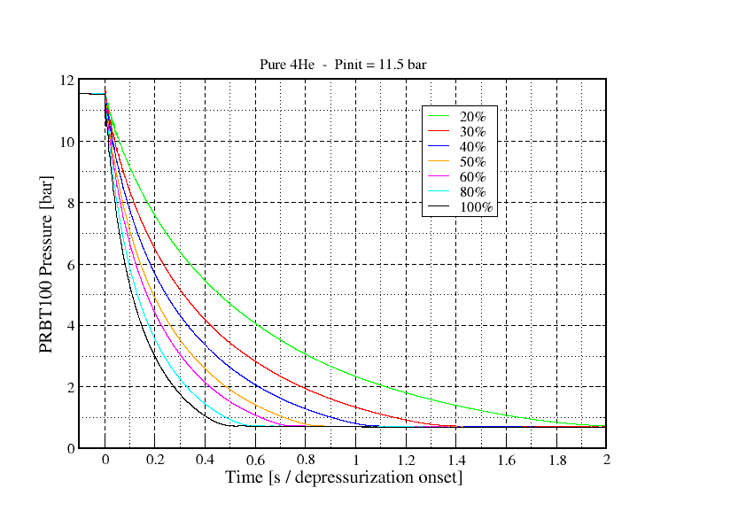 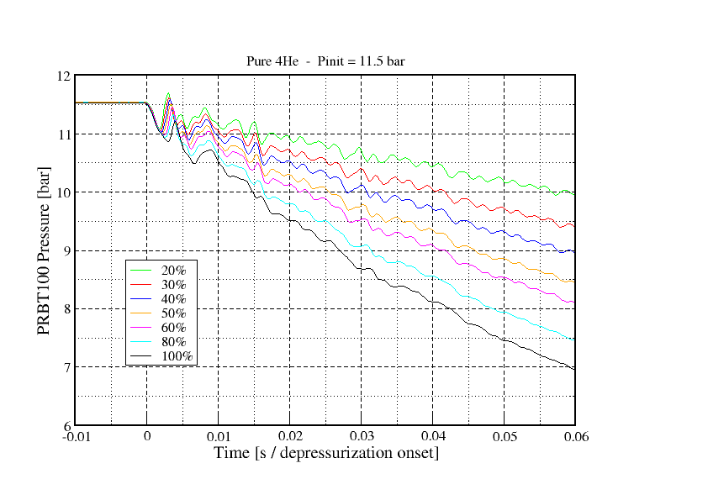

**Fig4: Kinetics of depressurization for various apertures of VABT04 controlled valve**

The same type of chart at 15bar pressure is given by Fig5 for the VABT03 controlled valve (Ø80mm). The time to reach the final pressure is 0.0392s for an aperture of 25% and 0.0155s for the full aperture. One can note that the slope of the pressure decrease is identical whatever the aperture during a few 3ms. Then, according to the aperture, the pressure curve presents a rebound before the pressure continuously decreases until its final value with the critical flow rate associated to the section at the throttle of the controlled valve.

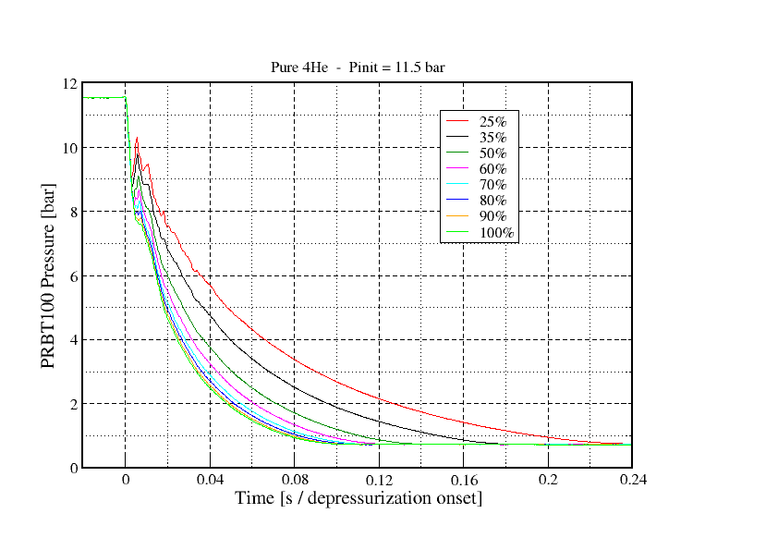 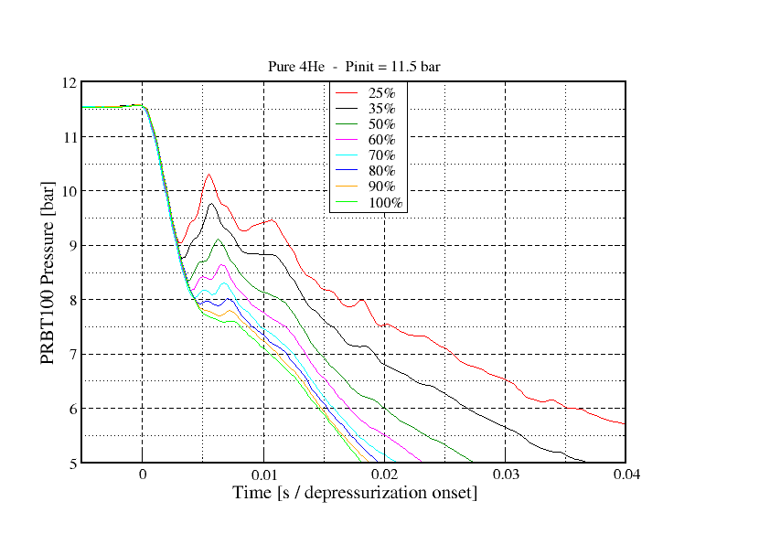

**Fig5: Kinetics of depressurization for various apertures of VABT03 controlled valve**

These results will be used with those obtained in further §IV.2 for gas mixtures and 3He depressurizations, in order to be able, in the future, to predict a depressurization curve from the knowledge of the fluid characterized by its quality and of the aperture of the controlled valve. These predictions will be useful for pre-test calculations with DULCINEE code as developed in §IV.3.

**IV.1.3 Fast-opening valves VABT01 and VABT02 temporizations reproducibility**

As seen before (§III.2), the two “tri” and “Δi” durations are important to be determined precisely in order to reach the experimental objective. During the transient rods qualification, more than 150 depressurizations were performed and statistical analyses allowed determining the new values for these two durations. Thus for tri the typical values are 7.1 and 0.6ms respectively for VABT01 and VABT02 valves with a standard deviation of 0.12ms.

Concerning the “Δi” duration, the following observations can be made.

* No significate effect of the pressure level of the control medium was detected for the two valves,
* For VABT02 valve and as shown on Fig6, the Δ2 duration is linear depending on the initial pressure of the fluid to depressurize. One can note that this duration varies significantly from 42 to 65ms between respectively 4 and 15 bar.



**Fig6: Depressurized fluid pressure effect on the Δ2 duration for VABT02 fast-opening valve**

* For VABT01 valve, this effect of the fluid initial pressure is weak and not clearly identified. On the other hand, the last tests performed with 3He show lower Δ1 durations in comparison with those obtained by depressurizing 4He and N2. The Δ1 duration with 3He varies from 92 to 99ms between 4 and 15 bar.

Due to these results, a precise prediction of Δ1 and Δ2 cannot be guaranteed at the end of the requalification tests. This prediction will be obtained before each final test by performing preliminary tests without neutrons so called “depressurization campaign tests” where these parameters will be measured according to the foreseen 3He initial pressure and to the up-to-date mechanical state of the two fast-opening valves.

**IV.1.4 Respect of the experimental objective (time difference between the openings of the two valves)**

Concerning the final experimental objective to improve the control of the time difference between the openings of VABT02 and then VABT01 valves, a set of specific depressurizations has been launched with identical parameters (initial pressure, controlled valves openings and T21 temporization). Fig7 presents the normalized pressure evolution for the 9 depressurizations performed and Fig8 presents a zoom of these evolutions at the instant when the VABT01 valve opens.

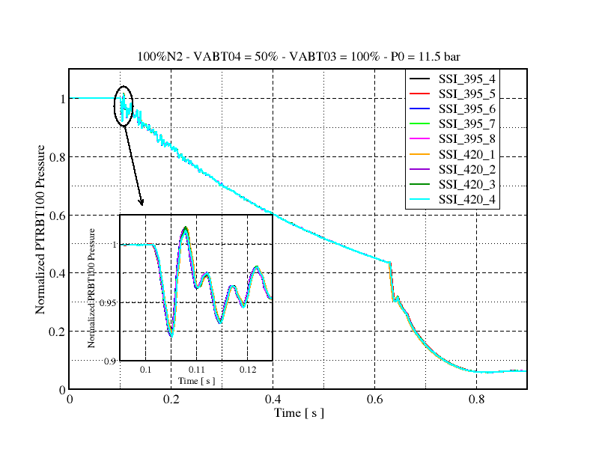 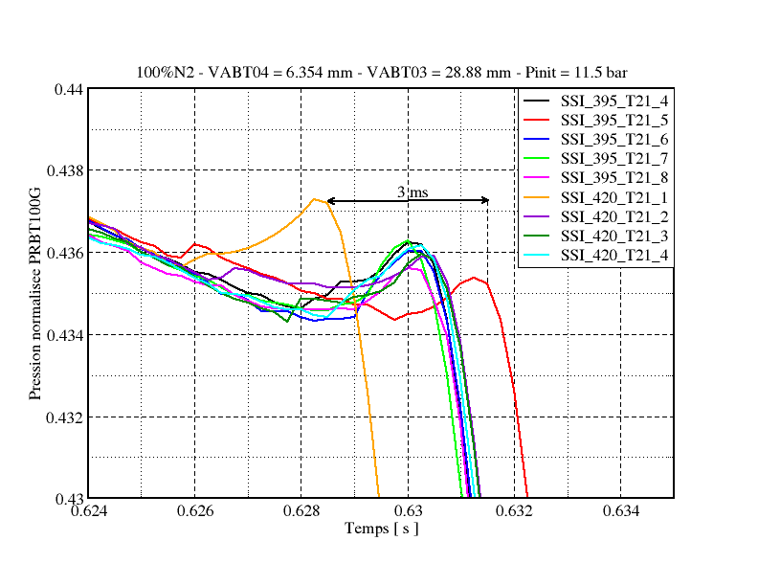

**Fig7: Normalised pressure evolutions for 9 shots Fig8: Zoom of the 9 evolutions at VABT01 opening**

Fig7 first shows the very good superposition of the 9 pressure evolutions during the 0.8s period of depressurization. The various curves have been plotted in order to make coincide the instant of the beginning of the pressure decrease due to the first fast-opening valve VABT02 opening (see the zoom on Fig7). Thus, one can note the perfectly reproducible pressure waves of the pressure evolution at the beginning of the opening of VABT02 (zoom from 0.1 to 0.125s). These waves are due to the hydraulic characteristics of the circuit and are typical for a specific opening of VABT04 controlled valve. Earlier Fig4 showed how these waves change with the aperture of the controlled valve.

Fig8 presents a zoom of the openings of VABT01 (at ~0.63s) and one can see the very short time deviation between the beginnings of the pressure decrease due to VABT01 openings. The maximum value of 3ms for this deviation is a very good one in comparison with the past values which were close to 6ms. This good result, obtained in depressurization configuration (without neutrons), is due to the accuracy of the K.P0 threshold detection and its associated delay T21 implemented in the Sequencer electronic Module (MS). This result has to be confirmed during the future commissioning tests with neutrons but is yet very encouraging.

# **IV.2 4He, 4He + N2 gas mixtures, N2 and 3He depressurizations**

Due to maintenance operations some impurities as air or else may be introduced into the 3He volume. The presence of air in this 3He volume is prejudicial for the experiment because this presence slows down the depressurization of the mixture and also reduces the 3He absorbent quantity in the transient rods and thus the reactivity that may be inserted. In order to be able to use the DULCINEE code for pre-test calculations, it is necessary to get the knowledge of the 3He depressurization curve and so to be able to predict this one. Thus, the commissioning tests were performed using various gases to be depressurized: 4He, different 4He + N2 gas mixtures, N2 and 3He with the objective to improve the present modelling of Cabri 3He depressurization.

Results for 4He depressurization were yet presented in §IV1.2.

The 4He + N2 mixtures (10 and 18% N2) were done by two successive introductions of a known volume of N2 in the initial pure 4He volume contained in the transient rods. The quality of the mixtures was validated by two mixture collections and chemical analyses. Then various depressurizations of 100% 4He, 90% 4He + 10% N2, 82% 4He + 18% N2 and 100% N2, for a same controlled valve aperture, were performed and the results are presented on Fig9.

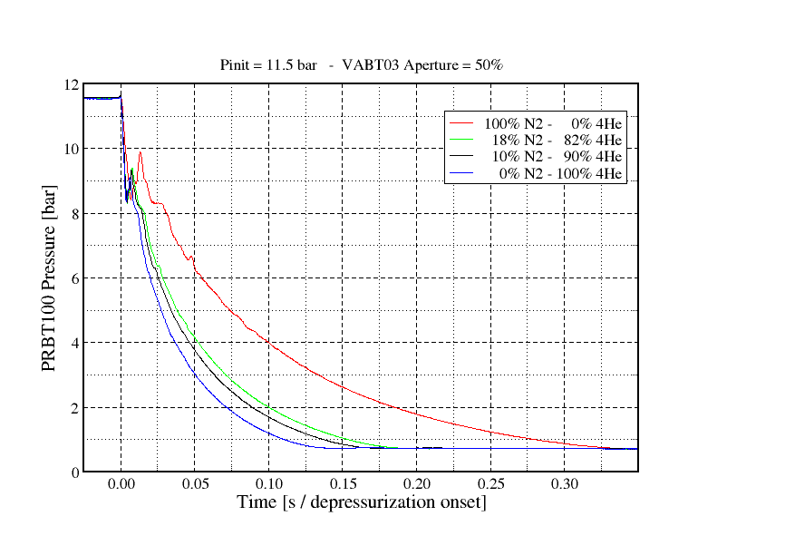 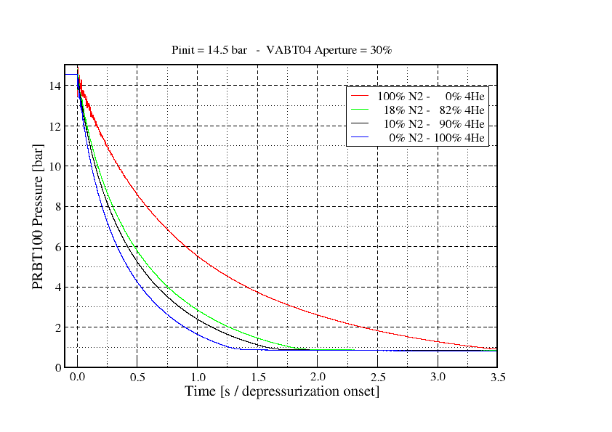

**Fig9: Depressurization curves obtained for pure 4He, pure N2 and two different 4He + N2 mixtures**

One can notice the important impact of the N2 presence in the mixture, the measured P0/2 durations amounting to 0.31s, 0.36s and 0.69s respectively for 10, 20 and 100% N2 to be compared to 0.25s for pure 4He as given as an example for a 50% aperture of VABT03 valve and an initial pressure of 11.5 bar.

After those mixture measurements and an important 3He circuits cleaning period, the 3He stored since 2003 in its storage tank has been introduced in the circuits. Some depressurizations have been performed so as a collection for chemical analyse. 3He depressurizations showed that the kinetics of the stored 3He depressurization is similar to the one of the pure 4He measured previously.

This result confirmed that the stored 3He was slightly polluted by impurities. So, a zeolite trapping operation of the 1000l 3He volume was performed. This trapping consists in imposing the 3He to go through a zeolite balls trap immerged in a Dewar flask filled by liquid N2. When the zeolite trap is full, there is no more polluted 3He passage through the trap. The latter one has to be isolated from the tanks where polluted and trapped 3He are temporary stored in order to proceed to its warming up to 200°C. After a period of 3 to 4 hours, the trap is cooled and the volume of impurities desorbed from the trap is directed to a specific waste tank. These operations were renewed four times in order to trap the whole 1000l 3He volume.

A new collection for chemical analyses and several depressurizations were then performed in order to be compared with the previous ones. This comparison is presented on Fig10.

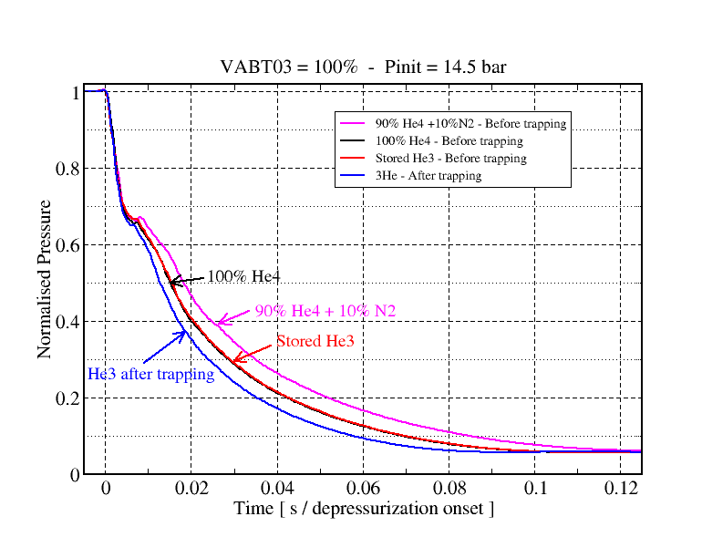 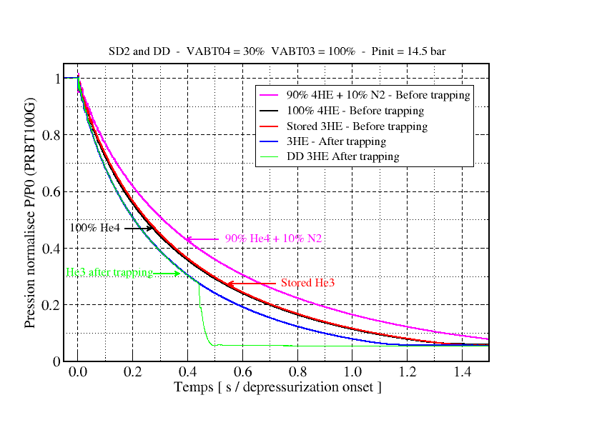

**Fig10: Depressurization curves obtained for pure 4He, 90%4He + 10%N2, stored 3He and trapped 3He**

One can notice that the trapping was very efficient. Indeed the trapped 3He depressurizes quickly in comparison with the initially stored 3He and pure 4He. The chemical analyses confirmed this result with a measured trapped 3He quality close to 99.5% which is largely sufficient for Cabri operation (past experimental campaigns were performed with qualities situated between 85 to 95%).

# **IV.3 Transient rods system performances**

**IV.3.1 Safety performances**

One of the main objectives of these commissioning tests was to verify the good functioning of the various safety systems implemented to guarantee the imposed drastic failure probability (< 2.10-9/ request). Thus, numerous tests were performed regarding this objective.

Concerning the ENACBT system, several anomaly tests were performed successfully at the beginning of the commissioning tests: non-authorization of the sequence launching or preventive actions in the case of various anomalies occurring before or during the test.

Then, the good functioning of the SS electronic modules has been checked by performing independent tests for the four criteria KmaxSS1, KmaxSS2, KminSS1 and KminSS2 of the SS1 and SS2 modules. Each test has consisted in succeeding for 3 criteria over 4 of them which leads to the non-authorization of the VABT01 valve opening.

Furthermore, several tests were performed in order to verify the independent good functioning of each of the existing authorizations. These tests consisted in adjusting the time for those various authorisations in order to give the final order for EVBT05 solenoid valve opening by the chosen authorization successively: T21 (experimental nominal final one), T1, SS1, SS2 and, at last, SSI. The tests succeeded while getting the real opening of the VABT01 valve (beginning of the pressure decrease) at the foreseen time for the tested authorization.

Concerning the SSI system, each one of the modules fabricated has been tested and characterized (measurement of the mean time delay duration) during this qualification campaign.

At last, these numerous commissioning tests allowed implementing and then improving the tests procedure in order to take into account the human factor.

**IV.3.1 Transient characteristics performances**

These commissioning tests were also defined with other experimental motivations. The first one has yet been briefly described in §IV.1.2 and consists in improving the knowledge of the gas depressurization of the transient rods. The important database got from the numerous tests performed in SD1 or SD2 will be useful to predict the transient shape by using the DULCINEE code. Indeed, this code allows deducing the transient power shape from the knowledge of the external reactivity. This last one can be evaluated with a combination of functions as follow [1]:

****(t) = **(PHe) ⊗ PHe(t)** where

* **(PHe) is given by real geometry neutronic calculations [3] using the stochastic TRIPOLI 4 code [4] and the JEFF 3.1.1 nuclear data library,
* PHe(t) corresponds to 3He pressure

The term PHe(t) is a preliminary measurement of 3He pressure in actual test conditions but without core operation. It can also be computed with the following analytical law.



with:

  2 / ( – 1) and  = Cp / Cv,   1.66 for Helium

B= a term characterizing the valve aperture and fitted to the experiments.

The future analyses of the depressurizations measured during the commissioning tests will allow validating this previous pressure law or lead to some modifications. Furthermore, the first future tests with neutrons will be “natural transients” ones (single depressurizations by VABT01 or VABT02 during the reactor operation) with a progressive approach, which will allow to validate the predictions of DULCINEE using the considered pressure law. The final objective is to explore the maximum Cabri performances in terms of energy deposit for that kind of short half width power transients while respecting the safety limits.

The second experimental motivation was to secondly study the “structured transients” by using the new ENACBT system in order to build transients of half widths from 20 to 80ms and even more if necessary. The tests will also be predicted by DULCINEE calculations applying directly the external reactivity introduced in the Cabri core as an input data.

All those tests will allow studying the Cabri capability to explore a wide scale of transients from the half width and the energy deposit points of view.

# **Conclusions**

This paper presents the renovation operations performed on the transient rods system for the reactivity injection in the Cabri core and the requalification tests associated.

The two main motivations of this renovation were to improve the control and the reproducibility of the 3He depressurization sequence and also to answer to the enhanced Cabri safety rules. The modifications of the circuits and components as well as the manufacturing of the new 3He depressurization control device were successfully tested during an important requalification campaign. Numerous tests were performed by depressurizing 4He, mixture of gas (4He + N2) and 3He which allowed constituting an important database which will be used to improve the existing Cabri depressurization models. These models are useful to the preparation of the future Cabri experiments. The next and final commissioning tests will be soon performed with the reactor in operation resulting in a wide scale of power transients. The new Cabri capabilities should then be defined regarding the half width an energy deposit points of view.

**References**

1. DULCINEE. Beyond neutron kinetics, a powerful analysis software G. Ritter, R. Berre, L. Pantera. RRFM IGORR 2012, Prague, Czech Republic, March 18-22, 2012.
2. SCANAIR reference documentation. Version V_6_1. A. Moal, F. Lamare, J.C. Latché, E. fédérici, V. Bessiron. February 18th, 2008
3. Neutronics computations in support of the Cabri core safety analysis O. Guéton, G. Ritter, F. jeury, C. Hée, B. Duc, C. Döderlein, A. Colas. 12th IGORR Conference, Beijin, China, October 28-30, 2009.
4. TRIPOLI-4 VERSION 4 USER GUIDE. Odile PETIT, François-Xavier HUGOT, Yi-Kang LEE, Cédric JOUANNE, Alain MAZZOLO. Rapport CEA-R-6169.

1. IRSN : French Institute of Nuclear Radiation protection and Safety.
2. In French : « Ensemble Numérique et Analogique de Commande des Barres transitoires » (ENACBT)
3. The time duration for this piston to reach its full stroke is lower than 5ms.
4. This nuclear security inhibition is necessary to avoid an automatic scram during the transient. After 1second, in case of trouble with the experimental scram order, the scram will automatically occur due to normal operation safety (doubling time and maximum power exceeded).
5. This temporization is mainly devoted to the “natural transients” performed with the unique opening of VABT01 fast-opening valve. For the “structured transients”, T1 can be adjusted in order to avoid a premature opening of VABT01 and so participates to safety in complement of the other devices (SS and SSI).
6. Tests consisting of opening a unique fast-opening valve (VABT01 or VABT02). The sequence is called”SD1” for Single Depressurization by VABT01 and “SD2” for VABT02. When the two valves are opened successively, the sequence is called “DD” for Double Depressurization
7. The time to reach half of the initial pressure was set as a reference to characterize the Cabri depressurization kinetics. This reference allows the comparison between the various depressurized fluids during the commissioning tests.