Irradiation Facilities Performance at RA-10

F. Sánchez¹, S. Bazzana¹, A. Cintas¹, N. Chiaraviglio¹, A. Márquez¹, J. Longhino¹, A. Yunes¹, A. Weir¹

- Reactor and Radiation Physics Department (CAB)
Av. E. Bustillo Km 9.5 Bariloche, Argentina.
CNEA - Argentine National Atomic Energy Commission

Corresponding author: sanchezf@cab.cnea.gov.ar

Abstract. A new multipurpose research reactor, the RA-10, will be built during the next years in Argentina. It will be primarily committed to medical radioisotope production and industrial applications. Also it will offer research opportunities for science and technology development. The project, supported by the National Administration, has started in 2010 and the reactor is planned to be operative in 2018. The RA-10 is a 30 MW_{th} pool-type reactor with a compact square array core containing 6 internal irradiation positions. A heavy water reflector tank surrounds the core and houses the ex-core irradiation facilities, including several positions for radioisotopes production with medicinal and industrial purposes (Mo-99, Ir-192, Lu-177). Five positions are set aside for the production of high quality silicon semiconductor, doped via NTD method. There will also be available a NPP fuel-testing loop and seven positions are reserved for Neutron Activation Analysis (NAA) using a pneumatic transfer system tubes. In addition, a Cold Neutron Source will be installed, providing cold neutrons for experimental facilities. For the same purpose, two thermal-neutron beams will also be available. Furthermore, an additional beam will be used to perform in-pool neutron radiography. The irradiation facilities have been designed using different neutronic codes (CONDOR, CITVAP, PUMA, MCNP, McStas). Using three dimensional models it was possible to calculate the performance of each facility and to fulfill widely with the requirements.

1. Introduction

The new multipurpose reactor RA-10 will be the first Argentine reactor committed to medical radioisotope production and industrial applications. It will also provide facilities to test new nuclear fuels and materials. Furthermore, it will offer new research and development opportunities based on neutron techniques for the scientific and technological system, [1].

The Argentine National Atomic Energy Commission (CNEA) is responsible for the design, construction and start-up of the RA-10 reactor, which is planned to be operative by 2018. It will provide a replacement for the RA-3 reactor increasing the capabilities for radioisotopes production in order to support the local and regional future demand. The main contractor is INVAP S.E. which is committed in the design and construction of the reactor and related installations. The current status is the detailed engineering stage, having already achieved a well-established reactor design and recently the construction license approval from the national regulatory agency.

In this paper the reactor facilities are fully described and their performances are evaluated. The results obtained were mainly elaborated by the Reactor Physics and Radiation Department from the National Atomic Energy Commission together with other Nuclear Engineering departments of CNEA and INVAP.

Hopefully the reactor would be beneficial for a numerous research areas as well as for manufacturing commercial products and providing services for the scientific community.

2. General Description of RA-10 Facilities

The RA-10 is a 30 MW_{th} pool-type reactor with a compact square array core containing 6 internal irradiation positions and 19 MTR fuel assemblies. A heavy water reflector tank surrounds the core and houses the ex-core irradiation facilities. The core and the heavy water reflector tank are both placed in an open pool containing the light water coolant. The irradiation rigs are independently cooled by means of the pools cooling system. The RA-10 will have about 29 fuel-power day fuel cycle.

The 6 in-core irradiation positions are focused on material testing such as neutron damage and corrosion studies. The two central positions present an intense fast neutron flux, while the four positions placed at the corners, show a reactor spectrum flux.

The ex-core irradiation facilities include: radioisotopes production, silicon doping, pneumatic tubes, a fuel-testing pressurized loop, an in-pool neutron radiography and beam extraction tubes: two thermal and two cold from a cold neutron source.

The production of medical radioisotopes includes Molybdenum-99 (⁹⁹Mo) generated by fission, Lutetium-177 (¹⁷⁷Lu) and Bismuth-213 (²¹³Bi). Iridium-192 (¹⁹²Ir) will be produced for industrial and also medical purposes. The reactor will also have additional positions for production of other radioisotopes (ORI) that might be of interest in the future.

The fuel-testing loop consists in a thermo hydraulic circuit under PWR temperature and pressure conditions, designed for testing nuclear power plant fuels in long-term steady state irradiations and transient situations, such as power ramps.

An in-pool neutron radiography facility will be available for the examination of irradiated devices.

Among the technological applications, the RA-10 will be able to provide high quality doped silicon material to the semiconductor industry. The process consists of adding a small amount of an impurity in order to improve its electrical properties. In the reactor, this is achieved by transmutation through a neutron capture reaction in silicon ${}_{14}^{30}{Si}\left(n,γ\right){}_{14}^{31}{Si→\left(β^{-}\right){}_{15}^{31}P}$ (T_{1/2}=2,62 h), where the dopant agent is the stable isotope Phosphorus-31. The outcome material is preferred for manufacturing power semiconductor devices.

Additionally, the reactor will have a pneumatic transfer system for Neutron Activation Analysis (NAA) and long term irradiations (SILT). It will be possible to irradiate samples to develop potential new radioisotopes, and also for material testing experiments.

For the scientific and technological community, the RA-10 will offer new capabilities based on thermal and cold neutron beams facilities for their applications to nuclear technology, material science and biology. Summing up, 8 neutron beams will be available, 4 thermal beams and 4 cold neutron beams fed by a liquid deuterium cold neutron source. The irradiation facilities distribution inside the reflector tank is shown in FIG. 1.

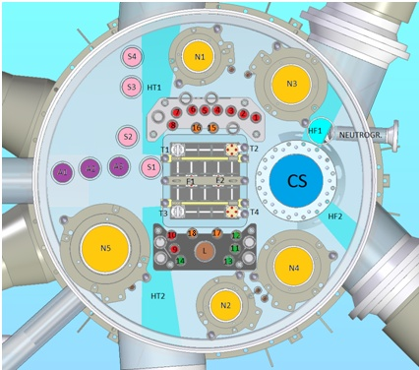
¹⁹²Ir_{Industrial} / ORI
⁹⁹Mo
¹⁹²Ir_{medical} / ¹⁷⁷Lu
Fuel-Testing Loop
Pneumatic Tubes (SILT)
Silicon doping (NTD)
Cold Neutron Source
Pneumatic Tubes (NAA)
FIG. 1. Facilities distribution in the reflector tank.

3. Irradiation Facilities Models

During the detailed engineering stage, neutronic simulations were run in order to guarantee the irradiation facilities performance requirements as well as the heat load for each facility and an estimation of radioisotopes production.

Irradiation facilities simulations were performed using the Monte Carlo transport code MCNP5 v.1.60 developed and supported by Los Alamos National Laboratory, [2], [3].
A highly-detailed core and reflector tank model was elaborated by using a spreadsheet, in which different configurations and operational states are easily varied. For instance: BOC, EOC, control rods positioning, considering facilities in or out, reflector tank level, among many possible changes. Additionally, the McStas code was used for performing neutron transport calculations through neutron guides.

The current status of the reactor model can be seen in FIG. 2. The heavy water reflector tank holds the ex-core irradiation facilities, the liquid deuterium cold neutron source and the neutron beams. The cold neutron source model is shown in FIG. 6. A description of each facility is presented as well as their technical requirements.

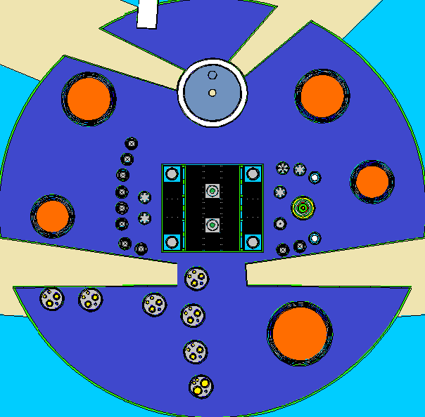
FIG. 2 MCNP reflector tank model.

3.1. Molybdenum-99

Mo-99 is produced by fission of low enriched uranium targets. The approximate irradiation time is 5 days under a thermal flux level between 1 and 1.5 x10¹⁴ n/cm²s. The targets can be extracted during normal reactor operation. Ten irradiation positions, containing 8 targets each, are required. However, it might be upgraded to 12 targets per irradiation position. The irradiation device consists of a target holder containing 4 positions each. Mo-99 positions are shown in FIG. 1 (in red, positions 1 to 10). Figure 3 shows the MCNP model for this facility.

3.2. Iridium-192

Ir-192 is obtained by means of metallic iridium activation. For the industrial use, the required flux is between 1 and 1.5 x10¹⁴ n/cm²s, and for medical applications >1.8x10¹⁴ n/cm²s is needed. A maximum of 4 irradiation devices positions are considered. The irradiation device model is shown in Figure 3. Wire-shaped medical iridium is placed in 10-centimeter-long container tubes, obtaining a total of 1.2 m per device. For industrial use, iridium foils are placed inside aluminium tubes, separated by aluminium discs. FIG. 1 shows positions for industrial use (green, positions 11 to 14) and for medical use (orange, positions 15 to 18).
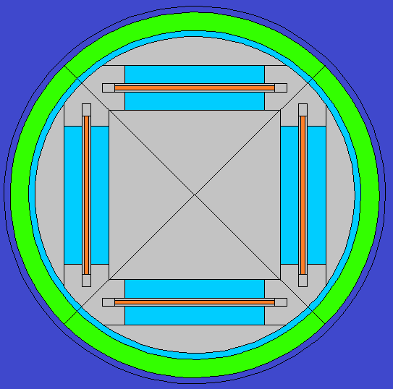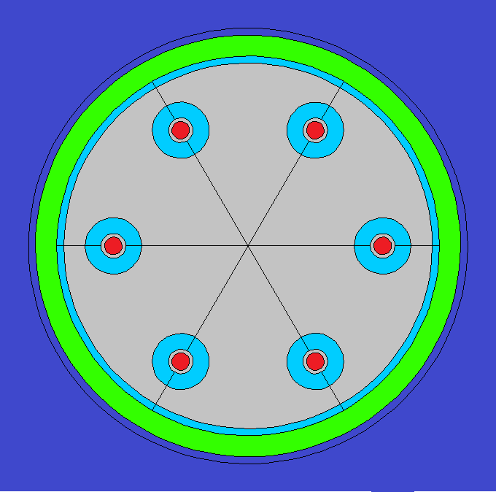
FIG. 3. MCNP model for Mo99 (left) and Ir192 production devices (rigth).

3.3. Lutetium-177

Lu-177 is produced by irradiating Lu-176 evaporated in glass tubes. These tubes have the same flux requirements as medical Ir-192 and share the same positions. See positions 15 to 18 shown in orange in FIG. 1.

3.4. Bismuth-213

Another radioisotope of interest is Bi-213, which will be studied in the future due to current lack of technical specifications.

3.5. In-core Facilities

For material testing applications, samples will be irradiated inside in-core capsules or devices. These devices can be placed in the center of the core (positions F1 and F2) for high fast flux irradiation (5x10¹⁴ n/cm2s) and at corners (positions T1 to T4) for reactor spectrum flux (3x10¹⁴ n/cm2s).

3.6. Fuel Loop Irradiation Facility

The Fuel Testing Loop Facility is a pressure containment placed inside the reflector close to the reactor core (FIG. 1, “L” position) designed to test power plant fuels rods in long-term irradiation and transient situations. Linear power densities between 200 and 600 W/cm are planned with PWR pressure and temperature conditions.

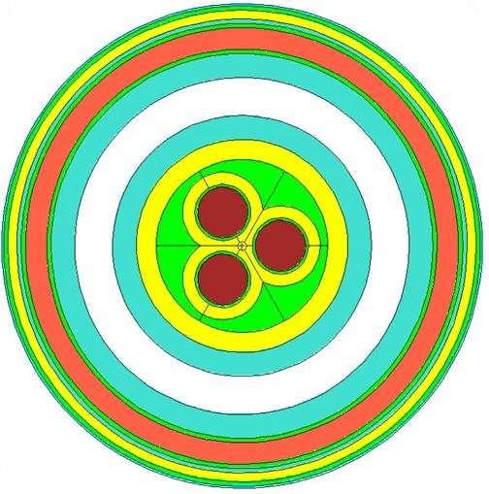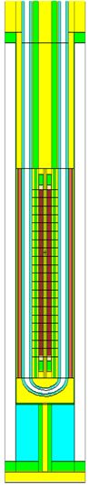
FIG. 4. MCNP model for the fuel loop irradiation facility.

3.7. Silicon irradiation - NTD

The neutron transmutation doping process will be done by placing silicon ingots in the reflector tank. The Si ingots require a neutron flux in a range of 1 x10¹³ n/cm²s to 4x10¹³ n/cm²s and the irradiation period will vary upon the target resistivity requested.
In order to provide a high quality semiconductor material, commercial requirements of NTD include achieving high axial and radial uniformity of the dopant agent in the silicon targets.
Axial uniformity is achieved by locating a neutron screen (flux flattener) around the Si ingot, obtaining a homogeneous neutron irradiation along the Si ingot, while radial uniformity is guaranteed by rotating the Si ingot at an adequate speed. The screen (see FIG. 5) was designed considering different absorbent materials (Al, Stainless Steel, H₂O) and thicknesses. Appropriate nuclear data libraries for the single crystal of Si³⁰, S(α,β), was provided by the Neutron Physics Department at Bariloche Atomic Centre.
RA-10 will have 5 positions for NTD, two for 6” ingots, two for 8” ingots and one position for a 10” ingot. The ingots positions are labeled as N1 to N5 in FIG. 1.

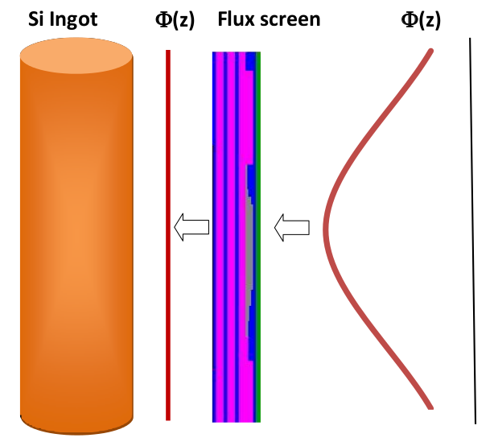
FIG. 5 Neutron screen method for uniform irradiation.

3.8. Pneumatic System

The pneumatic irradiation facilities are intended for material science studies through neutron activation analysis (NAA) and long term irradiation (SILT). Also it might be beneficial for developing new radioisotopes.
The samples are placed in a small capsule into the nitrogen pneumatic pipeline which can carry the capsule from the laboratory to the reflector tank.
The technical requirement for this system is an average thermal flux between 1 n/cm²s¹ and 2x10¹⁴ n/cm²s¹. A diversity of spectral ratios is accomplished by placing the rigs at different distances from the core. The required spectral ratio should be between 2 and 500. Positions in the reflector tank for NAA are labeled as A1 to A3 and for SILT as S1 to S4 in FIG. 1.

3.9. Cold Neutron Source

The neutron cold source, “CS” in FIG. 1, consists of an 18-litre moderator chamber containing Liquid Deuterium at a temperature of 20K, which is placed into a cylindrical vacuum container. Cold neutrons are extracted through two helium-filled tubes, which communicate the CS with both experimental facilities placed in the reactor face and the neutron guides which conduct these neutrons to the experiments hall. A highly-detailed geometrical model of the CS is shown in FIG. 6.

FIG. 6. Cold neutron source model.

3.10. In-pool Neutron Imaging Facility

An in-pool neutron imaging facility will be available for studying irradiated material and devices. Its main purpose will be to support the fuel loop irradiation facility by performing non-destructive tests.
This facility will have a quality factor L/D > 150 (where L is the distance from the neutron source to the sample and D is the source dimension) with a minimum effective area of 15 cm x 15 cm and a thermal neutron flux, Φ_{th} > 1x10⁷ n/cm²s.
The imaging system will consist of an Indium plate that captures the neutrons transmitted through the irradiated device. The plate is removed from the facility and processed to obtain the final imaged object.
3.11. Neutron beams

The thermal neutron beams consist of two extraction tubes that communicate a region of a high thermal neutron flux in the heavy water reflector with the experiments and guides where such neutrons are required.

For both cold and thermal neutron beams, transport calculations are performed by coupling MCNP and McStas codes [2] [4]: the first is used to obtain detailed neutron current densities at the inlet of the guides, while the second continues the neutron transport through the reflecting surfaces of the neutron guides. FIG. 7 shows the neutron guides layout for RA-10 reactor.

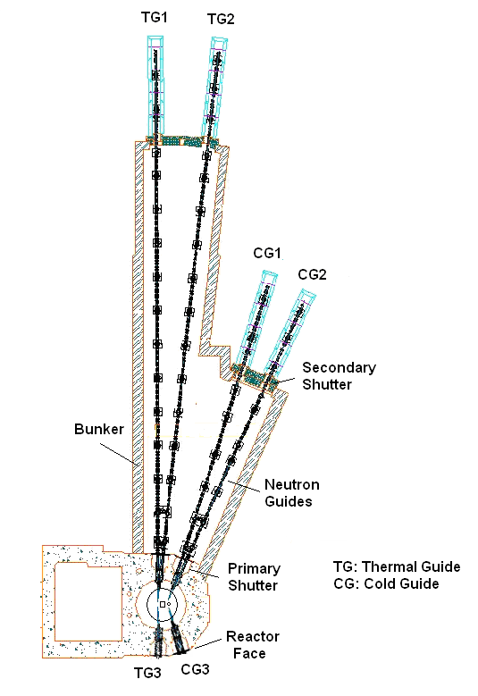
FIG. 7. Configuration of the neutron guides.

4. Results

A summary of the irradiation facilities performance (computed during basic engineering stage) is shown in Table I, along with the technical requirements. All the facilities widely fulfill the technical specifications.
The production values shown for Mo-99 correspond to 8 enriched uranium targets in each device. The maximum production capability, considering 8 targets in each device, is approximately 4000 Ci/week having 5 irradiation days and 6 decay days (excluding radiochemical process efficiency).

The maximum production values (without sharing positions in common) for medicinal Ir-192 is 34400 Ci/cycle and, for Lu-177, 1.85 Ci/cycle per mg of Lu.

For the NTD facility a satisfactory neutron screen design was accomplished. The axial homogeneity in the silicon ingots is about 5%. This value will be improved in the final screen design. The maximum production of doped silicon is about 70 ton/year.
The NPP fuel-testing loop is capable of irradiating up to 3 UO₂ fuel rods of 40 cm active length, cooled with light water at 18 MPa and 350 ºC. The current design fulfills the power and neutron flux requirements, and it will be possible to reach a burn-up of 50000 MWd/tonU. This design includes the use of liquid poison which allows performing power ramp experiments from 200 W/cm up to 600 W/cm.

The pneumatic irradiation system design has a wide variety of flux spectra and spectral ratios do to the rigs distribution in the reflector tank. The average thermal flux is between 1x10¹⁴ n/cm²s¹ and 2x10¹⁴ n/cm²s¹. Thermal to (epithermal + fast) flux ratio was found to be between 2 and 300, which are acceptable values.

5. Conclusions

CNEA has ventured into developing technologies not previously addressed, such as a cold neutron source, NTD, neutron guides and fuel-testing loop under irradiation conditions. It has also strengthened existing capabilities such as engineering for radioisotope production, neutron beams, material testing and activation analysis. The calculation tools have allowed analyzing the technical difficulties presented by each of the applications with a detail level consistent with this stage of engineering.
The performance of the experimental and production facilities of the RA-10 reactor exceeds by far the expectations previewed in the requirements. According to these results, the reactor will allow a high level radioisotopes production and a technological leap in the nuclear and scientific development of Argentina.

6. References

- H. Blaumann, A. Vertullo, F. Sánchez, F. Brollo and J. Longhino “RA-10: A new Argentinian Multipurpose Research Reactor”. International Conference on Research Reactors: Safe Management and Effective Utilization Proceedings (2011), Rabat, Morocco.
- Forrest Brown, et al., “MCNP5-1.60 Release Notes”, LA-UR-10-06235
- X-5 Monte Carlo Team, MCNP- “A General Monte Carlo N-Particle Transport Code”, Version 5 - Volume II: User’s Guide, LA-CP-03-0245 (April 2003, revised 2/1/2008).
- P. Willendrup, E. Farhi, E. Knudsen, U. Filges, K. Lefmann, J. Stein, “User and Programmers Guide to the Neutron Ray-Tracing Package McStas”, 2014. http://www.mcstas.org/documentation/manual/mcstas-2.1-manual.pdf

TABLE I. Technical Requirements and Results.
Location | Facility Application | Number of facilities | Technical Requirements |  |  | Estimated producction
 |  |  | Parameter of interest | Required value | Computed value
In-core | Irradiation device under a fast spectrum | 2 | Fast flux | >3E14 n/cm²s | 5E14 n/cm²s | -
 | Irradiation device under a reactor spectrum | 4 | Integrated flux | >1E14 n/cm²s | 3E14 n/cm²s | -
Out- core | Mo-99 production | 10 | Thermal Flux | >1E14 n/cm²s <1.5E14 n/cm²s | 1.6E14 n/cm²s | 4016 Ci/week^{(b)}
 | Ir-192 (medicinal) production | 4 | Thermal Flux | >1.8E14 n/cm²s | 2.5E14 n/cm²s | 34400 Ci/cycle^{(c)}
 | Lu-177 production |  |  |  |  | 1.85 Ci/mg.cycle
 | Ir-192 (industrial) production | 4 | Thermal Flux | >1E14 n/cm²s <1.5E14 n/cm²s | 1E14 n/cm²s | 12600 Ci/cycle^{(c)}
 | Other radioisotopes production |  |  |  |  | -
 | NTD (Silicon doping) | 5 | Thermal Flux | >1E13 n/cm²s <4E13 n/cm²s | 1.2-2.3E13 n/cm²s | Axial dopant homogeneity:  5% in 60 cm
 | NPP fuel elements irradiation | 1 | Base mode (constant power) | 200-600 W/cm | 200-600 W/cm
 |  |  | Power ramp mode | 4-100 W/cm min | 4-100 W/cm min
 | Pneumatic system: NAA and long time irradiation (SILT) | 14 | Thermal Flux | 1-20E13 n/cm²s | 1-20E13 n/cm²s
 |  |  | Espectral Ratio | 2-500 | 2<T/(E+R)<500
 | Pool Neutron Radiography | 1 | Thermal Flux | >1E7 n/cm²s | 1E7 in 15x25 cm²
 |  |  | L/D | >150 | 200
Beyond biological shielding | Thermal beams (reactor face) | 1 | Thermal Flux | >1E10 n/cm²s | 2.9E10 n/cm²s
 | Thermal beams (neutron beams hall) | 1 | Thermal Flux | >1E9 n/cm²s | 2.5E9 n/cm²s
 | Cold beam (reactor face )^{(a)} | 1 | Cold Flux | >4E9 n/cm²s | 1.4E10 n/cm²s
 | Cold beam (neutron beams hall) ^{(a)} | 1 | Cold Flux | >1E9 n/cm²s | 5.4E9 n/cm²s
- We consider: Cold neutron flux < 0.01 eV; Thermal flux: < 0.1 eV; Fast flux: > 0.1 MeV.
- Total production in 10 facilities considering 6 days of target decay.
- Total production, considering the 4 devices, for Ir-192 production.

