Use of Pulse-Mode Neutron Flux-Change-Rate as a Trip Condition in a Nuclear Reactor

F.N. Ferrucci, G.E. Ríos, C.A. Verrastro, D.S. Estryk, G.F. Rodríguez, J.E. Alarcón, J.J. Lee

Instrumentación y Control - Centro Atómico Ezeiza - Comisión Nacional de Energía Atómica

ferrucci@cae.cnea.gov.ar

Abstract. This work presents a pulse-mode flux measurement module and a flux-change-rate measurement module. Both units are fully implemented using Field Programmable Gate Array (FPGA) technology with proprietary algorithms and provide stable measurements with fast response time, even for count-rates as low as one pulse per second.

Based on these modules, the paper introduces two diverse trip strategies to mitigate the event of high neutron flux-change-rate. The first one compares the output of the flux-change-rate measurement module with a trip level. The second one is an indirect method that uses the output of the flux measurement module. This novel strategy has been called saturable flux ramp method.

The paper shows that the use of these two methods in a Reactor Protection System (RPS) provides a satisfactory detection of a reactivity excursion during reactor startup, with no presence of spurious trip. The positive results support the inclusion of these trip strategies in RA-10 RPS.

Finally, it is worth mentioning that the use of two distinct methods for the detection of high flux change-rate contributes to the Functional Diversity of the RPS, a very important characteristic for the mitigation of common-cause failures.

1. Introduction

During the startup phase of a research nuclear reactor, the neutron flux is measured by the pulse-mode instrumentation, comprised in general by the chain: detector, amplifier, pulse-shaping circuit, discriminator and count meter. In this mode of operation, the magnitude of interest is the rate of the discriminator output pulses, which maintains relation with the detector’s neutron interaction rate and gives information about the reactor's instantaneous power and neutron.

The behavior of the incoming time of these pulses is successfully modeled by a Poisson random process with mean count-rate, or intensity, c(t). When the reactor is at a constant power, the intensity c is also constant, resulting in a steady pulse rate (on the average). Conversely, when the reactor power is increased with constant reactivity, an exponential growth of the neutron flux ϕ(t) is verified. In this situation, c(t) also grows proportionally, Eq. (1).

$$\begin{aligned}ϕ(t)=ϕ_{0}⋅e^{θ⋅t} [{\text{cm}}^{−2}{\text{sec}}^{−1}] \\ c(t)=c_{0}⋅e^{θ⋅t} [\text{count}⋅{\text{sec}}^{−1}]\end{aligned}$$ | (1)
The exponent θ in Eq. (1) is called flux-change-rate. It has units of sec⁻¹; however, it is more common to express it in percentage per second, %.sec⁻¹. Thus, for example, a value of θ = 0.03sec⁻¹ corresponds to a count-rate change of 3%.sec⁻¹.

In pulse-mode operation, the count-rate c(t) generally spans from 10⁰ to 10⁶ count/sec (or cps), thus it is commonly represented in logarithmic scale. Besides, when the reactor is powered-up at constant reactivity, the growth of log₁₀c(t) is seen as a straight line.

The estimation of the count-rate and flux-change-rate is not a simple task, especially during the first decades of the count-rate, where the statistical fluctuation of the process is important. The traditional pulse-mode instrumentation utilizes pure analog circuits to generate signals proportional to the count-rate and flux-change-rate which are then compared with high and low thresholds in order to detect unsafe conditions. This setup works adequately in the comparison of the count-rate against the permissible values. However, this is not the case of the flux-change-rate, as the fluctuation in the reading al low count-rates obliges to remove the result of the comparison from the Reactor Protection System (RPS) SCRAM logic and relegate it to the rods extraction inhibition logic.

1.1 New Digital Neutron Instrumentation

The Department of Instrumentation and Control at the National Atomic Energy Commission, Argentina (CNEA) has developed new a digital neutron instrumentation system that includes two patented instruments that estimate the reactor count-rate and flux-change-rate. As it will be shown in this work, these instruments proved to have the required attributes to be included in the RPS SCRAM logic. Some of their most important features are:
- Fully implemented with Field Programmable Gate Array (FPGA) digital technology.
- Adaptive preset-count mode: which dynamically controls the accumulation count and best optimize the tradeoff between statistical precision and response time.
- Fast detection of sudden changes, for both the count-rate and flux-change-rate estimations.
- Fast response time.
- No user intervention required to change the instruments' parameters.

The two aforementioned instruments have been fully verified using an FPGA-based emulator of a neutron detection system [1], which generates random pulses with varying count-rates. They were also tested in the Argentinean RA-3 reactor, showing a successful operation.

In order to provide a functional diversity regarding the method used to estimate the flux-change-rate, this work also proposes an alternative technique that allows the detection of an excessively fast neutron flux increase, without an explicit estimation of θ. This novel strategy has been called saturable flux ramp method and will be explained in the present work.

Based on the instruments mentioned above, this work proposes to add the detection of the event 'high neutron flux-change-rate' in pulse-mode as part of the SCRAM logic. The detection would be performed by diverse instruments and methods.
This paper is organized as follows: Sec. 2 presents the digital Counting-Rate Meter instrument Sec. 3 introduces the digital Neutron Flux-Change-Rate Meter and studies its performance when it is used to detect excessively fast neutron flux excursions in the start-up phase (pulse-mode). Sec. 4 presents the Saturable Flux-Ramp Method, an alternative method that can detect excessively fast count-rate excursions in a diverse manner. Sec. 5 gives the final remarks and Sec. 6 lists the References.

2. Digital Counting-Rate Meter

This new digital instrument [2] provides measurements of count-rates spanning from 1count/sec to 10⁶ count/sec, making it very suitable for any start-up nuclear reactor's instrumentation chain. As its mode of operation is fully-automated, it doesn't need any operator intervention. The instrument gives count-rate estimations with bounded and known statistic errors. In addition, the implementation with FPGA technology allows fast processing while keeping simplicity. FIG. 1 shows a photograph of the instrument.

As it was mentioned in the introductory Section, the instrument implements an adaptive preset-count mode of operation, which has the objective of keeping the estimate error bounded at low count-rates, increasing the precision when the count-rate grows and adapting itself when occurs a sudden change in the count-rate. This last objective is achieved by the implementation of hypothesis-test procedures.

In order to give an example of the instrument's response when there is a sudden change in the input count-rate, FIG. 2 shows a simulation of such event. The initial count-rate was set in 10⁰cps and at time 2sec, it was raised to 10⁴cps. The Figure also compares the performance of the adaptive preset-count method implemented in the instrument with the traditional preset-time method [3].

The upper plot of FIG. 2 shows the count-rate evolutions and the lower plot shows the refresh time of the methods. The theoretic count-rate is plotted in black, the estimate obtained by the instrument presented here in red, and the preset-time method estimate, in magenta. The adaptive method presents a response time of less than 100msec, while the traditional method gives a response time of 1.5sec, more than ten times slower. The lower plot reveals that the adaptive method effectively detects the positive jump in the count-rate, thus reducing the refresh time while maintaining a bounded error.

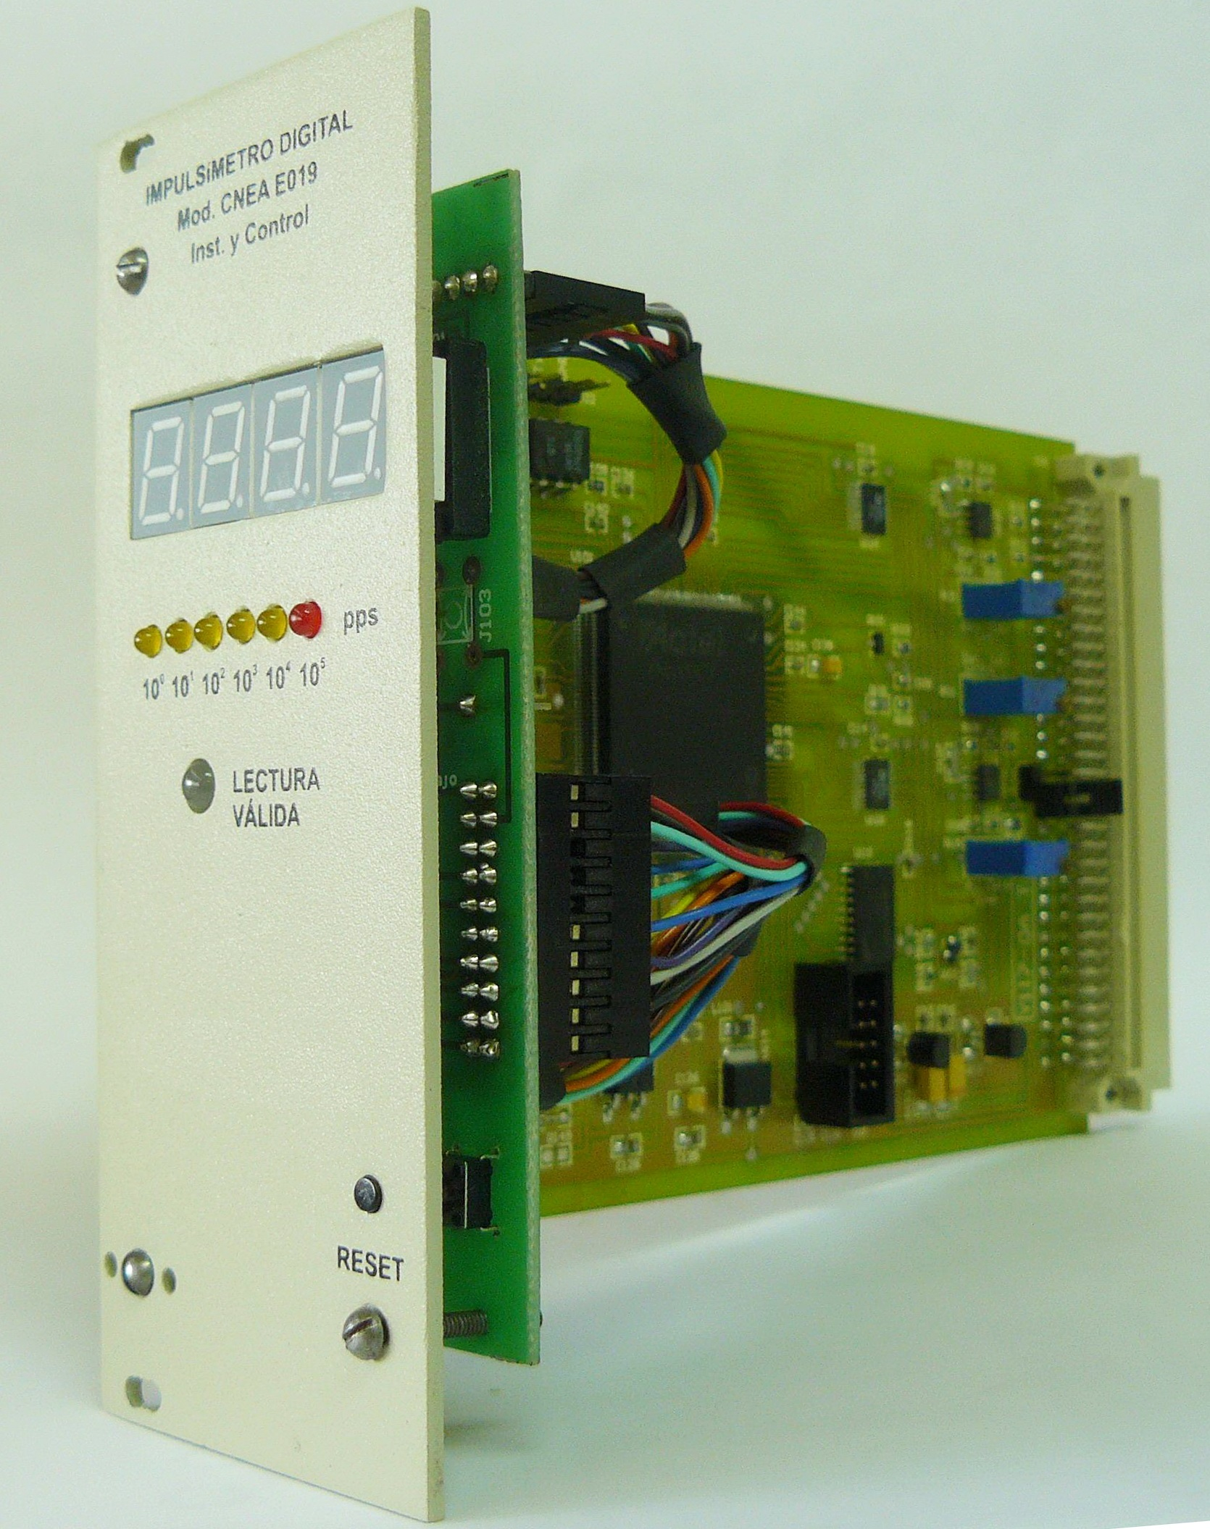
FIG. 1. Photograph of the Digital Counting-Rate Meter.

FIG. 2. Digital Counting-Rate Meter; response of the instrument
in a sudden change of the input count-rate.

FIG. 3 shows the response of the instrument when the input has exponential growth with initial count-rate of 100cps and a rate of change θ of 1% /sec. The plot exposes the inverse relation between the count-rate and the refresh time.

Table I evidences the excellent performance of the Counting-Rate Meter in steady-state operation. The values were obtained from the real instrument and connected to the emulator of random pulses mentioned in Sec. 1 [1]. The systematic error introduced by the dead-time effect has been already subtracted from the column that shows the errors.

FIG. 3. Digital Counting-Rate Meter; response of the instrument with an exponential growth of the input count-rate. The evolution of the refresh time of the estimates is also shown.

TABLE I. Digital Counting-Rate Meter, steady-state response.
Input  Count-Rate  [cps] | RMS Error  [%] | Refresh Time  [sec]
10⁰ | 9.32 | 31.471
10¹ | 3.45 | 3.142
10² | 2.67 | 0.313
10³ | 2.31 | 0.031
10⁴ | 2.06 | 0.013
10⁵ | 1.60 | 0.014
10⁶ | 0.82 | 0.018

3. Digital Flux-Change-Rate Meter

The Digital Flux-Change-Rate Meter gives reliable measurements of the neutron flux-change-rate in pulse-mode, with a range of operation that spans from -3%/sec to 7%/sec‏. To attain this range, the input count-rate must be between 1 cps and 10⁶cps. The instrument also successfully detects sudden changes in the flux-change-rate by dynamically adjusting its internal parameters. It uses the same hardware than the Counting-Rate Meter presented in Sec. 2.

FIG. 4 shows the performance of the instrument in steady-state operation. Recall that in this case the steady-state refers to an exponential growth of the input count-rate with constant parameter θ. The values were obtained by simulating 100 runs for each value of θ. The bands around the mean values represent to the Root Mean Square (RMS) error.

Table II summaries the performance of the instrument in the situation of a sudden change in the parameter θ to be estimated. In this case, the characteristic value of interest is the growth that suffered the count-rate from the moment at which the jump in θ occurred until the time that the estimation reached the 90% of the true value. This growth is measured in decades. The values were obtained from the real instrument connected to the emulator of random pulses mentioned in Sec. 1 [1].

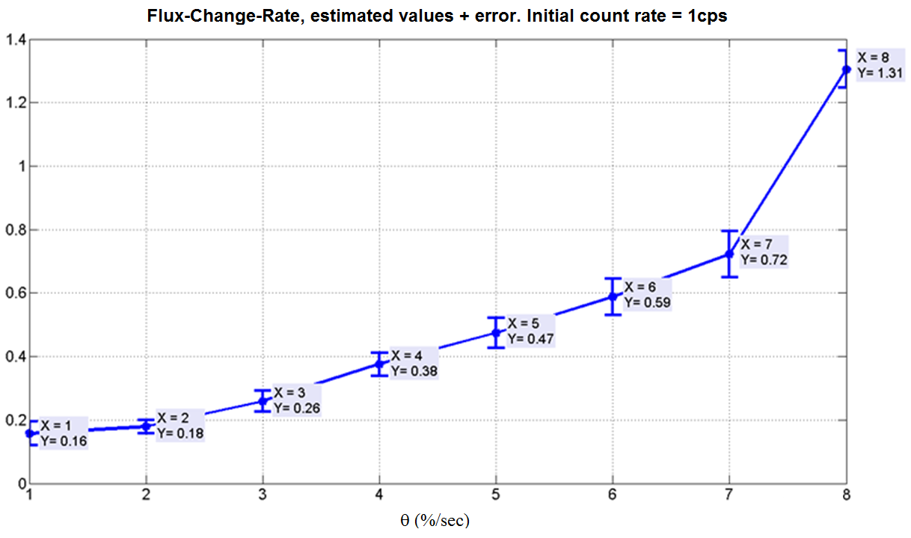
FIG. 4. Digital Flux-Change-Rate Meter; steady-state response with initial count-rate of 1cps.
TABLE II. Digital Flux-Change-Rate Meter. Delay in the response (given in decades)
when there is a sudden jump in the input flux-change-rate .
Flux-Change-Rate θ (%/sec) | Delay, in decades, to reach 90% of final value of θ, from θ₀=0%/sec
Flux-Change-Rate θ (%/sec) | Initial  count-rate  1e0 cps | Initial  count-rate  1e1 cps | Initial  count-rate  1e2 cps | Initial  count-rate  1e3 cps | Initial  count-rate  1e4 cps
1 | 3.29 | 2.28 | 1.47 | 0.87 | 0.39
2 | 2.49 | 1.47 | 0.80 | 0.45 | 0.26
3 | 2.37 | 1.32 | 0.71 | 0.41 | 0.23
4 | 2.27 | 1.35 | 0.81 | 0.44 | 0.23
5 | 2.33 | 1.58 | 0.94 | 0.53 | 0.25
6 | 2.44 | 1.68 | 1.03 | 0.59 | 0.29
7 | 2.64 | 1.78 | 1.11 | 0.62 | 0.33
8 | 2.73 | 1.93 | 1.17 | 0.67 | 0.36

3.1. Use of the Flux-Change-Rate Meter as a Trip Condition

This Section shows the use of the Flux-Change-Rate instrument to generate a trip condition based on an excessively fast growth of the count-rate.

For this purpose, it is established a trigger value of 7%/sec for the SCRAM logic. It is also assumed that, in principle, the inhibition system does not allow the reactor to be powered-up with a neutron flux-change-rate larger than 3%/sec. It should be stressed, however, that the limiting values expressed here are only indicative, as each installation must calculate them based on the specific safety criteria.

With the previous remark in mind, the reading of the Flux-Change-Rate instrument was compared against the value of 7%/sec. The trip condition was then triggered when the estimated θ exceeded that upper threshold.

Table III and Table IV show the results after the simulation of 100 runs. The initial count-rates are 10⁰ and 10⁴ cps, respectively. The values of the parameter θ go from 1 to 8 %/sec. The Table gives an important characteristic value, called delay to trip, which tells how much the count-rate has grown from the instant at which the sudden jump in θ occurred until the moment that the trip signal was trigged.

TABLE III. Use of the Flux-Change-Rate Meter as trip condition; probability
of trip and delay-to-trip with a threshold set to 7%/sec and initial count-rate of 1cps.
TABLE IV. Use of the Flux-Change-Rate Meter as trip condition; probability
of trip and delay-to-trip with a threshold set to 7%/sec and initial count-rate of 10⁴cps.
 |  | Initial count-rate: 1e0 cps, Flux-change-rate θ:
 |  | 1  %/sec | 2  %/sec | 3  %/sec | 4  %/sec | 5  %/sec | 6  %/sec | 7  %/sec | 8  %/sec
LEVEL  7 %/sec | Probability of trip (%) | 0 | 0 | 0 | 0 | 1 | 45 | 100 | 100
LEVEL  7 %/sec | Mean Delay-to-trip (decades) | - | - | - | - | 2.54 | 2.77 | 2.43 | 2.38
LEVEL  7 %/sec | Std Delay-to-trip (decades) | - | - | - | - | 0.00 | 0.65 | 0.31 | 0.14
 |  | Initial count-rate: 1e4 cps, Flux-change-rate θ:
 |  | 1  %/sec | 2  %/sec | 3  %/sec | 4  %/sec | 5  %/sec | 6  %/sec | 7  %/sec | 8  %/sec
LEVEL  7 %/sec | Probability of trip (%) | 0 | 0 | 0 | 0 | 0 | 48 | 100 | 100
LEVEL  7 %/sec | Mean Delay-to-trip (decades) | - | - | - | - | - | 0.49 | 0.35 | 0.36
LEVEL  7 %/sec | Std Delay-to-trip (decades) | - | - | - | - | - | 0.05 | 0.04 | 0.05
From Table III it can be seen that with a triggering value of 7%/sec and when the jump of the flux-change-rate occurs at a low initial count-rate (1cps), there is not spurious trip unless the change-rate is greater than 5%/sec. Besides, in the cases the spurious trip is triggered, they occurred several decades after the jump in θ has been produced. In a real situation, this would mean that the reactor had to be evolving with a maintained flux-change-rate greater than 5%/sec.

Table IV shows the situation of a jump in the value of θ with an initial count-rate of 10⁴cps, three decades after the previous example. There, there are no presence of spurious trip for θ smaller than 6%/sec. It is also worth highlighting that for values of θ greater or equal to the established threshold of 7%/sec, the trip is produced in 100% of the cases.

4. Saturable Flux Ramp Method

This new concept is based on the generation of a copy of the logarithmic count-rate, but limited in its maximum slope by a predefined value (for example 4%/sec). In this way, when the reactor's count-rate evolves with a slope greater than that value, the saturated copy of the input will separate from the real evolution. Consequently, if the separation overpasses a pre-established margin (for example, 1 decade), a trip signal is generated.

This method relies on the estimation of the count-rate given by the Counting-Rate instrument, already explained in Sec. 2. FIG. 5 shows a block diagram that describes the method; it also makes explicit the interconnection with the Counting-Rate Meter. The input corresponds to the log₁₀ of the count-rate and the output is the binary signal Trip. The variable c_{sat} represents the count-rate with saturated slope.

FIG. 5. Saturable Flux Ramp method; basic block diagram.
The method's parameters are shown in blue.
The algorithm's parameters are the following:
- θ_{max} : maximum allowed flux-change-rate (%.sec⁻¹)
- Δc_{trip} : maximum distance (in decades) between the input c_{in} and the saturated version c_{sat} above which the Trip signal is triggered.
- C_{min} : minimum value of input count-rate under which the saturated version c_{sat} stops following the c_{in}.

FIG. 6 shows an example of how the method works. Before the instant t_{min}, the input count-rate is lower than the threshold C_{min}, thus the internal variable c_{sat} gets the value of that threshold. Between the instants t_{min} and t₀, the slope of the input count-rate falls in the permissible range given by m_{max}, so c_{sat} is an exact version of the input. From t₀ onward, the input departs from the internal variable c_{sat}; this last keep growing but at a lower slope (fixed by the parameter m_{max}). Finally, at time t_{trip} the separation between the input count-rate and its saturated version is larger than the maximum allowed value Δc_{trip} and the trip signal is triggered.

4.1 Saturable Flux Ramp Method. Equations

To derivate the equations associated with the method, it is assumed that the input count-rate follows an exponential evolution as in Eq. (1). Applying log₁₀ to both sides of that Equation, Eq. (2) is obtained.
$${\text{log}}_{\text{10}}c(t)={\text{log}}_{\text{10}}c_{0}+\frac{θ}{\text{ln}(\text{10})}⋅t [\text{dec}]$$ | (2)
Eq. (2) describes a straight line with slope m = /ln(10), which gives the relation between the slope of log₁₀c(t) and the parameter  of the count-rate evolution. This expression is used in Eq. (3) to relate the maximum allowed  called _{max}, with the maximum slope m_{max} of the function log₁₀c(t).
$$m_{\text{max}}=\frac{θ_{\text{max}}}{\text{ln}(\text{10})}$$ | (3)
The parameter C_{min} determines a floor level for the value of the saturated evolution c_{sat}. As it will be shown later, this parameter was introduced in order to avoid spurious trip when the algorithm is operating at low input count-rates. Table V summarizes the algorithm's equations.

FIG. 6. Saturable Flux Ramp method; evolution that explains how the method works.
TABLE V. Summary of the Saturable Flux Ramp Method's equations.
Saturable Flux Ramp Method
$$\begin{aligned}c_{\text{in}}^{}(t)=\text{max}[{\text{log}}_{\text{10}}c_{\text{in}}(t),C_{\text{min}}] \\ c_{\text{sat}}(t)=\left\{\begin{matrix}c_{\text{in}}^{}(t) & , {\text{dc}}_{\text{in}}^{}/\text{dt} ≤m_{\text{max}} \\ c_{\text{in}}^{}(t_{0})+\frac{θ_{\text{max}}}{\text{ln}(\text{10})}(t−t_{0}) & , {\text{dc}}_{\text{in}}^{}/\text{dt} >m_{\text{max}}\end{matrix}\right. \\ \text{If}(c_{\text{in}}^{}−c_{\text{sat}})>{Δc}_{\text{trip}}⇒\text{Trip condition}\end{aligned}$$

An important characteristic value of the algorithm is the quantity δc, shown in FIG. 6. This value represents the growth (in decades) of the input count-rate from the instant at which the flux-change-rate exceeds the maximum allowed (θ > θ_{max}) until the moment the trip signal is trigged. It can be thought as a the delay of the method to trigger the trip, measured in decades.

Eq. (4) shows c as a function of both the algorithm's parameters and the input pulse-rate characteristic. In that Eq, the quantity c₀ corresponds to the initial value of the count-rate.
$$δc [\text{dec}]=\left\{\begin{matrix}\frac{{Δc}_{\text{trip}}}{1−\frac{θ_{\text{max}}}{θ_{\text{in}}}}+(C_{\text{min}}−{\text{log}}_{\text{10}}c_{0}) & {\text{, if log}}_{\text{10}}c_{0}<C_{\text{min}} \\ \frac{{Δc}_{\text{trip}}}{1−\frac{θ_{\text{max}}}{θ_{\text{in}}}} & \text{, otherwise}\end{matrix}\right.$$ | (4)

In order to chose the algorithm's parameters, a set of simulations were carried out. They comprised different evolution profiles of the count-rate c(t). The exact behavior of the Counting-Rate Meter was also taken into account. The final parameters are shown in Eq. (5).
$$\begin{aligned}C_{\text{min}}={\text{log}}_{\text{10}}\text{20}≈1\text{.}\text{301} {\text{seg}}^{−1} \\ {Δc}_{\text{trip}}=0\text{.}6 \text{dec} \\ θ_{\text{max}}=4 \text{\%}⋅{\text{seg}}^{−1}\end{aligned}$$ | (5)
The set θ_{max},Δc_{trip} was chosen so that in the case that the value of θ jumps from 0 to 9%sec⁻¹, the algorithm triggers the Trip signal with a delay of one decade (δc = 1). The value of C_{min} was selected so as to avoid spurious trip at low rate-counts. This happens because, if a jump of θ occurs at count-rates in the order of 1 seg⁻¹, the estimation of the count-rate presents a delay that it is seen as a sudden change in θ, which makes the algorithm to trigger the Trip output.

FIG. 7 shows two simulated responses of the algorithm. The input count-rates have the following characteristic: FIG. 7a, with parameters [c₀ =1cps, θ_{in}=3%/sec] doesn't show a trip condition. FIG. 7b, with [c₀ =10³cps, θ_{in}= 9%/sec] reports a trip at t=27sec.
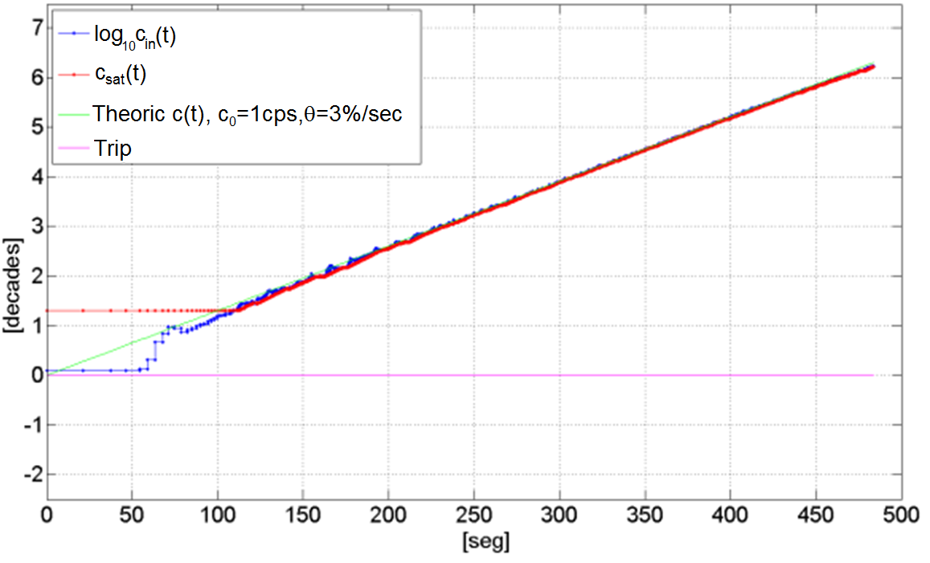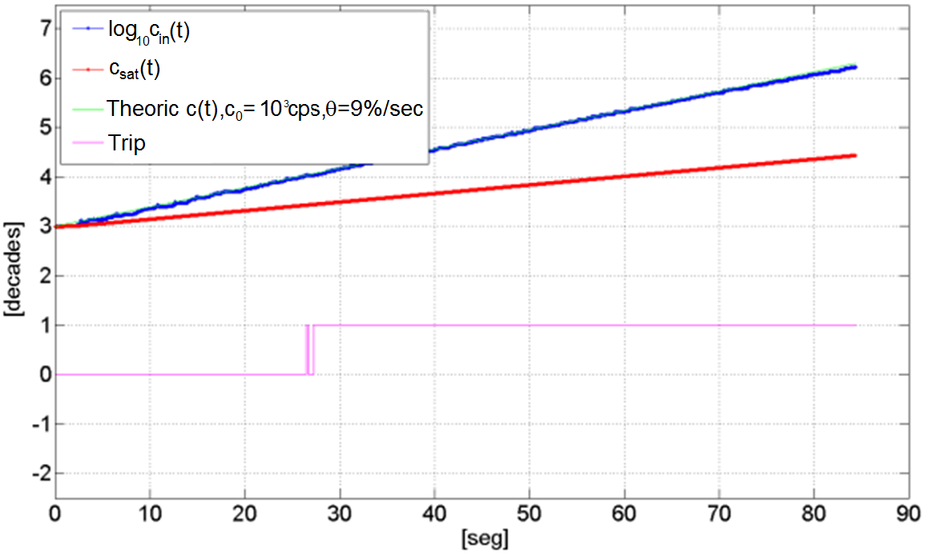
(a) (b)
FIG. 7. Saturable Flux Ramp method; operation of the algorithm for simulated count-rate inputs.
In (a) c₀ = 1 seg⁻¹, θ= 3% (no trip). In (b) c₀=10³ seg⁻¹, θ= 9%seg⁻¹(with trip).

Table VI presents is a summary of the values of delay-to-trip δc, in decades, for inputs with different values of initial count-rates and flux-change-rates. The Table was built by executing 100 runs of the algorithm for each distinct set [c₀,θ] and using the parameters shown in Eq.(5).

TABLE VI. Saturable Flux Ramp method. Summary of the values of δc (delay-to-trip)
for inputs with different values of initial count-rates and flux-change-rates.

Initial Input Count-Rate c₀ (count .sec ⁻¹) |  | Input flux-change-rate θ (%.sec⁻¹)
 |  | 1 | 2 | 3 | 4 | 5 | 6 | 7 | 8
1e0 | Mean(δc) (dec) | - | - | - | - | 3.73 | 2.77 | 2.47 | 2.31
1e0 | Std(δc) (dec) | - | - | - | - | 0.15 | 0.10 | 0.07 | 0.08
1e1 | Mean(δc) (dec) | - | - | - | - | 2.73 | 1.81 | 1.50 | 1.35
1e1 | Std(δc) (dec) | - | - | - | - | 0.15 | 0.08 | 0.06 | 0.06
1e2 | Mean(δc) (dec) | - | - | - | - | 2.46 | 1.53 | 1.20 | 1.06
1e2 | Std(δc) (dec) | - | - | - | - | 0.1 | 0.05 | 0.04 | 0.04
1e3 | Mean(δc) (dec) | - | - | - | - | 2.87 | 1.70 | 1.33 | 1.15
1e3 | Std(δc) (dec) | - | - | - | - | 0.06 | 0.03 | 0.03 | 0.01
1e4 | Mean(δc) (dec) | - | - | - | - | - | 1.77 | 1.38 | 1.18
1e4 | Std(δc) (dec) | - | - | - | - | - | 0.01 | 0.01 | 0.02

It is important to bring together the information given in Table VI with the results of the previous method shown in Tables III and IV. They show that neither of the two alternatives produces spurious trips for count-rate growths with θ less or equal to 4%/sec. This represents a very positive result, because, as previously stated in Sec. 3.1, the reactor is supposed to be powered-up with a neutron flux-change-rate not larger than 3%/sec. Consequently, there is no risk of spurious trip in normal operation.

5. Final Remarks - Conclusions

This work shows that the new digital pulse-mode nuclear instrumentation developed at CNEA can be effectively utilized to detect excessively fast neutron flux excursions in the reactor startup phase and generate trip signals for the SCRAM logic.

The paper introduces two diverse methods to detect that dangerous condition. Both the simulations and the real data evidence that these two approaches does not produce spurious trips when the reactor is being powered-up within permissible limits of neutron-flux-change-rates. Besides, when an accidental condition occurs, the trip will be triggered in 100% of the cases.

It is important to point out that the threshold values proposed in this work are only indicative, as they are dependent on each installation, which in turn depend on the specific safety criteria adopted.

6. References

- F. Ferrucci, C. Verrastro, G. Ríos, D. Estryk. "FPGA-Based Random Pulse Generator for Emulation of a Neutron Detector System in a Nuclear Reactor". VII Southern Programmable Logic Conference, 2011.
- G. Ríos. "Impulsímetro Digital para Canal de Arranque de Reactores de Investigación". Thesis work. Specialization in Nuclear Reactors and Fuel Cycle, 'Dan Beninson' Nuclear Technology Institute. March 2012.
- G. L. Knoll, “Radiation Detection and Measurement”, John Wiley & Sons, Third Edition, p. 623.

The parameter θ is more generally defined as the time derivative of the logarithm of the neutron flux ϕ(t); in this way, it remains defined when ϕ(t) doesn't follow an exponential evolution. Note that 1/θ is also the period of the neutron flux.

