Simplified Method For Thermal-Hydraulic Design And Evaluation Of Research Reactor Core, Coupled With Neutronic Montecarlo Calculation

M.A.N Giménez¹, J.B.E. Giménez¹

¹Centro Atómico Bariloche, CNEA
Av.E.Bustillo 9500, 8400 S.C.de Bariloche, RN, Argentina

nicolas.gimenez@cab.cnea.gov.ar; egimenez@cab.cnea.gov.ar

Abstract. Thermal-hydraulic evaluation of research reactor and small power reactor core usually relies on complex commercial programs. A method for a simple and fast evaluation tool of reactor core parameters is presented, with emphasis in thermal-hydraulics data. Regarding the MTR plate fuel element, it is feasible to develop a simple routine to calculate physical parameters which will serve as feedback for the neutron transport code. The basic input data includes geometry, material properties and power distribution from previous neutron transport code output for a given burn-up step. Coolant temperature and density as well as other parameters are evaluated for each fuel element and serve as input for a new evaluation of the neutron transport code. This scheme of iterations continues until desired convergence is reached. It is remarkable that thermal hydraulics data gains relevance in Research Reactor that operates at high power rates where changes in coolant density might affect neutron transport calculation. In particular, the CNEA Research Reactor RA3 case will be studied for a thermal power of 7.5 MW and spatial power distribution will be generated with the Monte Carlo code KENO-VI of the Scale package. The thermal-hydraulic code is based on a finite difference scheme and serves as a simple and versatile tool for reactor analysis that can be easily coupled to any neutron transport code. For this demonstration case, results were contrasted to more sophisticated systems such as FLUENT. It is shown that the proposed routine provides useful and sufficient data.

Introduction

The aim of this work is to present a simplified method for thermo-hydraulic calculations based on sub-channel analysis coupled with a neutron transport code. Then, it becomes in a useful tool for core reactors analysis and design. In [1] the authors present a general manager code for coupling neutron transport code with thermal-hydraulics routines, including burn-up, which is not considered in this case.

Neutron transport calculation provides a power distribution for a certain reactor configuration and burn up level, by fuel element and for a number of axial zones. For this reason, a Monte Carlo method has been selected, so it provides a full 3D description of the system. Thus, commonly used simplifications required by deterministic methods (i.e. collision probability, diffusion) are avoided, allowing a more realistic description of the reactor physics. On the other hand, the thermal-hydraulic calculations are performed on a code based on the finite difference scheme, providing a complete description of the coolant density and temperature, as well as the temperature of the fuel and its cladding.

This method is based on an iterative scheme where a first guess of power distribution is made by a neutron transport code. Afterwards, a finite difference code is used for thermo-hydraulic calculations and a new density and temperature of coolant is obtained. Such scheme is repeated until a satisfactory level of convergence is reached.

To clarify this procedure an application example is given with the CNEA Research Reactor RA-3 [2,3]. This reactor works at a relative high power and belongs to the MTR design family. However, it is important to remark that this method could be easily exported to other reactor configuration and fuel element geometry. For instance, it could be applied for the design of a Small Modular Reactor (SMR).

In the following sections the thermal-hydraulic calculation model will be presented (Section 2) and Section 3 presents a short description of the neutron transport code. Then, the coupling method is explained in Section 4 and the application example will be given in Section 5. Conclusions are summarized in Section 6.

- Thermal-Hydraulic Calculation Model

The aim of this model is to obtain a temperature and density axial profile of reactor coolant by fuel element which will be used as input data for the neutron transport code. This method is strongly dependent on the fuel element geometry; whereas it is possible to modify it for each case. The calculation model is based on the sub-channel analysis for parallel plate geometry in the MTR fuel element of RA-3 research reactor. Forced convection is assumed.

2.1. Sub-Channel Analysis Implementation

The sub-channel analysis is performed for each fuel element by mean of the evaluation of a single average plate. Then, every fuel element is treated as one isolated channel in which there is no mass transfer with neighbor channels and the forced convection regime was established.

The active region will be denoted simple as meat and it will be represented as one homogeneous media with weighted averaged properties. The axial axis will be denoted as “z” and is divided into NZFE zones. Each axial zone generates a certain heat which will be considered as constant inside the region. Mass flow inlet conditions are known and the temperature and density profiles are calculated.

For the sake of nuclear reactor calculation it was determined that the code will perform steady state calculation, whilst thermal properties of structural material and meat remain constant with temperature. Coolant temperature and density are calculated for NZFE zones for every fuel element, while a reduced number NZW zones is reported and serve as input for the neutron transport code. In this particular case, NZFE=10 and NZW(1)=5 and NZW(2)=3.

For each axial zone there is a set of equations for mass, momentum and energy conservation, where the first and second become trivial. The energy balance for a control volume i (see FIG.1) basically involves the power generation inside the meat and the fluid properties. Water properties of actual cell are “inherited” from the previous cell or from the inlet conditions. Coolant density is calculated from for each cell. The central temperature inside meat is calculated from the thermal resistance that include the convection coefficient, cladding resistance and internal resistance of meat.

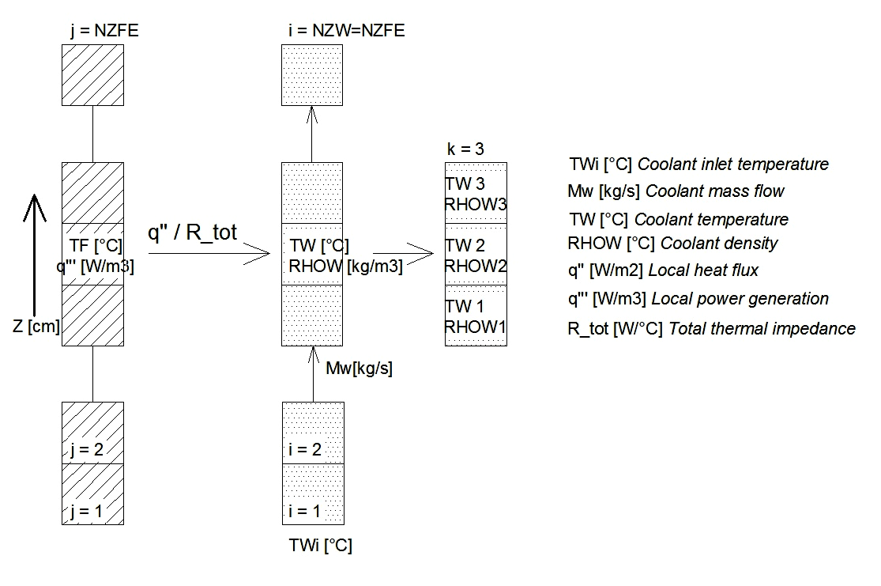

FIG 1. Schematic diagram in which the sub-channel analysis is implemented in a MTR-like fuel element.

Convection coefficient can be calculated by any correlation for turbulent regimes, i.e., Dittus-Boelter. The thermal resistance of the cladding wall is also calculated with a simple wall resistance model. From the water and external wall temperature, the Onset of Nucleate Boiling (ONB) margin can also be estimated by using the well-known correlation of Bergles-Rosenhow for subcooled boiling in water. This calculation scheme is repeated for each fuel element by using the i sub index for the axial distribution i = 1 to NZFE and j from j =1 to NFE (Number of Fuel Elements). The coolant water temperature and density is stored in two arrays: TW(NFE, NZW) and RHOW(NFE, NZW).

2.4 Verification With FLUENT

To verify the method explained above, it is compared against a model developed with the commercial solver ANSYS FLUENT V 6.3.26. A single plate from the most demanded fuel element was modeled, considering two half sub-channels of coolant adjacent to it as shown in FIG 2.

Thermal power generated within the meat region was modeled taking into account the axial profile provided by the neutron transport code. Therefore, higher accuracy is achieved by representing coolant heating with a full 3D model in which inhomogeneous velocity profile is considered. The “k-epsilon realizable” viscous model was used for the solution. Homogeneous properties for the U₃O₈ – Al meat were implemented after calculating a weighted-average.
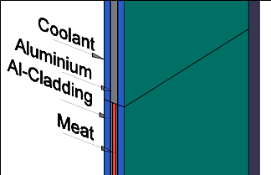
FIG 2. Single plate of a MTR fuel element modeled for calculation with FLUENT. Symmetry in the middle plane of plate was considered in order to reduce number of nodes.

Neutron Transport Code

It is well known that the power distribution in a reactor core is directly related to the neutron flux spectrum and spatial distribution. Therefore, a neutron transport code should be applied to provide power distribution data to the thermal-hydraulic method. In this work, the adopted code was the KENO-VI [4], which is one of the functional modules of SCALE-6.1. Its main application is to calculate the K_{eff} for a three dimensional system. It also allows the user to calculate power distribution, neutron flux as a function of energy, generation time, lifetime, energy dependent absorption, leakage and fission.

A distinctive feature of this code, is its ability to perform calculations in the continue energy mode as opposed to the traditional multi-group approach. The continue energy mode perform a lineal interpolation between the nuclear data at a certain temperature. However, there is no lineal interpolation between nuclear data at different temperatures. Instead, it approximates the nuclear data sets by the closest temperature. KENO-VI can also perform multi-group calculations. For the present work, ENDF/B-VII.0 Nuclear Data Library [5] was applied, under the continue energy mode.

Finally, a remarkable advantage of this code is its very flexible geometrical representation package which is capable of modeling almost any volume. In [4] a more detailed description of KENO-VI and other functional modules of SCALE-6.1, can be found.

Coupling Method

The coupling method is schematically represented in FIG.3. As it can be seen, the main components are the codes for neutron transport and thermo-hydraulic analysis. Both codes need a detailed geometrical description as well as material composition.

In regard of neutron transport calculation, detailed information about the isotopic composition of each material is needed. In this case, only fresh core is modeled and burn-up dependence remains out of the scope of this work. Meanwhile, the thermal-hydraulic code needs the thermal parameters and power generation profiles to perform the heat transfer balance.
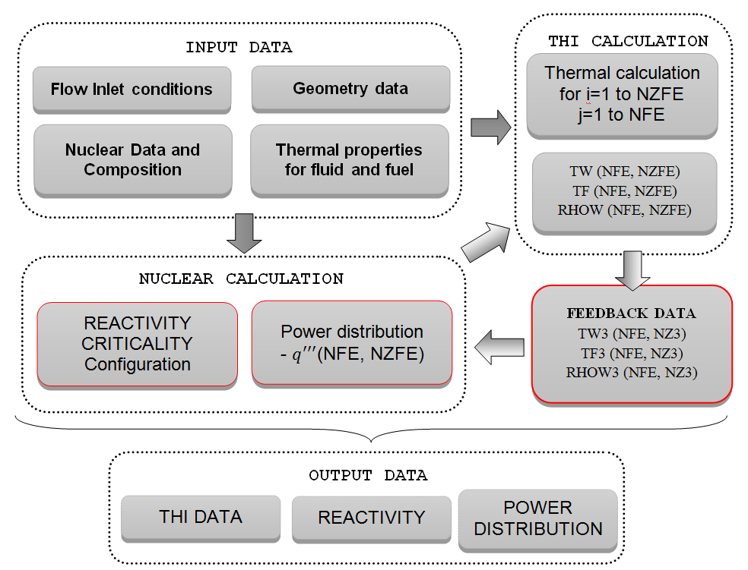

FIG 3. Flow diagram for input-output data.

The neutron transport code is based on the Monte Carlo method, which requires intensive usage of computer calculation. On the other hand, the deterministic nature of the heat transfer code, makes this considerable faster.

As previously stated, the coupling method is based on an iterative scheme. It begins with an initial guess of the power distribution obtained from KENO-VI for an isothermal reactor. Then, the calculated power distribution becomes the input for the thermo-hydraulic code which calculates the temperature and density profile of the coolant. Afterwards, the KENO input is updated with the coolant data. A new power distribution is obtained until a convergence condition is satisfied.

In general, within the first and second step of iteration a critical configuration is found by adjusting the control rods. After the initial guess, there could be a significant difference in the moderator/coolant density. Thus, some internal iteration must be done to find the critical configuration for each step.

The power distribution will be used as convergence criteria (once the control rod configuration is established): power level of each fuel assembly is compared with the previous step. Firstly, we assumed convergence when the maximum relative difference is below 1%. In addition, a figure of merit (EP) is defined by equation (1). Where the power generated by each fuel assembly is compared with the most accurate calculation:

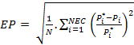; (1)

Where “i” represent one of the fuel elements, NEC the total number of fuel assemblies, is the reference power and the power to be compared.

The method under evaluation was used to study the sensitivity with regard of the number of coolant zones (NZW) employed in the neutron calculation. Calculations were performed with a certain discretization in the fuel zone and the coolant region which might be equal or not. It is desirable to use as many coolant regions as possible for accurate calculation. In this work we survey the effect of reducing the number of coolants zones without a significant change in reactivity and power distribution. The EP value is used for acceptance criteria.

Example of Application

An example of a typical MTR type reactor, the RA-3 owned by Comisión Nacional de Energía Atómica – Argentina [2] is included here, with results obtained with the calculation scheme presented.

  - RA-3 Core Description

The CNEA Research Reactor RA-3 is considered as a representative example. FIG.4 shows sections of its core and fuel assembly, generated by the KENO-PLOTTER. It has 25 fuel elements: 21 Normal Fuel Elements (NFE) and 4 Control Fuel Elements (CFE). Each NFE includes 19 fuel plates with an active zone composed of 24.6wt% pure Aluminum, and 75.4wt% U₃O₈ with a density of 4.8 g/cm³ and a thickness of 0.7 mm. On the other hand, the CFE has 14 fuel plates spaced by 2.7 mm of water and two gaps of 6.9 mm for the control blades, one on each side. The Uranium is enriched in 19.7wt% in both types of fuel elements.

Water is used as coolant and moderator, meanwhile the reflector is made of Graphite. The core configuration includes 22 Graphite blocks outside the core and 5 open aluminum boxes that can be filled with samples for irradiation. The absorber plates of the CFE are made of Ag-In-Cd as it active zone with a clad of SS-316.

For this calculation, a thermal power of 7.75 MW is generated, which is removed with a mass flow of 232.4 kg/s. The operating conditions considered are ascendant mass flow, system pressure of 2.0 bar and coolant inlet temperature of 45 °C.

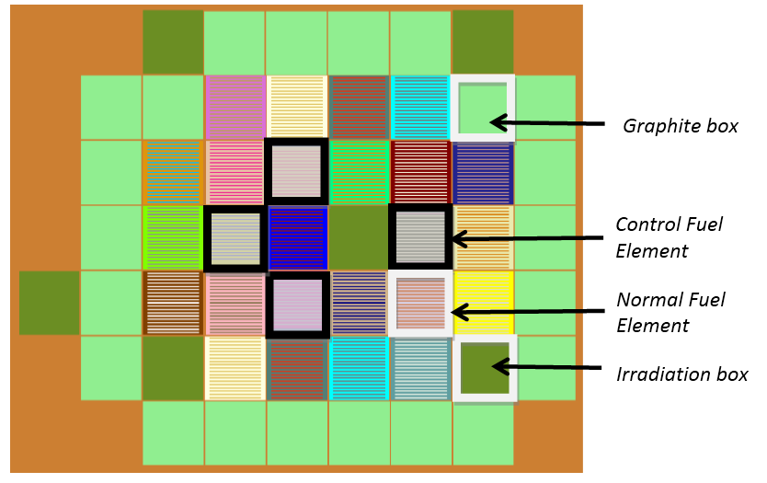

FIG 4. RA-3 fresh core configuration.

5.2. Results and Verification

The first model was built with a uniform temperature of 318 K (45°C) for the coolant, selected as a representative value to start with the iteration process. As the critical configuration of the control rods is unknown, a gross calibration is performed. It consists on finding the reactivity with all the control rods outside and inside the core. Then, one by one, each control rod is extracted while the rest is kept inside. This process provides the amount of reactivity that each rod introduce. Therefore, critical configuration can be found. All this preliminary calculations are done with low statistics in order to get a gross estimation. The number of coolant zones NZW was set up in 3.

FIG. 5 presents the relative change in reactivity for each iteration step. As it was previously stated, only two iterations are needed to assure a critical configuration. Coolant temperature and density profiles are plotted against the axial coordinate Z in FIG. 6 and FIG. 7 for two fuel elements with distinctive power generation. In addition, profile evolution for the second and third step of iteration is included.

FIG. 8 compares the coolant temperature profile for one fuel element in particular calculated with the proposed method and with FLUENT. It can be observed that absolute differences are acceptable and remain under 1.0 °C. Therefore, the simple one-dimensional finite difference scheme proposed can be used without introducing significant errors. The power distribution for this case is presented in FIG. 9, for the core configuration previously shown in FIG. 4.

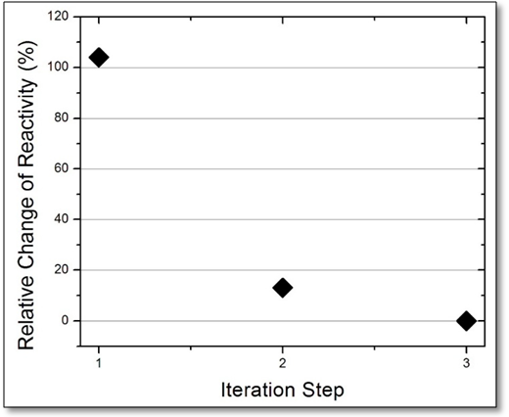

FIG 5. Reactivity change relative to the final configuration for a three-coolant zones model.

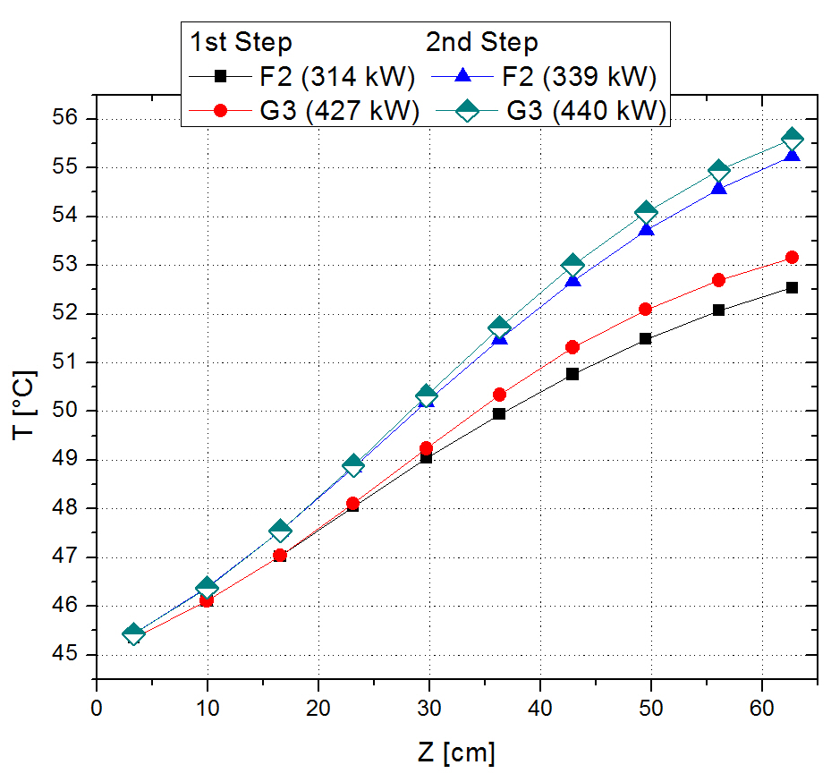

FIG. 6 Temperature profile for two fuel elements is presented. The first two iterations results are shown, revealing a minor difference between them. The selected fuel elements correspond to the nomenclature given at FIG. 9.

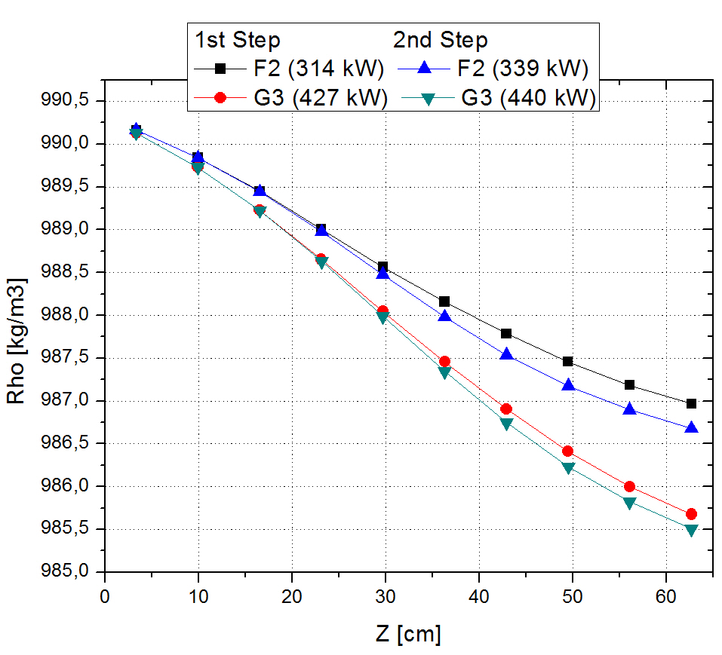

FIG. 7. Density profile for two fuel elements is presented. The first two iterations results are shown, revealing a minor difference between them. The selected fuel elements correspond to the nomenclature given at FIG. 9.

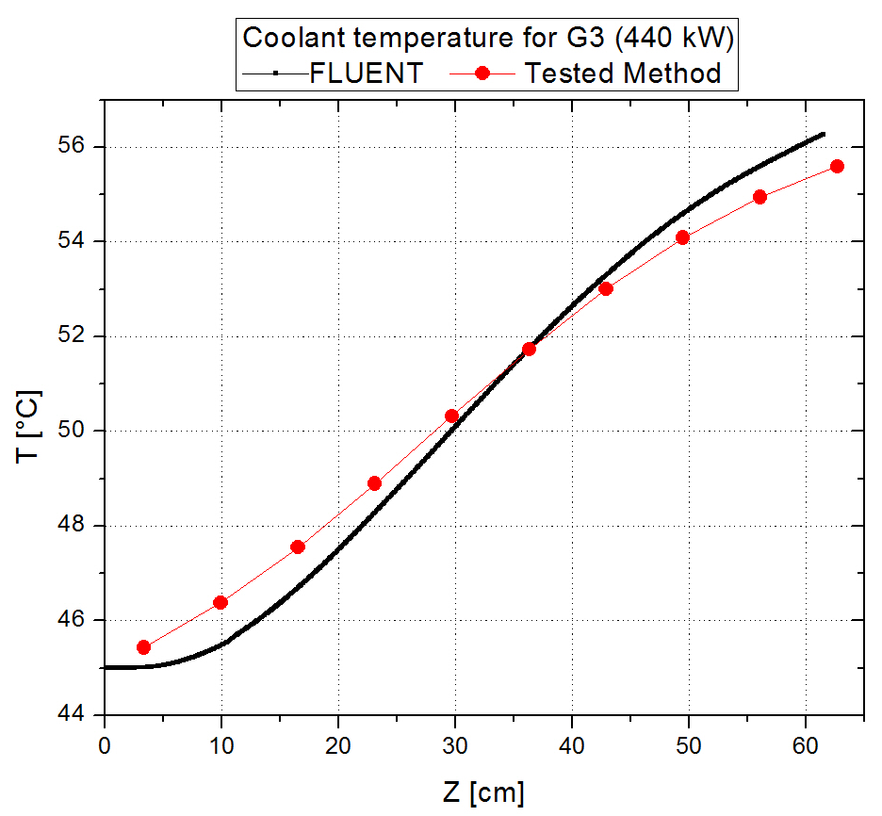

FIG. 8. Temperature profile for the most demanded fuel element, calculated by FLUENT and domestic method is shown. Absolute differences remain below 1.0 °C.

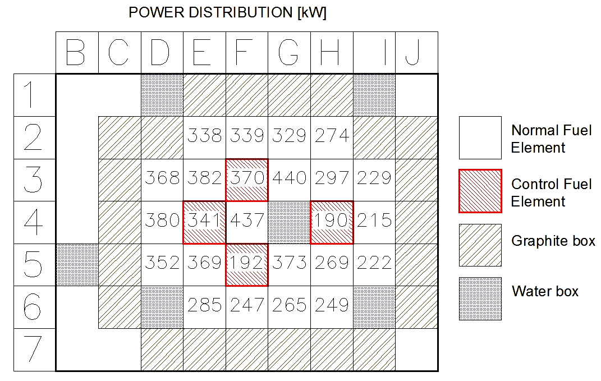
FIG. 9. Total power generated by fuel element expressed in [kW].

Finally, a parametric study was performed in order to determine a minimum amount of axial zones for the coolant representation in the neutron transport code calculation. Table 1 presents the K_{eff}, reactivity and the figure of merit EP (to compare changes in power distribution). It turns that the five and three coolant zones models can be used equally since criticality is maintained and power distribution is not perturbed significantly. Nevertheless, a single coolant zone should not be used for accurate calculation.

TABLE 1: Comparison of reactivity and power distribution as a function of coolant zones.

#Coolant Regions | K_{eff} | Rho (pcm) | EP | Maximum difference per fuel element (%)
1 | 0.9949±0.0003 | -520±90 | 0,185±0.02 | 17
3 | 0.9989±0.0003 | -110±90 | 0,0156±0.002 | 1,4
5 | 1.0016±0.0003 | 150±90 | - | -

6. Final Remarks - Conclusions

It was found for the MTR reactor that a simplified method of thermal-hydraulic evaluation, coupled with a Monte Carlo neutron transport code, can be easily coupled and implemented. In particular, when significant thermal power is generated, it is necessary for accurate calculation to estimate coolant temperature (and therefore, density) in a minimum discretization of three axial zones. The reduction from five to three coolant zones diminishes significantly the calculation time.

The finite difference scheme proposed for the thermal-hydraulic calculation was successfully verified against a FLUENT model without appreciable change in temperature and density profiles. It might be suggested its application for Small Modular Reactor evaluation since like the MTR configuration a compact nuclear core is calculated.

7. References

[1] F. Leszczynski, J.B.E. Giménez, “General Simple Method for Coupling Neutron Transport, Depletion and Thermal-Hydaraulic Codes for Nuclear Reactor Calculations”, PHYTRA 3- Marocco, May 12-14, 2014.
[2] G. Estryk, “Reactor RA-3, Descripción, Actividades y Cálculos neutrónicos”, CAE-CNEA Proyecto RLA/9/046, San Carlos de Bariloche, Argentina, November 2001.
[3] H.M. Dalle, G.R Ruggirello, G. Estryk, “Benchmark Measurements and Calculations of U₃Si₂-Al MTR Fuel Plates with Burned Fuel”, CNEA.
[4] D.F Hollenbach, L.M. Petrie, S. Golouglu, N.F. Lenders, M.E. Dunn. “KENO-VI: A General Quadratic Version of the KENO Program”, Oak Ridge National Laboratory, Oak Ridge Tennessee USA, June 2011.
[5] M. B. Chadwick, P. Oblozinsky, M. Herman at al., "ENDF/B-VII.0: Next Generation Evaluated Nuclear Data Library for Nuclear Science and Technology", Nuclear Data Sheets, vol. 107, pp. 2931-3060 (2006).

