Improving Immunity of the OPAL Reactor
to Electrical Power Disturbances

B. GITTOES*
Australian Nuclear Science and Technology Organisation (ANSTO)
Locked Bag 2001, Kirrawee DC, NSW 2234 Australia

*Corresponding author: gittoesb@ansto.gov.au, P: +61 2 9717 7252

ABSTRACT

The electrical distribution system for the 20 MW_{th} Open Pool Australian Light-water (OPAL) Research Reactor is designed with two radial electrical supplies (Train A and Train B), with subsystems and equipment organised into three Safety Categories that define the safety and reliability requirements. The subsystems and equipment have been designed with an operational life of 47 years and have an electrical capacity at least 20% greater than the expected demand. The power distribution throughout the OPAL Reactor facility is a combination of 415/240 Volts Alternate Current (AC). This system voltage is transformed and/or rectified into lower, Direct Current (DC) voltages as required for instrumentation, lighting and controls.

Since its commissioning, the OPAL reactor has been affected by offsite electrical disturbances that have resulted in unplanned reactor shutdowns. The estimated aggregate downtime is approximately 15 days over the life of the reactor to date. This paper describes how the electrical disturbances have been recorded, the avenues explored to rectify the issue, and the improvements achieved to date.

- Introduction
The Australian Nuclear Science and Technology Organisation’s (ANSTO) OPAL Reactor is a 20 MW_{th} multi-purpose research reactor that accommodates a wide range of needs for Australian medical, industrial, scientific and mining communities. OPAL was commissioned in 2006 and the electrical system is designed to meet the requirements of all the reactor operational states as well as post-accident conditions. OPAL’s maximum electrical demand is approximately 5 Mega Watts (MW), the Reactor, when at full power OPAL normally consumes 2.4MW of electrical power.

The electrical system provides both a diverse and reliable sources of electrical power which are physically separated as well as isolated, so in the event of a failure, its potential effect on a single source of supply does not propagate to another. In terms of topography the electrical system is divided three separate ways:

- Normal Power Supply (NPS) and Standby Power Supply (SPS) based on whether supply is available from the offsite energy provider (NPS) or alternatively via onsite Diesel Generators supply (SPS),
- High Voltage (HV) Power System (11,000 Volts AC) and a Low Voltage (LV) Power System (415/240 Volts AC),
- Power System Train A and Power System Train B.

The relationship between these divisions is shown below in Figure 1.

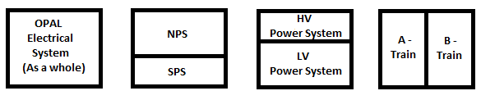
Figure 1: Relationship between NPS/SPS, HV/LV Power Systems and A/B Trains

Ever since commissioning, OPAL has been impacted by offsite electrical disturbances. These disturbances have resulted in either: a Reactor Trip, interruption of plant equipment where a reactor trip has been avoided, or no interruption to plant equipment and a series of alarms registered on the Reactor Control and Monitoring System (RCMS) or what is commonly referred to as a Distributed Control System (DCS). In this paper I aim to outline how the electrical disturbances are defined, ways they have been recorded, avenues that were explored to mitigated and rectify the disturbances and the improvements achieved to date and for the future.

- Electrical Disturbance
  - What defines an Electrical Disturbances
Electrical disturbances, such as the ones predominantly impacting OPAL, are symptoms of voltage deviations (electrical Sag or brown-outs) or Total Power Outages (Loss of NPS) which result in improper operation or corresponding failure of electrical infrastructure or localised equipment. Refer to Figure 2 for what a typical Electrical Sag/Brown Out looks like.

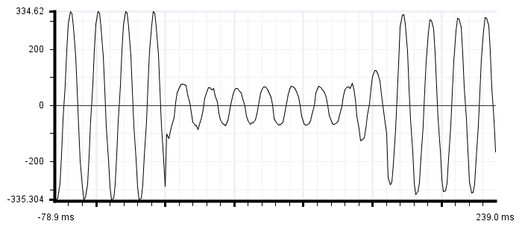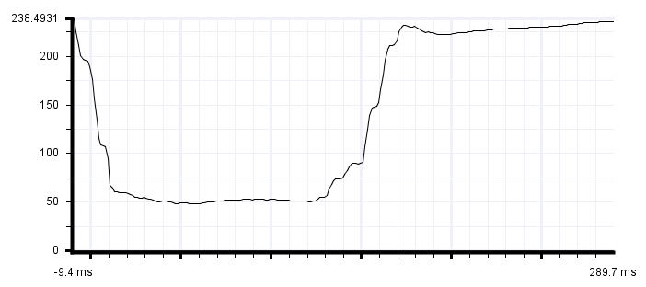
Figure 2: A typical Electrical Sag/Brown Out

During a Total Power Outage all the Engineered Safety Features (ESF’s) built into instrumentation and electrical related equipment are connected to the Standby Power System (SPS). Apart from the Containment Energy Removal System (CERS) due to its power consumption, all the ESF’s are backed by UPS to support continual electrical supply during the transition between NPS and SPS. A Total Power Outage is an anticipated operational occurrence rather than an indicator for a design basis accident.

  - Recording the Electrical Disturbances
How electrical disturbance have been recorded has been one of a conventional process. Around the time OPAL went critical for the first time a Microsoft Excel spread sheet was developed that allowed the Operational Shift Teams to record basic information as a result of a disturbance, it was titled the “OPAL Blackout Register”. The way it was outlined allowed the shift teams to record the date, time, duration, if it resulted in a reactor trip; the duration of the reactor was shut down after a trip, and possible cause and the main parts of plant equipment that were effected as a result of the disturbance. In doing so this enabled the disturbances to be clearly documented allowing focusing on the more vulnerable parts of equipment and strengthening them up to withstand future disturbance. The spread sheet also played an important role when notifying the energy provided and ensure that type of disturbance could be avoided in the future.

  - Avenue of explorations
Early on during OPAL’s operation, where the disturbances were really starting to impact the ongoing reliability and production, a project was raised to procure and install a pair of Rotary Uninterruptable Power Supplies (UPS). The concept was each UPS would be positioned, in-line, with either of the High Voltage feeders and when a disturbance was received, the UPS would, near-instantaneously, switch to the stored energy and continually provide a reliable power source. Once the disturbance past the UPS’s would, automatically return to normal power supply. The back-up supply time was designed for 5 to 10 seconds depending of the varying supply requirements of OPAL.

During the preliminary stages of the project, where cost evaluations were being explored, the project had quite a substantial financial commitment with 3 different options on the table. These options with their associated costs and be referred to below:
- Option 1, Installation 2 x 2MW Rotary UPS’s of either feeder HV to OPAL
  - Capital Cost of $1.7M, Infrastructure Cost $1.8M and Lifecycle Cost $7M
- Option 2, Installation of 2 x 4MW Rotary UPS’s of either feeder HV to OPAL
  - Capital Cost of $3.4M and Lifecycle Cost $10.2M
- Option 3, Installation of 2 x 10MW Rotary UPS’s of either feeder HV to OPAL
  - Capital Cost of $8.2M and Lifecycle Cost $25M

Option 1 had the lowest installation cost but was only designed in protecting essential reactor operational loads within OPAL and excluded supplies for ANSTO’s Bragg research facility and office related general light and power as well as air-conditioning. The estimated cost in installing an additional power source for these supplies incurred $1.8M. This option was taken off the table due to the logistics behind altering the existing infrastructure and it would also limit any future electrical expansions to OPAL. Option 2 was the preferred option on the table at the time but due to the cost not being quite as substantial as Option 3 and did not involve any alterations to the existing infrastructure. Option 3 was the ideal option but was not finically feasible due to the substantial costs related to it. After undertaking the cost benefit analysis process the project was placed on hold for looking into a more localised and potential affordable solutions by hardening up individual parts of equipment within OPAL.

  - Improvements Achieved
    - Installation of Localised Digital Power Recorders
A project proposal was raised to replace and upgrade the existing Digital Power Indicators to a more advanced Eaton Brand Power analysers to monitor electrical perturbations that affect the plant equipment supplied from OPAL’s Main Low Voltage Switchboards. Reliable electrical power is crucial for the operation and production of OPAL. This enhancement to focus on capturing any disturbed transients and harmonics that can be produced from either the upstream electrical supply or from downstream loads eg. Non liner electrical equipment (VSD’s, UPS’s) from both supply. The assessment of data from the analyser revealed the issues that adversely affected the operation and production within OPAL. The on-going collection of data was used to assess power quality trends and conditions to identify vulnerabilities to assets and operations, and provide input for future projects to improve the resistance of the OPAL power supply system to power disturbances, resulting in increased availability of OPAL.

    - Electrical Disturbance Training
Power quality training was undertaken by the OPAL Electrical Engineering and Maintenance team for them to better understand the sources, effects and how to control or rectify against disturbances. This gave them the knowledge to develop ways to act and execute task to pin point and harden up varies part of plant around OPAL. It also allowed them to have a more confident approach in using test equipment.

    - Re-commissioning of Power Factor Correction (PFC) Units
During 2008 the PFC Units situated on the main distribution switchboards within OPAL were found to have defective capacitors installed and were taken out of service, early in 2013 replacements were sourced and later commissioned. During the time the PFC Units were out of service and compared to after they were re-commissioned, it seemed OPAL was quite more susceptible to electrical disturbances as a higher rate of plant equipment reacted with the PFC Units out of service.

The theory behind this was that the units themselves severed the purpose they were designed for by improving the electrical efficiency by improving the power factor within the distribution system which in turn improves the power quality. The units also acted as energy assistors where, depending of the extent of the disturbance, the stored energy in PFC units would compensate by re-disperse power back into the system.

    - Operator Response to Disturbances
An achievement that has been recognised is the fashion the OPAL Operational personnel have improved in their response after a disturbance has been sustained. The expertise of acknowledging a disturbance, verifying the equipment that was affected by the power blip, ensuring the safe state of the reactor and executing the appropriate command has improved. In doing so, a majority of occasions a reactor trip has been avoided or in the now rare case when a trip has occurred the safe recovery time has been minimised to avoid a Xenon poisoning out occurrence.

    - Formal meeting with Energy Provider
One main action that came out of the justification to place the Rotary UPS on hold was a formal meeting with the energy provider (Ausgrid). The purpose of the meeting was to make them aware of the consistent disturbances ANSTO, specifically OPAL sustains, highlight the impact that offsite electrical events have to OPAL and the importance to minimise the impact for both regulatory and production requirements.

The meeting had a positive outcome, improvements were made such as planning there maintenance at the same time as OPAL’s scheduled shutdowns in the aim to avoid disturbance while the reactor is at power. Due to ANSTOs graphical position surrounded by national park a schedule was developed to cut back over hanging branches above the overhead power surrounding. Furthermore ongoing power quality assessments are being done on the Ausgrids power distribution network (poles & wires) aiming at potential future project based improvements.

    - Replacement of Cold Neutron Source Variable Speed Drive
Within the Cold Neutron Source (CNS) system, on one of the 250KW main compressors is a Variable Speed Drive (VSD) which varies the frequency going to the compressor motor which interns varies the speed the motor runs at. Due to the age of the VSD it had become very hard to support spare parts for the drive due to it being obsolete so a project was raise to procure a replacement. Because the drive was noticeably vulnerable to disturbance the replacement drive was fitted with what is referred to an Active Front End (AFE). The AFE acts as a regenerator that stores power within a set of DC capacitors and when a disturbance is sustained it utilises the stored energy to have momentary electrical disturbance ride-through capabilities. This has improved the operation of the CNS system when it sustains a disturbance.

  - Future Work
While utilising the OPAL Blackout Register, the Cooling Tower System, specifically the Cooling Tower (CT) Fans, seemed to be the most vulnerable part of the system that continually was affected by the disturbance. This was due to the CT Fan being controlled by VSD’s, meaning when a disturbance was sustained the VSD’s would “Fault” resulting in the Fans to stop and require restarting. After raising this issue with the VSD manufacturer it was discovered that these VSD’s have to facility to automatically restart after a power disturbance such as a Voltage Sap/Brownout. The automatic restart was enabled within the VSD’s but when tested, as soon as a Fault registered on the VSD, it would relay the Fault to the RCMS which would, in turn, stop the run signal going back to the VSD. To rectify this issue, a proposal has been raised to program a 5 second delay timer with the RCMS to allow the VSD’s to recover after a brownout. In this case, the RCMS provides the facility to remotely Start and Stop the Fans as well as provide visual indications to be able to monitor the status of the plant. The RCMS does not provide any electrical protection under fault conditions, the motor, including the mechanics relating to fans will still function as normal without delay.

  - Recommended Practices
The three key elements learned are as follows:
- Development of a register to record when the disturbance occurred and what areas of plant were impacted. This has been instrumental to cultivate localised and very minor changes to specific parts of plant equipment.
- Being able to capture the electrical characteristics of the disturbances. This allowed understanding to extent of the disturbances and integrating ways to avoid it re-occurring.
- Engaging the energy provider. Having to opportunity to discuss the issues with the energy provider made an immense improvement to the amount of disturbance ANSTO sustained.

