Nuclear Instrumentation System of RA-10
L. Marzano¹, G. Quesada¹, J. Zalcman¹

- Instrumentación y Control - Comisión Nacional de Energía Atómica (CNEA) - Centro Atómico Ezeiza – Presbitero Gonzalez y Aragón 15 (B1802AYA) Ezeiza - Buenos Aires - Argentina

Corresponding author: gquesada@cae.cnea.gov.ar

Abstract. The Nuclear Instrumentation System (NIS) is one of the key components of the Instrumentation and Control (I&C) system of a nuclear reactor.
The NIS is responsible for collecting the information about the reactor power levels and its dynamic state. This information is achieved by the measuring, processing and conditioning, in real time, of the signals coming from neutron flux detectors installed in the reactor.
In the RA10 reactor, the NIS is distinctively separated into four groups: the NIS directly associated with the Reactor Protection System (NIS RPS), the NIS connected to the Loop Protection System (NIS LPS), and finally the NIS connected to the Reactor Control and Monitoring System (RCMS) for the Automatic Pilot (NIS AP) and the Experimental Devices (NIS ED) operation facility.
The NIS RPS has three redundancies, each one with the highest safety level. Each redundancy is divided into three separate measuring channels depending on the reactor´s power levels: a wide range channel for “cold-start”, a wide range channel for low and medium power level, and a DC current channel for medium to full range power level.
The NIS LPS has also three redundancies with the highest safety level. It has only a DC current measuring channel per redundancy for the incoming signals from the Self-Powered Neutron Detectors (SPND).
The NIS AP and ED have no redundancies, since they are not safety systems. The NIS AP has two measuring channels: a wide range channel and a DC current channel, with direct connection to the RCMS for the operation of the AP. The NIS ED has only a current measuring channel, for each Experimental Devices in the RA10 reactor.
The analog signals coming from the NIS RPS are digitalized and sent, via optic fiber, directly to the RPS. This last one is the responsible for sending the appropriate information to the RCMS. This is a particularity of the RA10 instrumentation. All the RPS information required by the RCMS to know the operating state of the reactor, are fed digitally by the RPS, appropriately conditioned and electrically isolated, making the interconnection between the NIS and the other systems simpler.
All the electronic devices in the NIS have been designed using the latest proven technology available.

Introduction

There are two nuclear reactors in design and construction stage in Argentina. The first one it´s a small PWR reactor named Carem 25, which is the first power reactor completely designed in Argentina. It has many advanced safety features and a capability of 25 MWe. The other one is a research and radioisotope production reactor called RA-10. It will be a 30 MWth facility, located in the Ezeiza Atomic Center.

The I&C (Instrumentation and control) Department of the GAEN (Nuclear Energy Area Management) at CNEA (Atomic Energy National Commission) is in charge of developing the RPS (Reactor Protection System) and the NIS (Nuclear Instrumentation system) of the RA-10 [1]. The latter will be discussed on this paper.

The NIS is in fact composed of four different systems, each one with different requirements, categories, and tasks: NIS RPS, NIS LPS (Loop Protection System), NIS AP (Automatic Pilot) and NIS ED (Experimental devices) [2][3].

All the electronics are designed in 160x100mm Eurocard format and organized in 19” rack standard units.

The design applies all the safety features that are required by ARN (Nuclear Regulatory Authority) [4] and recommended by the IAEA [5] [6] [7] [8] [9] [10].

NIS RPS

The NIS RPS provides the RPS with the neutron flux signals necessary to monitor the reactor´s status. There are three equal NIS-RPS, one for each RPS redundancy (in a 2oo3 configuration), and they are located in the same room as the correspondent RPS.

Each redundancy has three measuring channels, mounted in two units: Cold start unit (Figure 2), and Operation unit (Figure 3). There are two wide range channels, composed of a FC (fission counter) and a wide range amplifier, configured to cover two different ranges (Figure 1).

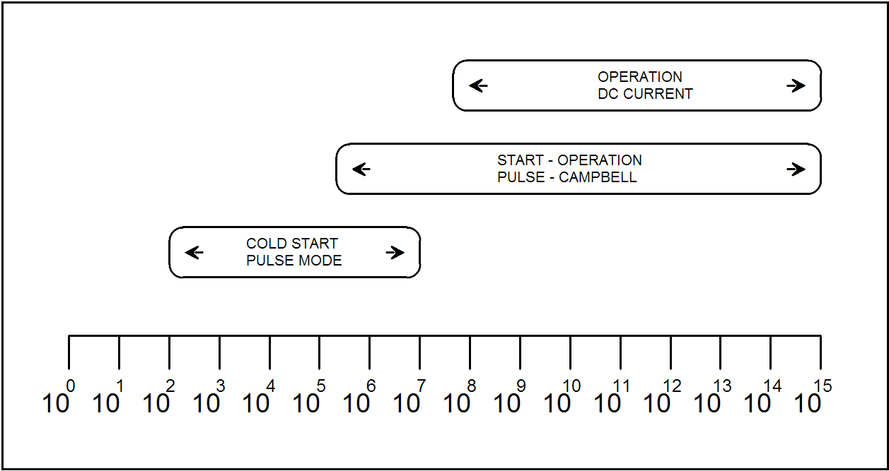
Figure 1 - Core flux (nv) and NIS RPS channels range

One of them is for the reactor cold start-up with a fresh new core and the other one to cover low to full power range level. The third channel is a CIC (compensated ionization chamber) and a current amplifier, for medium and full range power level (Figure 1).

Each detector has an associated HVPS (high voltage power supply).

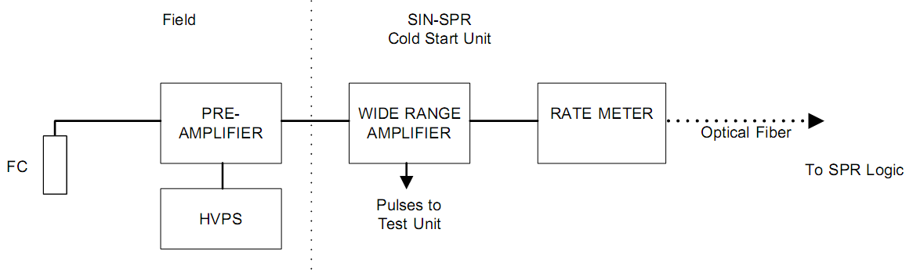
Figure 2 - SIN SPR cold start channel block diagram

The wide-range channels use a pre-amplifier (Figure 2 and Figure 3) located near the reactor pool to improve noise immunity and increase the signal strength coming from the FC. These channels also have two types of post amplifiers processors: a rate meter to process the pulses generated in the lower ranges, and another analog module to process the A.C. signal (Campbell mode) in the upper ranges [11]. Both modules deliver the linear, logarithmic and flux change rate signals, corresponding to their working power range.

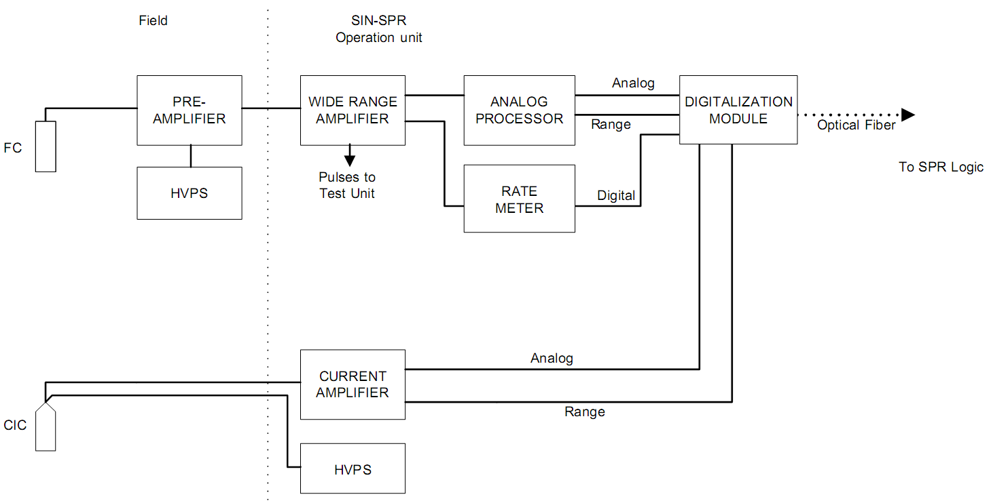
Figure 3 - SIN SPR operation channels block diagram

The outputs from modules and post-processors are included in a digital data frame by digitalization modules in each unit. These frames are sent to the RPS by two optical fibers to provide signal isolation.

All the components in these two units have the highest safety level (important to safety) [12].

The Rate Meters and Digitalization Modules are FPGA (Field Programmable Grid array) based, and they are designed under specific requirements for digital safety Instrumentation [12] [13] [14] [15] [16].

There is an extra unit () in each redundancy with test facilities. They are connected instead of the detectors, in order to test the proper operation of each channel.

There is also a multi-channel spectrum analyzer module to check the operation of the FCs and calibrate the wide range channels pulse discriminator levels.

This unit is not safety related and it´s only powered when the corresponding redundancy is in maintenance state.

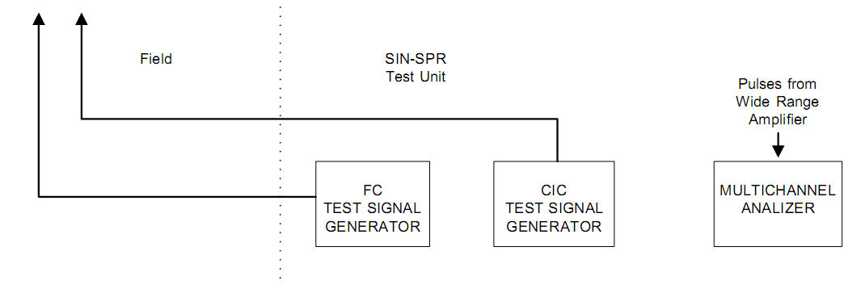
Figure 4 - SIN SPR test unit block diagram

NIS LPS

The RA-10 has a pressurized loop facility for fuel element testing. This loop will have neutron interaction with the reactor´s core, so, an extra NIS it´s needed for monitoring the neutron flux level in the fuel element being tested. This is part of the LPS.

In the NIS LPS, the concepts of modularization, safety, and redundancies, are similar than the NIS RPS, but the nuclear sensors are fast SPND (Self-Powered Neutron Detector), one for each redundancy. The signal from the SPND amplifier is digitalized, and it´s included in a digital data frame and sent to the LPS via optical fiber (Figure 5).

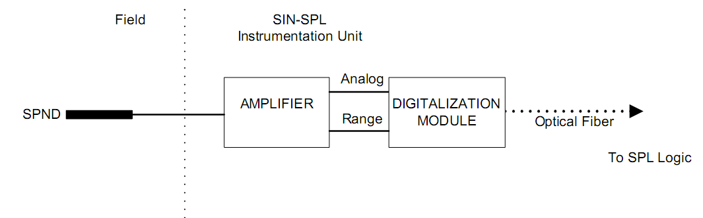
Figure 5 - SIN SPL block diagram

NIS AP

The RCMS (Reactor Control and Monitoring System) needs to measure the reactor power level in order to keep it stable in the desired level. These measurements are made by the NIS AP. It is part of the RCMS and it´s not considered a safety system, but a safety related system [15].

The NIS AP provides the RCMS with signals from two different detectors to provide a fast and precise adjustment of the desired power level.

The first detection channel is composed of a FC with its HVPS, pre-amplifier, wide range amplifier and a Campbell post processor with a linear output, used to get a real time reading of the reactor power level ().

The second channel is composed of a GIC (Gamma Ionization Chamber) to detect N16 (Nitrogen 16) activity, its HVPS, and its amplifier, and it´s used to calibrate the power level of the first channel (since this channel has more accurate reading of the total reactor power, but a slower response time).

Both signals are transmitted in a 4-20mA current loop interface to the RCMS, and the ranges are indicated by dry contacts (this is a requirement of the RCMS).

All of these modules but the FC pre-amplifier and the FC HVPS will be mounted in a 19” sub-rack unit.

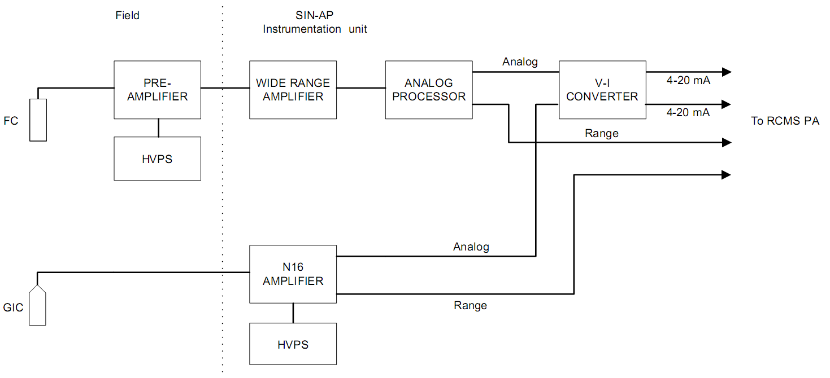
Figure 6 - NIS AP block diagram

NIS ED

The RA-10 is a multi-purpose research and production reactor and one of its facilities will irradiate semiconductors and other blankets with thermal neutrons. Several SPND are needed to measure the irradiation levels of the blankets. This task is accomplished by the NIS ED.

The SPND signals are transmitted in 4-20mA current loop interface to the EDCMS (Experimental Device Control and Monitoring System), and the ranges by dry contacts (Figure 7).

Several SPND amplifiers and converters can be mounted in a 19” sub-rack.

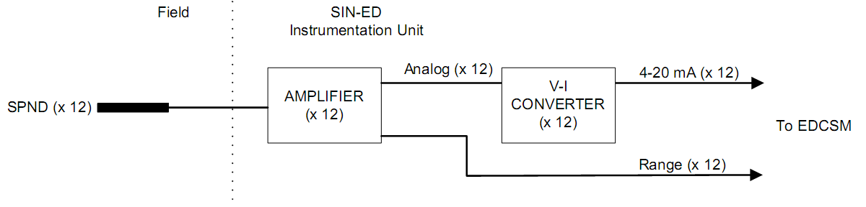
Figure 7 - NIS ED block diagram

Conclusions

This modular system, partly in the design stage, will provide an instrumentation system with modern characteristics, compliant with international criteria of design, diversity, redundancy, fail-safe, and other safety design criterions.

It has enough flexibility to be implemented not only in research reactors like the RA10, but also be used, with some modifications, in power reactors like Carem 25.

A total of 29 different PCBs need to be designed and 132 modules to be assembled, including eurocard modules and motherboards and the prototype has to be completed by 2016 [1].

The design includes analog and digital technologies to take advantage of each one, according to the field trends in nuclear instrumentation.

The I&C department is certified under ISO 9001 standards [17]. All the modules will be documented, manufactured and tested under this standard. Some other industrial and nuclear specific standards will be applied in order to assure several environmental [18] [19], safety, method [20], and design requirements.

References

- COMISIÓN NACIONAL DE ENERGÍA ATÓMICA, Provisión y desarrollo de la ingeniería de detalle del sistema de protección y el sistema de instrumentación nucleónica del reactor nuclear RA-10, Proyecto RA-10, AS-RA10-018, Argentina (2014)
- COMISIÓN NACIONAL DE ENERGÍA ATÓMICA, Descripción General del Reactor RA-10, Proyecto RA-10, IT-40 RA-10 0000-1-002, Argentina (2010)
- COMISIÓN NACIONAL DE ENERGÍA ATÓMICA, Criterios de Diseño del Reactor RA-10, Proyecto RA-10, IT-40 RA-10 0020-1-002, Argentina (2010)
- AUTORIDAD REGULATORIA NUCLEAR, Diseño de reactores de investigación, AR 4.2.2 Rev.1, Argentina (2002)
- INTERNATIONAL ATOMIC ENERGY AGENCY, Safety of Nuclear Power Plants: Design, Safety standard series Requirements NS-R-1 (2000)
- INTERNATIONAL ATOMIC ENERGY AGENCY, Defence in Depth in Nuclear Safety, Safety series INSAG-10 (1996)
- INTERNATIONAL ATOMIC ENERGY AGENCY, I&C Systems Important to Safety in Nuclear Power Plants, Safety standards NS-G-1.3 (2002)
- INTERNATIONAL ATOMIC ENERGY AGENCY, Basic Safety Principles for NPPs, Safety series 75-INSAG-3 rev. 1 (1999)
- INTERNATIONAL ELECTROTECHNICAL COMISSION, General Principles for Separation within I&C Important to safety, IEC 60709 ed. 2 (2004)
- INTERNATIONAL ELECTROTECHNICAL COMISSION, Nuclear power plants - Instrumentation and control systems important to safety - Requirements for coping with common cause failure (CCF), IEC 62340 ed.1 (2007)
- LUIS M. GIULIODORI, MARIO MILBERG, JULIO ZALCMAN, Medición del Flujo Neutrónico Basada en el 2do Teorema de Campbell, CNEA, Argentina (1997)
- INTERNATIONAL ELECTROTECHNICAL COMISSION, Nuclear Power Plants - Instrumentation and Control for Systems Important to Safety, IEC 61513 ed.2 (2011)
- INTERNATIONAL ELECTROTECHNICAL COMISSION, Nuclear Power Plants - Instrumentation and control important to safety – Data communication in systems performing category A functions, IEC 61500 ed.2 (2009)
- INTERNATIONAL ELECTROTECHNICAL COMISSION, Functional safety of electrical/electronic/programmable electronic safety related systems, IEC 61508 series ed.2 (2010)
- INTERNATIONAL ELECTROTECHNICAL COMISSION, Nuclear power plants - Instrumentation and control systems important to safety - Classification of instrumentation and control functions, IEC 61226 ed.3 (2009)
- INTERNATIONAL ELECTROTECHNICAL COMISSION, Nuclear power plants - Instrumentation and control systems important to safety - Selection and use of complex electronic components for systems performing category A functions, IEC 62566 ed.1 (2012)
- INTERNATIONAL ORGANIZATION FOR STANDARIZATION, Quality management systems – Requirements, ISO 9001 (2008)
- INTERNATIONAL ELECTROTECHNICAL COMISSION, Electromagnetic compatibility (EMC) - Part 4: Testing and Measurement Techniques, IEC 61000-4 series
- INTERNATIONAL ELECTROTECHNICAL COMISSION, Nuclear power plants - Instrumentation and control important to safety - Requirements for electromagnetic compatibility testing, IEC 62003 ed.1 (2009)
- INTERNATIONAL ELECTROTECHNICAL COMISSION, Analysis techniques for system reliability – Procedure for Failure Mode and Effects Analysis (FMEA), IEC 60812 ed. 2 (2006)

