Neutronic Analysis of the Jamaican SLOWPOKE-2 Research Reactor for the Conversion from HEU to LEU Fuel

H. Dennis¹, F. Puig²

- International Centre for Environmental and Nuclear Sciences, 2 Anguilla Close,
University of the West Indies, Mona, Kingston 7, Jamaica
2) Argonne National Laboratory, 9700 S. Cass Avenue,
Argonne, Illinois 60439, USA

Corresponding author: haile.dennis02@uwimona.edu.jm

Abstract. The Jamaican SLOWPOKE-2 (JM-1) is a 20 kW research reactor manufactured by Atomic Energy of Canada Limited that has been operating for 30 years at the University of the West Indies, Mona Campus in Kingston, Jamaica, applying neutron activation analysis to geochemical, agricultural, environmental and health studies. The University, with the assistance of the IAEA under the GTRI/RERTR program, is currently in the process of converting from HEU to LEU. As part of the safety analysis for conversion of the JM-1 reactor, full-reactor neutronic analysis was performed, using MCNP5, on both the existing HEU and proposed 198-pin LEU core configurations. The calculated excess reactivity for the HEU and LEU cores are in better agreement with experimental data than previous estimates, being overestimated by approximately 1.6 mk and 1 mk respectively. Similarly, calculations were also in good agreement with experimental data regarding the need for an increase in reactor power for the LEU configuration to maintain the 10¹² n.cm⁻²s⁻¹ flux in the inner irradiation channels.

- Introduction

The Jamaican SLOWPOKE-2 research reactor is a pool type reactor, designed by the Atomic Energy of Canada Ltd (AECL). It is fuelled by approximately 1 kg of uranium enriched to 93% ²³⁵U and has a thermal rating of 20 kW when operating at full power. JM-1 is owned and operated by the University of the West Indies, Mona Campus, and was commissioned in March 1984. During the last 30 years the reactor has been primarily employed in applying neutron activation analysis to geochemical, agricultural, environmental and health studies.

The current core configuration would allow the Jamaican SLOWPOKE-2 reactor to operate for another 14 to 18 years, at which time the addition of a large beryllium annulus could extend the life of the core by another 15 years. However, in keeping with the spirit of the Global Threat Reduction Initiative (GTRI) and the international consensus to eliminate civilian uses of HEU, Jamaica made a formal request via the IAEA to the GTRI and the Reduced Enrichment for Research and Test Reactors (RERTR) program to convert the JM-1 reactor to LEU fuel [1].

The HEU core of the JM-1 reactor consists of 296 fuel pins which are 228 mm long and 5.23 mm in diameter. The fuel is a coextruded uranium-aluminum alloy that is 28% uranium by weight, enriched to ~93% giving a mass of approximately 827 g of ²³⁵U. The fuel cladding and fuel cage are constructed from aluminum. The core is encased in a 102 mm-thick, 228 mm-high annular beryllium reflector and sits on a bottom 102 mm-thick beryllium disc 322 mm in diameter. The top reflector consists of semicircular beryllium plates, called shims, each only a few millimeters thick. Since no adjustment to the core is allowed, burn-up is compensated for by the addition of reflector shims on top of the core as it becomes necessary. The reactor also features five inner irradiation sites located within the beryllium annular reflector and one outer site just outside the annulus. With the exception of the fuel pins and fuel cage, all the components of the HEU core assembly will be reused, without modification, in the new LEU core. The reference case configuration for the proposed new LEU core for the JM-1 reactor has 198 fuel pins, which are 236.5 mm long and 5.26 mm in diameter. The LEU fuel will consist of sintered uranium oxide pellets with an enrichment of 19.86%, while the cladding and the fuel cage will be manufactured from Zircaloy-4. The total mass of uranium will be ~5600 g with ~1100 g of it being ²³⁵U.

This paper presents the results of the neutronic safety analysis of the HEU to LEU conversion of the JM-1 reactor, which will be used to support licensing of the LEU core.

- The JM-1 Reactor MCNP5 Model

A detailed model of the JM-1 HEU reactor was created, with MCNP5, in a three-dimensional Cartesian coordinate system, using data from engineering drawings of the reactor components. This model was based on the HEU core configuration at commissioning and was constructed in order to, as best as possible, capture all relevant features of the reactor. This was not entirely possible as there were no reliable data available on the precise uranium vector (uranium isotopic composition, comprising ²³⁴U, ²³⁵U, ²³⁶U and ²³⁸U) and the impurities present in the original HEU fuel. The fuel composition used in the HEU MCNP5 model was from the Research Reactor Core Conversion Guidebook (RRCGB) [2], which contains information on the typical composition of U-Al fuels enriched to 93.19% ²³⁵U, almost identical to that of the 93.18% enriched fuel used in the JM-1 research reactor.

The LEU model incorporated data obtained from the final fuel composition assay and is based on what the configuration will be at the time of the LEU core commissioning. As such, this model includes two self-powered cadmium flux detectors; one operational flux detector in irradiation site #2 and the one originally installed in the annular beryllium reflector at commissioning, which failed a few years later and could not be removed for replacement. The reactor, as modeled in MCNP5, is illustrated in Figure 1 and the current HEU and proposed LEU core cross section configurations in Figures 2 and 3 respectively.

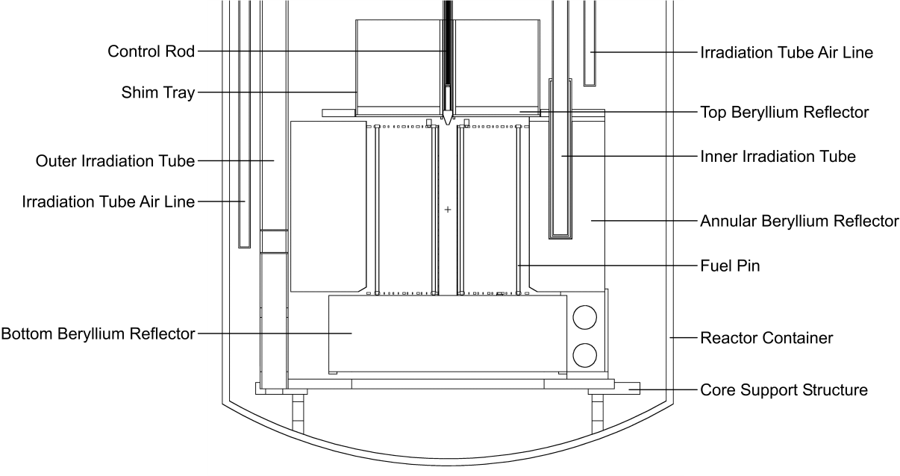
FIG. 1. Vertical cross section of the JM-1 HEU reactor model
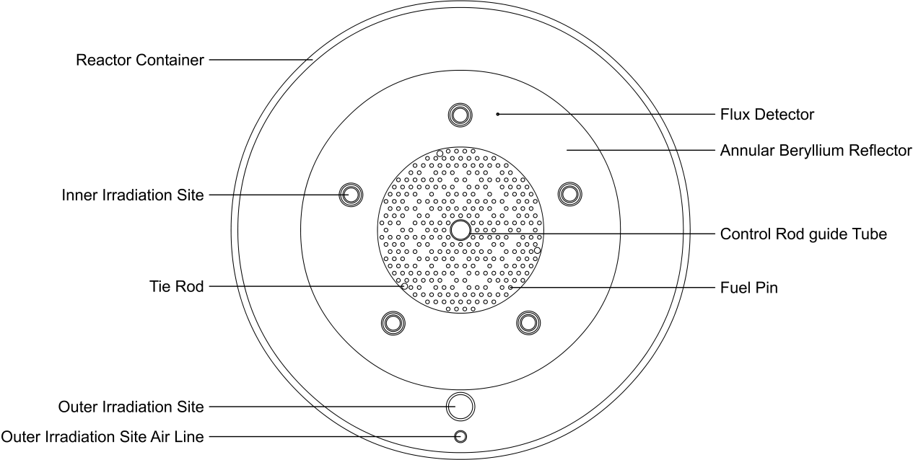
FIG. 2. Horizontal mid-core cross-section of the JM-1 HEU reactor model

- Reactivity Estimations

  - HEU core

The MCNP5 estimated HEU core excess reactivity was calculated to be 5.02 ± 0.08 mk (two standard deviations are used for the statistical margin of error throughout the paper, resulting in a 95% confidence interval). This reactivity estimate is higher than the 3.4 mk of excess reactivity that was installed at commissioning. In addition to possible small inaccuracies that could be expected due to intrinsic precision limitations of the cross section libraries data and the physics modeled by the code, the difference in the calculated and measured excess reactivity is likely to be partly related to the uncertainty in the actual fuel composition. A significant reduction in the calculated excess reactivity, of approximately 2 mk, was observed
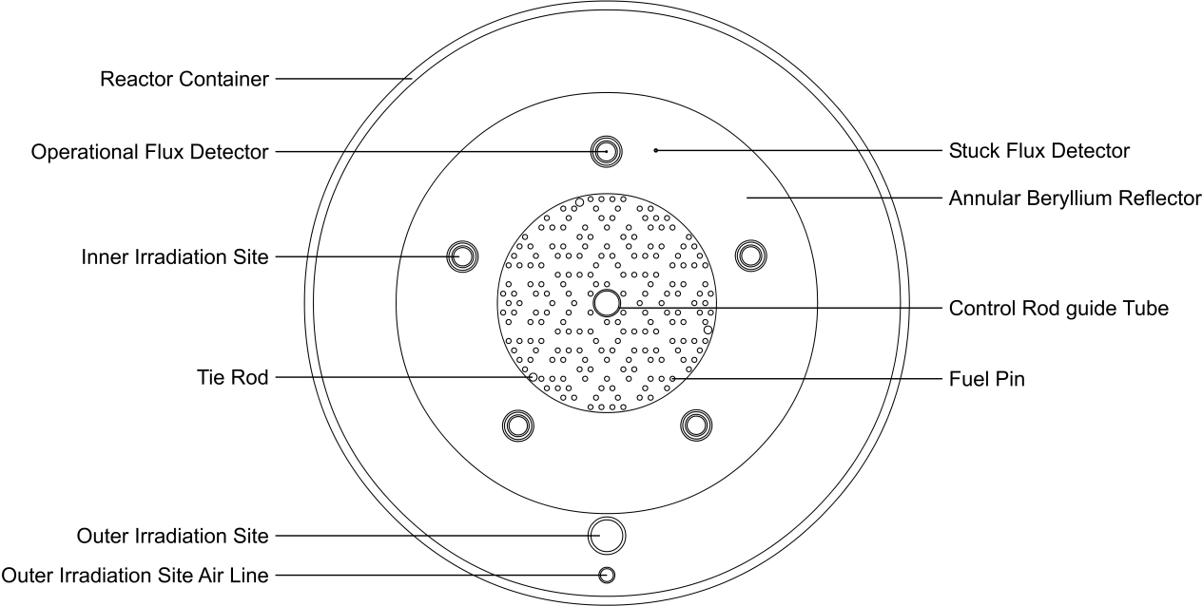
FIG. 3. Horizontal mid-core cross-section of the proposed JM-1 LEU reactor model
when the uranium vector in the MCNP5 calculations was adjusted from the 93% ²³⁵U and 7% ²³⁸U used initially as first approximation, to the more typical 93.18% ²³⁵U, 5.38% ²³⁸U, 0.44% ²³⁶U and 1% ²³⁴U, along with other minor impurities normally found in uranium-aluminum alloy fuels, as reported in the RRCGB [2]. The corresponding equivalent boron content (EBC) chosen according to estimates based on the reported alloy purity is 2.4 ppm, though values up to 6 ppm are considered typical for this type of fuel. If a value of 5 ppm were selected instead for the EBC, the total excess reactivity would be approximately reduced by an additional 0.3 mk.

The uncertainty in some beryllium impurity concentrations may also be a contributing factor to the excess reactivity overestimation, as these impurities were reported as being below specific values, assumed to be the respective detection limits of the techniques used to determine them. Although any specific choice within that range is somewhat arbitrary, concentration values were selected for the beryllium impurities corresponding to 66% of the reported detection limits. Given that the elemental concentrations effectively become truncated probability distributions and that the detection limits and the real values are likely to be of the same order of magnitude, the chosen estimate was considered to be more realistic than a 50% figure would be; resulting in a reactivity estimation of 5.02 mk. The maximum possible combined reactivity worth of these impurities was determined to be approximately −2.5 mk. Therefore, the resulting theoretical excess reactivity allowing for the uncertainty of beryllium impurities would range from about 4.2 mk to 6.7 mk; while not all the values within this range should be expected to be equally likely. Our best estimate results in an overestimation of 1.62 mk, which is very small, denoting a deviation of just 0.156% of total reactivity, as well as a significant improvement compared to previous modeling attempts which overestimated the excess reactivity of the SLOWPOKE HEU configuration by 119 mk, 13 mk and 3.3 mk respectively [3,4].

  - LEU core

The MCNP5 estimated excess reactivity of the LEU core was 4.76 ± 0.04 mk with the impurities of the beryllium reflectors set to 66% of the detection limits. This is only 1.07 mk higher than the reactivity value obtained for the HEU to LEU converted SLOWPOKE-2 reactor at École Polytechnique de Montreal (EPM) [5]. The calculated value is a very good estimate considering that the EPM reactor has five outer irradiation tubes, three large and two small – compared to the one large outer irradiation tube in the JM-1 model. When these additional irradiation tubes are incorporated into the JM-1 model for direct comparison with the EPM reactor (along with the removal of the additional cadmium flux detector), it leads to an excess reactivity reduction of about 0.6 mk, which results in a very good agreement between the calculated value and the measured 3.69 mk at EPM. It should be noted, however, that fuel is not identical, with 19.89% enrichment at EMP versus 19.86% for the JM-1, and small composition differences within the specifications may exist for the fuel and other reactor materials. The combined reactivity effect of these known and potential differences is expected to be less than ±1 mk but a precise direct comparison between the two reactors is virtually impossible. Though a really conclusive accuracy evaluation of the model won’t be possible until the actual reactor commissioning, the estimated excess reactivity for the LEU core in this work is, in any case, a substantial improvement over previous overestimations of 24 mk and 6 mk [4,6].

It would be a significant achievement to be able to predict, based on our model and with an accuracy of plus/minus one pin, the number of fuel pins that will be required to take the JM-1 LEU reactor, at commissioning, as close as possible to the 4 mk excess reactivity limit for SLOWPOKE-2 reactors without exceeding it. So far, preliminary estimates suggest that 196 pins combined with a thin layer of beryllium shims may be the actual configuration at commissioning, though the bulk of the analysis work has been performed for the 198-pin reference configuration. The differences between these two configurations are expected to be negligible for most relevant parameters, having no significant safety or performance implications.

An additional factor that has been taken into account in this comparison, though not yet fully analyzed, is the effect of neutron fluence on the beryllium reflector and its resulting influence in total reactivity. Buildup of neutron poisons, particularly Li-6 and He-3, has been identified as a very significant issue in reactors with higher neutron flux and harder energy spectrum [7], and has been also studied in MNSR reactors [8], with similar design to the SLOWPOKE-2. Due to the uncertainty that this issue might be of some relevance in the JM-1 conversion as well, it was taken into consideration and associated calculations were performed combining MCNP5 and ORIGEN2 codes. According to preliminary results, at the neutron fluence levels and corresponding energy spectrum of the JM-1 and EPM reactors, the depletion of the previously existing impurities in the beryllium reflector (such as boron, cadmium, samarium and gadolinium) seems to have a somewhat larger influence on reactivity than poison buildup, resulting in a slight reactivity increase. At this stage, while waiting for more conclusive results, it is considered that the differential reactivity effect due to different fluence levels between JM-1 and EPM reactors, with an estimated cumulative energy generation at the time of conversion of 100 MWh and 235 MWh respectively, is likely not significant (assuming equivalent initial impurities concentrations).

- Coefficients of reactivity

Reactivity coefficients have been studied in detail and estimated for both HEU and LEU cores and compared with experimental data to ensure that the core conversion will not significantly modify the reactor behavior nor affect its characteristic inherent safety features. Even though the agreement between measured and calculated reactivity coefficients and some other parameters of the HEU core is not essential or strictly related to the actual reactor performance with the LEU core, which is the main topic of interest of this work, it does provide additional validation of the existing models and further improves the confidence in the calculated results of the LEU reactor version.

The reactivity coefficients analyzed were the fuel temperature coefficient and the moderator void coefficient, as well as the overall temperature feedback, which essentially combines the temperature coefficients of the moderator, fuel and reflector. The corresponding series of experiments performed involved determining the excess reactivity by measuring the reactor period after full extraction of the control rod, starting from zero power at different uniform initial temperature conditions for the whole reactor, hence providing aggregate information. These overall values are also more representative of the actual reactor operation, at least for steady state, in which case some additional contribution from fuel temperature might be added to obtain the total reactivity feedback. Given that the individual contributions of the coefficients at the temperatures of interest are found to be quite small and the simulation precision with Monte Carlo methods is limited by the computation time, determining the cumulative reactivity impact by addition of the individual effects would increase statistical error or require impractically longer computation times.

  - Fuel temperature coefficient

The fuel temperature coefficient of the HEU core, estimated by MCNP5, is slightly negative (−0.0009 mk/°C) but essentially negligible for all practical purposes. The fuel temperature coefficient in the case of the LEU core is also negative and much larger in magnitude, as expected due to the much higher fraction of ²³⁸U contributing to parasitic absorption, correspondingly enhanced by the Doppler broadening of the cross section resonances. The obtained value was −0.008 mk/°C, which compares very well to the previously calculated value of −0.009 mk/°C for the EPM reactor [6]. Given that the range of fuel temperature variation is small compared to the ones typical in power reactors, the overall reactivity effect of fuel temperature coefficient will still be small under normal operating conditions, though significant given the very limited maximum excess reactivity of the SLOWPOKE-2.

  - Moderator void coefficient

The MCNP5 estimated core average moderator void coefficient of reactivity (MVCR) was determined by adjusting the density of the moderator within the core volume without changing the temperature, with void fraction ranging from 0 to 2%, to simulate the effect of bubble formation associated with incipient boiling. The estimated MVCR obtained for the HEU core was −3.132 mk/% of void or −0.041 mk/cm³. This is comparable to the previously calculated value of −0.046 mk/cm³ for the JM-1 and the experimentally measured value of −0.042 mk/cm³ for the SLOWPOKE-1 reactor, which is of very similar design to the SLOWPOKE-2 [8]. The corresponding MCNP5 result for the LEU core is smaller in magnitude but still strongly negative, −2.62 mk/% of void or −0.034 mk/cm³, which also compares well to the previously calculated (−0.033 mk/cm³) and measured values (−0.036 mk/cm³) for the EPM reactor [6].

  - Overall temperature-reactivity response

The overall reactivity variation as a function of temperature (uniform) was estimated by adjusting the reactor temperature and corresponding water density from 20.45°C to 45°C in MCNP5. Even though it might be worth simulating the reactor conditions at somewhat lower

FIG. 4. Calculated excess reactivity as a function of average temperature in the HEU core
temperatures to match available experimental data, the lower boundary becomes limited by the lowest temperature for which isotopic neutron cross section libraries are available. While some methods and tools do exist that allow generating cross section libraries at higher temperatures by means of Doppler broadening, the same is not possible in the opposite direction, so the analysis becomes limited by the 20.45°C threshold. Nonetheless, the simulation was still useful even for the HEU fuel, as it shows that from 20.45°C, there
is a continuous decrease in reactivity with increasing core temperature, as illustrated in Figure 4. It is also possible to notice that the results trend tends to flatten as the temperature decreases, making it perfectly compatible with the experimentally observed maximum at 19.4°C and the corresponding change of slope sign below that temperature.

The same approach was adopted in estimating the combined reactivity temperature response of the JM-1 reactor with the LEU core. Similarly, as with the case of the HEU, there is an initial reactivity increase with temperature, though with a maximum at 33°C according to experimental data from the LEU fuelled SLOWPOKE-2 reactors at the Royal Military College of Canada (RMC) and EPM. This reactivity trend was also observed in the MCNP5 simulations. Given the existence of small differences in total reactivity values between different series of experiments as well as with MCNP5 estimates, all the experimental data, in addition to the simulation results, were adjusted to the same maximum reactivity to allow for an easier and more direct comparison of the reactor behavior under these conditions, without the interference of small possible biases on the total reactivity resulting from calculations or from different initial conditions at the start of the experiments. This does not affect the reliability of the results since only the relative reactivity variations as a function of temperature are relevant on the reactivity coefficient analysis. The resulting comparison, illustrated in Figure 5, shows that the simulated reactor behavior with MCNP5 fits the experimental data very well, matching the AECL curve. This is a significant accomplishment, since no previous modeling attempt had managed to replicate the reactivity peak at 33°C, as exemplified by the EPM calculation result also shown [4,6].

The procedure to obtain the experimental data at the EPM reactor, which took place over several weeks in 2010, involved operating the reactor without pool cooling so that the reactor

FIG. 5. Excess reactivity versus core temperature for SLOWPOKE-2 LEU cores

FIG. 6. Calculated flux distribution in the inner irradiation channels at nominal power

temperature was higher each week. Each measurement was carried out after the reactor had been shut down for ~64 hours, so that thermal equilibrium had been reached throughout the reactor; core inlet and outlet temperatures were checked to ensure they were identical. The reactor period was then determined by measuring the time required, on startup, for the reactor
power to increase from 40% to 90% of preset reactor power levels. The reactor period obtained was then used to estimate the total excess reactivity as a function of moderator temperature. Two such experiments were performed at the EPM reactor, from 0.8 kW to 1.8 kW and from 8 kW to 18 kW, to determine if the more rapidly changing fuel temperature at the higher reactor power would significantly affect the measured excess reactivity behavior as a function of temperature, concluding it was not so. The excess reactivity measurements at the RMC reactor were performed by control rod balance in 1986 and the AECL correction curve, obtained from RMC experimental data, was used to make temperature corrections to excess reactivity measurements at LEU fuelled SLOWPOKE-2 reactors.

- Neutron flux distribution

In order for an average thermal flux of 10¹² n·cm⁻² s⁻¹ to be maintained in the inner irradiation channels with the HEU to LEU conversion, a ~11% increase in power will be required, resulting in a full nominal power of 21.23 kW with the LEU core. A similar increase was also observed for the EPM reactor, whose LEU nominal thermal power at a flux of 10¹² n·cm⁻² s⁻¹ was 19.84 kW up from 17.2 kW with the HEU core, corresponding to a ~15% increase [5,10]. Since accurate measurement of reactor power is highly challenging, it’s not surprising to find a larger discrepancy between the calculated and experimental power increase margins than between other parameters analyzed in this work. However, to provide some perspective on the error margins involved, all that would be needed for the EPM HEU/LEU power ratio to match our calculations is that the measured HEU core power be 1.8% higher and the LEU power be 1.8% lower. Therefore, the stated discrepancy does not decrease the confidence in the results obtained. In fact, given a reliable reference for flux to power ratio, or for effective energy released per fission, MCNP may help to obtain more accurate power estimates than some currently available measurements. The thermal flux distributions at 21.23 kW in the LEU core and at 19.08 kW in the HEU core in both the inner and outer irradiation sites are compared in Figure 6.

- Conclusions

A full reactor neutronic analysis has been performed using the MCNP5 radiation transport code as part of the safety analysis for the HEU to LEU conversion of the JM-1 research reactor. The estimated reactor parameters obtained so far exhibited very good agreement with experimental data from other existing LEU fueled SLOWPOKE-2 reactors (EPM and RMC), achieving a better agreement than all previously reported estimates for both the HEU and LEU configurations of the SLOWPOKE-2 reactor. The accuracy of the calculations presented, possibly complemented with actual manufacturing data, will be ultimately tested upon effective completion of the reactor conversion process, which is scheduled for September 2015.

- References

- Grant, C.N., Preston, J., “Progress Report on the Activities for the Core Conversion in Jamaica”, 34th International Meeting on Reduced Enrichment for Research and Test Reactor, Warsaw (2012).
- Research Reactor Core Conversion Guidebook, Volume 4: Fuels (Appendices I-K), IAEA TEC-DOC6-43, IAEA, Vienna (1992).
- Pierre, J.R.M., Low Enrichment Uranium (LEU)-Fuelled SLOWPOKE-2 Nuclear Reactor Simulation with the Monte Carlo based MCNP-4A Code, Master of Engineering Thesis, Royal Military College of Canada, Ontario (1996).
- Nguyen, T.S., Wolkin, G.B., Atfield, J.E., “Monte Carlo Calculations Applied to SLOWPOKE Full-Reactor Analysis”, AECL Nuclear Review, 1(2), 43-46 (2012).
- Edwards, G.E. Jones, R.T., Commissioning of the Ecole Polytechnique LEU SLOWPOKE-2 Research Reactor, FFC-RRP-087, Canada (1997).
- Winfield, D.J., Safety Analysis Report for the École Polytechnique Slowpoke-2 Reactor, RC-1598, Rev 1 (1998).
- Omar, H., Ghazi, N., Haddad, Kh., Ezzuddin, H., “Study the effect of beryllium reflector poisoning on the Syrian MNSR”, Applied Radiation and Isotopes 70, 988-993 (2012).
- Andrzejewski, K., Kulikowska, T., Bretscher, M., Matos, J., Beryllium Poisoning in the Maria Reactor, 22nd International Meeting on Reduced Enrichment for Research and Test Reactor, Hungary (1999).
- Aleta, C.R., Safety Report (Draft), SLOWPOKE-2 (UWI) Reactor, Centre for Nuclear Sciences, UWI, Mona, Kingston (1985).
- Burbidge, G.A., Wise, M.E., Garvey, P.M., Commissioning of the SLOWPOKE-2 (Ecole Polytechnique) Reactor, CPR-23 (1976).

