Implementation and Utilization of Positron Annihilation Spectrometry Methods at the PULSTAR Reactor

Ayman I. Hawari*, Ming Liu

Nuclear Reactor Program, Department of Nuclear Engineering,

North Carolina State University

Raleigh, NC 27695-7909, USA

Corresponding author: [ayman.hawari@ncsu.edu](mailto:ayman.hawari@ncsu.edu)

**Abstract**. A comprehensive user facility for performing positron annihilation spectrometry (PAS) for material studies has been implemented at the North Carolina State University (NCSU) PULSTAR reactor. The laboratory is centered on the PULSTAR’s reactor-based mono-energetic intense positron beam that is currently operational and is used for surface and thin film analysis. This beam drives two PAS spectrometers that are capable of probing metals, semiconductors and insulating materials. In addition, a digital bulk PAS system based on using Na-22 positron sources has been implemented. Positrons represent unique probes of matter that are capable of mapping the electronic density in a given material. By analyzing the characteristics (in the energy and time domains) of the 511 keV gamma radiation that results from the annihilation of positrons in a given sample, conclusions can be made about microstructure including the morphology of the porosity in the sample. Studies have been performed on various materials that illustrate the utility of PAS techniques and the complementarity of the results with the outcome of inelastic and elastic neutron scattering, porosimetry, microscopy, and X-ray diffraction methods. This includes, but is not limited to, examination of the nanostructure and defects of irradiated graphitic materials, microelectronic conductors, novel battery electrode/electrolyte materials, fuel cell and desalination membranes, polymeric fibers, and organic photovoltaic materials.

**1. Introduction**

The positron, as the anti-matter of the electron, has been extensively used as a unique and complementary probe for the characterization of vacancy-type defects and nanoscale free volume voids in condensed matter [1]. However, many of the positron spectrometry methods are hindered by the availability of positrons, especially the availability of high intensity mono-energetic positron beams. Using the high flux of thermal neutrons and high energy gammas at a nuclear reactor, a high rate of low-energy positrons can be generated through the pair production process and can be formed into a positron beam. Such an intense positron beam as well as a comprehensive positron lab has been established at the North Carolina State University (NCSU) PULSTAR reactor [2]. This user facility is equipped with two surface positron annihilation spectrometers driven by the intense positron beam. A positron microprobe with significantly enhanced spatial resolution is also being developed. In addition, a digital bulk PAS system based on a positron Na-22 source is also integrated as part of the user facility.

**2. The PULSTAR Reactor and the Positron User Facility**

The NCSU PULSTAR reactor is an open pool light water reactor operated with 4% enriched Uranium-235 in the form of Uranium dioxide. The reactor core contains 25 fuel assemblies forming a 5×5 square array with four Ag-In-Cd control rod blades, and operates at a power of 1-MWth since 1972. The reactor core is surrounded by six beam tubes including one through beam tube. Over the past few years, these beam tubes have undergone significant development, which resulted in the installation of an advanced neutron imaging facility, a neutron powder diffraction system, an ultra-cold neutron source, and an intense positron beam. These facilities have aided in establishing the PULSTAR reactor as a center for neutron research and nanomaterials characterization. The detailed description of the various beam tube facilities at the PULSTAR can be found in references [3-6]. Particularly, the positron generator is located inside beam tube #6, which has a square-shaped 11.5×11.5 inches cross section. Two banks of annealed tungsten foils (0.25 mm thick) in the form of interlocking vanes are used as the main positron generator/moderator, from which the pair-production positrons can diffuse to the surface and be emitted with an energy of several eV. These low energy positrons are electrostatically accelerated to 1 keV and focused into a beam. Subsequently, the beam is magnetically guided through the drift tube out of the reactor core region and is switched by steering coils to drive either one of the two spectrometers (see FIG. 1). A more detailed description of the primary beam can be found somewhere else [4]. The highest rate achieved of the primary positron beam was nearly 109 slow positrons per second, and the beam diameter is approximately 1 inch. Recently, a power upgrade has been accomplished to enable the PULSTAR reactor be operated at 2-MWth, which would is expected to double the positron production at the facility. In addition, a second generation primary positron beam is currently under development. In this new design, the present tungsten positron generator will be replaced by 4 banks of platinum moderators with further optimized geometry, which would provide significantly higher positron rate as well as beam rate stability over a longer period of time.

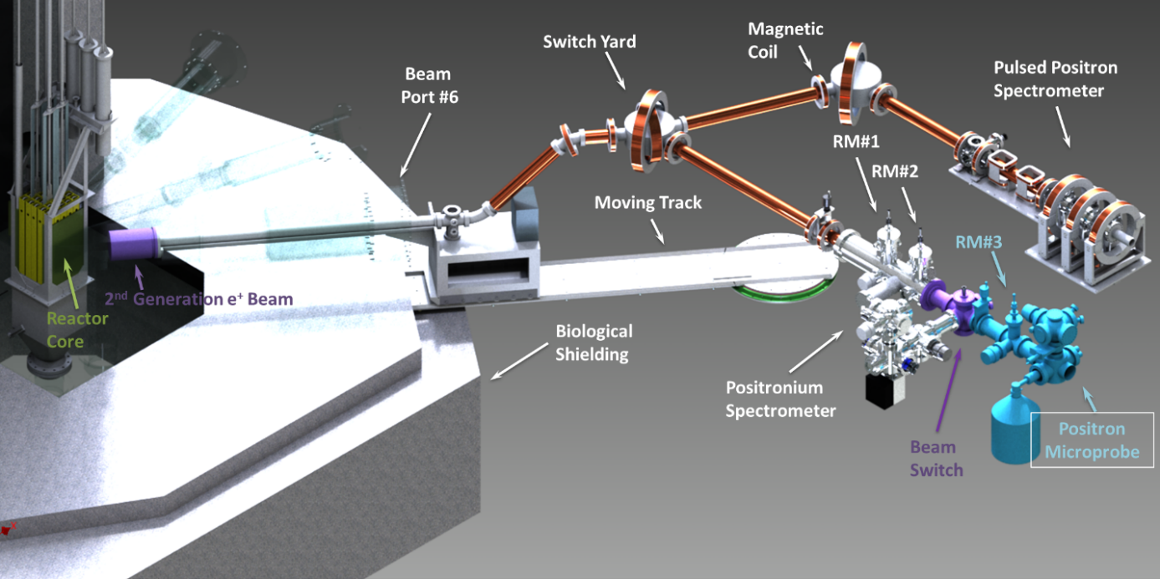As shown in FIG. 1, the primary 1 keV positron beam is magnetically transported into a switch yard, where the magnetic coils can steer the beam into either one of the labs to feed the Pulsed Positron Spectrometer or the Positronium Spectrometer. These spectrometers are both set up to conduct positron annihilation lifetime spectroscopy (PALS) and Doppler Broadening Spectroscopy (DBS) of annihilation irradiation, and are used as a nanomaterial characterization tool by internal and external users. Other positron methodologies could also be implemented per users’ request. The pulsed spectrometer has a superior timing resolution of approximately 280 ps, which resolves short positron lifetims in metals and traditional semiconductors. A transmission remoderator made of a 190 nm thick tungsten-molybdenum (WMo) foil [7] refines the phase space of the primary beam and also, in combination with a high-transmission mesh, acts as a pre-buncher to re-emit the positrons in 50MHz pulses. The pre-buncher also provides the stop signal in a time-reversed PALS histogram. Downstream, a double gap buncher operating at 50 MHz compresses the width of the beam pulses in the time domain. The beam is magnetically guided and the energy on target can be adjusted from 0.5 keV to 30 keV, which correspond to mean implantation depths of approximately 13 nm to 9 μm assuming the density of the material is 1 g/cm3. Given the routinely achievable positron rate of 5×108 e+/s, the on-target positron rate is approximately 6×105 e+/s considering the loss during the process of transporting, bunching, and re-moderating the beam.

*FIG. 1. A schematic of the PULSTAR reactor and the positron primary beam with the two attached PAS spectrometers.*

The second spectrometer, the Positronium Spectrometer, focuses on studies using the positronium (a meta-stable bond state of a positron and an electron) as a probe, and is electrostatically guided and focused. Two remoderation stages for brightness enhancement made of 150 nm nickel foils are installed to focus the beam to a 1-2 mm spot on target. A channel electron multiplier array (CEMA) with a center hole is positioned in front of the target to detect the secondary electrons emitted from the sample surface and used as the spectroscopic start signal. Due to the variation in time when the secondary electrons arrive at the CEMA, the timing resolution of this spectrometer is limited to ~1 ns. Comparing to the pulsed positron spectrometer, this spectrometer has a much wider timing window of 1000 ns. It specailizes in the detection of the annihilation events from long-lived positronium, and is suitable for studying insulating materials such as polymers. In-situ thermal treatment from cryogenic temperatures to 500°C can also be done in this spectrometer with its heating-cooling sample stage. A more detailed description of the design and performance of these two beam-based spectrometers is discussed in reference [8].

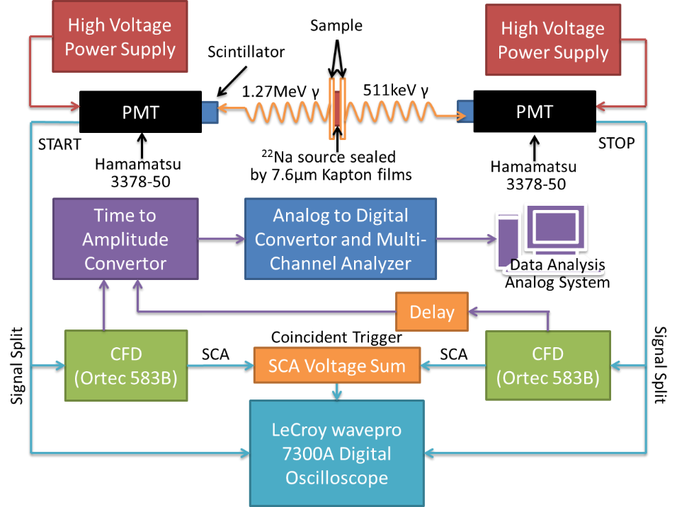Complementary to the beam-based spectrometers, the third spectrometer of the user facility is a digital bulk system based on a 15 μCi Na-22 radioactive source, sealed with 7.6 μm Kapton films. The schematics of this system is illustrated in FIG. 2. The source-sample package can be placed on a heating-cooling stage inside a vacuum chamber. The temperature of thermal treatment to the sample ranges from approximately 80K to 600K. Since Kapton degrades significantly at the higher end of this temperature range, thermal treatment under this condition would require a one-sided Tungsten-backed source. The small vacuum chamber is positioned in between two Hamamatsu H3378-50 photomultiplier tube (PMT) assemblies in combination with two cylindrical plastic scintillators of 1×1 inch in size. The raw pulses from the PMT assemblies are fed into a LeCroy wavepro 7300A digital oscilloscope, where the time stamps of these pulses are extracted by real-time digitization, interpolation, and linear least-squares fitting to the leading edge of the processed pulses. The signals from the PMTs are also split into two Ortec 583 discriminators, which provide the external triggers of the coincident events associated with the birth and the annihilation of the positrons. Meanwhile, an analog system also runs in parallel with the digital system when a higher count rate is needed while the timing resolution is not critical.

*FIG. 2. A schematic of the digital bulk-PALS system of the NCSU positron user facility*

In recently years, with the growing demand of mapping defects and pores on laterally small samples or specific small areas of samples, discriminating fine structures of samples spatially which requires a well focused beam down to the micrometer range became more important. To address this need, a positron microprobe, a major addition to the above spectrometers is being developed. The current two-stage remoderation of positronium spectrometer will be modified and improved for better beam focusing, and a third birghtness enhancement stage will be installed. Upon completion, this microprobe is expected to generate a focused beam of several micrometers in diameter on target. Combined with the depth-profiling capability and its high intensity, this microprobe would enable practical 3-dimensional mapping of nanoscale defect/nanopore morpholoy with reasonable measurement time.

**3. Materials Characterization Using the Positron Spectrometers**

The particular usefulness of positron annihilation spectroscopy (PAS) stems from the unique interactions of positrons with environmental electrons in the target material, both in the energy domain and in the time domain. Positrons can naturally diffuse to and be trapped in vacancies or voids, the characteristic information of which can be inferred by the annihilation characteristics. At the PULSTAR reactor, a number of studies covering a wide range of material types are on-going that illustrate the capability of the positron technique as well as its potential in materials science as a complement to some of the traditional and state-of-the-art methodologies.

Materials exposed to radiation, e.g. intense flux of neutrons, could be damaged on the atomic level due to the displacement of lattice atoms and the production of vacancies and interstitials. This damage can lead to the alteration of mechanical and thermal properties of the materials, and should be understood to support developing novel materials for application in high-irradiation environment. In addition, this damage may not be clearly visible using microscopy techniques, especially when the original material is amorphous. As an example, a series of reactor-grade graphite (NBG-10) samples were examined using the PALS technique after fast neutron irradiation at different temperatures [9]. It was found that, for similar doses, the irradiation at lower temperatures (280°C) stabilized the damage to the nanostructure as opposed to higher temperature (700°C). This is clearly observed from the drastic change of positron annihilation lifetimes within these materials, which correspond to characteristic mono-vacancies and probably V6 vacancy clusters. This observation also corroborates the fact that, in the X-ray and thermal neutron diffraction measurements, sharp diffraction peaks representing orders in the basal planes and their stacking disappear after irradiation.

With the ever shrinking feature size of microelectronics, nanoscale characterization of the novel candidate materials for the critical components of next-generation integrated circuits became a must. This is not only related to the application of nanoporous ultra-low-*k* dielectrics [10] where PAS found its unique power in characterizing the engineered free volumes, but also linked to more precise tuning of the doping impurities or defect concentrations of the semiconductor transistors and metal interconnects. In collaboration with clients in the microelectronics industry, it was demonstrated that depth profiled PALS and DBS can be used to deduce vacancy types and concentrations of metal and semiconductor thin films with high sensitivity. In recent years, organic semiconductors became an important category of semiconducting materials because of their low cost and flexibility. Many polymer-small molecule composites have been heavily studied as promising materials for photovoltaics or large area displays. In collaboration with NIST, the morphology of one of the typical organic photovoltaic materials, Poly(3-hexylthiophene) or P3HT [11], was studied using PALS. With progressive loadings of conducting Phenyl-C61-butyric acid methyl ester, or PCBM, the positronium lifetime dropped from 2.4 ns to 1.8 ns, which corresponds to pore diameter drop from 0.6 nm to 0.5 nm [12,13] and the positronium intensity was found to be significantly reduced (see FIG. 3). These effects are attributed to a pore-filling process of PCBM to the free volumes of P3HT. During this process, since the conducting PCBM is quenching the positronium formation within the range of Ps/positron diffusion, the trend of the Ps intensity according to the PCBM loading was found to be a monitor of the agglomeration of PCBM molecules. In FIG. 3 above, the calculated Ps intensity drops significantly faster if one assumes that the PCBM molecules are largely mono-dispersed. In addition, the deduced positron diffusion length was found to be positively related to the final instrument performance, which raised the question that if one could use the behavior of positron diffusion as a mimicking behavior of the holes, and find a much simplified optimization routine for new system development.

*FIG. 3. The Ps intensity drops according to growing PCBM volume concentration. From these trends, the effective Ps quenching region (region around PCBM molecules) was found to be much less than what mono-dispersed PCBM would produce, which suggests that PCBM agglomeration occurred.*

Novel crystalline material, such as metal organic framework, is another example of a material category wherein the pore size and the pore connectivity are crucial in defining the specific use in either gas adsorption or filtration. Researchers have studied the CO2 adsorption process in MOF5 which demonstrated the unique power of in-situ porosimetry enabled by PALS [14]. Recently, in collaboration with researchers at Indian Institute of Science Education and Research (IISER) Pune, an ultra-microporous MOF with exceptional CO2 capacity was studied with a combination of characterization techniques including PALS. The detailed results of this study will be published separately in another paper. In this on-going study, the free volume properties during the adsorption of guest molecules would also be investigated, which could help to further our understanding of the mechanism of gas adsorption in this media.

In general, PALS can be a technique of choice for materials characterization when the properties of the nanoscale voids are critical in determining the device performance, especially for particle transport and storage. Under circumstances when the pore morphology at the surface and the interface of the thin films plays an important role, depth-profiled PAS is needed to reveal the possible heterogeneous structure. In collaboration with partners in industry and national labs, pore characterization of polymer thin films, e.g. proton exchange membranes (PEM) and desalination (RO) membranes, has been more focused on the localized effects that are caused by fabrication and optimization processes. It should be noted that the systematic effects of depth-profiled PAS have to be carefully handled in order to produce meaningful results. In previous studies, polymeric fibers that were subjected to stress/strain were found to have increased porosities according to the number of deformation cycles. PALS was sensitive to this process at the very early stage of material fatigue that is invisible to microscopy methods, which suggests the possibility of using PALS as an evaluation tool for materials damage initiation.

**4. Conclusions**

A positron facility was established at the PULSTAR reactor of the North Carolina State University for internal and external users. With the completion of the power upgrade of the PULSTAR to 2-MWth, the positron rate is expected to be doubled. Meanwhile, a new generation primary positron beam is under construction, which would provide even higher positron intensity and better long term stability. Three spectrometers, including two beam-based PAS spectrometers and one digital bulk system, are available to users for materials characterization tasks. To enhance the spatial resolution of PAS techniques, a positron microprobe is currently under development. The unique power of PAS techniques have been illustrated by several studies that cover a spectrum of different materials.

**5. Acknowledgements**

This work was supported by the US Department of Energy INIE, NERI and NEUP programs, and the US National Science Foundation MRI program.

**6. References**

1. Schultz, P., et al., “Interaction of positron beams with surfaces, thin films, and interfaces,” Rev. of Mod. Phys. **60** (1988) 701.
2. The PULSTAR reactor, <http://www.ne.ncsu.edu/nrp/index.html>, 2014.
3. Mishra, K.K., Hawari, A.I., and Gillette, V.H., “Design and Performance of a Neutron Imaging facility at the NC State University PULSTAR Reactor,” IEEE Transactions on Nuclear Science, **53** (2006) 3904.
4. Hawari, A.I., et al., “Operation and testing of the PULSTAR reactor intense slow positron beam and PALS spectrometers,” J. of Phys: Conference Series **262** (2011) 012024.
5. DiJulio, D.D., and Hawari, A.I., “Characteristics and Performance of the Neutron Powder Diffractometer at the NC State University PULSTAR Reactor,” PHYSOR-2008: International Conference on the Physics of Reactors, Nuclear Power: A Sustainable Resource, Interlaken, Switzerland, 2008.
6. Korobkina, E., et al., “An Ultracold Neutron Source at the NC State University PULSTAR Reactor,” Nuclear Instruments and Methods in Physics Research A **579** (2007) 530.
7. Jorgensen, L.V., et al., “A rectifying tungsten-molybdenum foil for positron remoderation”, J. Appl. Phys. **81** (1997) 2725.
8. Liu, M., et al., “The Intense Slow Positron Beam Facility at the PULSTAR Reactor and Applications on Nano-materials Study,” AIP Conf. Proc. **1525** (2013) 455.
9. Liu, M., and Hawari A.I., “Positron Characterization of Neutron Irradiated Reactor-Grade Graphite,” Transactions of the American Nuclear Society, **110**, Reno, Nevada, June 15–19, (2014).
10. Volksen, W., et al., “Low Dielectric Constant Materials”, Chem. Rev. **110** (2010) 56.
11. Ro, H.W., et al., “Poly(3-hexylthiophene) and [6,6]-Phenyl-C61-butyric Acid Methyl Ester Mixing in Organic Solar Cells”, Macromolecules, **45** 16 (2012) 6587–6599.
12. Eldrup, M., et al., “The Temperature Dependence of Positron Lifetimes in Solid Pivalic Acid”, Chem. Phys. **63** (1981) 51–58.
13. Tao, S.J., et al., “Positronium Annihilation in Molecular Substances”, J. Chem. Phys. **56** (1972) 5499–510.
14. Liu, M., et al., “Evolution of nanoscale pore structure in coordination polymers during thermal and chemical exposure revealed by positron annihilation,” Adv. Mater. **22** (2010) 1598–601.