Development of Safety Management Portal System for HANARO Research Reactor

Hoan Sung Jung*, Sung Taek Hong, Jae Min Sohn, Young Cheol Ko, In Cheol Lim

Korea Atomic Energy Research Institute
111, Daedeok-daero 989 bungil, Yuseong, Daejeon, Korea

*Corresponding author: hsjung@kaeri.re.kr

ABSTRACT

KAERI has been using the integrated safety information management system, ANSIM, for over 5 years since developing information strategic plan for nuclear facilities in 2008. The ANSIM is a computerized management support system for quality assurance, radiation protection, nuclear material control, operation, and maintenance of nuclear facilities including HANARO research reactor. Most documentation and management works for the operation of the reactor are performed using ANSIM and documents are generated and stored as database in the dedicated computer server. ANSIM was developed to substitute for all paper works substantially. But it is inconvenient to get information for managerial purpose without several steps of searching. Based on the ANSIM, a safety management portal system, called Smart Board, was developed to give integrated information about the HANARO reactor facilities to operation people in a structured manner in 2013. Managers and staff should see the portal screen at first to use ANSIM system and can get information about number of approvals in progress, reactor status, work orders issued, accumulated dose of the user, status of procedures to revise due, safety performance index, etc. This paper describes features of the Smart Board and ANSIM.

- Introduction to ANSIM
The operation of Hanaro research reactor began by the KAERI since February, 1995. Management system for operation and maintenance was adapted from the practices of nuclear power plant. In the beginning, there were sufficient people for operation of the facilities because most researchers involved for design were joined in operation organization. But most researchers moved out to new project gradually. So operation organization suffered from the lack of human resources. The need for computerization of process for management had been raised to cope with the limitation of human resources, to keep knowledge accumulated during operation, and to face up with the modernization trend of business environment.
The computerized management system, ANSIM (Advanced Nuclear Safety Information Management) had been developed from 2008 starting with common modules as quality management system and radiation protection. Based on the common modules, the management system for the nuclear facilities had been developed one by one. The management system for the Hanaro was the first priority. Task analysis for the facility operation and management was performed based on O&M procedures and interviews with the involved staff in 2008 and the development of program had been finished in 2012. The figure1 and 2 show the schedule and the overall structure of ANSIM. The software was developed by Enterprise Architects design tool. Tools for programing are framework, Flex with ORACLE database and APACHE web server. The ANSIM supports the following activities for overall nuclear facilities in KAERI.
- Radiation Safety Management
- Radiation Safety Management of Advanced Radiation Technology Institute
- Management of Radiation and Radioactivity Analysis
- Management of HANARO (High Advanced Nuclear Application ReactOr) Facilities
- Management of IMEF (Irradiated Material Examination Facilities)
- Management of PIPF (Post Irradiation Examination Facilities)
- Management of RWTF (Radioactive Waste Treatment Facilities)
- Document Management of New (Gijang) Research Reactor Design
- Document Management of Jordan Research Reactor Design
- Document Management of SMART (System integrated Modular Advanced ReacTor) Design
- Management of Nuclear Material Control and Accounting
- Management of IAEA Expended Declaration
- Management of Nuclear Emergency Preparedness
- Management of Nuclear Quality Assurance

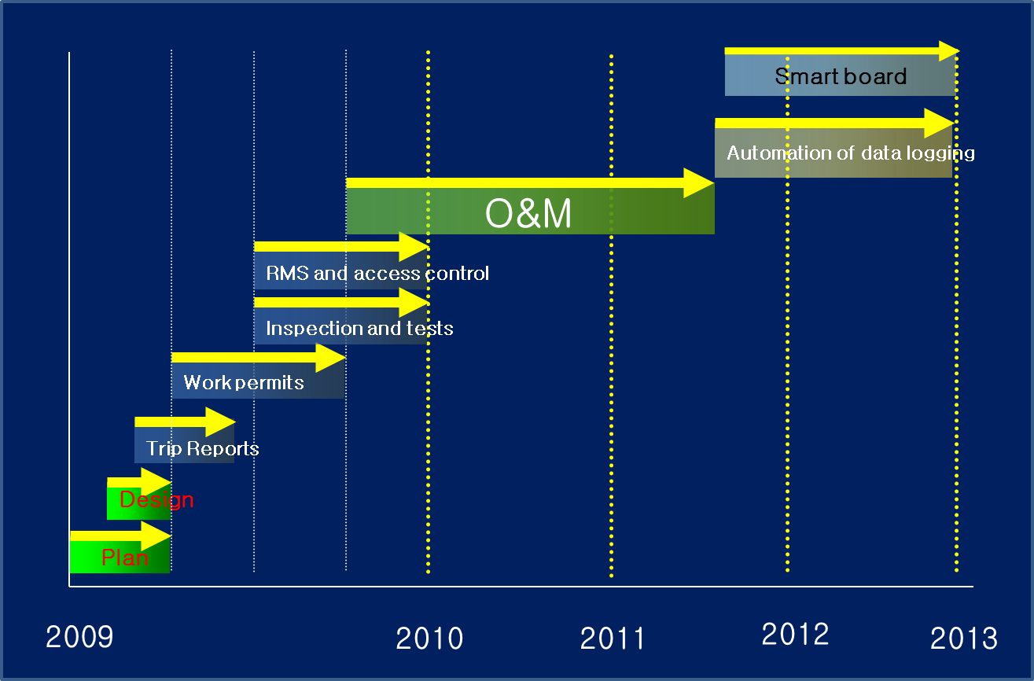
Figure 1 Schedule

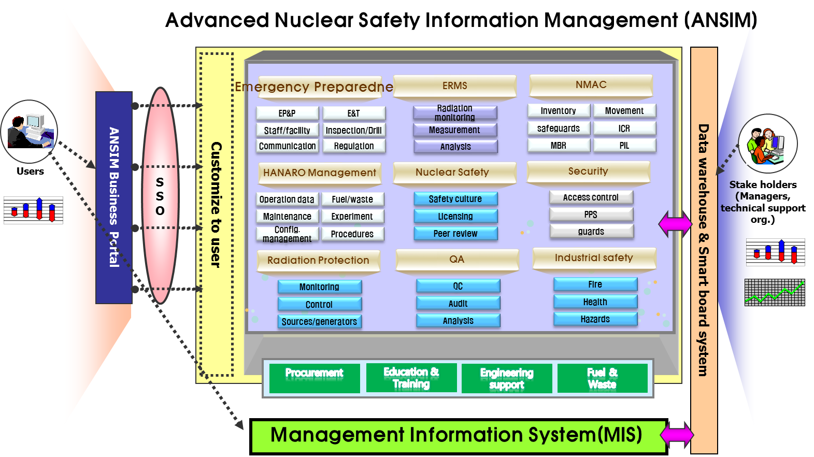
Figure 2 ANSIM

- Development of Smart Board
Contents, functions and user interfaces are well organized and work well. The program supports business activities and generates data bases. To access and retrieve the documents and databases it is needed to pass several steps of data mining process because the data is provided in a pre-formatted report equivalent to hard copy. The safety information for the managers and the staff can be retrieved from the database thru some manipulation of raw data. It takes a lot of time and is a tedious work. So we developed a kind of a portal system, Smart Board, to provide some useful information to the managers, users, and staff in an effective way. Information and design of the portal screen is in figure 3. To ensure safety in operation and maintenance, the following information is provided in the portal screen.
- Applications unapproved (only to logged user)
- Personal dose accumulated (only to logged user)
- Notice (events, trips, and campaign)
- Reactor schedule
- Reactor power
- Tasks to do
- Work permits to be approved
- Works unfinished ( in progressing)
- Inspection and tests scheduled to do
- Documents to be revised
- Major safety parameters with alarming function ( linked to regulatory body)
- Jobs in progressing using common facilities (like crane)
- Number of persons in the RX hall
- Collective dose accumulated per works
- Safety Performance Index
- Contacts phone address for major facilities
- Search

This portal screen supports the users logged in for working and monitoring of their activities. And it can be used as a safety information system for general user in KAERI, like high level managers related to Hanaro to get overall picture of safe operation.

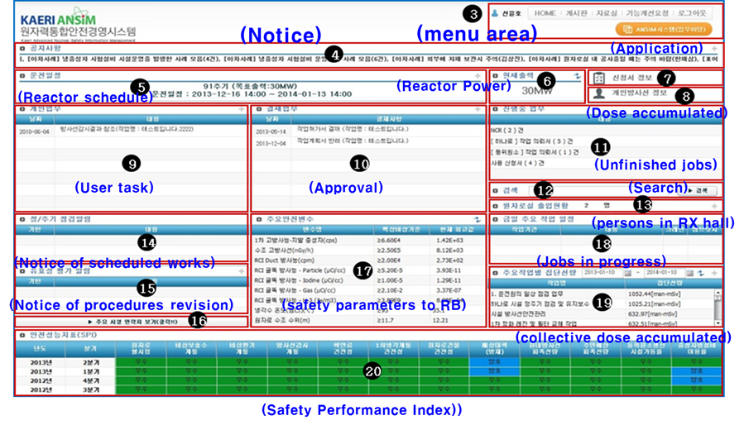

Figure 3 Smart Board Screen

- Concluding Remarks
Data itself stored the database does not provide some meaningful information to users. The Smart Board provides statistics and some useful information to users according to the user’s job position. Operators can check overall activities are being done in the Rx hall. Maintenance staff can check work permits, jobs to do, procedures to revise and accumulated dose. Reactor manager can get information about open or unresolved activities like non-conformance reports and monitor the safety performance index. It can be used as a display board for public visiting Hanaro. ANSIM and Smart Board will contribute to enhancing safety and performance of Hanaro in operation and maintenance with some automation of data collection function. It will be a part of Digital Hanaro plan as shown in Figure 4

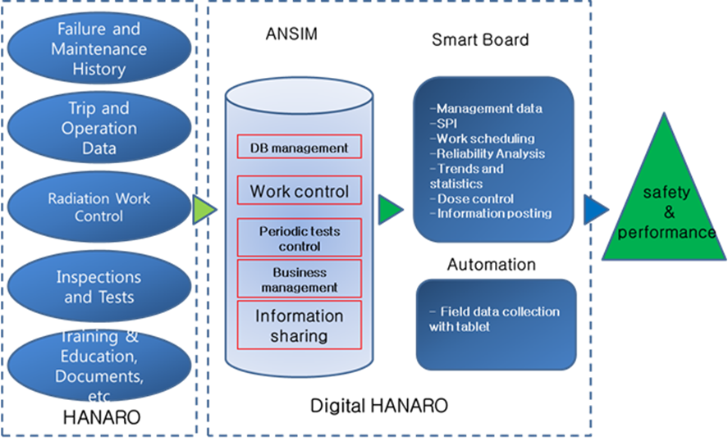

Figure 4 Digital Hanaro Plan

References

[1] Jae-min Sohn, et al., Development of the Advanced Nuclear Safety Information Management (ANSIM) System, Proceedings of Korean Nuclear Society Spring Meeting, 2012

