Neutron Absorbing Glass Microspheres as Second Shutdown System

I. Gana Watkins¹, N. Silin², M. Prado^{1, 2}

1) Departamento Materiales Nucleares, Centro Atómico Bariloche, Comisión Nacional de Energía Atómica (CNEA), Av. Bustillo 9.500, PO Box 8400
San Carlos de Bariloche, Argentina
2) CONICET, Consejo Nacional de Investigaciones Científicas y Técnicas, Av. Pioneros 2350, PO Box 8400
San Carlos de Bariloche, Argentina

Corresponding author: ignacioganaw@cab.cnea.gov.ar, ignagw@gmail.com

Abstract. Different kinds of Safety Shutdown Systems are used in Research Reactors and Nuclear Power Plants.
In this work we propose the use of glass microspheres as neutron absorbing component of a second Shutdown System for water cooled reactors. We present wear tests results produced on a 304L stainless steel by the impingements of a water jet containing low fractions suspension of glass microspheres with an average diameter of 150microns. We obtained a threshold flux speed of 2.7±0.5m/s under which there are no observable particle impacts on the metal surface. In addition we present cell calculations using Monte Carlo Methods where we show that a homogeneous dispersion of glass microspheres of diameters less than 100microns in the reactor cooling water, present similar neutronic effectiveness as an acid or salt dilutions.

1. Introduction - Shutdown Systems in Nuclear Reactors

Nowadays IAEA requirements establish that a Second Shutdown System is needed for the licensing process of Nuclear Power Plants. In Research Reactors these systems are optional and its implementation depends on the characteristics of the facility [1].
The main system for reactivity control as well as for reactor shutdown is the control rods bank. In water cooled reactors, the incorporation of boric acid or a gadolinium salt solution in the cooling system is widely used for reactivity control and for Second Shutdown Systems. However, these procedures present several disadvantages related to the physical and chemical properties of these compounds as its low solubility, elevated corrosion generation, in addition to the complex actions and processes needed to remove them from the cooling systems after been used [2].

In this context we propose a heterogeneous and biphasic alternative Shutdown System for Nuclear Reactors where the neutron absorbing material is retained in an inert matrix with microsphere particles. The proposed system acts as a neutron absorber when the microspheres are incorporated into the reactor core cooling system, moderator or specific compartments obtaining a homogeneous dispersion. Finally when shutdown is achieved the microspheres are removed from the system by a simple mechanical process. The microspheres conserve its integrity during all the process, and do not produce damage on the mechanical components of the reactor.

1.1 Test material: alumino-borosilicate glass microspheres

Currently different compositions of glass or ceramic microspheres are widely used for different applications such as cancer radiotherapy treatments, drug delivery and even as proppants for the Oil industry.
In this work we characterized an alumino-borosilicate glass as the main component of the alternative proposed Shutdown System. The neutron absorbing material has a composition of 71.7 SiO₂; 8.4 B₂O₃; 8.6 Al₂O₃; 1 MgO; 2.7 CaO; 7.5 Na₂O % wt [3].
Table I shows several bulk properties of the alumino-borosilicate glass.

TABLE I: alumino-borosilicate glass physicals properties.

Physical properties | alumino-borosilicate glass [3]
Vitreous transition temperature (°C) | 560
Density (gr/cm³) | 2.3
Young modulus (GPa) | 73
Poisson modulus | 0.22
Vickers hardness (kgf/mm²) | 550

Glass microspheres can be obtained by several methods, and the product properties will rely on the chosen production process. In this work, we obtained the glass microspheres from melted glass by the In Flame Spherodization Method (IFSM). In this method, irregular glass particles are fed into a flame with a temperature distribution well over the vitreous transition temperature (Tg). During their passage through the flame and in a few milliseconds the glass particles increase their temperature causing significant viscosity decrease, which together with the action of the surface tension gives the particle a spherical form [4].
FIG. 1. shows the IFSM scheme: the irregular glass particles are slowly fed to the hot region of the flame through the Powder Feeder System which consists of a set of vibratory sieves, and then at the center zone of the flame the glass particles become spherical. Finally the obtained microspheres travel through the cool region of the flame (where the temperature is below Tg) into a Cyclone System, which collects all the spherical particles.

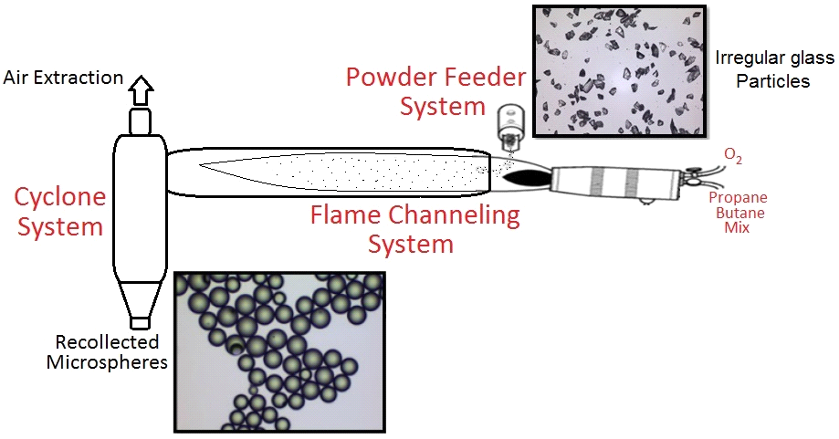
FIG. 1. IFSM scheme, present pictures of irregular glass particles and glass microspheres.
2. Characterization of Glass Microspheres as Second Shutdown Systems

The behavior of all nuclear materials have to be characterized in their neutronic, mechanical, chemical, thermal, hydraulic, and irradiation behavior before being incorporated into a nuclear reactor. We propose a biphasic system where the glass microspheres are suspended in the coolant or the moderator system. So we need a complete analysis of the neutron absorbing materials array, the glass microspheres and the liquid phase in the reactor system.

Preliminary research works determined that the alumino-borosilicate glass microspheres are resistant to water corrosion, and exhibit radiation stability [5]. Also it was shown that their compression breakage resistance decreases with microspheres size [6].
In this work we made wear tests on metallic surfaces simulating internal components of a reactor that could be damaged by the impact of the suspended glass microspheres. Moreover, we made Monte Carlo calculations of the neutronic effectiveness of glass microspheres compare to a typical Boric acid aqueous solution. These preliminary tests will allow us to determine the feasibility of implementing the glass microspheres as the main component of a Second Shutdown System for Water Cooled Reactors and compare this System with the boric acid or salt solutions.

2.1. Wear of Metal parts Test

Wear is the main cause of failure in systems that use suspensions of solid particle, e.g. glass in liquid. This phenomenon is the combination of two effects: cutting wear made by particles that flow parallel to the surface, and the deformation wear made by normal impact of particles on the surface. Several parameters are involved in wear effects: solid phase concentration; particles size and shape; temperature and surface properties [7].

In this work, we developed a methodology to quantify the damage produced on a metallic surface by a low fraction alumino-borosilicate glass water suspension. We built a hydraulic circuit where a jet carrying the glass microspheres impacts against a test specimen of polished 304L Stainless Steel. We determined the damage by analyzing optical microscopy images of the metallic surfaces after each test.

2.1.1 Experimental Procedure Setup

Figure 2 shows a) a schematic diagram of the hydraulic circuit, b) a schematic diagram of the support device for the 304L Stainless Steel specimen.

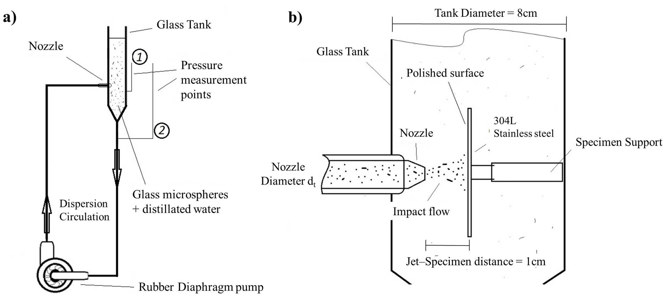
FIG. 2. a) schematic diagram of the hydraulic circuit, b) schematic diagram of the 304L Stainless Steel specimen support device.

The hydraulic circuit has a glass tank, an adjustable flow rubber diaphragm pump FLOW-POWER© FL35 (nominal flow rate=12.5l/min, Maximum Pressure=35Psi), and acrylic pipes (internal diameter D_{i}=16mm). The transparent materials allow us to observe the flow during all the experiments and to assess the cleanness of the circuit.
We alternatively use a set of nozzles with a diameter reduction from D_{i} to d_{t} =3 or 6mm, designed to accelerate the flow of microspheres impinging the tested surface. By construction the biphasic flow carrying the glass microspheres impacted directly on the center of the 304L Stainless Steel specimen. This material is similar to those used in pipes, pumps and internal components of Water Cooled Reactor.
The 304L Stainless Steel properties are: Young Modulus=200GPa, grain size=80microns, Vickers Hardness=210kgf/mm² [8], and the specimen measure is 24x24mm².
Before the wear test, each specimen was polished with successively finer grains down to 1 micron diamond paste to obtain a mirror surface. After this process, any observable damage on the surface of the specimens can be related to the impingements of the glass microspheres.

FIG. 3 shows: a) optical image of the polished surface of a Stainless Steel specimen before the test, b) optical image of the same surface after the microspheres impingement test, a wear “halo” can be observed c) SEM micrography of a region of the surface after the test, showing that wear is caused by plastic deformation.

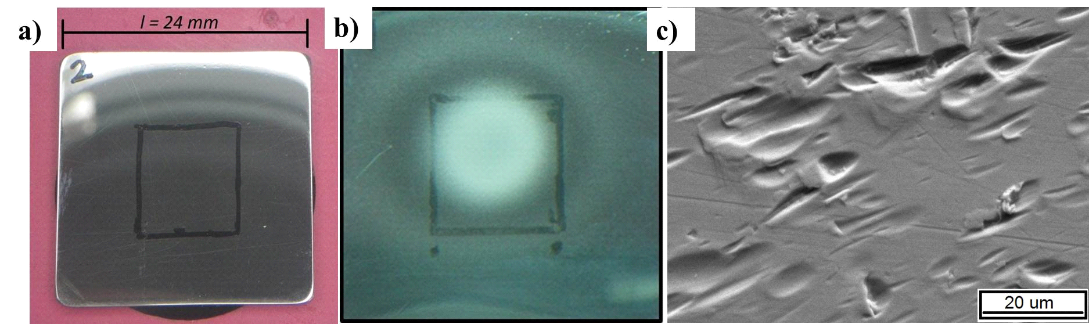
FIG. 3. a) optical image of the polished surface of a Stainless Steel specimen before the test, b) optical image of the same surface after the test, and c) SEM micrography of a region of the surface after the test. We can observe on c) the impacts of glass microspheres and on b) the effect on the polished surface with a wear “halo”.

We tested different Stainless Steel specimens with impacts jet velocities of 1, 2.9, 3.2, 4.5, and 6.1m/s during 30 minutes. The concentration of suspended glass microspheres in water was m_{sph}=1.4gr/l which represents a low solid volume fraction approximately 0.06%. In this conditions, the estimated average specific rate of impacts on the surface was lower than 60 impacts/(seg*mm2). We used a size distribution of glass microspheres that can be approximated by a Gaussian function with an estimate average diameter of 150microns and standard deviation σ=70 microns.

To quantify the damage on each specimen we analyzed the observable impacts of the glass microspheres. We used optical micrographs obtained by a LEICA© DM 2500M microscope with a magnifying object of 50x.
FIG. 4 shows optical micrographs of tested specimens polished surface at jet velocities of 2.9, 4.5, and 6.1m/s (a, b and c respectively).

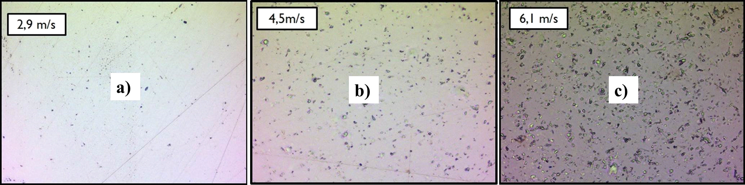
FIG. 4. Optical micrographs of the surface of tested specimens at velocities of 2.9, 4.5, and 6.1m/s (a, b and c respectively). We observe an increment of the observable impacts and their size with the velocity increase.

With an image processing treatment software and the ImageJ© software we processed the micrographs to obtain profiles of specific surface density of observable impingements and deformed volume produced by plastic deformation made by the impacts of glass microspheres on different regions of each tested specimen.
Finally to be able to quantify the total damage produced by the biphasic jet, we estimated the Total Number of observable impacts (N_{T}) and the Total deformed volume (V_{T}) on each plate using the formulas (1)

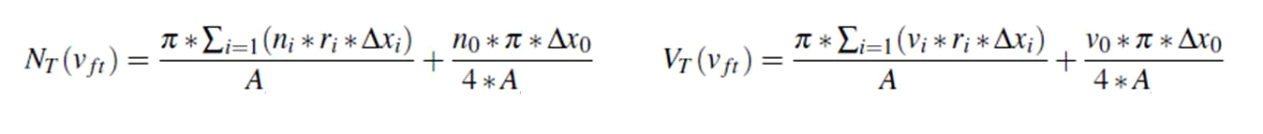

where v_{ft} is the impact flow velocity, n_{i} and v_{i} is the specific surface density of observable impacts and deformed volume in the analyzed image i of the surface taken at a distance r_{i} from the jet impact center, and A is the micrography area. n₀ and v₀ correspond to the analyzed image of the jet impact center.
In this approach we assume that the specific density of observable impingements and deformed volume remains constant within each ring of width Δx_{i} around the jet impact center of the tested plate.

2.2. Neutronic Characterization

We characterized the neutronic behavior of alumino-borosilicate glass microspheres and compared their effectiveness against the use of a water solution of Boric acid to determine the conditions for the biphasic systems to have the same neutronic effectiveness as the acid solution. We performed cells calculation on SERPENT© v4 code that allows us to easily incorporate the microspheres in the model [9].
We made a parametric analysis calculating the Infinite Multiplicity Factor (k_{inf}) in a cell where we incorporate different sizes and different quantities of glass microspheres (sph) in the cooling region, and then compared the results with the k_{inf} of different concentrations of boric acid dilution (B) cell. Also we calculated the reactivity difference between the cells (k_{sph}-k_{B}/(k_{sph}*k_{B})).
The boron concentrations typically used in Water Cooled Reactors are limited to approximately 1200ppm because of solubility problems [2]; this concentration can be reached and surpassed by a glass microsphere shutdown system.

2.2.1 Description of the Cell Model

The cell model considers a Zircaloy (Zr) cladding of outer diameter D_{vo}=9.5mm and inner diameter D_{vi}=8.3mm, inside the Zr cladding there are pellets of UO₂ (4% enriched in 235Uranium) with a size D_{p}=8.2mm. Surrounding the Fuel Pin there is a cuboid of cooling light water with a side length of L_{c}=12.6mm. All the cell data is according to a fuel Pin of a Pressured Water Reactor [2]. The cell height is Hc=5mm because the neutronic simulation of the glass microspheres represent the main cost in calculation time.
We used the software MATLAB2010© to calculate the position of the microspheres in the cooling region of the cell in a random distribution, to represent a homogeneous dispersion of the absorbing material.

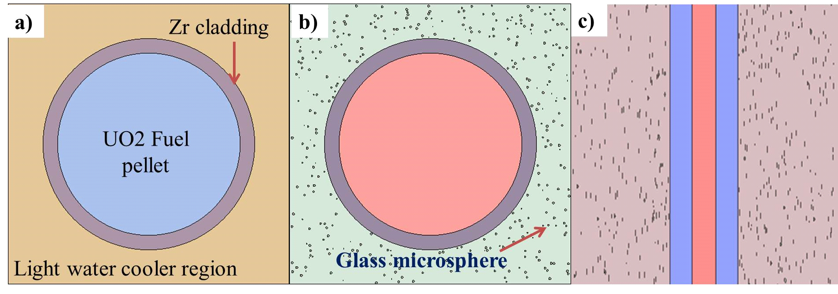
FIG. 5. a) section of the model cell – front view; b) section of the model cell with microspheres homogeneous dispersed in the cooling region– front view; c) section of the model cell with microspheres – lateral view. The distorted microspheres are an optical effect of the image.

FIG. 5 shows the model cell. The glass microspheres are observed as distorted ellipsoids because the image represents a cut-section of the cell and cuts the microspheres in different slices of their volume.
We performed simulations for Boron concentrations from 100 to 1700ppm. To determine the number of glass microspheres needed for each concentration we used the formula (2).

$$N_{sph}=\frac{3*c_{B}*z*(L_{C}^{2}-π{(D}_{Vo}^{2}/4))}{4*C_{Bsph}*ρ_{SG7}*R_{sph}^{3}}$$

were N_{sph} is the number of glass microspheres required, c_{B} is the Boron concentration in the water cooling region, ρ_{SG7} is the glass density=2,3gr/cm3, and C_{Bsph} is the Boron concentration of the glass microspheres=1,2% wt.
It’s remarkable that a concentration of Boron around the 1700ppm only represents a solid volume fraction of 6% in the water cooling region.
The simulations were performed with glass microspheres of radii R=25, 50, 75, 100, 200, 250 and 500 microns. The Calculation parameters were set on: Neutron Population per cycle=10000, active calculation cycle=5000. All calculations were done at room temperature (25°C).

3. Results

3.1. Wear Test

FIG. 6 shows the surface density of observable impacts and deformed volume profiles (in arbitrary units) for the specimens tested at 2.9, 4.5, and 6.1m/s (a, b and c respectively).

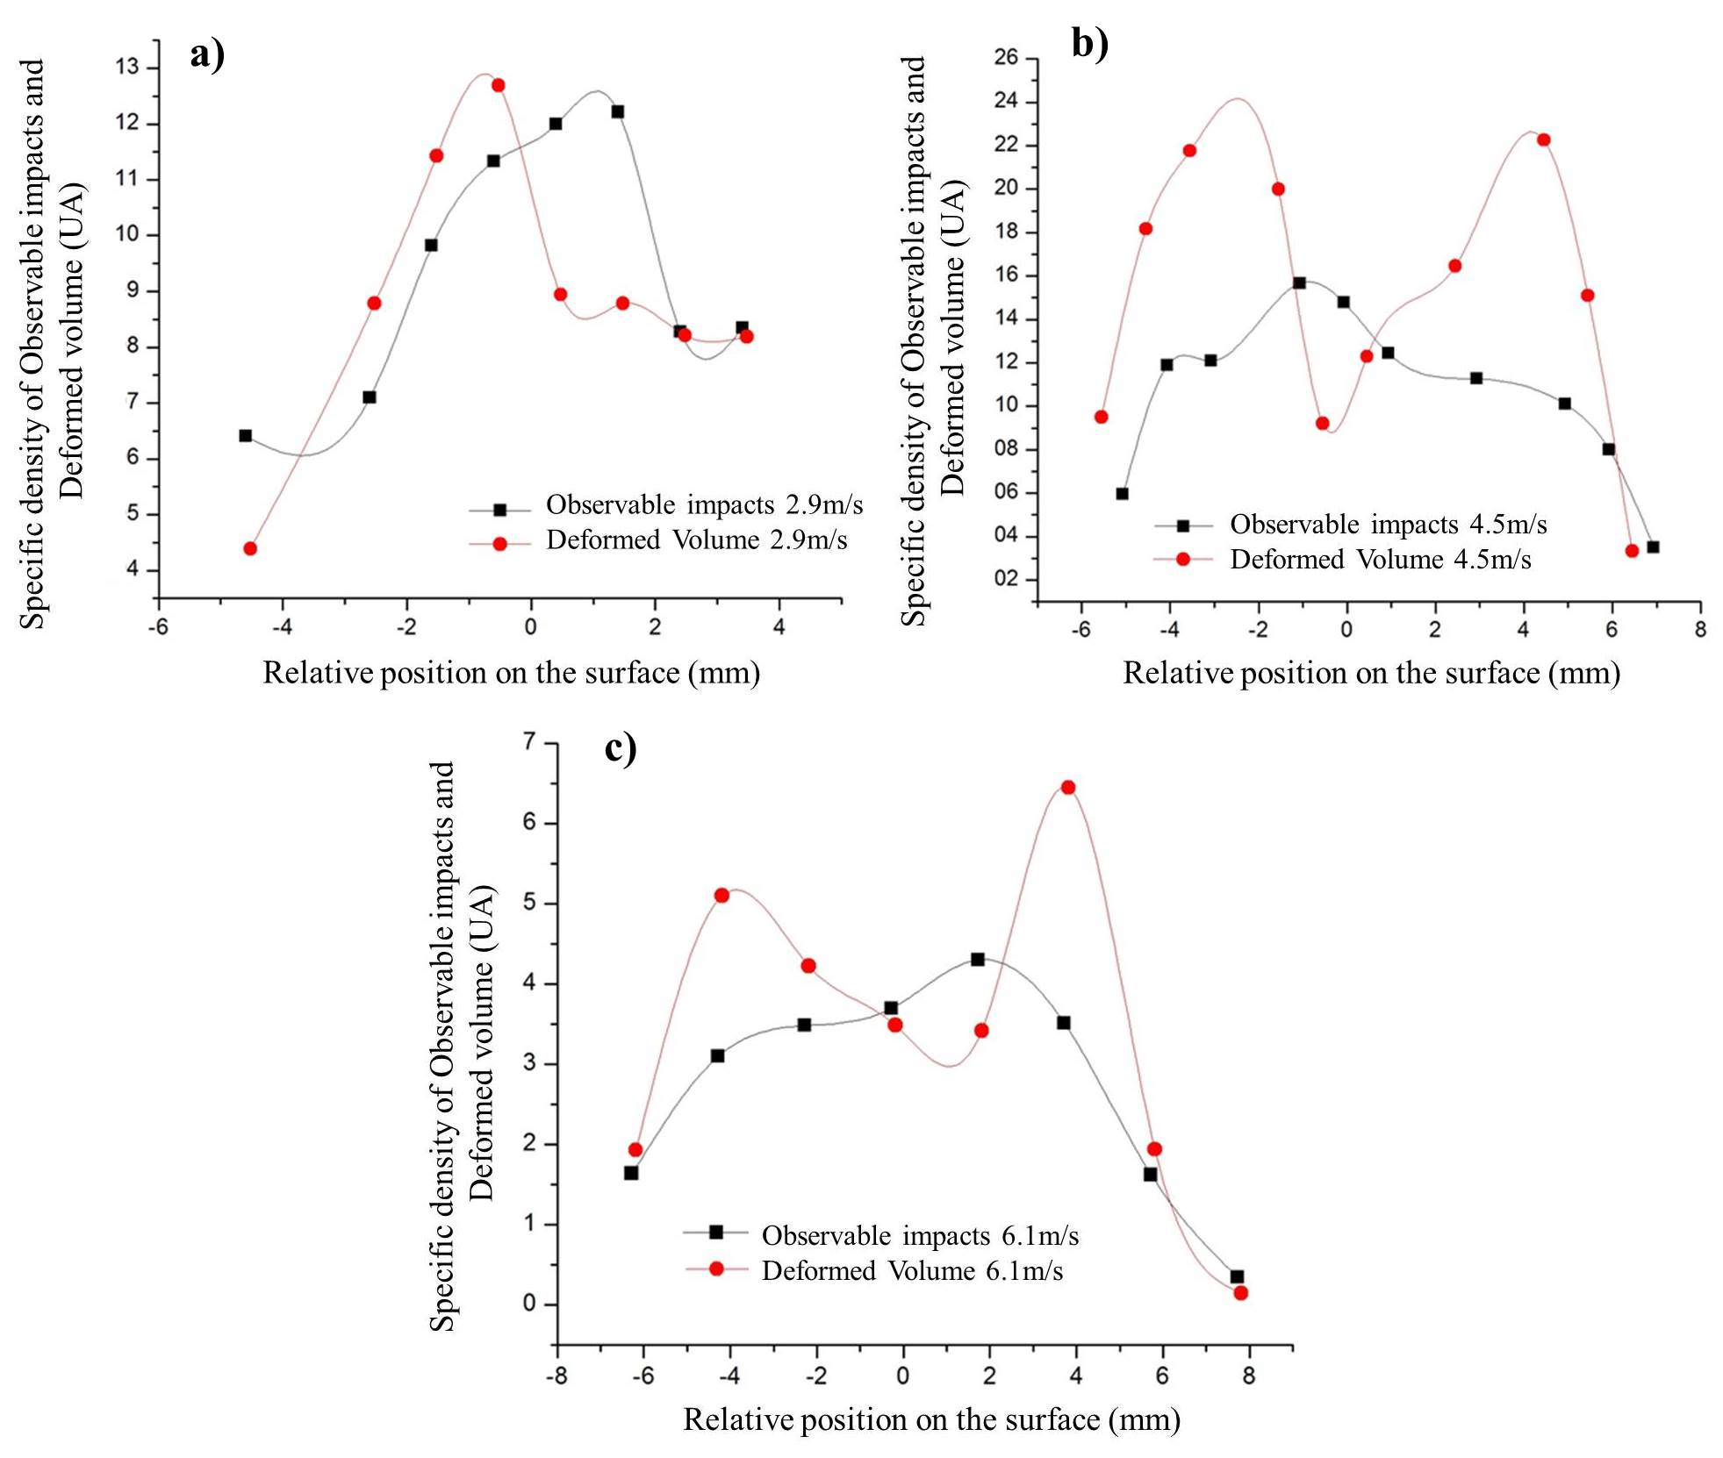
FIG. 6. Surface density of observable impacts and deformed volume profiles for the specimens tested at 2.9, 4.5, and 6.1m/s (a, b and c respectively). The density of observable impacts is always greater at the impact flow center of each specimen, but the specific deformable volume shows a camelback profile (in b and c). UA mean Arbitrary Units.

The density of observable impacts is always greater in the jet impact center of each specimen. We observe a camelback profile (in FIG. 6 b and c) for the surface density of deformed volume (wear “halo” in FIG. 3 b). This is in agreement with the available bibliography about wear of ductile surfaces [7]. It is significant that the plate tested with a jet velocity of 1m/s didn’t show observable impacts after the test.

Using formulas (1) we can obtain a relationship between the Total number of observable impacts (N_{T}) and the Total deformed volume (V_{T}).
FIG. 7 shows the V_{T}/N_{T} ratio in function of the impact flow velocity for all the analyzed specimens.

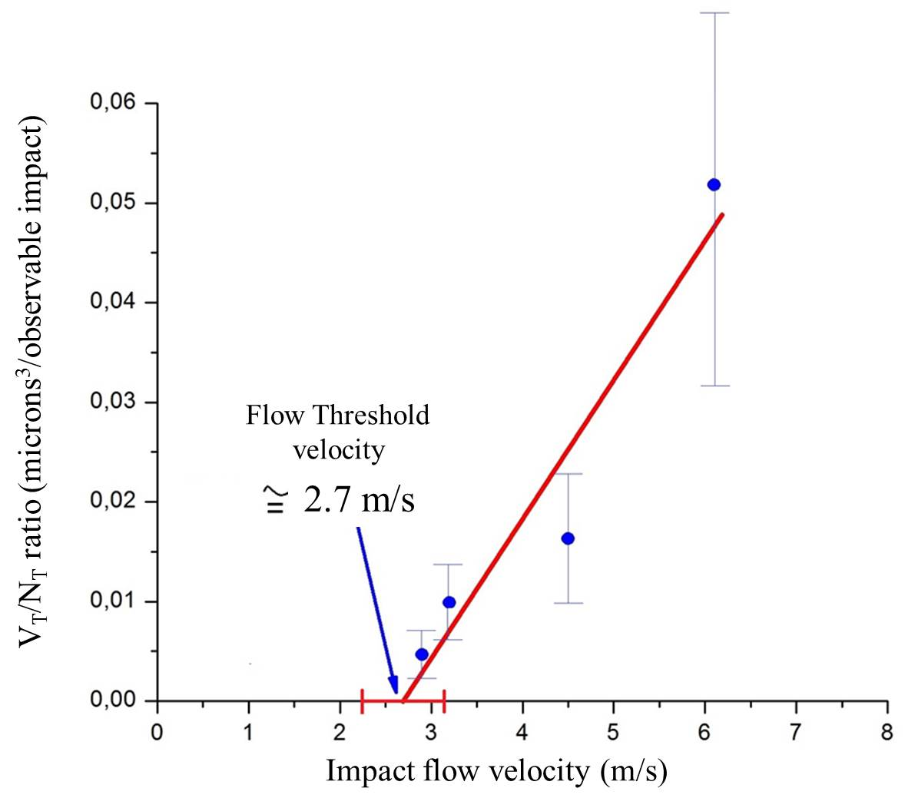
FIG. 7. V_{T} /N_{T} ratio in function of the impact flow velocity. We observed a linear relationship with an impact threshold velocity of 2.7±0.5m/s.

The V_{T}/N_{T} ratio can be thought of as the average deformed volume produced by an average microsphere particle. Given a material and a microsphere size distribution, this effect is only a function of the flow velocity.
We observe a linear relationship with an impact threshold velocity of 2.7±0.5m/s. This result is in agreement with the specimen tested at 1m/s, where we didn’t observe impacts on the surface.

3.2. Neutronic Characterization

FIG. 8 shows the a) k_{inf} in function of the Boron concentration for 25, 50, 250 and 500microns microspheres, b) a detail of the 1200ppm Boron concentration region.

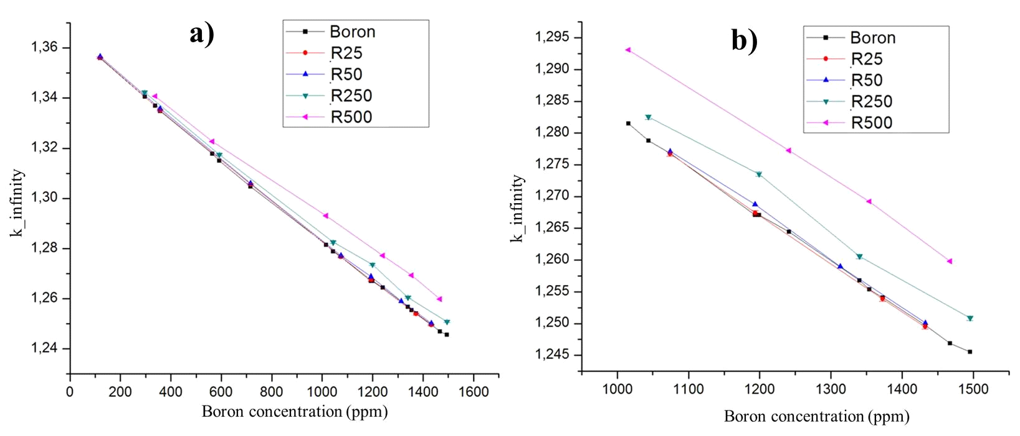
FIG. 8. k_{inf} as a function of the Boron concentration for 25, 50, 250 and 500microns microspheres, b) a detail of the 1200ppm Boron concentration region.

We observe that the k_{inf} curves for 250microns and larger glass microspheres are always above the Boron curve.

FIG. 9 shows the reactivity difference in function of the Boron concentration between the boric acid cell and the corresponding glass microspheres cells.

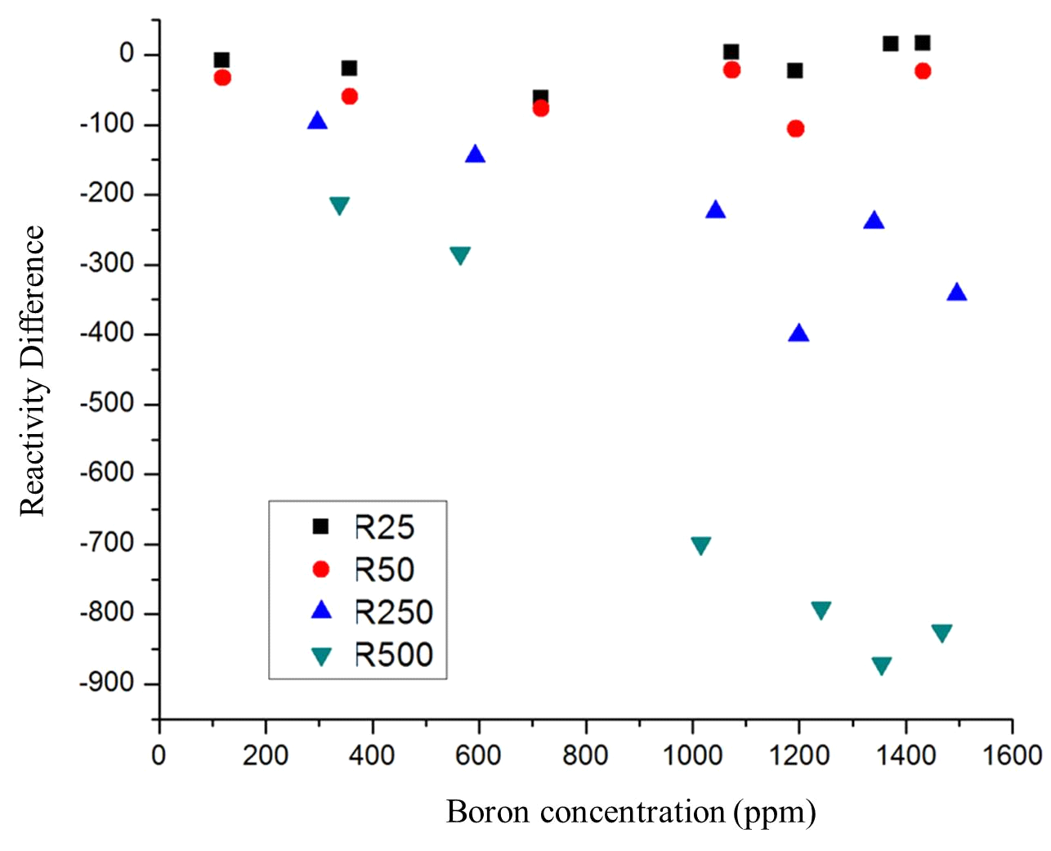
FIG. 9. Reactivity difference in function of the Boron concentration between the boric acid cell and the corresponding glass microspheres cells.

From the reactivity difference we observe that the effectiveness of glass microspheres decrease with the particle size, namely on Boron concentration around the 1200ppm. This reduction on effectiveness is related to the loss of homogeneity in systems with bigger microsphere sizes and the increase in the increase in the self-shielding factor in the absorbing material.

4. Final Remarks - Conclusions

We make a basic mechanical and neutronic evaluation of our proposal: the use of glass microspheres as neutron absorbing material for Water Cooled Reactors Second Shutdown Systems.
After performing a wear test we obtained a threshold flow velocity of 2.7±0.5m/s, under which the glass microspheres didn't produce observable impacts on a polished 304L Stainless Steel surface. This result shows that for a given microsphere size distribution it is possible to find a range of velocities within which the metallic surfaces are not damaged. That means safety operation conditions where we can incorporate the microspheres to the reactor core without compromising the reactor integrity.
Neutronic calculations showed that a homogeneous dispersion of glass microspheres of radii under 50 microns behaved with similar neutronic effectiveness as water solution of boric acid. The reactivity difference calculations showed that the effectiveness is very sensible to the microspheres size.
Using these results we can conclude that it exits a given size distribution and a specific flow velocity range for alumino-borosilicate glass microsphere, where we can use them as neutron absorbing material with the same effectiveness as the Boron acid dilution and without safety risks over the reactor systems.

6. References

- INTERNATIONAL ATOMIC ENERGY AGENCY, Safety Series of Research Reactors, IAEA Safety Standards Series No. NS-R-4, Vienna (2005).
- CACUCI, D., “Handbook of Nuclear Engineering”, Karlsruher Institute for Nuclear Technology and Reactor Safety (KIT), Ed. Springer (2010).
- AUDERO, L et al., “Immobilization of Simulated High-level Waste in Sintered Glass”, Journal of Nuclear Materials, N°223, page 151-156, CNEA, Bariloche (1995).
- BORTOT, M.B. et al, “Production and Characterization of Glass Microspheres for Hepatic Cancer Treatment”, Procedia Materials Science N°1, page 351-358, CNEA, Bariloche (2012).
- GANA WATKINS, I., “Estudio de microesferas como absorbentes neutrónicos”, - Proyecto Integrador de Ingeniería Nuclear, Instituto Balseiro - Universidad Nacional de Cuyo, San Carlos de Bariloche (2010).
- GANA WATKINS, I. et al, “Mechanical Properties of Glass Microspheres”. Procedia Material Science, International Congress of Science and Technology of Metallurgy and Materials SAM - CONAMET (2013), Elsevier (2014) to be published.
- BYEONG-EUN, L., et al “Computational Study of Solid Particle erosion rate for a single tube un cross flow”, Elsevier/Wear 240, page 95-99 , (2000).
- SANFILIPO, M., “Apuntes de Laboratorio de Metalografía”, Departamento Materiales Nucleares, Centro Atómico Bariloche, CNEA (2012).
- LEPPANEN, J., PSG2/SERPENT a continuous energy Monte Carlo Reactor Physics Burnup Calculation Code, User Manual (2011).

