JULES HOROWITZ REACTOR OPERATION IN MOCK-UP MODES

J. Estrade, JY. Malo, C. Blandin

French Alternative Energies and Atomic Energy Commission - Nuclear Energy Directorate
Cadarache Research Centre - France

Corresponding author: jerome.estrade@cea.fr

Abstract. The Jules Horowitz Reactor (JHR) is a new modern Material Testing Reactor (MTR) currently under construction at CEA Cadarache research centre in the south of France. It will be a major research facility in support to the development and the qualification of materials and fuels under irradiation with sizes and environment conditions relevant for nuclear power plants in order to optimise and demonstrate safe operations of existing power reactors as well as to support future reactors design. It will also represent an important research infrastructure for scientific studies dealing with material and fuel behaviour under irradiation. The JHR will as well contribute to secure the production of radioisotope for medical application. This is a key public health stake.

The construction of JHR is going-on with a foreseen operation by the end of this decade. Once in operation, the reactor will provide modern experimental capacity in support to R&D programs for the nuclear energy for the next 50 years.

This reactor will be currently used at nominal full power (70 to 100 MWth depending of experimental programs). As other MTR’s, it could also operate under low-power, so called mock-up mode (up to 2.4 MWth), cooled by natural or low forced convection. In these states, the reactor would be dedicated to dosimetry programs, education and training, physics experiments and neutron and gamma heating measurements in the different in-pile locations
This paper gives the description of this mock-up mode of JHR: the flexibility, the capability and the access to the core and the reflector experimental locations.

1. Introduction

This paper focusses on the description of the mock-up modes of the Jules Horowitz (JHR) Material Testing Reactor (MTR) and presents the main related experimental programs.

The JHR facility (see FIG. 1.) has been designed to provide modern experimental capacity to support R&D programs for the next 50 years [1] and [2]. Intense neutron fluxes can be produced thanks to a “double-peak neutron spectrum” i.e high thermal neutron flux (applications for research carried out in current Gen II/III reactors) and high fast neutron flux (applications for 4th generation fast reactor). The JHR will also be one of the main radioisotope supplier for medical purposes, ensuring 25 to 50% of Europe’s requirements. It will be operated by the CEA within Cadarache Research Centre, as an international user’s facility.

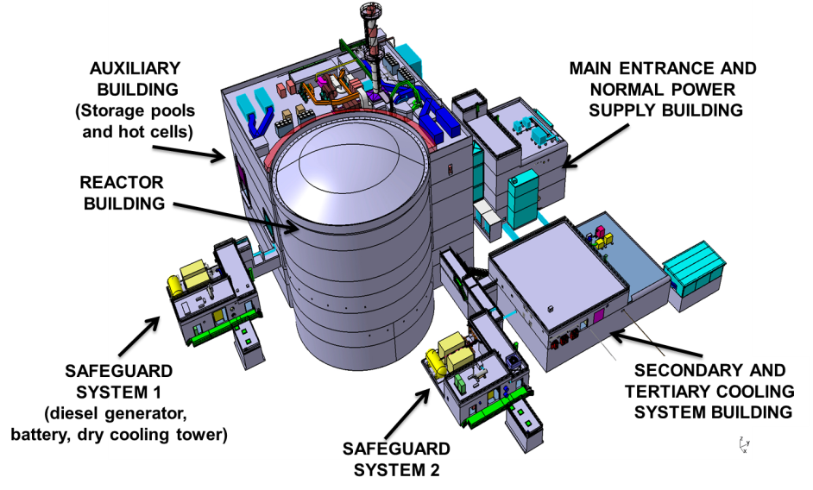
FIG. 1. The JHR Facility

The construction started in 2007 and by the end of 2013, about 80% of the nuclear unit erection (Reactor and Auxiliaries Buildings) was completed (see FIG. 2.). The JHR reactor would be in operation by the end of this decade.

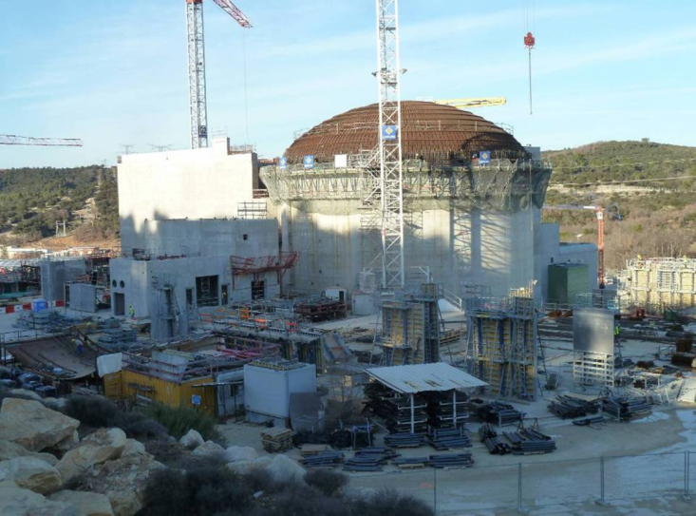
FIG. 2. The JHR Building Progress as of April 2014

The JHR is a pool-type reactor designed to operate at a maximum power of 100 MW. It provides a large experimental capability inside and outside the reactor core. Due to the high power density, the core primary circuit is slightly pressurized.
Several systems and equipment are implemented in the reactor building (see FIG 3.) to support the experimental programs, such as:
- 7 hot cells, to prepare and examine experimental samples before and after irradiation. It will be possible to proceed to the first simple post irradiation examinations (PIE),
- non-destructive examination benches (gamma spectrometry, X tomography, neutron imaging system), installed in the reactor pool, in the storage pool, and in the hot cells,
- specific laboratories (fission product lab, chemistry lab and dosimetry lab).
FIG. 3. Views of the JHR facility and the reactor core

2. The JHR core, a large hosting capacity [3]

The core (600 mm fuel active height) will be started up using an U3Si2 fuel with an uranium enrichment of 19.75%. The fuel assembly is circular in shape (set of curved plates assembled with stiffeners) and comprises a central hole that can be used as an experimental location. The core area is surrounded by a reflector which enhances the core reactivity, then the core cycle duration. The reflector area is made of water and beryllium components and also includes numerous experimental locations.
Thus, test devices can be placed either in:
- the core area (in a fuel assembly central hole or in place of a fuel assembly), to address typical material issues with high disrupted fast neutron flux (with energy higher than 1 MeV) up to 5.5 10¹⁴ n.cm⁻².s⁻¹ and material ageing up to 16 dpa/y (under 100 MW),
- the reflector area (in fixed locations, but also on displacement systems as an effective way to investigate transients occurring in incident or accident situations), to address typical fuel issues with disrupted thermal neutron flux (lower than 0.625 eV) up to 5.10¹⁴ n.cm⁻².s⁻¹ and 600W.cm⁻¹(on 1% 235U enriched fuel for simple fuel experiments).
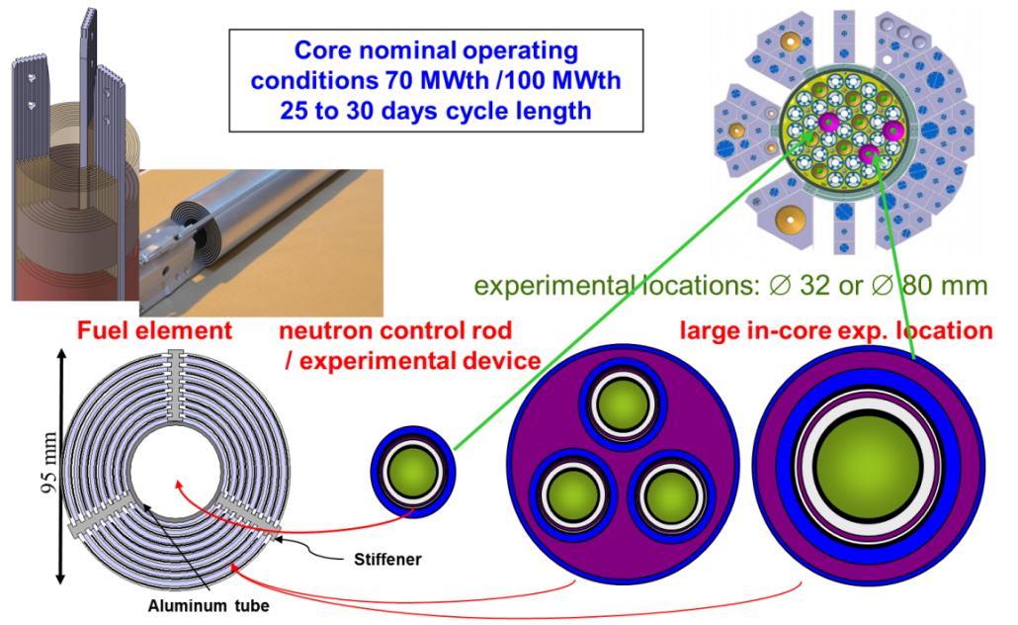
FIG. 4. The JHR Core.

The JHR will therefore be able to carry out around twenty experiments at the same time (~ 10 in the core and ~ 10 in the reflector).

3. Operation highlights

The JHR has been designed to operate for around 250 effective full power days per year, with cycles lasting around 25 days. The targeted number of cycles per year is 10. Between cycles, shutdown periods lasting around 6 days will be used to reload the core with fuel, carry out light maintenance and handling operations required for the experiments.
More consequential maintenance operations will be carried out during specific longer shutdowns.

As the JHR does not comprise an associated reactor neutron mock-up, such as ISIS for OSIRIS reactor (CEA/Saclay), periodic reactor operations under mock-up modes will be used to perform specific measurements or physics experiments.

Regarding the experimental capability, experiments (or measurement devices) can be loaded or unloaded in the reflector, with the reactor still in operation, whatever the reactor state, without changing the rector power. This means that nuclear measurements mapping in the reflector area can be performed during normal reactor operation. On the contrary, loading or unloading of experiments (or measurement devices) located in the core area require a reactor shutdown.

4. Mock-up operation modes

The JHR has been designed to operate in various low-power modes, with the possibility of selecting the most suitable reactor vessel configuration, reactor power and coolant convection conditions.

The normal JHR operation states are defined as follows:
HP
(< 100 % Nominal Power)

 |  |  |  | BP-CF  (< 2 MW) |  |  | HP  (< 100 % Nominal Power)
CRITICAL REACTOR STATE (maximum power available) | BP-CN  (< 300 kW)
NON CRITICAL reactor state | AO-CN |  | AO-CF |  |  | AF
Pumping regime | NATURAL CONVECTION OR VERY LOW FORCED CONVECTION |  | LOW FORCED CONVECTION |  |  | NOMINAL FORCED CONVECTION
Reactor Vessel configuration | OPEN Reactor Vessel (Direct access to the core, no upper internals) OR CLOSED |  |  |  |  | CLOSED (Access only to experimental locations)
FIG. 5. Main Reactor Operation states.

At the nominal HP state, up to 100 MW using the three primary pumps with high velocity, the JHR will operate with a closed and pressurized reactor vessel (see FIG. 6.). The high irradiation performance related to neutron fluxes expected in the experimental locations, will be reached in this state.

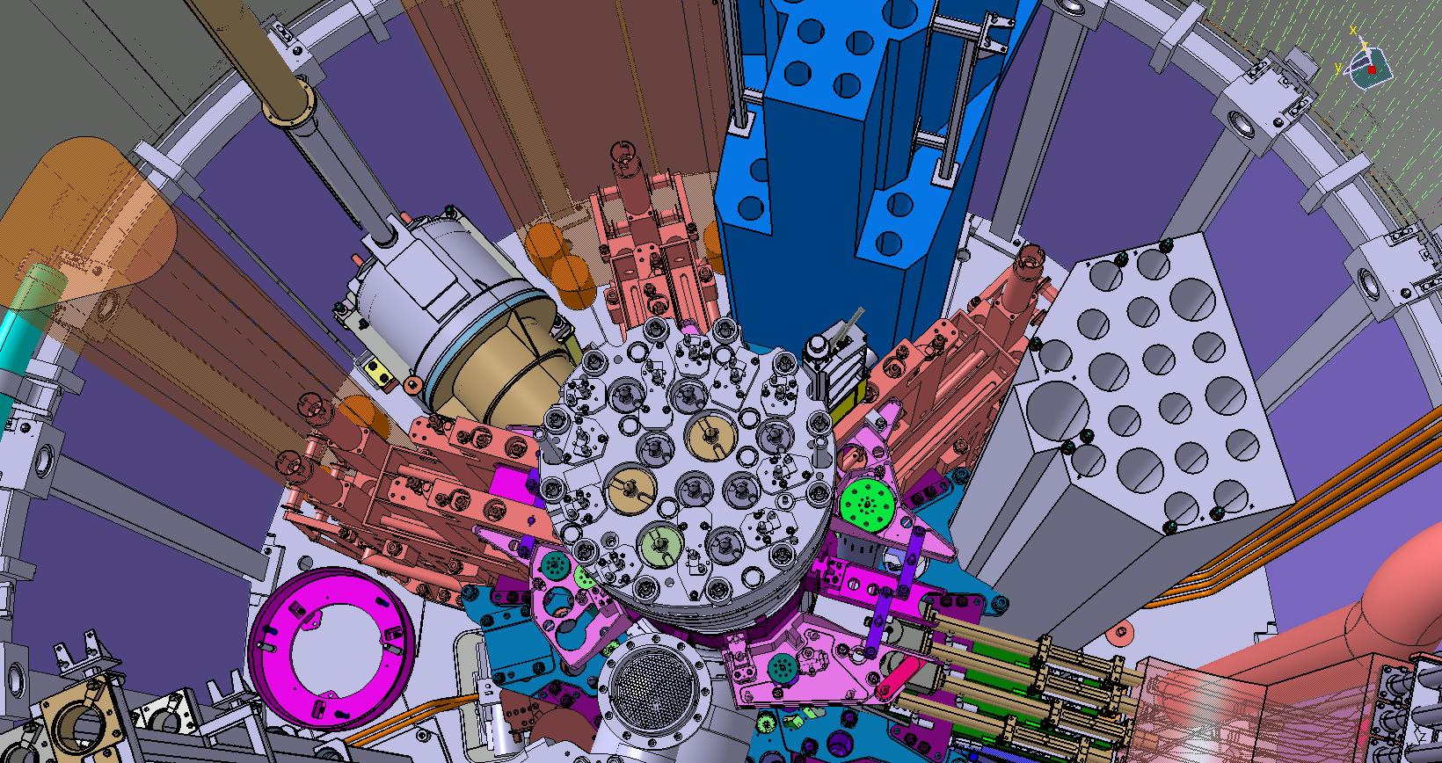
FIG. 6. Nominal reactor vessel configuration (closed and pressurized reactor vessel)

The reactor will also be operated under two low-power states:
- BP-CF, up to 2 MW, the JHR being cooled by low forced convection provided by two primary pumps with low velocity,
- BP-CN, up to 300 kW, the reactor being cooled by natural convection or, if needed, by very low forced convection provided by one primary pump with low velocity.

The main objective of the BP-CF state is to provide a power high enough with complete access to the core, in order to locate any failed fuel assembly. This state can also be used for neutron and nuclear heating studies, as it is discussed hereafter.

The BP-CN state corresponds to the reactor neutron mock-up. It will be used to perform fine in-core measurements. That corresponds to an essential need in MTR, in order to:
- Assess the core performance, during the commissioning phase and then, during reactor operation, as a function of cycles and core configurations. The objective is to characterize some key parameters under representative JHR operation conditions and real geometry or to test new core configurations, new fuel assemblies or irradiation experiments,
- Support fuel or material experimental programs, by characterizing the key irradiation parameters in experimental locations (inside the test device or not). This data is required to design the test devices (e.g. the nuclear heating can be a key design parameter, in particular for material hosting devices) and to prepare the irradiation program (e. g. identification of the best locations according to the core loading, checking before in-pile implementation, data to improve the interpretation of the experiments, …).

4.1. Reactor vessel flexibility

As the two low-power states do not require any pressurization, the reactor can operate with an open or closed reactor vessel, according to the needs.

Operating the reactor using an open reactor vessel provides direct access to the core, as shown on FIG. 7.

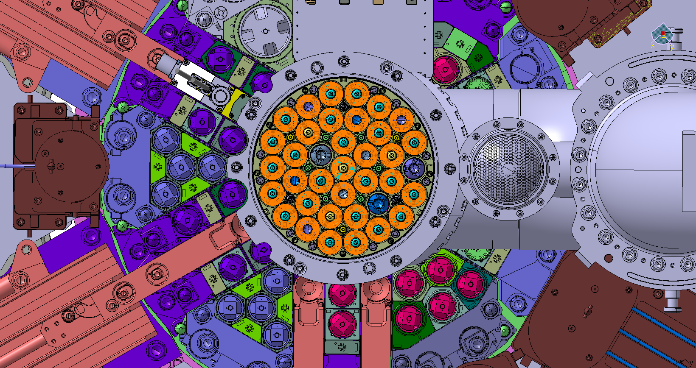
FIG. 7. Open reactor vessel view, with direct access to the core
In this configuration, the reactor vessel top and all upper internals (including experiment guide tubes in experimental locations across the core) are removed. The main assets of the open reactor vessel configuration are as follows:
- Complete access to the core, in additional locations than those of the experiments,
- Simpler core component configurations (no guide tube across the core), to minimize the flux disruption, which can be usefull to reduce the uncertainties for calculation-to-experiment comparisons,
- Use of short measurement devices (< 1 m, to compare with around 5 m with closed vessel configuration), to obtain a better accuracy in the axial position for instance.

The nominal closed vessel configuration, with upper internals implemented, provides the main following advantages:
- Exact geometry representativity of the experimental locations under nominal reactor conditions (HP state),
- Physical protection of the fuel assembly, the core access being limited to experimental locations only.

4.2. Experimental programs capability

The main experimental program that can be performed in low-power states will be to provide fine in-core measurements, to support fuel or material experiments or to assess the core performance.

The BP CN state with open reactor vessel is fully dedicated to perform these measurements by minimizing flux disruption (no test device in the core locations), or in additional locations available in this complete core access configuration. That concerns neutron flux and nuclear heating mapping, power distributions, spectral indices, reactivity effects, the checking of the calculated loading configurations …

Regarding neutron flux and nuclear heating characterizations, some dosimetry or on-line measurement devices will be used, based on simple technologies such as fixed activation dosimeters (absolute neutron flux measurements but off-line), calorimeters (for nuclear heating), fission chambers or Self Powered Neutron Detectors (SPND) (for relative/absolute neutron flux assessment).
Some innovative and more sophisticated devices will also be used, such as CARMEN (CAlorimetry and Nuclear Emission on-line Measurement in Reactor) [5]. It is a mobile device (axially moved) that provides simultaneous on-line measurements of the relevant physical parameters, using various sensors which can be combined to reduce the uncertainties (see FIG. 8.).

FIG. 8. Example of two CARMEN integrated cells, comprising numerous nuclear detectors, for experimental locations mapping (tested in OSIRIS reactor in 2012)

The BP CN state with open reactor vessel will also be the configuration of the reactor during the first criticality. This configuration will make fine and accurate reactivity effects measurements possible.

The configuration with closed reactor vessel will be used to complete the previous “no disrupted flux” measurements, by providing fine characterizations of the irradiated conditions inside the experimental locations or test devices, exactly in the geometry under nominal reactor conditions (with the guide tube across the core).

Operation under BP CN state is demanding: the residual power should be limited in order to provide neutron fluxes high enough despite the limitation of the power, up to 300 kW. Thus, the BP CF state can be used to provide higher power (up to 2 MW) and level of neutron flux. That can be useful for on-line measurements accuracy or to limit the irradiation time of activation dosimeters measurements.
In addition, thanks to the forced convection conditions available in this state, a more representative thermal core distribution can be provided.

Furthermore, both low-power states will be used for education and training programs, in addition to existing facilities (simulator,…).

5. Final Remarks - Conclusions
The low-power modes of the JHR provide a large flexibility, with the possibility to select the most suitable reactor vessel configuration (open reactor vessel with complete access to the core, or closed vessel as under nominal reactor conditions), reactor power (up to 300 kW or 2 MW) and coolant convection conditions (natural or forced convection).
These reactor states will be used to perform accurate and fine core nuclear measurements, to support fuel and material experiments or to assess the core performance. They will also be used for education and training programs.
6. References

- International Atomic Energy Agency (IAEA), Sustaining Material Testing Capacity in France: From OSIRIS to JHR (2012)
- European Research Reactor Conference (RRFM), The Jules Horowitz Reactor: a new high performances Europeans MTR with modern experimental capacities : toward an international centre of excellence (2012)
- International Group on Research Reactors (IGORR), Fuel and Material Irradiation Hosting Systems in the Jules Horowitz Reactor (2013)
- International Group on Research Reactors (IGORR), Jules Horowitz Reactor : Organisation for the Preparation of the Commissioning Phase and Normal Operation (2013)
- Advancements in Nuclear Instrumentation Measurement Methods and their Applications (ANIMMA), Combined analysis of neutron and photon flux measurements for the Jules Horowitz Reactor core mapping (2011)

