COCONEUT: An innovative deterministic neutronic calculation tool for research reactors

J.-G. Lacombe¹, J. Koubbi¹, L. Manifacier¹

1) AREVA TA, CS 50497, 13593 Aix-en-Provence Cedex 3, France

Corresponding author: jeangael.lacombe@areva.com

AREVA TA developed a new, highly flexible, 2D exact geometry, full core neutronic calculation tool based on multigroup transport theory, purposely designed for Research Reactors (RR) for early stages of core conception, named COCONEUT (COre COnception NEUtronic Tool). Using the deterministic code APOLLO2 (CEA, French Atomic Energy Commission) and its pre-processing user interface SILENE, one can easily model a wide range of RRs, provided they are based on rectangular fuel assemblies with MTR-type planar fuel plates (for the moment). Any type of irradiation device, reactivity control system (single or multiple) or reflector can also be modelled. It is designed to compute any kind of core layout in its exact geometry, using the Method Of Characteristics (MOC) solver of APOLLO2. It benefits from most outcomes of the use of the deterministic calculation scheme HORUS-3DN achieved within the frame work of the JHR (Jules Horowitz Reactor) program.

In addition to providing k-eff and flux values anywhere, this tool also handles rise to equilibrium for the core, given one or several user-provided shuffling strategies (which can be modified during the rise to equilibrium). Despite its 2D characteristics, results are satisfying and benchmarks with AREVA designed RR cores such as FRG1 (Germany) or HOR (Netherlands) show discrepancies with historical calculations on fuel assemblies burnup less than 1.4% (these safety calculations which we compare with being themselves formally validated during the long-term operation of these cores).

This neutronic core analysis tool is very useful and reliable for preliminary safety assessments and results in a considerable time gain, full core equilibrium being achieved within two days of CPU time only.

This paper presents:
- The issue to address: Monte-Carlo codes are useful for flux calculations but don’t match deterministic approaches when it comes to rise to equilibrium,
- The synergies with the other calculation schemes: such a tool is ideally used along with a full-3D Monte-Carlo code for accurate performance calculation,
- The results achieved: very promising for design purposes,
- Further developments for this calculation scheme which now focus on its next generation 3D deterministic sibling.

1. Introduction

In the early stages of core conception many different core configurations have to be tested: several types of fuel elements and control assemblies can be studied, as well as various core layouts and refuelling strategies [1].
It is usually impossible to carry out a detailed study for each core configuration (set of assemblies, core layout, cycle length and refuelling strategy). Hence, AREVA TA has developed a neutronic calculation tool that emphases flexibility and swiftness, named COCONEUT.
It is based on the deterministic lattice code APOLLO2 [2] and its pre-processing user interface SILENE [3]. Both tools are developed and maintained by the CEA.
APOLLO2 has successfully been used in the field of RRs in the past ([4], [5]) as well as in the field of other light water reactors. However, calculation schemes based on APOLLO2 are usually dedicated to one particular core. The goal of this tool developed by AREVA TA is to be more generic.

This scheme has to determine any RR core equilibrium state within 48 hours of CPU-time and provides data such as reactivity variations, output burnup, burnup swing, and core material balance.
Determining the most adapted set of assemblies, core layout, cycle length and refuelling strategy is a required step before carrying out more detailed calculations; which can be achieved swiftly and easily with this scheme.
The present document details the models on which the scheme is based and presents a benchmark for one of the verification cases performed: namely the FRG1 core [6], [7]. The set of tools that ensures sufficient flexibility when calculating large numbers of different core configurations in a short period of time is also introduced.
This document is established in the framework of an AREVA TA and CEA/Direction of Nuclear Energy collaboration.

2. Core Modeling

The COCONEUT calculation scheme is based on the deterministic code APOLLO2 [2]. It is based on a full core 2D model that uses the MOC solver [8], [9]. The use of MOC solver enables one to compute the core’s exact geometry which is a strong asset in the field of RR where rectangular MTR-type assemblies are mixed with any kind of geometry for the in-core facilities (e.g. cylindrical experimental targets, non regular shaped absorbers, etc.) on a regular basis. The global architecture of the scheme is presented in FIG 1.

FIG 1 : Schematic description of the COCONEUT calculation scheme – This is a 2D exact geometry, full core neutronic calculation tool based on multigroup transport theory, purposely designed for RR for early stages of core conception. The COCONEUT calculation scheme is based on the deterministic code APOLLO2 [2] and uses its MOC solver. A special output permits to link COCONEUT with a 3D Monte Carlo code, namely MCNP [10], in order to determine accurate flux performances and safety parameter.

The nuclear database currently used is based on JEF2.2 evaluation and has 172 energy groups. It should soon be upgraded to JEFF3.1.1 with 281 energy groups [11]. When modelling a RR, a specific fuel media is declared for each fuel plate in the core that depletes on its own. Each fuel plate contains several cells for flux calculation (in order to take into account the high flux gradient in the fuel plates and in the water channels).

COCONEUT being a full core 2D model, it is not possible to model absorbers movements during the burnup cycles. Moreover, in a nuclear core, most of the power is produced below the absorbers’ position and a 2D calculation needs to reproduce this in order to accurately predict the burnup map at the end of the cycle. Former tests performed by AREVA TA showed End Of Cycle (EOC) burnup maps are best reproduced by modelling the core with its absorbers completely withdrawn.

2.1. Rise to equilibrium

In COCONEUT, rise to equilibrium starts from a fresh batch core. Successive depletion cycles of the core are performed. Between each cycle, a null power cool down phase is applied in order to simulate the reloading period of the core. Its duration is an input data and can be adjusted by the user. All isotopic balances are calculated during the cool down although its main effect is the decay of neutronic poisons.

After each cool down period, the shuffling strategy is applied according to the input data from the user. Fuel and control assemblies can either be displaced or replaced by fresh ones. The successive shuffling strategies may be periodic or different for each cycle as the user sees fit.

The depletion calculations are based on the variation of extracted energy in MW.days/t_{U}. This method means that the cycle length in EFPD (Equivalent Full Power Days) is converted to energy using the initial ²³⁵U mass and power of the core.

An equilibrium criterion was implemented to assess whether the core has reached equilibrium or not. This criterion describes the discrepancy between burnup maps at the end of two successive cycles. The equilibrium is stated when these EOC burnup maps are identical within a user defined tolerance:

$${\text{Eq}}_{\text{critetion}}\left(\text{cycle} N\right)=\sum_{i=1}^{\text{Nass}}{Δ\left({\text{BU}}_{i}\right)} = \sum_{i=1}^{\text{Nass}}{\left[\sqrt{\frac{1}{N_{\text{ass}}}{\left({\text{BU}}_{i,N}−{\text{BU}}_{i,N−1}\right)}^{2}}\right]}\frac{1}{{\text{BU}}_{\text{eff},N}}$$

Due to controllability considerations, a RR does not usually start its rise to equilibrium phase from a full fresh core. However, when using periodic shuffling strategies, it appears one reaches the same equilibrium state whether the rise starts form a fresh core or not.
The choice to start from a full fresh batch core is a convenient numerical method that does not impact the equilibrium state for periodic shuffling strategies. This method does not work however for transition cores (for instance: HEU/LEU conversion).

2.2. Self-shielding

Self shielding in COCONEUT is carried out during the first calculation step using the 172 energy groups mesh [12]. The geometry for self shielding is a one-dimensional transversal description of the core as shown on FIG 2 (red arrow). The main difficulty is to choose the more representative position for the transversal description of the core.

Shielded cross sections for the full fresh core are then condensed on the 37 energy groups mesh used for 2D flux calculations. Those cross sections are also applied to the fresh assemblies that will be loaded in the future depletion cycles. The 37 energy groups mesh is one of the standards in the field of RRs [4], [5].

FIG 2: Example of 1D transversal description of a core for self shielding (HOR core) during the first calculation step using the 172 energy groups mesh. The main difficulty is to choose the more representative position for the transversal description of the core.

Calculating self shielding only at step 0 is a strong hypothesis but interesting for CPU-time considerations. However, assembly calculations using a periodic self shielding (such as every 5GW.days/t_{U}) showed little impact on reactivity and isotopic balance mainly due to the low fuel temperature usually found in open pool water research reactors (unlike PWRs or JHR). These impacts are considered acceptable for the early phase of conception.

In addition periodic self shielding models applied to full core calculations could not fill the CPU-time criterion for the rise to equilibrium (48 hours max). Detailed studies will imply periodic self shielding re-calculations.

3. COCONEUT: a tool for engineers

COCONEUT is composed of different modules which are articulated in order to form a complete package for neutronic design of the RR. The core of this scheme is the calculation code APOLLO2, but around it, there are a pre and post-processing GUI, a package of procedures, a refuelling algorithm, etc.
These different components of the COCONEUT scheme are presented in the following paragraphs and cover:
- Pre-processing for mesh generation,
- Pre-processing for refuelling patterns creation,
- Post-processing for results edition.

3.1. Mesh generation with SILENE: the use of a mesh database

SILENE is a pre and post-processing tool used to model geometry and to produce various geometric meshes easily and swiftly. This tool developed by CEA [3] is a very strong asset in our scheme.

Specifically for our application, SILENE is used first for the automatic generation of any MOC geometry file from a component database (“.tdt” format for APOLLO2).
SILENE’s component database is a tool that recursively assembles mesh blocks together in order to produce a larger mesh.
Each basic block can be declared directly in the component database for regular parts of the mesh. If the mesh is more complex, SILENE allows to create manually a special part of the global mesh (experimental devices for instance). These specific meshes are saved in files and called in the database.

All mesh blocks are saved and can be called in another mesh if required. It is then possible to create a new mesh with blocks already created. This functionality is very interesting especially for early stages of core conception.

Practically, a full core mesh (from 25000 to 50000 cells) can be produced with a few hundred lines in the component database. An example is shown on FIG 3.

The 1D geometry for self shielding is automatically computed from the full core mesh by a dedicated script.

Another strong asset of SILENE is it handles media instantiation (this functionality is called “mutant”) which prevents the user from creating hundreds of fuel media in the dataset. The various fuel media are automatically declared as separate media with the adequate isotopic balance when the mesh file is created.

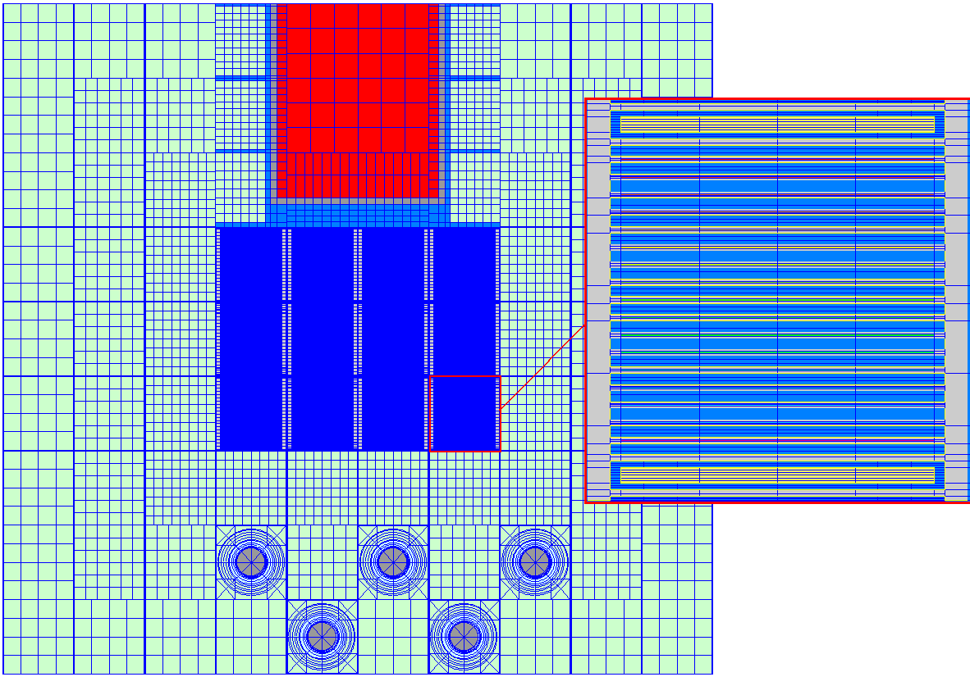
FIG 3: Example of a core mesh with SILENE (FRG1 core). This core is created throughout a component database that recursively assembles mesh blocks together in order to produce a larger mesh. All mesh blocks are saved and can be called in another mesh if required. It is then possible to create a new mesh with blocks already created. As it shown on this example, the core can be meshed in an irregular way (rectilinear grid).

3.2. Automated reloading patterns for dataset input

Displacement and replacement of assemblies between cycles is performed in COCONEUT by switching media positions in the geometry. Given the number of different media in the core (several hundreds) and the potential number of different patterns, such an operation may not be feasible manually. In order to apply shuffling patterns easily, a dedicated program has been developed that enables to create any number of shuffling patterns within a single command line.
The displacements and replacements are set using “(X,Y) coordinates” for each assembly. After that, the program controls the patterns’ conformity, with the geometry file, and produces a subroutine containing all necessary informations for APOLLO2. The COCONEUT dataset then simply calls this subroutine. This was made in order to limit error in the shuffling patterns. An illustration of the shuffling methodology is given in the FIG 4.

The refueling algorithm included in the APOLLO2 calculation scheme also keeps track of all assemblies in the core (cycle of entry, position of entry, current position) so that they can be differentiated at all times.

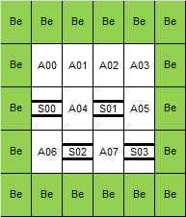 | 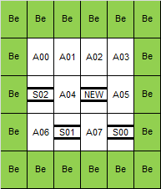
Cycle 1 | Cycle 2
FIG 4: Example of the refueling strategy for control elements in FRG1. In this case, the displacement and replacement sequence, between Cycle 1 and Cycle 2, is the following: NEW ➔ S01, S01 ➔ S02, S02 ➔ S00, S00 ➔ S03, S03 ➔ OUT. This strategy, defined by the user, can be different for each cycle.

3.3. Post-processing for core dimensioning

The main purpose of the COCONEUT is to carry out early stages of core conception with maximum flexibility. This implies:
- to swiftly define the nature of fuel and control elements,
- to test various core layouts,
- to optimize cycle length according to the shuffling patterns (periodicity and reloaded fraction per cycle) defined.

To do so, it is necessary to test large numbers of core configurations in a short period of time, and select a few of them for more detailed studies. Then, the interest parameters usually are:
- output burnup (at plate or assembly level) and average core burnup,
- BU swing,
- maximum flux values in specific parts of the core and its layout,
- fuel consumption per cycle,
- k-eff BOC (Beginning Of Cycle) and EOC at equilibrium.

Fluxes in any point of the core can be obtained using SILENE (see FIG 5). COCONEUT has a special output to edit fluxes in SILENE format. Burnup and k-eff data are edited using a dedicated post-processing. COCONEUT also edits the material balance of the core at any point of the cycle. The isotopic balance for each plate can be edited separately.
A 2D model cannot accurately determine the exact reactivity of the core, although some reactivity variations can be assessed (e.g. reactivity impact of cycle length, uranium density, shuffling patterns, etc.) by this way.

In order to obtain this information, a specific output was developed to link COCONEUT with MCNP to perform 3D calculations. Reactivity worth of absorbers is computed through 3D MCNP calculations using the material balance of core at equilibrium.

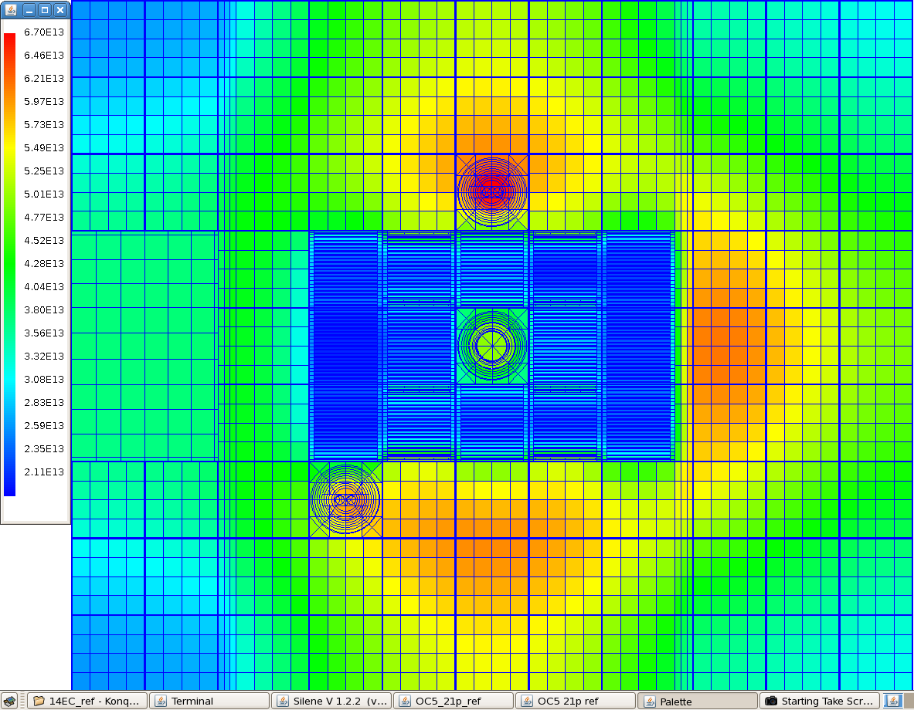
FIG 5: Example of thermal flux (n/cm²/s) post-processing with SILENE (E<0.625 eV). COCONEUT has a special output to edit fluxes in SILENE format. This post-processing is very valuable for spectral distribution analysis and for power peak factor research.

This also leads to difficulties when assessing the EOC reactivity for the equilibrium core. This can be done with 3D MCNP calculations or directly with the 2D model if reactivity biases are well known.
Such biases are mostly core dependant and cover:
- core composition which is axially homogenous,
- radial leaks due to neutron guides,
- experimental load.

Having knowledge of those biases enables one to determine which k-eff value (at equilibrium, EOC) must be reached in the 2D calculations to stand for critical state for the actual core. 3D MCNP calculations are used to determine more accurately fluxes in the cells of interest.

4. Benchmark

The COCONEUT purpose is to test large numbers of core configurations in a short period of time, and select a few of them for more detailed studies. This is only possible if results produced by COCONEUT are accurate and reliable, although tolerance on discrepancies is obviously higher than for a calculation tool dedicated to safety studies.

Various test cases were selected (HOR [13], FRG1 [6], [7], AIEA MTR benchmarks [14]) to evaluate the precision of the scheme. Results presented in this section are related to the FRG1 core. The reference values were extracted in the FRG1 safety report [6], [7]. HOR yields as promising results as FRG1.

FRG1 is a compact core operating at 5MW (8 fuel assemblies and 4 control assemblies). Assemblies dimensions are 8.1x7.71 cm with 60 cm active height (see FIG 6). Fuel meat is 4.8g/cm³ of uranium at 19.75% ²³⁵U. Fuel elements have 23 fuel plates. Control elements have 17 fuel plates and Hafnium forks (2 blades per fork).

FRG1 Standard Fuel Assembly | FRG1 Control Assembly with its Hf blades
FIG 6: FRG1 fuel (left) and control (right) elements [6], [7]. Assemblies’ dimensions are 8.1x7.71 cm with 60 cm active height. Fuel meat is 4.8g/cm3 of uranium at 19.75% 235U. Fuel elements have 23 fuel plates. Control elements have 17 fuel plates and Hafnium forks (2 blades per fork).

FRG1 core is surrounded by Beryllium (Be) reflector blocks on all sides. An empty neutron guide is modeled on the north face (in the actual core, there are several neutron guides, but each one covers only a part of the active height). 4 experimental devices are implemented on the southern face.

FRG1 ran with 70 EFPD long cycles and was reloaded by one third per cycle (2 fuel elements and a control element). Element shuffling pattern was to remove the most used elements after each cycle; other elements were moved in positions from the least used spots to the most used ones. Fresh elements were inserted in positions of the least used elements.
Materials definition also included impurities, as detailed in [6]. FRG1 safety report is based on 3D probabilistic and deterministic calculations and proved to be consistent with the actual operation of the core. Re-computing such studies with a 2D model creates deviations that we have studied.

The FRG1 model in COCONEUT sets a specific media for each fuel plate; the geometric mesh is shown in FIG 3. Fuel plates are described using a 4x3 cells mesh for flux calculations. The water gap between fuel plates contains 6x3 cells. For Be reflector, mesh is refined on the first row of Be blocks and is degraded for the second and third rows of Be blocks, with respectively 9x9, 7x7 and 5x5 cells per block. Each Be block is surrounded by a waterway.

Rise to equilibrium is computed from a full fresh core and with absorbers completely withdrawn. Equilibrium is reached after 8 cycles (120GW.days/t_{U}).

FIG 7: Rise to equilibrium performed by COCONEUT for the FRG1 core. Rise to equilibrium is computed from a full fresh core and with absorbers completely withdrawn. Equilibrium is reached after 8 cycles (120GW.days/tU).The yellow points represent each calculation step for the rise to equilibrium. The depletion calculation has taken 36 hours CPU-time.

FIG 8: BOC and EOC burnup maps (% of initial ²³⁵U mass) for the FRG1 core at equilibrium (cycle 8). Burnup maps calculated with COCONEUT are in good agreement with the values presented in [6], [7]. The maximal burnup deviation is 1.4% of ²³⁵U initial mass (6% max relative error). The BU swing is reproduced with a 0,3% absolute difference (3% relative) with FRG1 safety report.

Burnup maps calculated with COCONEUT are in good agreement with the values presented in [6], [7]. The maximal burnup deviation is 1.4% of ²³⁵U initial mass (6% max relative difference).

The BU swing is reproduced with a 3% relative difference with FRG1 safety report. This discrepancy is most probably due to the difference in the rate of non-fissile neutron capture by uranium that comes from the simple self shielding model in COCONEUT.
Other parameters, such as Xenon level at BOC and kinetic parameters were also checked with good results as shown in TABLE I.

TABLE I : Estimated error for Xenon level and kinetic parameters for COCONEUT. Xenon level and β_{eff} discrepancies are given for FRG1, discrepancy on Λ* is given for AIEA MTR benchmarks.

 | COCONEUT | Relative Error
Xe level  (BOC, Δk/k) [6] | 0.0324 | -7.4%
β_{eff} [6] | 736 pcm | -1.9%
Λ* [14] | 50.5 μs | 12.8%

These levels of error are believed to be acceptable in the early stages of core conception and are compatible with the COCONEUT purpose.

5. Conclusions

The COCONEUT is a new calculation scheme based on the deterministic code APOLLO2 [2] and its pre and post-processing user interface SILENE [3].
Its purpose is to enable engineers to have a reliable, accurate and user-friendly tool in order to test very large numbers of possible core definitions with ease and in a short period of time. Therefore, it was designed to compute equilibrium state for any planar fuel plate RR within 48 hours of CPU-time.
Moreover, the use of SILENE and other pre and post-treatment tools ensure great flexibility in calculations so that modelling any core from scratch takes minimum amount of time and efforts for the user.
Although the precision requirements are not as high as for safety studies tools, verification calculation performed show promising results. Precision for burnup maps and k-eff variations is good enough to carry out early stages of core conception:
- assembly definition,
- core layouts tests,
- optimization of cycle length and shuffling patterns.
Calculations with COCONEUT are a first step before more detailed studies but this scheme does enable engineers to focus quickly on the most promising core definitions.
The main drawback of this calculation tool comes from the 2D model of the core. A 3D sibling, based on APOLLO2 assembly calculation and 3D CRONOS2 diffusion calculations, complements it.

6. References

- M. Boyard, P. Péré, L. Chabert, L. Lamoine, T. Bonaccorsi, "Practices for Neutronic Design of RRs: Safety and Performances", International Conference on Research Reactors: Safe Management and Effective Utilization Rabat - Morocco, November 14-18, 2011
- R. Sanchez and al. “Apollo2 year 2010”, Nuclear Engineering and Technology, 42:474-499 (2010)
- Z. Stankovski, “La java de silène : A graphical user interface for 3d pre & post processing”, Joint International Conference on Mathematical Methods and Supercomputing, for Nuclear Applications, Saratoga Springs - USA, October 6-10, 1997
- O. Gueton, “The ANUBIS scheme used for safety assessment and operations management of the OSIRIS reactor”, IGORR 12th edition, Beijing - CHINA, October 28-31, 2009
- C. Döderlein and al., “The 3D neutronics scheme for the development of the Jules-Horowitz-Reactor”, International Conference on the Physics of Reactors Nuclear Power: A Sustainable Resource, Interlaken - Switzerland, September 14-19, 2008
- SIEMENS, “Abschlußbericht zur Kernoptimierung des 3x4-Kompaktkems FRG-1”, FRG1 Safety report, November 27, 1998
- P. Schreiner, W. Krull, W. Feltes, “Increasing the neutron flux at the beam tube positions of the FRG-1”, IGORR 6th edition, Taejon, KOREA, May 1998
- S. Santandrea, R. Sanchez, “Acceleration techniques for the characteristic method in unstructured meshes”, Annals of Nuclear Energy, 29:323–352 (2002)
- R. Sanchez, A. Chetaine, “A synthetic acceleration for a two-dimensional characteristic method in unstructured meshes”, Nuclear Science and Engineering, 136:122–139 (2000)
- X-5 Monte Carlo team, “MCNP – A general Monte Carlo N-particle transport code, version 5”, LA-UR-03-1987
- C. Vaglio-Gaudard, A. Santamarina, D. Bernard, R. Eschbach, “JEFF3.1.1 validation of the fuel inventory calculation for high burn-up PWR fuel (up to 85 GWd/t) with the ALIX experiment”, ICAPP 2011, Nice - FRANCE, May 2-6, 2011
- A. Santamarina, C. Collignon, C. Garat, “French Calculation Schemes for Light Water Reactor Analysis”, PHYSOR 2004, The Physics of Fuel Cycles and Advanced Nuclear Systems: Global Developments, Chicago - USA, April 25-29, 2004
- SIEMENS, “Contributions to the safety analysis report of HOR interfacultair reactor instituut - TU Delft”, KWU-NLS2/93/0013
- Research Reactor Core Conversion from the Use of Highly Enriched Uranium Fuels: Guidebook, IAEA TECDOC Series No. 233, IAEA Vienna Agency, 1980

