Experimental Study on Downward Two-Phase Flow
in Vertical Narrow Rectangular Channel

T.H. Kim, B.J. Yun, J.H. Jeong

School of Mechanical Engineering, Pusan National University
Geumjeong-gu, Busan, Korea

Corresponding author: jihwan@pusan.ac.kr

Abstract. Adiabatic vertical two-phase flow of air and water through narrow rectangular channels was investigated. The rectangular channel has a narrow gap of 2.35 mm with width 66.7 mm and is approximately 780 mm in height. The test section consists of a stainless steel body and acryl windows. This study involved the observation of flow using a high speed camera and flow regimes were determined by image processing program using a MATLAB. The flows regimes in channel with downward flow are similar to those found by previous studies with upward flow, and can be classified into bubbly, slug and churn flow. In downward flow, the transition lines for bubbly-slug and slug-churn flow shift to left in the flow regime maps with flow regimes with the superficial gas velocity as the horizontal coordinate and the superficial liquid velocity as the vertical coordinate. The flow regimes in downward flow at low liquid velocity are different from the previous studies with upward flow. Bubbly flow was different behavior even at very low liquid and gas flow velocity. Bubble size was growing very fast. And large bubbles are stay in the middle of the test section for a long time. The downward flow regime has good agreement with transition criteria developed by Hibiki and Mishima (2001) even though the flow is the opposite direction. According to the experimental results, there are two major differences between the downward flow and the upward flow in the rectangular channel. First is the cap-bubbly flow occurs at slug flow region in Hibiki and Mishima (2001) flow regime map. Second is the superficial liquid velocity ranging from 0.5 to 0.8 m/s has the bigger bubble size and the lower bubble velocity by the side of the superficial liquid velocity over 1.0 m/s. For superficial liquid velocity under 1 m/s, a new model may be needed for the criteria with the cap-bubbly flow regime for the downward flow.

1. Introduction

Two phase flow in vertical tube or channel has been extensively studied over 50 years. Most previous studies of two phase flow have predominantly consisted of upward flow in medium size circular tube. In spite of there being numerous differences between upward and downward flow, most of these studies have been concentrated on vertical upward flow and those on vertical downward flow in a channel are relatively scarce. In addition, the behavior of gas-liquid two phase flow bounded to the gap of inside the rectangular channel differ from that in a tube due to the increase of surface forces and frictional pressure drop. The sub-channel of the plate type nuclear fuel has a range of several millimeters. The downward flow in a rectangular channel is used to cool the plate type nuclear fuel in research reactor. The objective of this study is to suggest the flow regime on downward two phase flow in narrow rectangular channels.
Wilmarth and Ishii [1][2] were performed on upward two phase flow in rectangular channel with the gaps of 1 and 2 mm. They compared their data with predictions by models Mishima and Ishii [3], and concluded that a new distribution parameter was needed for the transition from bubbly to slug flow. Xu [4] was performed experimental research for adiabatic air-water upward two phase flow in rectangular channel with the gaps of 0.3, 0.6 and 1.0 mm. The flow regime in channel with the gaps of 0.6 and 1.0 mm were similar to those found in the previous studies. But, the other case was different from the previous studies. Hibiki and Mishima [5] performed measurements of flow regime, void fraction, slug bubble velocity and pressure drop in rectangular channels with the gaps of 1.0, 2.4 and 5.0 mm. They suggested the newly developed criteria in narrow rectangular channels with the gaps of 0.3 to 17 mm.
Oshinowo and Charles [6] performed experimental research in a vertical downcomer and classified the flow regimes with six categories and correlated them with different fluid properties. The transition of bubbly flow to slug flow and slug to annular flow was investigated by Martin [7] and Kulov et al. [8]. The flow regime maps for downward two phase flow using a wide range of experimental conditions are reported by Usui and Sato [9], Spedding and Nguyen [10], Barnea et al. [11] and Kendoush and Al-Khatab [12]. Also, Barnea et al. [11], Usui [13] and Goda et al. [14] proposed theoretical models for the downward two phase flow regimes transitions. The difference of the upward and downward two phase flow as a consequence of the interaction of the liquid inertia and the buoyancy force are reported [15][16].
Literature survey has shown that most of studies investigated the upward two phase flow in the round tube. There are only a few experimental studies investigating the downward two phase flow in the round tube and the upward two phase flow in the narrow rectangular channel. According to the author’s knowledge there is not any experimental study conducted for the downward two phase flow in the narrow gap rectangular channels in open literature. In view of this, new flow regime map for downward two phase flow in vertical rectangular channels with the gap of 2.35 mm have been suggested in this study. We have analyzed for basic flow regimes such as bubbly, slug, churn-turbulent, annular and large bubble flow using the image process method in the Matlab. Newly suggested flow regime map have been compared with the upward two phase flow regime criteria proposed by Hibiki and Mishima (2001).

2. Experimental Facility and Methods

2.1. Experimental Facility

The two phase flow experiment was performed by using air-water flow in the closed loop facility. Fig. 1 shows the schematic diagram of the two phase test facility and the test section. The test facility consists of a vertical rectangular test section, a pump, a pre-heater, a condenser, a cooler, a degassing system, measurement instruments, and a control and data acquisition system. The test section consisted of two bubble generators in up and down plenums and acrylic window whose total lengths is 780 mm with the gap of 2.35 mm. Air was supplied by a compressor and was introduced into a bubble generator through a porous media with the pore size of 1 μm. The air and water were mixed in the bubble generators and the mixture was injected downwards through the test section. After flowing through the test section, the air was released into the atmosphere through a separator, while the water was circulated by a centrifugal pump. The flow rates of the air and water were measured with a coriolis flowmeter and thermal mass flowmeter, respectively. The flow rate to the test section was controlled by the opening of the valve installed at the downstream of the pre-heater. The temperatures in the experimental facility were measured using T-type thermocouples. The inlet and outlet pressures of the test section were measured using pressure transmitters. The measurement uncertainties of flow rate, temperature, and pressure were 0.1% of reading, 0.3 ℃, and 0.05% of span (3.0 kPa), respectively.

Fig. 1 The schematic diagram of the two phase test facility and the test section.

2.2. Visualization and Image Analysis

The bubble images were recorded using a high speed digital video camera with a double laser sheets source. The shadow image technique is applied for obtaining both the shape and the location of individual bubbles. In the test section, a high speed camera is utilized for performing the measurement of both phases. The trigger timings of the laser and a high speed camera are synchronized using a pulse generator supported by laser generation system. The basic recording speed and image size of the camera were set to 5,000 frames per second and 1024 × 512 pixels.
RGB images were captured by the high speed cameras, but the extraction of bubble parameters required the binary images, so it’s necessary to transform the initial RGB images with noise to binary images that apply for filtering methods. In this process, many kinds of digital images processing methods were used, such as type conversion of image, noise filtering, painting algorithms and edge detection. Images are stored as a matrix in which every element is the pixel value. In RGB images, pixel color consists of three components, grayscale images only have the strength information in the images and binary images only have black and white which are referred using 0 and 1 respectively. In order to automate the image acquisition and data processing procedure, an in-house routine was developed using Matlab image processing toolbox. With this technique it was able to process a large number of bubbles and properly estimate bubble behavior.
First step of image processing is to remove noises such as backgrounds. Noises are mixed in the initial images due to being disturbed. In general, noises are removed to use filter such as linear filtering, median filter. As common kinds of linear filter, mean filter applies to filtering the grain noise in images. Median filter operates easily and can protect the boundary in images, especially it is effective for filtering the salt and pepper noise, but sometimes, thin lines and small target regions might be lost.
Second step of image processing is to change the binary image from gray scale image. In the image processing, the key point is to find a threshold that can divide the bubble and noises. In this paper, the difference between the target and the background of the bubble images is obvious, so the images could be binarized using the two-dimensional Otsu adaptive threshold algorithm.
Third step of image processing is to separate between the air and the water. Highlight region might generate due to reflection when images collecting. So hole might generate after images filtering and binaryzation. The hole must be filled with image corrosion and dilation so that the edge detection could proceed effectively.
Last step of image processing is to fine the edge. In image, the edge refers to the end of a feature area and the beginning of another feature area. Edge detection actually is to detect the position where the images features have changed. The edge detection can be achieved based on grayscale images using the operator. The common operators for edge detection include differentiating operator, sobel operator, Laplacian of Gaussian operator and Canny operator. We used sobel operator to detect the bubble edge based on grayscale image. Although the bubble edge was detected using operator of edge detection, there were a lot of background points being.

3. Experimental Results and Discussion

3.1. Flow Regime Identification

Also like the upward flow conditions, downward two phase flow regimes are usually classified into four or five regimes. But it is important whether downward two phase flow regimes have considered differences with upward flow regimes, with the sectional shape change of the sub-channel. In this paper, two phase flow regimes are classified into six categories base on the average void fraction in downward rectangular channel.

Falling film flow and large bubble (LB) Low mass flow rates of gas and liquid induce the falling film flow that the liquid phase streamed down near the wall. As the gas flow rate increases the flow pattern becomes the annular flow. In case of increases of some liquid velocity, the flow is developed into the slug flow. On the contrary, the flow pattern becomes the bubbly flow as the liquid flow rate increases. If the superficial liquid velocity is less than 0.8 m/s and the superficial gas velocity is lower than or equal to 0.2 m/s in the bubbly flow development process, the bubble diameter for large bubble is similar to the width of the channel. Occasionally, the bubbles are gathered into a center of the channel and the size of bubbles grows. When the drag force and the inertia force working on the bubble are balanced, the bubble is not flowing with the liquid and stays at the center of the channel. Fig. 2(a) and (b) shows the shape of large bubbly flow and the line averaged void fraction in downward rectangular channels.
(a) bubble shape | (b) averaged void fraction
Fig. 2 Bubble shape and void fraction of large bubbly flow in rectangular channel
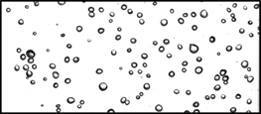
(a) bubble shape | (b) averaged void fraction
Fig. 3 Bubble shape and void fraction of bubbly flow in rectangular channel

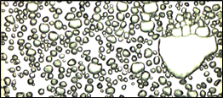
(a) bubble shape | (b) averaged void fraction
Fig. 4 Bubble shape and void fraction of cap-bubble flow in rectangular channel

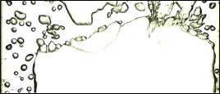
(a) bubble shape | (b) averaged void fraction
Fig. 5 Bubble shape and void fraction of slug flow in rectangular channel

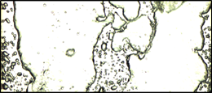
(a) bubble shape | (b) averaged void fraction
Fig. 6 Bubble shape and void fraction of churn-turbulent flow in rectangular channel

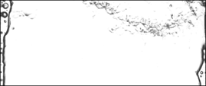
(a) bubble shape | (b) averaged void fraction
Fig. 7 Bubble shape and void fraction of annular flow in rectangular channel

Bubbly flow (B) The liquid phase is continuous and small dispersed bubbles flow within the liquid. The bubbly flow is essentially similar to that in the upward flow with circular tube. The main difference can be observed in that the bubbles size is smaller than the gap of rectangular channels, and average void fraction is less than 0.25. Fig. 3(a) and (b) shows the shape of bubbly flow and the line averaged void fraction in downward rectangular channels.
Cap-bubbly flow (CB) The gas flow rate increases, the confinement to the sub-channel caused the growing bubbles to be flattened and distorted to appear as small overturned caps due to coalescence. The cap bubbles in downward flow are formed with lower gas fraction than for the upward flow case. For vertical downward flow, the buoyancy force affects in against direction gravity to the mean flow. Despite its low values of the gas and liquid flow rate, the small slug similar in shape of overturned caps. The transition from cap-bubbly to slug flow happens at the void fraction approximately 0.7. Fig. 4(a) and (b) shows the shape of cap-bubbly flow and the line averaged void fraction in downward rectangular channels.
Slug flow (S) The transition criteria is widely used that the bubbly to slug flow in a round tube occurs at the void fraction approximately 0.3 [1][10][14][17]. The slug flow observed in the co-current downward flow is quite different from that observed in the upward flow at the narrow rectangular channel. Due to the small gap and wide width of sub-channel, the cap-bubble to slug transition occurs at the line averaged void fraction approximately 0.7. The line averaged void fraction of slug flow was fluctuated by liquid slugs that bridge the test section. Fig. 5(a) and (b) show the shape of slug flow and the line averaged void fraction in downward rectangular channels.
Churn-turbulent flow (CT) With increase of the gas flow rate, a breakdown in the slug flow leads to an unstable flow regime. The continuity of the liquid band is repeatedly destroyed. This liquid is accumulated, forms a bridge and is again lifted by the gas. Typical of churn-turbulent flow is this fluctuation of the liquid. The line averaged void fraction of churn-turbulent flow was similar to slug flow but fluctuated by liquid slugs as much more chaotic, frothy and disordered. Fig. 6(a) and (b) shows the shape of churn-turbulent flow and the line averaged void fraction in downward rectangular channels.
Annular flow (A) The gas phase flows as a continuous in the center of channel and the liquid phase flows near the widely side wall of the channels. Usually, parts of the liquid phase are entrained as small droplets in the gas flow region, but it is quite uncommon for bubbles to be entrained in the liquid side. Fig. 7(a) and (b) shows the shape of annular flow and the line averaged void fraction in downward rectangular channels.

3.2. Flow Regime Map

As mentioned above, flow regime map of the narrow rectangular channel with the gap of 2.35 mm were recognized into six categories using void fraction signal. The flow regime map with 60 downward flow conditions with superficial gas velocity ranging from 0.02 to 8 m/s and superficial liquid velocity ranging from 0.5 to 2.5 m/s has been investigated. Fig. 8 shows the flow regime map with transition criteria of Hibiki and Mishima [5] in the narrow rectangular channel. Hibiki and Mishima [5] suggested the transition criteria for the vertical upward flow. The basic phenomena of the experimental results were the same as that of transition criteria of Hibiki and Mishima [5].
Fig.8 shows the results data with the transition criteria by Hibiki and Mishima [5]. The downward flow regime in rectangular channel has good agreement with transition criteria developed by Hibiki and Mishima [5] for vertical flow even though the flow is the opposite direction. The present flow regime showed that the transition criteria for the upward flow could be applied the downward flow in relatively high liquid velocities over 1 m/s.
However, for superficial liquid velocity under 0.8 m/s, a new model may be needed for the criteria of flow regimes for the downward flow in narrow rectangular channel. Furthermore, the results in this experimental study showed that the cap-bubbly flow occurs at slug flow region in Hibiki and Mishima [5] flow regime map. In addition, the cap bubbles in downward flow are generated in lower gas fraction than for the upward flow. This difference can be explained because the bubble coalescence in downward flow is increased in the sub-channels. Barnea [18] presented modified model for the effect of inclination angle. According to his paper, for superficial liquid velocity lower than 1 m/s, the two phase flow regimes are affected by the buoyancy force. In present study, for superficial liquid velocity approximately 0.3 m/s, the gas phase flow is continuous in the channel core. And the liquid phase flows in both sides of the breadth of sub-channel. The superficial liquid velocity ranging from 0.5 to 0.8 m/s has the bigger bubble size and the lower bubble velocity by the side of the superficial liquid velocity over 1.0 m/s

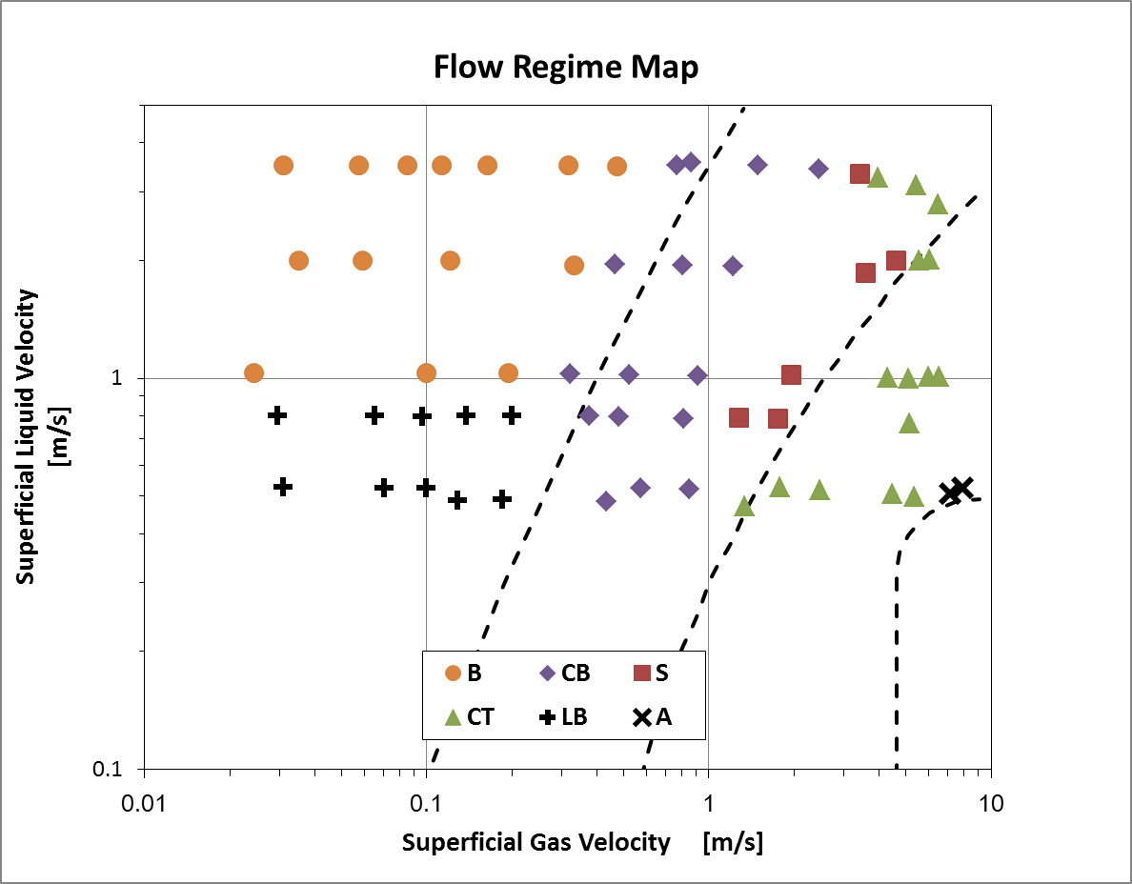
Fig. 8 Two phase Flow regime map for downward flow in rectangular channel

4. Conclusion

The two phase flow regime has been identified for the vertical downward flow in narrow rectangular channel with gap of 2.35 mm using the image processing method of Matlab. The basic concept of the flow regimes is essentially similar to that of Wilmarth and Ishii [1] characterization for the upward flow in rectangular channel. The flow regimes was classified by six patterns such as large bubbly, bubbly, cap-bubbly, slug, churn-turbulent and annular flows that are recognized by the line averaged void fraction using image processing in the high speed camera image.
The result data have been compared to Hibiki and Mishima [5] criteria. The downward flow regime has good agreement with transition criteria developed by Hibiki and Mishima [5] even though the flow is the opposite direction. The present flow regime showed that the transition criteria for the upward flow could be applied the downward flow in relatively high liquid velocities over 1 m/s. According to the experimental results, there are two major differences between the downward flow and the upward flow in the rectangular channel. First is the cap-bubbly flow occurs at slug flow region in Hibiki and Mishima [5] flow regime map. Second is the superficial liquid velocity ranging from 0.5 to 0.8 m/s has the bigger bubble size and the lower bubble velocity by the side of the superficial liquid velocity over 1.0 m/s. For superficial liquid velocity under 1 m/s, a new model may be needed for the criteria with the cap-bubbly flow regime for the downward flow.

5. References

- WILMARTH, T., ISHII, M., “Two-phase flow regimes in narrow rectangular vertical and horizontal channels”, Int. J. Heat Mass Transfer 37 (1994) 1749–1758.
- WILMARTH, T., ISHII, M., “Interfacial area concentration and void fraction of two-phase flow in narrow rectangular vertical channels”, J. Fluids Eng. 19 (1997) 916–922.
- MISHIMA, K., ISHII, M., “Flow regime transition criteria for upward two-phase flow in vertical tubes”, Int. J. Heat Mass Transfer 27 (1984) 723–737.
- XU, J., “Experimental study on gas–liquid two-phase flow regimes in rectangular channels with mini gaps”, Int. J. Heat Fluid Flow 20 (1999) 422–428.
- HIBIKI, T., MISHIMA, K., “Flow regime transition criteria for upward two-phase flow in vertical narrow rectangular channels”, Nuclear Engineering and Design 203 (2001) 117–131
- OSHINOWO, T., CHARLES, M.E., “Vertical two-phase flow. Part I. Flow pattern correlations”, Can. J. Chem. Eng. 52 (1974) 25–34.
- MARTIN, C.S., “Vertically downward two-phase slug flow”, J. Fluids Eng. Trans. ASME 98 (1976) 715–722.
- KULOV, N.N., et al., “Pressure-drop, mean film thickness and entrainment in downward two-phase flow”, Chem. Eng. J. 18 (1979) 183–188.
- USUI, K., SATO K., “Vertically downward two-phase flow, (I). Void distribution and average void fraction”, J. Nucl. Sci. Technol. 26 (1989) 670–680.
- SPEDDING, P.L., NGUYEN V.T., “Regime maps for air water two phase flow”, Chem. Eng. Sci. 35 (1980) 779–793.
- BARNEA, D., et al., “Flow pattern transition for vertical downward two phase flow”, Chem. Eng. Sci. 37 (1982) 741–744.
- KENDOUSH, A.A., AL-KHATAB, A.W., “Experiments on flow characterization in vertical downward two-phase flow”, Exp. Th. Fluid Sci. 9 (1994) 34–38.
- USUI, K., “Vertically downward two-phase flow, (II). Flow regime transition criteria”, J. Nucl. Sci. Technol. 26 (1989) 1013–1022.
- GODA, H., et al., “Drift-flux model for downward two-phase flow”, International Journal of Heat and Mass Transfer 46 (2003) 4835–4844
- JULIA, J.E., et al., “Local flow regime analysis in vertical co-current downward two-phase flow”, Experimental Thermal and Fluid Science 44 (2013) 345–355
- SWANAND, M.B., AFSHIN, J.G., “Similarities and differences in the flow patterns and void fraction in vertical upward and downward two phase flow”, Experimental Thermal and Fluid Science 39 (2012) 213–227
- TAITEL, Y., et al., “Modelling flow pattern transitions for steady upward gas–liquid flow in vertical tubes”, AIChE J. 26 (1980) 345–354.
- BARNEA, D., “A unified model for prediction flow pattern transitions in the whole range of pipe inclination”, Int. J. Multiphase Flow 13 (1978) 1–12

