Thermal-hydraulic aspects of RMB design

J. Lupiano Contreras¹, A. Doval¹, F. Francioni¹, P.E. Umbehaun², W.M. Torres², A. C. Prado², A. Belchior. Jr²

1) INVAP S.E. Comandante Luis Piedrabuena 4950, 8400 San Carlos de Bariloche, Río Negro, Argentina
2) Instituto de Pesquisas Energéticas e Nucleares IPEN/ CNEN-SP
Avenida Professor Lineu Preste 2242, Cidade Universitária, CEP 05508-000 São Paulo, Brazil

Corresponding author: JLupianoContreras@invap.com.ar

Abstract. The Brazilian Multipurpose Reactor (RMB, from Portuguese) is a 30 MW open pool reactor to be used in research, materials and fuel testing and radioisotope production. The most relevant aspects of the thermal-hydraulic design are presented, including a description of the cooling of the fuel assemblies, in-core irradiation positions, core chimney, control rod guide boxes and control plates. Reference is made to the adopted design criteria, safety and operational features and computational tools used.
A special section is devoted to describe the cooling of the out-of-core irradiation facilities, mainly, the Molybdenum irradiation facilities.
A distinctive feature of RMB is the Beryllium grid “cut” in the reflector vessel, housing a set of Beryllium blocks for a fuel testing loop. A description of different alternatives proposed for the cooling of the Be blocks is also presented.
A mention of the engineered safety features considered to comply with the decay heat removal of the core and the Mo targets, in case of an anticipated operational condition such as a Loss of Flow, is included.

1. Introduction

The Brazilian Multipurpose Reactor (RMB) is a 30 MW Open Pool Reactor developed based on OPAL main features. Removing the heat generated and deposited on the different structures is essential in order to avoid phenomena which might compromise their integrity.

This paper presents the thermal-hydraulic design of the reactor. It contains a description of the core, the out-of-core irradiation facilities, the Beryllium reflectors and the associated cooling systems, as well as the thermal-hydraulic design criteria and the safety and operational features.

2. General description of the core

The Reactor Core consists of twenty-three Fuel Assemblies (FA) and two In-Core-Irradiation Facilities (ICIF). Two guide boxes (CRGB) containing three control rods (CR) each run parallel to the FA. The CR contain a neutron absorbing material so that reactivity is controlled by inserting and withdrawing them into and out of the core. All of these structures are supported by the core grid (CG) and surrounded by a chimney. A plant view of the core configuration is shown in FIG. 1.
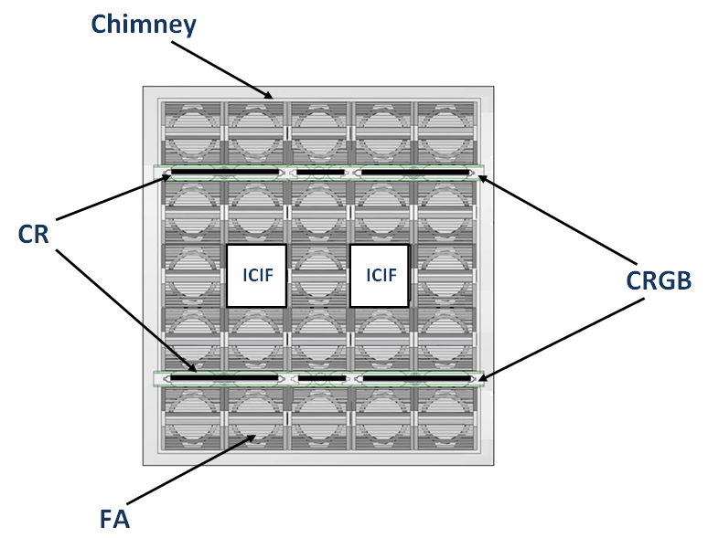
FIG. 1. Plant view of RMB core

Each FA consists of twenty-one fuel plates containing Uranium Silicide powder dispersed in an Aluminium matrix. A nozzle is placed at the bottom, allowing the coolant to enter the FA and flow between the plates, thus removing heat. The lower end of the inner fuel plates is held by a comb which provides mechanical stability to them and prevents strains to be induced by the high coolant velocities reached during normal operation. Due to structural requirements, the external plates are different from the internal ones as they are longer and thicker. They also contain windows allowing the coolant to make a by-pass and properly remove the heat deposited on them. Lateral and upper views of the FA are seen in FIG. 2.

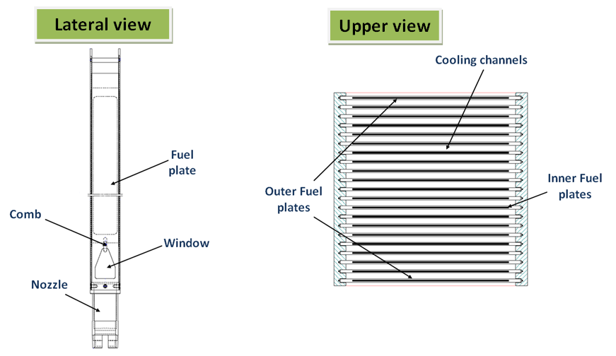
FIG. 2. Lateral and upper view of a FA
The CR are part of the First Shutdown System (FSS) and they are involved in reactivity control and safety functions. Each CR is fixed to a Zircaloy follower, used to move them along and inside the CRGB. The coolant enters into the CRGB through orifices placed on the core grid and it removes the heat deposited on the CR and on the CRGB by flowing through the channels between them. An upper view of one of the CR in the CRGB is illustrated in FIG. 3.

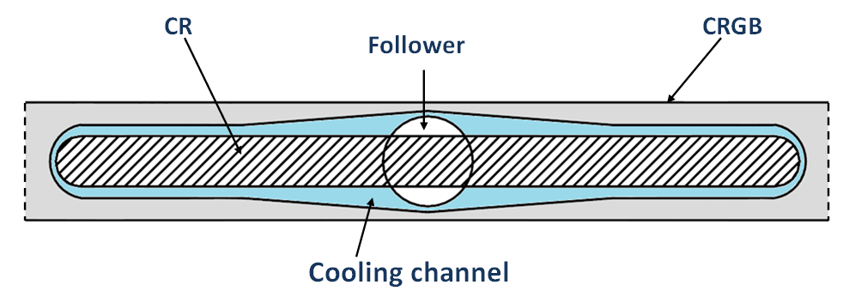
FIG. 3. Upper view of CR in CRGB

2.1. Description of the Core Cooling System

The heat generated in the core and deposited on the different structures is removed by light water supplied by the Core Cooling System (CCS). The circuit is illustrated in FIG. 4. The coolant flows upwards through the core and moves towards a tank where the activated Nitrogen is allowed to decay. The main line is divided into three 50% capacity branches, each of them containing a pump and a heat exchanger. During normal operation, two of the pumps provide the required coolant flow to the core while a third one is left in stand-by. The heat removed from the core is transferred to the Secondary Cooling System (SCS) in the CCS heat exchangers before the coolant returns to the reactor core through two inlet pipes. Inside the Reactor Pool (RP), there are two flap valves in each line, located at different levels, the Upper and Lower Flap Valves. The Upper valves act as siphon-breakers in case of a Loss of Coolant Accident (LOCA) while the Lower valves main function is to provide a natural circulation loop for the core in case of pump shutdown.

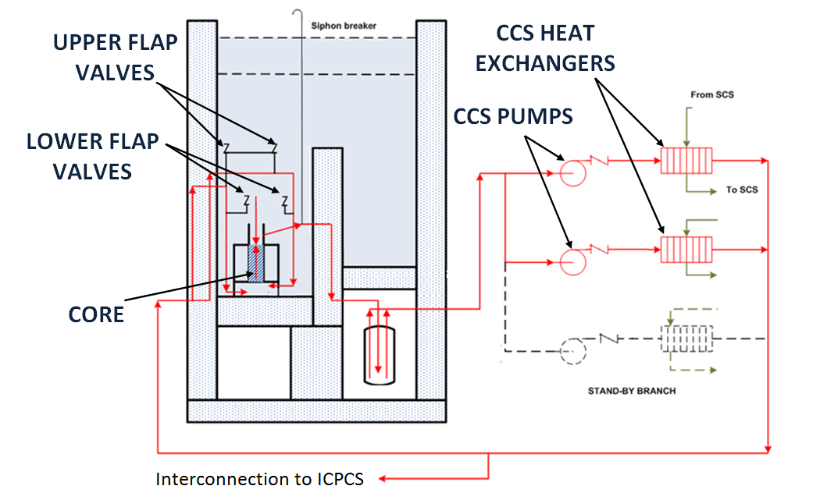
FIG. 4. Simplified scheme of the CCS

During normal operation, an important amount of energy needs to be removed and high coolant velocities are required to meet the design criteria thus justifying the need for a forced convection cooling regime. Since these coolant velocities may lead to an important pressure drop, an upward flow direction is preferred as it enables a dynamic pressurization of the core thus increasing the saturation temperature and enhancing the thermal margins considered in the design.

The pumps contain an inertia flywheel to provide the required flow in case of a pump shutdown. If this event takes place, the FSS is triggered to shutdown the reactor. As the pressure drops, the flap valves open and a natural circulation cooling regime is established to remove the decay heat of the core. The upward flow direction guarantees that there is no flow inversion during the transient, thus avoiding a null coolant velocity and the consequent critical heat flux.

2.2. Thermal-Hydraulic Design Criteria

The appearance of critical phenomena leading to a boiling crisis may result in a rapid increase in cladding temperature and fuel plate damage. The phenomena leading to this boiling crisis and to an eventual damage to the FA are relevant for the reactor safety and they are therefore considered important to define the design criteria.

Design limits with an adequate margin to safety limits have been established in order to avoid thermal or hydraulic fuel damage during normal steady state operation and anticipated operational transients. For the steady state, the following safety relevant margins have been adopted for the thermal design:

Departure from Nucleate Boiling Ratio (DNBR): is the ratio between the heat flux leading to the DNB (q"_{DNB}) phenomenon, and the maximum heat flux in the hot channel (q"_{max}).

$$\text{DNBR}=q_{\text{DNB}}^{\text{\} \} \} over \{q rSub \{ size 8\{}max\text{\} \} rSup \{ size 8\{}}≥2\text{.}0$$ | ( )

Redistribution Ratio (RDR): is the ratio between the power resulting in the Flow Instability, phenomenon (P_{RD}), and the integrated power in the hot channel (P_{max}).

$$\text{RDR}=\frac{P_{\text{RD}}}{P_{\text{max}}}≥2\text{.}0$$ | ( )

In addition to these limits, specific thermal-hydraulic conditions are used as design constraints or warnings in order to anticipate to these critical phenomena. The Onset of Nucleate Boiling (ONB) phenomenon is a non-destructive event which may result in unacceptable flow regimes and neutronic perturbations. Consequently, the following non-safety relevant margin has also been considered for the design:

Onset of Nucleate Boiling Ratio (ONBR): is the ratio between the heat flux resulting in the ONB (q"_{ONB}) phenomenon, and the maximum heat flux in the hot channel (q"_{max}).
$$\text{ONBR}=q_{\text{ONB}}^{\text{\} \} \} over \{q rSub \{ size 8\{}max\text{\} \} rSup \{ size 8\{}}≥1\text{.}3$$ | ( )

Since the heat flux spatial distribution is not homogeneous along the core, there will be certain spots in which the heat flux is higher than the average value (q"_{ave}). To uncouple from neutronic calculations a truncated cosine axial power profile is considered and a Power Peaking Factor (PPF) equal to 3, representing an envelope condition for all the possible core configurations, has been defined to account for the non homogeneous spatial distribution so that:
$$\text{PPF}=q_{\text{max}}^{\text{\} \} \} over \{q rSub \{ size 8\{ ital }ave\text{\} \} rSup \{ size 8\{}} = 3$$ | ( )

Additional requirements have been established to guarantee the structural design of the fuel, thus conditioning the thermal-hydraulic design. These requirements include:

Maximum coolant velocity in the FA inner channel (V_{max}): 10 m/s

Maximum cladding temperature: 150°C

Thickness of the oxide layer: ≤ 50 μm [1]

Maximum temperature difference through the oxide layer: 120°C [1]

In case of an anticipated operational transient the design criteria considered for the FA, besides DNBR ≥ 1.5 and RDR ≥ 1.3, include the following margins:

Burn-Out Ratio (BOR): is the ratio between the heat flux leading to the Burn-Out (BO) phenomenon (q"_{BO}), and the maximum heat flux (q"_{max}) in the hot channel.

$$\text{BOR}=q_{\text{BO}}^{\text{\} \} \} over \{q rSub \{ size 8\{}max\text{\} \} rSup \{ size 8\{}}≥1\text{.}3$$ | ( )

Boiling Power Ratio (BPR): is the ratio between the Boiling Power (BP) and the maximum power in the hot channel.

$$\text{BPR}=\frac{\text{BP}}{P_{\text{max}}}≥1\text{.}3$$ | ( )

Additionally, the temperature in the cladding material must be kept below the blistering temperature, conservatively assumed as 450°C.

2.3. Thermal-hydraulic design at Power State

Both, the power distribution and the integrated power in the hot channel vary depending on the fuel cycle, the CR insertion and the FA burn up state. An adequate thermal-hydraulic design must guarantee that every core configuration fulfills the design criteria.

Table I summarizes the operating conditions considered for the design.

TABLE I: Operating conditions

Parameter | Value
Core nominal power | 30 MW
Coolant | Demineralized water
Flow direction | Upwards
Water column height above the core | 10 m
Coolant inlet temperature | 38°C

Since all the cooling channels are connected to a common inlet and outlet plenum, the pressure drop in all of them must be the same. Consequently, the total flow is distributed along the channels according to this pressure drop. The thermal-hydraulic design must guarantee that the coolant velocity in each channel, resulting from this flow distribution is high enough as to guarantee that the design criteria are accomplished.

For the CR and the CRGB additional design requirements must be considered. On one hand, and in order to avoid elastic deformations which may affect the CRs' movement, a positive pressure difference between the inner and the outer faces of the CRGB must be guaranteed. A second point to consider is that the coolant velocity must be limited to a range between (i) a maximum value in order to avoid the dragging of the CR away from the core and (ii) a minimum value to avoid the ONB phenomenon.

2.4. Uncertainties

Deviations from the fabrication and construction processes, unknown variables, hypotheses considered in the thermal-hydraulic and neutronic analysis and deviations in the operating conditions introduce uncertainties which must be considered when performing the thermal-hydraulic calculations.

Uncertainties are treated statistically, as it is unlikely that the extreme values of the deviations are achieved at a same point. In this approach, the standard deviations are combined in a statistical manner to obtain the total deviation from the safety parameter under analysis.

2.5. Computational tools

The steady state thermal analysis for the forced convection cooling mode was performed with TERMIC [2] code while CAUDVAP [3] was used for the hydraulic calculations. These computer programs were developed by INVAP for the calculation and thermal-hydraulic design of MTR type reactor cores.

2.6. Results

A total core coolant flow equal to 3100 m³/h was calculated and it guarantees that both, the thermal hydraulic design criteria and the design requirements are satisfied. Almost 98% of this total flow is distributed along the channels in the FA while the reminding 2% flows through the channels in the CRGB. Table II summarizes the results of the thermal-hydraulic calculations for a hot channel in the FA at the average cooling velocity.

TABLE II: Calculated values for the hot channel

Parameter | Value
Total coolant flow in core | 3100 m³/h
Average coolant velocity in FA | 9.4 m/s
Temperature increase | 22°C
RDR | 2.3
DNBR | 2.5
ONBR | 3.6
Maximum wall temperature | 109°C

For the CRGB and CR, a simplified model was developed considering a conservative approach; preliminary results are summarized in TABLE III.

TABLE III: Calculated values for the CR and CRGB

Parameter | Value
Minimum - maximum coolant velocity | 4.1- 4.6 m/s
Calculated coolant velocity | 4.3 m/s
Temperature increase | 31°C
ONBR | 1.4
Maximum wall temperature | 110°C

The pressure distribution along the FA and the CRGB is illustrated in FIG. 5.

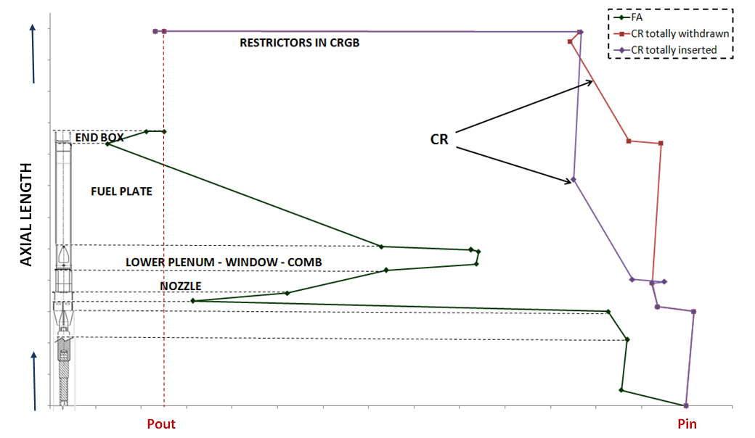
FIG. 5. Pressure distribution along the FA and the CRGB

2.6. Thermal-hydraulic design during expected operational transients

An operational transient considered for the thermal-hydraulic design includes the Loss of Flow Accident (LOFA). An event causing the pumps in the CCS to stop, leads to a reduction in the coolant flowing through the core.

The FSS is actuated as the flow through the core falls under 90% of its nominal value. The pumps in the CCS are provided with an inertia flywheel thus guaranteeing enough coolant flow as to remove the decay power without causing damage to the fuel. The reduction in the coolant flow leads to a reduction in pressure in the inlet pipe. When the pressure difference between the inlet pipe and the RP falls below a given value, (proportional to the valve counterweight), the flap valves open, and the water from the RP flows through the core, thus removing heat in a natural circulation cooling regime. This process is illustrated schematically in FIG. 6.

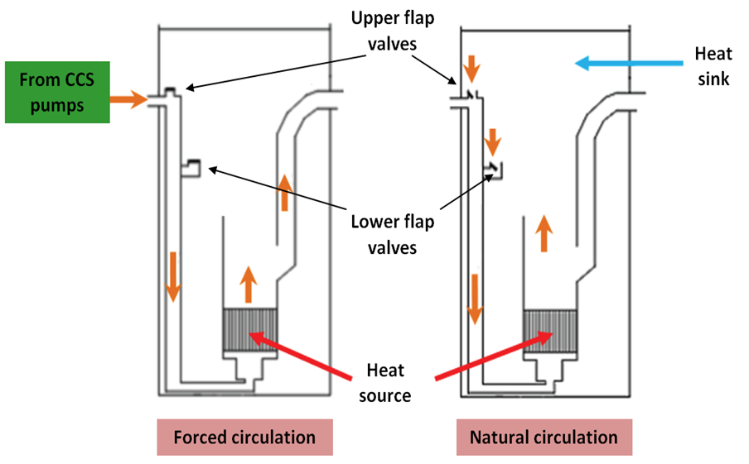
FIG. 6. Forced and natural circulation cooling regimes

The thermal-hydraulic calculations involved specifying the moment of inertia of the flywheel to guarantee a smooth transition from the forced to the natural circulation cooling regime when the flap valves open.

To perform this analysis a dynamic model of the CCS, including the core, was built in RELAP code [4]. The reactor core was modeled considering as a hot channel, an average channel and a by-pass channel while the SCS was specified as a boundary condition. Even though RELAP was specifically developed for Power Plants it has proved to be adequate for the analysis of transient scenarios in Research Reactors. Table IV shows the results of this analysis.

TABLE IV: Results for the transient analysis

Parameter | Value
Opening time for flap valves after pump shutdown | > 90 seconds
Moment of inertia of each fly-wheel | 100 kg∙m²
Maximum wall temperature | 125°C
BOR | 2.4
BPR | 2.8
3. Thermal-hydraulic design aspects of the Out-Of-Core Irradiation Facilities

The reactor core is surrounded by a cylindrical structure made of Zircaloy-4, which constitutes the Reflector Vessel (RV). This vessel contains heavy water to provide neutron reflection and a large volume with a high neutron flux for target irradiation and research purposes. A space cut in the RV and filled with light water houses a Power Ramp Loop and Beryllium Reflector blocks (BR).
Rigs are vertically inserted in the irradiation tubes of the RV and are known as Out-of-Core Irradiation Facilities (OCIF). They have different diameters and they house targets for specific purposes. A top view of the RV with the OCIF and BR is illustrated in FIG.7.

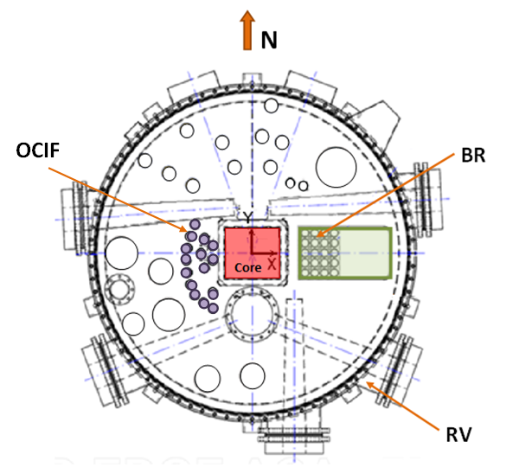
FIG.7. Top view of OCIF and BR in RV

Neutron irradiation of the heavy water and structures results in heat deposition. This heat must be removed to avoid regions with high temperatures and to guarantee a more uniform temperature distribution. The Irradiation tubes in the RV act as a physical barrier between the rigs and the RV, allowing the light water from the pool to flow downwards in a forced circulation cooling regime through the rigs. This flow-rate is part of the In-Confinement Pools Cooling System (ICPCS).

The water flowing through the rigs is collected in a plenum below the RV and taken to a tank where the activated Nitrogen is allowed to decay. Two flap valves are located in the outlet pipe, close to the plenum. During normal operation, the pressure developed in the pipes force the flap valves to remain closed. The ICPCS contains two 100% pumps, one in a stand-by condition, forcing the coolant back to the RP. The heat removed from the OCIF is transferred to the SCS through the ICPCS heat exchanger before closing the loop.

A simplified scheme of the ICPCS is illustrated in FIG.8.
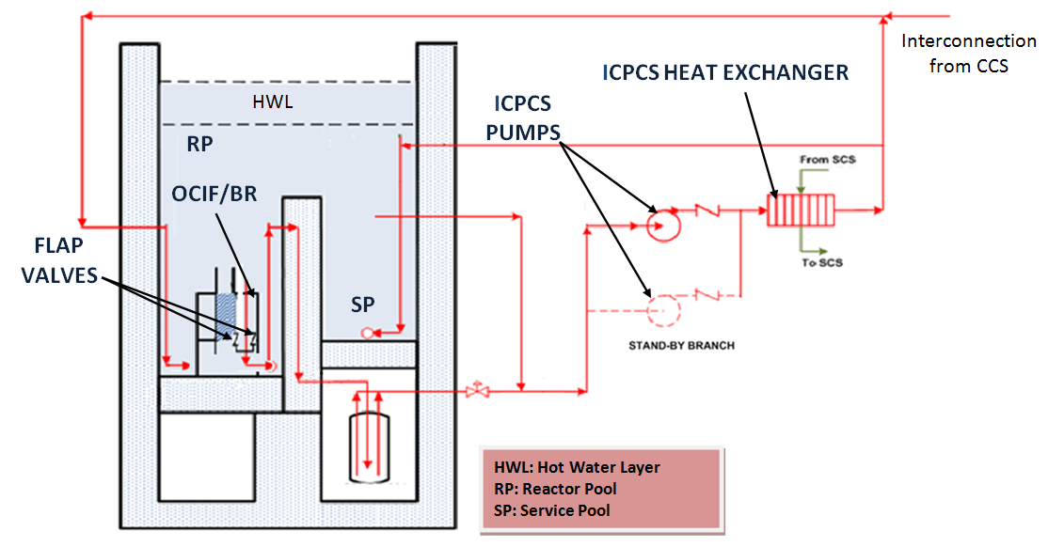
FIG.8. Simplified scheme of the ICPCS

In case of a pump shutdown, the coolant flow decreases thus causing the pressure to fall and the flap valves to open. Water from the RP enters through the pipe and flows upwards through the OCIF in a natural circulation cooling regime. The transition from the forced to the natural circulation cooling regime involves a flow inversion which must be considered during the thermal-hydraulic design.

3.1. General description of OCIF and BR

Different targets, such as Molybdenum, Iridium for medical and industrial purposes, and Silicon ingots for Neutron Transmutation Doping are to be irradiated in RMB. The most relevant OCIF, from the thermal-hydraulic point of view are the Uranium targets for ⁹⁹Mo production. There are ten irradiation tubes, each of them containing up to twelve Uranium flat plates. Due to ⁹⁹Mo production requirements, the heat flux generated in these OCIF falls within the order of magnitude of the heat generated in the core. At the same time, it must be considered that these rigs must be removed and reloaded during normal operation. The plates are placed in holders following a square arrangement and the coolant flows through the channels surrounding them.

The BR are solid blocks containing a central hole which allows the coolant to flow through them, thus removing heat. A maximum of ten BR are expected to be arranged in a grid containing a total of twenty-five positions. Only three of the ten positions can contain samples to be tested. The remaining fifteen positions of the grid are occupied with a plug with a central hole to allow the coolant flow.

3.1. Thermal-hydraulic design criteria for OCIF

For the Steady State, an ONBR equal to 1.3 has been adopted for the thermal-hydraulic design of the ⁹⁹Mo OCIF.
For the BR, a maximum wall temperature of 90°C has been established as a design criterion. This temperature prevents degassing and guarantees an adequate margin to the coolant´s saturation temperature (118 °C at 190 kPa).
An additional design requirement establishes a maximum pressure drop of 70 kPa along the OCIF and BR.

For the anticipated operational transients, the Margin to Critical Heat Flux (MCHF) is considered only for the ⁹⁹Mo OCIF. It is defined as the ratio between the critical heat flux at the Counter-Current Flow Limit (CCFL) condition (q"_{CCFL}), and the maximum local heat flux.

$$\text{MCHF}=q_{\text{CCFL}}^{\text{\} \} \} over \{q rSub \{ size 8\{}max\text{\} \} rSup \{ size 8\{}}≥1\text{.}3$$ | ( )

3.2. Thermal-hydraulic design of the OCIF at Power State

The minimum coolant velocity in the ⁹⁹Mo OCIF is calculated considering a hot ⁹⁹Mo RIG with a truncated cosine power distribution and a PPF of 1.4 thus representing an envelope case. Calculations were done using the TERMIC [2] program, considering uncertainties and including an additional 10% to account for the heat deposited on the Aluminium structure.

After evaluating different cooling alternatives the thermal-hydraulic design of the BR was solved allowing the coolant to flow through a central hole (different diameters depending whether they house any sample or not). This alternative not only improves the hydraulic performance but reduces the possibility of the coolant flow bypassing the BR, as well. Once again, a truncated cosine power profile distribution with a PPF of 2.5 was considered for the design and the flow distribution through the different channels was evaluated in order to guarantee that the required minimum coolant velocities are achieved.
The thermal-hydraulic design of the BR was performed by using the Thermal-Desktop software [5].

3.3. Results

TABLE V summarizes the results obtained for the most demanded ⁹⁹Mo OCIF and for the two types of BR, with and without sample.

TABLE V: Calculated values for ⁹⁹Mo OCIF and BR

Parameter | Value
 | ⁹⁹Mo OCIF | BR with sample | BR without sample
Minimum coolant velocity | 4 m/s | 2.6 m/s | 2.1 m/s
Temperature rise in channel | 14°C | 5.0°C | 5.0°C
Maximum wall temperature | 111°C | 58°C | 73°C
ONBR | 1.3 | (*) | (*)
Total pressure drop | 57 kPa
Coolant flow per position | 13 m³/h | 2 m³/h | 3 m³/h
(*) Not considered in the design

FIG.9. shows the temperature distribution in a BR with and without sample.
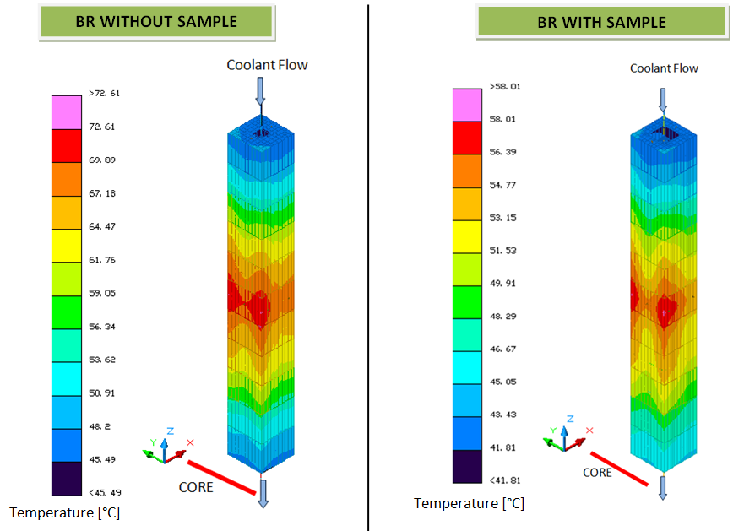
FIG.9. Temperature distribution in BR

3.4. Thermal-hydraulic design of the OCIF during expected operational transients

The events leading to the CCS pump shutdown may also cause the pumps in the ICPCS to stop. The transition from the forced to the natural circulation cooling mode involves a flow inversion with a reduction in the coolant's velocity which might lead into damage in the ⁹⁹Mo plates. As the coolant flow falls, the reactor shuts-down, thus reducing the heat flux in the OCIF, particularly, in the ⁹⁹Mo plates. The thermal-hydraulic calculation involves determining the moment of inertia for the pump flywheel, as an engineered safety feature, so that the coolant flow is maintained and the flap valves open once the MCHF has been achieved. Results are summarized in TABLE VI.

TABLE VI: Results for the transient analysis in OCIF

Parameter | Value
Opening time for flap valves after pump shutdown | ~ 140 seconds
Moment of inertia | 50 kg∙m²
MCHF | 1.4

6. References

- R. E. Pawel, G. L. Yoder, D. K. Felde, “The Corrosion of 6061 Aluminium under Heat Transfer Conditions in the ANS Corrosion Test Loop”, Oxidation of Metals, Vol. 36, N° 1-2, 1991.
- TERMIC v4.3, A program for the thermal-hydraulic analysis of a MTR core in forced convection mode, User’s Manual.
- CAUDVAP v3.60, A computer program for flow distribution and pressure drop calculation in a MTR type core, User’s Manual.
- RELAP5/MOD3 – Idaho National Engineering Lab. – NUREG/CR-5535.
- C&R Technologies, Thermal Desktop 4.8 version, User’s Manual

