Implementation of the Neutron Noise Technique for Measurement of Reactivity in Subcritical of the Low Power Research Reactor RA-4

J. Orso¹

1) Comisión Nacional de Energía Atómica, Rosario, Argentina.

Corresponding author: orsojose@hotmail.com

Abstract. Reactor core RA-4 is divided into two parts that come together to start the reactor. The reactor with divided core has the greatest subcritical condition, this condition is the safest; therefore, it's the condition of the reactor in a shutdown state. In this paper measurements are made of the decay constant of the neutron prompt “α_{p}”, using the α-Rossi and α-Feynman methods to calculate the reactivity of the reactor core for different positions. Both techniques are compared and reactivity is obtained for several positions of the reactor core using the α-Rossi method. Both techniques are also verified using a non multiplicative system.

1. Theory

The α-Rossi and α-Feynman methods are based on measuring the reactor in subcritical and stationary states with an external neutron source.

The reactivity is obtained by:

$$\$=\frac{α_{p}−α_{c}}{α_{c}}$$

where $ is the reactivity in dollars, α_{p} is the decay constant of the neutron prompt and α_{c} is the decay constant of the neutron prompt for the critical state.

1.1. The α-Rossi Method

The application of the Equation (1) gives rise to the α-Rossi method.

$$ξ=ε^{2}⋅F^{2}+\left[\frac{ε^{2}⋅F⋅D⋅L_{1}}{2⋅β^{2}⋅(1−\$)⋅Λ^{}}\right]⋅e^{α_{p}⋅(t_{2}−t_{1})}$$
(1)

Where ε is the absolute efficiency of detector, F is the fission rate, D is the Diven factor, $ is the reactivity in dollars, β is the fraction of delayed neutron, α_{p} is the decay constant of the prompt neutron, Δ* is the reduced time between reproductions, L₁ is the finite reactor geometry and t₁, t2 is the time.

For the measurement, the use of multichannel scaling with a small channel width “Δt” is needed so that the detection of zero or one account occurs in the first channel c₁ corresponding to t₁ and in the second channel c₂ corresponding to t₂.The measurement involves recording the frequency of occurrence of one account in c₁ and one account in c₂, in function of (t₂-t₁). The first term of the equation (1), corresponds to the uncorrelated part of the probability (see FIG.1.), while the second term corresponds to the correlated part of the probability (see FIG.2.). From normalizing and then fitting the experimental data, a function P(t) is obtained, which is the probability of detection of a neutron in a time interval Δt₂ around the time t₂. Previously, another neutron has been detected at the time t₁ in the time interval Δt₁. From function P(t), α_{p} is obtained and therefore, the reactivity. [1] [2] [3]

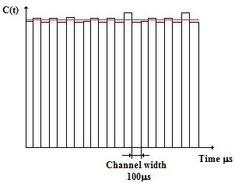
FIG. 1. Distribution of the pulses as a function of time in an uncorrelated system.
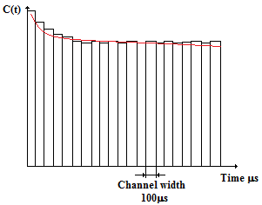
FIG. 2. Distribution of the pulses as a function of time in a correlated system. [4]

1.2. The α-Feynman method

The application of the Equation (2) gives rise to the α- Feynman method.

$$V(t)=\frac{\overline{Z^{2}}−{\overline{Z}}^{2}}{\overline{Z}}=1+\left[\frac{ε⋅\overline{ν_{p}⋅(ν_{p}−1)}⋅L_{1}}{β^{2}⋅(1−\$)^{2}⋅{\overline{ν}}^{2}}\right]⋅\left\{1+\frac{1−e^{α_{p}⋅t}}{−α_{p}t}\right\}$$
(2)

where $Z=ε\text{Ft}$is the number of accounts obtained in the time interval “t”, $\overset{−}{ν}$is the average value of the number of neutrons produced in a fission, ν_{p} is the number of the prompt neutrons produced by fission.

This method involves repeatedly measuring the number of accounts “N_{c}” in a time interval “t” and obtaining the mean value <N_{c}>, the variance σ²(t) and the reduced variance

$$V(t)=\frac{σ^{2}}{N_{c}(t)>}$$

being V(t):

$$V(t)=1+Y_{1}⋅\left[1+\frac{1−e^{α⋅t}}{−α⋅t}\right]$$

Where

$$Y_{1}≃\frac{ε⋅D⋅L_{1}}{β^{2}⋅(1−\$)^{2}}$$
(3)

The value of α=α_{p} is obtained from the fit of the experimental data with the function (4):

$$Y(t)=V(t)−1=Y_{1}⋅\left[1+\frac{1−e^{α⋅t}}{−α⋅t}\right]$$
(4)
From equation (3) the absolute efficiency of the detector can be obtained and, in consequence, the power of the reactor. [1] [2] [3]

2. Description of the Nuclear Reactor RA-4

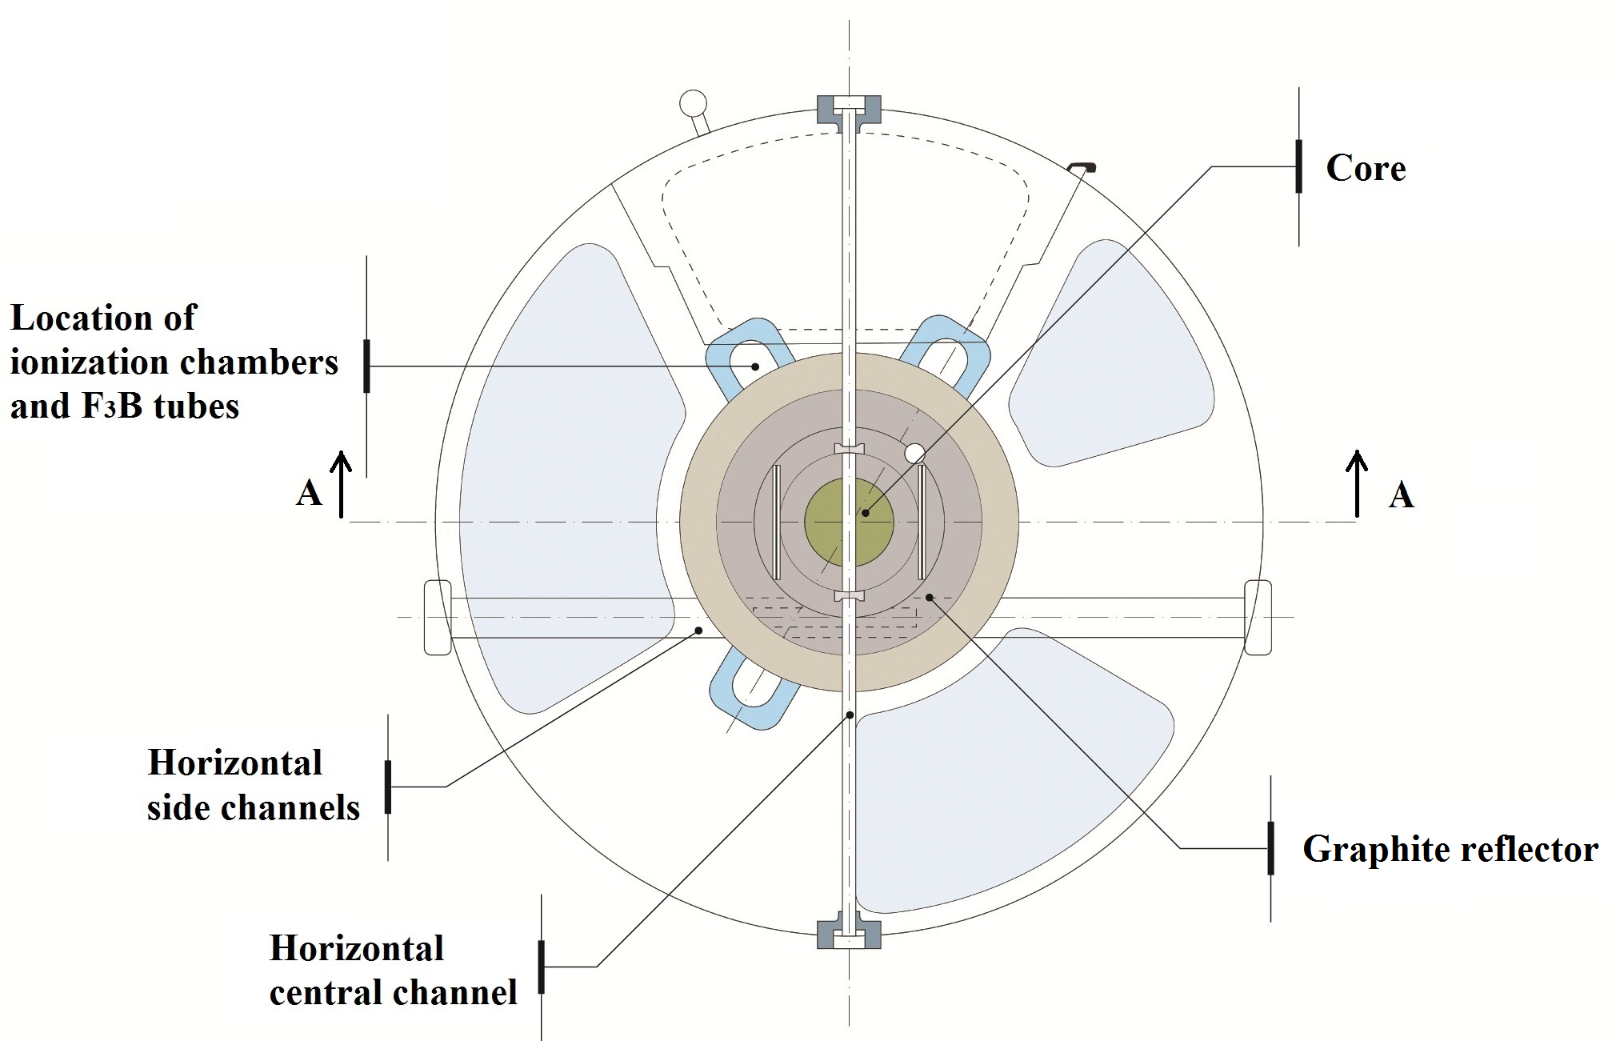
FIG. 3. Top view of research reactor RA-4.

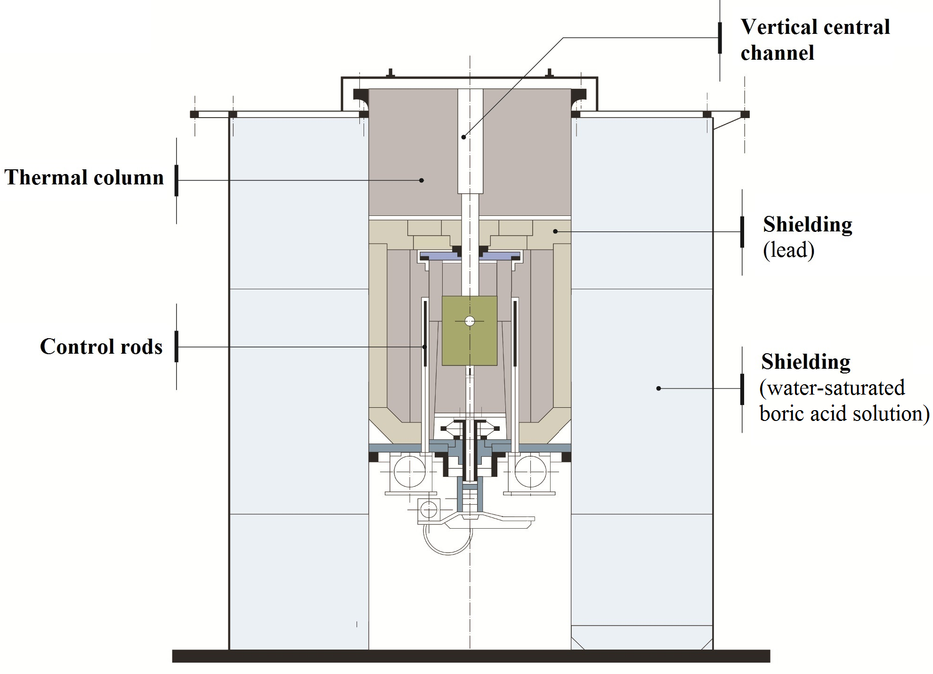
FIG. 4. Section A-A view of research reactor RA-4.

It is a homogeneous nuclear reactor and the maximum power operation is 1000 mW. The core is cylindrical and it is 24 cm in diameter and 26 cm tall. The core is divided into two parts that come together to start the reactor. The reactor with divided core (core position 0 cm) has the greatest subcritical condition, this condition is the safest; therefore, it's the condition of the reactor in a shutdown state. The position corresponding to the bonded core is 4.7 cm.

The RA-4 reactor has 3 horizontal channels of experimentation and 2 vertical channels of experimentation. One of the horizontal channels of experimentation passes through the center of the reactor core (see FIG.3.).

The core is composed of stacked uranium disks enriched to 20% homogeneously mixed with polyethylene. The polyethylene is a neutron moderator. The control rods are of cadmium, located on the sides of the core. The core is surrounded by a graphite reflector. The core and reflector are surrounded by a lead shielding. Finally, the core, the reflector and the shield are surrounded by a tank of water-saturated boric acid solution that serves as a biological shielding for neutron and gamma radiation (see FIG4.). [5] [6]

3. Measurement System

3.1. Circuit and Equipments Used to Measure α Constant Using the α-Rossi Method

Measurements were made using only one neutron detector located in the center of the horizontal central channel of irradiation.

After the detection of a neutron, sweeping of multichannel scaling (MCS) starts, then MCS counts pulses from the detector and accumulates them on the different channels depending on the time of arrival of each. The dwell time is 100μs. The MCS has 1024 channels.

In order to measure using this technique, an additional circuit was constructed (see FIG.5.).
A pulse from the detector is amplified and sent to the additional circuit made up of a CI 555 and a CI 74HC00, among other electronics components (see FIG. 6.).

The additional circuit starts the sweeping of MCS when a pulse from the detector (trigger pulse) enters pin 2. When the MCS ends the sweeping in channel 1024, the additional circuit remains waiting for the new trigger pulse. The main function of CI 555 is that it does not start a new cycle if the previous cycle has not finished. The cycle is repeated until good statistics are obtained. The data contained in the channels is sent to the computer to fit equation 1.

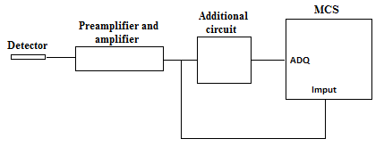
FIG. 5. Block diagram of the measurement system for the α-Rossi method.
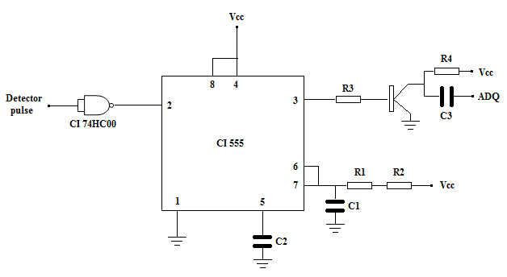
FIG. 6. Additional circuit used to measure using α-Rossi method.

3.2. Circuit and Equipments Used to Measure α Constant Using the α-Feynman Method

Measurements were made using a neutron detector located in the center of the horizontal central channel of irradiation.

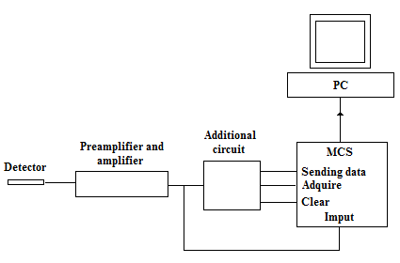
FIG. 7. Block diagram of the measurement system for the α-Feynman method.

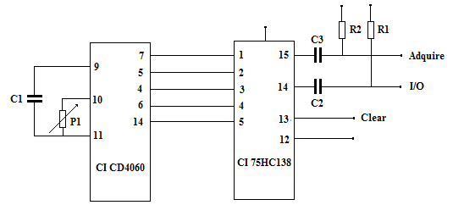
FIG. 8. Additional circuit used to measure using α-Feynman method.

To use the α-Feynman method, it is necessary to measure n times the count of neutrons from detector for a time t. The MCS dwell time is set up for several values of time: 100, 200, 300, 400, 500, 600, 700, 800, 900 μs y 1, 2, 3, 4, 5 ms. (see FIG.7.). When the sweeping in the MCS is completed, the additional circuit starts sending the data contained in the channels to the computer. (see FIG. 8.). After that the additional circuit resets the MCS counter to zero and starts a new sweeping. The cycle is repeated depending on the number of times the count of neutrons for a given value of dwell time is made.

4. Experimental Results

4.1. Reactivity values for the Core Position of 3.5 cm Using α-Feynman and α-Rossi Methods

Table I shows reactivity values obtained using α-Feynman and α-Rossi Method for a core position of 3.5 cm. (see FIG. 9.). (see FIG. 10.).

TABLE I: Reactivity value obtained with both methods.

 | Reactivity (dollar)
Core Position (cm) | α-Rossi | α-Feynman
3.5 | -5.5 +/- 0.8 | 5.4 +/- 0.3
FIG. 9. Fit of measurement using the α-Rossi method for a core position .

FIG. 10. Fit of measurement using the α-Feynman method for a core position.

4.2. Obtaining Reactivity Depending on the Core Position Using α-Rossi Method

FIG. 11. Fit of measurement using the α-Rossi method for several core position.

Table II shows reactivity values obtained using α-Rossi Method for several core position values. (see FIG. 11.).

TABLE II: Reactivity value obtained with α-Rossi method for 5 core positions.

Core Position (cm) | Reactivity (dollars)
0 | -11 ±1
3 | -7 ± 1
3.5 | -5.5 ±0.8
4.2 | -3.8 ± 0.3
4.5 | -3.0 ± 0.1

4.3. The α-Rossi and α-Feynman Methods Applied to an uncorrelated system

The α-Feynman and α-Rossi Methods were applied using a radioactive source of gamma emission and the neutron detector was replace by a scintillator. (see FIG. 12.). (see FIG. 13.)

FIG. 12. Measurement using α-Rossi method for a non-multiplicative medium.
FIG. 13. Measurement using α-Feynman method for a non-multiplicative medium.

5. Conclusions

Reactivity values for different positions of core are: $[0 cm] = (-11±1) dollar, $[3 cm] = (-7±1) dollar, $[3.5 cm] = (-5.5±0.8) dollar, $[4.2 cm] = (-3.8±0.3) dollar y $[4.5 cm] = (-3.0±0.1) dollar.

In Table I it can be seen that both methods give similar values of reactivity. As both methods are statistical, the measurement value depends on the measurement time for the α-Rossi method and on the number of measurements for the α-Feynman method. Reactivity value can be improved by increasing the measurement time for the α-Rossi method and increasing the number of measurements for the α-Feynman method.

In FIG. 11 it can be seen that the lifetime of fission chains is less than 0.01s. Also it can be seen that the higher the subcriticality, the lower the lifetime of fission chains.

In FIG. 12 and FIG. 13 it can be seen that both methods applied using a non-multiplicative system show no deviation from the Poisson distribution.

All measurements were performed at the same temperature of 22°C, because reactivity is highly dependent on temperature. It has been experimentally estimated that a difference in temperature of 1°C represents a reactivity variation of 0.0323 dollars, in the critical condition of the reactor.

6. References

- GOMEZ, A., "Métodos de Medición en Física de Reactores Nucleares. Cinética y Ruido Neutrónico", CNEA-ITE-06REC-203. Rev. 2, Buenos Aires (2008).
- BELLINO, P., GÓMEZ, A., “Aplicación de la técnica ruido neutrónico en subcrítico utilizando un nuevo sistema de adquisición de datos”, AATN, Buenos Aires (2009).
- BELLINO, P., GÓMEZ, A., “Estimación de parámetros cinéticos mediante mediciones en subcrítico en el reactor RA-3”, AATN, Buenos Aires (2010).
- MILICIC, B., “Experiencias utilizando el reactor de docencia SUR 100”, Schule fur Kerntechnik, Karlsruhe (1984).
- SCOLARI, H., “Informe de seguridad de reactor nuclear RA-4”, CNEA.C.RCN.DGE.001, Revisión 1, Rosario (2002)
- UGO, F., ORSO, J., “Desarrollo de software de simulación del conjunto crítico RA4 UNR”, AATN, Buenos Aires (2011).

