RMB: THE NEW BRAZILIAN MULTIPURPOSE RESEARCH REACTOR

J.A. PERROTTA¹, I.J.OBADIA¹,

1) Comissão Nacional de Energia Nuclear (CNEN), Av. Prof. Lineu Prestes 2242, Cidade Universitária, 05508-000, São Paulo, SP, Brazil.

Corresponding author: perrotta@ipen.br

Abstract. The Brazilian research reactors have a limited capacity for radioisotopes production, leading to a high dependence on external supply for radioisotopes used in nuclear medicine. In order to overcome this condition and due to the old age of these research reactors, the Brazilian Nuclear Energy Commission decided to develop a new research reactor. The new reactor named RMB (Brazilian Multipurpose Reactor) will be part of a new nuclear research center, to be built on a site about 100 kilometers from São Paulo city, in the southern part of Brazil. The new nuclear research center will have a 30 MW open pool type research reactor using low enriched uranium fuel, and several associated laboratories in order to produce radioisotopes for medical and industrial use, to use thermal and cold neutron beams in scientific and technological research; to perform neutron activation analysis; and to perform materials and fuels irradiation tests. This article updates some technical information and the development status of the RMB project.

1. Introduction

Brazil has four research reactors (RR) in operation: IEA-R1, a 5 MW pool type RR; IPR-R1, a 100 kW TRIGA type RR; ARGONAUTA, a 500 W Argonaut type RR, and IPEN/MB-01, a 100 W critical facility. The first three were constructed in the 1950’s and 1960’s, for teaching, training, and nuclear research, and for many years they have been the basic infrastructure for the Brazilian nuclear developing program. The last, IPEN/MB-01, is the result of a national project developed specifically for qualification of reactor physics analysis. Considering the relatively low power of Brazilian research reactors, with exception of IEA-R1, none of the other reactors are appropriate for regular radioisotope production, and even IEA-R1 has a limited capacity. As a consequence, the amount of ⁹⁹Mo needed to attend the Brazilian nuclear medicine demand has been imported. Due to the 100% dependence on external supply, the 2008/2009 international ⁹⁹Mo supply crisis affected significantly the Brazilian nuclear medicine services, and this vulnerable condition supported, in 2010, the decision of the Brazilian Nuclear Energy Commission to build a new research reactor [1,2]. The new reactor named RMB (Brazilian Multipurpose Reactor) will be a 30 MW open pool type reactor, using low enriched uranium fuel. The reactor facility will be the seed of a new nuclear research institute, to be built in Iperó, about 100 kilometers from São Paulo city, in the southeast part of Brazil. Besides producing radioisotopes for medical application, the complex will have several facilities, as a neutron beam laboratory to use thermal and cold neutron beams for research; a facility to process the radioisotopes produced in the reactor for several applications; a radiochemistry laboratory to apply neutron activation analysis techniques; and a post-irradiation analysis laboratory of materials and fuels specimens irradiated in the reactor. The neutron beam laboratory is foreseen to work as a national laboratory in complement to the Brazilian Synchrotron Light Laboratory (LNLS). Besides the reactor, there is an additional facility used to store, for at least 100 years, all the reactor’s spent fuel elements [3]. A facility to process and store medium and low level waste is also designed. This paper presents some characteristics of the new center and the status of the project development. Other papers in this conference will present the reactor facility design and some technical aspects of the neutronic and the thermal hydraulic analysis.

2. The RMB nuclear center

The Brazilian Nuclear Energy Commission (CNEN) has four nuclear research reactors that are installed in three different nuclear research centers. Each research center is located inside university campuses in the urban area of big cities (São Paulo, Belo Horizonte, and Rio de Janeiro). As the sites of the existing nuclear research centers do not allow, due to licensing requirements, a new research reactor with significant power, any new development will lead to the construction of a new center by CNEN.

RMB is the new CNEN´s nuclear research and production center that will be built in Iperó, a county about 100 kilometers from Sao Paulo city, in the southeast part of Brazil. The RMB Center site has an area of about 2 millions square meters. The new site infrastructure has to be designed and constructed considering not only the reactor and its complementary laboratories, but also future facilities of the nuclear program. As a new nuclear center, it is necessary to have all the environmental and nuclear site licenses issued by the competent authorities adding more time and effort for the project development.

The center will have three main nucleus: for research and production, administrative and infrastructure. Figure 1 presents the RMB center layout view.

The research and production nucleus (RPN) is the main reason of the project and comprises the nuclear and radioactive facilities of the RMB project. The RPN will be discussed in more details in the next item. The administrative nucleus will have a library, an administration building, a hotel, a restaurant, an ambulatory, and a training center. The infrastructure nucleus will have a water treatment plant, a warehouse, a workshop, a facility for the fire brigade, a garage, a sewage treatment station, a chemical treatment plant, a meteorological station, the main gate, and the electrical substation.

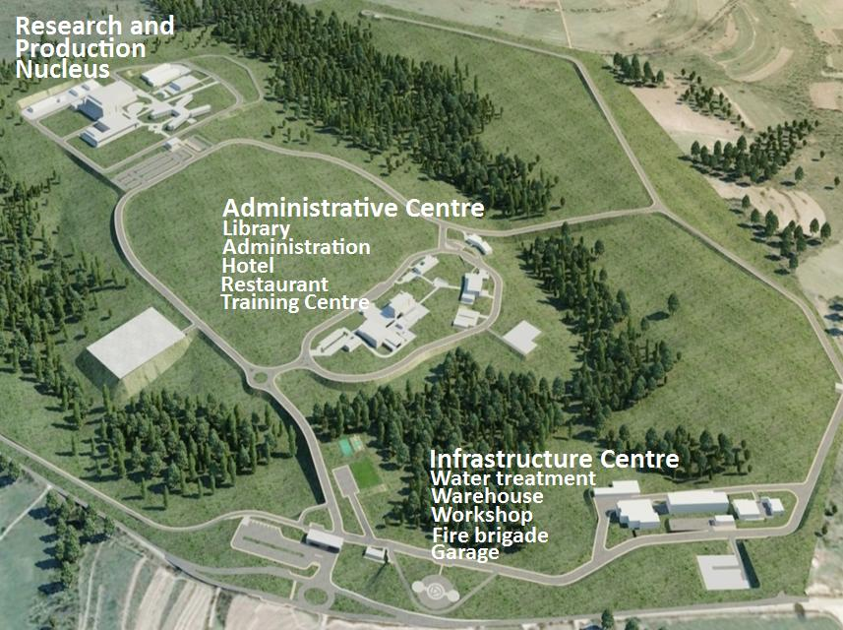
Fig 1. Artistic view of RMB nuclear research center.

3. The research and production nucleus

The research reactor is the main installation of what is called the “research and production nucleus (RPN)”, which includes the reactor building itself and the spent fuel storage building coupled to it, the radioisotope production facility and three laboratories: one for scientific and technological research utilizing neutron beams, one for radiochemistry and neutron activation analysis and the third one for post irradiation analysis of irradiated materials and nuclear fuels specimens.

The radioisotope production facility will have two lines of hot cells: the first one for production of the radioisotopes ⁹⁹Mo and ¹³¹I through the processing of irradiated LEU targets; and the second one for processing “sealed sources”, like ¹⁹²Ir and ¹²⁵I, for industrial and medical applications. According to the established requirement, this radioisotope facility coupled to the reactor characteristics will have the capacity to produce radioisotopes and sealed sources to attend the national needs beyond 2020.

The neutron beams laboratory will have lines of thermal and cold neutrons for experiments involving different neutron beam techniques like diffraction, small angle scattering, and reflection, as well as other methods like neutrongraphy and prompt gamma activation analysis.

The radiochemistry laboratory will have two pneumatic connections to the reactor to receive long life irradiated samples, plus five pneumatic tubes connected directly to the reflector vessel for cyclic irradiations of short life products and delayed neutron activation analysis.

The post irradiation laboratory is the facility that, together with irradiation capsules and rigs in the reactor, allows tests of materials and fuels specimens focused in the needs of the Brazilian nuclear program for power reactors.

Seven more facilities complement the research and production nucleus: the reactor auxiliary building, the cooling towers, the electrical supply and distribution building, a radioactive waste management facility, a workshop, an operator’s support building, and a researcher’s building. Figure 2 shows the main facilities of the research and production nucleus.

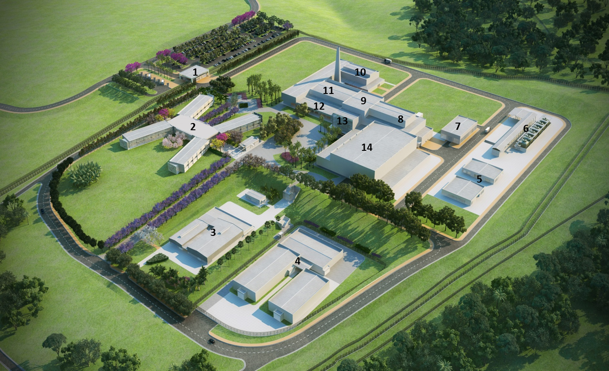 | 1 – RPN Entrance  2 – Researchers Bld.  3 – Workshop Bld.  4 – Waste Processing and  Storage Bld.  5 – Electrical Supply Bld.  6 – Cooling Towers  7 – Reactor Auxiliary Bld.  8 – Reactor Bld.  9 – Spent Fuel Bld.  10 – Post Irradiation Lab.  11 – Radioisotope  Processing Bld.  12 – Radiochemistry Lab.  13 – Operator Support Bld.  14 – Neutron Beam Lab.
Fig 2. Artistic view of RMB research and production nucleus.
In 2010, a decision was taken to adopt for the new research reactors of Brazil (RMB) and Argentina (RA10), the conceptual model of the OPAL research reactor based on INVAP design.
For the Brazilian RMB research reactor, in addition to radioisotope production and neutron beam utilization, two other design requirements were established by CNEN. The first one was the capability to test fuels and materials for the Brazilian nuclear reactor power program, and the second was the requirement to have the necessary infrastructure to allow the interim storage, for at least 100 years, of all spent nuclear fuel used in the reactor.

RMB is a MTR open pool type reactor that uses beryllium and heavy water as reflector, and light water as moderator and cooling fluid. The power of the reactor is 30 MW, and its main requirements were established by CNEN technicians during the feasibility study and conceptual design.

To comply with the requirement to allow the interim storage, for at least 100 years, of all spent nuclear fuel used in the reactor, a building named “Spent Fuel Storage Building” was designed adjacent to the reactor building. This building, which can be accessed directly from the reactor building, will have two pools: one for temporary wet storage of the spent fuel used in the reactor, and the other for handling and storage of rigs that were used for material and fuel irradiation tests. This building has a dry store zone for spent fuels in shielded casks.

The description of the reactor building and systems, and the spent fuel building and systems will be presented in other paper of this IGORR conference.

4. Project development status

The Ministry of Science, Technology and Innovation granted CNEN with financial resources for the conceptual and preliminary designs of the RMB project. It allowed, in 2012, the signature of a contract with INTERTECHNE, a Brazilian company, to develop the engineering work for the preliminary design phase of all buildings, facilities and infrastructure of the new center. In 2013 the contract with INVAP was signed for the work related to the preliminary engineering of the reactor and connected systems. The conclusion of both contracts is planned for November 2014.

Also in 2012, a contract was signed with MRS, a Brazilian company with tradition in environmental studies, to perform environmental and site studies for the RMB project. The Environmental Impact Report was finished by the middle of 2013, allowing the starting of the environmental licensing process with IBAMA (Brazilian Environmental Licensing Authority). Three public hearings were done, in October 2013, where the RMB project was discussed with the local and the state society. It is expected that IBAMA will issue the first Environmental license by the end of 2014.

The Site Evaluation Report for the nuclear site license was prepared in 2013. The Nuclear Regulatory Directorate of the Brazilian Nuclear Energy Commission is analyzing the report and is supposed to issue the license by the end of 2014.

Site topography was already surveyed; ground geotechnical analysis and sampling were completed, and a meteorological tower was installed and is operational since 2012.

5. Final Remarks

Next steps for the development of the project are: contract the detailed engineering design, procurement, manufacturing, construction, assembling, commissioning and management. These phases will be carried out by national and international companies and their implementation still depend on Federal Government decision to supply the corresponding necessary budget.

6. References

[1] J. A. Perrotta, I.J. Obadia, “The RMB project development status”, on Proceedings of the 2011 International Conference on Research Reactors: Safe Management and Effective Utilization, held in Rabat, Morocco, 14-18 November 2011; International Atomic Energy Agency, Vienna, Austria (2012), available at: http://www-pub.iaea.org/MTCD/Publications/PDF/P1575_CD_web/datasets/abstracts/C6Perrotta.html

[2] I. J. Obadia, J. A. Perrotta, “A sustainability analysis of the Brazilian Multipurpose Reactor Project”, on Transaction of 14th International Topical Meeting on Research Reactor Fuel Management (RRFM-2010), held in Marrakesh, Morocco, 21-25 March 2010; European Nuclear Society, Brussels, Belgium (2010), ISBN 978-92-95064-10-2, available at: http://www.euronuclear.org/meetings/rrfm2010/transactions/RRFM2010-transactions-s6.pdf

[3] J.A. Perrotta, A.J. Soares , “RMB: The New Brazilian Multipurpose Research Reactor”; Transaction of 1??the International Topical Meeting on Research Reactor Fuel Management - RRFM 2014 ;30 March - 3 April 2014, Ljubljana, Slovenia ; available at:
http://www.euronuclear.org/meetings/rrfm2014/transactions/RRFM2014-transactions.pdf

