Production Facilities for Reactor Produced Radioisotopes

V. Wilkinson¹, F. Molli¹, C. Maneiro¹, J. Merino¹

¹INVAP S.E., Radiochemical Process Department, Av. Cmte. Luis Piedrabuena 4950, R8403CPV, S.C. de Bariloche, Argentina

Corresponding author: jmerino@invap.com.ar

Abstract. INVAP supplies turnkey production facilities for reactor produced radioisotopes based on the know-how of radiochemical process from the Argentine Atomic Energy Commission (CNEA). The partnership INVAP-CNEA allows to cover all the phases needed to develop a project, from the conceptual design and safety analysis report to the commissioning and handover with radioactive material.
Among the available radioisotopes, it can mentioned ⁹⁹Mo from LEU targets irradiation, ¹³¹I (dry distillation and fission method), ¹²⁵I, ⁵¹Cr, ¹⁹²Ir (medicinal and industrial use), ¹⁵³Sm and ¹⁷⁷Lu. The plants are designed to produce these radioisotopes as bulk radioisotope or radiopharmaceutical end product, following the guidelines of Good Manufacturing Practice (GMP).
This paper will cover description of supplies related to the R&D, design, preparation and irradiation of targets, production hot cells, radiochemical process equipment, radiation monitoring, ventilation system, waste management and commissioning and training.

1. Introduction

Following INVAP´s capability as a supplier of multipurpose research reactors, it has also taken up the supply of radioisotopes plants and services.

INVAP supplies turn key projects for the radioisotopes production for medical and industrial use on the know-how basis of the radiochemical processes that belong to CNEA.

Among the already completed supplies we can mention the Radioisotope Production Facility (RPF) for “Inversiones Gamma”, in La Havana (Cuba), the Mo-99 process LEU based for ANSTO in Sydney (Australia) and the RPF facility for AEA in Cairo (Egypt). About the projects currently under execution we can mention the Mo-99 Production Facility LEU based for the Board of Radiation and Isotope Technology, Mumbai (India).

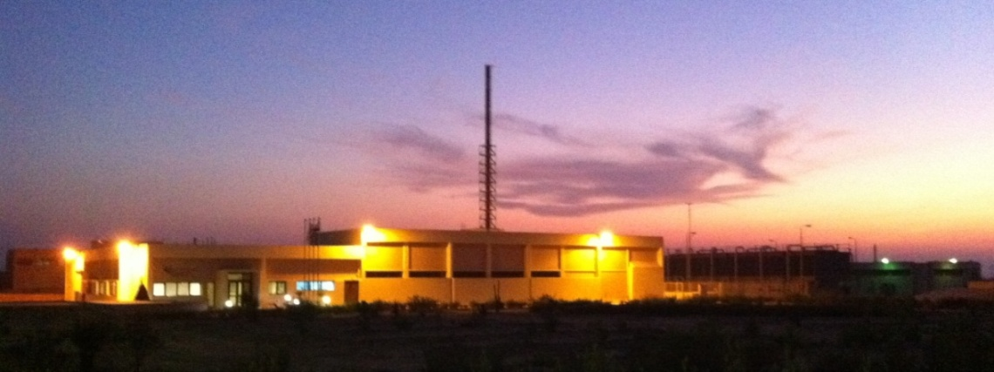
FIG. 1. Radioisotopes Production Facility (Egypt).

The INVAP-CNEA partnership as radioisotope production facility vendors allows mastering the following fields:

- Project Management
- Process Knowhow
- Development and Design
- Manufacturing and Installation
- Commissioning
- Training and Handover
- Operation and Maintenance Manuals
- Licensing Documentation
- Safety Analysis Report
- Quality Assurance

Among the radioisotopes and radiopharmaceuticals we can mention the following:

- ⁹⁹Mo and ¹³¹I from LEU (FIG.2)
- ¹³¹I by neutron capture nuclear reaction of Tellurium
- ¹²⁵I by neutron capture nuclear reaction of enriched ¹²⁴Xe
- ¹⁹²Ir wires for brachytherapy
- ¹⁹²Ir sealed sources for industrial gamma radiography
- ⁵¹Cr by Szilard-Chalmers process
- ¹⁵³Sm by neutron capture nuclear reaction of enriched ¹⁵²Sm
- Labelling of molecules with ¹³¹I and ¹⁵³Sm
- Loading of Technetium Generator (⁹⁹Mo/^{99m}Tc)

2. Research & Development

INVAP developed, designed and performed a method for the production of Mo-99, at a small scale, based on the irradiation of a solution of LEU, in a process that represents the operation of a homogeneous reactor, under contract by Babcock and Wilcox. The experiments were executed, in a dedicated and special facility, constructed at the RA-6 reactor in the Bariloche Atomic Center of the CNEA.

The conceptual study for the conversion from HEU to LEU of the separation method of Mo-99 and I-131 for the Institut National des Radioéléments (IRE) in Belgium was also carried out.

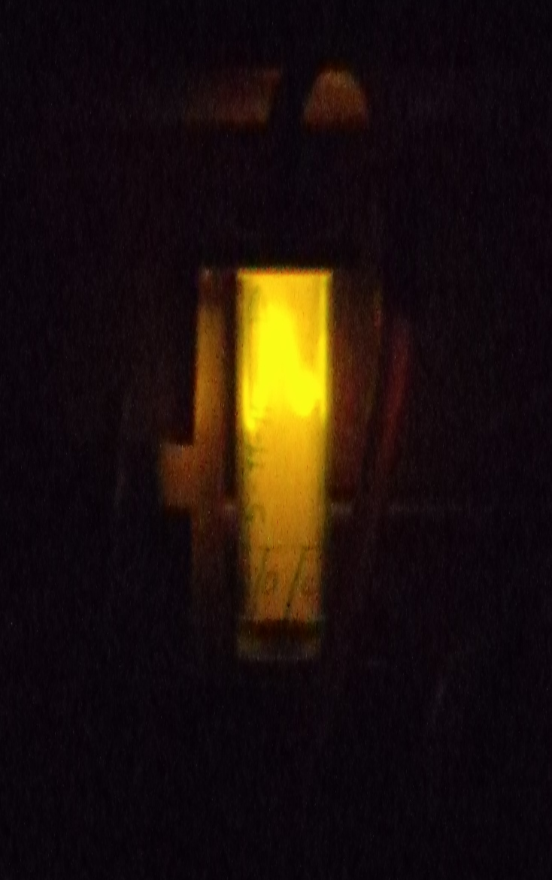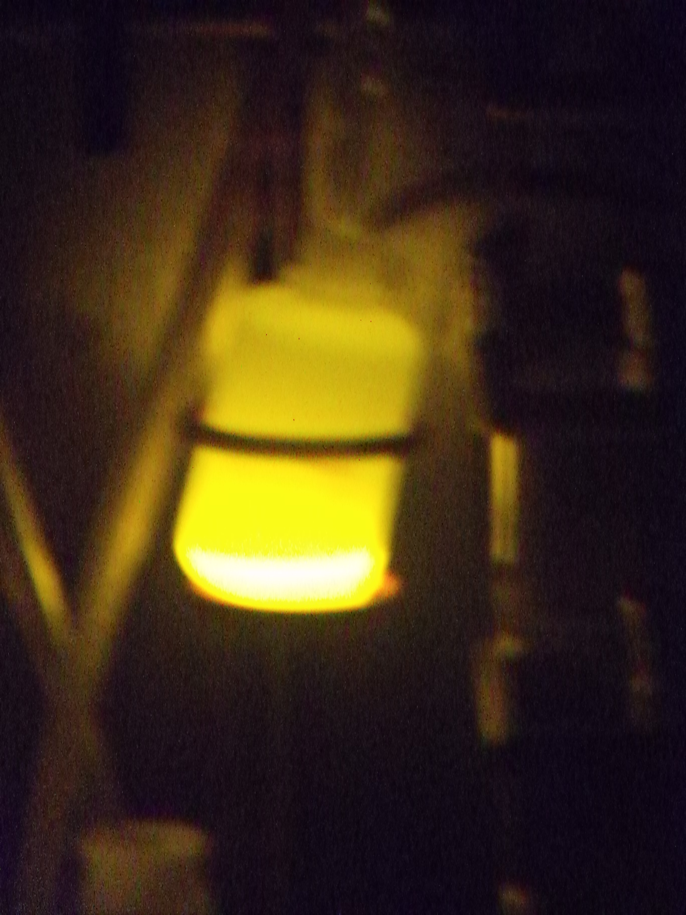
FIG. 2. Typical Cherencov Emission from ⁹⁹Mo Solution.

3. Design, Manufacturing and Installation

INVAP´s multidisciplinary engineering capability allows to do the design of the different systems in the radioisotopes plants, as well to continue with the fabrication of components in its own or third-parties workshops. The in-site erection and installation stages are supervised by INVAP qualified teams with vast experience in this kind of facilities.

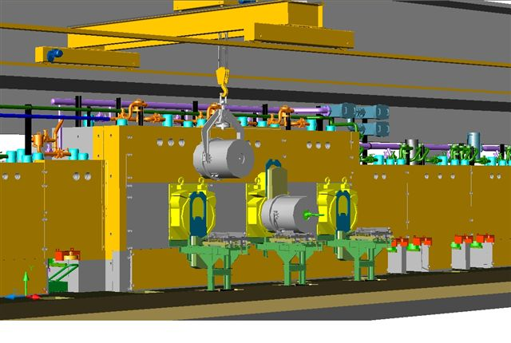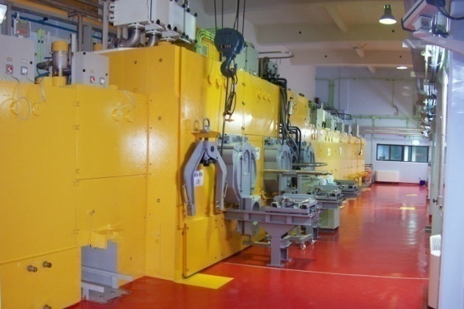
FIG. 3. Example of Design and Installation Comparison.

In the next sections the different involved radioisotopes areas are presented:

3.1. Targets & Target Irradiation Devices

The raw material for the production of radioisotopes are the targets irradiated in a research reactor, which calls for the integrated design of the irradiation facilities, the irradiation conditions and the irradiated target transfer systems between the reactor and the radioisotope facility.

The supply of the process systems covers the design and supply of the targets and devices for the irradiation with the respective thermo-hydraulic and neutronic calculations.

Targets are prepared at a specific plant or laboratory designed for that purpose. As it is non-radioactive material, they are manually transferred to the research reactor, where the targets are loaded into the respective irradiation device. From the pool head, the device is installed in its irradiation position in the grid or core.

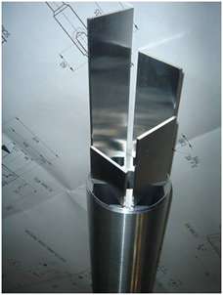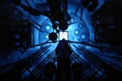
FIG. 4. Example of Target and Research Reactor for Irradiation.

3.2. In-Cell Process Equipment

The design of the equipment for the radiochemical process require dimensioning according to the production capacity and this implies, among others, the mass and energy balance, structural calculations, appropriate materials selection according to the estimated lifetime, etc.

Each production cell has the necessary process equipment to separate, purify and dispense radioisotopes, as well the vessels for the temporary storage of gaseous, liquid and solid waste.

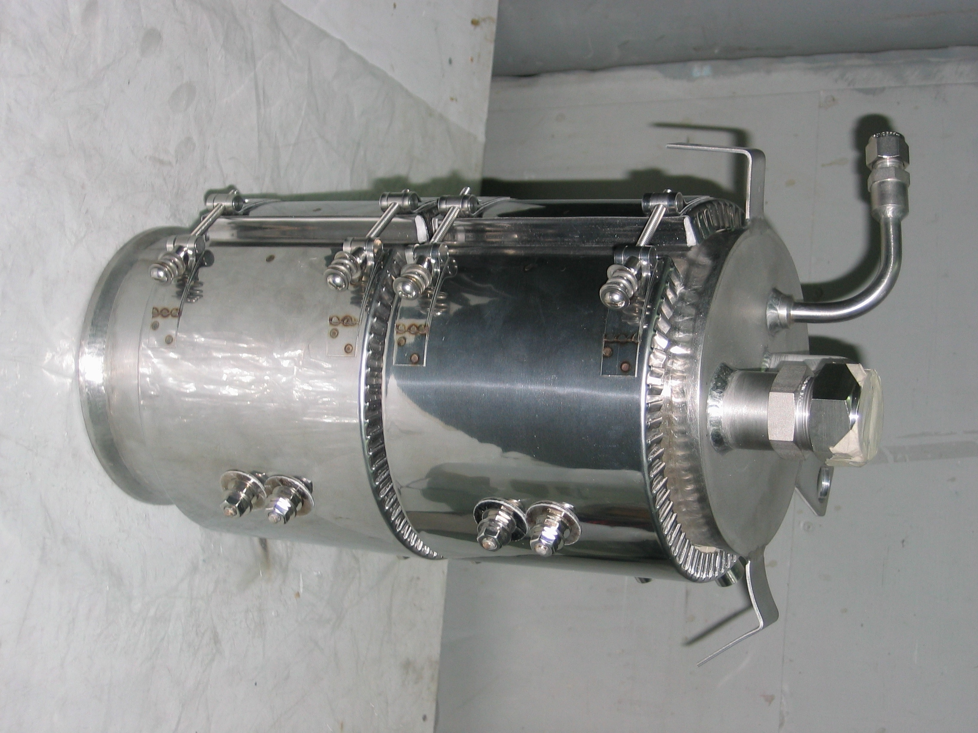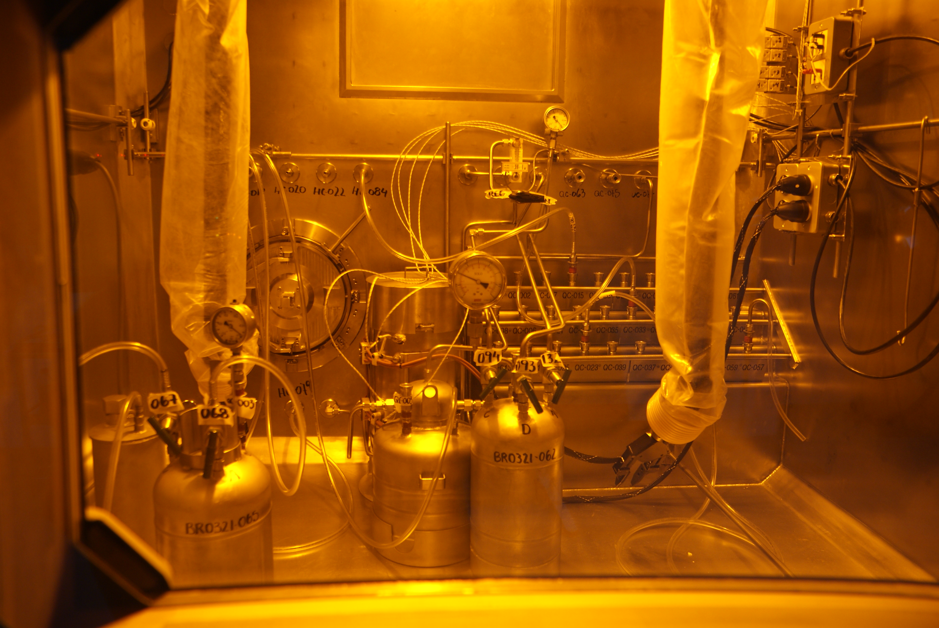
FIG. 5. Example of In-Cell Process Equipment.

3.3. Instrumentation & Control

The scope of supply includes the instrumentation and control systems of the plant. They can be divided into:

- Facility control and monitoring system
- Radiological control and monitoring system
- Ventilation system field instrumentation
- Radiochemical process field instrumentation

The Radiological Monitoring System performs the radiation monitoring throughout the facility, including areas, gaseous effluent (emission) through the stack, processes involving liquid and solid waste and personnel supervision inside the plant.

3.4. Hot Cells and associated gadgets

The hot cells outstand among the mechanical facilities, which assure the biological shielding to carry out the production tasks in safe mode from the radiological point of view.

INVAP has designed and fabricated more than thirty hot cells using lead, steel and heavy concrete as shielding materials.

The design starts with the definition of the tasks to be done in its interior and, according to activity inventory, the shielding thickness is estimated. Mock-ups are constructed during the engineering stage in order to confirm proposed technical solutions.

The following are the hot cells main components:

- Structure and Shielding
- Containment enclosure
- Access & Passages
- Master-slave manipulators
- Viewing
- Electrical and Lighting System

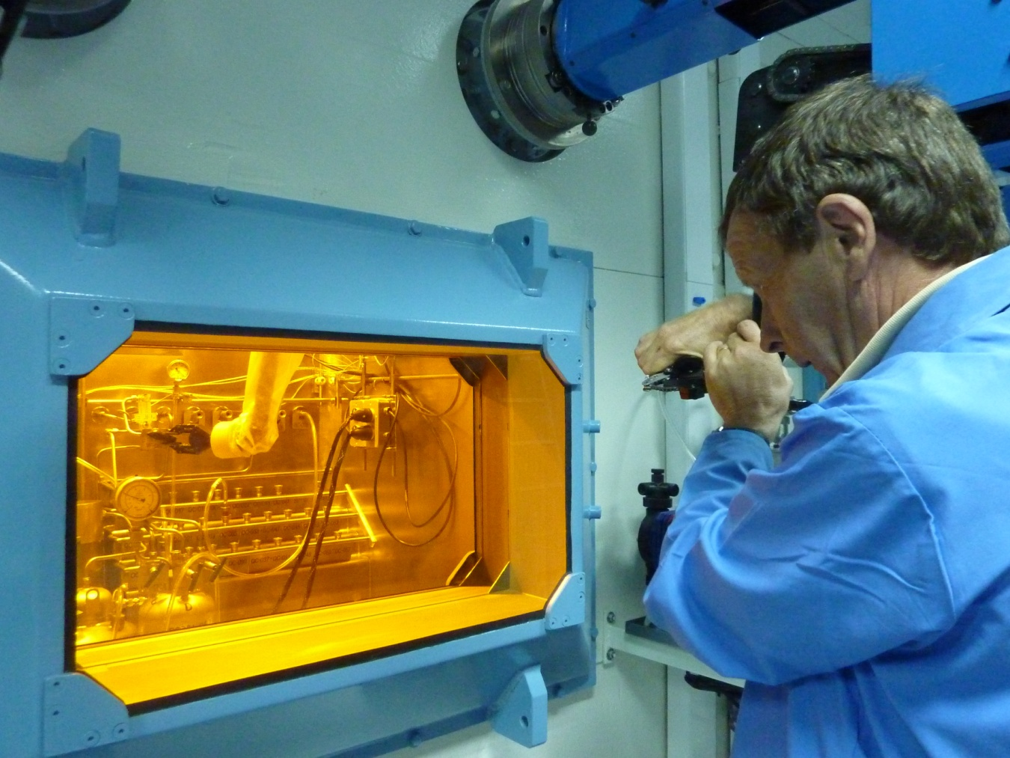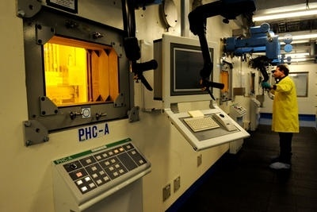
FIG. 6. Example of Hot Cell Operation Side.

3.5. Transfer & Transport Container

The movement of radioactive materials is done using shielded containers which must be designed according to the activity inventory to be transported and the decay heat to remove (e.g. the heat transfer mechanism to save the irradiated targets integrity).

Containers type A and B(U) are also supplied for the waste dispatch and final products.

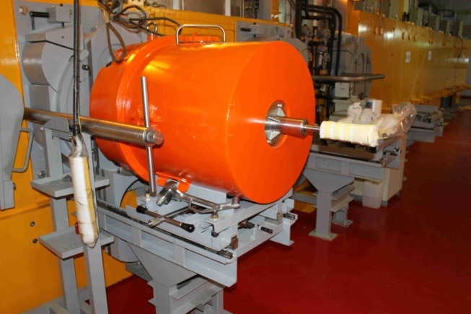
FIG. 7. Example of Transfer and Transport Containers.

3.6. Waste Management and Conditioning

The radioisotopes plants mainly generate low and intermediate activity radioactive waste which has to be appropriately managed.

INVAP design the premises so the waste gets the appropriate interim storage inside the plant until it is dispatched to the conditioning and disposal sites.

3.7. Building and Quality Control Laboratories

The building to develop production tasks and radioisotopes quality control must observe personnel and materials circulation and a layout and production facilities that follow the standards and guidelines of radiological protection and good manufacturing practice (GMP).

The facility has the following laboratories:

- Target preparation
- Reagents for production preparation
- Quality control
- Packaging and finished product storage area
- Decontamination area
- Workshop

The supply includes the quality control laboratories with all its equipment and the control techniques set to use.

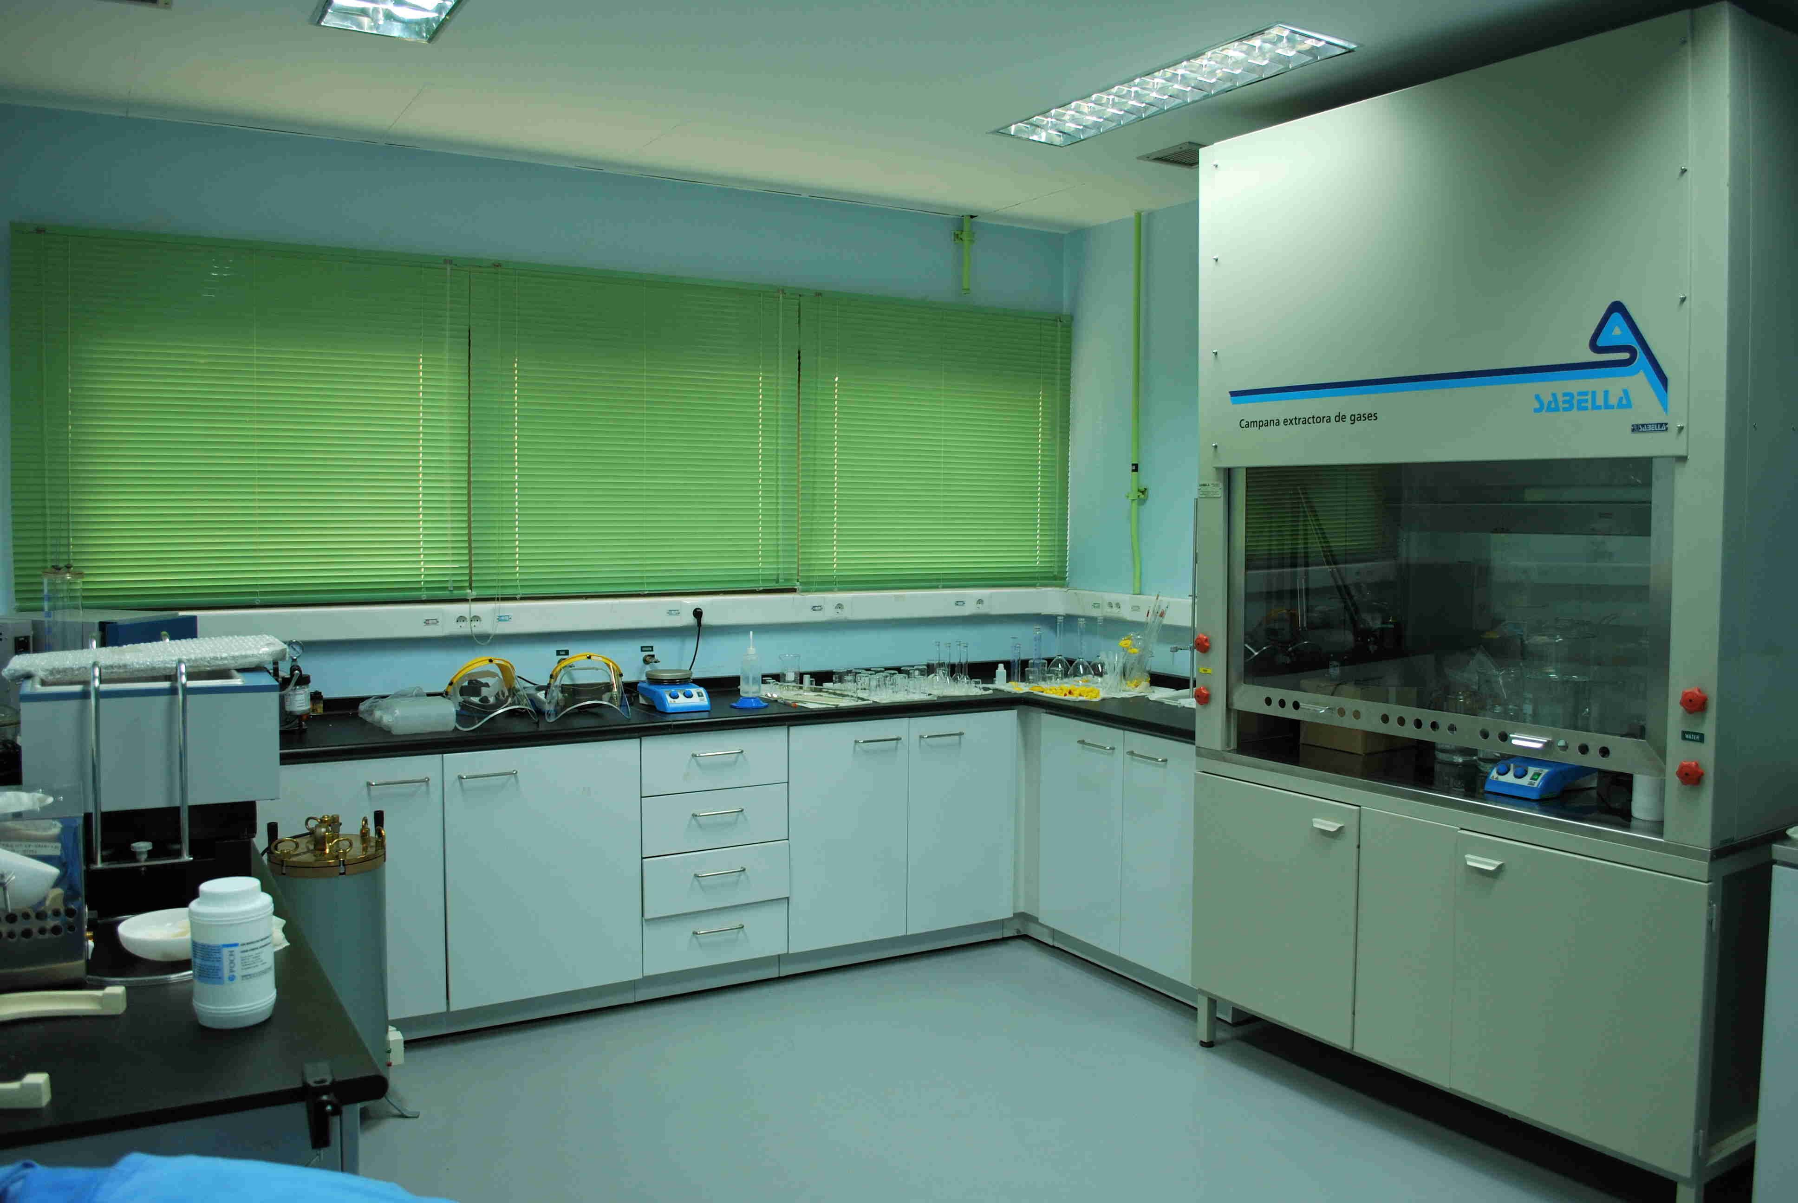
FIG. 8. Example of Active Laboratory.

3.8. Facility General Services

The general services of the facility include fire, electrical and air-compressed systems.

The ventilation system comprises the radiological and non-radiological areas and the hot cells. The hot cells ventilation comprises with iodine and aerosols retention. According to the production capacity of the facility and limit of emission to the environment it might be necessary a specific system for the xenon and iodine emissions abatement.

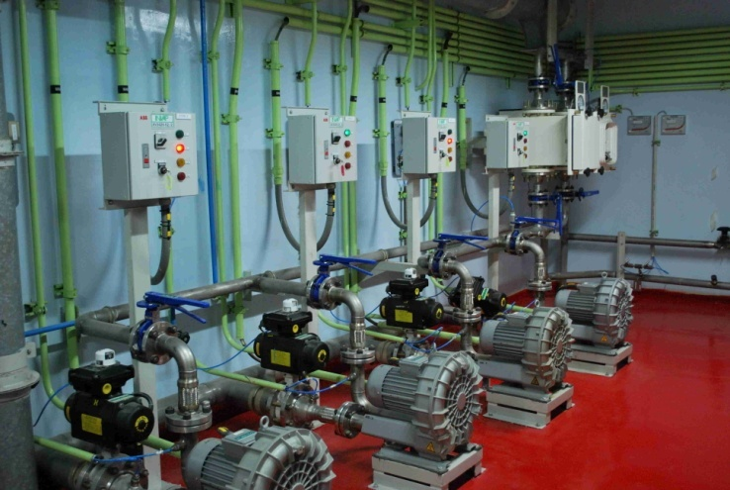
FIG. 9. Example of Facility General Services.

4. Commissioning and Training

The commissioning of the radioisotopes plant has a cold pre-operation period (without radioactive materials) and a final operational period with radioactive materials.

The cold commissioning stage starts with the Factory Acceptance Tests (FAT) and concludes with the Site Acceptance Tests (SAT) and the production systems without radioactive materials integrated period.

During the FAT the main components will be entirely assembled in the workshop so as to identify and correct any possible issue and to avoid concerns on site. The SAT and integrated cold tests allow to assess the functional and performance parameters of all the systems before loading radioactive material.

The hot commissioning consists of pre-determined number of runs using radioactive materials, progressively increasing radioactivity levels until reaching the capacity of nominal production.

Once this stage is completed the operation and performance of the facility within the design parameters is demonstrated and also the accomplishment of the final product specification according to the pharmacopoeia.

Initially the training is focussed on the first operation team. This training include theoretical and on-the-job training for the future operators, maintenance and utilisation staff.

The theoretical course is done with specialised personnel in the different topics. The on-the-job training is done in CNEA´s facilities in Argentina and in the radioisotopes production facility in site, supervised by specialists in the different areas of interest.

Through the start-up, operational staff is incorporated into teams to participate and observe the operations. This allow staff to become familiar with the facility and ensure a smooth take over.

These training activities normally include:

- Participating in the operation in mock-ups
- Participating in maintenance tasks
- Typical manoeuvres executed with tongs and master-slave manipulators
- Health Physics practices
- Quality control routine
- Witnessing in process plant operation.

