Replacement of the Oregon State University TRIGA® Reactor Annular Reflector

S. Todd Keller, Steven R. Reese, Robert A. Schickler

Oregon State University, A100 Radiation Center, Corvallis, OR 97331

Corresponding author: kellerst@engr.orst.edu

Abstract. The integrity of the annular reflector of the Oregon State University TRIGA® Reactor (OSTR) was compromised, allowing the interior graphite to become water saturated. This resulted in decreased reflector efficiency and neutron flux reduction in ex-core facilities. The reflector was replaced during a six-month reactor outage in 2013. This paper presents a time-line and description of activities involved with reflector replacement. Activities included defueling and complete dismantling of the reactor, removal and replacement of the reflector and re-assembly of the reactor. A discussion of dose management is also included. The total deep-dose/whole-body exposure for the job was 0.031 sievert (3.1 rem). After job completion, flux in the thermal column increased by a factor of 3 and flux in the tangential beam line increased by a factor of 10.

1. Introduction

The Oregon State University TRIGA® Reactor (OSTR) is a General Atomics TRIGA® Mk II water-cooled, pool-type reactor originally built in 1967. It is licensed to operate at 1.1 MW, utilizes 30 wt%/20% enriched U-ZrH fuel, has a pulsing capability, and typically operates between 60-80 MW-days per year. In 2011, Oregon State University was awarded a grant by the U. S. Department of Energy (USDOE) to replace their annular graphite reflector. The grant was awarded via the Nuclear Energy University Program – Major Reactor Upgrades. The reflector is an integral part of the reactor structure and had lost integrity in the mid 1990’s as evinced by significantly reduced flux levels in external facilities. Gas venting from the reflector also occurred regularly during reactor operation.

Since repairing the reflector in situ would be very difficult, replacement was the only option to restore the reactor to optimal performance. Although a large job, removal and replacement of the reflector allowed additional opportunities for uncommon reactor maintenance activities such as ultrasonic inspection of the reactor tank and reinforcement of seams and welds.

The reflector was replaced during a six month reactor outage from July through December, 2013. The outage followed a year and a half of bidding and job planning. Major components were fabricated by General Atomics, who was also contracted to assist in the reflector replacement.

This paper contains a timeline of all major activities involved in replacing the reflector. Certain activities considered unique or of special interest are discussed in detail. A discussion of the radiation fields involved in the work and dose management is also included.

2. Timeline of Major Activities

2.1. Overview

Since the reflector is an integral part of the reactor structure, replacement of the reflector required defueling and complete disassembly of the reactor. A detailed timeline of activities is given in Table 1. Reactor operation was suspended on July 1, 2013. Fuel was allowed to cool for a month prior to removal to the Bulk Shield Tank (BST), the initial repository for all highly radioactive items removed from the reactor tank. While the fuel was cooling, a fuel storage rack was installed in the BST. A shielded transfer bucket was also constructed (Figure 1). All non-essential equipment was removed from the reactor top and BST areas in order to facilitate fuel transfer.

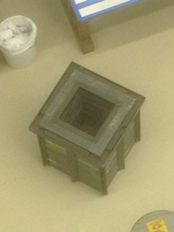
Figure 1, Shielded Transfer Bucket

All fueled components were removed from the reactor tank to the BST in three days (Figure 2). Disassembly and removal of support equipment and experimental facilities continued throughout the month of August. Once all detachable items had been removed, the reactor tank was partially drained, leaving 2.4 meters of water remaining in the tank (Figure 3). This water served as shielding for the strongly activated items remaining in the tank.

The reflector assembly was moved to the BST on September 10, 2013. Prior to removal, a steel bellows/clamp assembly which physically connected the reflector to the reactor tank had to be disconnected. Once the reflector was out of the tank, the remaining water was removed, the tank was thoroughly cleaned and visual and ultrasonic inspections were performed.

The new reflector was delivered on October 23, 2013 and installed shortly thereafter (Figure 4). Most adjunct structures were replaced with new copies. The reflector rests on a stand attached to the tank bottom, but is held in place only by gravity and the flexible bellows attached to Beam Port #4 (BP4). Once the reflector and major hardware were in place, control rods were installed in the core. This was followed by installation of graphite reflector elements and then loading of the fuel. Fuel was loaded per the same loading plan used in the initial LEU fuel load of 2008. The reactor achieved initial criticality on 67 fuel elements. Fuel loading continued until the operational core configuration was achieved. Routine calibrations were performed and the reactor was restored to normal service on January 6, 2014.

2.2. Timeline

Table 1, Timeline of Major Activities
Activity | Date
NEUP Grant Awarded | 12/2011
Repair Contract Awarded | 3/2013
Reactor Operation Suspended - Outage Begins | 7/1/2013
Fuel Storage Rack installed in BST | 7/12/2013
Transfer Basket Fabricated | 7/19/2013
Commence Fuel Offload | 8/5/2013
All Fissionable Material Removed from Reactor Tank | 8/7/2013
All Nuclear Instruments and Experimental Facilities except Lazy Susan Removed from Reactor Tank | 8/9/2013
Rotating Rack Removed from Reactor Tank | 8/12/2013
Collimator Removed from BP4 | 8/15/2013
Drained Reactor Tank to 2.4 Meters Above Tank Bottom | 8/26/2013
Installed BP4 Inflatable Plug | 8/28/2013
Subcontractor Team Arrives. Beam Port Shim Plates Removed. | 9/3/2013
BP4 Bellows and Clamps Removed | 9/5/2013
Three Air-Powered Hoists Installed for Reflector Removal | 9/9/2013
Reflector Assembly Transferred to BST. Reflector Stand Transferred to BST. | 9/10/2013
All Remaining Loose Items/Debris Removed from Tank. All Remaining Tank Water Removed. | 9/11/2013
Initial Reactor Tank Survey Conducted | 9/12/2013
Access Scaffolding Erected in Reactor Tank | 9/19/2013
Tank Cleaning and Preliminary Inspection | 9/20/2013
Detailed Visual Inspection of Tank Welds Conducted. Ultrasonic Inspection of Tank Walls Conducted | 9/30/2013
All Welds and Seams in Lower Portion of Tank Reinforced with Epoxy | 10/23/2013
New Reflector Arrives | 10/25/2013
New Reflector Stand Installed. New Reflector Placed on Stand. | 10/29/2013
BP4 Bellows Installed. Leak Test Failed. | 10/30/2013
BP4 Bellows Successfully Installed | 10/31/2013
Support Equipment Installed. Thorough Tank Cleaning. Scaffolding Removed. Tank Partially Re-Filled. | 11/1/2013
Tank Re-Fill Complete. Support Equipment Installed. | 11/6/2013
Rotating Rack Installed | 11/20/2013
Nuclear Instruments Installed. Pneumatic Rabbit Installed. | 11/25/2013
BP4 Collimator Installed | 12/2/2013
Reflector Elements Installed in Core. Source Installed. | 12/5/2013
Control Rods Installed | 12/10/2013
Criticality Achieved with 67 Fuel Elements Installed | 12/16/2013
Operational Core Configuration Established | 12/18/2013
Calibrations and Flux Mapping Completed | 1/3/2014
OSTR Restored to Normal Operation | 1/6/2014

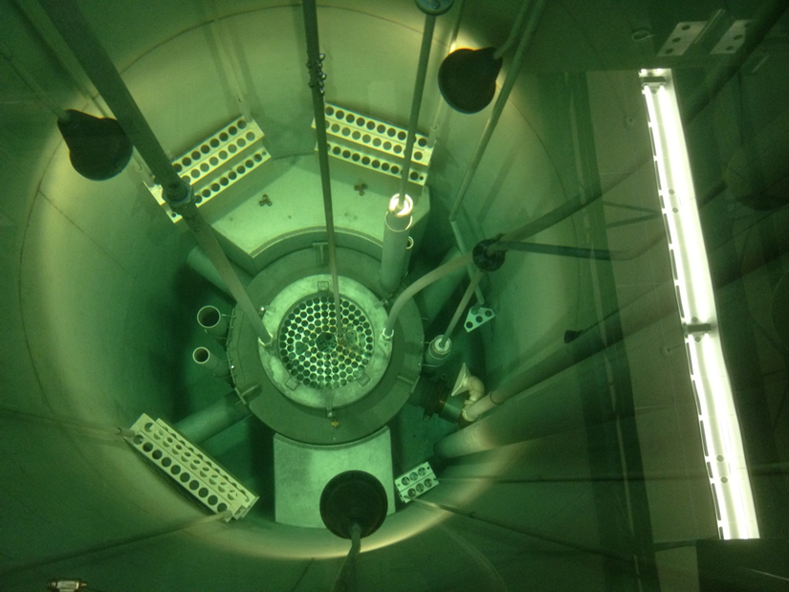
Figure 2, OSTR, Defueled

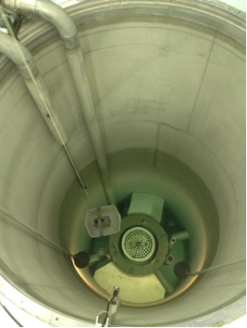
Figure 3, Old Reflector, Ready to Come Out, Tank Partially Drained, Radiation Survey in Progress

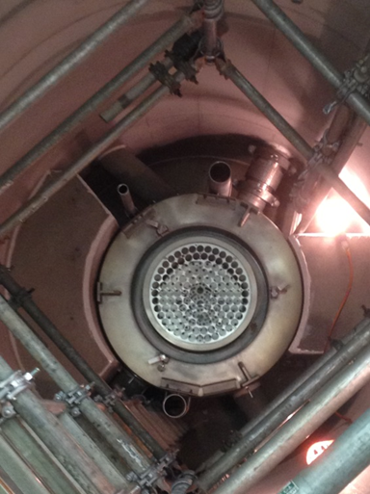
Figure 4, New Reflector and Bellows (Note Access Scaffold and Epoxy)

2.3. Details

Some of the more interesting/complex activities are described in detail below. Some activities were one-of-a-kind, and are never expected to be repeated at the OSTR. Some activities required fabrication of special tools or working in constrained or otherwise challenging environments.

Moving fuel out of the reactor tank is not a common activity, but the staff was well practiced by virtue of the 2008 core offload and conversion to LEU fuel. OSU possesses a shielded transfer cask. To move an element from the reactor tank to the BST involved lowering the cask into the tank until it was submerged about 1 meter. The fuel element was then picked up and brought close to the surface and lowered into the cask from the top. The cask containing the element was then moved to the BST using the crane where the element was placed in the custom made fuel storage rack (Figure 5). Fuel-followed control rods were moved in a similar manner, although the long connecting rods presented a challenge due to limited headroom. Total round-trip time to move one element was about ten minutes. All fuel was removed from the tank in three days.
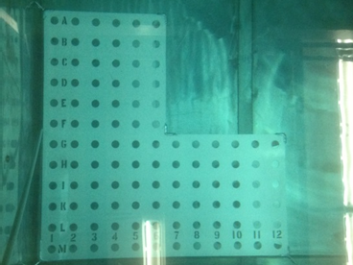
Figure 5, Fuel Storage Rack

Removal of the rotating rack was challenging because it was one of the most radioactive items to be moved, and it was quite buoyant. The reactor tank was left full for shielding, so once dismounted from the reflector, the rotating rack tended to rise to the surface unless restrained. Lead weights were attached to the rotating rack to counteract this tendency. One crane operator remained in the reactor bay while the rack was moved to the BST. Dose rate at 2 meters was observed to peak at 60 mSv/hr (6000 mR/hr) during the move.

BP4 is physically connected to the reflector by a stainless steel bellows assembly. A Prompt Gamma Neutron Activation Analysis (PGNAA) facility is installed at BP4. Part of the apparatus is a collimator which extends through the bellows and slightly into the reflector itself. To remove the reflector and bellows, the collimator had to be removed. The PGNAA facility was removed, but the collimator was stuck in place due to small amounts of corrosion products that had built up between the collimator and the beam tube. A gantry and chain fall was used to apply pressure to extract the collimator, but it refused to move under maximum allowable force. Penetrating oil and gentle, repeated tapping were applied to the collimator over the next several days and it finally broke loose. The beam port was thoroughly cleaned, painted with epoxy and lined with PTFE to prevent this problem from reoccurring.

Removal of the BP4 bellows was intended to be performed underwater for shielding purposes. With the collimator removed, there would be unobstructed flow path out of the tank after the bellows was removed. To prevent outflow, a custom plug with a compressible seal (Figure 6) was fabricated to fit BP4. Pressure tests performed on the plug before removing the bellows indicated a good seal. No water was seen in BP4 after the bellows was removed.

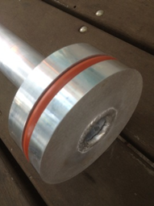
Figure 6, Beam Port #4 Inflatable Plug

Bellows removal was challenging. The job was performed by several personnel working about three meters above the tank bottom (0.5 meters above the water level). All tools had to be attached to extension handles. Additional viewing angles were provided by cameras. The bellows is attached by two clamps and each clamp is secured with two bolts. All items had been under water for over 40 years. The more stubborn bolts ultimately required the use of an air wrench to break free. Once un-bolted, the clamps still had very little clearance, but finally the clamps and bellows were disconnected and placed in the shielded transfer bucket for removal.

After bellows removal, the reflector was resting on a square support platform but was no longer physically connected to the tank. Three air hoists were mounted on the bridge crane hook and connected to the three lifting eyes. The system was tensioned using the main crane hook and then the reflector was lifted – carefully – out of the tank. The initial portion of the lift had very tight clearances due to close proximity of beam ports and the thermal column. Once the reflector was about 1 meter above the tank bottom, all obstacles were clear and the lift became straightforward. Dose rates from the reflector were actually significantly lower than dose rates from the rotating rack.

Once all removable components were out of the reactor tank, the rest of the water was removed and a dose rate survey was performed. Results are discussed in section 3. Dose rates were low enough to allow personnel entry, but stay times were limited to manage dose. With all components removed, the highest measured dose rate was 20 mSv/hr (2 rem/hr) on contact at the face of the thermal column. The tank was thoroughly cleaned and then inspected. All welds and seams were visually inspected. Tank wall thickness was also measured ultrasonically. Visual and ultrasonic inspections indicated no tank degradation. Following the inspections, a scaffolding was erected inside the tank to allow normal personnel access.

As a preventive measure, an epoxy sealant was applied to all welds and seams in the lowest 2 meters of the reactor tank. The product selected for this work was BIO-DUR 561 epoxy. This type of epoxy has been used successfully at other facilities and is rated for underwater applications and use in elevated radiation fields. The epoxy was applied using a dual mixing caulk gun. Custom hand tools were used to access hard-to-reach places and smooth the final coatings. The epoxy took about 48 hours to cure.

The new reflector arrived about six weeks after the old reflector was removed. New components were fit-tested and assembled. Installation of the new reflector was quite a bit easier than removal since the new reflector was not activated and the job was not performed underwater. Installation of the new BP4 bellows and clamps was tricky and it took several tries to pass an integral leak test.

Once the reflector was in place, the rest of the components were installed. Except for the rotating rack and nuclear instruments, all components were newly fabricated and non-radioactive. Getting the rotating rack back into position turned out to be easier than removing it. The only significant difficulty encountered during re-assembly was insertion of the collimator back into BP4. Interference was encountered during the last 35 cm of insertion. It was determined that the new bellows had a slightly smaller inner diameter than the old one. With such tight clearances in BP4, the collimator would not clear the bellows. As a solution, the last 35 cm of the collimator was removed.

Reload and restart of the reactor proceeded smoothly. The reloading plan from the initial LEU startup in 2008 was re-used. The reactor went critical on the same number of fuel elements. Control rod and nuclear instrument calibration was performed. All other maintenance items that could not be completed due to absence of the reactor were also completed. Flux levels were measured in all reactor experimental facilities. Fast and thermal flux were unchanged in the core center. Thermal flux in the thermal column increased from 8E10 neutron/cm^2-sec to 3E11 neutron/cm^2-sec. Thermal flux in the radiography facility (Beam Port #3) increased from 5E5 neutron/cm^2-sec to 5E6 neutron/cm^2-sec. Flux in BP#4 was not characterized.

2.4. Lessons Learned

Overall the job proceeded smoothly and completed on schedule. There were a few glitches, but given a job of this magnitude, setbacks were few and minor.

Rotating Rack Removal. This job was complicated due to the buoyancy of the rotating rack. Ultimately, several kilograms of lead weights were added to the rotating rack which allowed much easier control and crane transfer out of the reactor tank.

Collimator Removal. The BP#4 collimator had to be removed in order to remove the reflector. The collimator was stuck for several days before it finally broke loose. Alternate plans included sawing through the bellows or sawing through the flanged BP#4 extension extending from the reflector. Either option would have produced loose contamination issues. Prior to re-insertion, BP#4 was painted and then lined with PTFE. For future collimator design, increased clearance between Beam Port and collimator is suggested.

Remote Cameras. Remote viewing capabilities are essential.

Custom Tools. Several custom tools were fabricated, mostly to allow torqueing nuts in locations difficult to access. Initial work was done under 1-2 meters of water.

Rusty Nuts. Most TRIGA® components are aluminum. Some of the nuts on the reflector stand appeared suspiciously rusty. When removing the stand, these nuts were radioactive hot spots, but were not as hot as expected for steel that had been irradiated for over 40 years.

Tank Inspections. Visual inspection of all welds was performed. Ultrasonic inspection was performed to check for reduction of tank wall thickness. No defects were identified. Use of Dye-Penetrant inspection was discussed but not performed due to concerns over post-test dye removal.

Tank Access. Scaffolding with mounted ladders was constructed inside the reactor tank for access. A retrieval winch was also required as safety gear for confined space entry. Standalone ladders would have been adequate for access, but the scaffolding allowed for construction of stable work platforms at various heights above the tank bottom.

Obtaining Bellows Seal. Obtaining a seal on each side of the bellows took several attempts. After the initial attempt, the bellows was pressurized and checked with a soap solution. No bubbles were observed, but a subsequent helium leak test indicated significant leakage. Clamps were tightened several times and a Teflon coating was added to one gasket before a good seal was obtained and leakage was reduced to zero.

Tank Re-Fill. The reactor tank was re-filled with water purified using ion exchange resin beds. Water entering the tank was very clean, but when circulation was initiated, lots of floating impurities were observed. The tank had been thoroughly cleaned after reflector replacement, but apparently some debris remained in crevices and hard-to-reach places. A recirculating filtration system was devised and this quickly removed remaining debris. Water conductivity returned to normal levels after a few days of filtration and circulation through the installed ion exchanger.

Collimator Re-Insertion. After collimator removal, BP4 was scrubbed, painted and lined with PTFE. Collimator insertion proceeded smoothly until the last 35 cm where it encountered binding and obstruction. It was determined that the inner diameter of the bellows was slightly smaller than the previous bellows, and the collimator was too large to pass. The innermost 35 cm of the collimator was removed and the PGNAA facility was restored to an otherwise normal configuration.

Alignment of Fuel When Re-Loading. The TRIGA® fuel lattice has very tight clearances between elements, in some cases just a few millimeters. Each fuel element has an indexing pin on the bottom which mates with a corresponding dimple on the lower gridplate. While loading fuel in the B-ring, one element was slightly cocked. The very slight mis-alignment was exaggerated as more fuel was loaded. When loading fuel in the C-ring, it became obvious that there was an alignment problem. Use of a remote camera that fit through the upper gridplate was very helpful when diagnosing this problem.

3. Dose Rates and Dose Management

An ALARA plan was written prior to replacing the reflector, but once tank access was possible the plan was revised due to higher than anticipated dose rates. The OSU ALARA plan was based on dose rates measured during a similar job at a different reactor, but the nature of the work necessitated higher exposures for the OSU work. The revised plan limited total person-rem for the job to 40 mSv (4 Rem) deep dose equivalent and 200 mSv (20 Rem) to extremities. Higher dose rates in the OSU tank were due primarily to thicker structural aluminum components and longer power history. Although aluminum has a very short half-life, trace materials in the aluminum contribute significantly to dose rates. Most of the exposure was received while removing the BP4 bellows and while applying epoxy. Total dose received during the job was 30.72 mSv (3072 mrem) deep dose equivalent, 31.99 mSv (3199 mrem) shallow dose equivalent and 42.62 mSv (4262 mrem) extremity.

Where possible, dose was minimized by the use of portable shielding. This proved problematic in most cases since work space at the bottom of the reactor tank was extremely limited and much of the work required access to the hottest surfaces and components. A map of dose rates at the bottom of the tank is shown in Figure 7. All OSU staff members completed confined space training so that the total dose could be spread out over more workers. The highest individual dose was 6.83 mSv (683 mrem) deep dose equivalent and 7.75 mSv (775 mrem) extremity.

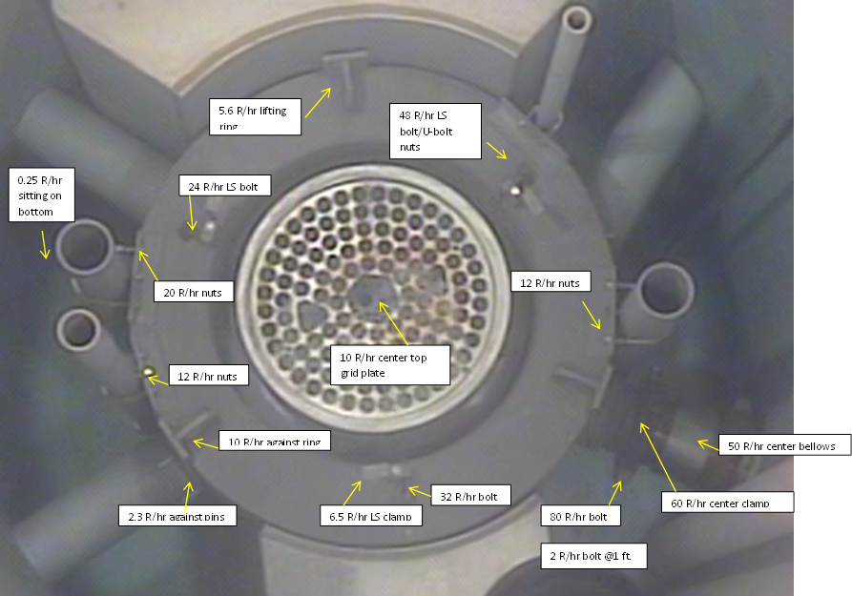
Figure 7, Dose Rate Map

4. Conclusion

Reflector replacement was a complex job requiring coordination between several large organizations. The job was completed on schedule and on budget thanks to the professionalism and experience of the people involved. The OSU staff greatly appreciated the enthusiastic assistance of Greenberry Industrial and General Atomics.

