Research Reactor Spent Fuel Management in Argentina

L. Mottillo¹, D. Russo¹, A. Coppo¹, O. Novara²

1) National Program for Spent Fuel and Radioactive Waste Management
2) Nuclear Fuel Department
Argentine Atomic Energy Commission (CNEA), Av. Del Libertador 8250
Ciudad Autónoma de Buenos Aires, Argentina

Corresponding author: mottillo@cae.cnea.gov.ar

Abstract.
Argentina has six operating research reactors. The option for spent fuel management activity dealt with the identification of technically viable possibilities for research reactor spent fuel management, particularly for operational and interim storage (wet and dry), spent fuel transport and spent fuel conditioning. Moreover, it aimed to be the main source of information for the design and implementation of related facilities.
The main Argentine research reactor, which is dedicated to radioisotope production, is RA-3 (10 MW). It is located at Centro Atómico Ezeiza in Buenos Aires, and its spent fuel is stored in a separate decay pool, physically independent of the reactor pool, located inside the reactor building.
In this work we are describing the current activities relate with the interim storage and the medium and long term alternatives under consideration regarding the management of the spent fuel from the present and future Argentine research reactors.

1. Introduction
The Argentine Atomic Energy Commission (CNEA, for its acronym in Spanish) is the governmental institution that advises the executive power on nuclear policy in Argentina and, among many other incumbencies in the nuclear activity of the country, it is responsible for the spent fuel and radioactive waste management. CNEA is the owner and operates all the research reactors in the country; Argentina has six operating research reactors that can be divided into two groups.
The first group comprises the reactors that operate according to a regular schedule, which includes research reactors RA-1, RA-3 and RA-6. The second group comprises the critical assemblies RA-0, RA-4 and RA-8. Nuclear fuels elements and its characteristics are shown in Table I. The multi-purpose RA-10 reactor is being constructed in order to produce radioisotopes at a commercial scale and currently it is in the design stage. CNEA developed the Siting Assessment, Environmental Impact Study and Preliminary Safety Report; from which the Nuclear Regulatory Authority (ARN) granted the construction license.
The purpose of this publication is not to present ready solutions fo r RR SNF management in Argentina, but to present possible ways to assess all aspects on reprocessing and recycling affecting the decision-making process in defining their RR nuclear fuel cycle back-end management strategies. In this work we present the new interim wet storage facility and the medium and long term alternatives under consideration regarding the management of the spent fuel from the present and future Argentine research reactors.

2. Main stages of nuclear fuel cycle and back end strategy.
This section introduces the main stages of the nuclear fuel cycle. The front-end comprises all stages of nuclear fuel manufacture, from mining of raw material to fabrication of fuel assemblies. The back end comprises the SF management after its removal from the reactor core. Many issues are needed to be taken into consideration by a country while developing a back end strategy for its RR SF.

TABLE I: Research Reactors in Argentina
Reactor | Reactor Type | Status | Power | Fuel
 |  |  |  | Type | Cladding | Core | Enrich-ment
RA-0 | Critical assembly Zero power | Operating | 1 W | Extruded rod | Al | UO2 / graphite | 20%
RA-1 | Critical assembly | Operating | 40 kW | Rod | Al | UO2/C | ≤ 20%
RA-3 | Radioisotope production and research | Operating | 10 MW | Plates MTR | Al | U3O8/Al -U3Si2 / Al | ≤ 20%
RA-4 | Critical assembly Zero power | Operating | 1 W | Annular discs | Poly-ethylene | U₃O₈ | ≤ 20%
RA-6 | Research and Teaching (BNCT) | Operating | 3 MW | Plates MTR | Al | U3O8/Al - U3Si2 / Al | ≤ 20%
RA-8 | Critical assembly Zero power | Closed | 10 W stationary 100 W transitory | Rod | Zircaloy | UO2 | 1,8 - 3,4%
RA-10 | Radioisotope production and research | Design stage | 30 MW | Plates MTR | Al | U3Si2 | ≤ 20% (19,7%)

Currently, the choice of a strategy for the management of spent nuclear fuel (the so-called back end strategy) is limited to the following three possibilities (Figure 1):

(1) “Direct disposal” or “once through fuel cycle”

The direct disposal strategy has not been implemented to date in any country. In a limited number of countries, such as Sweden, Finland, Switzerland, France or USA, projects for SNF and high-level waste (HLW) disposal facilities are in advanced stages of implementation (for example siting or licensing). But this strategy is not available for every country operating research reactors, due to the many difficult issues that must be addressed (financial, technical and political issues, public opinion, etc.)

(2) “Storage and postponed decision” or “wait and see option”

After discharge from the core, RR SNF is stored under water, usually in at reactor (AR) facilities, for a period of time to allow for cooling. This wet storage can be extended, in AR or away-from-reactor (AFR) facilities, in some cases over long periods (~50 years), or the RR SNF may be transferred to dry storage (AR or AFR) sites and stored dry for even longer periods.
None of the above-mentioned strategies for RR SNF management can be considered as the end point of the RR nuclear fuel cycle. Regardless of how long this extended interim storage is drawn out, the resolution of the back end problem will remain, and proliferation, safety, and physical protection concerns will continue. There is also the risk of the claddings of the spent fuel assemblies (SFA) in long duration wet storage to lose their tightness releasing fission products to the water due to corrosion. During dry storage, there is the risk of losing the constructive integrity of the SFA. Management of leaky and/or defective SFA requires additional expenses.

(3) “Reprocessing and recycling” or “closed fuel cycle”.

Considering current technologies, for the generating country one of the end points of the RR nuclear fuel cycle is attained when the RR SNF is returned to the country of origin in the framework of the take-back programmes (i.e. the US Foreign Research Reactor Spent Nuclear Fuel (FRR SNF) Acceptance Programme and the Russian Research Reactor Fuel Return (RRRFR) Programme), or sent for reprocessing and further utilization in one of the countries that offer commercial back end fuel cycle services, such as France and Russia.

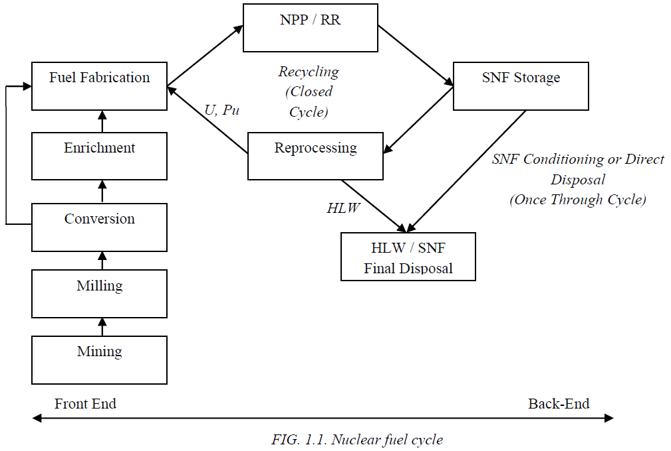
FIG. 1. Nuclear Fuel Cycle.

Perpetual postponement of a final decision regarding the end point for the RR spent fuel produced nowadays is not ethical or technically reasonable considering that after achieving their goals the take-back programmes will certainly cease. Then every country with a RR will face the necessity to develop a national strategy for RR SNF management, and for countries with small nuclear power programmes the expensive construction of AFR extended interim storage facilities and/or geological repositories for the relatively small amounts of spent fuel accumulated may not be practicable.
Different countries have different approaches to the back end management of the fuel cycle. It can be once through or closed fuel cycle with SNF reprocessing. For example, a main strategic principle of the Russian policy in the field of atomic energy is the closure of the nuclear fuel cycle, which must result in a more efficient use of uranium resources and artificial fissile materials generated in nuclear reactors, ensuring the minimization of radioactive waste from fuel reprocessing and of waste volumes for final disposal.
According to the general principle of the Russian policy all RR SNF shall be reprocessed in the future. This opens the main option for reprocessing SNF not only from Russian RR but also from foreign RR.
A big amount of SNF will continue to accumulate and be stored during many years at RR sites. A number of industrial entities in several countries offer international SNF management services on a commercial basis. These services may provide the basis for viable SNF management options for RRs, depending upon their scope, technical compatibility, cost and accessibility.
Each country possessing RR SNF will have to make a decision on its management based on a unique set of criteria, although many of these criteria will be common. Examples of criteria against which strategies may be assessed include:

- Is the strategy publicly acceptable?
- Is the strategy environmentally responsible?
- Is the strategy technically sound?
- Is the strategy safe and secure?
- Is the strategy economically feasible?
- Does the strategy offer value for money?
- Does the strategy place undue burdens on future generations?
Following reprocessing and recycling RR SNF the volume of radioactive material to be stored for a long term or to be disposed of in final repositories is significantly reduced, as well as the safety and security measures necessary for resulted radioactive waste are much less complex and costly than in the case of the SNF.
Developing a geological repository for SNF and HLW is not an easy task. Only in a few advanced countries, great progress has been made towards its implementation, including Finland, the USA, Sweden, and France.

3. Description of the Storage Facilities in Argentina

Presently the spent fuel is storage in a facility called Central Storage Facility (CSF), located about 2 kilometers from RA-3 RR at Ezeiza Atomic Center. The CSF could be considered a wet operational storage away from reactor since it is located in the RR site.

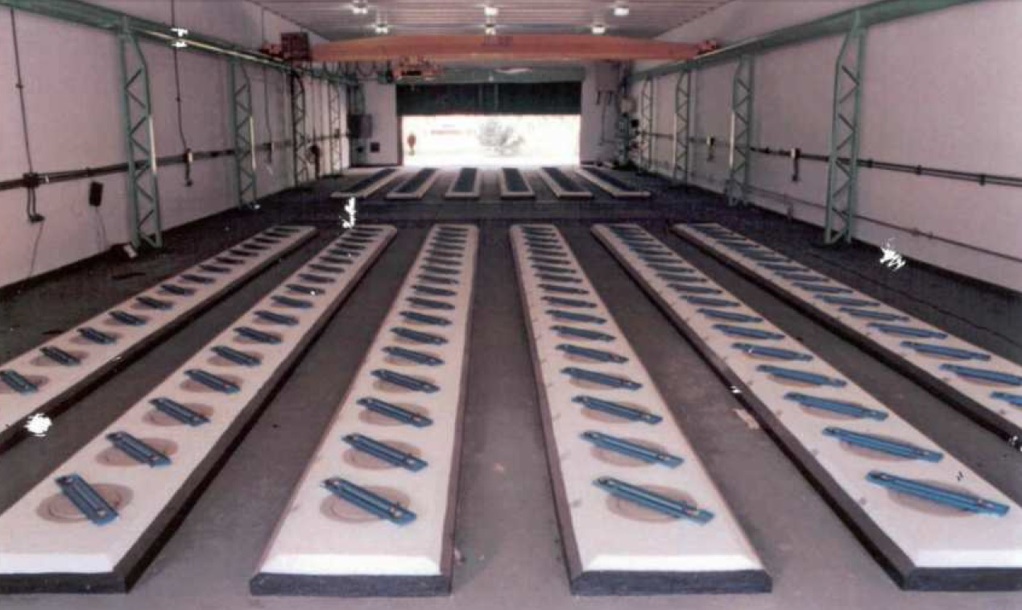
FIG. 2. Central Storage Facility.
The CSF contains two sectors of in-ground storage tubes for spent nuclear fuel. The front sector has 6 rows with 16 storage tubes per row (Figure 2). The back sector has 6 rows with 17 tubes per row. The storage rows have raised curbs at grade level with a lead filled plug in the top of each storage tube. Total capacity is 198 storage tubes (2 meters long) holding a maximum of 2 standard assemblies or 1 control assembly per tube. The tubes are interconnected via a filtration/de ionization system with recirculation capability (Figure 3). Besides the CSF, both RA-3 and RA-6 have in-reactor wet storage, for cooling before transfer to CSF, with capacity of around 50 SNF in both reactors .

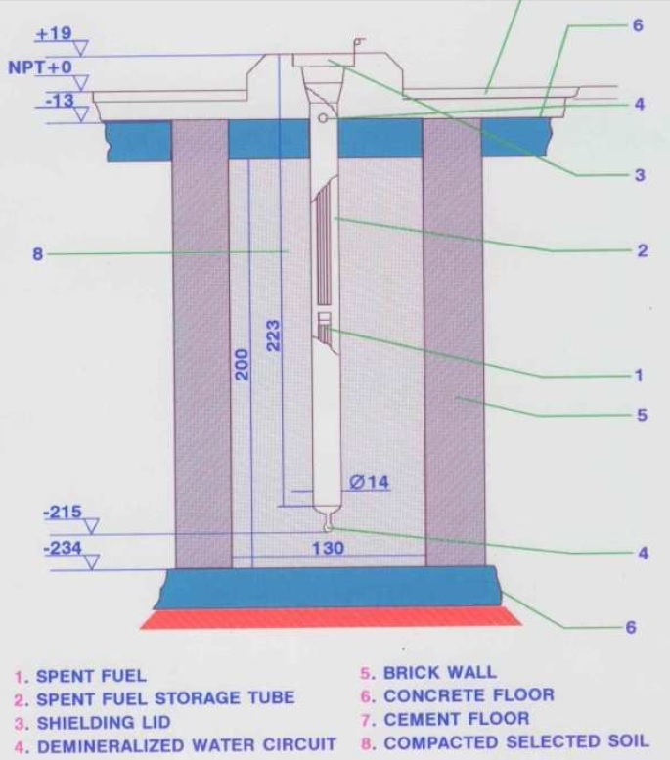
FIG. 3. Tubes for spent nuclear fuel at CSF.

The only reactors with reasons for concern related to storage over medium and long-range periods are RA-3 and RA-6. The others are zero power reactors, or low power RRs with very low burn up.
MTR-type fuel elements have a residence time of about 2 years in the RA-3 reactor; after that, they are moved to a decay pool (RA3 DP), an open stainless steel pool, to cool down enough before they are tranferred to another basin, the Central Storage Facility (CSF); although less than a year is supposed to be enough time in the DP, the fuel elements may stay there for periods of up to 10 years.
The RA-6 reactor started to work in January 2009 with the LEU core conversion; due to its low power some of the fuel elements have not been replaced and have stayed for almost 6 years inside the reactor pool (RA6 RP); some others have been deposited in an adjacent decay pool (RA6 DP).
Nowadays, CNEA has concluded FACIRI´s project, the new wet facility located also at Ezeiza, in a pool located at the post irradiation facility, taking into account to utilize the infrastructure already existing at this building that will allow operational flexibility and integration with other operations of spent fuel management: inspection, conditioning, etc. This new interim wet storage facility has been designed to store all SF from current RR of Argentina with a total capacity of 608 positions.
About 180 RA-3LEU spent fuel assemblies will be transferred from the CSF to the FACIRI storage pool during the next year, but previously will be characterized by gamma spectrometry in a small pool at CSF.
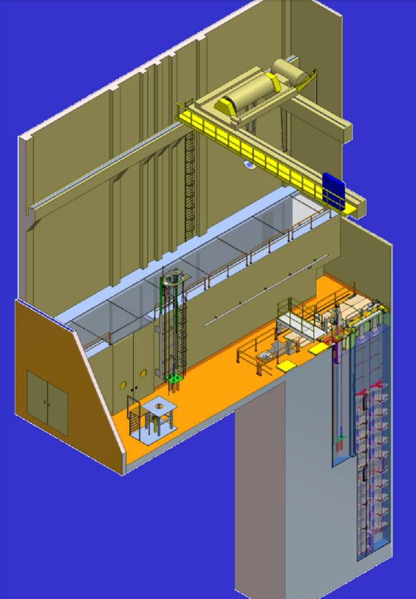
FIG. 1. FACIRI Interim Wet Storage Facility.

4. Legal and institutional aspects
The Argentine Atomic Energy Commission is an autarchic organism created on 31 May 1950 that depends of the Ministry of Federal Planning and Public Investment. CNEA develops its wide scope of activities within an extensive legal frame. The two main laws in this frame are the Decree–Law N° 22.498/56, ratified by Law N° 14.467, and the Law N° 24.804 “National Law for the Nuclear Activity”. Besides, CNEA is responsible for the application of the National Law Nº 25.018 “Management of Radioactive Waste” and of the “Joint Convention on the Safety of Spent Fuel Management and on the Safety of Radioactive Waste Management”, ratified by National Law Nº 25.279 in June 2001.

TABLE II: Institutional Strategic Plan Objectives related with spent nuclear fuel management.
NUCLEAR FUELS | Strategic Objective | Consolidate the domain of the irradiated fuel element reprocessing technology.
NUCLEAR FUELS | Specific Objectives | Consolidate the recovery capability of fissionable material.
NUCLEAR FUELS | Specific Objectives | Optimize the separation technology of fissile material for manufacturing of MOX fuel elements.
RADIOACTIVE WASTE AND SPENT NUCLEAR FUELS MANAGEMENT | Strategic Objective | Keep spent fuels safely stored. These spent fuels are derived from experimental reactors and radioisotope production.
RADIOACTIVE WASTE AND SPENT NUCLEAR FUELS MANAGEMENT | Specific Objectives | Optimize storing conditions of the spent fuels of experimental and radioisotope production reactors.
RADIOACTIVE WASTE AND SPENT NUCLEAR FUELS MANAGEMENT | Specific Objectives | Evaluate dry storage systems for spent fuels deriving from RA-1 and RA-3.
RADIOACTIVE WASTE AND SPENT NUCLEAR FUELS MANAGEMENT | Specific Objectives | Participate in the analysis and definition of spent fuel treatment and storage system generated in RA-10

In 2010, after two years of continuous work, The Institutional Strategic Plan was published at the time of CNEA 60th Anniversary. This plan intended to define the course of activities to follow as well as the nuclear projects of CNEA for the 2010-2019 decade. This document sets strategic and specific objectives in the fields of nuclear fuel and radioactive waste and spent nuclear fuel management (Table II).
The Radioactive Waste Management Strategic Plan approved by CNEA includes the strategy for RRSF management that is to be periodically reviewed in order to have the opportunity to consider or adopt new concepts and processes.
Current planning for the development of a deep geological repository includes the construction and operation of an underground research laboratory starting in 2030 and the operational start-up of the deep geological repository by 2060.

5. Medium and Long Term Alternatives Under Consideration
At present there are five alternatives and one presents different technological particularities depending on the nature of the political decision to make. These alternatives are:

- Repatriate spent nuclear fuel.
- Interim Storage, safely, without any processing of spent nuclear fuel itself. In facilities licensed for this purpose (wet or dry storage).
- Conditioning of spent nuclear fuel for disposal without additional generation of radioactive waste streams.
- Processing of spent nuclear fuel for final disposal:
              - Dissolution of spent nuclear fuel followed by the treatment and conditioning of radioactive waste streams.
              - Dissolution of spent nuclear fuel followed by the separation of two streams of radioactive waste treatment and conditioning, for U / Pu on the other side and other radioactive waste.
              - Dissolution of spent nuclear fuel followed by recovery of U / Pu and other radionuclides of interest for reuse plus treatment and conditioning of radioactive waste streams.
- Reprocessing spent nuclear fuel abroad. France and the Russian Federation made ​​commercially dissolution of spent nuclear fuel; thus returning the U / Pu as the various streams of conditioned radioactive waste as part of contract negotiations.

Repatriation background
CNEA created two projects in the past to carry out the SNF shipments and settled the local counterparts of the representatives from the DOE Acceptance Program, the receiving facilities and the cask vendor. The first project was the PRECI, for the restitution of the RA-3 HEU SNF inventory. The second is the ongoing UBERA-6 project, for the core conversion of the RA-6 reactor and shipment of the corresponding HEU fuel, which also involved the RA-2 shipment. This project is currently focused on the recovery of the HEU from filters used for the production of 99-Mo by fission process.
Since the exportation of nuclear material such as SNF is considered sensitive by the Argentine Government, the National Commission for Control of Sensitive Exportations and Belligerent Material (created in 1992 by Decree N° 603) has to issue a previous license for exportation. For this, the 603 Commission, which includes representatives from the Ministries of Defence, Economy and Foreign Affairs, requires the material receptor to provide assurances that the material will not be used for nonpeaceful purposes by delivering an End User Certificate. The issue of this Certificate by the US Government and subsequently the issue of the 603 License have been critical paths in the shipment timelines having produced significant delays in the shipment projects completion.
The Nuclear Regulatory Authority (ARN), has a major role in shipment campaigns. ARN revises the transport cask design and issues a local revalidation of the package license, subjected to the validity of the original one, which in the case of the US, is issued by the DOE. ARN also authorizes the practice of fuel conditioning, loading and transport, in order to ensure that the operator meets safety, security and safeguards requirements. Besides, ARN issues an Authorization of Exportation required by the Argentine Customs to permit the exportation of the nuclear material. Finally, ARN is the advisor organism for the 603 Commission in nuclear matters as well as the official liaison with safeguards organisms.
Safeguards in Argentina involve the IAEA and the ABACC. The last one is an organism that came up from a bilateral agreement between Argentina and Brazil for common accountancy and control of nuclear material. Subsequently, a quadripartite agreement was signed by Argentina, Brazil, the ABACC and the IAEA for the application of international safeguards (INFCIRC 435).

6. Final Remarks

CNEA has a varied number of research reactors which use different types of fuel elements. Thus a variety of SNF is generated mainly MTR plate-like, with fissile uranium oxide or uranium silicide core. The future commissioning of the Multi-purpose Reactor RA-10 will increase the number of SNF filling the wet storage capacity until 2030. It is in this context that we must consider viable alternatives that CNEA should look for proper management of these fuels in order to have an operational capacity before that date.
The National Program for Spent Fuel and Radioactive Waste Management need to analyze the different alternatives that can be implemented in the management of spent fuel elements generated during the operation of research reactors in Argentina. Strategic aspects as technical to the Argentine Atomic Energy Commission (skills and technological resources, ongoing projects) are being considered in a non-published document yet, in order to conclude with a recommendation that allows the taking of political-institutional decision required.
Considering that one of the functions of CNEA is "Promoting the training of highly skilled human resources and the development of science and technology in nuclear matter, including the implementation of programs of development and promotion of technological innovation enterprises" the weight of the options to generate the training and development in our country is greater when comparisons.

7. References

- NOVARA, O.E. “Argentine experience in shipping irradiated fuel to the United States of America”, IAEA-TECDOC-1593, Vienna (2008) 47–61.
- GOLDSCHMIDT, A., NOVARA, O., LAFUENTE, J., “Preparations for the Shipment of RA-3 Reactor Irradiated Fuel” (Proc. 24th RERTR Meeting, Bariloche – Argentina, 2002). Available at: http://www.rertr.anl.gov/Web2002/2003Web/FullPapers-PDF/Goldschmidt.pdf
- INTERNATIONAL ATOMIC ENERGY AGENCY, Experience of Shipping Russian-origin Research Reactor Spent Fuel to the Russian Federation, IAEA-TECDOC-1632, IAEA, Vienna (2009).
- INTERNATIONAL ATOMIC ENERGY AGENCY, RETURN OF RESEARCH REACTOR SPENT FUEL TO THE COUNTRY OF ORIGIN: REQUIREMENTS FOR TECHNICAL AND ADMINISTRATIVE PREPARATIONS AND NATIONAL EXPERIENCES, IAEA-TECDOC-1593, Vienna (2008).
- Management and storage of research reactor spent nuclear fuel : proceedings of a technical meeting held in Thurso, United Kingdom, 19–22 October 2009 – Vienna : International Atomic Energy Agency, 2013. (Proceedings series, ISSN 0074-1884) STI/PUB/1592 ISBN 978-92-0-138210-8
- Plan Estratégico de CNEA 2010-2019
- Plan Estratégico de Gestión de Residuos Radiactivos y Combustibles Gastados (PEGRRyCG) aprobado por Resolución de la Presidencia de CNEA N° 461/12

