Review of Low-Power Research Reactor
Developed for Education and Training

I.C. Lim¹, C. Park¹, J. Kim¹, S.T. Hong¹, D.S. Sohn²

- Korea Atomic Energy Research Institute, 989-111, Daedeok-daero,
Yuseong-gu, 305-353 Daejeon, Korea
- Ulsan National Institute of Science & Technology, UNIST-gil 50,
Ulsan 689-798, Korea

Corresponding author: iclim@kaeri.re.kr

Abstract. The number of new-comer countries that wish to introduce low-power research reactors is increasing, and their objectives are to use a research reactor as a tool for education/training or to make one serve as the infrastructure for the introduction of a nuclear power program. This was the same for developed countries when they built many research reactors in the 1950s and 1960s. Thus, it is very valuable for new-comer countries to review the trend of low-power research reactors in developed countries to decide on their direction of investment. The low-power research reactors built in the USA or European countries were mainly for education/training in the areas of neutron or radiation utilization and the validation of a new power system. On the other hand, those in Russia were mainly critical assemblies. An analysis using the IAEA RRDB shows that the powers of most low-power RRs for education/training are lower than 250 kW and their thermal neutron flux is less than 10¹³ n/cm²s. By the end of 2012, the number of decommissioned RRs is 306 and 75% of them are RRs whose powers are less than 250 kW, which means the role of low-power RRs has been declining. This also tells us that the evolution or paradigm change of nuclear engineering education is necessary in the area of RR experiments to the direction of wider use of the potential benefits from low-power RRs. This is very important in that a RR is a very costly experimental tool that should be built under a well-established strategy of utilization. This will also stimulate the development of a very innovative and safe low-power research reactor.

1. Introduction

Many countries have used research reactors as tools for educating and training students or engineers and for scientific services such as neutron activation analysis[1]. As the introduction of a research reactor is considered as a stepping stone for a nuclear power development program, many newcomers are considering having a low-power research reactor[2]. The IAEA has continued to provide forums for the exchange of information and experiences regarding low-power research reactors[3,4,5]. Considering that a research reactor is a long-lasting and costly scientific tool, one should be very cautious in defining its user requirement and the selection of design. In these step, it is believed to be very important to understand how the role of low-power research reactors has been changed and to identify what are the challenges for low-power research reactors to keep their value. Thus, in this paper, the history of low-power RR development was reviewed and the elements for its continuous contribution to education and training are proposed.

2. Definition of Low-Power Research Reactor for Education and Training

The definition of ‘Low-Power’ varies depending on the references. In IAEA SRS-41[6], a research reactor is called as a low-power reactor when its power is between 100kW and 2MW. On the other hand, IAEA NP-T-5.3 calls a research reactor as a low-power reactor when its power is between 100kW and 2MW[7]. IAEA RRDB[8] provides general information for research reactors such as power, neutron flux and utilization area. When they are depicted together as in Fig. 1, it gives a definition of low-power RR for education and training. From this figure, it is reasonable that its power is generally less than 250 kW and its thermal neutron flux is less than 10¹³ n/cm²s. Thus, it is believed that these numbers can be considered as its upper bound in view of power and neutron flux.

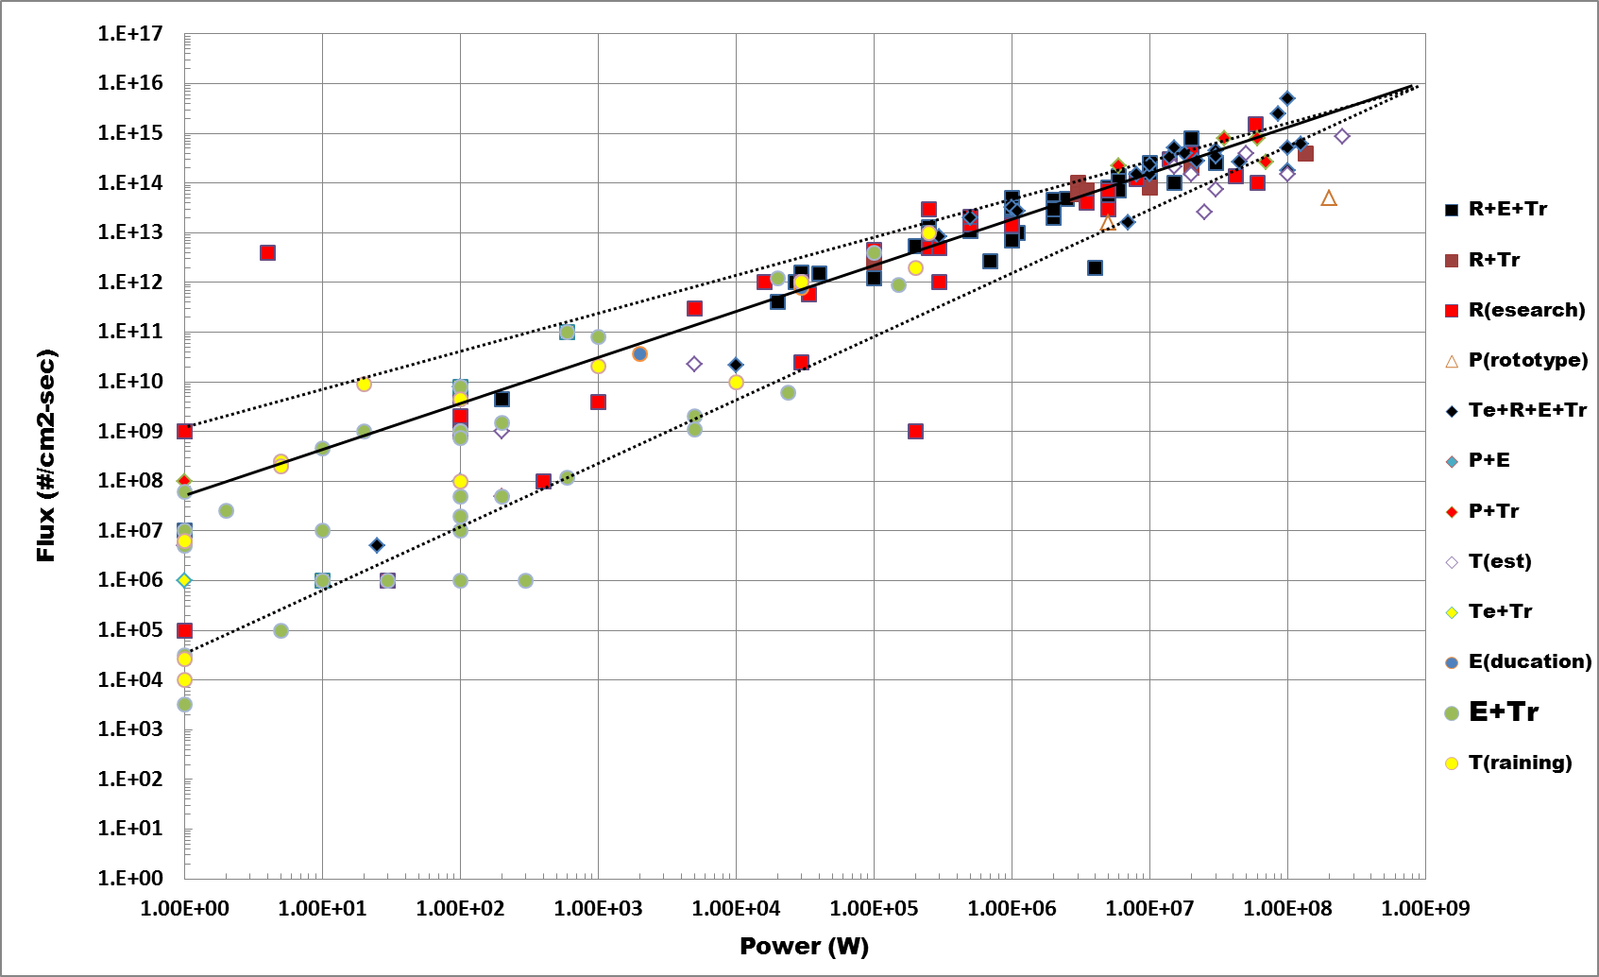
FIG. 1 Distribution of power and neutron flux of operating research reactors[7]

3. Trend of RR for Education and Training

3.1 Birth and Growth

In 1950s following the birth of the first nuclear reactor in 1942, the main objective of nuclear technology was shifted from the experimental demonstration of theory to the development of application technology. The development of nuclear reactors for ‘Atoms for Peace’ started to be differentiated into the validation of power reactor engineering and the R&D using neutron and radiation. The professional education for nuclear technology was disseminated to universities and the first nuclear engineering program was established at the North Carolina Univ. in 1950. In 1953, a 17 week program was opened at Penn. State University. These stimulated the construction of research reactors. 10kW R-1 and 100kW PSBR were built at these universities in 1953 and 1954, respectively. In 1957, ANL researchers developed 10KW ARGONAUT (ARGOnne Nuclear Assembly for University Training) and it was widely spread for the universities in USA[9]. ARGONAUT operates at power levels between 2 W and 300 kW. The ARGONAUT is graphite reflected, light water moderated and cooled and, operated either with high enriched or low enriched U-Al alloy in a plate geometry. A variety of core configurations are possible ranging from one slab, two slabs (arc or straight slab) or annular core depending on design and intended use. In 1958, GA developed TRIGA(Training Research and Isotope-production General Atomic) reactor and it became the most widely spread research reactor. TRIGA reactors are versatile, multipurpose reactors with a world-wide distribution of more than 50 facilities. They range in power levels from 18 kW to 14 MW with 250 kW to 1 MW being the most common operating level[10]. The TRIGA uses the U-Zr-H fuel in a rod shape and it brings a large negative power coefficient and enables the pulse mode. About the same time, Aerojet-General Nucleonics developed ANG models. The AGN reactor is a homogenous thermal reactor used for education and training. The fuel is normally 20% enriched UO₂ powder embedded in radiation-stabilized polyethylene, which acts as the moderator[11].

In 1960s, national R&D programs to use the nuclear technology started in many countries and this raised the demands for research reactors. The number of RRs built in 1960s is about 300. In this period, the constructions of new RR were more active in Europe, Japan and Russia than in USA. The RRs built in Europe, Japan and USA were low-power critical assemblies, medium power multi-purpose RRs or high-power material test reactors. On the other hand, most of the Russia RRs built in 1960s were low-power critical assembly or high power demonstration reactor.

Entering 1970s, the number of new RR construction decreased a lot. A reason is that the number of RRs in the universities was saturated. In addition, it is believed that the interest to research reactors decreased due to the fact that the benefit of the experiences from research reactors to the construction or operation of nuclear power reactor was felt limited. From the second half of 1970s, the number of RRs decommissioned or in extended shutdown became greater than the number of new RRs. The SLOWPOKE reactor was developed by the AECL for isotope production and neutron activation analysis at universities, hospitals and research institutes. It is a pool type reactor with a typical power of 20kW, and samples can be irradiated in a thermal neutron flux of up to 1.0x10¹² n/cm²s [12]. The SLOWPOKE uses a rod type fuel having HEU in U-Al alloy. In 1980s, China remodeled it as MNSR and it was built in several developing countries. The MNSR was designed by CIAE and its characteristics are very similar to those of SLOWPOKE. The MNSR is a very useful tool for reactor physics education and training, and for short-lived NAA. Therefore, this reactor has become increasingly popular in developing countries as it is the cheapest research reactor presently available[10]. Even though the utilization of SLOWPOKE and MNSR is very limited, they are good examples showing that a low-power research reactor which has a merit in cost and in safety is attractive for the purpose of education and training.

3.2. Evolution

In 1990s, zero power critical assemblies were built in India and Russia and 30kW reactors were built in middle-east and African countries. The power of multi-purpose research reactors built in this period was high than 20MW. An attention should be paid to the fact that in this period, there were no constructions of research reactors ranged from 100kW to 2MW in power. One of the reason for this is believed that the benefit from these reactors was felt lower than the cost for those. In addition, those built in 1960s and 1970s were operated and did their roles.

Table 1 shows the status of low-power research reactors constructed in brand names. AGN and ARGONAUT were developed for universities with the consideration of their financial burden and thus, were limited for design change or power upgrade to accommodate varieties in utilization. This made 70 to 80% of them decommissioned or in prolonged shutdown. The 60% of TRIGAs are still in operation. However, the TRIGAs in the universities of USA are not well utilized.

TABLE I: Status of Brand-Name Low-Power Research Reactors

Name | Decommi- ssioned | Prolonged  Shutdown | In Operation or  Temporary  Shutdown | Total
TRIGA | 19(8) | 7(1) | 37(12) | 63(21)
AGN | 16(16) | 1(0) | 7(7) | 24(23)
ARGONAUT | 19(5) | 5(0) | 5(3) | 29(8)
SLOWPOKE or  MNSR | 7(2) | 9(0) | 12(1) | 19(3)
- No. in parenthesis : No. of RRs in universities

4. Challenges in Low-Power RR for Education and Training

The issues in low-power research reactors are as follows;

- Ageing of materials or SSCs(System, Structure and Components)
- Aged operators and difficulties in finding substitutes
- Decrease of usefulness because of the accomplishment of original objectives or the reduction of needs
- Decrease of support from governments for operation and utilization
- Reduction or cancellation of nuclear power program
- Simulators replacing research reactors for training

On the other hand, ANS has stated the necessity of continued national support to maintain and expand research and test reactor programs and the necessity of efforts in identifying and addressing the future needs by working toward the development and deployment of next-generation nuclear research and training facilities[13].

The revolution of low-power research reactor is not so fast. However, there are still demands for them. They contributes to the phase 1 of NPP program milestones when a country is developing a general understanding of the implication of a nuclear power program before taking the decision[14]. In addition, there is no substitute of research reactors for RI utilization, NAA and neutron radiography.

For the continuation of revolution, it is believed that there are two important elements ; intrinsic safety and the safety in operation, and the innovative design.

A guide for research reactor bidding process[15] gives technical aspects that should be considered for intrinsic safety and the measures for the safety in operation and they include the followings.
- Negative power coefficient as large as possible
- Passive decay heat cooling
- No fuel failure during transients
- Human engineering and cyber security considering that the facility will be accessed by many users
- Minimization of the possibility of risk occurrence by the mistakes of users
- Information service system for the management of the facility for integrated management and experience feedback for operation and utilization.

In view of innovative design, the followings should be considered :
- Research reactor to bring a balance between computer analysis and experiment in nuclear education program
  - More than conventional reactor experiments such as criticality approach and rod-worth measurement
  - “Enjoy in reality” of physical phenomena
  - Training on the use of in-core instruments
- Adoption of technologies used at high power beam reactors to maximize the neutron flux level in a low-power RR
- Reduction of fuel cost
- Design of reactor and labs for NAA which will help revenue generation

5. Remarks

In this paper, a review was given to find the trends in low-power RR development and the challenges to define the considerations and need for future of the low-power RR for education and training. From the review, it is believed that intrinsic safety and the safety in design as well as the innovative design are the important aspects for the future of low-power research reactors. Especially, for the innovative design, the variety in education and training program, the cost effectiveness in utilization and the capacity to accommodate future needs should be emphasized.

Acknowledgement

This work was supported by the Advanced Research Center for Nuclear Excellence (ARCNEX) program by the Ministry of Science, ICT and Future Planning of the Republic of Korea.

References

- IAEA Nuclear Energy Series, NG-T-6.1, Status and Trends in Nuclear Education, IAEA, Vienna(2011).
- D. Ridikas and et al., New Opportunities for Enhanced RR Utilization through Networks and Coalitions, presented at the Int. Conf. on Research Reactor, Nov. 14-18, Rabat, Morocco(2011).
- IAEA Workshop, Meeting Report of the Small Research Reactor Workshop, Jan. 13-17, University of the West Indies, Kingston, Jamaica(2003).
- IAEA Workshop, Innovative Application of Low Flux Research Reactors, Dec. 6-10, Kingston, Jamaica(2010).
- IAEA Workshop on Innovative Applications of Small Research Reactors, Small Neutron Generators and Isotopic Neutron Sources, April 30 to May 3, City University of Hong Kong, Kowloon, Hong Kong(2012).
- IAEA Safety Report Series No.41, Safety of New and Existing Research Reactor Facilities in Relation to External Events, IAEA, Vienna(2005).
- IAEA Nuclear Energy Series No. NP-T-5.3, Application of Research Reactors, IAEA, Vienna(2014).
- IAEA, Research Reactor Data Base, http://nucleus. iaea.org/RRDB/RR/ReactorSearch. aspx
- http://www.ne.anl.gov/about/reactors/training.shtml.
- H. Bock and M. Villa, Survey of Research Reactors, http://www.reak.bme.hu/ Wigner_Course/WignerManuals/Bratislava/Research_Reactors_I.htm
- The University of New Mexico AGN-201M Reactor Operation and Training Manual, Dept. of Chemical and Nuclear Engineering, Univ. Of New Mexico, Albuquerque, NM, USA(2011).
- E,K. Ronald and et al., SLOWPOKE: A New Low-Cost Laboratory Reactor, Int. J. of Applied Radiation and Isotopes, Vol.24, pp.509-518 (1973).
- ANS Position Statement, Research and Training Reactors, revised June 2011.
- Chairmen’s Report for IAEA TM, The Role of Research Reactors and Related Infrastructures in the Development of Nuclear Energy Programmes, Dec. 4-7, IAEA, Vienna(2012).
- IAEA Nuclear Energy Series No. NP-T-5.6, Technical Requirements in the Bidding Process for a New Research reactor, Vienna, IAEA, Draft(2013).

