Dog-Bone Studies In U-Mo-Zry-4 Miniplates Fabrication Process

M. López¹, F.R. Gribaldo², E.N. Olivar², B. Picchetti¹

1) Gerencia del Ciclo de Combustible Nuclear, Centro Atómico Constituyentes
2) Departamento de Ensayos No Destructivos y Estructurales, Centro Atómico Constituyentes

Comisión Nacional de Energía Atómica, Avenida Libertador 8250, 1429, Buenos Aires, Argentina

Corresponding authors: marlopez@cnea.gov.ar; picchetti@cnea.gov.ar

Abstract. The studies of high density nuclear fuels led us to work with Uranium Molybdenum alloys and Zry-4 as cladding. Nowadays, the study is focused on the application of this alloy to monolithic fuel plates development. The Zry-4 alloy used as cladding material is extensively known in the nuclear industry due to its low neutron capture section efficiency and excellent mechanical and corrosion resistance properties. Since first experiments in 2003, CNEA is employing this material as cladding. Miniplates fabrication process involves a welded compact made of two Zry-4 covers and a frame surrounding a monolithic U-Mo core, which is co-rolled at high temperature. The alloy contains 7% to 10% (mass) of Molybdenum, which guarantees the presence of meta-stable bcc gamma phase without penalizing in excess the neutron economy due to the capture cross section of the isotope Mo⁹⁸.

In previous works has been studied the Dog-Bone effect under different external conditions (temperature and compressive stress) and the influence on the fabrication process. In this work, the aim was to control the co-rolling process step by step. Based on theoretical calculus -obtained by experimental data- the co-rolled method was developed. Three different experiments were tested: 1) a co-rolling process with constant reductions (of 0.25 mm); 2) a co-rolling process with constant percentage reduction (5%) and 3) a co-rolling process with a decrease reduction method (from 15% to 5%).

Concerning the monolithic U-Mo plates fabrication, involved in the ALT FUTURE experiment a new workshop has been conditioned. The aim is to use all the valuable information collected during the miniplates fabrication for the full scale plate fabrication development.

1. Introduction

The decision to develop and qualify monolithic plate fuels is based on an increase on the fuel density [1, 2, 3]. Considering this objective and the already known properties of Zircalloy-4 (Zry-4) in the nuclear industry [4], the National Commission of Atomic Energy in Argentine (CNEA) have been developing co-rolled fuel miniplates employing Uranium-Molybdenum Alloy (UMo) as core and Zry-4 as cladding. UMo alloy that contains more than 5% (mass) of Molybdenum (Mo) and co-rolled at a temperature above 565ºC [5], will show metastable gamma structure.

The hcp crystalline structure of metals like zirconium plays a very important role in the nuclear power reactors. The microscopic and macroscopic evolution of this material under irradiation has been very well studied [5, 6, 7, 8]. This material is the first barrier of the radioactive fuel material; which means that it must confine the fissile U235 and fission and capture products from the external coolant. It must also maintain its integrity during the irradiation in core and after the nuclear service, in transportation and storage steps of the spent fuel life cycle.

In previous works [9, 10, 11] have been concluded that the optimum co-rolling conditions are at 650ºC temperature and a low compressive stress (371-2394 MPa). Under these conditions the interaction between both materials is enough to bind correctly but not enough to lead to regions enriched in Mo that can cause precipitation of U alpha [1]; in addition, the Dog-Bone is smaller in comparison to those obtained ad higher temperature and compressive stress. Considering these results and the preliminary calculus [12] new co-rolling protocols were proposed. Taking control of the reduction step by step, it aims to study its influence on the Dog-Bone effect and establish a new protocol that minimize the thickness difference between the center and the edges.

1. Materials and Methods

The miniplates were made by picture and frame process, employing as fuel an alloy of U10%Mo and Zry-4 as cladding. These materials were assembled and TIG (tungsten inert gas) welded at external borders. After that, they received a hot co-rolling treatment process at 650ºC. The co-rolling process performed in several steps with intermediate heating during 5 minutes in a furnace without controlled atmosphere.

The UMo alloy was cut employing a linear precision saw (Buehler IsoMet 5000) from a plate provided by INL (Idaho National Laboratory-USDoE). Edges and surfaces were polished with Struers Labopol-2 polish machine up to grinding paper #1500. The polish process was finished with clothe and diamond paste of 3 µm. The same process was applied to Zry-4 pieces.

General dimensions of the core were 20 mm wide, 20 mm long and 1 mm thickness. Dimension of the Zry-4 sheets (cladding) were 50 mm x 50 mm and 2.6 mm thickness; the frame had the same dimensions as the Zry-4 sheets, but 1 mm thickness. All sheets have the same surface finishing as well as the UMo core. The bottom, top and frame Zyr-4 material was TIG welded confining the UMo core inside. The miniplates were co-rolled to find the final thickness of 1.4 mm – 2.2 mm.

Due to the importance of maintain de Dog-Bone between the allowed limits, the principal objective of this work is to obtain a homogeneous thickness along the fuel core. The theoretical co-rolling model [12] indicates that this could be achieved controlling the reduction of the miniplate in each step. To verify this model three different samples were studied, under different conditions: sample 1 was co-rolled with constant reductions of 0.25 mm (increasing the percent reduction in each step); sample 2 was done with constant percent reduction of 5%; sample 3 was co-rolled decreasing the percent reduction (three reductions of 15%, two reductions of 10%, two reductions of 7% and the rest 5%). The details are shown in TABLE I.

X-Ray images were taken (Andrex) of intermediate steps and of the final miniplate (TABLE II). To estimate the core thickness a qualitative method, which studies the Grey Value of the image [9, 10], was employed. This parameter is proportional to the amount of material.

Once obtained the miniplates and taken the X-Ray images, the samples were cut and polished (core region). Analyses in a scanning electron microscope (FEI QUANTA 200) were done, in order the measure the core thickness.
TABLE I: dimensions of the core, compact and co-rolling conditions for each sample.

Sample |  | 1 | 2 | 3
Core | Lenght (mm) | 19.07 | 19.40 | 19.34
Core | Width (mm) | 19.25 | 19.46 | 19.38
Core | Thickness (mm) | 0.94 | 0.67 | 0.88
Compact | Lenght (mm) | 48.18 | 48.16 | 48.3
Compact | Width (mm) | 47.66 | 48.35 | 48.19
Compact | Thickness (mm) | 5.71 | 5.72 | 5.89
Co-rolling | Reduction | 0.25 mm | 5% | 15% x3  10% x2  7% x2  5% x13
Co-rolling | Steps | 20 | 20 | 20
Final thickness (mm) |  | 1.41 | 2.17 | 1.43

TABLE II: X-Ray conditions in which each image was taken.

Step | Sample | Voltage (Kv) | Amperage (mA/min) | Time (min) | Film
3 | 2 | 180 | 4.5 | 3’ 20’’ | D7
4 | 1 | 180 | 4.5 | 2’ 40’’ | D7
6 | 2 | 160 | 4.5 | 2’ | D7
8 | 1 | 180 | 4.5 | 2’ | D7
9 | 2 | 150 | 4.5 | 2’ | D7
10 | 2 | 140 | 4.5 | 2’ | D7
11 | 2 | 135 | 4.5 | 2’ | D7
12 | 1 | 160 | 4.5 | 2’ | D7
13 | 2 | 130 | 4.5 | 2’ | D7
15 | 2 | 125 | 4.5 | 2’ | D7
16 | 1 | 140 | 4.5 | 2’ | D7
18 | 2 | 125 | 4.5 | 2’ | D7
20 | 1 - 2 | 120 | 4.5 | 2’ | D7
21 | 3 | 120 | 2.5 | 2’ | D7

3. Results

In FIG. 1 are shown the X-Ray images obtained for sample 1, co-rolled in 20 steps with reduction of 0.25 mm. Different gray intensity on regions of the same material are due to different thickness values; a lighter gray indicates thicker regions, while darker grays indicates thinner. It can be easily view in FIG. 1 steps 16 and 20, the Dog-Bone on the edges of the core. The thickness difference between the centre and the edges was estimated with software that can measure de gray intensity on the region desired (Grey Value, GV). These values are shown on TABLE III. It was only possible to estimate this difference only with the X-Ray images from steps 16 and 20; in previous steps the difference is not significant. In the same table can be seen the real thickness difference, measure by SEM. SEM images are shown in FIG. 2.
  Step 4 |   Step 8
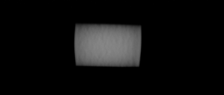  Step 12 | 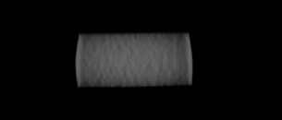  Step 16
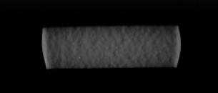
Step 20
FIG. 1: X-Ray images obtained for selected steps of the co-rolling process of sample 1.

TABLE III: Dog-Bone obtained for sample 1, obtained by comparison of the center and edges Grey Value; is also shown in this table the core thickness, measured on the SEM image.

Step | Reduction | Accumulate reduction | Core reduction | GV Method | SEM Method
4 | 3.38 % | 14.19 % | - | Difference is not considerable | -
8 | 3.21 % | 29.25 % | - | Difference is not considerable | -
12 | 5.72 % | 45.18 % | - | Difference is not considerable | -
16 | 6.98 % | 61.30 % | - | 6 % - 5 % | -
20 | 16.0 % | 75.31 % | ~66 % | 48 % - 33 % | 57 % - 56 %

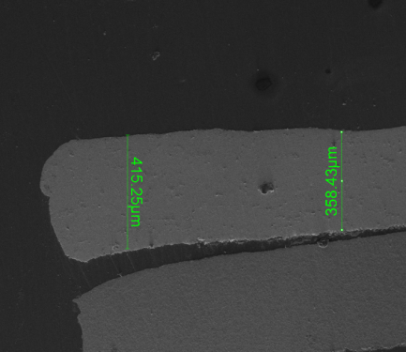 | 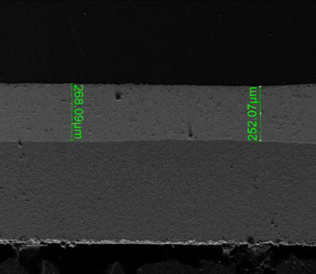 | 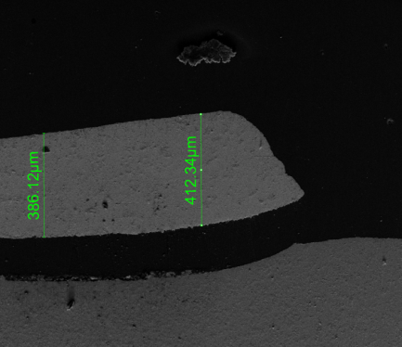
FIG. 2: SEM images obtained for sample 1 of center and edges. Mag: 200x.

In FIG. 3 are shown the X-Ray images for sample 2, co-rolled in 20 steps with percent reductions of 5%. In contrast with the results obtained for sample 1, in this case the grey intensity is not evident. It was not possible to measure de GV of these images, due to the little difference between the value of the centre and the edges. In FIG. 4 are shown the SEM images; it can be observed that the fuel core thickness is homogeneous. Percent difference based on SEM measurement is shown in TABLE IV.

  Step 3 |   Step 6 | 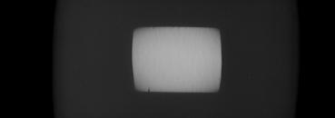  Step 9
  Step 10 |   Step 11 | 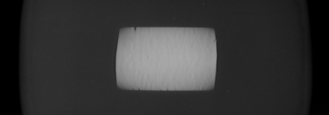  Step 13
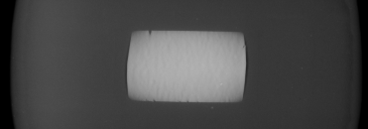  Step 15 | 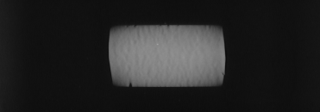  Step 18 | 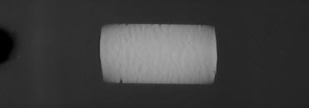  Step 20
FIG. 3: X-Ray images obtained for selected steps of the co-rolling process of sample 2.

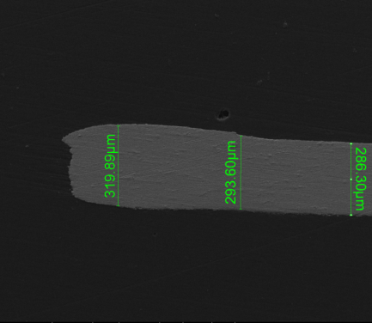 | 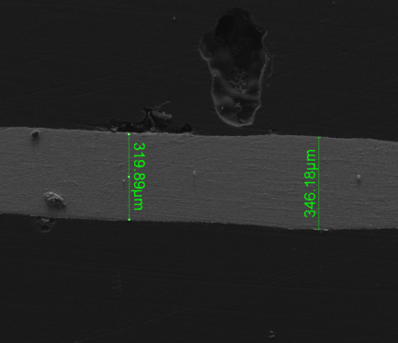 | 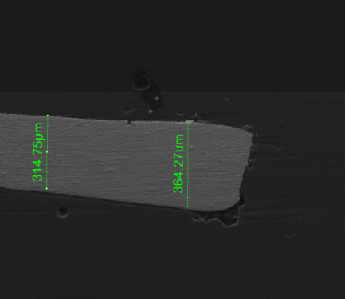
FIG. 4: SEM images obtained for sample 2 of center and edges. Mag: 200x.

TABLE IV: Dog-Bone obtained for sample 2, obtained by comparison of the center and edges Grey Value; is also shown in this table the core thickness, measured on the SEM image.

Step | Reduction | Accumulate reduction | Core reduction | GV Method | SEM Method
3 | 4.70 % | 13.22 % | - | Difference is not considerable | -
6 | 1.73 % | 25.88 % | - | Difference is not considerable | -
9 | 3.06 % | 35.01 % | - | Difference is not considerable | -
10 | 6.59 % | 39.29 % | - | Difference is not considerable | -
11 | 4.60 % | 42.09 % | - | Difference is not considerable | -
13 | 4.38 % | 47.11 % | - | Difference is not considerable | -
15 | 3.31 % | 51.02 % | - | Difference is not considerable | -
18 | 5.04 % | 57.91 % | - | Difference is not considerable | -
20 | 2.25 % | 59.59 % | ~61 % | Difference is not considerable | 15 % - 1 %

The third and last experience consists on a co-rolling process with decreasing percent reduction. In this case only one X-Ray image was taken, once the miniplate reached the desired thickness (FIG. 5). The GV shows that de Dog-Bone is fewer than 15% (TABLE 5). Contrarily, the thickness measure did on the SEM images shows a Dog-Bone higher than 60% (FIG. 6, TABLE V). This inconsistence can be attributed to the different experimental condition employed for this last X-Ray image.
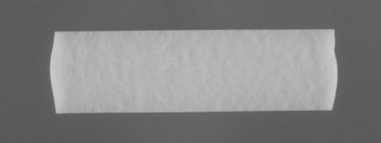
FIG. 5: X-Ray image obtained for sample 3, of the final co-rolling step.

TABLE V: Dog-Bone obtained for sample 3, obtained by comparisson of the center and edges Grey Value; is also shown in this table the core thickness, measured on the SEM image

Step | Reduction | Accumulate reduction | Core reduction | GV Method | SEM Method
21 | 2.05 % | 75.72 % | ~73 % | 12 % – 10 % | 65 % - 73 %

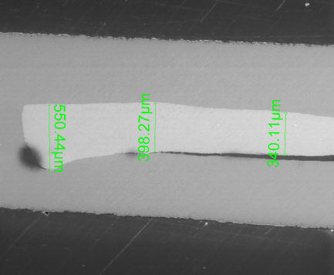 | 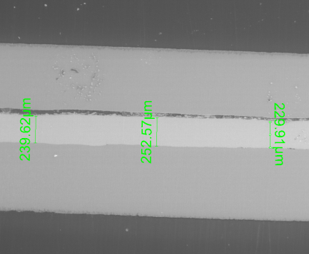 | 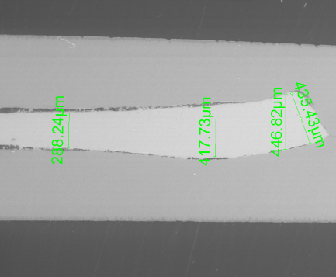
FIG. 6: SEM images obtained for sample 3 of center and edges Mag: 90x.

In FIG. 7 can be seen the graphics of Grey Value vs. horizontal moving on the core for each sample. Although these results do not have a quantitative value, are useful to estimate qualitatively the presence of Dog Bone.

FIG. 7: Grey Value vs. x (horizontal shifting on the core) for each sample.

4. Discussion

It was observed that during the co-rolling of sample 1, the Dog Bone appear between steps 12 and 16 (with a difference of thickness between edges and center of about 6%). Between these steps the reductions were from 5 to 7%. In the following steps the percent reduction was increasing, until reach a reduction of 16% in the last step. The Dog-Bone at the end of the co rolling process is higher than 50%. Based on these results the second experience was developed: maintain the reductions under 5%.

Results obtained for sample 2 shows that when reductions are under 5%, the core thickness stays homogeneous during the co-rolling process. A disadvantage of this process is that the process requires more steps to reach the desire thickness. In this case, this final thickness depends on the miniplates irradiation conditions [13]

Considering the results obtained in these two experiences, a new co-rolling protocol was developed, in order to minimize both the Dog Bone and the number of steps. A commitment between these characteristics is obtained with decreasing percent reductions, as it is was made in sample 3. The irradiatios specifications for a miniplate fuel [13] demand the Dog Bone to be under 30%. The results obtained for this protocol shows that the final dimensions of the plate, the core thickness in particular, are not optimum for irradiation.

The better co-rolling process consists on maintaining the percent reduction under 5%. The new objective is to extrapolate these results to a full-size plate.

5. Conclusions

Based on the experiences detailed in this work, it can be concluded that the co-rolling process can be done with constant percent reductions: up to a 5% reduction or less are suggested. This way, the thickness difference between the edges and the center is less than 30%.

6. References

[1] K. Tangri, G.I. Williams, J. Nucl. Mater., 4 (1961) 226-233.

[2] M. López, H. Taboada, A. González, Observations in the Sequence of UMo Monolithic Miniplates Preparation. in European Research Reactor Conference, Rome, Italy, 2011

[3] C.R. Clark, G.A. Moore, J.F. Jue, B.H. Park, N.P. Hallinan, D. Wachs, D.E. Burkes, Update on US High Density Fuel Fabrication Development. en Research Reactor Fuel Managment - International Group on Research Reactors, Lyon, France, 2007.

[4] K. Hannerz, G. Vesterlund, Nuclear Engineer and Design, 33 (1975) 205–218.

[5] A.M. Monti, A. Sarce, N.S.D. Grande, E.J. Savino, C.N. Tome, Philos. Mag. A, 63 (1991) 925-936.

[6] M. Griffiths, Philos. Mag. A, 63 (1991) 835-847.

[7] R.A. Johnson, Philos. Mag. A, 63 (1991) 865-872.

[8] A.G. Mikhin, Y.N. Osetsky, V.G. Kapinos, Philos. Mag. A, 70 (1994) 25-33.

[9] M. López, B. Picchetti, H. Taboada, A. González, CNEA Developments in U-Mo-Zry-4 Miniplates and Plates Fabrication Process. in European Research Reactor Conference, Saint Petersburgh, Russia, 2013.

[10] M. López, B. Picchetti, H. Taboada, A. González, Desarrollo alcanzado en el proceso de fabricación de placas y miniplacas de U-Mo-Zry-4, in XL Reunión Anual de la Asociación Argentina de Tecnología Nuclear, Buenos Aires, Argentina, 2013.

[11] M. López, B. Picchetti, H. Taboada, A. González, Difussion couples of UMo-Zry in different conditions. in European Research Reactor Conference, Saint Petersburgh, Russia, 2013.

[12] B. Picchetti, M.V. Moscarda, H. Taboada, Aspectos numéricos de la colaminación de miniplacas con núcleo de UMo recubierto por Zry-4, in XL Reunión Anual de la Asociación Argentina de Tecnología Nuclear, Buenos Aires, Argentina, 2013.

[13] Document ID: SPC-1308 - Specification for the RERTR-11A Experimental Plates for Irradiation in the ATR

