Wide Range Amplifier for Neutron Flux Measurement

Luis M. Giuliodori ¹, Julio Zalcman².
1) I&C, Centro Atómico Ezeiza, Ezeiza, Bs. As. Argentina.
2) I&C, Centro Atómico Ezeiza, Ezeiza, Bs. As. Argentina.
E-mail: lmgiulio@cae.cnea.gob.ar

Abstrat: A wide range amplifier is presented to process current pulses from a neutron flux detector over a range of 9 to 10 decades. The equipment generates digital pulses in the range corresponding to the lower 5 decades of neutron flux, which allows the measurement of flux by the conventional method of counting pulses in the time unit. In the corresponding higher five decades range, the amplifier generates a fluctuation signal, which allows the measurement of neutron flux by the method of measuring the mean square value of the AC component signal or Campbell method. Circuit description, laboratory measurements and behavior of the amplifier connected to a Centronic fission counter placed near the RA3 reactor core, are presented.

- Introduction

In order to measure the neutron flux in power reactors, in the range of 9-10 decades with one decade of overlapping, using a fission counter (FC) as single detector, we combine the pulse counting method with the mean square value (MSV) of the AC component signal or fluctuation method, known as the Campbell method.[1] [2]
Both parameters: pulse counting rate and MSV of the alternating current fluctuation of the detector, are reactor neutron flux representative.
For this reasons we proposed to develop a wide range amplifier design to process the current pulses from fission counter, which has the following characteristics:
1.1. Must accept FC current pulses with a rate of 1-10⁵ p/s, with amplitude of around 1uA, and a width of 200ns.
1.2. Must accept a minimum signal fluctuation of about 1,4.10⁻²²A² / Hz (corresponding to a pulse rate of 10⁴ p/s according to the typical sensitivity of FC in use), and a maximum fluctuation signal of 1,4.10⁻¹⁶A²/Hz (corresponding to a pulse rate of 10¹⁰ p/s).
The latter two requirements enable complete a total coverage of about 10 decades of neutron flux range: first 5 decades in pulse mode plus 6 decades in fluctuation mode with one decade of overlapping between that two modes.
1.3 . Must be situated at a maximum distance of about 20m from the FC.
1.4. Must generate the following signals:
1.4.1. Pulses with constant amplitude and width (< 100ns), to be further processed by a pulse counter. The rate of these pulses will measure the neutron flux of the reactor for the first 5 to 6 decades.
1.4.2. A slow AC analog signal within a band pass of about 200KHz, where it is MSV value, further processed by a squaring circuit can will measure, according to 2nd Campbell theorem, the neutron flux in the reactor for the last five or six decades variation.
1.4.3. A fast Gauss shaped analog pulse proportional to the net charge.
This signal, after being processed by a multichannel analyzer, allows us to build an energy spectrum of the pulses from the detector.
2. Implementation [3], [4], [5] (See Fig 4)
2.1. Preamplifier stage
In order to simplify the installation and, at the same time, minimizing the risk of EMI on the amp, it was necessary to connect the fission counter detector to the electronics with a single triaxial cable. This involves sending by the same cable, the signal and the high voltage (HV) that polarizes the detector; this fact forced us the choice of a triaxial cable HV insulation type, as the Belden 9222 model.
It was decided to design a low noise and high bandwidth voltage amplifier first stage.
This stage is a voltage amplifier with the input signal at the non inverting input, with sufficiently voltage gain (G = 23) to minimize the noise effect to the next amplifier stage.
The input resistive impedance is equal to the characteristic impedance of the triaxial cable (50Ω).
That adaptation of the coaxial cable signal allows:
- To avoid reflections that may distort the measurement of the average pulse rate.
- The cable length to be limited only by the attenuation of the transmitted signal and the degree of immunity to possible external interference that the coaxial cable has.
The chip selected was the AD797: equivalent noise voltage = 0,9nV / Hz^{1/2}; Product Gain-Bandwidth (GWB) = 80MHz.
With these data we can calculate signal (peak value) to noise (RMS value) ratio for a BW = 3.5Mhz, and a peak signal value 1μA, obtaining: S / N = 26dB for the Gauss shaped analog output, that initially seemed acceptable.
The noise in the fluctuation mode at minimum signal level (10⁴p/s) is, for previous calculations, of around 78% of total signal fluctuation; it is reduced to only 27% for a signal level corresponding to 10⁵ p/s. In all cases, the noise can be interpreted as a background, and therefore can be canceled in the squaring circuit module located following the amplifier in the instrumentation chain.

2. 2. Integration stage
Following the first preamplifier stage, the 2nd implemented stage is an integrating circuit of the voltage pulse previously transformed into a current pulse. The constant of integration is chosen of around 5 times the original width detector current pulse, which ensures that the output pulse amplitude of the integrator is proportional to the net charge per pulse. The latter is valid within the range of verified statistical variation of the FC pulse width of about ± 40%.
(See Fig. 2).
In short, the signal output from the integrating stage is a voltage ramp of around 10mV peak, followed by a decay to zero with time constant of about 1µs.

2.3. Fluctuation output
At the output of the integrating stage two signal branches are produced:
One branch is directed to the fluctuation signal output stage, and the other branch goes to the analog signal processing channel.
The fluctuation output stage is a single pole pass band filter amplifier, with about a width of 1,3KHz to 300KHz. These values are originated, by previous measurements, from the Fourier components analysis of the fluctuation signal.
Another important feature of stage, is that it allows a large dynamic range of voltage fluctuation with 3,3V_{RMS} of maximum output value for crest factor 3.
This is an adjustable gain stage, with typical set point at 5mV_{RMS} output, corresponding to pulse rate of: N = 10⁴ p/s. Hence, for a maximum of 3,3V_{RMS}, the corresponding pulse rate will be: N_{MAX} = 10⁴ p/s . (3.3 / 0.005) ² = 4.4 10⁹ p/s (according to the 2nd Campbell theorem, the pulse rate is proportional to the MSV signal fluctuation).
This means a covering a range of 5.6 decades on the total variation of the neutron flux for the fluctuation mode.

2.4. Analog pulse processing channel
As was mentioned in the previous paragraph, the second branch of the signal at the output of the integrator stage is routed to analog channel signal processing.
In order to reduce the width of the analog pulses to avoid pileup problem when the rate is high, canceling pole-zero circuit was implemented. This circuit cancels the original pole that the slow decay (a constant of about 1μs) represents from the previous pulse integrator circuit, and adds a new much faster pole of about 100ns.
In the following steps, another two poles with time constant around 50ns each one are added; these poles give a Gaussian shaped pulse characteristics with at full width at half maximum (FWHM) of about 200ns.
The pulse shaped this way, is again amplified by the following stage which has the option to change its output polarity by a jumper, such that at the output of the stage, the polarity of the pulse is always positive for input pulse polarity positive or negative.
Finally this fast and Gaussian shaped pulse, is fed into the fast output stage of the analog processing channel pulse with an adjustable level of 1 to 5 Vp.
The output resistance of this stage is 50Ω, to absorb reflections that may occur at the end of the coaxial connection. (See Fig 3)

2.5. Digital pulse processing channel
The analog pulse described above, whose polarity is always positive, is simultaneously injected to a fast comparator circuit.
This circuit operates as a discriminator circuit that generates an active low level output whenever the input pulse exceeds the upper trigger level (adjustable) of the comparator, and maintained at this low level while the input level pulse is maintained above the lower trigger level. This is done, in order to reject spurious noise pulses accompanying the signal.
For the purpose of achieving a digital output pulse type, that is a height and width constant pulse, the discriminator pulse is injected to monostable circuit, which generates a reduced width (about 80ns.) and TTL amplitude pulse.
The monostable is implemented with a quad NAND integrated circuit, where the gates propagation time is used to generate a low width TTL pulse.
Finally, the generated digital pulse is injected into the fast output amplifier. This is based on a fast operating chip amplifier as AD8055, configured with gain of 11.
That gain value was defined with the only purpose of reducing the bandwidth to about 20MHz in order to increase the amplifier phase margin and thus obtain a pulse of about 3,5Vp without overshoot. This is the reason why there is a resistive attenuator at the monostable output, before injecting the pulse into the non inverting input amplifier AD8055.

3. Specifications (Lab. measurements)
3.1. Inputs:
3.1.1. FC:
-Input signal FC: rectangular current pulses typically 10⁻⁶ A amplitude and 200 ns. wide (reference signal input) (see Fig. 1)
-Supports positive or negative pulses, depending on the position of
jumper on printed circuit board.
-Input Impedance: 51Ω.
-Pulse Rate: 1-10¹¹ p/s.
-Connector: BNC, triaxial type.

3.1.2. HV:
-High Voltage: 600Vdc .. max.
-Single pole low pass filter incorporated: 1.5ms

3.2. Outputs
3.2.1 Digital Output Pulse:
-Rectangular voltage pulses amplitude (open circuit): 3,6V 60ns wide.
-Rise time = Decay time = 18ns.
-Output impedance: 51Ω.
-Maximum load: 500Ω
Behavior:
-Maximum random rate input pulses (for 10% error):
2,2.10⁵ p/s, (discr. level 30%) (*)
-Average rate of spurious noise shots:
<2 p/s. (discr.level 20%) (*)
-Double pulse resolution: 0,4μs. (discr. level 30%) (*)
-Discr. range adjustment: between. 0 and 60% (*)
(*) In all cases the discr. level refers to the percentage of the reference value of the input signal.

3.2.2. Analog Pulse Output
-Amplitude: Internally adjustable from 5 to 10V, open circuit.
-Fwhm: 250ns.
-Output impedance: 51Ω.
-Max load: 500Ω
-Analog output pulses: Gussian shaped.
S/N (peak value of pulse / noise RMS value) = 23dB.

3.2.3 Fluctuations Output
-AC voltage signal of about 5mV_{RMS} (internally adjustable) to 3.3 V_{RMS} ,
corresponding to an average rate of 10⁵ p/s to 10¹¹ p/s, respectively, of the
input reference signal in random mode.
-Output impedance: 51Ω.
-Max. load: 500Ω.
-Max. crest factor: 3.
-Min. S/R (for 10⁵ p/s) (Signal RMS value / noise RMS value) 2 = 22dB.
4. Waveforms Displayed
Fig.1
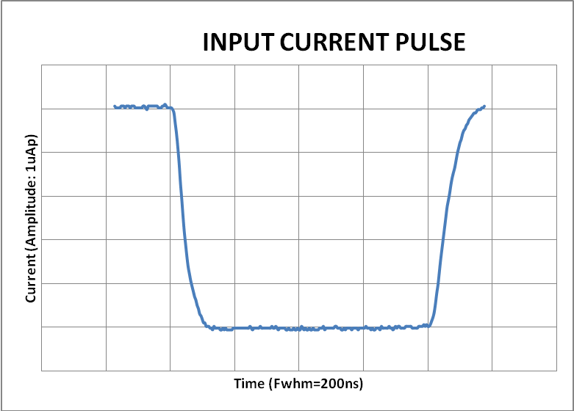
Fig. 2
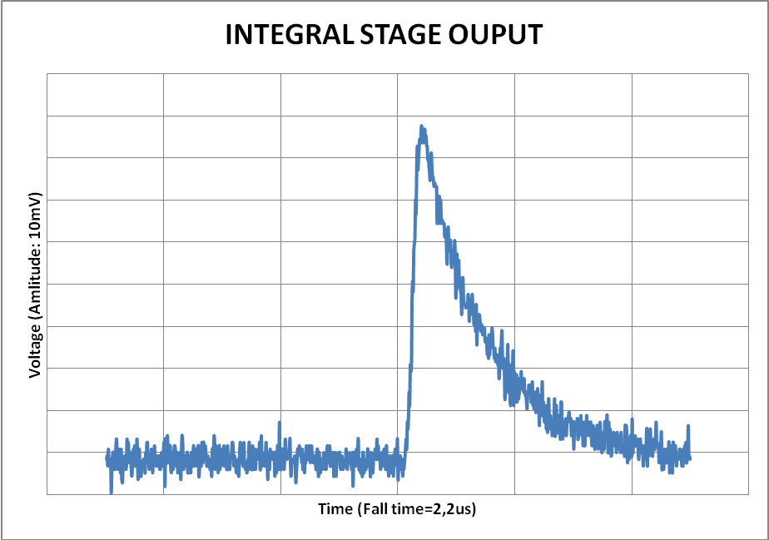
Fig. 3
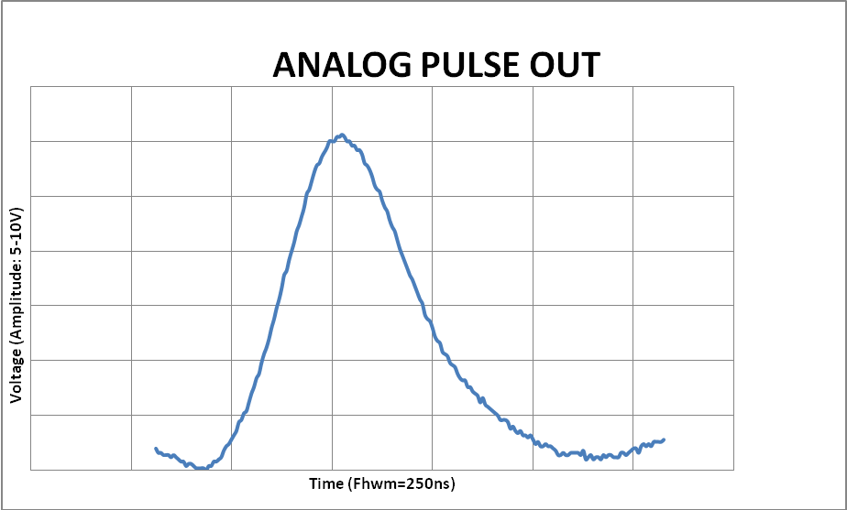
5. Block Diagram
U108
U103
U109
Monostable
Adjustable Amplifier
Integrator
U102
Low Noise Voltage Amplifier
FC INPUT
U101

U110
U106B
U105
U104
FLUCT.
OUPUT
DIGITAL
OUPUT
ANALOG
OUPUT
U106 A
P/Z
Cancel.

J108
Fast Output Amplifier
Polarity Change
Fast Output Amplifier
Pass Band Amplifier
Adjustable Comparator

Adjustable
Amplifier

Fast Amplifier

HV INPUT
LOW PASS FILTER
Fig. 4
6. Reactor Measurements [6]

On August 28, 2013, neutron flux measurements were made from a fission counter signal mounted on thermal fission reactor column of RA6 reactor, in Ezeiza Atomic Center.
For this experience we used a Centronic model FC-165 fission counter connected to our prototype through 16m of Belden model 9222 triaxial cable put inside a tight mesh designed to achieve an additional shielding.
The MSVsignal was calculated by squaring the value indicated by a true rms meter model HP 3400B, minus the squared value of the background noise without signal.
The counter pulse mode was evaluated from the digital output pulse rate by using a linear rate meter.
The analog output pulse was used to build the energy spectrum of the input pulses by a multichannel analyzer (MCA).
A full report of the experience, for summarizing these results was performed:
-The energy spectrum of the pulses coming from the fission counter with MCA was lifted from analog pulse output, for varying levels of neutron flux.
Peak/valley ratio of about 5 shows excellent performance for both pulse rate 23.10³p/s, and 184 .10³p/s.
This allows placing the discriminator level in a position to easily discriminate neutron pulses from the detector alpha background pulses
-It can be measured in pulse mode at a rate of: > 370.10³p/s with a default error <5%.
-It can be measured in fluctuation mode at a rate < 95.10³p/s, with a default error<7%, or at a rate < 23.10³p /s with a default error <13%.
-This means that it is possible to measure in both the startup zone and the power zone of the reactor with a single fixed detector by combining two measurement methods: pulse counting and MSV or Campbell methodo with 0.6 decades of overlapping between the two areas with an error <10%.
-As can be seen, for the measured values, such overlapping could be extended to 1.2 decades admitting an error <13%. This leads to the conclusion that it does not seem difficult to obtain an overlapping of one decade, with an error <10%, as initially was proposed, with only some improvement in the noise characteristics of the amplifier in the fluctuation mode.
7. Conclusions

Based on the measured values in the laboratory, coherent with the values obtained in experiencies made in the RA3 facility, we can say that we have available a wide range amplifier working in conjunction with a fission counter connected to it with a single triaxial cable longer than 16m capable of measuring the neutron flux over a range of more than 10 decades, by using both pulse mode and Campbell mode with one decade of overlapping between them.

8. References

[1]. POPPER G.F.,.LIPINSKI W.C. A Wide Range Counting Campbelling Neutronflux System.. Argone National Laboratory (TID-4500) 1967.
[2] DU BRIDGE,R.A., Campbell theorem-system concepts.
General Electric Company.- 1967
[3] LUIS M. GIULIODORI, MARIO MILBERG Y JULIO ZALCMAN, Medición del flujo neutronico basada en el 2º teorema de Campbell.
4th Meeting on Nuclear Applications, Pocos da Caldas. Brasil, Agosto 1977.
[4] THORP,S.I. Ensayo de un sistema Campbell de medición de flujo neutrónico en la pileta del RA3, CNEA.C.RCN.221 (2002) (CNEA, Informe interno)
[5] L GIULIODORI, E MATATAGUI, M.MILBERG, S. THORP, J ZALCMAN.
Application of Campbell´s método to a wide range neutron flux cannel measuring system.
International conference on research reactor utilization, safety, decommissioning, fuel and waste management; Santiago (Chile); 10-14 Nov 2003; IAEA-CN--100;IAEA-CN--100/31P; 4 refs, 1 fig
[6] G. RIOS, Resultados de la medición con el prototipo de canal de amplio rango del SIN en columna térmica del RA3 del 23/08/13. IN-06Y-120 Rev 0 (CNEA, Informe interno).

***

