Neutron Flux and Reactor Kinetic parameters Calculations in the RA0 Reactor

L. Romero, C. Barberis

Reactors and nuclear power plants research division, National Atomic Energy Commission (CNEA)
Av. Gral. Paz 1499 CP 1650, San Martín, Buenos Aires, Argentina

E-mail: lromero@cnea.gov.ar

Abstract. A detailed model of the RA-0 nuclear reactor with the MCNP5 code was developed and comparison with the results obtained with the WIMS-PUMA calculation chain and experimental measurements was carried out in order to validate the model. With this model the neutron flux in the central reflector, in the core and in the graphite reflector was calculated. The core effective beta (effective fraction of delayed fission neutrons), the time between production, Λ and the alpha parameter were also calculated. A comparison with the alpha value obtained by the neutron noise technique was also carried out. The installation model proposed consisted of detailed description of all the relevant materials and components as well as a detailed full core description with the fuel elements in their actual position in the grid.

- Introduction.

The RA-0 research reactor is a critical facility which offers the possibility of carrying out experiments for the training of university students, training and research of professionals and technicians. It operates at very low nominal power of about 1 W. It is located at the National University of Cordoba and owned by the National Atomic Energy Commission. The purpose of this work was to provide a detailed model of the Reactor with MCNP5 [1] code. Thermal ​ (0 <E <0.1eV) and epithermal flux (0.1eV <E <100KeV) were calculated at a facility located in the central reflector, in the core and at a facility located outside graphite. Calculated values ​​were compared with previous deterministic calculations and experimental measurements [2].

- Model description.

A detailed model of the system with the MCNP5 code was developed. The model provides a description of all the materials and components as well as detailed full core description with the fuel elements in their position in the grid.

It should be noted that in cases where all the information about the composition and type of impurities of all constituent materials was not available, appropriate compositions and typical impurities of the materials were used.

The RA-0 is a tank-type critical assembly with cylindrical geometry moderated and
cooled with light water and reflected with graphite. It has an inner cylindrical reflector at the centre of the core and several graphite blocks as outer reflector.

The fuel assemblies are vertically accommodated in a grid composed of five circular sectors, each of which is formed by three parallel plates with holes slightly greater in diameter than those of the fuel element sheaths. The grid has a total of 232 holes for fuel elements and 4 detector tubes or experimental facilities.
The control system consists of four (4) control rods of approximately equal equivalent negative reactivity worth and constituted by a cadmium plate covered by a stainless steel sheath. These rods are inserted vertically and tangentially to the reactor tank.

The following figures (see Fig 1,2 and 3) show some cross sections in MCNP model:

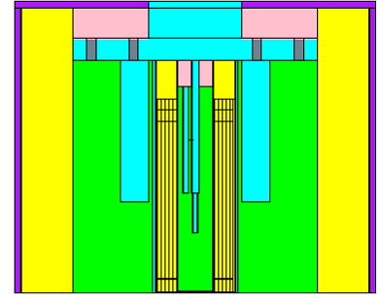
FIG. 1.RA-0 MCNP model. The facility in the central reflector and the facilities outside graphite.

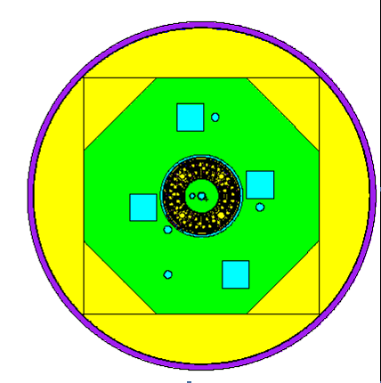
FIG. 2.RA-0 MCNP axial model. Reflectors and facilities.

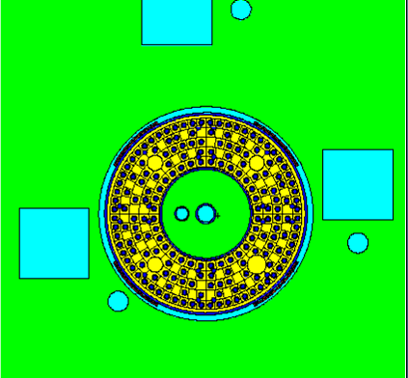
FIG. 3. RA-0 MCNP axial model. Control Rods, fuel assemblies and facilities.

- Calculations

The same model was used for two different calculations, with the corresponding changes as needed for the desired configuration.

  - Thermal and epithermal flux calculation

The calculation of the thermal and epithermal fluxes was carried out once the reactor model was completed.

The position of control rods (BC): BC1, BC2 and BC3 (100% withdrawn) and BC4 (77.3% removed) and a power of 0.85 W.
The neutron flux was calculated at different axial positions, taking the z=0 value at the middle plane of the core active zone.

  - Kinetic parameter calculation

For the calculation of the kinetic parameters the following control rod configuration was adopted: BC1 (84.5% removed); BC2, BC3 and BC4 (100% withdrawn) [4].

- Results

Thermal and epithermal flux values were obtained for the three facilities mentioned and compared with experimental data [2] as shown in Table 1.

TABLE 1. Comparison between the experimental and calculated fluxes
The following figures (fig. 4 to fig. 9) show the thermal flux profile and epithermal flux in each of the facilities.

FIG. 4. Profile of thermal neutron flux in the central reflector.

FIG. 5. Profile of epithermal neutron flux in the central reflector.

FIG. 6. Profile of thermal neutron flux in the core.

FIG.7. Profile of epithermal neutron flux in the core.

FIG. 8. Profile thermal neutron flux in the graphite facility.

FIG 9. Profile epithermal neutron flux in the graphite facility.

The MCNP values for the kinetic parameters are shown in Table 2.

TABLE 2. Kinetic parameters obtained from the calculation with MCNP
β (pcm) | (753 $±$0.81)
Λ (υseg) | (132.6 $±$0.35)
α (1/seg) | (56.77 $±$0.69)

The kinetic parameter values obtained with the code WIMS-PUMA, are shown in Table 3.

TABLE 3. Kinetic parameters obtained by (WIMS-PUMA)
β (pcm) | 792
Λ (υseg) | 101
α (1/seg) | 78.4
Table 4 shows the alpha parameter value obtained using the neutron noise technique.

TABLE 4. Kinetic parameter obtained by the neutron noise technique.
α (1/seg) | (65.21 ± 0.33)

- Conclusions

In Table 1 we can see that the thermal flux values obtained experimentally [2] and those obtained with MCNP are very similar and differ some 16% in the worst case (central reflector).
Both in the core and the graphite reflector the differences are smaller than 5%.
The epithermal flux differences are greater than those obtained for the thermal flux. This behaviour is the same as that obtained with MCNP for the RA1 for an energy range up to 100 keV, as shown in [2].

With respect to the comparison with the parameters calculated by WIMS-PUMA codes, MCNP calculated beta effective is 5% less than the calculated value, the time between reproductions is 23% larger than the calculated and the alpha parameter is a 27.5% lower. As concerns the alpha parameter the noise technique of noise gives values that are about 17% lower than those calculated with MCNP.

- References

[1] MCNP5. A general Monte Carlo N- Particle Transport Code, Versión 5. Los Alamos National laboratory.
[2] L.Wentzeis Medición del Flujo Neutrónico del Reactor RA-0. Internal technical report, ITE-06REC-252.CNEA (2013)
[3]M.Higa , Informe técnico CNEA-RE-CA 91-29, CNEA (1991).
[4] Mediciones para la estimación de parámetros cinéticos en el reactor RA0 A.Gomez, P. Bellino. Internal technical report, ITE-06REC-249, (CNEA 2012).

