Level 1 Probabilistic Safety Assessment for licensing of RA-10 reactor

Grinberg, M¹; Braida, I¹; Campregher, M¹; Quiroga, D¹; Giménez, M.¹

1) CNEA, Centro Atómico Bariloche, S.C. de Bariloche, Río Negro, Argentina.
grimberg@cab.cnea.gov.ar; braida@cab.cnea.gov.ar; campregher@cab.cnea.gov.ar; quirogad@cab.cnea.gov.ar; gimenez@cab.cnea.gov.ar

Level 1 Probabilistic Safety Assessment (L1 PSA) of RA-10 reactor has been developed having as goal to give support to licensing of reactor, according to regulatory body for Research Reactors. Moreover, L1 PSA has been used to give support to design, identifying requirements for different engineering areas. The objective of L1 PSA is to reduce installation radiological risk and to improve its availability, too.

L1 PSA is a tool for systematic analysis that allows identifying failures in structures, systems and components, contributing to evaluate the radiological risk of installation. With application of methodology of probabilistic assessment is possible to make an integral probabilistic model of systems of nuclear installation and dependencies among them. Different systems of reactor such as process, electrical and control and instrumentation processes have been analyzed in the context of L1 PSA. These analyses have allowed evaluating failures that can lead to initiating event occurrence or not allow to accomplishment of a safety function.

According with the scope of this work, reactor core and experimental facilities of Uranium-Molybdenum were considered as sources of radioactive material. Development of L1 PSA has had as objective determination of event sequences of events that lead to damage state of plant. The tasks associated to L1 PSA development were: grouping of initiating events, development of fault trees for quantification of frequencies of initiating event and unavailability of headers of event trees and development event trees.

These tasks have been developed in the context of a Quality Program for L1 PSA. According to it, procedures were used for developing tasks. Risk Spectrum PSA was used as support tool to develop models.

Information of conceptual and basic engineering of RA-10 reactor was used in L1 PSA. Probabilistic models were quantified with data from international statistics of research reactors and power reactors, and by using postulated data, taking into account that it is a preliminary work.

Finally, quantification of frequencies of plant damage states was obtained. Moreover, contribution of different initiating event to plant damage states was analyzed. Then, this information is required for development of L2 PSA and L3 PSA. A complete PSA allows to determine radiological risk associated to installation for public and to verify accomplishment of regulatory criterion.

Introduction

In this paper is resumed the development of Level 1 Probabilistic Safety Assessment (L1 PSA) for RA-10 research reactor. This work has been developed in the context of license of reactor, specifically for Preliminary Safety Assessment Report (PSAR). It has been considered information regard to conceptual and basic engineering of RA-10 reactor.

The results from L1 PSA are the input for the development of Level 2 (L2) and Level 3 (L3) PSA, with the objective to evaluate risk associated to installation as function of Argentinean Regulatory Criterion. Moreover, L1 PSA has contributed to identify relevant aspects to take into account in the design of reactor, in order to reduce risk associated to installation.

In this paper, in first time methodologies of L1 PSA and techniques are described. Then, some aspects related to characteristics and engineering of reactor RA-10 that are used in L1 PSA development are explained. After that, the development of L1 PSA is explained. Obtained results are show. Moreover, contributions from L1 PSA to design of reactor are indicated. Finally, the conclusions are mentioned.

Level 1 Probabilistic Safety Assessment Methodology

Probabilistic Safety Assessment (PSA) is an integral assessment of a nuclear plant safety. It allows identifying strengths and weaknesses of installation in a systematic way and it allows evaluating radiological risk in public and operators. PSA is divided in L1, L2 and L3.

In particular in L1 PSA, it is analyzed sequences of events. Consequences of event sequences can imply damage in core or in irradiation facilities. L1 PSA requires specific deterministic analyses for supporting related tasks.

For the development of L1 PSA, following tasks are made:
- Grouping of postulated initiating event
- Event sequences analysis
- Systems analysis
- Dependent failure analysis
- Data analysis and models quantification

L1 PSA tasks have been made according to methodologies based on international references as well nuclear power plants as research reactors ([1][2][3][4]), and PSA studies for research reactor (RA-3, RA-1 y RA-6), and nuclear power plant (Atucha I-CNAI, Atucha II-CNAII y Embalse-CNE), located in Argentina. Moreover, a Quality Program is implemented for developing L1 PSA of RA-10 reactor.

Brief description, characteristics and systems of RA-10 reactor

Brief description

The RA-10 Reactor is a multipurpose, research and production nuclear reactor of high neutron flux, enough to ensure its simultaneous use in a wide range of applications. It will aim to expand and consolidate the production of radioisotopes, to provide irradiation facilities for materials and fuels and to provide new applications in the field of science and technology.

The core has 25 positions in a 5x5 arrangement. The four corners and two centre positions are used as irradiation boxes for testing materials, the rest of the arrangement will be completed with 19 standard fuel elements. The nominal core power is 30 MW. The Fuel Elements are MTR type, square section, each with 21 flat fuel plates.

The Neutron Moderator to be used is light demineralized water. The Neutron Reflector in the reactor serves to decrease the loss of neutrons due to leakage through the external surfaces of the core. In the case of RA-10 it has been selected a liquid reflector: Heavy Water D₂O. Heavy water is contained in a reflector tank, surrounding the lateral surface of the core and maintaining a tight seal.

Reactor Applications

With respect to the use of the reactor, it presents irradiation facilities (IF) inside the core and outside the core:
- Irradiation facilities internal to the core of thermal or fast spectrum (instrumented or not instrumented).
- Irradiation facilities external to the core: Molybdenum by fission of mini plates (U-Mo), Medicinal Iridium by wire activation, Industrial Iridium by foils activation, Medicinal Lutetium by activation, other radioisotopes, irradiation of samples in pneumatics headers, Silicon doping.

The reactor also has a Cold Neutron Source. Another irradiation facility of the reactor is the Irradiation of Power Fuel Rods, whose function is irradiate fuel rods from power reactors in total or partial operating conditions, to study their behaviour.

Reactor Systems

The following is a brief description of the main systems of the reactor, whose information of engineering was necessary for the development of the L1 PSA, considering its scope.

First Shutdown System

The First Shutdown System (FSS) is the system that manages the insertion and removal, in a controlled manner, of the absorbing rods in the reactor core.
There are a total of six control rods for the function of neutron capture that on the one hand controls the reactivity during the reactor operation and on the other also handles the fast shutdown signal to the Reactor Protection System.

Control rods are inserted into one of the two guide boxes, which restrict them to a vertical movement. The command is made with control mechanisms housed in the mechanisms room. Each control mechanism has two trigger valves arranged in parallel, when actuated they allow the passage of compressed air for the insertion of the control rods.

Second Shutdown System

The Second Shutdown System (SSS) plays a role in the extinction function of the reactor by partially draining the heavy water contained in the reflector tank. The level decrease of the neutron moderator leads the core to a subcritical condition.

The draining of the heavy water from the reflector tank is realized by gravity through a series of valves disposed in parallel to a storage tank of heavy water.

Primary Cooling System

The role of the Primary Cooling System (PCS) is to remove the heat generated by fission inside the core in normal operation and shutdown plant conditions, keeping the coolant inlet temperature within the values ​​set.

Outside the Reactor Pool (RP) the flow is divided into three branches of impulsion and cooling, where each branch can promote the 50% of the flow required for cooling at full power. Each branch has a pump and a plate heat exchanger. The cooling of the core is with upward flow. The extracted heat is transferred to the Secondary Cooling System (SCS) through plate heat exchangers. In the external circuit to the pools, upstream of the flow and cooling branches, there is a tank to allow the decay of N₁₆ dissolved in the water of the circuit. Meanwhile, at the exit of the heat exchangers there is a bypass flow to the Pools Cooling System for generating a plugging flow in the upper part of the RP, preventing the rise of activated water towards the surface of the Pool.

Two pairs of flap valves, a pair on each input line to the RP, create a natural circulation circuit within the RP that allows the removal of decay heat from the core, with pools acting as heat sinks, in case of natural convection.

Reactor and Service Pools Cooling System (RSPCS)

The Reactor and Service Pools Cooling System (RSPCS) has the function of remove the generated heat by irradiation facilities external to the core and the spent fuels in the Service Pool (SP). There are two operating mode: normal and turned off.

In the Reactor Pool irradiation facilities are cooled by forced downward circulation; the water is collected in a plenum under of the reflector tank. All inside pipes RP and SP have siphon effect breakers.

Outside pipes of the RP go to a decay tank the PCS. Downstream are redundant pumps of RSPCS, which one is in standby. There is a heat exchanger that transfers the heat to the Secondary Cooling System (SCS).

Secondary Cooling System

Secondary Cooling System (SCS) has as function to transfer thermal load of reactor in normal operation to environment. Moreover, residual heat is removed by this system. RSPCS transfers thermal load to this system too.

SCS transfers heat to a cooling tower. This cooling tower is formed by five cells. They function by countercurrent flow and induced draft. SCS has three main pumps of 50% capability. One of them is in stand-by.

Reactor Protection System

The Reactor Protection System (RPS) is the safety system that starts the protection actions related to reactivity control and radionuclides containment for failure in the plant, operation failure or external events. The RPS measures reactor safety variables and start automatic protection actions when some variable reaches limit value. The RPS is made with Field Programmable Gate Array (FPGA).

The safety signals are digitize and compared with a reference signals in the comparative logic module. The result is called initiation signal. This signal is send to the others trains and each train receives its initiation signal and the others trains.

The signal from each comparative logic module goes to a voting and trigger logic module, this generate the protection signals. Them they are subject to two out of three voting in a final voter module. The generated signal in the final voting logic activates the actuator of the protection action.

Reactor Monitoring and Control System

All automatic systems for operation and supervision of reactor are made for the Reactor Monitoring and Control System (RMCS). Limitation actions are implemented in this system too. RMCS regulates reactor power, according to changes in the reactivity.

Electric System

The electrical system is divided into Normal Power Supply and Essential Power Supply.

The Normal Power Supply meets the electrical requirements of the reactor in all its operational states (forced convection, natural convection, shutdown and core modifications). The input voltage is performed in 13.2 kV and it has a trunk distribution scheme with two redundant divisions of 100%. Without this system of normal supply available, automatic reactor shutdown occurs.

The Essential Power Supply is secured with diesel generators in low AC voltage (for interruptible loads) and with Uninterruptible Power Systems (UPS) in low AC and DC voltage

Development of L1 PSA of RA-10 reactor for preliminary safety report

Objectives and scope of L1 PSA of RA-10 reactor for Preliminary Safety Assessment

Primary objectives of L1 PSA reactor have been the following:

- To give support to license process of reactor in order to verify Argentinean Regulatory Criterion (AR 4.1.3 [5]).
- To give support to design process. L1 PSA is a methodology of systematic analyses that allows identifying elements in design that contribute significantly to failure of structure, systems and component (SSC), evaluating design options and identifying dependences and interactions among components, including human factor.

It is important to indicate that development of L1 PSA in first stages of design (Conceptual and Basic Engineering) can have uncertainties associated with knowledge of systems. However, development of L1 PSA in these stages allows analyzing systems design and dependences, and identifying, correcting o improving in first stages of project possible design weaknesses. It represents an advantage since point of view safety as optimization of project resources.

The scope of L1 PSA is:

- Reactor in operational state of Forced Circulation: It is considered that initiating events can happen at full power. It is considered that initiating events or reactivity insertion by extraction of control rod can happen in transition state of cold start-up and without Xenon.
- Radioactive sources: Core and irradiation facilities (only U-Mo).
- Only initiating events that can affect core or irradiation facilities are considered.
- Only internal initiating event and loss of site power as precursor are considered.
- Safety function to include in event trees: Control of power, Refrigeration of core and nuclear facilities (U-Mo).
- Frontal systems to consider as headings in event trees: safety systems and available systems in plant to control initiating event.
- Mission time: 10 h
- Human actions are not considered to control initiating events.

Groups of initiating event analyzed in L1 PSA

Initiating events (IE) that can occur in forced circulation state in the RA-10 reactor have been identified, selected, postulated and grouped among families. Initiating events lists referenced in [6], [8] and [9] and engineering judgment were used to identify them. Then IE were selected or excluded according on their applicability to the design of the reactor.
Initiating events that were postulated for the development of L1 PSA are listed in Table I.

Table I. Grouping of models of event trees, according to affected radioactive source.
Groups of initiating events that affect to core and IF (U-Mo)
A. Reactivity insertion by extraction of control/s roads
B. Other initiating events of reactivity insertion
C. Loss of offsite power
I. Loss of primary circuit coolant
J. Loss of pools circuit coolant
L. Loss of heat sink
Initiating events that only affect to core | Initiating events that only affect to IF (U-Mo)
D. Failure of one or both pump of PCS | N. Failure of a pump of RSPCS
E. Core by-pass | P. IF by-pass
Q. Generic Transient | P. IF by-pass

System analysis for development of L1 PSA

Systems analysis was made in order to quantify unavailability of headings used in event trees and to determinate some frequencies of initiating events. Fault trees were used as technique for systems analysis. Risk Spectrum PSA was used as support tool to develop models.

Event sequences analysis for development of L1 PSA

Events sequences analysis was performed by event tree technique. Core and irradiation facilities (U-Mo) were considered as sources of radioactive material, according to the scope established for this work. In Table I the event tree models developed are shown taking into account on the one hand, the grouping of initiating events mentioned in the previous point, and on the other hand, the radioactive source affected, reactor core and/or IF (U-Mo).

Initiating events that only affect the reactor core, doesn’t compromise forced circulation at IF. Initiating events related to IF only affects them; core remains cooled by forced circulation. On the other hand, there are events that because their phenomenological characteristics or affected systems can cause damage to the core or IF, as well. Therefore event trees are developed for both sources of radioactive material.

Deterministic simulations and engineering judgment have been used as support the development of event sequences. Hypotheses used for developing event trees are the following:

- Time analysis is 24 hours, according to international practices for the development of event trees for PSA. However, the time required for Primary Cooling System and Secondary Cooling System as support system is 10 hours, according to deterministic simulation.
- Pool can be cooled during 24 hours by RSPCS or by Extended Pools Cooling System.
- Core damage condition: Departure nuclear boiling (DNB), Margin to Burn Out (MBO) and Margin to redistribution (MRD) less than one.
- Irradiation facilities (U-Mo) condition: In the case of sequences of events which can affect IF, fusion is postulated when they cannot be refrigerated, or when reactor is not shutdown.

Events trees headings represent frontals and supports systems and human actions required after an initiating event. Each event sequence is characterized by conservatively assumed consequences for developed trees events sequences, according to whether the source of radioactive material affected is core or IF (U-Mo). These consequences have been postulated according results of deterministic analyses and engineering judgment.

Analysis case: Event trees for Loss of normal power supply

Loss of normal power supply is considered when off-site (external to reactor site) or on-site (failure in transformer substation) fail. Also network as frequency or voltage excursions are considered.

Event tree considering the core as source of radioactive material

Function of extinction is required through FSS, which is intrinsically demanded, or SSS through Reactor Protection System. The cooling function is performed by natural circulation, given the opening of at least one of flap valve (PCS). In case of failure of extinction function of FSS and SSS, reactor goes to low power, due to initiating event characteristics (both PCS pump stop and out of service of power regulation system) and reactivity coefficients feedback. Deterministic simulations show that when the reactor extinction fails, partial melting of core (DN1) is produced, regardless success or failure of PCS flap valves.

Event tree is showed in Figure 1. The considered headings are the FSS (PSP.0 model, intrinsically demanded because of the initiating event), SSS (SSP.11 model) and the PCS flap valve demanded to establish natural circulation. As shown in event tree, there are sequences that result in a controlled plant state (OK1: reactor shutdown and cooled) and others in partial core damage (DN1).

Event tree considering the irradiation facilities (U-Mo) as source of radioactive material

Given the initiating event described in previous section, reactor is shutdown by FSS or SSS. RSPCS pumps are cooled by SCS, so they are shutdown given the initiating event. As consequence, cooling is performed by natural circulation by the opening of at least one of RSPCS flap valve. In sequences with failure of the cooling or in sequences with failure of extinction function, total fusion of IF is postulated (DF). Event tree is showed in Figure 2.

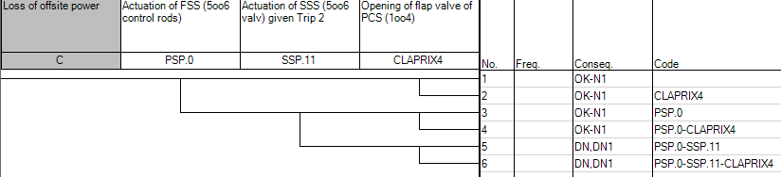
FIG. 1. Event tree of Loss of offsite power, considering core as radioactive source.

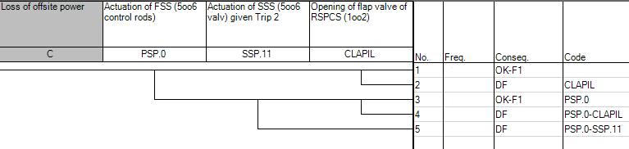
FIG. 2. Event tree of Loss of offsite power, considering IF (U-Mo) as radioactive source.

Data analysis, quantification and simulation models for L1 PSA

Quantification of Fault Trees and Event Trees models and subsequent simulation was performed based on the corresponding procedure. The data used for quantification of probabilistic models have been analyzed according to their applicability to them. These data come from international databases both experimental reactors and power reactors ([10], [11] and [12]). In some particular cases postulated values have been used as design objective values, given the state of the basic engineering stage. With respect to human error quantification screening values ​​were used, according to the reference [13].

The integration of event trees, fault trees and basic events is performed with the support of the RiskSpectrum PSA code.

Dependence Analysis

The following topics are included in Dependence Analysis:

- Physical dependence: Environment degradation that affects SSC is evaluated.
- Common cause initiating events: Events that require reactor extinction and that affect safety function.
- Residual common cause failures: They represent residual dependences that cannot be explicitly modelled in sequences or headings.

Dependence analysis is limited by the stage of reactor engineering. Particularly, in common cause failure analysis beta factor model is applied.

Results

An integrated model of L1 PSA that includes fault trees and event trees has been developed. RiskSpectrum PSA code has been used. Consequently, core and IF (U-Mo) damage frequencies have been calculated:

f _{Core damage}= 5,3 E-07 year⁻¹
f _{IF damage}=4,0 E-05 year⁻¹

Moreover, contribution from each initiating event group or subgroup in core damage frequency has been determinate. Contribution over 0,1% are showed in Figure 3. Initiating event of Loss of coolant due to RSPCS piping ruptures has the highest contribution (80%), followed by Loss of coolant due to PCS piping ruptures. Then, Loss of heat sink event and Loss of coolant due to ruptures in flushing piping has a contribution of 3% to core damage frequency.

It is observed that initiating event where the safety function of refrigeration is affected (C. Loss of offsite power, D1. Failure of a pump of PCS, D2. Failure of both pump of PCS; Q. Generic transient) and reactivity insertion have a depreciable contribution to total core damage frequency.

It is showed that the event of Loss of offsite power (C) has an occurrence frequency higher than event of Loss of heat sink (L), but both have same sequences and consequences. It is as consequence that initiating event C requires actuation of FSS intrinsically. In the case of initiating event L, core damage frequency is dominated by failures of components that generate Trip 1 and Trip 2, signals that demand FSS and SSS, respectively. In case of Loss of coolant due to ruptures in PCS piping, it is considered as safety feature only the actuation of flap valves, without reposition of inventory from a makeup water system. Siphon effect breakers are required in case of failure of check valves in the interconnection piping of RSCPS/PCS. Control of initiating events of loss of cooling is made by PCS if it is available or cooling by natural circulation where passive systems are required. As consequence, contribution to core damage frequency is low.

Figure 4 shows the contribution to core damage frequency according to the different core damage states identified.

In the case of initiating events that affect IF (U-Mo), it can be observed in Figure 5 that the higher contribution to IF damage is the event of IF cooling by-pass. This is because there is an only parameter to detect the spurious flap valve opening or a piping rupture. Moreover, in order to provide IF cooling by natural circulation, RSPCS pump has to be shutdown. Conservative hypothesis has been used in sequences where IF cannot be cooling, because deterministic analyses had not been made.

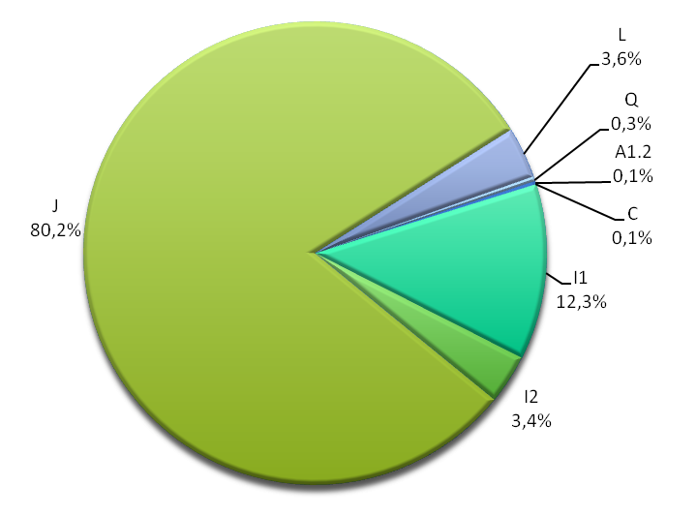
FIG. 3. Contribution of initiating event groups to core damage frequency.
A1.2: Spurious extraction of control road to nominal speed during reactor operation to normal power; C: Loss of offsite power; I1: Loss of coolant by rupture in main pipings of PCS; I2: Loss of coolant by rupture in flushing pipings; J: Loss of coolant by rupture in piping of RSPCS; L: Loss of heat sink; Q: Generic trasient.
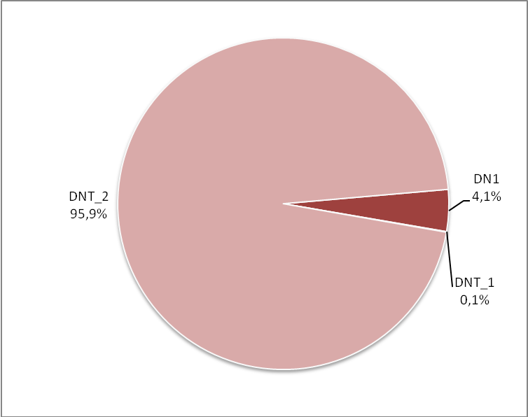
FIG. 4. Contribution of the different core damages states to core damage frequency.
DN1: Partial core damage; DNT_1: Total core damage by excursion of power; DNT_2: Total core damage by undercover.

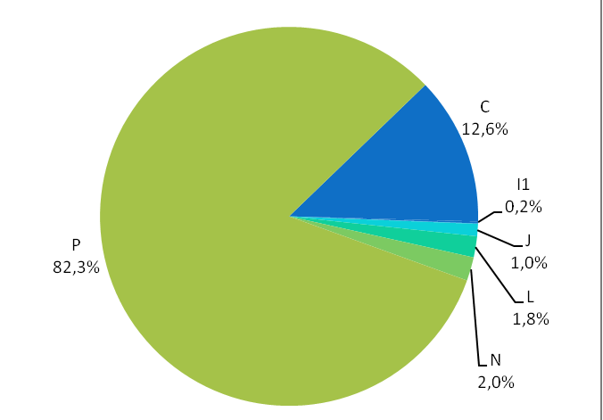
FIG. 5. Contribution of initiating event groups to IF damage frequency.
C: Loss of offsite power; I1: Loss of coolant by rupture of main pipings in PCS; J: Loss of coolant by rupture of piping in RSPCS; L: Loss of heat sink; N: Failure of a pump of RSPCS; P: FF.II. by-pass.

Use of L1 PSA as support to design

L1 PSA has been used to support RA-10 reactor design, since basic engineering. These improvements have had as objectives exclusion or reduction of initiating event frequencies and reduction of core and IF damage sequences frequencies.

For instance, the following tasks were found to be analyzed:
- Design of electric system (off-site and on-site) in order to reduce frequency of occurrence of initiating event of loss of power. This event affects availability of plant too.
- Design of regulation power system in order to reduce frequency of initiating event of abnormal extraction of a control rod to a higher speed than normal value and control rod bank outdraw.

Conclusions

In this paper, L1 PSA of RA-10 research reactor for PSAR has been resumed.

It is important to mention that L1 PSA has been developed following international practices for power and research reactors, taking into account the scope of this work. Also, L1 PSA has been developed according to a quality program; where inside document structure has operative procedures for probabilistic tasks such as System analysis, Development of event trees and Data analysis.

As result, total core damage frequency and contribution of each initiating event group have been obtained. Core damage frequency is lower than international standard frequency for power reactor (f_{CD}=1E-05 year⁻¹ for new designs and y f_{CD}=1E-04 year⁻¹ for power plants in operation). In future updates of L1 PSA, other initiating event that can affect other irradiation facilities, radioactivity sources and operator will be analyzed.

Moreover, consequences of event sequences have been analyzed with support of deterministic simulations. Frequencies and consequences are used to develop interface between L1 PSA to L2/L3 PSA.

On the other side, L1 PSA is a useful methodology to support the design since an early stage of project. Moreover L1 PSA will be used to support, in next engineering stage, maintenance and reactor operation.

References

- IAEA-SSG-3. Development and application of Level 1 PSA for NPP. Austria, 2010.
- IAEA SAFETY SERIES Nº 50-P-4: Procedures for Conducting Probabilistic Safety Assessments of Nuclear Power Plants (Level 1).
- IAEA. TECDOC-400. Probabilistic Safety Assessment for Research Reactors.
- IAEA. SSG-20. Safety Assessment for Research Reactors and Preparation of the Safety Analysis Report.
- ARN. AR 4.1.3. Criterios Radiológicos Relativos a Accidentes en Reactores de Investigación.
- ARN. Guía AR 4. Diseño de reactores nucleares de investigación. Autoridad Regulatoria Nuclear, Argentina, 2003.
- NUREG-0492. Fault Tree Handbook, 1981.
- IAEA NS-R-4, Safety of Research Reactors - Safety Requirements, IAEA, 2005.
- IAEA, Research Reactors Accidents / Incidents.
- IAEA.TECDOC-636. Manual on reliabililiy data collection for research reactor PSAs.
- IAEA.TECDOC-930. Generic component reliability data for research reactor PSA.
- IAEA.TECDOC-478. Component reliability data for use in probabilistic safety assessment.
- NUREG-CR4772. Accident Sequence Evaluation Program: Human reliability analysis procedure. Swain, A. USA, 1987.
- RiskSpectrum Theory Manual. Version 3.0.0. Relcon Scandpower 2008.

