Kinetic Parameters Estimation in the RA-0 Research Reactor

P. Bellino, A. Gomez

Experimental Reactor Physics Division, National Atomic Energy Commission (CNEA)
Av. Gral. Paz 1499 CP 1650, San Martín, Buenos Aires, Argentina

Corresponding author: pbellino@cnea.gov.ar

Abstract. Different kinetic parameters were estimated at the RA-0 critical assembly. The complete set of measurements was separated in two stages: a first stage with the standard critical core, and a second stage with subcritical core configurations. During the first stage the power calibration of the reactor was performed. Using the spectral neutron noise technique for estimating the reactor power, one of the power range channels of the reactor was calibrated. With the same technique the critical prompt neutron decay constant α_{c} was also estimated. In the second stage, measurements were performed in subcritical configurations with an external neutron source. The method of α-Feynman was applied for reactivity estimation, using four proportional counter detectors. The subcritical level of the reactor was modified in two different ways: changing the water level of the moderator and withdrawing one of the control rods. In both cases the reactivity was estimated at each level and the critical α_{c} value was obtained. In order to study spatial effects in the reactor a new core configuration was arranged: a whole central ring of fuel elements was removed in order to create two separate fuel zones in the core. Finally, the source strength was estimated by subcritical rod-drop analysis. Using this value, a subcritical digital reactimeter was implemented in the reactor instrumentation.

1. Introduction

The RA-0 critical assembly is an Argentinean 1W research reactor located at the National University of Cordoba and owned by the National Atomic Energy Commission. In this work we show the main results obtained from several experiences performed for the estimation of kinetic parameters of the reactor. The first stage of these measurements was done in the standard critical core configuration [1]. By means of the spectral analysis based on the neutron noise technique [2][3], a power calibration of the reactor instrumentation was accomplished. This calibration consists in obtaining the conversion factor between the current of one of the power range channels and the thermal power of the core. The calibration was done in the in the range 0.1W to 10W. Simultaneously, the spectral analysis also allows the estimation of the critical prompt neutron decay constant α_{c} which is of central importance in reactor safety analysis, especially in criticality accidents.

In a second stage of the experience, all the measurements were performed in subcritical cores with an external neutron source [4]. The aim of these measurements was the estimation of the α value for different subcritical levels (from which the reactivity could also be obtained) and the determination of the α_{c} via extrapolation of measured values. For this set of measurements, the method of α-Feynman [5] was applied using the signal from four neutron proportional counters. The data acquisition system used performs a time-stamp at each individual pulse and could run with up to three detectors simultaneously. The subcritical level of the reactor was modified in two different ways: changing the moderator level and the control rod insertion. The reactivity worth of both the control rod and water of the moderator were estimated. In order to study spatial effects in the reactor a new core configuration was arranged: a whole central ring of fuel elements was removed in order to create two separate fuel zones in the core.

Finally, the source strength was estimated by subcritical rod-drop analysis using the Least Squares Inverse Kinetic Method (LSIKM) [6]. The estimated value was used for the implementation of a subcritical digital reactimeter in one of the start-up channels (with a BF₃ proportional counter) of the reactor instrumentation. Once operative, this novel application was validated performing new reactivity estimations using the α-Feynman method for different moderator heights.

2. Description of the methods

2.1. Neutron Spectral Analysis

This neutron noise technique is mostly used for the absolute determination of the reactor power and the estimation of the α_{c} value at critical state [7]. When used in a signal from an ionization chamber, the method relies on the spectral analysis of the measured detector current , where is the mean value of the time independent current (the reactor must be in a critical steady state) and is the fluctuating component of the signal. The Normalized Auto Power Spectral Density (NAPSD) of the current can be expressed as:

 | 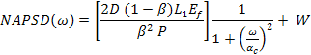 | (1)

Where : Diven factor
: mean energy released per fission
: correction factor due to reactor geometry
: reactor power
: effective delayed neutron fraction
: non-correlated white noise

This last equation is used to fit the experimental data for the estimation of the measured spectral density of the signal, from which the parameters, and are obtained. Only the first two are relevant for this work.

2.2. α-Feynman Method

This method is based on a statistical analysis of the number of detected counts from a neutron proportional counter. All the measurements are done in a steady state level of a subcritical reactor with an external neutron source. In the absence of a multiplying medium, the number of counts detected () follows a Poisson process where its mean value equals the variance . Moreover, this property is independent of the time interval where the pulses are counted. However, the occurrence of neutron chains due to fission process, increase the variance of the detected counts [7]. Also the increase of variance becomes dependent on the time . The α-Feynman method consists in the estimation of this deviation from a Poisson process. The theoretical expression for the relative variance deviation from that of a Poisson process can be written as:

 | 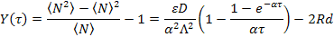 | (2)

Where : prompt neutron decay constant
: mean generation time
: detector absolute efficiency
: mean count rate
: dead time of the measuring system

The second term of the last equation accounts for the effect (up to first order) of the detection system dead time [8]. Other corrections, such as delayed neutron and finite time measurements [9], did not improve significantly the results obtained with the expression given in Eq. (2).

The α-Feynman estimation consists in taking the sample mean and sample variance of the counts detected during a time interval , and obtaining the value. This procedure must be repeated for several and then the data is adjusted with the Eq. (2) from which the parameters α, ε and d were estimated. Once the α is obtained, the reactivity can be estimated using the definition α = (1-$)/Λ*. In this work, the bunching technique [10] was used for computing the statistics of different in order to reduce the measurement time. The FIG.1 shows the measured curve for different subcritical levels obtained by changing the extraction level of the control rod 1 (CR1) of the reactor.

The α values obtained in each subcritical configuration can be used to obtain an estimation of the α_{c} value. Using the relation of a subcritical steady state reactor (where is the effective neutron source strength), the definition of the α value can be expressed as:

 | 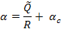 | (3)

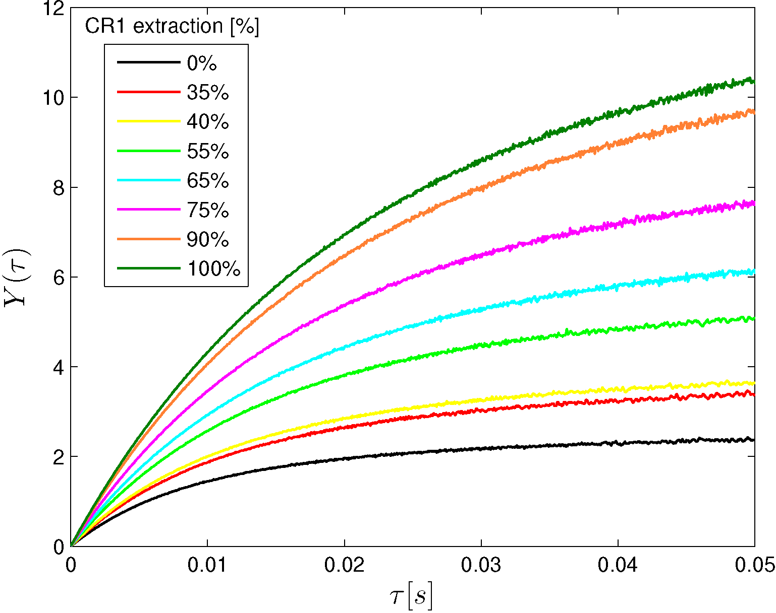
FIG. 1. α-Feynman curves for different extraction levels of the control rod CR1 from the D2 detector.
From the Eq. (3) a linear relation is found between the estimated α and 1/R at each subcritical level. A linear fit of these magnitudes allows the determination of the α_{c} value. The importance of this procedure is that the α_{c} estimation is based only on measurements performed at subcritical states.

2.3. Least Squares Inverse Kinetic Method

This method was used for the determination of the effective neutron source strength , which in turn, is the key element for an implementation of the inverse kinetics equation [11][12] for subcritical reactors (digital reactimeter):

 | 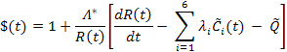 | (4)

Being the effective precursor density of the i^{th} group of delayed neutrons, λ_{i} the delayed decay constants and Λ∗=Λ/β the reduced mean generation time. The balance equations for the other six parameters are omitted. The method is applied during the transient delayed evolution after a rod-drop between two subcritical states, and consists in the linearization of the evolution by defining the auxiliary variable:

 | 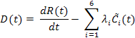 | (5)

It can be shown [6] that during the transient evolution, the following relations holds between the count rate R(t) and the D(t):

 | 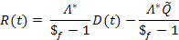 | (6)

Where is the final reactor reactivity after the rod-drop. Using a linear least square fit an estimation of the can be obtained. This value is clearly detector dependant, so this estimation must be done with the same detector where the reactimeter has to be implemented.

3. RA-0 Research Reactor

The RA-0 is a tank-type critical assembly with cylindrical geometry moderated and refrigerated with light water and reflected with graphite. It has an inner cylindrical reflector at the centre of the core and several graphite blocks as an outer reflector. The core is made of five concentric rings of fuel elements, which can be distributed according to the configuration needed. The reactor is controlled by four control rods located between the core and the external graphite. The reactor power under normal operation is 1W, and is allowed to reach 10W during transient operations. The reactor is dedicated mainly to educational purposes, research activities and as an irradiation facility. In FIG.2. a schematic representation of the reactor is shown with its most important components, as well as the detector locations used during both stages of the experiences.

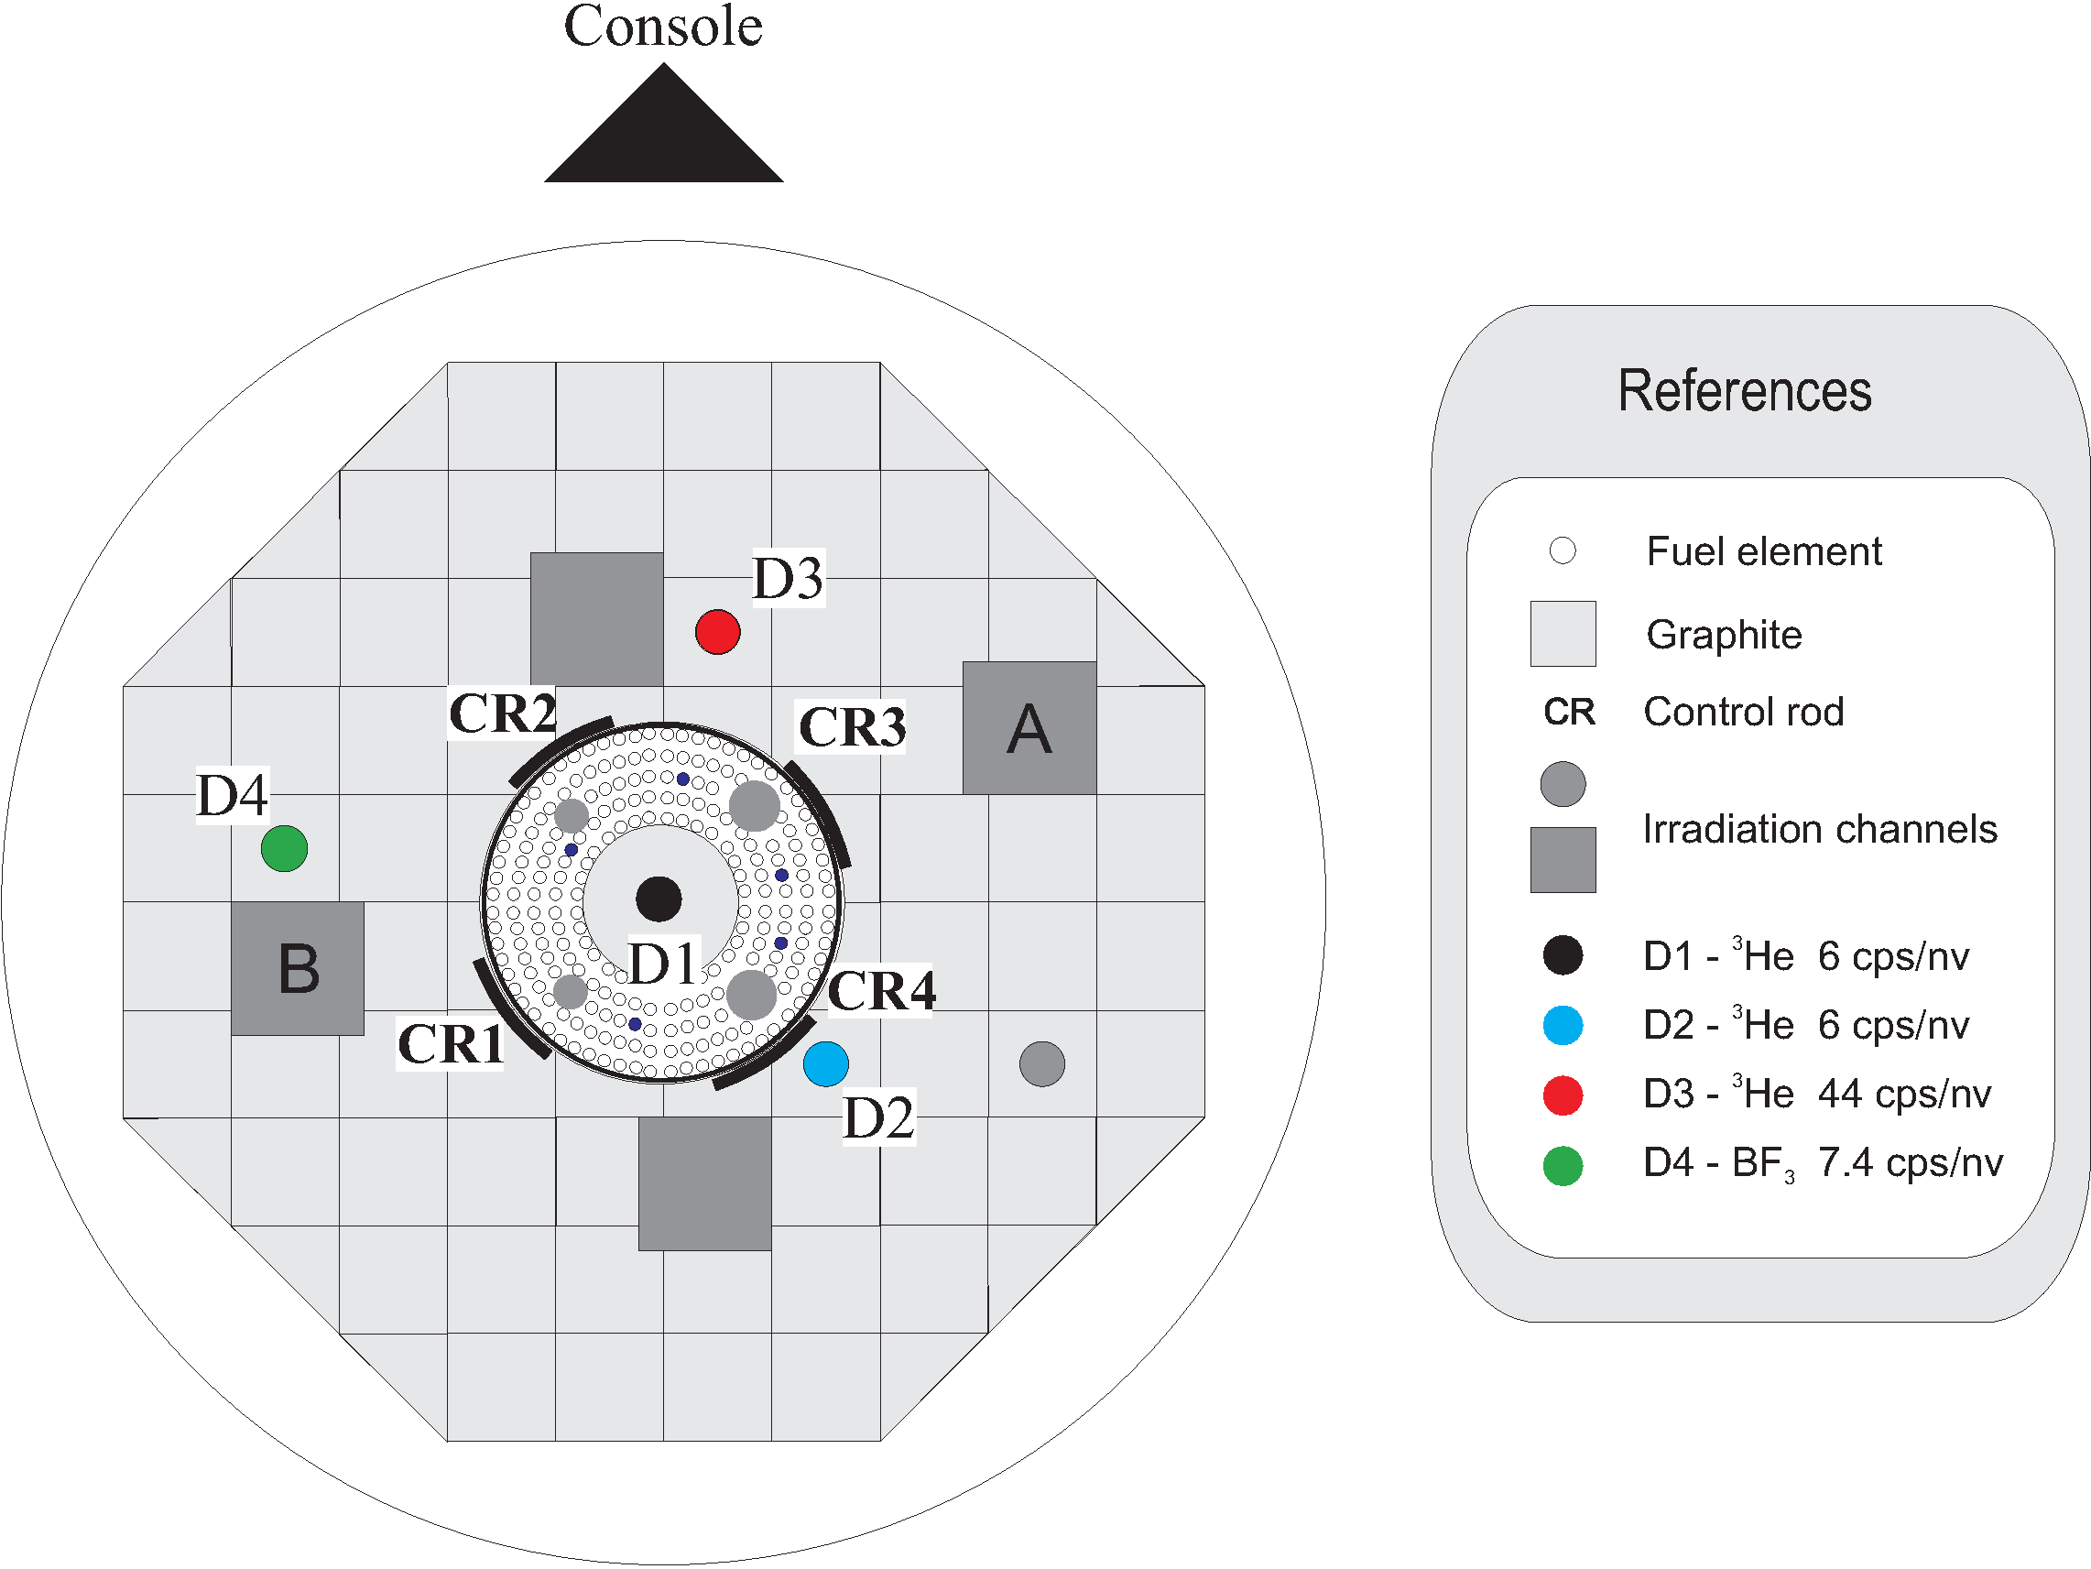

FIG.2. Schematic view of the RA-0 reactor. The detectors shown were used for the subcritical measurements. The ionization chambers CI1 and N6 were placed at the A and B locations, respectively, during the power calibration.

4. Reactor Power Calibration

The reactor power calibration was made with the core configuration most used during normal reactor operation, denominated Core 14A (shown in FIG.2.). The calibration was made using a reference detection system for the neutron noise measurement. It consists on a compensated ionization chamber (CI1) with its corresponding electronic system: current to voltage converter, fluctuation amplifier/separator and an anti-aliasing filter. Both signals, the fluctuating component and the mean value, were acquired and processed to obtain the power and the α_{c} value by fitting the model given in Eq. (1).

The calibration was performed at five different power levels in the range 0.1W to 10W. At each level the value of the estimated power was associated to the current of one of the linear power range channel of the reactor called N6 (also a compensated ionization chamber). Both detectors CI1 and N6 were placed at two external irradiation channels, called locations A and B respectively in FIG. 2. The control rod configuration for this experience was: CR1, CR2 and CR3 completely withdrawn and the CR4 with 85.5% of extraction from the core. The moderator height was fixed at H = 75 cm.

With this procedure it was also possible to check for the linearity of the N6, against the CI1 current, in the whole range were the calibration was performed (see left plot of FIG.4.). The calibration factor of the N6 channel was obtained from a linear fit of the estimated power versus the N6 current. In the right plot of FIG.4. the results of the calibration are shown.

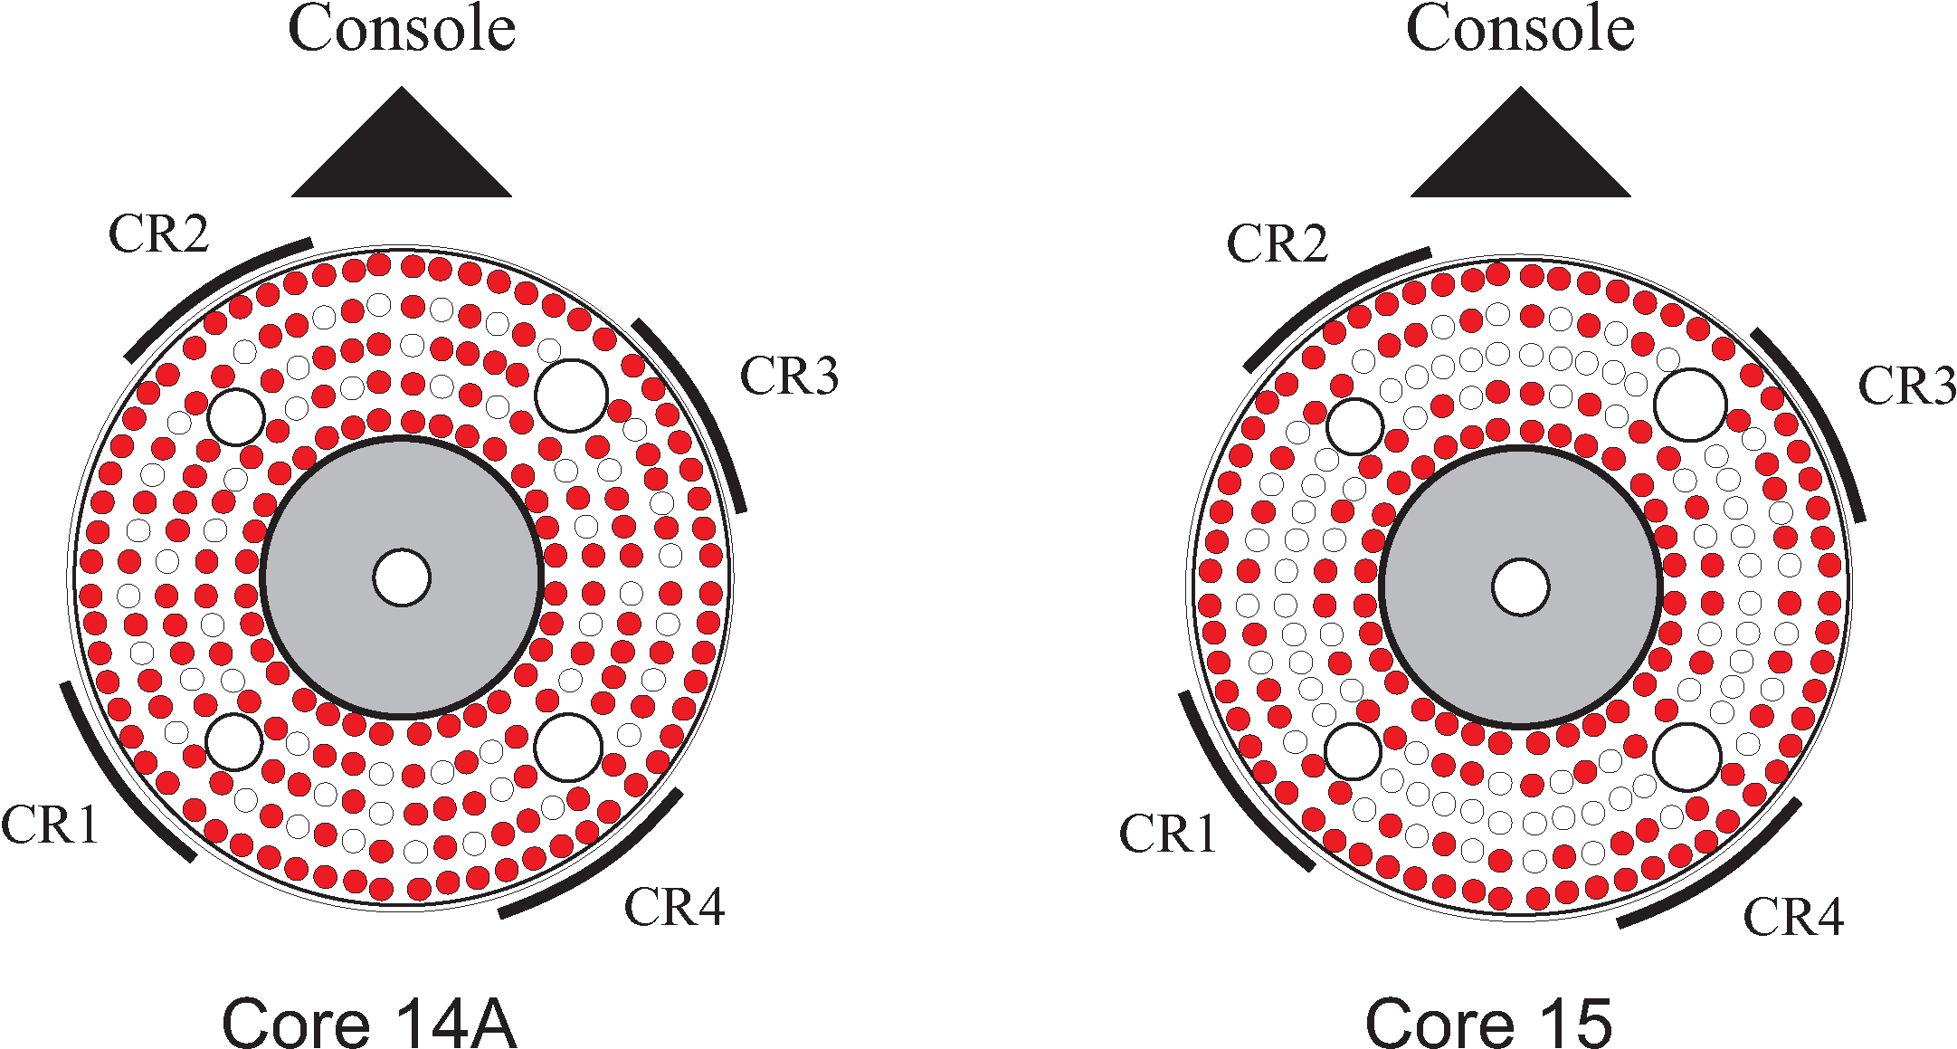

FIG. 3. Upper view of the RA-0 core. The standard critical configuration (Core 14A) and the subcritical configuration without a central ring of fuel elements (Core 15).

The calibration factor for the N6 channel obtained from the lineal fit was:

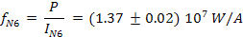

At each level, also the α_{c} value was estimated through the spectral density of Eq. (1). The weighted mean value obtained from all the estimations at each measured level was:

This result can also be expressed as the reduced mean reproduction time of the reactor:

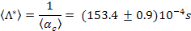

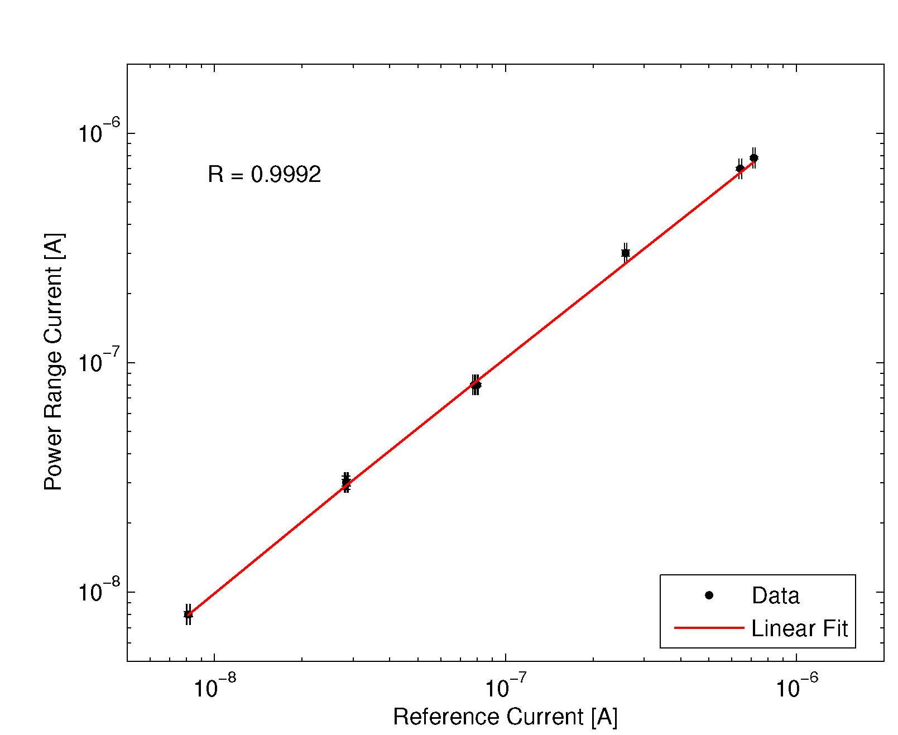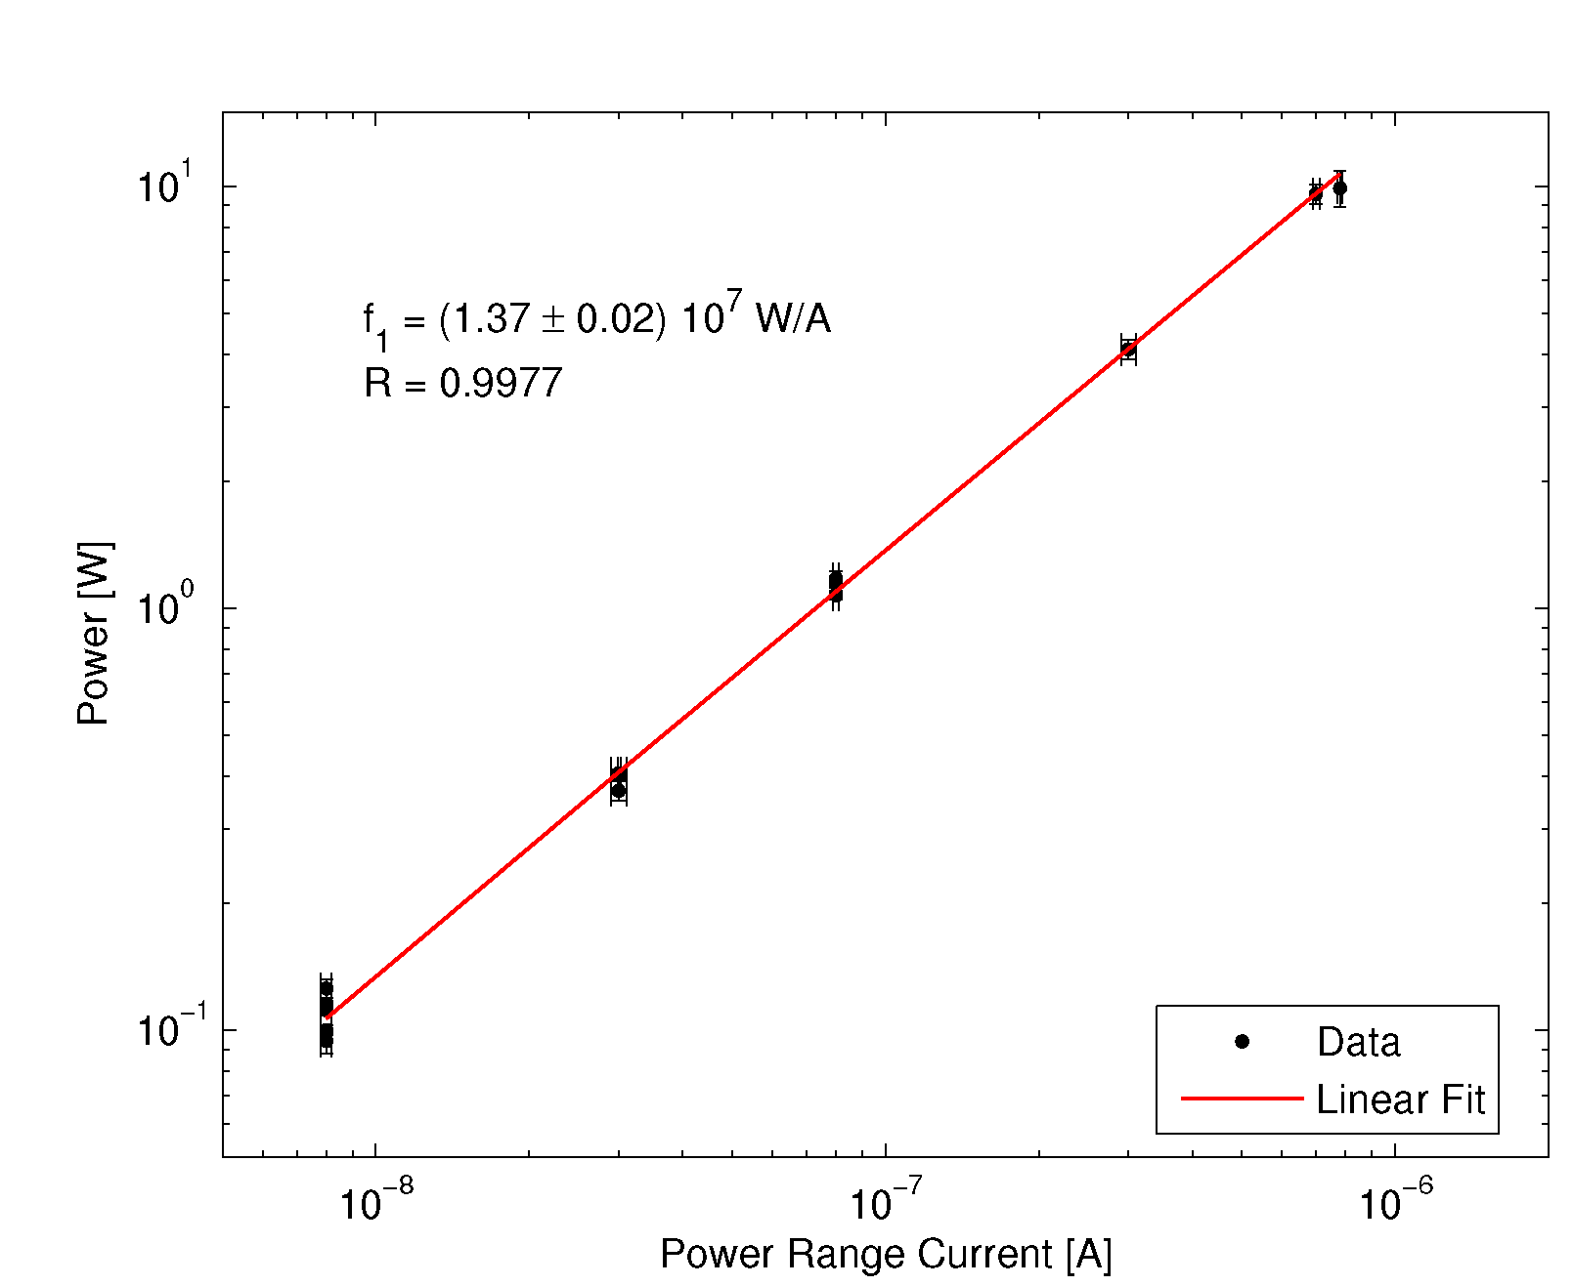
FIG. 4. Linearity of the N6 channel was checked against the reference CI1 system (left graph). Power calibration of the N6 current from which the calibration factor was obtained (right graph).

5. Subcritical Measurements

The second stage of the measurements was performed in subcritical core configurations. The Core 14A was used for almost all the experiences, except for a single case where the Core 15 configuration was arranged (see FIG. 3.). Four proportional counters were located over the inner and outer graphite reflector. In FIG. 2. the exact positions of each detector are shown indicating also their neutron sensitivity. Detectors D1, D2 and D3 where specially placed for these measurements, and D4 was a BF₃ proportional counter belonging to one of the start-up channels of the reactor. Due to the low reactivity excess of the Core 14A, the insertion of the three detectors reduced the reactivity excess to a negative value. This means that the reactor remained subcritical even with the four control rods withdrawn and the moderator at its maximum height. An Am-Be neutron source was located below the inner graphite reflector.

The data acquisition was done with a time-stamping system where the exact time of arrival of individual pulses was recorded [13]. The system was controlled with a program made with LabVIEW and uses a PCI TTL pulse counting board. The complete information of the pulse detection was obtained with this system, allowing the implementation of any of the neutron noise methods: α-Feynman, α-Rossi or Spectral Analysis, depending on the post-processing applied to the signal. As the acquisition is synchronized, covariance methods for correlation of the detectors can also be implemented. However, in this work only the α-Feynman method is used, as it was found to be the most adequate in most cases.

As previously mentioned, the bunching technique was used for the α-Feynman method. The base time interval was and then consecutive intervals were added up to reach a maximum time interval of . Once the estimated curve was obtained, it was fitted with the model of Ec. (2) in order to obtain the α value.

5.1. Results

The first series of measurements were performed changing the subcritical level with the extraction of one of the control rods of the reactor. The moderator height was fixed at its maximum level and the control rods CR2, CR3 and CR4 remained completely withdrawn. The CR1 started with an extraction of 0% and in eight steps it reached an extraction of 100%. The α estimated was plotted as a function of 1/R in order to make a linear fit to obtain the α_{c} value with Eq. (3). The left graph of FIG. 5. shows the results obtained.
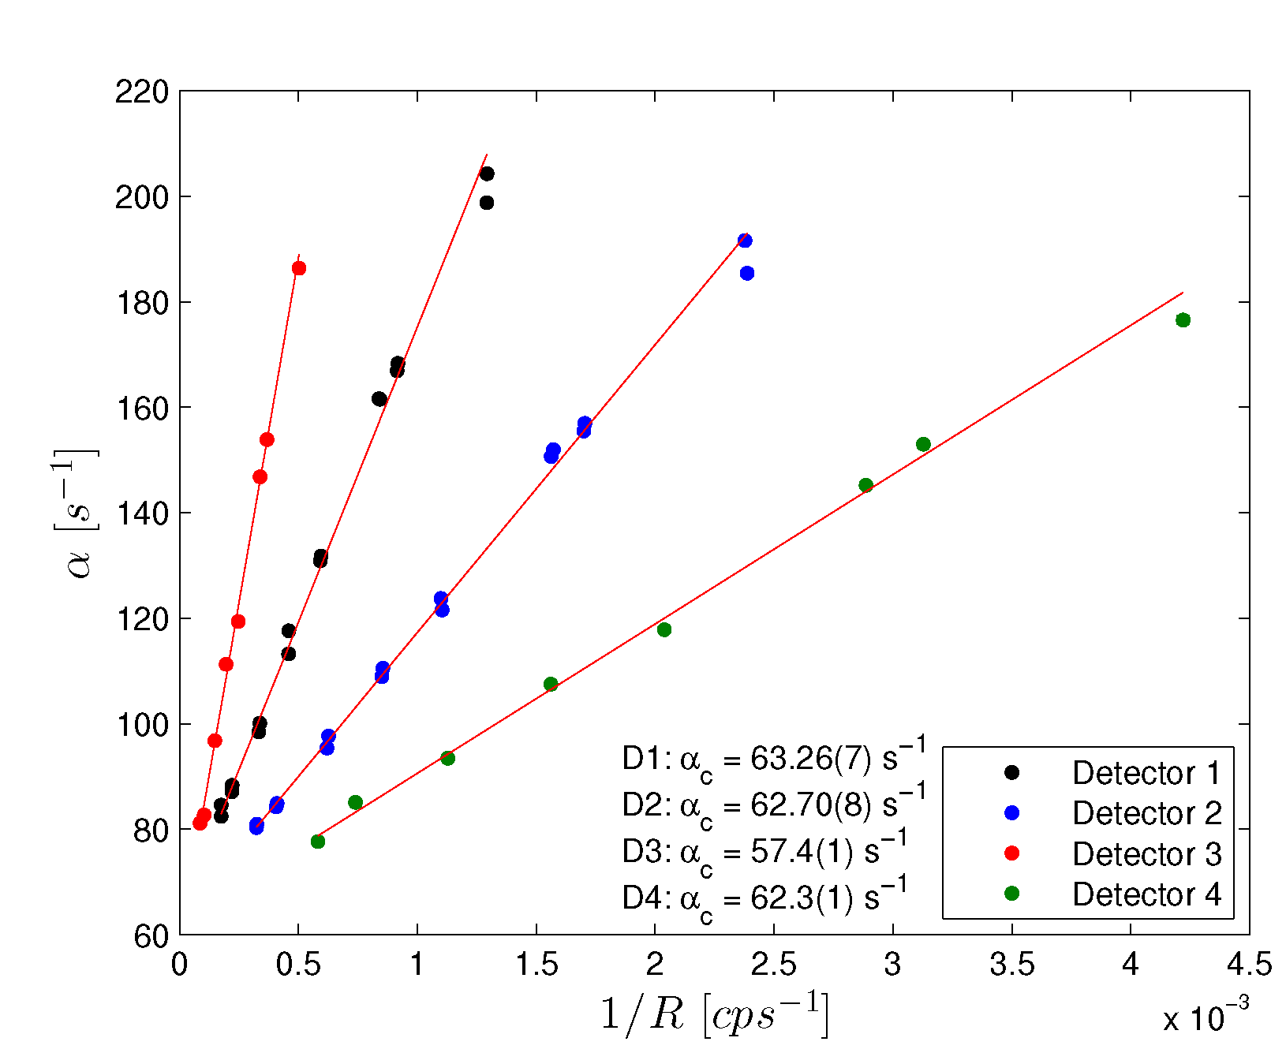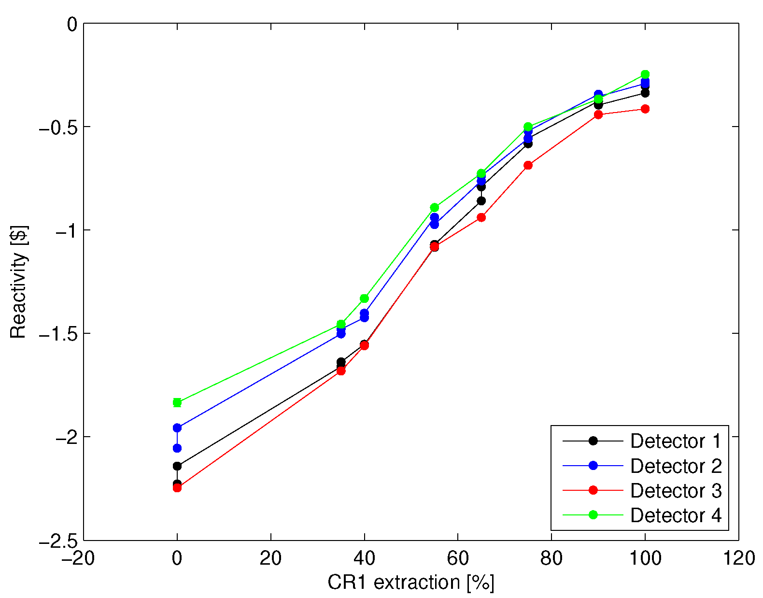
FIG. 5. Subcritical measurements modifying the control rod extraction. Linear relation of α vs. 1/R used for estimation of the α_{c} (left graph). Reactivity estimation at each measured level (right graph).
TABLE 1: Estimates of α_{c} obtained with extrapolation of the measured data in the two experiments.
Detector
Detector | CR1 extraction | Moderator height
D1 | 63.26(7) | 62.1 (1)
D2 | 62.70(8) | 64.8 (1)
D3 | 57.4(1) | 58.9(2)
D4 | 62.3(1) | 62.7(2)

In TABLE 1 the results of the α_{c} estimation for each detector are shown (first column). The estimations depend on the detector used, but the value obtained with the detector D3 is clearly different from the others. The reactivity is also found to be detector dependant (see FIG. 5.).

The second series of measurements were performed also with the Core 14A but in this case the different subcritical levels were obtained by increasing the moderator height H. The reference H=0 cm was taken at the bottom of the reactor tank where the grid is placed. As a reference, the active length of the fuel element started at 10 cm and ended at 64 cm from that reference. All the control rods remained completely withdrawn during this experience. The most subcritical level was with H=40 cm, as smaller values corresponded to highly subcritical level that cannot be measured with the available detector efficiency.

The left graph of FIG. 6. shows the results of the linear fit used to obtain the α_{c} values for each detector. The estimated α_{c} are shown at the second column of the TABLE 1. As the previous experience, in this case the estimations also become detector dependent, and the D3 detector again estimates a value apart from those of the rest of the detectors. In the right plot of FIG.6. the reactivity estimation for each moderator height is shown. Even though there are differences in the reactivity when the moderator level is low, when the height increases and the reactor comes near the critical state, the discrepancies tends to disappear.

Regarding the results obtained with the detector D3, an anomalous behaviour during the experiences was found. It was so subtle, that it could only be visualized through its absolute efficiency ε estimated at each level. While the efficiency of the other detectors remained almost constant, the detector D3 showed fairly large variations compared to its error band.
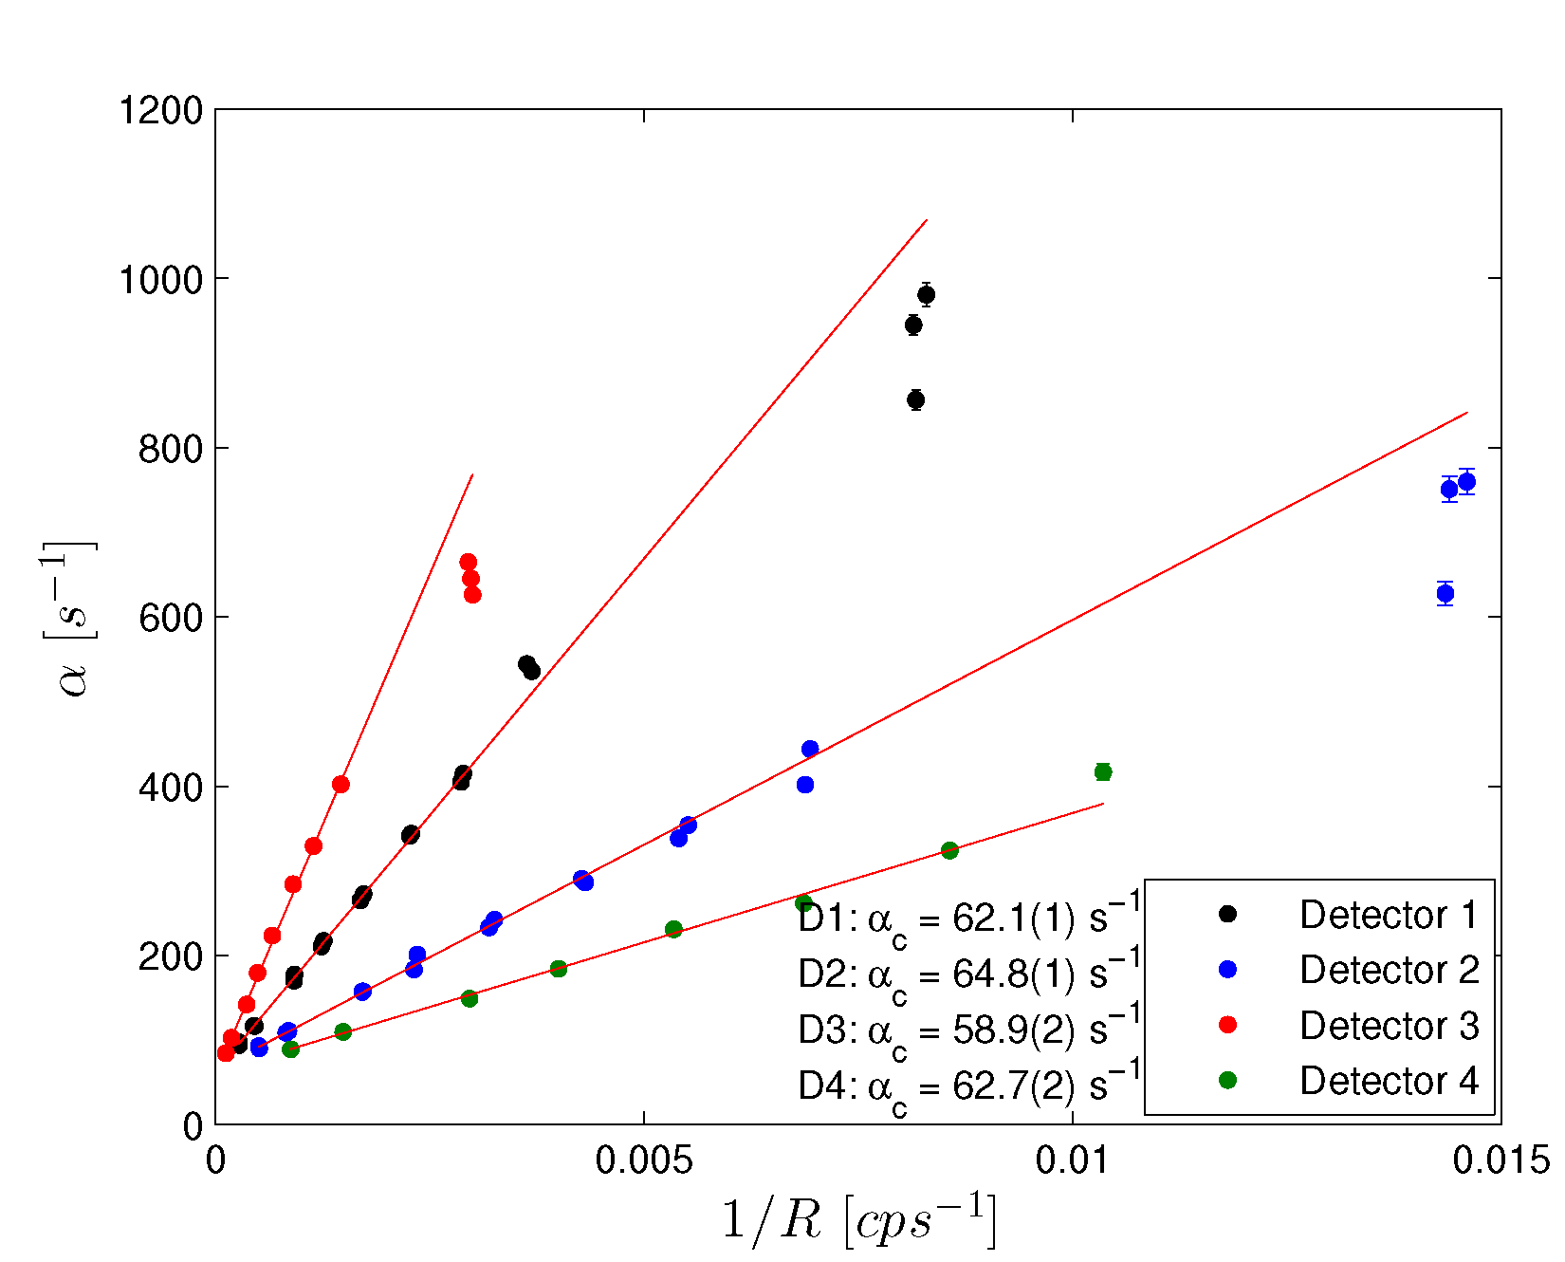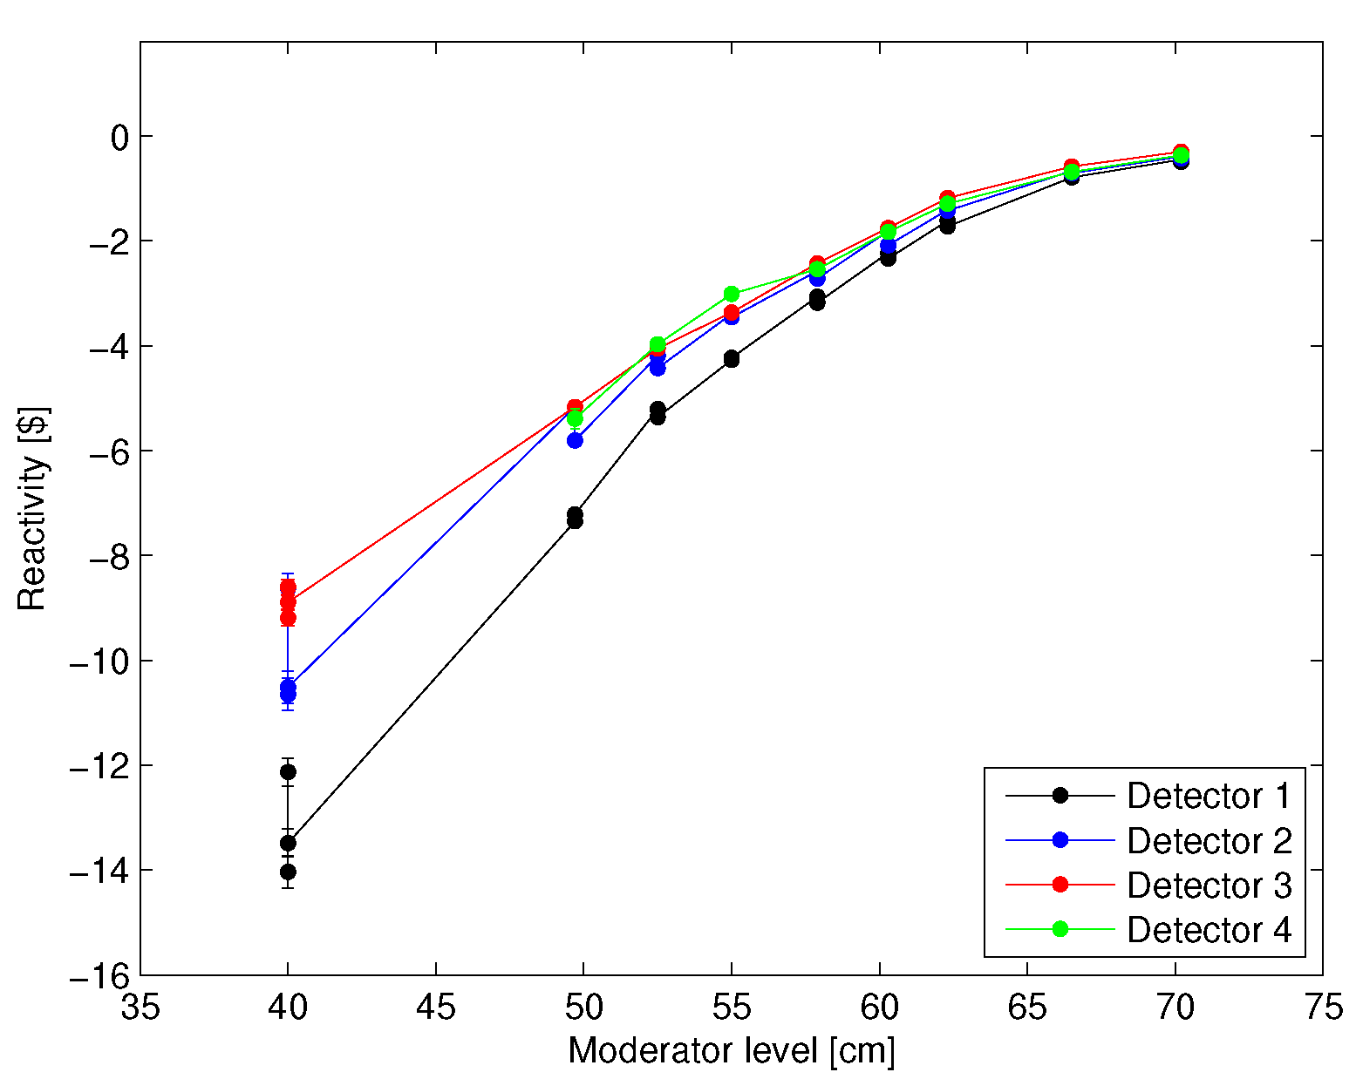
FIG. 6. Subcritical measurements modifying the moderator level. Linear relation of α vs 1/R used for estimation of the α_{c} (left graph). Reactivity estimation at each measured level (right graph).
5.2. Enhancement of Spatial Effects

In order to get a better insight in the analysis of the spatial effects encountered during the previous experiences, a new core configuration was arranged. Having in mind the theory of coupled reactors [14] which is usually applied for the study of spatial effects, the Core 15 was used (see FIG. 3.). Removing a central ring of fuel elements, produces a core with two zones clearly differentiated: an inner zone (inner graphite with two rings of fuel elements) and an outer zone (external graphite with two rings of fuel element). The detectors D1 and D2 (in the same locations as before) were used for comparison between the α value estimated in the inner and the outer one.

The α-Feynman method was used in this new configuration with four different moderator heights. The α estimated by detector D1 and D2 were called α₁ and α₂ respectively, and the relative difference between them (as a measure of spatial effects) was (α₁ – α₂)/α₁. In FIG. 7. the relative difference is plotted as a function of the moderator height for the two core configurations.

It was found that, as expected, the spatial effects are reduced as the reactor approaches its critical state with a high moderator level. However, the important result is that in all the cases, the differences at the Core 15 are systematically greater than those of the Core 14A, confirming that spatial effects are increased with the new core configuration. In order to make a rigorous and quantitative analysis of the data obtained, the theory of coupled reactors will be applied in the future.

6. Subcritical Reactimeter

The Least Squares Inverse Kinetic Method was applied for the estimation of the effective neutron source associated to the N2 start-up channel (detector D4) of the RA-0 reactor. This estimation allows the use of the inverse kinetic equation given in Eq. (4) for an implementation of a digital subcritical reactimeter. Even though that it is possible to estimate using any of the neutron noise techniques, the LSIKM was preferred as the statistical error of the estimation is lower.

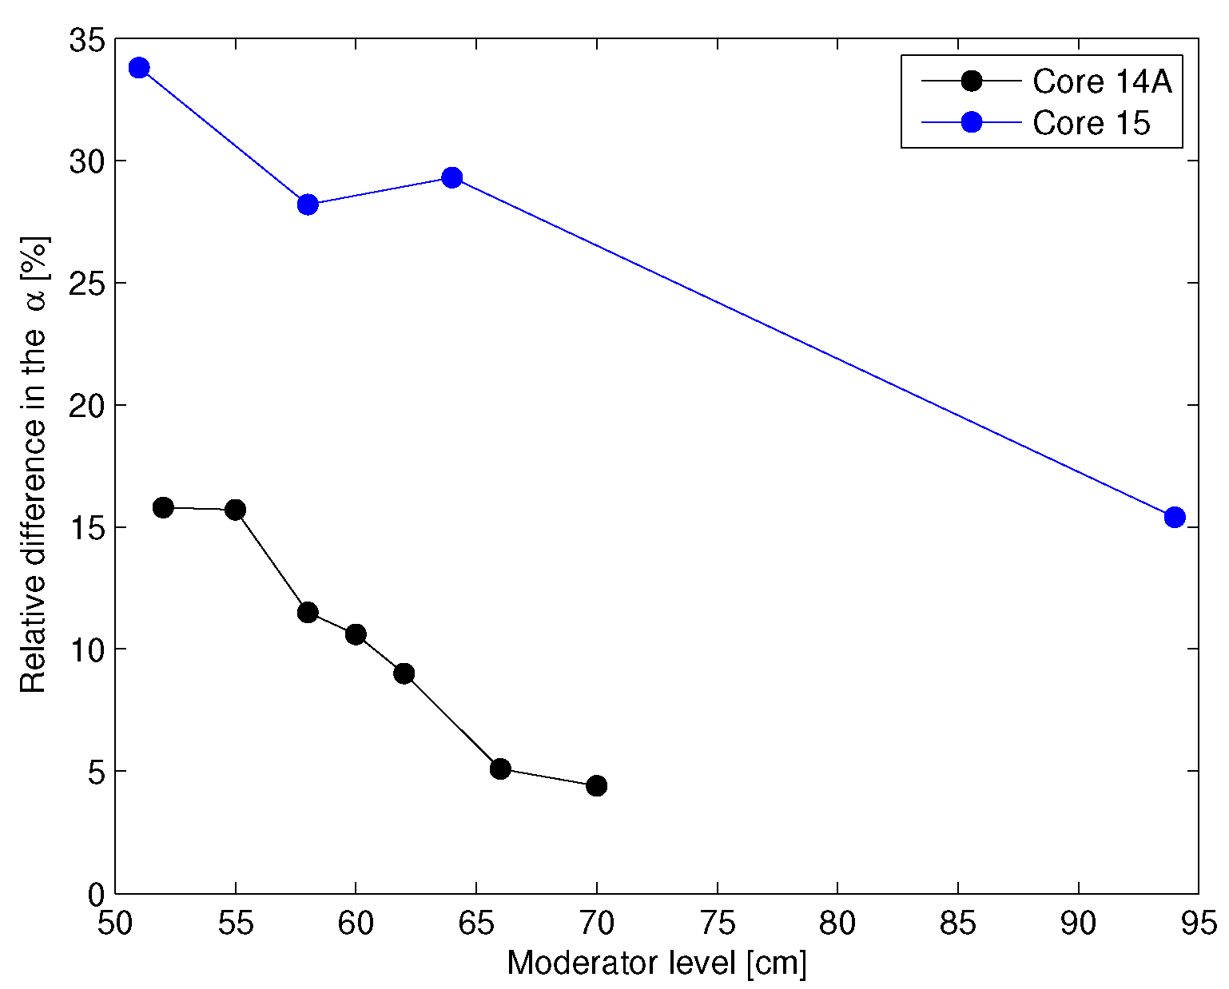
FIG. 7. Increase in the spatial effects observed for the α estimation with the α-Feynman method
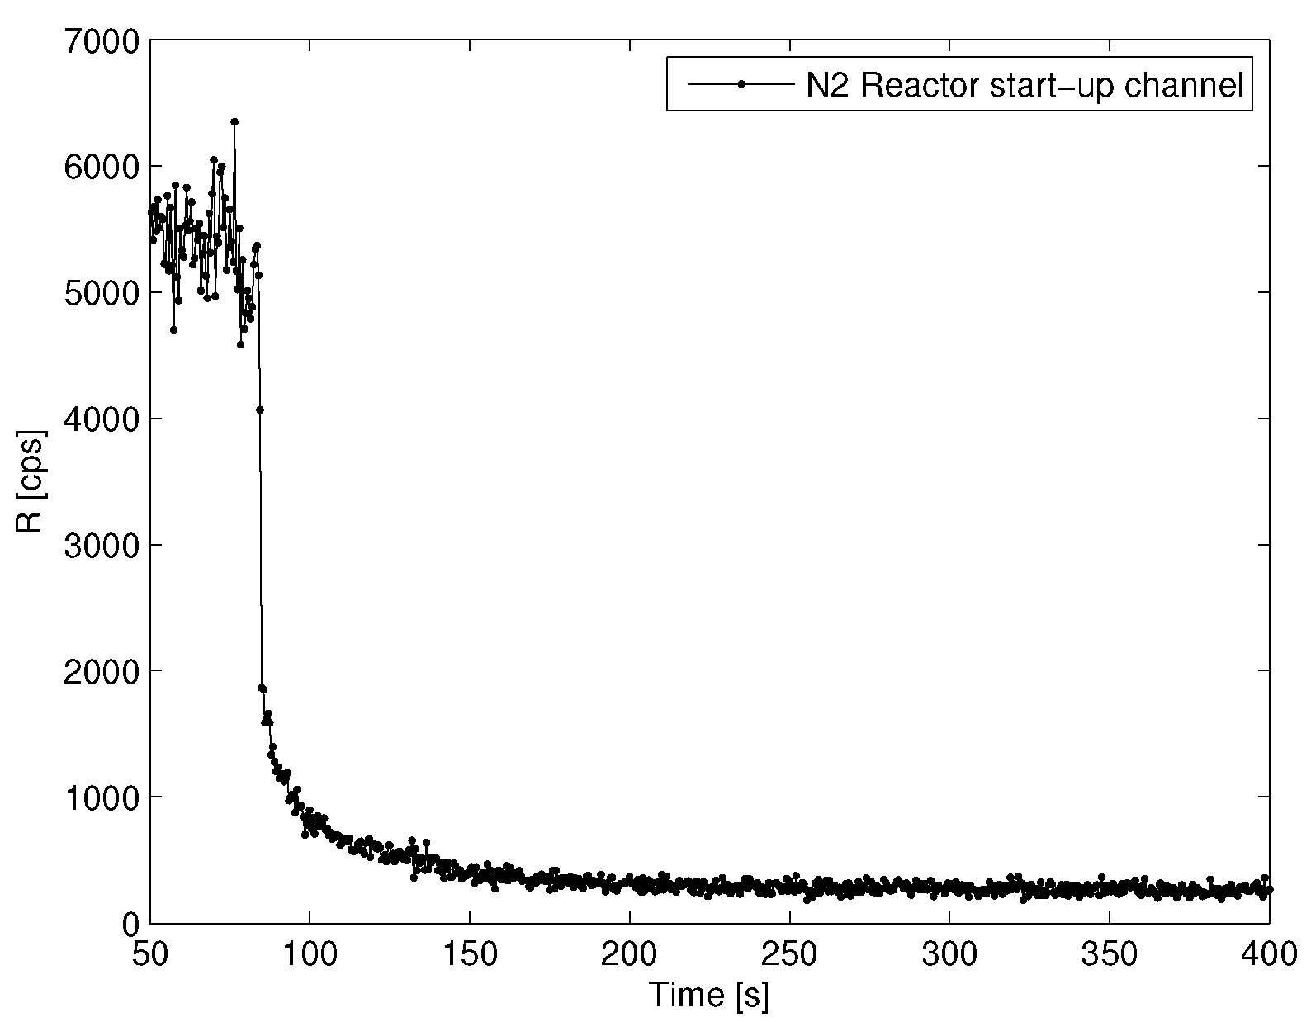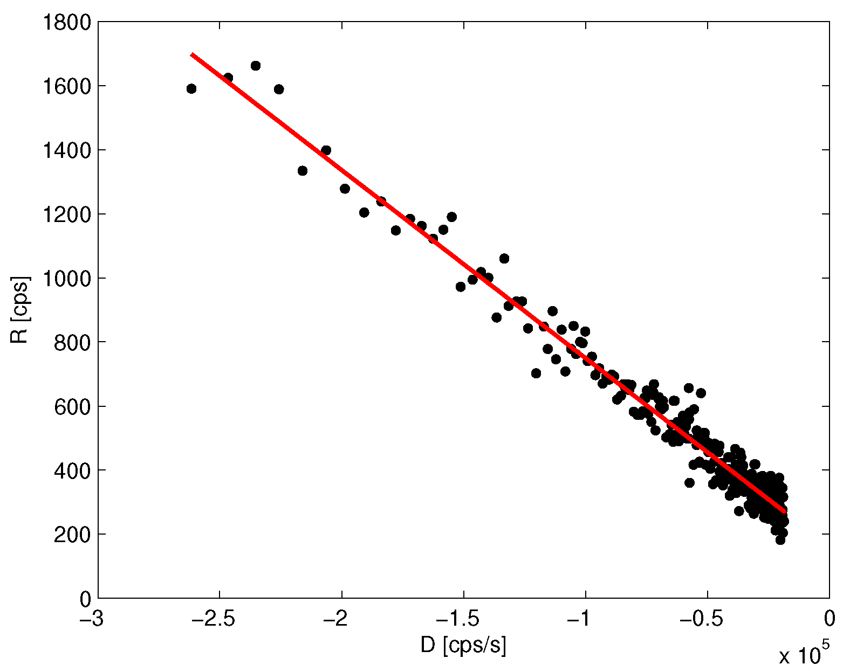
FIG. 7. Count rate evolution during the rod-drop of the CR1 (left). Estimation of the value with a linear fit of the delayed evolution (right).

As the subcritical reactimeter is meant to be used during the normal operation of the reactor, the Core 14A was chosen for this experience. The moderator height was at its maximum level (H=90 cm) and the CR1 was used for the measurement. Initially the control rod configuration was: CR2, CR3 and CR4 fully withdrawn and CR1 with 55% of extraction. The evolution of the N2 count rate during the rod-drop is shown in FIG. 7.

Using Eq. (4) and Eq. (5) the delayed evolution was fitted given a source strength of:
This value was introduced in the Data Acquisition Electronic System (SEAD) which is the principal system for acquiring and visualizing data in the reactor. In this way, the subcritical reactimeter became fully functional.

Finally, with the aim to validate the implemented subcritical reactimeter, a new series of measurements were performed. The α-Feynman method was applied to obtain the reactivity and compare it with the value given by the reactimeter in the SEAD. The reactor configuration for the validation was chosen to differ (as much as possible) from the configuration used in the estimation. With all those considerations, the moderator height was increased in three steps and all the control rods remained fully withdrawn. In TABLE 2 the reactivity estimations of the two methods are shown together with the estimated with the α-Feynman method. When the reactor height is low the reactivity given by the reactimeter differs considerably from that of the α-Feynman method, but agrees for the two less subcritical states.

TABLE 2: Values of the subcritical reactimeter from the SEAD compared to those obtained with the α-Feynman method for different moderator heights.
H [cm] | α-Feynman |  |  | SEAD
H [cm] | [cps/s]
54.0 | 32000(4000) | -7.1(4) |  | -5.8
59.9 | 28000(1600) | -1.43(1) |  | -1.4
63.5 | 25000(900) | -0.442(6) |  | -0.45

The discrepancy of the first result can be explained taking into account that the at that configuration differs from that obtained by the LSIKM due to the large change in the moderator level (the LSIKM was applied with H= 90 cm). This fact is a limitation in the validity of the reactimeter as an accurate estimator for any subcritical level: the core configuration must not differ significantly from the configuration used for the source determination.

7. Conclusions

The power calibration of one of the power-range channels of the RA-0 reactor was accomplished, and its linearity was checked in the range 0.1W to 10W. Using also the neutron noise technique, the estimation obtained of the critical prompt neutron decay constant was .

The α-Feynman neutron noise method was applied for the α estimation at different subcritical configurations using four neutron detectors. Each subcritical level was modified by changing the moderator height and the control rod extraction. The reactivity worth of both, control rod and moderator height, were obtained. In each experience, the α_{c} values were estimated by a linear fit of the data. In this way, a critical reactor parameter was estimated using only measurements at subcritical states. The obtained values of α_{c} were found to be detector dependant, indicating the presence of spatial effects. To enhance these effects, a new core configuration with two separate zones was arranged, each with its owns α values. It was shown that in this case the spatial effects were more important than in the previous core configuration.

Using the ILSKM the neutron source strength was estimated for the N2 start-up channel of the reactor. This estimation allowed the implementation of a subcritical digital reactimeter in the reactor control system. The new system was validated against independent reactivity estimations given by the α-Feynman method. A good agreement has been found provided the measured subcritical configuration is similar to the one used for the ILSKM source estimation.

8. Acknowledgement

The authors wish to express their thanks to all RA-0 reactor staff members who cooperated in the large and laborious experiments. Without their help, kindness and patience this work would not have been accomplished.

9. References

- GOMEZ, A. and BELLINO, P. “Mediciones para la estimación de parámetros cinéticos en el reactor RA-0”, Internal Technical Report, ITE-06RCN-249, CNEA (2012)
- GOMEZ, A. et al., “Measurement of power in research reactors using the neutron noise technique”, Annals of Nuclear Energy, Vol. 19 (1992), 267-285.
- UHRIG, R. “Random noise techniques in nuclear reactor systems”, The Ronald Press Company, (1970).
- BELLINO, P. and GOMEZ, A. “Estimación de parámetros cinéticos mediante mediciones en subcrítico aplicando la técnica de ruido neutrónico en el reactor RA-0”, Internal Technical Report, ITE-06RCN-265, CNEA (2013)
- FEYNMAN, R.P. et al, “Dispersion of the neutron emission in U-235 fission”, Journal of Nuclear Energy, Vol. 3 (1956), 64-69.
- TAMURA, S. “Signal fluctuation and neutron source in inverse kinetics method for reactivity measurement in the sub-critical domain”, J. Nucl. Sci. Technol, Vol. 40 (2003), 153-157.
- WILLIAMS, M. “Random Processes in Nuclear Reactors”, Pergamon Press, (1974).
- HASHIMOTO, K. et al, “Experimental investigations of dead-time effect on Feynman-α method”, Annals of Nuclear Energy, Vol. 23 (1996), 1099-1104.
- WALLERBOS, E. and HOOGENBOOM, J. “The forgotten effect of the finite measurement time on various noise analysis techniques”, Annals of Nuclear Energy, Vol. 25 (1998), 733-746.
- KITAMURA, Y. et al., “General formulae for the Feynmann-α method with the bunching technique”, Annals of Nuclear Energy, Vol. 27 (2000), 1199-1216.
- OTT, K. and NEUHOLD, R. “Introductory Nuclear Reactor Dynamics”, ANS, (1985).
- BELLINO, P. et al, “Kinetic parameters estimation in a MTR research and production reactor in subcritical states”, Proceedings of the International Conference on Research Reactors: Safe Management and Effective Utilization. Rabat, Morocco, (2012).
- BELLINO, P. and GOMEZ, A. “Aplicación de la técnica de ruido neutrónico en subcrítico utilizando un nuevo sistema de adquisición de datos”, Internal Technical Report, ITE-06RCN-229, CNEA (2010)
- DIFILIPPO, F. and WALDMAN, R. “Kinetics of a coupled two-core nuclear reactor”, Nuclear Science and Engineering, Vol. 61 (1976), 61-71.

