Measurement of the Xenon-135 Reactivity
Evolution after a Shutdown in the RA-3
Research and Production Reactor

P. Bellino¹, A. Benhaim

Experimental Reactor Physics Division, National Atomic Energy Commission (CNEA)
Av. Gral. Paz 1499 CP 1650, San Martín, Buenos Aires, Argentina

Corresponding author: pbellino@cnea.gov.ar

Abstract. The ¹³⁵Xe reactivity evolution was measured in the RA-3 reactor after its shutdown. The measurement was made using the inverse kinetic equations in a highly subcritical core employing photoneutrons as an external source. The maximum xenon concentration, where the reactivity has its minimum value, was found 10 hours after the shutdown in agreement with the expected value. On the other hand, a minimum in the count rate due to the simultaneous effects of the xenon concentration and the decay of the photoneutrons was found. That minimum was detected 26 hours after the shutdown in agreement with results obtained from simulations performed with point reactor kinetics.

- Introduction

The ¹³⁵Xe concentration in power reactors has an important influence on the neutron flux during transient evolutions. This phenomenon occurs because of the very large absorption cross section of the ¹³⁵Xe for thermal neutrons ($σ_{a}=2.7 {10}^{6}b$). In a stationary reactor the xenon concentration and its associated reactivity will reach an equilibrium state which will be maintained over time. Nonetheless, it is in the transient evolutions where the xenon effects are evidenced due to its complex balance relation between its production and destruction.

In this work, the ¹³⁵Xe evolution after the shutdown is studied. Under this condition, the xenon concentration rises due to ¹³⁵I decay and then falls because of the xenon decay. The maximum concentration reached is called xenon peak and produces a minimum reactivity that under certain circumstances does not allow having the reactor critical again. In this case, some time must pass until the xenon reactivity reaches the reactivity excess of the core. It will take between one and two days, depending on the reactor characteristics, leaving the reactor inoperable during that period. For these reasons, it is utterly important to characterize empirically the reactivity during the hours following a shutdown.

Usually, when the xenon reactivity is estimated after the shutdown, a control rod is used to compensate its reactivity and maintain the critical state at low power. With the rod calibration it is possible to estimate the xenon reactivity in every step. Unfortunately, this method can only be applied until the xenon reactivity is less than the core reactivity excess. When this happens, all control rods can be extracted and yet the core would remain subcritical. In this work, in contrast, reactivity estimation is based on a reactimeter for subcritical states. Knowing the neutron evolution after the shutdown, the core reactivity was obtained during the whole evolution of the xenon concentration.

- Theory

Assuming that the poison is uniformly distributed inside the reactor, it will affect mainly the thermal utilization factor $f'$ defined as

$$f'=\frac{Σ_{a}^{f}}{Σ_{a}^{f}+Σ_{a}^{m}+Σ_{a}^{p}}$$

where the absorption cross sections are: $Σ_{a}^{p}$ for the poison, $Σ_{a}^{f}$ for the fuel and $Σ_{a}^{m}$ for the rest of the materials in the reactor. The poison will produce a reactivity change $Δρ$ compared to the reactor without it. The reactivity change is estimated using the six factors formula

$$ρ=\frac{k-1}{k}, k=ηpfϵP_{FNL}P_{TNL}$$

From this expression it is deduced that the changes will be due to modifications in f (thermal utilization factor associated to k=1) and due to the thermal non-leakage probability $P_{TNL}$, thus we can express the change as

$$Δρ=\frac{f^{'}-f}{f'}+\frac{P_{FNL}^{'}-P_{FNL}}{P_{FNL}^{'}}$$ | (1)

If the P_{TNL} definition is taken into account

$$P_{TNL}=\frac{1}{1+L^{2}B_{g}^{2}}, L^{2}=\frac{D}{Σ_{a}}=\frac{1}{3Σ_{tr}Σ_{a}}$$

assuming $L^{2}B_{g}^{2}≪1$, the reactivity change can be expressed as

$$Δρ≈\frac{σ_{a}^{p}X}{Σ_{a}\left({1+L}^{2}B_{g}^{2}\right)}$$ | (2)

showing the dependence with the xenon concentration X.

While the 5% of times the ¹³⁵Xe is generated as a fission product, in the remaining 95% is produced by beta emission according to the decay chain

$${}_{}^{135}{Te\underset{→}{2min}{}_{}^{135}I}\underset{→}{6.68h}{}_{}^{135}{Xe}\underset{→}{9.13h}{}_{}^{135}{Cs}\underset{→}{2 {10}^{4}a}{}_{}^{135}{Ba}$$

where ¹³⁵Te is a fission product. The ¹³⁵Xe also disappears by neutron capture, being the dominant mechanism once equilibrium is reached.

Considering the decaying times, we can assume that the ¹³⁵I is formed directly by fission, and that the ¹³⁵Cs is stable. Hence, the balance equations for both iodine and xenon concentrations will be written as

$${\frac{dI}{dt}=γ_{I}Σ_{f}Φ-λ_{I}I \atop \frac{dX}{dt}=γ_{x}Σ_{f}Φ+λ_{I}I-λ_{x}X-σ_{x}XΦ}$$ | (3)

where
$$I, X$$ | iodine and xenon concentrations
$$γ_{I}, γ_{x}$$ | fission yields
$$λ_{I}, λ_{x}$$ | decaying constants
$$Φ$$  $$σ_{x}$$ | thermal neutron flux  absorption cross section of xenon
$$Σ_{f}$$ | fission macroscopic cross section

Considering a stationary state with a constant flux $Φ_{0}$, the equations (3) allows to calculate the iodine and xenon concentrations at equilibrium as

$$I_{0}=\frac{γ_{I}Σ_{f}Φ_{0}}{λ_{I}}$$ | (4a)
$$X_{0}=\frac{λ_{I}I_{0}+γ_{x}Σ_{f}Φ_{0}}{λ_{x}+σ_{x}Φ_{0}}≈\frac{(γ_{I}+γ_{x})Σ_{f}Φ_{0}}{λ_{x}+σ_{x}Φ_{0}}$$ | (4b)

If the condition $λ_{x}≪σ_{x}Φ_{0}$ is satisfied then the xenon concentration in the equilibrium does not depends on $Φ_{0}$. Nevertheless, for the RA-3 reactor operating at 8MW this condition is not fulfilled.

In order to analyze what happens after the reactor is shutdown, an initially stationary level is considered in which the flux becomes zero instantaneously. Under this hypothesis, equations (3) may be simplified even more, obtaining

$${I(t)=I_{0}e^{-λ_{I}t} \atop X(t)=\frac{λ_{I}}{λ_{I}-λ_{x}}I_{0}\left(e^{-λ_{x}t}-e^{-λ_{I}t}\right)+X_{0}e^{-λ_{x}t}}$$ | (5)

The time when the xenon reactivity reaches its minimum is obtained by maximizing the concentration evolution. The expression obtained is:

$$t_{max}=\frac{1}{λ_{I}-λ_{x}}\ln\left[\frac{{λ_{I}}/{λ_{x}}}{1+\frac{λ_{x}}{λ_{I}}\left(\frac{λ_{I}}{λ_{x}}-1\right)\frac{X_{0}}{I_{0}}}\right]≈9.2h$$ | (6)

  - Reactivity Estimation

In this work the evolution of the reactor reactivity is estimated after the shutdown, and the xenon effects are analyzed. For the reactivity estimation the inverse kinetics equations were used, based on the point reactor model. The equations were solved numerically assuming that the neutron density $n(t)$ changes linearly during a time step, obtaining the relationships

$${\$_{j}=\frac{Λ^{*}}{n_{j}}\left[\frac{\left(n_{j+1}-n_{j}\right)}{Δt}-\sum_{i=1}^{K}{λ_{i}C_{ij}-S_{j}}\right]+1 \atop C_{i,j+1}=C_{i,j}e^{-Δtλ_{i}}+\frac{b_{i}}{λ_{i}Λ^{*}}\left[\left(n_{j+1}-n_{j}\right)+\left(1-e^{-Δtλ_{i}}\right)\left(n_{j}-\frac{n_{j+1}-n_{j}}{λ_{i}Δt}\right)\right] i=1,…,K}$$ | (7)

where

$$Δt=$$ | time step
$$\$_{j}=$$ | reactivity at $t_{j}$
$$n_{j}=$$ | neutron density at $t_{j}$
$$C_{i,j}=$$ | i-th delayed precursor concentration at $t_{j}$
$$b_{i}=$$ | $${β_{i,eff}}/{β_{eff}}$$
$$Λ^{*}=$$ | $$Λ/{β_{eff}}$$
$$K=$$ | number of delayed neutron groups
$$S_{j}=$$ | external neutron source at $t_{j}$
In these equations, the neutron source is independent of the flux. Even though there was no external neutron source during the measurements, a time dependant source was considered. In this source, the whole evolution of the photoneutrons was included, so in equation (7) only the delayed neutrons are taken into account. The photoneutron source was assumed to behave in the same way as the neutron flux after the shutdown of the reactor (once the delayed neutron contribution has vanished).

As the source evolution could not be measured, it was simulated using the direct kinetic equations. For this simulation, the photoneutrons were included as extra nine groups of delayed neutrons (using the Keepin constants for ²³⁵U and deuterium), and the xenon was omitted. A step change in reactivity was assumed to model the SCRAM of the reactor. The source evolution obtained in the simulation was defined up to a constant. For this reason, the curve was normalized with a source value previously measured in a subcritical rod-drop experience by the Least Squares Inverse Kinetic Method (LSIKM) [2]. In this way, the determination uses a simulated temporal evolution but with its values adjusted with an actual measurement.

Once the complete source evolution was obtained, the set of equations (7) were solved in order to obtain the reactivity of the reactor. The six delayed neutron constants were those give by Tuttle, whereas $Λ^{*}=834 {10}^{-5} s$ and $β_{eff}=0.007682$.

3. Experimental Procedure

Measurements were performed in the RA-3 research and production reactor after two hours from the shutdown. The reactor had been operated at a normal power operation of 8 MW. All the delayed neutrons and photoneutrons were considered to be in its equilibrium values. For the shutdown of the reactor a SCRAM was performed employing four control rods, three of them were initially completely withdrawn and the fourth extracted 38,4 %. A scheme of the reactor core is described in FIG.1. with the position of the detector and the location of its most important components.

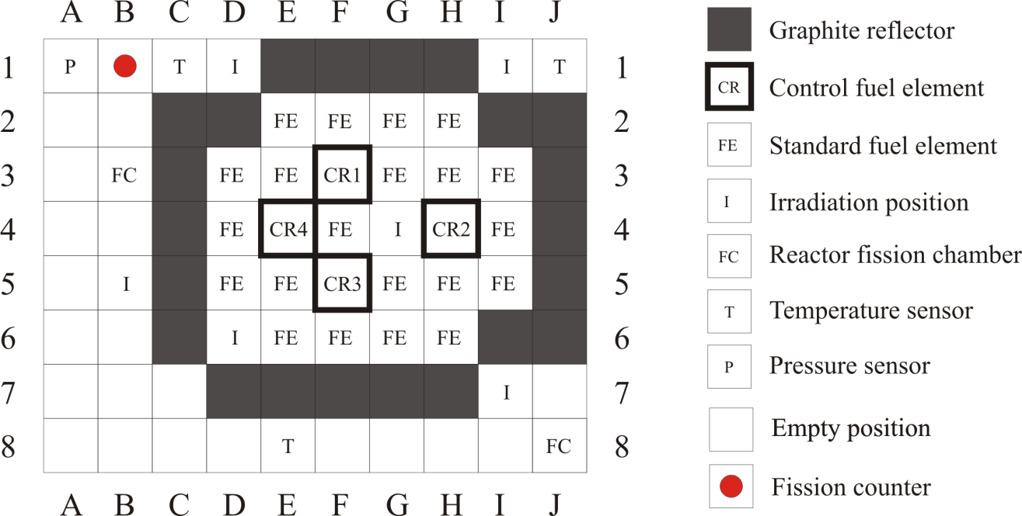

FIG.1. Schematic view of RA-3 reactor and detector position.

3.1. Signal Acquisition and Processing

The detector used for this work was a fission counter placed in the position B1 of the reactor grid. Its thermal neutron sensibility was 0.36 cps/nv and was axially centered with the mid plane of the core. The electronic system associated with this detector was: an amplifier and a high voltage power supply CANBERRA 7820-ADS-7821-HT models.

The data acquisition system consisted in a PCI board National Instruments model PCI-6602. The TTL pulses were acquired and processed with a program developed by this group named “Multi Reactímetro Digital”. The counts were done in a time bin of $Δt=1s$. However, in the signal processing a 200 point average was applied from which a new $Δt=200s$ was obtained. This value was used as the time step for the discretization of the inverse kinetic equations.

4. Results

The evolution of the count rate, after two hours from the shutdown is shown in FIG.2. A minimum at 24 hours can be seen, which is a consequence of both the maximum xenon concentration and the decay of the source of photoneutrons.

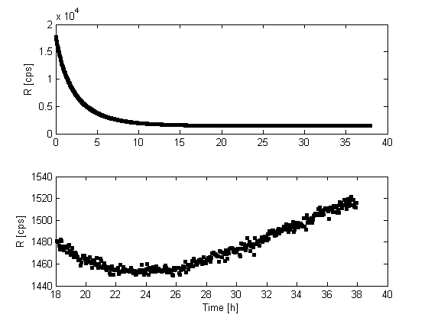
FIG.2.Count rate evolution measured in RA-3 reactor.

As previously mentioned, the evolution of the source of photoneutrons was obtained solving analytically the direct kinetics equations. An initially critical and stationary reactor was considered in which a reactivity change was produced similar to the SCRAM of the RA-3. That change was $Δ\$=\left(18.8±0.2\right)$ as was estimated in previous experiences [6][7]. The photoneutron yield was measured in [8]. Xenon was not included in this simulation because its contribution to the photoneutron source was negligible. Finally, the evolution was normalized with the measured value at t = 13 hs using the LSIKM. This measurement was performed during another shutdown assuming the same source evolution after any shutdown. The normalization value was $S\left(t=13h\right)=4.8 {10}^{6}cps/s$.

FIG.3. shows the reactivity values estimated for the measurement performed. The figure shows a reactivity minimum $\$=-\left(24.9±4.2\right)$ around ten hours after the shutdown. This matches the theoretical predicted time in which the maximum of xenon concentration occurs.

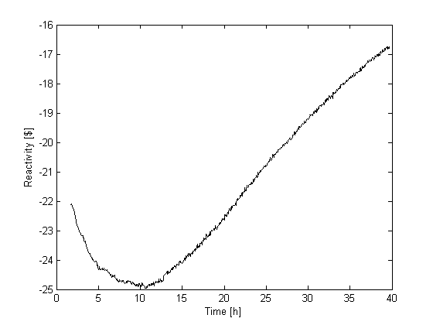
FIG.3. Estimated core reactivity after the shutdown.

In order to understand the results obtained, direct kinetic equations were solved to find the evolution of the theoretical count rate. For this, photoneutrons were considered as extra groups of delayed neutrons. The reactivity used for this simulation consisted in the reactivity jump due to the SCRAM and the theoretical contribution due to the xenon.

The reactivity used for the SCRAM simulation was obtained from measurements performed in the RA-3, when rod calibrations were done and the reactivity of the control rods were estimated [6][7]. Because the control rod four was released from a 38.4% of extraction, its calibration curve was used in order to estimate the contribution to the reactivity change (see Appendix A).

The reactivity due to the xenon was simulated numerically using the differential Eq. (3). From Eq. (2), the reactivity was estimated finding its minimum value of $\$=-10.9$. The results for the reactivity and the simulated flux are shown in FIG.4. Regarding the flux, it can be seen that the minimum occurs at 26 hours, then increases reaching a maximum and finally diminishing until it eventually vanishes.

The count rate recorded by the fission chamber and the one obtained by point kinetics are compared in FIG.5. after being normalized with their initial values.

In order to estimate the xenon reactivity in an experimental way, the reactivity of the control rod bank and the reactivity excess (calculated by the diffusion code PUMA) were subtracted from the measured core reactivity. The comparison of the xenon reactivity evolution obtained from the simulation and the measured one are shown in FIG.6. The minimum reactivity value occurs at the same time and matches the expected theoretically.

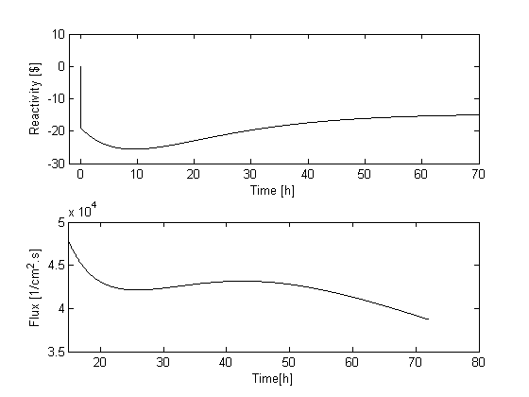
FIG.4. Reactivity used for the simulation (top) and simulated flux evolution (bottom).

While developing this analysis, it was found that the method employed in this work is very sensitive to the neutron source value used to normalize the functional form of the time dependant photoneutron source. For instance, a 4% change in the source produces a 10% change in the estimated reactivity.

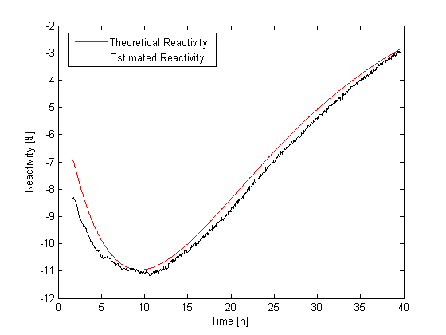
FIG.5. Xenon reactivity estimated and its theoretical value.

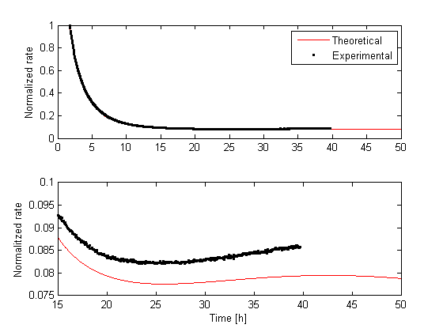
FIG.6. Evolution of the normalized count rate. Detail of the minimum (bottom). Time expressed relative to the shutdown of the reactor.

5. Conclusions

In this work, it was measured the count rate evolution in the RA-3 reactor between 2 and 40 hours after the shutdown. This showed a minimum after 26 hours, reflecting the change in the reactivity due to the xenon concentration.

The inverse kinetic equations were employed to estimate the reactivities in subcritical domains. The reactivity evolution of the reactor was obtained, finding a minimum value of $\$=-\left(24.9±4.2\right)$ at 10 hours. Using the control rod bank reactivity and the core reactivity excess it was possible to calculate the xenon reactivity. At its minimum point, the value obtained was $\$=-10.9$.

For using the subcritical reactimeter it was necessary to estimate the neutron source which contains the whole photoneutron evolution. This estimation was performed by the LSIKM using a rod-drop. It could be established that its value affects considerably the estimated xenon reactivity.

6. Acknowledgement

The authors wish to express their gratitude to all RA-3 reactor staff members who cooperated in the experiments. Without their help, kindness and patience this work would not have been accomplished. We also thank Guillermo Estryk for his invaluable contributions in the calculus made by the PUMA code.

7. References

- OTT, K. O., NEUHOLD, R. J. “Introductory nuclear reactor dynamics”, ANS, (1985).
- TAMURA, S. “Signal fluctuation and neutron source in inverse kinetics method for reactivity measurement in the sub-critical domain”, J. Nucl. Sci. Technol, Vol. 40 (2003), 153-157.
- OTT, K. and NEUHOLD, R. “Introductory Nuclear Reactor Dynamics”, ANS, (1985).
- KEEPIN, G. R. “Physics of nuclear kinetics”, Addison-Wesley Reading, MA, (1965).
- BENHAIM A., BELLINO P., and GOMEZ A. “Determinación de la reactividad mediante la cinética inversa para reactores en estado crítico y subcrítico”,XXXIX Annual AATN Meeting, Buenos Aires, Argentina, December 2012.
- PECOS L. and GOMEZA. “Medición de parámetros físicos en el arranque del reactor RA-3 en el año 2012”,Technical Report, CNEA.
- PECOS L. and GOMEZA. “Medición de parámetros físicos en el arranque del reactor RA-3 en el año 2014”,Technical Report, ITE-06REC-273-CNEA.
- BELLINO P. and GOMEZ A. “Estimación de parámetros cinéticos mediante mediciones en subcrítico en el reactor RA-3”, Technical Report. ITE-06RCN-235, CNEA, 2011, Rev.0.

Appendix A - Control Rod Calibration

Physical parameters measurements performed in the RA-3 reactor [6] [7].

TABLEI: Control rod calibration (BC4)  Percentage $  0 0.0000±0.0000  9.6 0.2100±0.0001  16.0 0.4251±0.0002  21.2 0.6613±0.0002  26.5 0.9704±0.0002  31.8 1.3541±0.0002  36.9 1.7631±0.0003  41.4 2.1574±0.0003  46.1 2.5644±0.0003  50.9 2.9889±0.0003  56.0 3.4122±0.0003  60.9 65.5 70.1 74.6 81.0 100 3.7780±0.0004 4.1027±0.0004 4.3856±0.0004 4.6185±0.0004 4.8492±0.0004 4.9743±0.0005 | 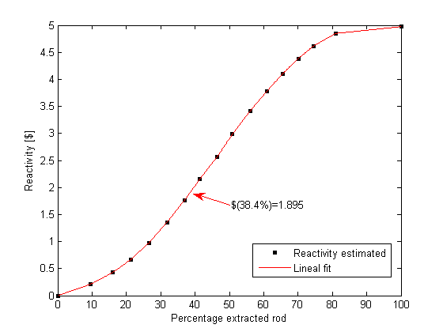  FIG.7. Control rod calibration.

