Instrumentation & Control Systems for the Brazilian Multipurpose Reactor - RMB

P. Carvalho¹, I. Santos¹, M. Santana¹, R. Libardi², A. Soares², J. Drexler³ , C. Rucalski³, A.Vidal³, D. Mollo³, E. Forlani³, M. Scasso³, J. Castellarin³

1) Instituto de Engenharia Nuclear (IEN), Rua Helio de Almeida 75, Cidade Universitária - Ilha do Fundão, CEP 21941, Rio de Janeiro, RJ, Brasil
2) Instituto de Pesquisas Energéticas e Nucleares (IPEN), Av. Lineu Prestes 2242, Cidade Universitária, CEP 05508000, São Paulo, SP, Brasil
3) INVAP, Av. Cmte. Luis Piedrabuena 4950, 8403 San Carlos de Bariloche, Argentina

Corresponding author: paulov@ien.gov.br

Abstract. The Brazilian Multipurpose Reactor (RMB) project is an open pool multipurpose nuclear reactor with a thermal power of 30 MW for radioisotope production to be used in human health and industry applications, materials test and irradiation, advanced reactor fuel tests, and to produce neutron beams for basic and applied research in various knowledge domains. The RMB instrumentation and control system is based on INVAP’s approach in the instrumentation of Australian OPAL research reactor. However, some improvements in the design are taken into account with the purpose to include more recent technologies and to cope with some particular characteristics of the Brazilian project development. The RMB I&C system is based on digital technology, distributed control systems, the integration of information in data networks, and advanced Control Rooms where the main operations and monitoring interfaces are present. The RMB instrumentation and control systems is divided into 5 main packages: 1) neutronic instrumentation system 2) reactor protection system, 3) post accident monitoring system, 4) reactor control and monitoring system, and 5) radiation monitoring system. The purpose of this paper is to describe the RMB instrumentation and control system comprising the reactor protection system, the supervisory and control system, and control room facilities, including basic design scope and safety criteria, standards, technological features, and main interfaces with other reactor systems.

1. Introduction

The Brazilian Multipurpose Reactor (RMB) will be an open pool type multipurpose nuclear reactor with a nominal power of 30 MW. RMB is being designed to meet Brazil’s current and future needs for neutron source to be used in radioisotope production, general research, and materials testing. This paper describes RMB Instrumentation and Control (I&C) systems. The aim is to present the specific safety requirements and safety design bases applicable to the instrumentation and control system, to provide a summary description about the design and operation of the system, from a safety point of view, and to identify the safety features that contribute to nuclear and personnel safety. The I&C system follows the IAEA safety classification [1].

Modern I&C systems are based on the use of digital technology, distributed control systems and the integration of information in data networks (Distributed Control and Instrumentation Systems). This has a repercussion on Control Rooms (CRs), where the operations and monitoring interfaces correspond to these systems. The RMB I&C follows this approach.

The I&C system (Figure 1) is composed by:

- Reactor Protection Systems (RPS) that includes all electrical and mechanical devices and circuits for the First, and Second Reactor Protection Systems (FRPS & SRPS). These generate signals associated with protective functions that are carried out by the safety actuation systems. Both the FRPS and SRPS are Engineered Safety Features and Safety Category 1 Systems.
- Post Accident Monitoring System (PAM) includes all electrical components required to monitor conditions of the facility during and after an accident. The PAM system is an Engineered Safety Feature and a Safety Category 2 System.
- Plant Control and Monitoring System (CMS) includes all the components required for reactor process control, monitoring during normal operation and plant incidents. It is the main interface for plant operations through the Main Console (MC) in the Main Control Room (MCR). CMS includes an extensive numbers of signals and systems; therefore it is divided into several subsystems, such as the Reactor Control end Monitoring System (RCMS), Facilities Control and Monitoring System (FCMS), and other subsystems to control different plant facilities.
- Reactor operators use the MCR area where reactor and associated systems are normally controlled by graphical interfaces. The ECR is an alternate control room for the purpose of shutting down the reactor, and maintaining the reactor in a safe shutdown state if the MCR is uninhabitable. FIG.1 presents an overview of I&C system.

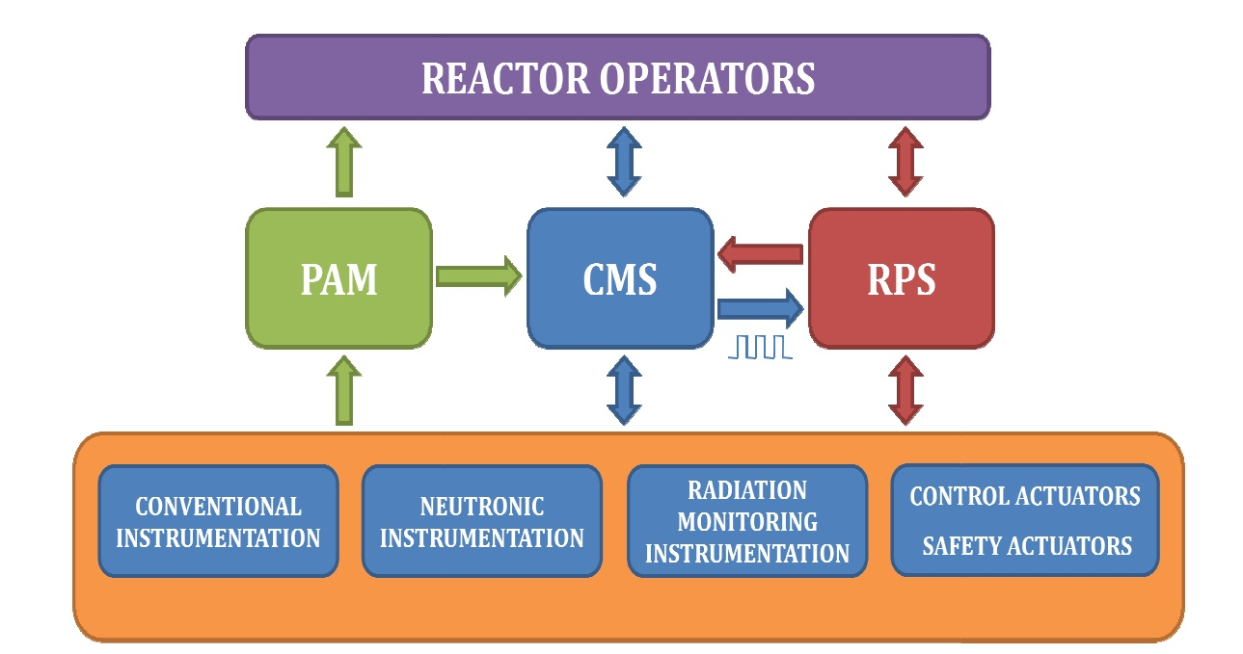

FIG.1. RMB I&C systems block diagram.

2. Neutronic Instrumentation

All nucleonic parameters handled by the FRPS and SRPS come from the Nucleonic Channels. They consist of neutron flux and nitrogen-16 gamma detection instruments that supply information to the RPS and PAM system, describing the state of the reactor regarding neutron production and its evolution. The neutron flux measurement is based on fission chambers, wide range fission chambers, and compensated ionization chambers which are able to monitor neutron flux for the whole operational range of the reactor. There is an overlap between the channels, as well as an adequate margin able to measure flux above the full power level for the unlikely event of a power excursion. The nucleonic instrumentation comprises 3 Start-up Channels, 3 Wide Range Logarithmic Channels, 3 Power Channels, a Wide Auto-range Linear Channel, and a Nitrogen-16 Linear Channel as shown in FIG.2.
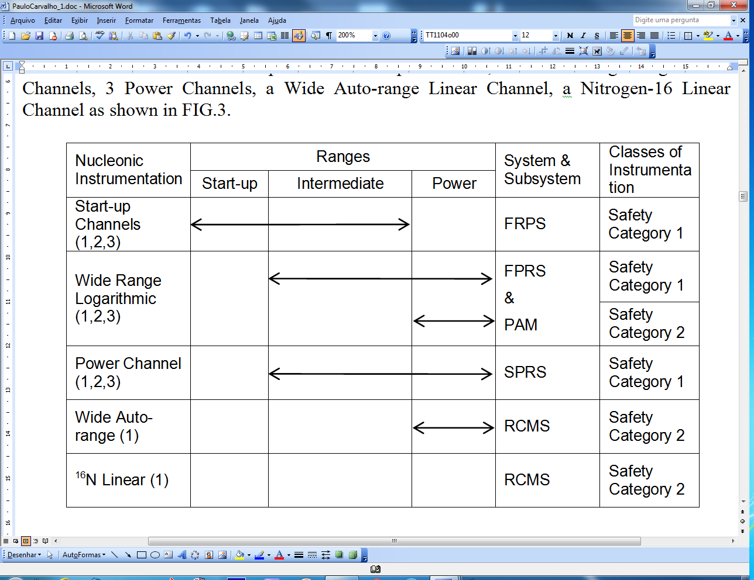

FIG. 2. Overview of the Nucleonic Instrumentation System.

The RPS, PAM and RCMS include neutronic instrumentation channels to cover the neutron flux over the whole range of operation of the reactor: from source level up to 125% of full power level. To comply with safety and reliability requirements, each parameter of the FRPS (start-up channel and wide range logarithmic channel) and SRPS (power channel) is measured by of three redundant channels, which are entirely independent from the detector to the electronic measuring modules. Additionally the SRPS and FRPS trains, in which these channels are located, are diverse and share no instrumentation in common.

3. Reactor Protection System

The purpose of the RPS is to trigger safety systems to protect the integrity of safety barriers that prevent the release of fission products inside or outside the reactor building, and to prevent exposure of staff to radiation. RPS comprises I&C components that initiate the actions to safely shutdown the reactor and re-configure the ventilation system when radioactive discharges in the building stack are above safety settings. The RPS also has priority in establishing reactor operational states and to provide status and control signals to other systems such as the RCMS. The RPS also incorporates interlocks that prevent reactor start-up unless certain conditions are met. It is composed by 2 different and diverse systems: the First Reactor Protection System (FRPS) and the Second Reactor Protection System (SRPS). Both systems are classified as Safety Category 1 and to assure a reliable operation, RPS systems are designed considering redundancy, physical separation, diversity, and equipment qualification.

The main functions of the RPS are:
- To start protective actions in order to shutdown the reactor, remove decay heat, contain radioactive materials and mitigate accident consequences.
- Reliably initiate protective actions to prevent or limit reactor fuel damage following abnormal operational transients.
- To limit the uncontrolled release of radioactive materials initiating protective actions after fuel cladding gross failure or after detection of the release of fission products.
- To detect conditions that threaten the reactor from process parameters that are direct measurements of operational conditions.
- To respond correctly to process parameters over the expected range and to the rates.
- To provide a sufficient number of sensors for monitoring essential parameters that have spatial dependence.

The FRPS and SRPS use diverse technologies. FRPS consist of a combination of hard-wired (manly for neutronic parameters) and digital processing modules. The protective functions associated with this system are:
- Protection Interlocks.
- Trip 1 (FSS - fast insertion of control rods).
- Reconfiguration of Reactor Confinement Ventilation Systems.

The SRPS are based on hard-wired technology only. The protective function associated with this system is the Trip 2 action (SSS - open the valve to drain the tank of heavy water) and also the Trip 1 action (if Trip 1 fails). These functions are described in FIG. 3.

FIG.3. Reactor Protection Systems.

To accomplish protective actions the RPS monitors parameters from various plant systems. Among them, the nucleonic systems provide the reactor power and power rate information that initiates trip actions.

The basic architecture for RPS is shown in Fig.4 at block diagram level. The FRPS is based on triple-redundant measurement channels, triple redundant voting and protective logic (VPLU) which are called trains and the First Final Actuation Logic (FFAL). This redundant configuration fulfils the safety requirements and provides high reliability and availability to the whole system. The logic carried out in the voting logic module is a 2oo3 logic. The SRPS architecture is similar to the FRPS architecture. The main difference is that the SRPS is based on hard-wired Trip Comparator Units (TCUs) combined with hard-wired VPLUs.

FIG. 4. Architecture of RPS.

4. Post Accident Monitoring System

The Post Accident Monitoring (PAM) system provides the necessary information for operators to monitor and take actions during, and after an accident condition. In addition, it provides information to indicate whether plant safety functions are being accomplished and it is an important tool for implementing recovery actions. The PAM system comprises all the electrical devices and circuitry involved in generating the PAM signals for display in the MCR and ECR. The PAM system is classified as Safety Category 2 and based on double redundant trains. Some primary sensors are shared with the FRPS and SRPS. These sensors must have galvanic isolation, because PAM is SC2 and RPS SC1. Isolated PAM signals are used by the RCMS to display the PAM parameters.

The PAM system shall be designed to provide information to operators in wall panels to indicate whether critical plant safety functions are being accomplished, indicating the successful operations and alert operators to take safety actions for initiating a system or function that is not automatic. It should also indicate to operators when barriers to fission product release have the potential for being breached or have been breached and determine the magnitude of radioactive materials released.

Figure 5 shows the architecture of the PAM system and its interface to the RCMS. The PAM system is configured with two independent redundant measurement trains. Each of these trains is composed of measurement channels comprising a sensor or transducer, a Conditioning Unit (CDU) and an Isolation Unit (IU).

FIG.5. PAM Architecture and Interlinks with RPS and RCMS.

5. Reactor Control and Monitoring System

The RCMS is a distributed, computer-based, high-availability system, which reads all plant, and reactor information, and presents it to the operator at control rooms, and local plant stations. The RCMS also enables reactor control, process command and overall data management. The system cover all necessary automatic and manual functions to operate and monitor the facility in normal conditions and to ensure that safety actions are executed under interlock conditions or when limits are exceeded. From the safety perspective, the RCMS is a safety-related system (Safety Category 2). In all cases, the FRPS and SRPS have priority over the RCMS. The RCMS and the FRPS and SRPS are functionally, physically and electrically independent. FRPS and SRPS signals are only sent to the RCMS, without feedback, using galvanic de-coupling devices. The RCMS does not perform any Safety Category 1functions. The RCMS is a reactor control, instrumentation, monitoring, display, alarm and warning system that serves the normal operating requirements of the reactor plant including:

- Reactor plant open and closed loop control system(s).
- Reactor control and monitoring instrumentation, including isolated inputs from the FRPS, SRPS and PAM.
- MCR and ECR, reactor operator control and monitoring workstations, control and indication panels and instrumentation.
- Historical data storage and retrieval system.
- Engineering, development, diagnostics and maintenance tools to maintain and upgrade the system.
- Redundant and separate reactor control and supervision data networks.

The RCMS complies with applicable ISO 8802 series and IEEE standards and incorporates computer-based reactor operator control and monitoring workstations. Workstations are provided for the MCR, ECR and other specific locations. The RCMS is equipped with a dedicated Local Area Network (LAN) system, which is totally independent from the administrative LAN. The external network connections to the RCMS supervision LAN possess "read only" access and external communications are carried out by an isolated server-client set connected by optical fiber.

5.1. RCMS Architecture

The RCMS incorporates the reactor and plant process control and supervision, including the Radiation Monitoring System, and integrates the control and supervision information of the FRPS, SRPS, PAM system, and the Facilities Control and Monitoring Systems, responsible to control the several reactor facilities, such as radioisotope production, material irradiation, and so forth. The system comprises the MCR console and supervision desks, the ECR console and supervision desks, local supervision centers, processing hardware and software, wiring and networking and plant instrumentation. Dedicated workstations are included for the Facilities Control and Monitoring System (FRCMS). The RCMS is a distributed computer-based system, with an open architecture of three hierarchical processing levels:
- supervision level;
- control level;
- field level.

Supervision level units (SU) run the man-machine interface that is used for reactor’s processes supervision, command, and data recording and management. These units are located in the MCR console, in the ECR console and in the local supervision workstations and desks. At control level there are units (CU) used to collect and centralize plant data from field units FUs, to execute overall operational control algorithms, and to output all actuation signals corresponding to control loops. Field Units (FU) are located within the boundary of the system and constitute the link between CUs and intelligent devices, sensor and actuator devices. Input data are acquired from plant sensors and processed here, before sending the information to upper levels in the hierarchy. Local process control loops are performed in these units. Plant output data generated in a CU is sent to the appropriate FU and then to the appropriate plant actuators or intelligent devices.

The RCMS possesses three dedicated communication networks or LAN, physically redundant, which are responsible for data link communication between the different processing levels. Each unit is treated as a node into the LAN system that is connected to. The three networks are:
- Supervision Network: This LAN performs the data link connection between SUs and the Control Network. Its main function is to distribute information and supervision data.
- Control Network: This LAN performs the data link communication between CUs and is connected to the Supervision Network and the Field Network. Its main function is to distribute monitoring and control data.
- Field Network: This individual LAN performs the data link communication between each CU and a set of FUs. Its main function is to distribute local monitoring and control data.

The RCMS dedicated LAN is totally independent from the Administrative LAN. The RCMS overall architecture is shown in Figure 6.

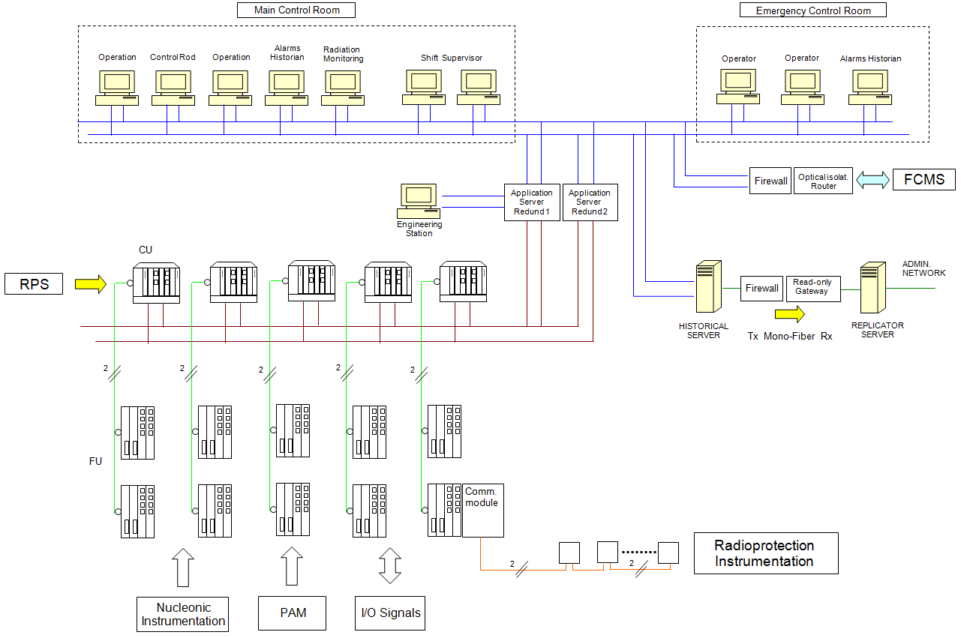

FIG.6. Generic Architecture of the Reactor Control and Monitoring System.

6. Main Control Room Design Human Factors Engineering Program

Human factors correspond to a group of information related to the abilities, limitations and other human characteristics that are relevant to the system design [2]. The human factors engineering search through laboratory experiments, simulation techniques, to obtain data on human characteristics in order to enter this data in the design of tools, machines, systems, interfaces and equipment for effective use by humans in conditions comfortable and safe [3]. In order to develop the Control Room System there is a need to develop an human factors engineering program to design the RMB’s control centre. The aim is to ensure that human factors requirements have been satisfactorily integrated into the design, development and evaluation of the control centre of the reactor RMB. The main contributions of human factors engineering are:

- ensuring the necessary means for operators to perform their jobs with comfort and safety;
- ensure that the tasks to be performed by operators are correctly specified;
- ensure that procedures and training requirements are compatible with the desired performance;
- ensuring that control room and human-system interfaces designs are consistent with the cognitive characteristics of operators;
- ensuring that control room and human-system interfaces designs allow a human performance compatible with the desired mission minimizing human errors;
- ensuring that control room and human-system interfaces designs make available adequate information about the status of systems, allowing the tasks effectively by operators in normal, abnormal and emergency procedures.

The approach used to reach these objectives is the implementation of a human factors engineering program, inserted in the life cycle of the RMB control centre in five phases: planning, analysis, implementation, verification/validation and operational monitoring. Figure 7 shows some activities of these five stages to be performed during the life cycle of the reactor control centre.

Planning  Management of HFE  Operator experience review | Analysis  Functional analysis  Function allocation  Task analysis  Qualification and quatification of operators  Human reliability analysis | Implementation  Control room (centre) design  Procedure design  Training program | V&V  Human factors requirements V&V | Monitoring  Operators’ performance evaluation

FIG.7. Activities of the HFE program.

The Main Control Room (MCR) and Emergency Control Room (ECR) are the main areas for reactor control. Their designs take into consideration nuclear safety and radiological protection requirements, and reactor utilization for radioisotope production and neutron research. However, there are other control points distributed in the plant, grouped according to functions or systems. All points shall have the necessary attributes and information for the operators to correctly execute their tasks. The distribution of tasks is arranged to avoid overloading of the MCR with information that may distract or divert the operator’s attention from their specific function. The MCR view shown in Figure 8 and layout shown in Figure 9 will have three main elements:
- main console (MC);
- supervisor console (MCS);
- facilities operator console (FCMS).

The operators have access to Visual Display Units (VDUs) for all the systems from which periodical or on-demand information is required. Similarly, the type of graphical presentation is defined for all the parameters present at the control room or remote centers. Desks have pushbuttons, touch-screens, dedicated keyboards and track-balls. Information is delivered through VDUs or hardwired instruments. In general, the horizontal section of the consoles will house pushbuttons, keyboards and keys, and the vertical areas will house hard-wired displays, alarm panels and VDUs. VDUs provide operating personnel with the information on system status and parameter values needed to meet task requirements in normal, abnormal and emergency situations.

Priority principles are established and applied to the layout and arrangement of alarm signals, displays and controls. They are determined by the function of a system and by the priority ranking between similar elements in the layout of the panels. The priority ranking rules derived from these principles are consistent for all panels in the plant.

The major functional requirements of the displays are as follows:
- Safety-related information displays are suitably located and uniquely identified on control panels.
- Appropriate types of displays are selected, depending on the purpose of an individual display.
- Necessary information is available to the operators, when required, without ambiguity or loss of meaning.
- Information shown is clearly understood by the operators.
- Symbols are standardized and the range of symbol sizes limited.
- Direction of process flow paths and the sequence of events in schematic displays are in accordance with population stereotypes.

Controls and their associated displays are correctly integrated to ensure effective operation of the plant by MCR and ECR staff according to the following requirements:
- Location criteria are followed such that controls are located near or below the associated display. Operation of a control produces a compatible change in the relevant display.
- The form of control adopted is consistent with the form of associated information display.
- The grouping of controls and their associated displays reflect the need to achieve system objectives and are consistent with the user's mental model of the system.
- Where operational sequence is an essential factor, the organisation of controls and displays reflect cause and effect relationships.
- The organization of controls embodies user population stereotypical groupings.
- The form of codes used for display and the associated controls are entirely consistent.
- Engineering units are consistent with the degree of accuracy needed by the operator. All displays indicate values in a form immediately usable by the operator without requiring conversion.

The Main Console shall be divided into areas corresponding to specific systems. On the left side: shutdown actions, alarms, and RPS. PAM system information is presented through wall panels. In the center: nuclear and conventional process parameters, selected presentations requested by the operator, Control Rod Drive actions. On the right side: graphics selected by the operator, authorizations and conventional system commands. There is an integrated communication and CCTV system, which will enable an operator to see and communicate with any area inside and outside of the plant.

From the supervisor’s desk, all operator actions may be verified but not controlled. The supervisor shall have an integral communication system allowing him to see and communicate with any area of the plant without interfering with the operator.

VDUs and hard-wired panels allow the operator to determine the state of the safety parameters and to take actions by providing:
- displayed parameters identified by a code;
- condition: normal condition or alarm;
- action: automatic or manual;
- location in the system.

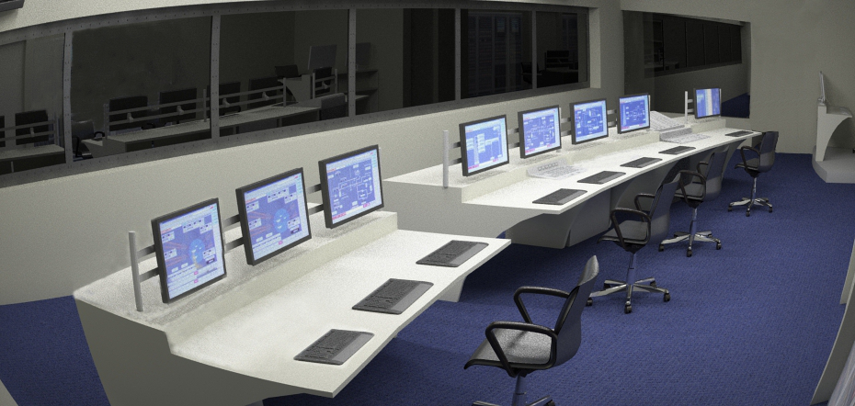

FIG.8. Main Control Room view.

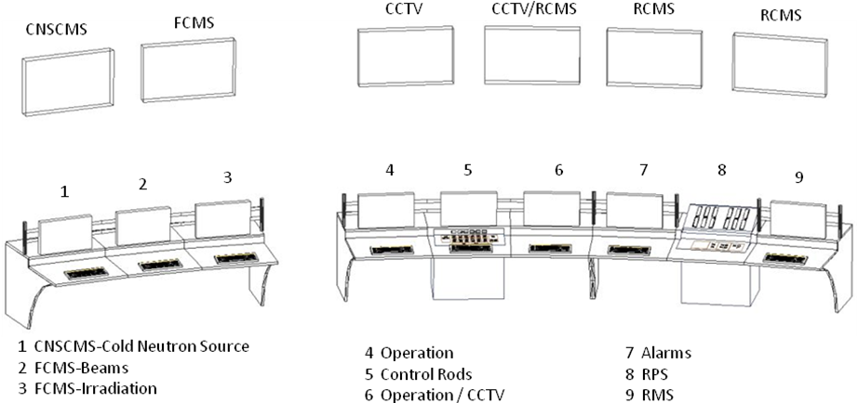

FIG.9. Main Control Room layout.

6. Conclusions

The results described here has shown an I&C system based on the extensive INVAP’s experience in designing the instrumentation systems for the RMB research reactor that combines new technologies with proven design solutions according to the most recent nuclear safety and human factors engineering regulations.

7. References

- INTERNATIONAL ATOMIC ENERGY AGENCY, IAEA Safety Series 35-S1 Code for the Safety of Nuclear Research Reactors – Design, Vienna (1992).
- NUREG 700 (rev 2), Human-System Interface Design Review Guidelines. USNRC, 2002.
- NUREG 711(rev 2), Human Factors Engineering Program Review Model. USNRC, 2002.

