Use Virtual Environments for Training in Nuclear Facilities

D. Machado^{1, 2}, A. Cotelli¹, A. Mól¹, V. Freitas¹, M. Vidal², P. Carvalho¹

- Instituto de Energia Nuclear - IEN, Rua Hélio de Almeida, 75, Cidade Universitária - Ilha do Fundão, Rio de Janeiro, Brasil

- Instituto Alberto Luiz Coimbra de Pós-Graduação e Pesquisa em Engenharia - COPPE, Universidade Federal do Rio de Janeiro – UFRJ, Av. Horácio Macedo 2030, Cidade Universitária. Rio de Janeiro, Brasil

Corresponding author: paulov@ien.gov.br

Abstract. The health and safety of people working in areas with radiation can be preserved following some rules. Among these rules are safe limits of radiation level, proximity of radiation sources, time of exposition to radiation sources, and a combination of these factors. In this way, previous training and simulations of operation procedures helps to better prepare people to work in places subject to radiation, minimizing the absorbed dose. Virtual Reality is a technology used for training in many areas, enabling simulation of real places and hypothetical scenarios, with a good level of realism, and without danger of the same activities in the real world. As a virtual environment doesn’t present any health risks, it’s possible to train workers beforehand to several operation or maintenance scenarios. In this virtual environment, the dose rate distribution can be visualized, and the dose absorbed by the worker, represented and simulated in the virtual environment by a virtual character (avatar) can be shown. Therefore, the tasks to be done can be better planned, evaluating the workers actions, the time needed, and the overall performance to reduce failures and health risks. This work describes a tool to build and navigate in virtual environments, enabling the training of activities in nuclear facilities exemplified with a virtual environment of the Argonauta research reactor, located in the Instituto de Engenharia Nuclear.

1. Introduction

Over the years health and safety concern of people working in nuclear facilities has been increased. There are many rules and procedures that aim to ensure such security, especially in radioactive facilities. According to ALARA principle [13] exposure to radiation, if required, should be as low as reasonably practicable. The standard aims to ensure the minimization of dose and the limits of radiation dose [13] to prevent harm in the workers.

We can define controlled areas as those with high levels of radiation, requiring tight control and monitoring. When an intervention is necessary workers should stay there the shortest time as possible, limiting the dose within the limits set by the standard CNEN-NN-3.01. When a worker is exposed to high doses of radiation in a short period of time, he should stay away for a period (proportional to the dose received) of activities that may expose the worker to new doses. Among others, equipment for instantaneous monitoring of radiation equipment is used to perform this control.

Methods and techniques that can estimate the amount of radiation dose absorbed by an individual are extremely useful in this context. Thus, prior planning of activities to be carried out under controlled areas is critical to ensure that the dose limits will be respected. This paper proposes computer simulations of activities involving radiation exposure, allowing a preliminary estimate of the doses absorbed by workers without the need of actual exposure. The dose exposure in the environment is simulated using Artificial Neural Networks (ANNs). These simulations can contribute to the planning of activities and evaluation of health risk of the workers in nuclear and radiological facilities. The use of Virtual Reality (VR) in computer simulations enables the visualization of environments through three-dimensional graphics giving the user an overview of immersion, ie, providing the user the perception of being "inside" the environment.

2. Related Work

There are several recent studies that used VR for simulations and training in nuclear industry.
The study described by Cotelli [4] used the VR to develop a tool that allows the visualization and planning action strategies in a virtual environment, with the aim of training the security team. This project also enabled multi-user interaction in virtual environment which provided more realism and increased the degree of complexity of the system.
Mól et al. [10] develop a tool for building virtual environments that can simulate nuclear facilities, allowing the user to scroll through virtually the installation, accounting for receipt of radioactive doses.
The VRDose was developed by the Halden Virtual Reality Centre [7] for use in the decommissioning of nuclear power plant in Tsuruga Fugen in Japão. The VRDose System is designed to prepare a work plan taking into account the view of radiation and the dose estimates.
Mol et. al. [9] developed a VR system for training and evacuation in drills, in places with large concentrations of people. To develop the core game the Unreal Engine 2 Runtime was used and the system was adapted to meet the speed of movement of avatars in accordance to real human movements. The system can be controlled in a network and have multiple users interacting in the same scene, providing greater realism for the evacuation training.
Aguina and colleagues [2] uses RV to develop a virtual control desk of a nuclear pressurized water reactor simulator. The virtual control desk is used as an option for operators training providing an easier and new way to understand basic principles of the reactor functioning.

3. Virtual Reality

Recently, Virtual Reality, also known as VR, can be considered a huge potential technology and applicability in diverse areas of human knowledge, and especially in training, simulations and virtual experimentation [3-5]. VR enables the integration of three basic ideas: involvement, immersion and interactivity. The involvement may be seen as the degree of motivation of the user with the activity performed, the immersion is associated with the human perception of reality, and the interaction with the user ability to manipulate virtual objects [3,14]. The set of technologies, techniques and interface modes that enable the integration of a user, computer system, and immersion in a virtual environment can be called Virtual Reality [14,15].

3.1 Virtual Environments

In this environment occurs the simulation of reality where representative scenarios are created. Virtual environments can be considered scenarios where it is possible, through an avatar (representation of a person in a virtual environment), to move in the virtual world, interacting with elements, objects, and even other avatars [6].

3.1 Unreal Engine

Game Engine or core game is the basics for creating electronic games center. Such engines can be adapted and used for other applications requiring graphics generated in real time. The game engine chosen to develop the virtual environment used in this research was the Unreal Engine (Epic Games, Inc.), where the core game can be modified to fit the needs of this project.

The Unreal Engine was chosen due to a number of factors:

- Can produce virtual environments with visual quality and realism, because it has a 3D core;
- Has a modeling program that enable scenarios or objects creation using basic geometric figures such as cubes, cylinders and spheres;
- The physical quantities are represented with good approximation, for example, gravity;
- It has an own script language, object-oriented and similar to Java;
- It enables the use of avatars (virtual character) to represent the user in the virtual environment.

4. Artificial Neural Networks

Artificial Neural Networks (ANNs) are composed of a mathematical model inspired by the brain structure computational techniques, with the premise that knowledge is established through experience. The first artificial neuron model was designed in 1943 by researchers Warren McCulloch and Walter Pitts. Several models have been proposed since then, with several enhancements, culminating in the structure currently used. An ANN is composed of a number of artificial neurons, also known as processing units. These units are connected by communication channels associated with certain weights. Each unit performs network operations locally, treating only those entries received by their connections. Similarly the biological neural network, knowledge of the ANNs are developed from the interactions between neurons [8].

5. Methodology

Initially we need to estimate the dose rate in a particular area. After that these values are inserted in the modeled virtual environment following the physical dimensions of the real environment. Through radiation detectors it is possible to measure the radiation dose in some specific points of the controlled area. Some factors such as the interaction of radiation with the objects present and the uniqueness of each installation hinder this estimate. Thus, we use ANNs to interpolate the data measured to produce dose estimation within each point of the area.

Area radiation monitors (Fig. 1) are installed in radioactive facility for measuring different types radiation, including gamma, alpha and neutron detectors. Data from these sensors will feed table dose, which will be used in the interpolation of radiation. The radiation monitor (Fig. 1), a radiation monitor that digital area can be connected to different types of probes for monitoring environmental radiation [11,12]. Is generally used together with the probe SGM Geiger-Müller counter 7027 is able to detect gamma rays and X rays, may also be used with other probes, such as SPQ 7026 for detecting surface contamination alpha, beta and gamma, to detect SNT 7026 neutrons TCS and 7026 to detect gamma and x-ray radiation 7027 MRA can be used alone as a radiation monitor area or can be used in conjunction with other network monitors MRA 7027 connected to a supervisory computer through its channel serial communication.

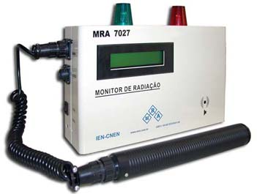
FIG. 1. Radiation Monitor 7027 MRA together with the probe SGM Geiger-Müller 7027

5.1 Interpolation by RNA

The technique for transforming a set of discrete data set is called a continuous interpolation. An ANN is trained to interpolate the different areas of the facility according to the data sheets generated by area radiation monitors .

5.2 Area Monitors Network with Unreal Engine

The data of the detectors in real time are required within the Unreal, so three main procedures have been established:
- A process receives and publishes the data measured by MRA.
- Another process sends this data to the Unreal Engine
- A third method serves as an interface between the two cases cited.

These processes are accessible to everyone else through a TCP / IP network and can reside on one or more computers.

5.3 ANN Trained in Virtual Environment

UnrealScript language with a new class was scheduled to enter a neural network in Unreal. The trained ANN generates interpolation functions, each one referring to an area that, when inserted in the schedules span the space locomotion of avatar.

6. Argonauta Reactor: Case study

This work was based on the Argonauta Reactor of the Institute of Nuclear Engineering. This reactor has an outlet neutron channel, called J9, to irradiate objects for research, leading to the release of gamma radiation in the environment.

The Argonauta reactor (Fig. 3 and 4) was the first research reactor built in the country by a national company. It is a thermal pool type reactor that uses uranium as fuel enriched to 20% U-235, with maximum output of 5kW (but operates by default between 170 and 340W of power). It is used in research involving neutrons in the areas of reactor physics and nuclear physics since 1965 and currently has as main research nondestructive testing with thermal neutrons in biology, industry, environment and national public safety.

In this application was purchased only measures the dose range of the reactor and the ANN was performed by interpolation using a so-called Neuroshell [16] application, employing grnn architecture. With networks trained and tested three interpolation functions in c ++ programming language were generated. After an adjustment was made for these functions UnrealScript language which is the language used in Unreal. These functions were then entered as calculation of dose received by the avatar. Thereby generating data such as: position of the avatar, Argonauta reactor power, and the dose received by a virtual user.

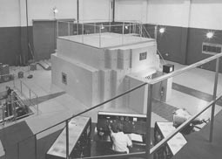

FIG. 2 Reator Argonauta

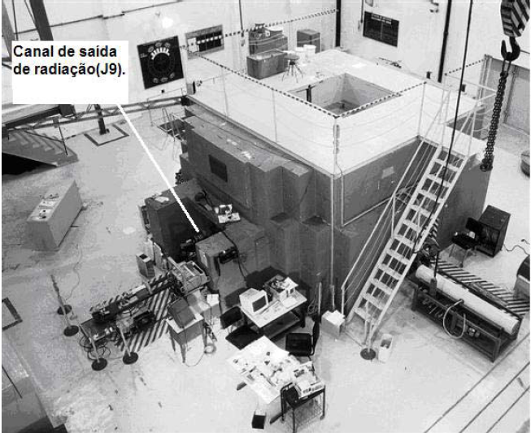

FIG. 3 Reator Argonauta

6.2 Results

In Figures 4, 5, 6 and 7 it ​​can be seen the program running. It is possible to view gamma dose received by the avatar. This dose received depends on the position of the avatar, reactor power and the extent of fixed detectors.

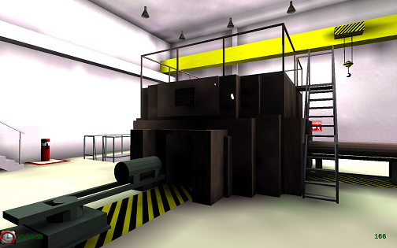

Fig. 4 Virtual Argonau
ta Reactor.

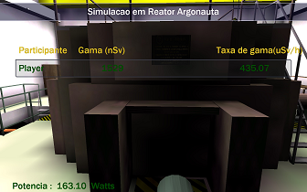

Fig. 5 Simulation of received dose range.

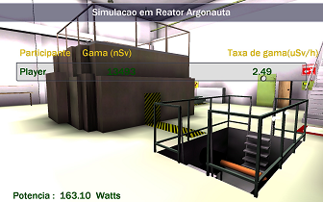

Fig. 6 Simulation of received dose range.

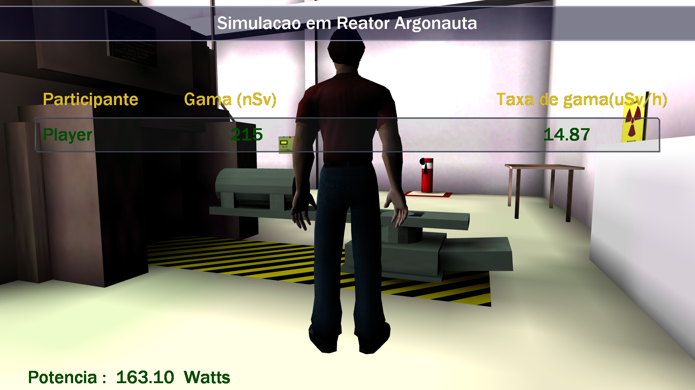

Fig. 6 Dose range received accumulated over space and time by the worker

7. Conclusion

The objective of this study was to develop a system for predicting radiation doses in a virtual environment, based on real (measured) dose rates. Dose values in the area were estimated in continuous profile interpolated by artificial neural networks and inserted into the core of Unreal engine, enabling the connection of the real installation to the VR simulation. The proposed method was applied in the Argonauta reactor experiments hall. Using the interpolation it was possible to make a quantitative analysis of the average dose that a worker receive in the Argonauta reactor hall, enabling training to minimize workers exposure to high levels of radiation.

8. Acknowledgments

The authors would like to acknowledge the support of Instituto Alberto Luiz Coimbra de Pós-Graduação e Pesquisa em Engenharia - COPPE, Universidade Federal do Rio de Janeiro – UFRJ, and Conselho Nacional de Pesquisas CNPq. Our thanks also to the Comissão Nacional de Energia Nuclear - CNEN, that, through the Instituto de Engenharia Nuclear - IEN, has provided all necessary resources to the development of this work.

9. References

- Augusto, S.C., Mól, A.C.A., Jorge, C.A.F., et al., 2007. Use of Virtual reality to Estimate Radiation Dose Rates in Nuclear Plants. 2007 International Atlantic Conference – INAC 2007, Santos, São Paulo, Brazil, October 2007.
- Aghina, M.A.C., Mól, A.C.A., Jorge, C.A.F., Pereira, C.M.N.A., Varela, T.F.B., Cunha, G.G., Landau, L., 2008. Virtual Control Desks for Nuclear Power Plant Simulation: Improving Operator Training. IEEE Computer Graphics and Applications, v. 28, p. 6-9, 2008.
- Burdea, G., Philippe, C., 1994. Virtual reality technology. John Wiley & Sons, New York.
- Cotelli, A., 2013. Estudo Da Viabilidade Do Uso De Realidade Virtual Na Criação De Uma Ferramenta De Apoio Ao Planejamento De Segurança Física Em Instalações Nucleares, MSc Thesis, Instituto de Engenharia Nuclear, Rio de Janeiro, Brasil (2013).
- Francis, G.A., Tan, H.S., 1999. Virtual Reality as a Training Instrument. The Temasek Journal 7, 4-15.
- Goldstone W., Unity 3.x Game Development Essentials, Packt Publishing, New York, United States of America (2011).
- Halden Virtual Reality Centre. VRdose software. Available from: http://www.ife.no/en/ife/departments/software-engineering/products/vrdose [Accessed 15 Oct 2014].
- Haykin, S., 2001. Redes Neurais: Princípios e práticas; trad. Paulo Martins Engel, 2 ed, Porto Alegre: Bookman, 2001.
- Mól, A.C.A., Jorge, C.A.F., Couto, P.M., 2008. Using a Game Engine for VR Simulations to Support Evacuation Planning. IEEE Computer Graphics and Applications, v. 28, p. 6-12, 2008.
- Mól, A.C.A., Couto, P.M., Augusto, S., Cunha, G.G., Landau, L., 2009. Virtual environments simulation for dose assessment in nuclear plants. Progress in Nuclear Energy, v. 51, p. 382-387, 2009.
- Oliveira, M.V., Aghina, M.A.C., Soares, M., 1997. Sistema de monitoração de radiação 7027. In: Proceedings of the 4th Brazilian National Meeting on Nuclear Applications and 11th Brazilian National Meeting on Reactor Physics and Thermal Hydraulics, Poços de Caldas, MG, Brazil, pp. 473-476.
- Oliveira, M.V., Aghina, M.A.C., Mól, A.C.A., 2000. Sistema de monitoração de radiação 7027 do reator Argonauta. In: Proceedings of the 5th Brazilian National Meeting on Nuclear Applications, 8th General Congress on Nuclear Energy and 12th Brazilian National Meeting on Reactor Physics and Thermal Hydraulics, Rio de Janeiro, RJ, Brazil, pp. 473-476.
- Recommendations of the International Commission on Radiological Protection. In: ICRP Publication 60, 1990.
- Ródenas, J., Zarza, I., Felipe, A., et al., 2005. Generation of Dose databases for na Operator Training Application in Nuclear Facilities.
- Stanney, K.M., 2002. (Ed.) Handbook of Virtual Environments: Design, Implementation, and Applications, 2002.
- Ward Systems Group INC, All Rights Reserved 1997 – 2009. Available from: www.wardsystems.com/engine.asp.

