Neutronic Simulation of IPR-R1 TRIGA First Configuration using Serpent and MCNP Codes

S. P. de Meireles¹, A. Z. Mesquita¹, M. A. de B. C. Menezes¹, A. A. C. dos Santos¹

1) Nuclear Technology Development Center (CDTN), Av.Pres. Antônio Carlos, 6.627 - Campus UFMG, CEP 31270-901 Belo Horizonte, Minas Gerais, Brazil

Corresponding author: spm@cdtn.br

Abstract. The IPR-R1 reactor is located at the Nuclear Technology Development Center – CDTN (Belo Horizonte, Brazil). It is a TRIGA Mark I type reactor which remains in operation since its first criticality in 1960. During this period, the reactor has been used in the production of radioisotopes for studies in radiobiology; in the manufacture of radioactive sources for industries; in the production of tracers used in industrial processes; in the irradiation of samples to analysis by neutron activation and training of personnel to operate reactors. Due to a very long history of operations and the absence of information about the current composition of the fuel elements, it was proposed to simulate the reactor since the first configuration, in order to minimize the effects of uncertainties about the current composition of the reactor. At the first configuration, its positions and composition of each fuel element are known. This paper presents the data obtained from simulations by using the Monte Carlo codes: MCNP and Serpent for 1960’s reactor at the beginning of its life. Three models have been proposed for the reactor simulation. The first model provides: a core which is formed by cylindrical fuel elements, reflector, rotary specimen rack (or “lazy Susan”) and pneumatic tube. The second model included the central tube, the control rods guides, aluminum thickness on the rotary specimen rack located in the reflector, and designed a new geometry for the fuel elements. Finally, the third model included the control rods from the reactor. Through this work, it is expected to conduct the study of the effects of control rods in the simulations and reproduce the same behavior observed in the experiments involving the positions of the control rods, obtaining a reliable model for future studies.

1. Introduction

Research reactors usually play an important role in a series of activities related to research and training such as radioisotope production, analysis by neutron activation, reactor physics and thermal-hydraulics experiments. Furthermore, research reactors can provide valuable knowledge for testing and validation of nuclear codes

The research reactor IPR-R1 TRIGA was acquired by the government state of Minas Gerais in 1960, the American government through the "Atoms for Peace" program. Housed in the Institute of Radioactive Research (IPR), Current Development Center of Nuclear Technology (CDTN), which remains in operation (see FIG.1).

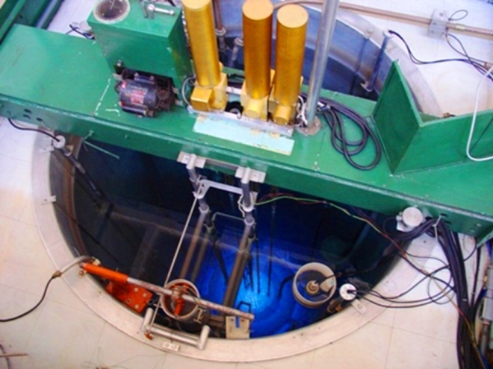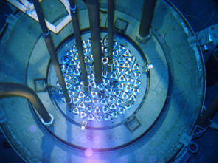

FIG. 1. IPR-R1TRIGA MARK I [13].

Its first criticality was on November 6, 1960 with a maximum thermal power of 30 kW. Later, new fuel was added to the core elements increasing power to 100 kW, which is the current maximum licensed power. In 1998, work began to allow operation at 250 kW [10-12]. New fuel elements were added allowing power to reach 250 kW and studies to assess the heat transfer in the core were performed [13-14]. Presently, the core has a cylindrical configuration currently with 63 cylindrical fuel elements, 59 aluminum-clad fuel elements and 4 stainless steel-clad fuel elements with 20 % enrichment in ²³⁵U and 8.5 wt % uranium.

The main applications of the IPR-R1, are: neutron activation analysis, training for nuclear operator and experiments on neutronic and thermal-hydraulics. All work carried out using the reactor are dependent on the data flux and neutrons temperature, as well as other parameters. These data are extremely important, especially when it is applying the k0 standardized neutron activation [15-17], the method is a routine in the Laboratory of Neutron Activation of CDTN. Therefore, validation of the parameters is of vital importance to guarantee reliability of the work, also contributing as a safety measure, indicating possible problems with the reactor.

Previous work focused on determining the fuel burnup from 1960 to 2004 [4] and the neutron flux on each of the irradiation rack positions [5-6]. Both used simplified geometry for the core of reactor and new investigations become necessary.

In this study the focus is modeling the IPR-R1 TRIGA Mark I reactor using different radiation transport codes: MCNPX [17] and Serpent [1] Monte Carlo reactor physics calculation codes. The influence on neutronic parameters of the models geometry was studied by simulating three progressively detailed geometries. The first configuration of the reactor was considered to avoid uncertainties regarding fuel composition present in previous modeling works [4-6].

3. Numerical Methodology

Considerable uncertainty exists about the current composition of the IPR-R1 reactor fuel. So as a strategy to minimize uncertainty factors was decided to use the first configuration of the reactor. Data for BOL (Begin Of Life, 1960), positions and composition of each fuel element are well known. Three different geometries for the reactor were evaluated. A comparison between the Monte Carlo codes MCNP [17] and Serpent [1] was performed. All the simulations used the same compositions for the materials that make up the reactor.

3. 1 Geometry

In the first evaluated geometry, named Geometry A, the reactor consists of cylindrical fuel elements and a core without control rods, central tube and thick aluminum samples in table located in the reflector. This geometry is equivalent to that used in previous simulations [4-6].

The second evaluated geometry, named Geometry B, is a more refined geometry by introducing new structures. It includes by the central tube, guide the control rods, aluminum thickness in the sample table located in the reflector. The upper and lower ends of the reactor fuel elements gained a new geometry closest to the real element. The ends of the fuel element in this new model become thinner.

The third evaluated geometry, named Geometry C, the control rods were inserted in the out of core position in order to reproduce the same behavior observed in experiments involving the positions of the control rods. According to the Manual of General Atomics control bars have a cylindrical shape and are sealed in an aluminum container, the lower end has a conical shape to reduce the resistance imposed by water during a shutdown. The conical tip was not reproduced.

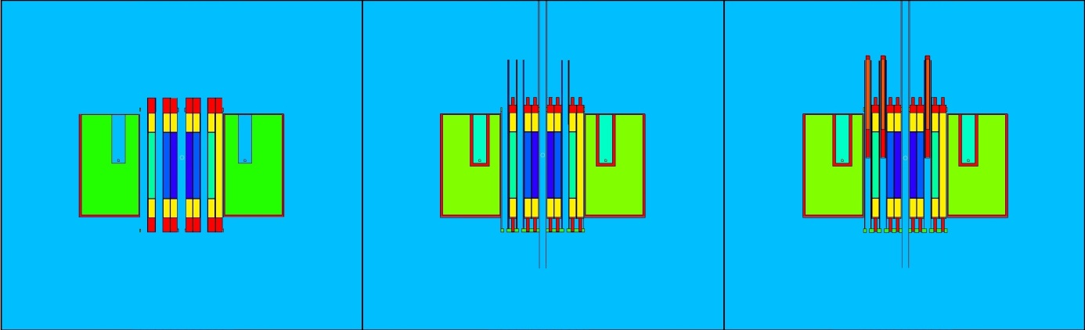
A
B
C

FIG. 2. Geometry A, B and C.

3.4. Monte Carlo Codes and Libraries

Serpent is a three-dimensional continuous-energy Monte Carlo reactor physics burnup calculation code, developed at VTT Technical Research Centre of Finland since 2004. The publicly available Serpent 1 has been distributed by the OECD/NEA Data Bank and RSICC since 2009, and next version of the code, Serpent 2, is currently in a beta-testing phase. Similar to other Monte Carlo codes, such as MCNP and Keno-VI, Serpent uses a universe-based combinatorial solid geometry model, which allows the description of practically any two- or three-dimensional fuel or reactor configuration. The geometry consists of material cells, defined by elementary surface types.

The MCNP is a general-purpose Monte Carlo N-Particle code that can be used for neutron, photon, electron, or coupled neutron, photon, electron transport. MCNP is not just limited to a particular area. MCNP can is used for calculations in radiation protection and dosimetry, radiation shielding, radiography, medical physics, nuclear criticality safety, detector design and analysis, nuclear oil well logging, accelerator target design, and fission fusion reactor design, decontamination and decommissioning.

For these tests, the ENDF/B-VII library was used to perform all simulations. Some nuclides do not have the cross section defined by the ENDF/B-VII, in this case Serpent fill the gaps with data from libraries: BROND 2.2, JENDL 3.2, JEF 2.2, JEFF 3.1.1, JENDL 3.3, or ENDF/B VI.8.

If the neutrons transported have sufficiently low energies (typically less than 4eV) to the point that the effects of molecular bonds become important (molecules formed by hydrogen bonds like water, and some crystalline solids, among other materials) a specific thermal scattering library needs to be used in addition to free-gas cross sections - S(α,β). These libraries are used to replace the low-energy free-gas elastic scattering reactions for some important bound moderator nuclides, such as hydrogen in water or carbon in graphite. Thermal systems cannot be modeled using free-atom cross sections without introducing significant errors in the spectrum and results.

In the Serpent 2.1.20, data for zirconium hydride are not available. In the simulation data was imported from the library file ENDF 70/sab available to MCNPX and used for both codes. The materials that used the thermal scattering data from this library were: light water, hydrogen in zirconium hydride, zirconium on the zirconium hydride and graphite.

4. Results

Simulations were performed of the first configuration of IPR-R1 TRIGA reactor with Serpent 2.1.20 and MCNPX with different geometrical complexities. The simulations were performed with an initial neutron population of 10 000 neutrons and was sampled for 5000 time steps after initial 1000 steps. The tests were run on Linux operating system, divided into four processors. As an evaluation parameter the effective multiplication constant was calculated. The effective multiplication constant can be calculated by different methods. The presented values are the final estimated value by Collision and Absorption methods. The results and standard deviation (SD), of Geometry A are presented in Table I.

TABLE I: Comparison between MCNP and Serpent - Geometry A.

 | MCNPX |  | Serpent 2.1.20 |  | ∆ K_{eff}
Method | K_{eff} | SD | K_{eff} | SD | ∆ K_{eff} (pcm) | SD
Collision | 1.01375 | 0.00017 | 1.01215 | 0.00021 | 160 | 38
Absorption | 1.01377 | 0.00012 | 1.01222 | 0.00014 | 155 | 26

In Geometry B the introduction of the guide tube central control rod, aluminum thickness in the sample table located in the reflector, and the new geometry of the fuel element was inserted a negative reactivity with respect to the initial model. The value of the effective multiplication constant was reduced by about 470 pcm in each simulation. The data can be seen in Table II.

TABLE II: Comparison between MCNP and Serpent - Geometry B.

 | MCNPX |  | Serpent 2.1.20 |  | ∆ K_{eff}
Method | K_{eff} | SD | K_{eff} | SD | ∆ K_{eff} (pcm) | SD
Collision | 1.00904 | 0.0002 | 1.00728 | 0.00024 | 176 | 44
Absorption | 1.00907 | 0.00014 | 1.00733 | 0.00017 | 174 | 31

The insertion of control rods in Geometry C introduced in the simulation about 150 pcm of negative reactivity when compared with Geometry B. This shows that even in the out position the control rods interfere in the reactivity. When compared to Geometry A, the changes add up to a negative reactivity insertion around 660 pcm. See data in Table III.

TABLE III: Comparison between MCNP and Serpent - Geometry C.

 | MCNPX |  | Serpent 2.1.20 |  | ∆ K_{eff}
Method | K_{eff} | SD | K_{eff} | SD | ∆ K_{eff} (pcm) | SD
Collision | 1.00755 | 0.00014 | 1.00568 | 0.00017 | 187 | 31
Absorption | 1.00726 | 0.00010 | 1.00538 | 0.00012 | 188 | 22

5. Final Remarks - Conclusions

Neutron transport simulations were carried out on the first configuration of TRIGA IPR R1 reactor using MCNPX and Serpent 2.1.20. Effects on reactivity due to increased geometrical complexity in the model were evaluated. Results showed that the geometry and details of the reactor should be included in the model as it has significant impact on reactivity calculation.

Comparisons made between the codes MCNPX and Serpent 2.1.20 showed consistent differences of the results obtained for reactivity for all simulated geometries. As the geometrical complexity increased a slight increase in the calculated reactivity was observed. In all calculations Serpent estimated a lower value for K_{eff}.

In future works temperature effects will be evaluated and a fuel burn up calculation will be performed to the present day. Available and new experimental results will be used to validate the simulations.

6. Acknowledgement

This research is supported by the following Brazilian institutions: Nuclear Technology Development Center (CDTN), National Nuclear Energy Commission (CNEN), Research Support Foundation of the State of Minas Gerais (FAPEMIG), National Council for Scientific and Technological Development (CNPq), the National Institute for Innovative Nuclear Reactors (INCTRNI), and Eletrobras Eletronuclear.

7. References

- LEPPÄNEN, J., et al., “Calculation of effective point kinetics parameters in the Serpent 2 Monte Carlo code”, Annals of Nuclear Energy, 65, (2014) 272-279.
- BROW, F., Kiedrowski, B., Bull, J., 2010. MCNP-1.60 Release Notes, Los Alamos National Laboratory, LA-UR-10-06235, (2010).
- KIEDROWSKI, B., Brown, F.. Bull, J., 2010. MCNP-1.60 Feature Enhancements and
Manual Clarifications, Los Alamos National Laboratory, LA-UR-10-06217,(2010).
- DALLE, H. M., “Simulation of the IPR-R1 TRIGA reactor using methods of transport by Monte Carlo”. 2005. 189p. Ph.D Thesis, Faculdade de Engenharia Química, Universidade Estadual de Campinas, Campinas, (in Portuguese), (2005).
- GUERRA, B.T. “Obtaining the neutron flux in the irradiation terminal of IPR-R1 TRIGA reactor using the method of transport Monte Carlo”. Thesis, Departamento de Engenharia Nuclear, Escola de Engenharia da UFMG, Belo Horizonte, (in Portuguese), (2011).
- SALOMÉ, J. A. D., “Evaluation of Neutron Flux in Al-Au alloy Different Dimensions of the IPR-R1 TRIGA Reactor Using the Monte Carlo Method” Thesis, Departamento de Engenharia Nuclear, Escola de Engenharia da UFMG, Belo Horizonte, (in Portuguese), (2011).
- N. TOMSIO, "Characterization of TRIGA Fuel", General Atomics Report Project 3442, General Atomics Technologies, United States of America ,October (1986).
- R. A. MOSER, “Training Manual for the Torrey Pines TRIGA Reactor”, General Atomics, GA-1729, San Diego, California, United States of America, November (1960).
- FOUQUET, D.M.; RAZVI, J.; WHITTEMORE, W.L., 2003, “TRIGA Research Reactors: A Pathway to the Peaceful Applications of Nuclear Energy”, Nuclear News, Volume 46, Number 12, (2003).
- SOUZA, R. M. G. P., RESENDE, M. F. R., “Experiments proposed to 100kW and 250kW to increase power of the IPR-R1 TRIGA reactor”, CNEN/CDTN, NI-AT4-005/98 Rev.1, Belo Horizonte (1998). (in Portuguese).
- DALLE, H.M., “Neutronic Evaluation of the IPR-R1 TRIGA Reactor for 250kW Operation”, CNEN/CDTN, NI-CT4-04/99, Belo Horizonte (1999). (in Portuguese).
- SOUZA, R. M. G. P., RESENDE, M. F. R., MESQUITA, A. Z. “Final Test Procedure to Increase the IPR-R1 TRIGA Reactor Power”, CNEN/CDTN, NI-AT4-03/02, Belo Horizonte (2002). (in Portuguese).
- MESQUITA A. Z., “Experimental Investigation on Temperatures Distributions in a Research Nuclear Reactor TRIGA IPR-R1”, Ph.D Thesis, Universidade Estadual de Campinas, São Paulo, (in Portuguese), (2005).
- FORTINI 2004
- DE CORTE, F., “The k0 - standardization method:;a A move to the optimization of neutron activation analysis”, Ryksuniversiteit Gent, Faculteit Van de Wetenschappen, (in English ),(1986).
- MENEZES, M.A.B.C., JAĆIMOVIĆ, R. “Optimised k[sub]0-instrumental neutron activation method using I IPR-R1 reactor at CTDN/CNEN”, Nucl. Instrum, Methods Phys Res., Sect. A, Accel. v. 564, Issue 2 (2006).
- MENEZES, M.A.B.C., et al., “Neutron Flux Parameters in the TRIGA Mark I IPR-R1 Research Reactor, CDTN/CNEN, for k₀-INAA Method”. In: International Nuclear Atlantic Conference 2013; ABEN - Associação Brasileira de Energia Nuclear, Recife, Brazil (2013).
- BRIESMEISTER, J. F., 2003. MCNP - A General Monte Carlo N-Particle transport code, version 5. Los Alamos National Laboratory, report LA-CP-03-0245.

